Australian Capital Territory
Planning and Development (Plan Variation No 355) Approval 2020

Notifiable instrument NI2020-85
made under the
Planning and Development Act 2007, section 76 (Minister’s powers in relation to draft plan variations)

1 Name of instrument
This instrument is the Planning and Development (Plan Variation No 355) Approval 2020.

2 Approval of draft plan variation
(1) I approve under section 76 (2) (a) of the Planning and Development Act 2007 the draft plan variation No 355 to the Territory Plan.
(2) In this section:
Draft plan variation No 355 to the Territory Plan means the draft plan variation in the schedule.

Mick Gentleman MLA
Minister for Planning and Land Management
03/02/2020

Planning and Development Act 2007

Variation to the
Territory Plan
No 355

Calwell Group Centre -
Zone changes and amendments to the Calwell Precinct Map and Code

Final variation prepared under s76 of the
Planning and Development Act 2007

This page is intentionally blank.

Contents

1. EXPLANATORY STATEMENT 1
1.1 Background 1
1.2 Summary of the Proposal 1
1.3 The National Capital Plan 2
1.4 Site Description 2
1.5 Current Territory Plan Provisions 4
1.6 Changes to the Territory Plan 5
1.7 Consultation on the Draft Variation 5
1.8 Revisions to the Draft Variation Recommended to the Minister 5
2. VARIATION 6
2.1 Variation to the Territory Plan map 6
2.2 Variation to the Territory Plan 7

This page is intentionally blank.

- EXPLANATORY STATEMENT
  - Background
Territory Plan Variation number 355 (V355) Calwell Group Centre incorporates the planning related recommendations of the Calwell Group Centre Master Plan 2016, which has been undertaken as part of the ACT Government initiative for encouraging the rejuvenation of selected commercial centres, and to direct development within the centre over time. The Territory Plan amendments are intended to provide guidance for future development in the Calwell Group Centre particularly in relation to the desired built form and character.

  - Summary of the Proposal
This variation rezones part of block 41 section 787 from Commercial CZ3 Services Zone to CZ1 Core Zone to ensure that the entire block is included in one zone and to provide a moderate increase in development opportunities in this location consistent with the master plan. The variation also rezones part of block 8 section 788 along Johnson Drive from the Transport TSZ Services Zone to the CFZ Community Facilities Zone. This is intended to promote community uses in this location consistent with the master plan.
Provisions allowing additional merit track commercial services uses in the Commercial CZ1 Core Zone have been removed from the Calwell Precinct Map and Code under V355. This is consistent with the master plan intention to focus commercial services uses, particularly industrial trades and the like, within the existing CZ3 Services Zoned areas. This will improve the amenity of the group centre consistent with the recommendations of the master plan.
The existing building heights in the Calwell Group Centre have been retained at predominantly two storeys under V355. However there is a site specific allowance of up to four storeys towards the eastern edge of the centre. This is intended to provide a moderate increase in development opportunities in this location consistent with the master plan.
V355 introduces new rules and criteria into the Calwell Precinct Map and Code to improve public spaces, pedestrian places and thoroughfares. These include requiring active building frontages to have awnings, maintaining solar access to public places and improving public safety through passive surveillance measures.

  - The National Capital Plan
The Australian Capital Territory (Planning and Land Management) Act 1988 established the National Capital Authority (NCA) with two of its functions being to prepare and administer a National Capital Plan (NCP) and to keep the NCP under constant review and to propose amendments to it when necessary.
The NCP, which was published in the Commonwealth Gazette on 21 January 1990 is required to ensure that Canberra and the Territory are planned and developed in accordance with their national significance. The Planning and Land Management Act 1988 also required that the Territory Plan is not inconsistent with the NCP.
In accordance with section 10 of the Australian Capital Territory (Planning and Land Management) Act 1988, the National Capital Plan defines the planning principles and policies for Canberra and the Territory, for giving effect to the object of the NCP and sets out the general policies to be implemented throughout the Territory, including the range and nature of permitted land uses.
It also sets out the detailed conditions of planning, design and development for areas that have special significance to the National Capital known as designated areas and identifies special requirements for the development of some other areas.

  - Site Description
The land subject to V355 is the Calwell Group Centre. The centre is located 5km south east of Tuggeranong Town Centre and approximately 17km south of the city centre. The centre is bounded by Johnson Drive to the north, Were Street to the west and south, and playing fields to the east.
The centre consists of a central single storey commercial mall surrounded on three sides by surface car parking, with a nearby service station, sporting club and car wash facilities in separate stand-alone single storey buildings.

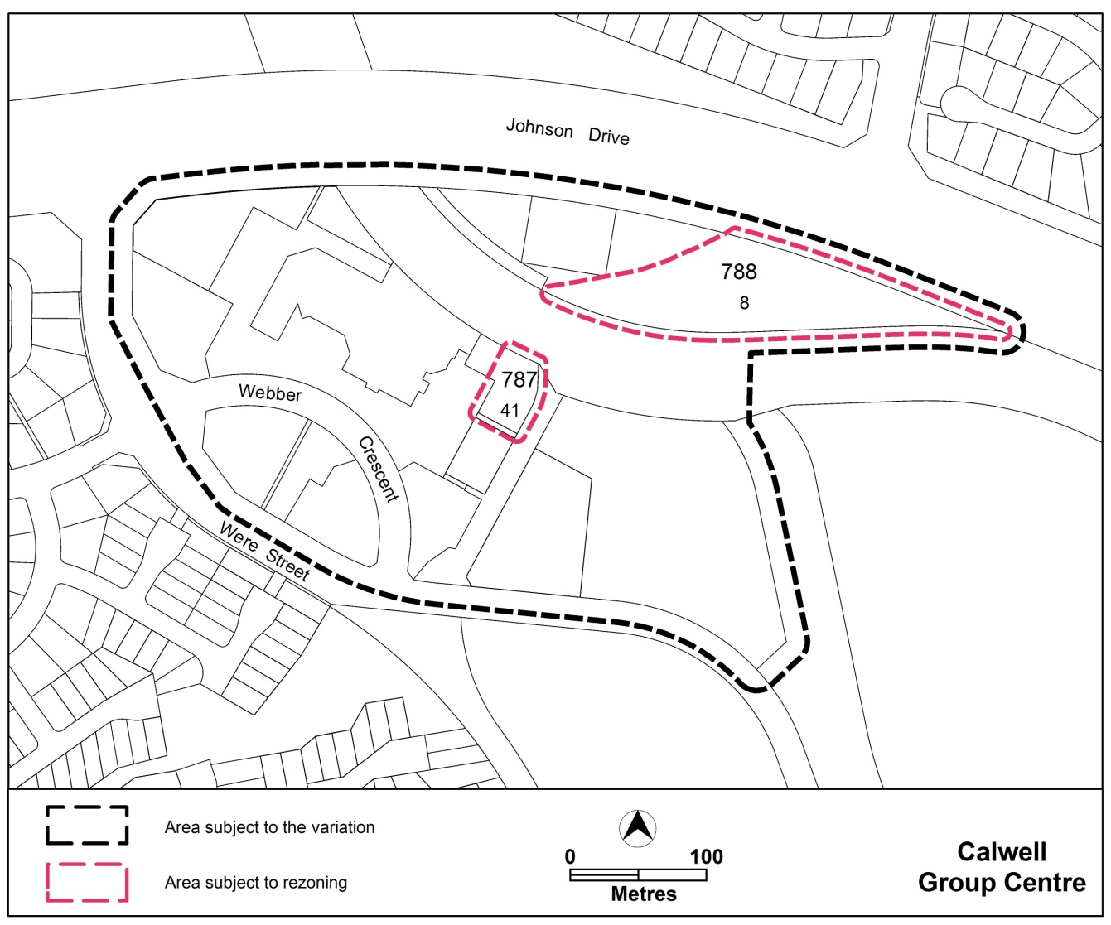
Figure 1: Site Plan

  - Current Territory Plan Provisions
The Territory Plan map for the area subject to this draft variation is shown in Figure 2.

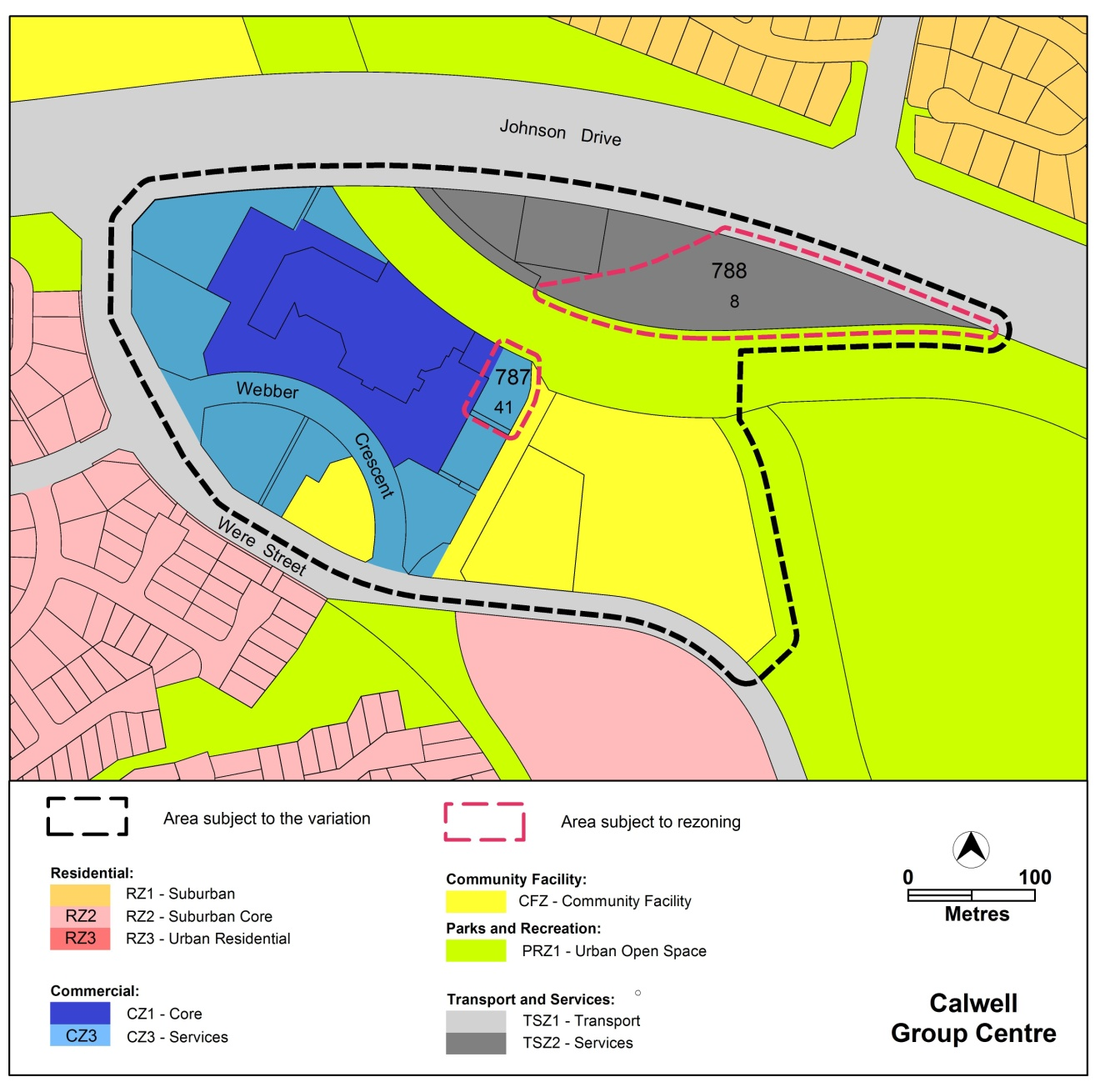
Figure 2 Territory Plan Zones Map

  - Changes to the Territory Plan
Detailed changes to the Territory Plan are noted in section 2 of this document.
  - Consultation on the Draft Variation
Draft Variation No 355 (DV355) was released for public comment between Friday 10 August 2018 and Monday 24 September 2018. A consultation notice under section 63 of the Planning and Development Act 2007 (P&D Act) was published on the ACT Legislation Register on Friday 10 August 2018.
A total of three written submissions were received and the following key issues were raised:
- Building heights – 1 submission
- Implications for redevelopment on block 41 section 787 Calwell – 1 submission
- Commercial services – 1 submission
- Planning process and consultation – 1 submission
- Car parking within the group centre – 1 submission
- Solar access to pedestrian pathways – 1 submission
- Plot ratio – 1 submission
- Focus on the Calwell Group Centre – 2 submissions
- Community uses – 1 submission
- Playground and pedestrian path upgrades within the group centre – 1 submission each
- Upgrades and provisions for area outside the group centre – 2 submissions.

The above issues were considered and are detailed in a report on consultation. Changes were made to the draft variation DV355 that was recommended to the Minister. These changes were informed by the issues raised. The outcomes of consultation were considered by the Minister for Planning and Land Management responsible for planning prior to approval of this variation.

  - Revisions to the Draft Variation Recommended to the Minister
The following changes were made as directed by the Minister for Planning and Land Management under section 76(2)(b)(iv). Consistent with the ACT Government Response to the Standing Committee Report number 10 which was tabled in the Legislative Assembly on 26 November 2019:
- Rule 2 was revised to allow residential ground floor uses on block 41 section 787 Calwell except along the primary active frontages.
- Figure 1 was amended to identify block 41 section 787 as a location for residential ground floor uses.

- VARIATION
  - Variation to the Territory Plan map
The Territory Plan map is varied in all of the following ways:
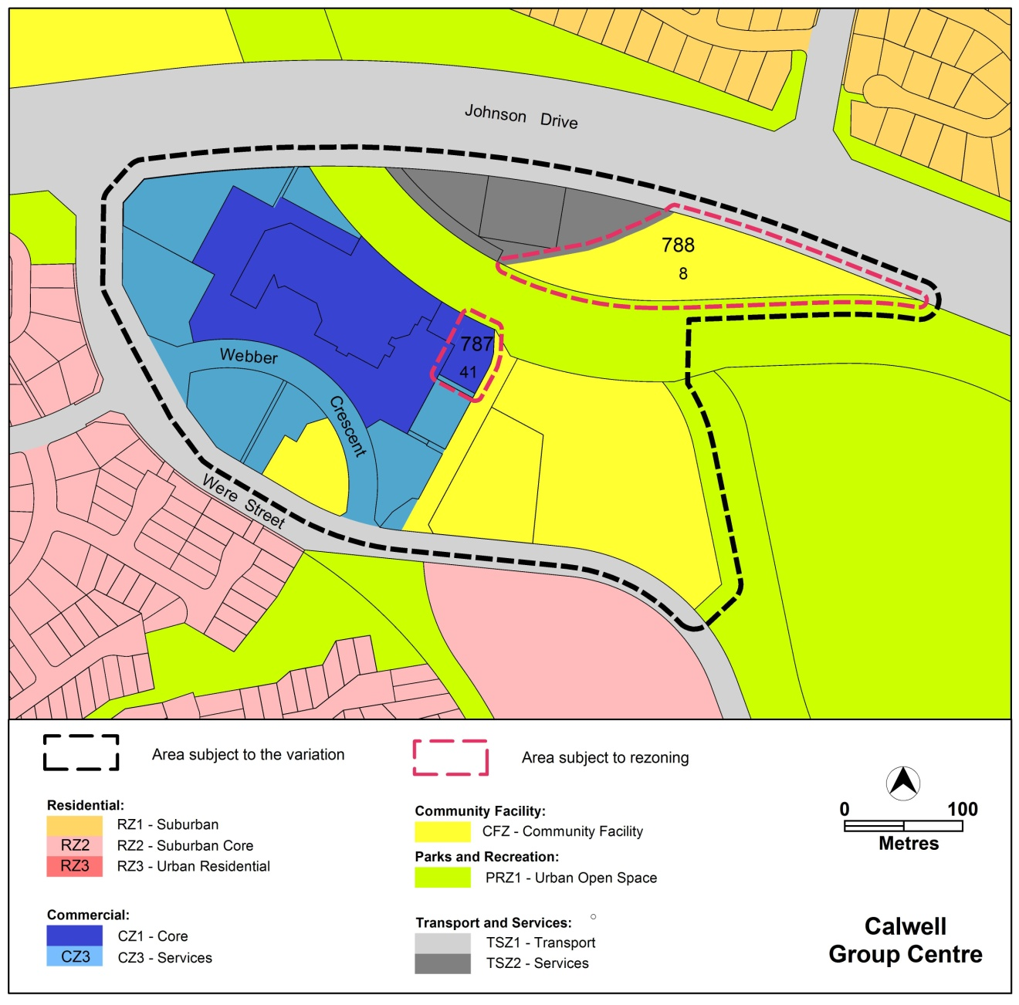

  - Variation to the Territory Plan

The Territory Plan is varied in all of the following ways:

Variation to the Calwell Precinct Map and Code
2. Precinct map and code, Calwell Precinct Code
Substitute all of the following with the nominated attachments
Calwell Precinct Map – Attachment A
Calwell Precinct Code, RC1 – Calwell Group Centre – Attachment B
Insert
RC2 – Calwell Community Facilities – Attachment C
Renumber
RC2 – Calwell / Conder Fire Station to RC3 – Calwell / Conder Fire Station
Substitute
This part applies to blocks and parcels identified in area RC2 shown on the Calwell Precinct Map
with
This part applies to blocks and parcels identified in area RC3 shown on the Calwell Precinct Map
Renumber all components within the new RC3 as follows:
Element 1: Buildings to Element 4: Buildings
item 1.1 Height to 4.1 Height
Rule R1 to R20
item 1.2 Setback to 4.2 Setback
Criterion C2 to C21
item 1.3 Screening to 4.3 Screening
Rule R3 and Criterion C3 to R22 and C22
item 1.4 Environment to 4.4 Environment
Rule R4 to R23

Interpretation service

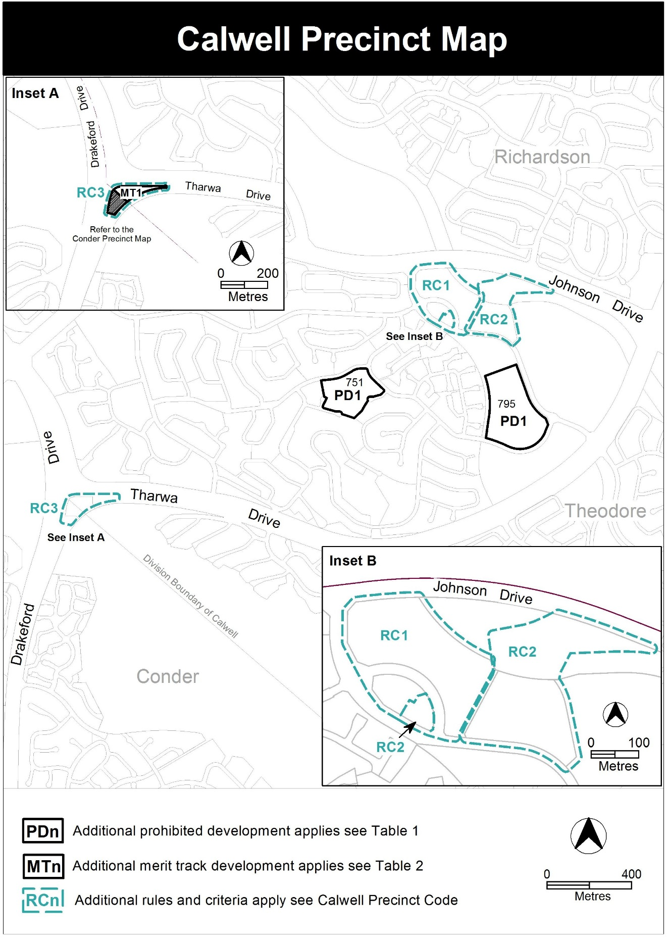

Assessment Tracks

The following tables identify the additional prohibited development and additional merit track development for blocks and parcels shown in the Calwell Precinct Map (identified as PDn or MTn). Development that is exempt from requiring development approval, other prohibited development and the minimum assessment track applicable to each development proposal is set out in the relevant zone development table.

The following tables constitute part of the relevant zone development table.

Table 1 – Additional prohibited development
Additional prohibited development
Suburb precinct map label | Zone | Development
PD1 | CFZ | retirement village  supportive housing

Table 2 – Additional merit track development
Additional merit track development that may be approved subject to assessment
Suburb precinct map label | Zone | Development
MT1 | TSZ1 | emergency services facility

RC1 – Calwell Group Centre
This part applies to blocks and parcels identified in area RC1 shown on the Calwell Precinct Map. RC1 includes the Calwell Group Centre.
- Use
Rules | Criteria
  - Ground floor uses – CZ1
R1  This rule applies to sites with frontages to primary active frontages shown in Figure 1.  Only the following uses are permitted at the ground floor level:  - business agency  - club  - community activity centre  - drink establishment  - financial establishment  - hotel  - indoor entertainment facility  - indoor recreation facility  - public agency  - restaurant  - SHOP. | This is a mandatory requirement. There is no applicable criterion.
  - Residential use – ground floor
R2  This rule applies to areas ‘A’ in Figure 1.  RESIDENTIAL USE is permitted on the ground floor consistent with all of the following:  - it is not located on a primary active frontage as identified on Figure 1  - it complies with the Australian Standard AS4299 – Adaptable housing (class C) and the Access and Mobility General Code. | This is a mandatory requirement. There is no applicable criterion.

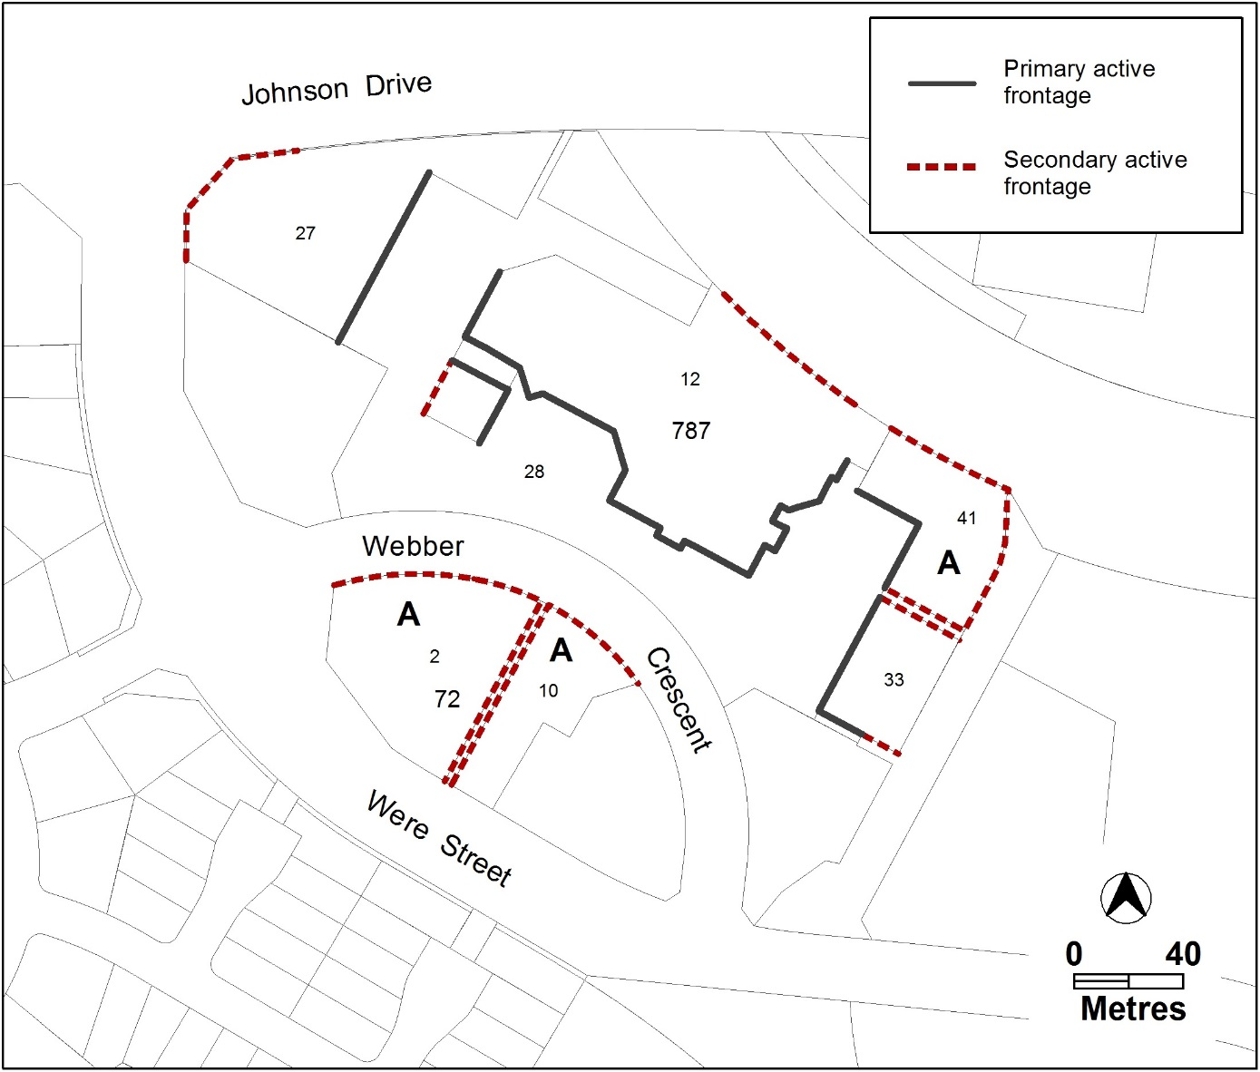
Figure 1 Active frontages, ground floor uses and commercial adaptability

Rules | Criteria
  - Development on nominated car parking areas
R3  This rule applies to the area shaded grey shown in Figure 2.  Development complies with all of the following:  - the existing number of car parking spaces is retained on the site and made available for public use at all times  - provides car parking that is generated by the development on site in accordance with the Parking and Vehicular Access General Code in addition to the spaces required by item a). | C3  Development meets all of the following:  - in accordance with the Parking and Vehicular Access General Code, there is enough car parking for the needs of the centre as a whole  - the development does not adversely affect the overall function of the centre in terms of economic, social, traffic and parking and urban design impacts.

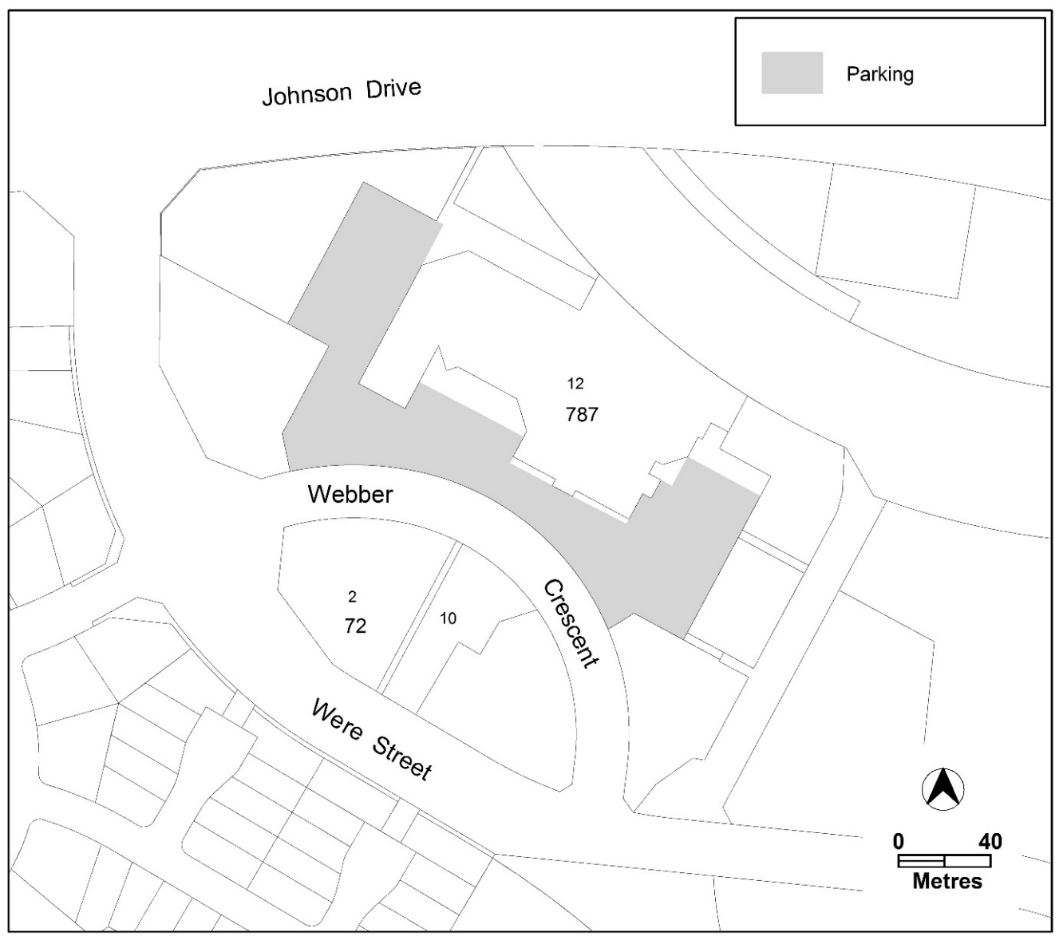
Figure 2 – car parking

- Buildings
Rules | Criteria
  - Building heights
R4  The maximum height of buildings is 2 storeys except areas A and B in Figure 3.  Plant room set back a minimum of 3m from the building facade of the floor immediately below is not included in the number of storeys. | This is a mandatory requirement. There is no applicable criterion.
  - Building heights
R5  This rule applies to areas A and B in Figure 3.  The maximum height of building in areas A and B is 2 storeys. | C5  The maximum height of building in areas A and B may be increased to 4 storeys where:  - development maintains reasonable solar access on the surrounding publicly accessible areas.  - area A achieves all of the following:  - is contained within block 41 section 787 Calwell  - is measured from the north western most boundary of block 41  - is a maximum of 26 metres wide.  - area B achieves all of the following:  - is contained within block 12 section 787 Calwell  - is measured 10.5metres from the western boundary of area A  - is a maximum of 22 metres wide  - is a maximum of 60 metres long.

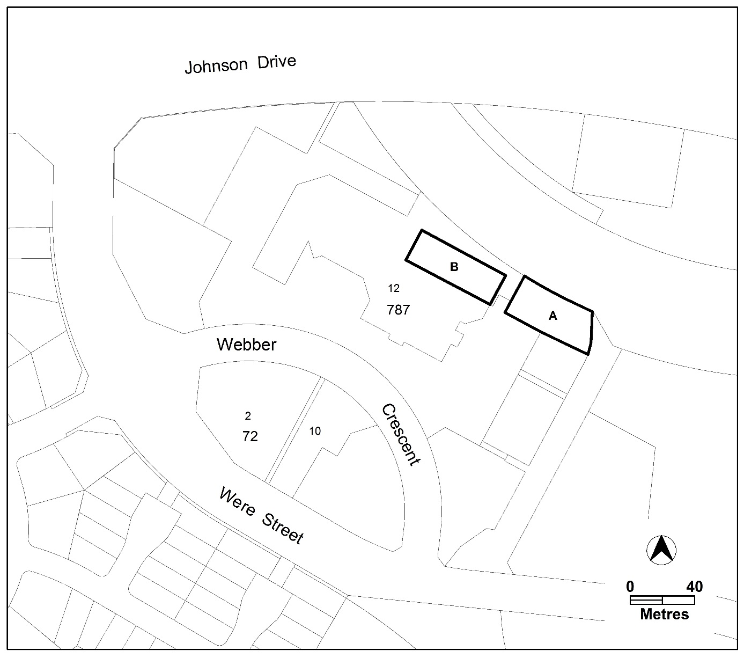
Figure 3: building heights

Rules | Criteria
  - Building design
R6  This rule applies to development along primary and secondary active frontages shown in Figure 1.  The minimum floor to ceiling height at the ground floor level is 3.6m. | C6  The ground floor level of buildings is adaptable for commercial uses.
There is no applicable rule. | C7  Building design achieves all of the following:  - entrances to common areas for residential use provide strong visual connection to the street and ensure a high level of surveillance  - driveways and pedestrian entrances to the site are visible from the block boundary  - west-facing facades incorporate sun shading into building designs  - car parking does not front onto main pedestrian routes and streets at ground floor, and  - service access does not adversely impact on or limit active frontages and/or public places.
  - Plot ratio
There is no applicable rule. | C8  Plot ratio achieves consistency with the desired character.
  - Setbacks
There is no applicable rule. | C9  This criterion applies to development on the southern block boundary where it adjoins at least one of the following:  - public spaces identified on Figure 4 or  - the proposed and existing pedestrian access paths identified in Figure 4 that are located north of Webber Crescent.  Building elements above the first floor are setback from the southern block boundary to retain reasonable solar access to public spaces and pedestrian access paths.

Rules | Criteria
  - Solar access
R10  Development retains a minimum 3 hours solar access to the main daytime living areas and principal private open space of dwellings and habitable rooms on adjoining blocks between the hours of 9am and 3pm on the winter solstice (21 June). | C10  Development retains reasonable solar access to dwellings and habitable rooms on adjoining blocks and their associated principal area of private open space.

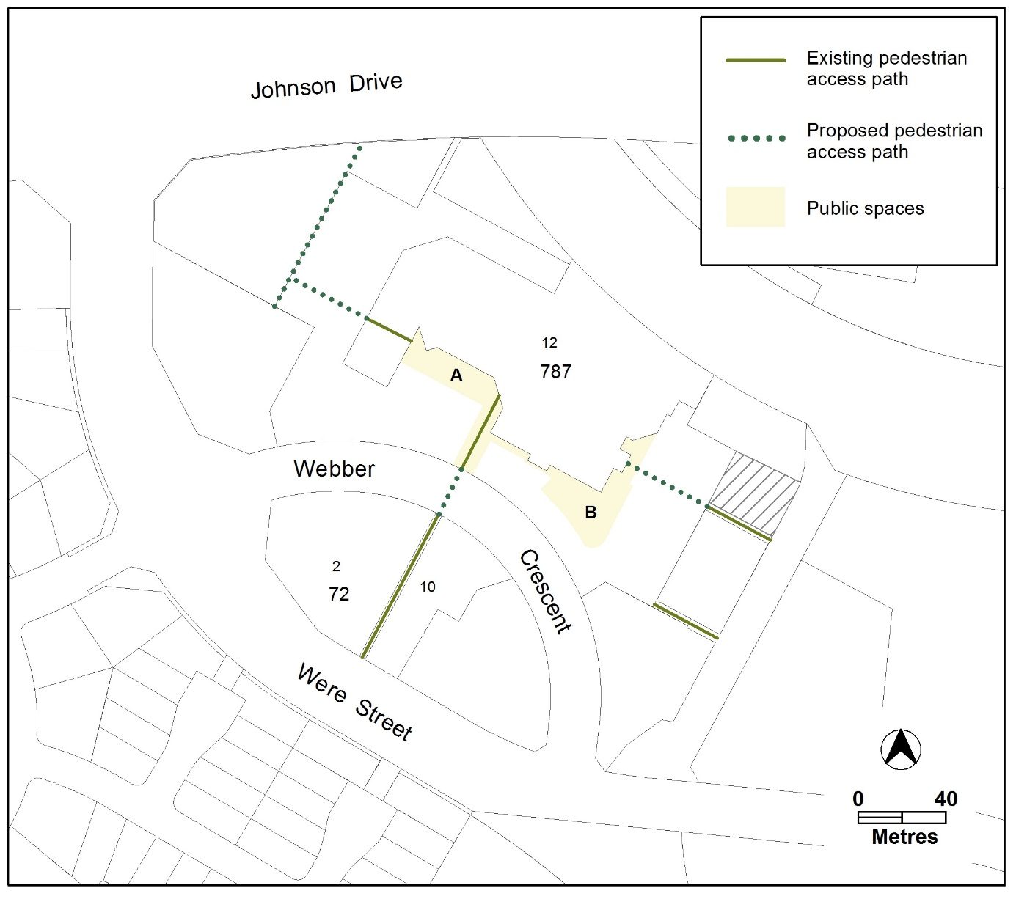
Figure 4: public spaces and pedestrian paths
Rules | Criteria
  - Public spaces
R11  This rule applies to the public spaces shown in Figure 4.  Public spaces are provided and comply with all of the following:  - area A on Figure 4 has a minimum area of 540m²  - area B on Figure 4 has a minimum area of 800m²  - are connected to each other  - are accessible by existing and proposed pedestrian paths  - have no buildings or structures located within the area (excluding basements)  - are paved and landscaped. | C11  Public spaces are provided and comply with all of the following:  - are located generally in accordance with Figure 4  - are of a scale and dimensions that provide usable open spaces  - are publicly accessible  - are paved and landscaped.
  - Pedestrian connections – section 787
R12  This rule applies to the proposed pedestrian access paths shown in Figure 4.  A pedestrian connection is provided that complies with all of the following:  - a minimum unobstructed width of 6m  - a minimum extent of 30% glazing at the ground floor measured along the length of the pedestrian connection, and  - access to ground floor commercial tenancies adjoining the pedestrian connection  - the pedestrian access path remains unenclosed and publicly accessible at all times. | C12  Pedestrian connections are provided generally in accordance with Figure 4 and achieve all of the following:  - reasonable public access  - views into and out of adjoining commercial premises and  - clearly identifiable entrances.

Rules | Criteria
R13  This rule applies to development in the hatched area in Figure 4.  Development incorporates an extension to the existing public pedestrian path onto block 41 section 787, shown in Figure 4, by providing a pedestrian path along the entire length of the southern boundary that complies with all of the following:  - Has a total minimum width of 6m when combined with the existing public pathway  - is finished at the level of the pedestrian path and with matching materials and  - remains unobstructed and publicly accessible at all times. | This is a mandatory requirement. There is no applicable criterion.
  - Active frontages
R14  For new buildings located along primary active frontage areas identified in Figure 1, frontages and building design comply with all of the following:  - buildings incorporate clear display windows and/or shop fronts at the ground floor level  - buildings incorporate direct pedestrian access at grade with the verge level for access and egress for persons with disabilities  - any small areas of walls without windows contain displays, showcases and/or public art, with a maximum of 30% blank frontage per tenancy  - open structured car parks and/or loading docks are not located along the frontage. | This is a mandatory requirement. There is no applicable criterion.

Rules | Criteria
There is no applicable rule. | C15  For buildings located along secondary active frontage areas identified in Figure 1, frontages and building design complies with all of the following:  - commercial buildings incorporate clear display windows and shop fronts at the ground floor level  - buildings incorporate direct pedestrian access at grade with the verge level for access and egress for persons with disabilities  - building facades are not dominated by extensive lengths of blank facades, open structured carparks, loading docks, substations or other service infrastructure  - residential development of 2 storeys or more incorporates balconies and windows to habitable rooms addressing the public realm.

Rules | Criteria
  - Awnings
R16  This rule applies to buildings fronting primary active frontage areas shown in Figure 1 except where the awning is contained wholly within a block.  Awnings are provided along the length of the building frontage consistent with all of the following:  - are a minimum height of 3m above finished pavement or ground level of the verge  - are integrated into the building design at the first floor level  - are a minimum of 3m in cantilever depth, except  - where opposing primary active frontages are 6m apart or less, awning depth may be reduced to ensure awnings are separated by 0.5m  - where a reduction in awning depth is required to accommodate existing infrastructure and/or existing or replacement street trees. | C16  Awnings provide continuous all weather pedestrian shelter and activity in a form compatible with existing awnings.
R17  This rule applies to new buildings fronting the primary active frontage areas shown in Figure 1 where awnings are wholly contained within the block boundary.  Awnings comply with all of the following:  - a minimum height of 3m above the finished pavement or ground level  - a minimum of 3m depth  - integrated into the building design at the first floor level  - have posts at 3m intervals along the outside edge of the awning  - extend the full facade of the building. | C17  Awnings provide continuous all weather pedestrian shelter and activity in a form compatible with existing awnings.

RC2 – Calwell Community Facilities
This part applies to blocks and parcels identified in area RC2 shown on the Calwell Precinct Map.

- Built form
Rules | Criteria
  - Pedestrian connection – section 788
R18  This rule applies to section 788 shown in Figure 5 where the active travel path is shown.  Development retains the existing active travel path connecting the Calwell Group Centre to Johnson Drive. | C18  Development that alters the existing active travel path complies with all of the following:  - retains a publicly accessible path of travel connecting Calwell Group Centre and Johnson Drive with a minimum width of 3m  - is endorsed by Transport Canberra and City Services.
  - Active frontages
There is no applicable rule. | C19  For buildings located along secondary active frontages shown in Figure 5, building design achieves all of the following:  - where public building access is provided, it is direct pedestrian access at street level  - buildings, and associated areas of open space where provided, provide opportunities for views into and out of the building to adjoining public spaces  - building facades are not dominated by extensive lengths of blank facades, open structured car parks, loading docks, substations or other service infrastructure.

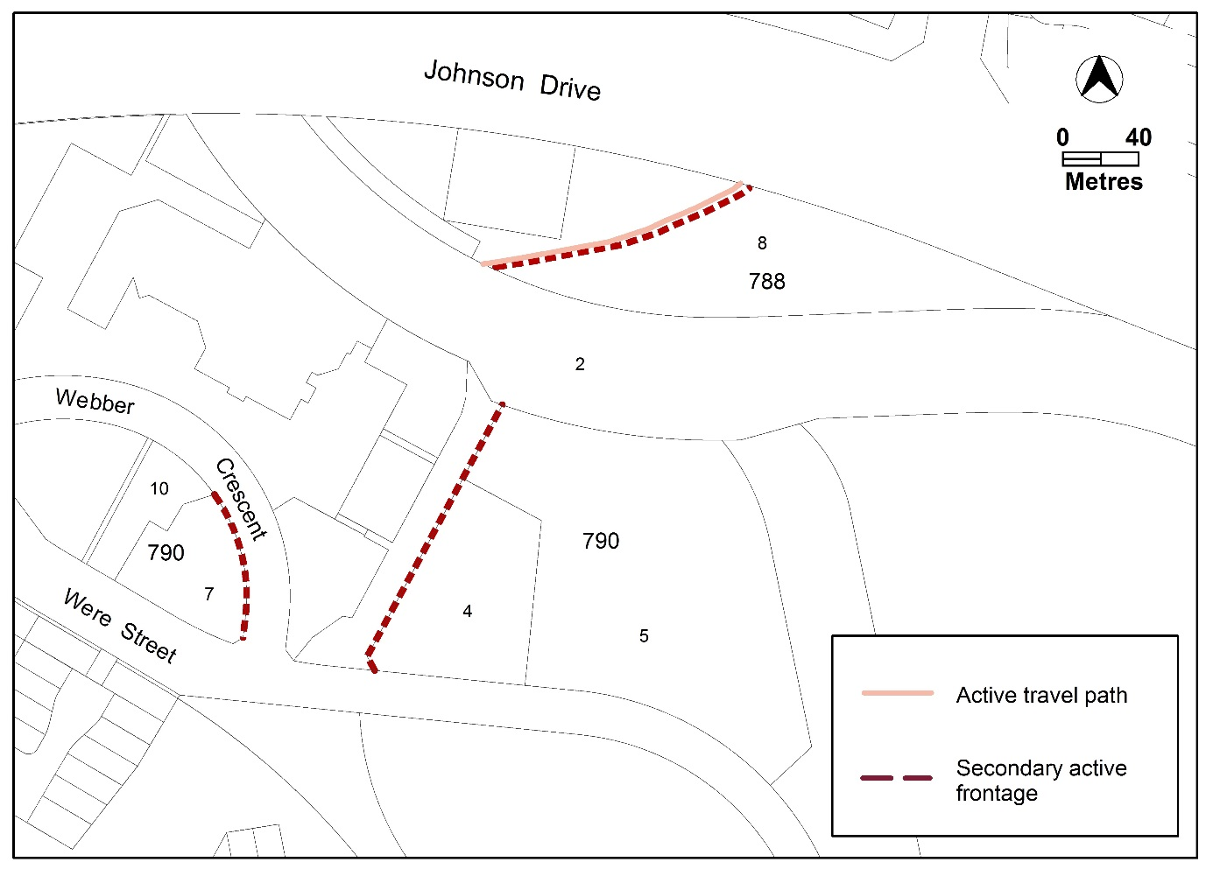
Figure 5 Secondary active frontages and pedestrian connection

