Australian Capital Territory
Heritage (Decision about Provisional Registration of 8 Westgarth Street, O’Connor) Notice 2020
Notifiable instrument NI2020–89
made under the
Heritage Act 2004, s34 (Notice of decision about provisional registration)

1 Name of instrument
This instrument is the Heritage (Decision about Provisional Registration of 8 Westgarth Street, O’Connor) Notice 2020.
2 Decision about provisional registration
On 6 February 2020, the ACT Heritage Council (the Heritage Council) decided not to provisionally register 8 Westgarth Street, Block 16, Section 47, O’Connor (the Place).
3 Description of the Place
The description of the Place is in the schedule.
4 Reasons for the decision
The Heritage Council is not satisfied on reasonable grounds that the Place is likely to have heritage significance as defined by section 10 of the Heritage Act 2004. A detailed statement of reasons, including an assessment against the heritage significance criteria, is provided in the schedule.
5 Date decision takes effect
The decision not to provisionally register the Place takes effect on 7 February 2020 (being the day after the Heritage Council made its decision in writing as set out in the schedule).

Fiona Moore
Secretary (as delegate for)
ACT Heritage Council
6 February 2020

Schedule
(See sections 3 and 4)
STATEMENT OF REASONS
DECISION NOT TO PROVISIONALLY REGISTER
8 westgarth streetWamboinName of Place
BLOCK 16 AND SECTION 47, O’Connor
IN THE ACT HERITAGE REGISTER

In accordance with s32 of the Heritage Act 2004, the ACT Heritage Council has decided not to provisionally register 8 Westgarth Street, O’Connor. This Statement of Reasons provides an assessment of 8 Westgarth Street, O’Connor, and finds that the place does not meet any of the criteria under s10 of the Heritage Act 2004.

This statement refers to the location of the place as required in s34(5)(b)(ii) of the Heritage Act 2004.
LOCATION OF THE PLACE

8 Westgarth Street, Block 16 Section 47 O’Connor.

This section refers to the description of the place as required in s34(5)(b)(iii) of the Heritage Act 2004. The boundary of the place and extent of features listed below are illustrated at Image 1.

DESCRIPTION OF THE PLACE

8 Westgarth Street, consisting of a post-war Canberra red-brick cottage, defined in the Government Property & Tenancy Registers 1925 to 1968 as a ‘Brick House Type 218.’

This statement refers to the Council’s reasons for its decision as required in s34(5)(b)(iv) of the Heritage Act 2004.
REASONS FOR DECISION

The Council is not satisfied on reasonable grounds that the place is likely to have heritage significance as defined by s10 of the Heritage Act 2004.

This statement refers to the Council’s assessment of the place against the heritage significance criteria as a part of its reasons for its decision as required in s34(5)(b)(iv) of the Heritage Act 2004.
ASSESSMENT AGAINST THE HERITAGE SIGNIFICANCE CRITERIA

The Council’s assessment against the criteria specified in s10 of the Heritage Act 2004 is as follows.

In assessing the heritage significance of 8 Westgarth Street, O’Connor, the Council considered:
- the original nomination and documentary evidence supplied by the nominator;
- the Council’s Heritage Assessment Policy (March 2018);
- information provided by a site inspection on 17 December 2019 by ACT Heritage;
- the report by the Council titled, Background Information 8 Westgarth Street, O’Connor, February 2020 containing photographs and information on history, description, condition and integrity; and
- information on the conditions and alterations to the place provided by the owners via letter submitted on 6 December 2019.

Pursuant to s10 of the Heritage Act 2004, a place or object has heritage significance if it satisfies one or more of the following criteria. Future research may alter the findings of this assessment.
- importance to the course or pattern of the ACT’s cultural or natural history;
The Council has assessed 8 Westgarth Street against criterion (a) and is satisfied that the place does not meet this criterion.
As Canberra developed, the provision of accommodation was a constant challenge as it needed to be built as required. After World War II, Canberra’s housing shortfall was critical. At this time, the Department of the Interior aimed to address the post-war housing crisis with notable innovative responses that included the supply of relocated and prefabricated homes. 8 Westgarth Street was constructed at this time in the post-war suburb of O’Connor, however, it was designed by the Department of Works and Housing as a ‘brick house type 218’ and as such is one of at least 100 types of small 2 or 3 bedroom cottage devised during the National Capital Planning and Development Committee (NCPDC) era from 1938 to 1957. Therefore, while 8 Westgarth Street was built during the immediate post-war era as part of a response to a pressing need, it is one type among many and is not connected with a notable thrust for addressing the post-war housing.
- has uncommon, rare or endangered aspects of the ACT’s cultural or natural history;
The Council has assessed 8 Westgarth Street against criterion (b) and is satisfied that the place does not meet this criterion.
Over a number of decades, hundreds of small two or three bedroom cottages were built across a spread of Canberra suburbs to house the growing population of workers and public servants. Many of the pre-war cottages, especially those designed by the Federal Capital Commission (FCC) are retained within heritage listed precincts preserving the original setting and planning intentions of their time, especially the ‘Garden City’ design. Also massed within a precinct, the houses within the O’Connor ‘Tocumwal Heritage Precinct’ represent the innovative bulk response of the Department of the Interior to addressing Canberra’s post-war housing needs. In contrast, as a singular suburban dwelling, built by the government to house Canberrans in the post-war period, and as one type among many, that is additionally not intact and not massed within a setting or precinct, it cannot be claimed that 8 Westgarth Street stands above any other singular government-built cottage to claim a clear association with an important part of the ACT’s cultural history and therefore it cannot be the case that 8 Westgarth Street holds uncommon, rare or endangered aspects of the ACT’s cultural history.
- potential to yield important information that will contribute to an understanding of the ACT’s cultural or natural history;
The Council has assessed 8 Westgarth Street against criterion (c) and is satisfied that the place does not meet this criterion.
8 Westgarth Street was built in the late 1940s to a design by the Department of Works and Housing that is archived online by the National Archives of Australia (NAA). Archives ACT holds records regarding the early tenancy of the property as a rental rebate house. Both the NAA and Archives ACT hold such records for numerous other properties and housing types across a spread of Canberra suburbs. In addition to providing information on 8 Westgarth Street as a ‘218’ type house, the online resources provide opportunities for the study of other properties and housing types, enabling contextualisation of 8 Westgarth Street. Thus, useful online documentation exists for the study of 8 Westgarth Street within its context. Whilst documentary resources may shed light on 8 Westgarth Street within its context, there is no evidence before Council that any detailed examination of the fabric or archaeology of 8 Westgarth Street would yield information contributing to an understanding of the ACT’s cultural history.

- importance in demonstrating the principal characteristics of a class of cultural or natural places or objects;
The Council has assessed 8 Westgarth Street against criterion (d) and is satisfied that the place does not meet this criterion.
8 Westgarth Street is a post-war suburban brick cottage built as a ‘218’ type, that was one design among many devised by the Department of Works and Housing during the National Capital Planning and Development Committee era 1938 – 1957. As one variation among many similar suburban house designs of the same era, it cannot be argued that 8 Westgarth Street demonstrates the principal characteristics of a class of place in the same way that the relocated or prefabricated homes of the same era, for example, can represent the government’s innovative response to the hasty supply of post-war housing. Additionally, 8 Westgarth Street is a singular suburban dwelling that does not exist within a streetscape or a precinct demonstrating anything beyond the ordinary.
- importance in exhibiting particular aesthetic characteristics valued by the ACT community or a cultural group in the ACT;
The Council has assessed 8 Westgarth Street against criterion (e) and is satisfied that the place does not meet this criterion.
Externally, aside from modified windows, 8 Westgarth Street is an intact brick post-war cottage within an established suburb in Canberra’s leafy inner north. Its aesthetic characteristics include its construction from Canberra red bricks, its compact size compared to the modern houses being built in Canberra’s inner north and the general utilitarian restraint of its form and design. Whilst some people may value the aesthetic characteristics of such post-war cottages, the extent of this valuing and the ascribing of it to a representative group that speaks for an identified cultural group in the ACT or the wider ACT community has not been able to be established as required by the Heritage Assessment Policy (2018). Therefore, there is no evidence before Council that 8 Westgarth Street meets this criterion.
- importance in demonstrating a high degree of creative or technical achievement for a particular period;
The Council has assessed 8 Westgarth Street against criterion (f) and is satisfied that the place does not meet this criterion.
8 Westgarth Street was designed by the architects of the Department of Interior and is one design among many, similar two or three-bedroom cottages. In its design and construction 8 Westgarth Street represents a utilitarian response to meeting a pressing need, which was to supply public housing for Canberra’s growing post-war population. Built as a practical response to a pressing need, 8 Westgarth Street is a utilitarian building and does not exhibit a high degree of creative or technical achievement for a particular period.
- has a strong or special association with the ACT community, or a cultural group in the ACT for social, cultural or spiritual reasons;
The Council has assessed 8 Westgarth Street against criterion (g) and is satisfied that the place does not meet this criterion.
8 Westgarth Street was built for public housing and retained for such a purpose until 2018. It is a compact, utilitarian building located on an ordinary inner north street, in an ordinary inner north suburb in Canberra. Whilst 8 Westgarth Street could be important to past tenants, and indeed one of them nominated the property, there is no evidence before Council that the place has a strong or special association with the ACT community, or a cultural group in the ACT for social, cultural or spiritual reasons.

- has a special association with the life or work of a person, or people, important to the history of the ACT.
The Council has assessed 8 Westgarth Street against criterion (h) and is satisfied that the place does not meet this criterion.
While a number of number of people have been involved in the design, construction and management of 8 Westgarth Street via the departments for which they have worked and whilst it is likely that 8 Westgarth Street has had a series of tenants, there is currently no evidence before Council of any association between people and place that could be considered special.
SITE PLAN

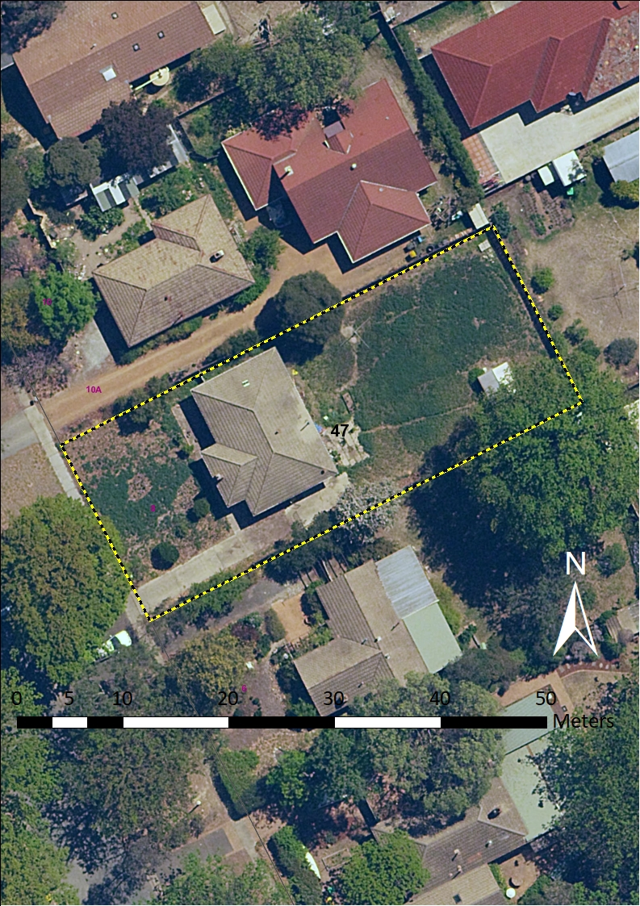
Image 1 8 Westgarth Street site boundary

