Australian Capital Territory
Veterinary Practice (Registrar) Appointment 2021 (No 1)

Notifiable Instrument NI2021–116
made under the
Veterinary Practice Act 2018, section 104 (Appointment of registrar)

1 Name of instrument
This instrument is the Veterinary Practice (Registrar) Appointment 2021 (No 1).
2 Commencement
This instrument commences the day after it is notified.
3 Appointment of executive officer
The ACT Veterinary Practitioners Board (the Board) appoints position number E00821, Executive Branch Manager, Governance and Ministerial Services for Transport Canberra and City Services as the Registrar for the Board.
4 Revocation
This instrument revokes NI2020-211 Veterinary Practice (Registrar) Appointment 2020 (No 1).

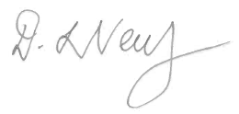

Dr Debbie Neutze
President
ACT Veterinary Practitioners Board
24 February 2021

