Australian Capital Territory
Electoral (Place of Nomination) Approval 2021
Notifiable instrument NI2021–157
made under the
Electoral Act 1992, s 108 (Place and hour of nomination)

1 Name of instrument
This instrument is the Electoral (Place of Nomination) Approval 2021.
2 Commencement
This instrument commences on the day after its notification day.
3 Approval
I approve the ACT Legislative Assembly, Civic Square, 196 London Circuit, Canberra City as a place of nomination for ACT Legislative Assembly elections.
4 Revocation
This instrument revokes NI2020-616.
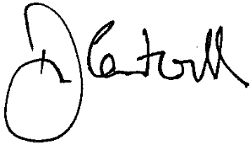
Damian Cantwell AM CSC
Electoral Commissioner
12 March 2021

