Australian Capital Territory
Planning and Development (Technical Amendment—Rezoning boundary changes) Plan Variation 2021 (No 1)

Notifiable instrument NI2021—184
Technical Amendment No 2021-03
made under the
Planning and Development Act 2007, section 89 (Making technical amendments) and section 90A (Rezoning boundary changes)

- Name of instrument
This instrument is the Planning and Development (Technical Amendment—Rezoning boundary changes) Plan Variation 2021 (No 1).
2 Commencement
This instrument commences on the day after its notification day.
3 Technical amendment
I am satisfied under section 89(1)(a) of the Planning and Development Act 2007 (the Act) that the Rezoning boundary changes plan variation is a technical amendment to the Territory Plan.
4 Dictionary
In this instrument:
Rezoning boundary changes plan variation means the technical amendment to the Territory Plan, variation 2021-03, in the schedule.
Note: No consultation was required in relation to the Rezoning boundary changes plan variation under section 87 of the Act.
Lesley Cameron
Delegate of the planning and land authority
25 March 2021

Planning & Development Act 2007

Technical Amendment
to the Territory Plan
Variation 2021-03

Rezoning boundary changes

March 2021

This page is left intentionally blank

Table of Contents
1. INTRODUCTION 4
1.1 Purpose 4
1.2 Public consultation 4
1.3 National Capital Authority 4
1.4 Process 4
1.5 Types of technical amendments under the Act 5
2. EXPLANATION 6
2.1 Background 6
2.2 Changes to the Territory Plan Map 6
3. TECHNICAL AMENDMENT 13
3.1 Territory Plan Map 13

This page is left intentionally blank
- INTRODUCTION
  - Purpose
This technical amendment makes the following changes to the Territory Plan:
Territory Plan Map
- Realigns zone boundaries on the following blocks:
  - Belconnen section 52 block 38
  - Lyneham section 41 blocks 29 and 30

  - Public consultation
Under section 87(1)(b) of the Planning and Development Act 2007 (the Act) this type of technical amendment is not subject to public consultation.

  - National Capital Authority
The National Capital Authority does not need to be advised of this technical amendment as per 1.2.

  - Process
This technical amendment has been prepared in accordance with section 87 and made in accordance with section 89 of the Act.
  - Types of technical amendments under the Act
The following categories of technical amendments are provided under section 87 of the Act:
- Each of the following territory plan variations is a technical amendment for which no consultation is needed before it is made under section 89:
(a) a variation (an error variation) that –
- would not adversely affect anyone’s rights if approved; and
- has as its only object the correction of a formal error in the plan;
(b) a variation to change the boundary of a zone or overlay under section 90A (Rezoning – boundary changes);
(c) a variation, other than one to which subsection (2)(d) applies, in relation to an estate development plan under section 96 (Effect of approval of estate development plan);
(d) a variation required to bring the territory plan into line with the national capital plan;
(e) a variation to omit something that is obsolete or redundant in the territory plan.
- Each of the following territory plan variations is a technical amendment for which only limited public consultation is needed under section 90:
- a variation (a code variation) that –
- would only change a code; and
- is consistent with the policy purpose and policy framework of the code; and
- is not an error variation;
- a variation to change the boundary of a zone under section 90B (Rezoning – development encroaching on adjoining territory land);
- a variation in relation to a future urban area under section 90C (Technical amendments – future urban areas);
- a variation in relation to an estate development plan under section 96 (Effect of approval of estate development plan) if it incorporates an ongoing provision that was not included in the plan under
section 94(3)(g);
- a variation to clarify the language in the territory plan if it does not change the substance of the plan;
- a variation to relocate a provision within the territory plan if the substance of the provision is not changed.
TA2021-03 has been prepared in accordance with section 87(1)(b) of the Act.
- EXPLANATION
This part of the technical amendment document explains the changes to be made to the Territory Plan.
  - Background
Belconnen
The block boundaries of Belconnen section 52 block 38 were adjusted to prepare the block for sale. The northern boundary of block 38 was extended into the Emu Bank road reserve, which is zoned TSZ1 Transport zone. The zone boundaries are adjusted accordingly to match the new block boundaries.
Lyneham
The block boundaries of Lyneham section 41 block 29 were adjusted to prepare the block for sale. The north-eastern boundary of block 29 was moved inwards to exclude a stormwater retaining wall from the block. The south-eastern boundary has been extended outwards onto block 30 by approximately 0.95m to bring it into line with an existing fence. The zone boundaries are being adjusted accordingly to match the new block boundaries.
  - Changes to the Territory Plan Map
In accordance with section 90A of the Planning and Development Act 2007 this technical amendment will realign the zone boundaries of the:
- Commercial CZ1 Core zone and TSZ1 Transport zone at Belconnen section 52 block 38 and Emu Bank road reserve
- Parks and Recreation PRZ1 Urban Open Space zone, Public Land Pe Urban Open Space overlay, and Residential RZ1 Suburban zone at Lyneham section 41 blocks 29 and 30
The planning and land authority was requested to make changes to the zone and overlay boundaries by the relevant land custodians.

Compliance with the Planning and Development Act 2007

Section | Statement
Section 87(1)(b) - a variation to change the boundary of a zone or overlay under section 90A (Rezoning boundary changes)
Section 90A
- This section applies to a zone or overlay in relation to land if the land adjoins unleased territory land or land for which the Territory is the registered proprietor (the adjoining territory land). | This technical amendment proposes to adjust zoning on land which the Territory is the registered proprietor, and on unleased land at:  - Belconnen section 52 block 38  - Lyneham section 41 blocks 29 and 30
- The planning and land authority may vary the territory plan under section 89 (Making technical amendments) to change the boundary of the zone or overlay to encroach onto the adjoining territory land if the change is consistent with— (a) the apparent intent of the original boundary line; and (b) the objective for the zone. | - Belconnen section 52 block 38  The proposed technical amendment is considered to be consistent with the apparent intent of the original Commercial CZ1 Core zone boundary. The technical amendment will correct the zone boundaries in line with the minor block boundary adjustment. This amendment will make sure that Belconnen section 52 block 38 only has one zone.  This technical amendment will facilitate the outcomes expressed in the zone objectives (Commercial CZ1 Core zone) to allow for development of a mixed use development on block 38, while retaining the functions and objectives of the road reserve at Emu Bank (TSZ1 Transport zone).  - Lyneham section 41 blocks 29 and 30  The proposed amendment is considered to be consistent with the apparent intent of the original zone boundaries. This technical amendment facilitates the achievement of the zone objectives. The amendment to the zone boundary results in an overall small gain to the Parks and Recreation PRZ1 Urban Open Space zone to include the stormwater retention wall, and a small reduction of Residential RZ1 Suburban zoned land.
- The planning and land authority may vary the territory plan under section 89 to change the boundary of an overlay to encroach onto the adjoining territory land if— (a) the authority is advised to do so by— (i) the conservator of flora and fauna; or (ii) the custodian of the land for the overlay; and (b) the conditions in subsection (2) (a) and (b) are satisfied.  - In this section: overlay means an overlay identified in the territory plan. | The planning and land authority has been advised to make the changes by the land custodian Transport and City Services, and Environment Planning and Sustainable Development Directorate.  The conditions in subsection (2) (a) and (b) are satisfied as explained above.

Belconnen – Existing Territory Plan Map
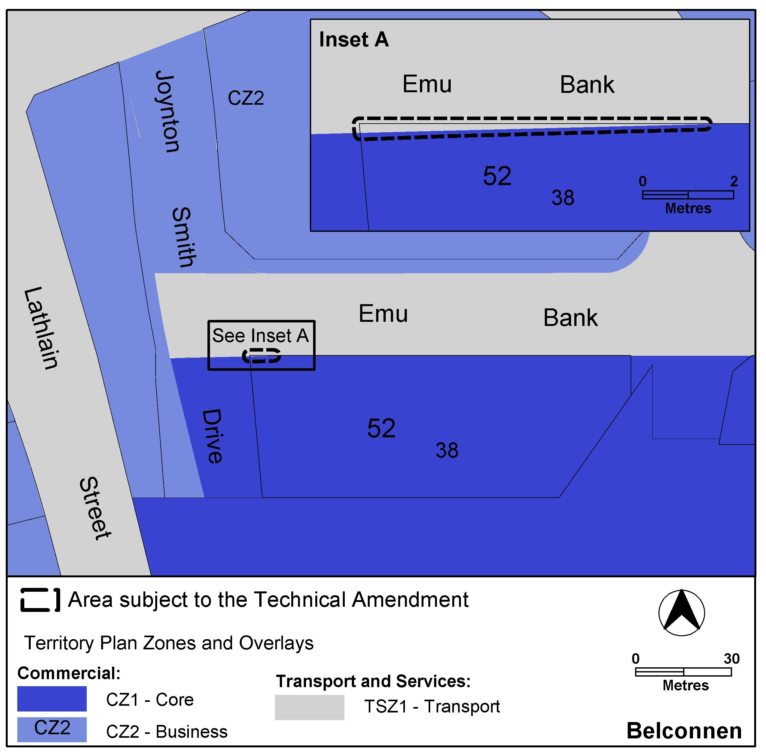

Belconnen – Proposed Territory Plan Map
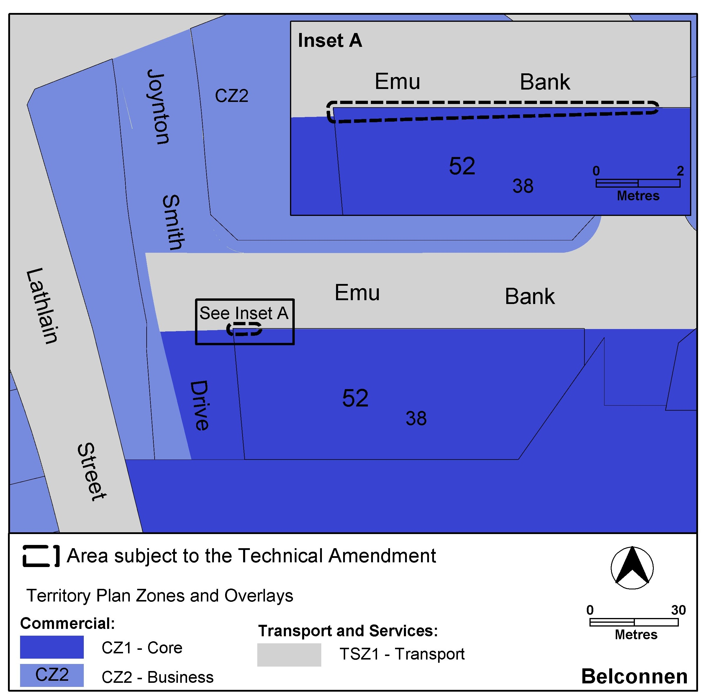

Lyneham – Existing Territory Plan Map
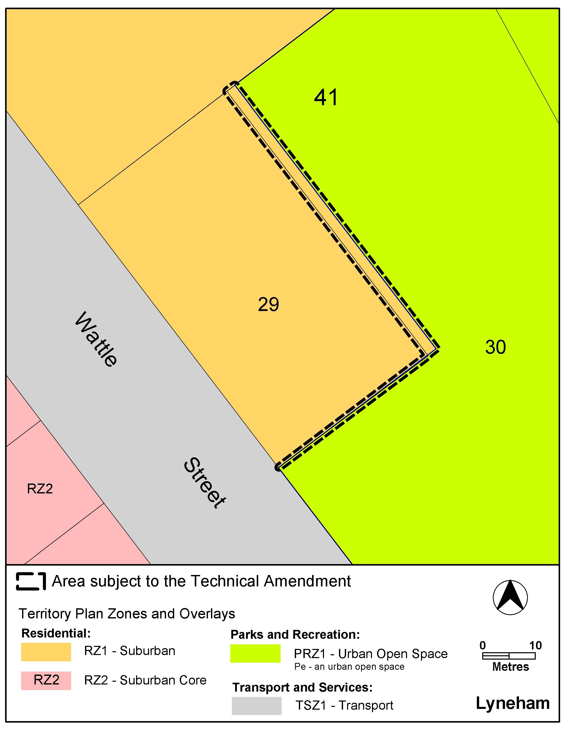

Lyneham - Proposed Territory Plan Map
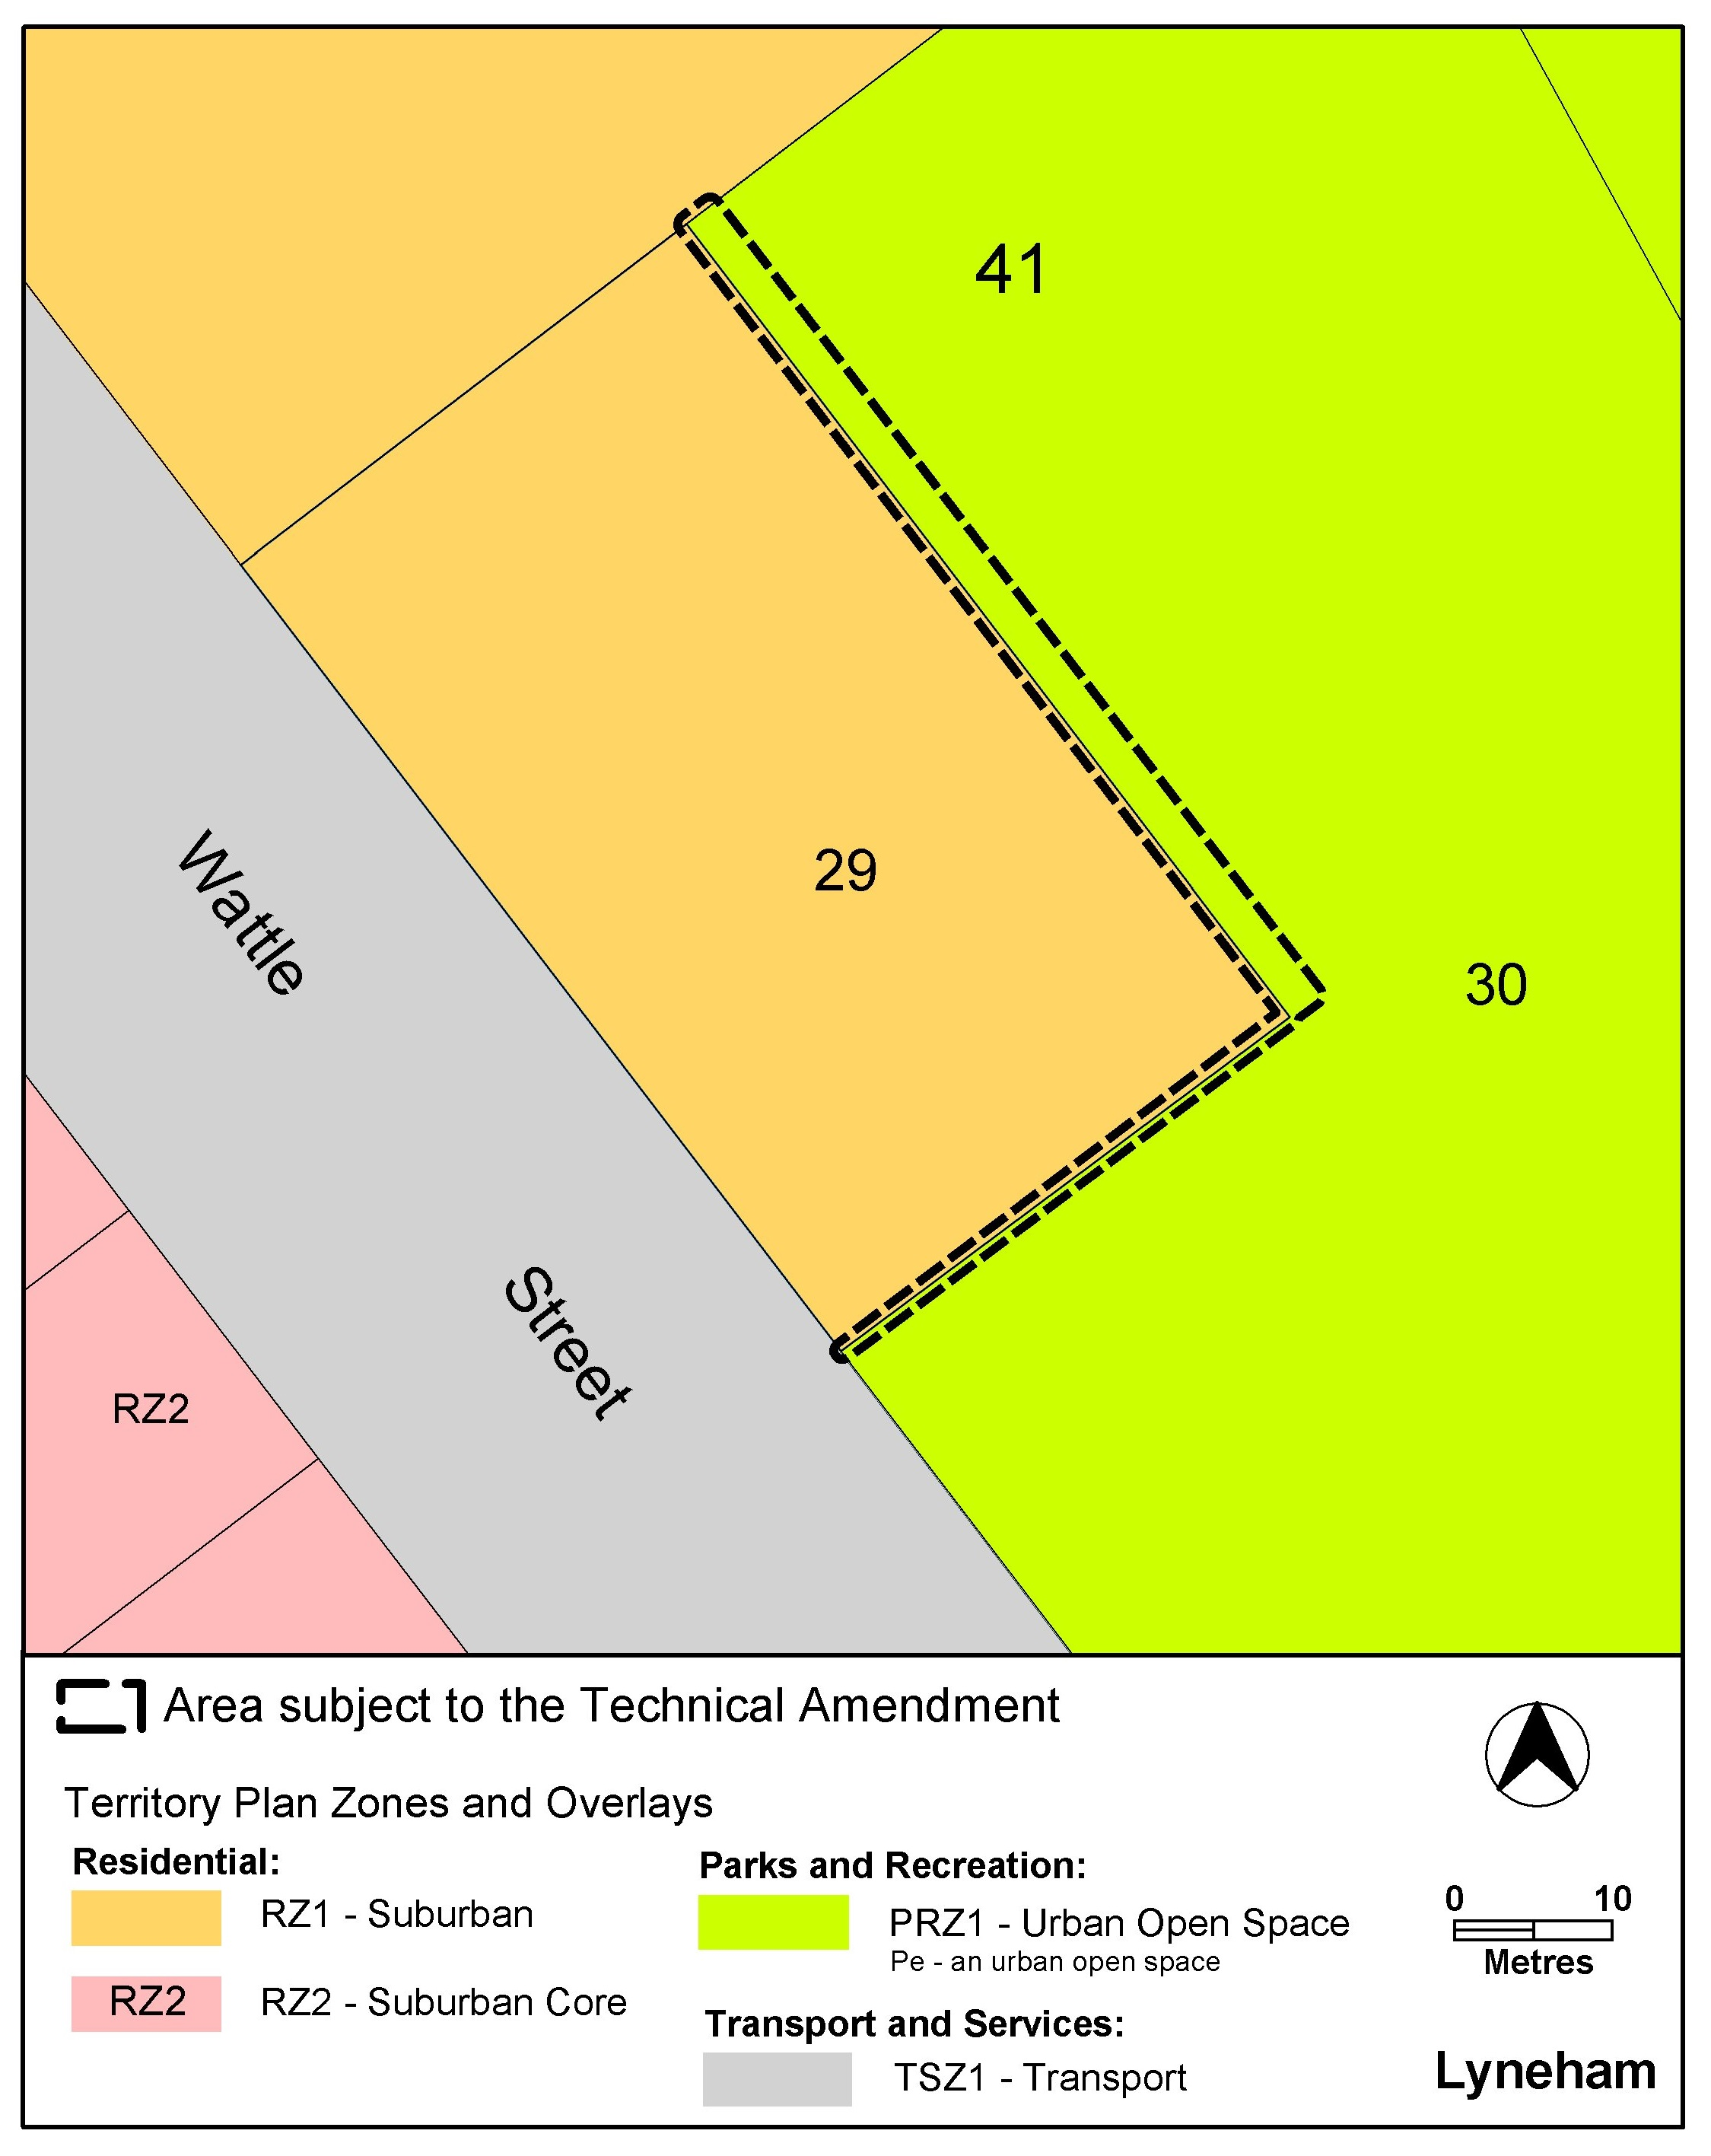

- TECHNICAL AMENDMENT
This section of the technical amendment document provides the actual instructions for implementing the changes to the Territory Plan.
  - Territory Plan Map
- Territory Plan Map
The Territory Plan map is varied as indicated below.

- Territory Plan Map
The Territory Plan map is varied as indicated below.

Interpretation service
