Australian Capital Territory
Heritage (Decision about Registration of Ginninderra Creek Corroboree Ground Cultural Gathering Place, Belconnen) Notice 2021
Notifiable instrument NI2021—322
made under the
Heritage Act 2004, s 40 (Decision about registration)

1 Name of instrument
This instrument is the Heritage (Decision about Registration of Ginninderra Creek Corroboree Ground Cultural Gathering Place, Belconnen) Notice 2021.
2 Decision about registration
On 27 May 2021, the ACT Heritage Council (the Heritage Council) decided to register Ginninderra Creek Corroboree Ground Cultural Gathering Place, Rural Block 1621, Belconnen (the Place).
3 Registration details of the Place
The registration details of the Place are in the schedule.
4 Reasons for the decision
The Heritage Council is satisfied on reasonable grounds that the Place has heritage significance as it meets one or more of the heritage significance criteria in section 10 of the Heritage Act 2004. A detailed statement of reasons including an assessment against the heritage significance criteria is provided in the schedule.
5 Date registration takes effect
The registration of the Place takes effect on the day after this notice is notified.

6 Revocation
The Heritage (Decision about Provisional Registration of Ginninderra Creek Corroboree Ground Cultural Gathering Place, Belconnen) Notice 2021 (NI2021—73) is revoked.

Edwina Jans
A/g Secretary (as delegate for)
ACT Heritage Council
27 May 2021

Schedule
(See Sections 3 and 4)

AUSTRALIAN CAPITAL TERRITORY
HERITAGE REGISTER
(Registration)

For the purposes of s40 of the Heritage Act 2004, an entry to the heritage register has been prepared by the
ACT Heritage Council for the following place:

GINNINDERRA CREEK CORROBOREE GROUND CULTURAL GATHERING PLACE

RURAL BLOCK 1621, BELCONNEN
DATE OF REGISTRATION
27 May 2021 Notifiable Instrument: 2021–

Copies of the Register Entry are available for inspection at ACT Heritage. For further information please contact:

The Secretary

ACT Heritage Council

GPO Box 158

CANBERRA ACT 2601

Telephone 13 22 81

This statement refers to the location of the place as required in s12(b) of the Heritage Act 2004.
LOCATION OF THE PLACE

Ginninderra Creek Corroboree Ground Cultural Gathering Place is contained within Rural Block 1621, Belconnen.

The place is adjacent to the edge of Ginninderra Creek in Belconnen. The northern boundary of the block in which the place is situated forms part of the border of the Australian Capital Territory with New South Wales. The suburb of West Macgregor is located to the southwest of the place.

This statement refers to the description of the Ginninderra Creek Corroboree Ground Cultural Gathering Place as required in s12(c) of the Heritage Act 2004. The attributes described in this section form part of the heritage significance of the place. For the purposes of s12(c) of the Heritage Act 2004, the boundary of the place is at Image 1.
DESCRIPTION OF THE PLACE
The Ginninderra Creek Corroboree Ground Cultural Gathering Place is located on what is now rural pastureland composed of gently undulating terrain on the edge of Ginninderra Creek.

The Ginninderra Creek Corroboree Ground Cultural Gathering Place is associated with intangible heritage values relating to corroborees, as such the place is relevant to the history of the region and Aboriginal cultural values. Registration relates to the preservation of this locality as open space, as close to the natural state as can be managed given the landscape changes that have occurred since colonisation.

This statement refers to the heritage significance of the Ginninderra Creek Corroboree Ground Cultural Gathering Place as required in s12(d) of the Heritage Act 2004.
STATEMENT OF HERITAGE SIGNIFICANCE

The Ginninderra Creek Corroboree Ground Cultural Gathering Place represents an aspect of the past which contributes to the identity of the contemporary Aboriginal community in the Canberra region. In the past this place hosted corroborees and, although these cultural activities are no longer practised at this location, they form part of the historical memory of local Aboriginal people. Corroborees were special community events and as such have endured in oral resources and collective conscious. The place has a strong association for the Aboriginal community in the ACT with their cultural practises that were disrupted by colonisation. The importance of the place is also embedded within a broader associative cultural landscape.
CONSERVATION OBJECTIVE

The guiding conservation objective is that Ginninderra Creek Corroboree Ground Cultural Gathering Place shall be conserved and appropriately managed in a manner respecting its heritage significance.

The ACT Heritage Council may adopt heritage guidelines applicable to the place under s25 of the Heritage Act 2004.

For further information on guidelines applicable to the place, or for advice on proposed works or development, please contact ACT Heritage on 13 22 81.
REASON FOR REGISTRATION

The Council has assessed the Ginninderra Creek Corroboree Ground Cultural Gathering Place, Belconnen against the heritage significance criteria and is satisfied that the place is likely to have heritage significance when assessed against criteria [a, c, g] under s10 of the Heritage Act 2004.
ASSESSMENT AGAINST THE HERITAGE SIGNIFICANCE CRITERIA

The Council’s assessment against the criteria specified in s10 of the Heritage Act 2004 is as follows.

In assessing the heritage significance of Ginninderra Creek Corroboree Ground Cultural Gathering Place, Belconnen, the Council considered:
- the original nomination and documentary evidence supplied by the nominator. The nomination was submitted by Kate Waters (Waters Consultancy Pty Ltd) on behalf of the Ginninderry Aboriginal Advisory Group (GAAG) which includes the ACT Registered Aboriginal Organisations (RAOs) and the NSW Registered Aboriginal Parties (RAPs);
- the Council’s Heritage Assessment Policy (March 2018);
- information provided by a site inspection on 18 January 2021 by ACT Heritage;
- consultation with Representative Aboriginal Organisations (RAOs).
- the report by ACT Heritage titled, Background Information: Ginninderra Creek Corroboree Ground Cultural Gathering Place, February 2021, containing site photographs as well as information on history, description, condition and integrity.

Pursuant to s10 of the Heritage Act, a place or object has heritage significance if it satisfies one or more of the following criteria. Future research may alter the findings of this assessment.
importance to the course or pattern of the ACT’s cultural or natural history;
The Council has assessed Ginninderra Creek Corroboree Ground Cultural Gathering Place against criterion (a) and is satisfied that the place is likely to meet this criterion.
This place bears a strong association in the collective memory of Aboriginal people with corroborees, an important aspect of ceremony embedded within the Aboriginal culture practised in the ACT. The importance of the place also relates to the fact that it is a node embedded within a broader associative cultural landscape. This represents cultural interpretations associated with the movements of Aboriginal people along pathways and songlines and the associated cultural interpretation of landscape features.
has uncommon, rare or endangered aspects of the ACT’s cultural or natural history;
The Council has assessed Ginninderra Creek Corroboree Ground Cultural Gathering Place against criterion (b) and is not satisfied that the place is likely to meet this criterion.
Although this place represents a rare aspect of the ACT’s cultural history that is no longer practised, this association is not evident in the physical fabric of the place.

potential to yield important information that will contribute to an understanding of the ACT’s cultural or natural history;
The Council has assessed Ginninderra Creek Corroboree Ground Cultural Gathering Place against criterion (c) and is satisfied that the place is likely to meet this criterion.
Due to its location next to the Ginninderra Creek, the fact that archaeological sites that have yielded important information are located nearby, and as a known hub of cultural activity, this place has a high potential to yield information regarding the cultural history of Aboriginal people in the ACT. The place is located immediately adjacent to the archaeological site MW5. The excavation of MW5 revealed one of the highest density sites excavated to date in the ACT and some rarely observed artefact attributes. MW5 also had clearly defined cultural activity areas thus demonstrating that locations along the Ginninderra Creek potentially retain some archaeological integrity. It has also been noted that, in general, locations near the Ginninderra Creek are more likely to possess higher densities of artefacts and be the focus of cultural activities.
importance in demonstrating the principal characteristics of a class of cultural or natural places or objects;
The Council has assessed Ginninderra Creek Corroboree Ground Cultural Gathering Place against criterion (d) and is not satisfied that the place is likely to meet this criterion.
Although this place could be considered representative of a relatively rare class of Aboriginal culture ‘corroboree grounds,’ this characteristic is not evident in the physical fabric of the place.
importance in exhibiting particular aesthetic characteristics valued by the ACT community or a cultural group in the ACT;
The Council has assessed Ginninderra Creek Corroboree Ground Cultural Gathering Place against criterion (e) and is not satisfied that the place is likely to meet this criterion.
There are no known aesthetic characteristics associated with the significance of this place.
importance in demonstrating a high degree of creative or technical achievement for a particular period;
The Council has assessed Ginninderra Creek Corroboree Ground Cultural Gathering Place against criterion (f) and is not satisfied that the place is likely to meet this criterion.
To date there are no known physical features of this place that relate to a high degree of creative or technical achievement. However, there is potential for this to change. This place is a known hub of cultural activity located adjacent to site MW5 and it is known that some of the artefact attributes recorded in the analysis of artefacts from MW5 were rare in the ACT.
has a strong or special association with the ACT community, or a cultural group in the ACT for social, cultural or spiritual reasons;
The Council has assessed Ginninderra Creek Corroboree Ground Cultural Gathering Place against criterion (g) and is satisfied that the place is likely to meet this criterion.

This place has a special association for the Aboriginal people as a place where corroborees were held. Because corroborees were special community events the memory of this place has endured in oral resources and collective conscious. Although corroborees are no longer held at this location, the place has a strong association for the Aboriginal community in the ACT with their cultural practises that were disrupted by colonisation thus contributing to their sense of cultural continuity and identity.
has a special association with the life or work of a person, or people, important to the history of the ACT.
The Council has assessed Ginninderra Creek Corroboree Ground Cultural Gathering Place against criterion (h) and is not satisfied that the place is likely to meet this criterion.
To date there are no known associations between this place and specific achievements of an Aboriginal person or people.
SITE PLAN

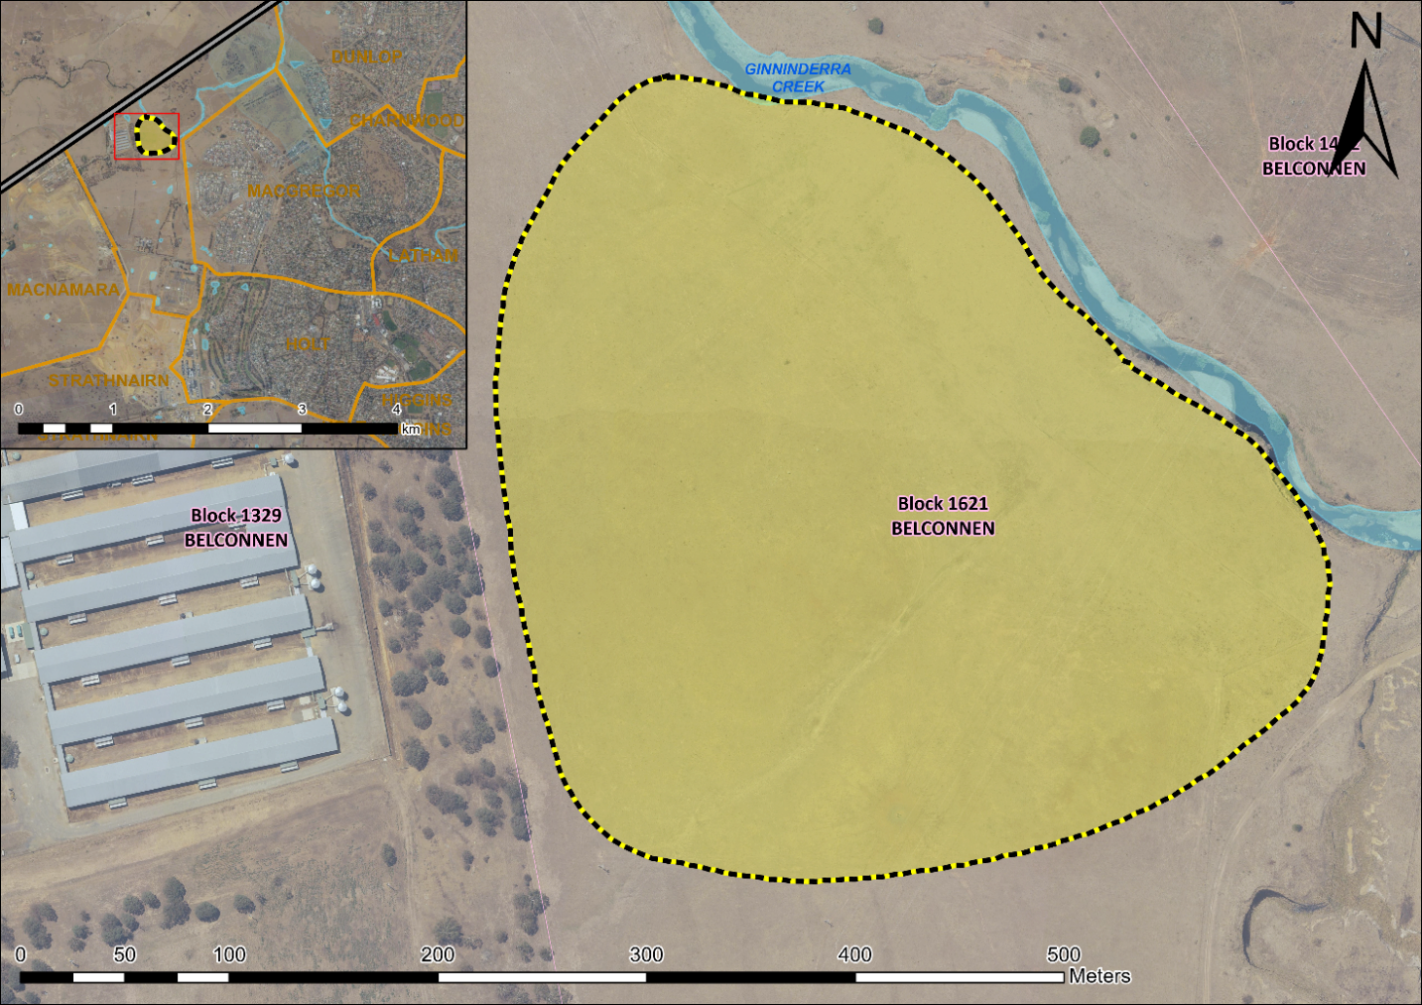
Image 1 Ginninderra Creek Corroboree Ground Cultural Gathering Place site boundary

