Australian Capital Territory
Electoral (Declaration of Candidates - Aboriginal and Torres Strait Islander Elected Body Election) Declaration 2021 (No 1)
Notifiable instrument NI2021–335
made under the
Electoral Act 1992, s 109 (Declaration of candidates) as applied by the Aboriginal and Torres Strait Islander Elected Body Act 2008, s 31 (Application of Electoral Act)

1 Name of instrument
This instrument is the Electoral (Declaration of Candidates - Aboriginal and Torres Strait Islander Elected Body Election) Declaration 2021 (No 1).
2 Commencement
This instrument commences on the day after it is notified.
3 Declaration
I declare the following people duly nominated to be candidates in the 2021 Aboriginal and Torres Strait Islander Elected Body election. They are listed in the order in which they will appear on the ballot paper:

- Jacob KEED
- Patrick VANN
- Helen WRIGHT
- Neville PERKINS
- Deanne BOOTH
- Ross FOWLER
- Oliver KICKETT
- Maurice WALKER
- Tanya Michelle KEED
- Paula McGRADY
- Kartika MEDCRAFT-SMITH
- Margaret BLACKMAN
- Lynnice CHURCH
- Jo CHIVERS
- Leah HOUSE
- Karen DEMMERY
- Brooke RIGNEY
- Jackson TAYLOR-GRANT

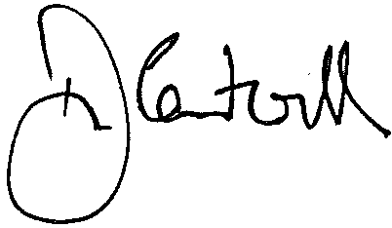

Damian Cantwell AM CSC
Electoral Commissioner
3 June 2021

