Australian Capital Territory

Nature Conservation (Closed Reserves) Declaration 2021 (No 3)

Notifiable instrument NI2021–359
made under the
Nature Conservation Act 2014, s 259 (Conservator may close reserve)

1 Name of instrument
This instrument is the Nature Conservation (Closed Reserves) Declaration 2021 (No 3).

2 Commencement
This instrument commences on 21 June 2021.

3 Declaration
(1) I declare that public access to those parts of Bullen Range Nature Reserve indicated in the map at schedule 1 is prohibited.
(2) I declare that public access to those parts of Molonglo River Reserve indicated in the map at schedule 2 is prohibited.
(3) I declare that public access to those parts of Namadgi National Park indicated in the map at schedule 3 is prohibited.

4 Exceptions
Section 3 does not apply to:
- a conservation officer exercising a function under the Act; or
- a person who is licensed under the Act to conduct activities in relation to the management of pest animals within the closed reserves.
5 Expiry

This instrument expires on 25 June 2021.

6 Definitions
Pest animal has the same meaning as in the Pest Plants and Animals Act 2005.

Ian Walker
Conservator of Flora and Fauna
16 June 2021
Schedule 1 Area of Molonglo River Reserve closed to public access

(see s 3)
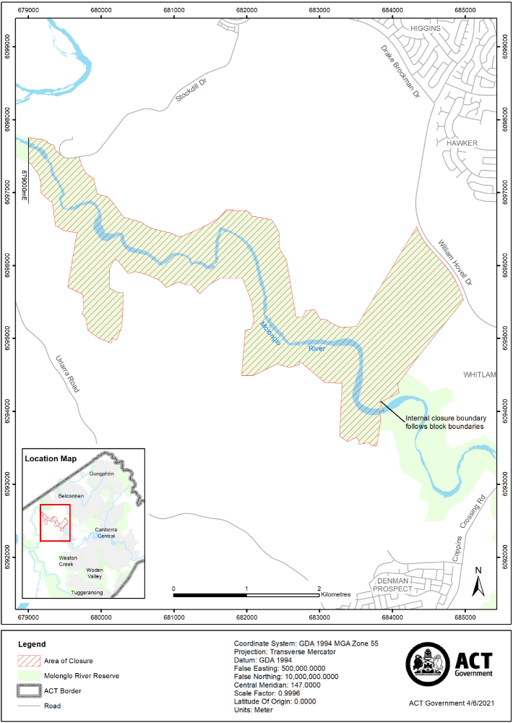

Schedule 2 Area of Bullen Range Nature Reserve closed to public access
(see s 3)
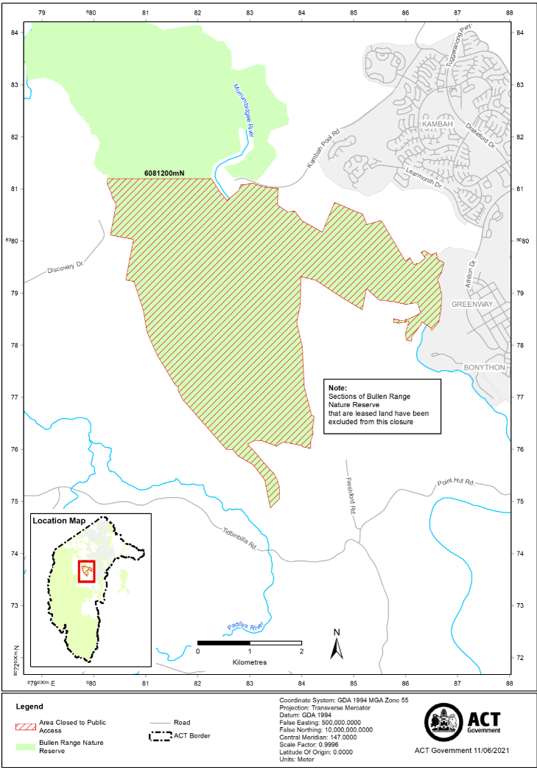

Schedule 3 Area of Namadgi National Park closed to public access
(see s 3)
