Australian Capital Territory
Planning and Development (Plan Variation 374) Approval 2021

Notifiable instrument NI2021-371
made under the
Planning and Development Act 2007, s 76 (Minister’s powers in relation to draft plan variations)

1 Name of instrument
This instrument is the Planning and Development (Plan Variation 374) Approval 2021.
2 Commencement
This instrument commences on the day after its notification day.
3 Approval of draft plan variation
(1) I approve under section 76 (2) (a) of the Planning and Development Act 2007 the draft plan variation 374 to the Territory Plan.
(2) In this section:
draft plan variation 374 to the Territory Plan means the plan variation in the schedule.

Mick Gentleman MLA
Minister for Planning and Land Management
18 June 2021

Planning and Development Act 2007

Variation to the
Territory Plan
374

Kaleen Indoor Sports Club
Kaleen section 89 block 4
Zone change and amendments to the Kaleen Precinct Map and Code

Final variation prepared under s76 of the
Planning and Development Act 2007

This page is intentionally blank.

Contents
1. EXPLANATORY STATEMENT 1
1.1 Background 1
1.2 Summary of the Proposal 1
1.3 The National Capital Plan 1
1.4 Site Description 2
1.5 Current Territory Plan Provisions 4
1.6 Changes to the Territory Plan 5
1.7 Consultation on the Draft Variation 5
1.8 Revisions to the Draft Variation Recommended to the Minister 6
2. VARIATION 6
2.1 Variation to the Territory Plan Map 6
2.2 Variation to the Territory Plan 7

This page is intentionally blank.

- EXPLANATORY STATEMENT
  - Background
An existing indoor sports facility and licensed club operate at Kaleen section 89 block 4. The building, which contains a gym (including a boxing gym) and courts for indoor soccer, netball, cricket, volleyball and dodgeball is nearing the end of its useful life and is in need of redevelopment to continue to meet the needs of the community.
The variation allows redevelopment of the indoor sports facility and club and introduces residential development.
The site is rezoned from Parks and Recreation PRZ2 Restricted Access Recreation to Commercial CZ5 Mixed Use, which allows recreational, commercial and residential uses.
As the CZ5 zoning does not allow a club, controls are introduced into the Kaleen Precinct Map and Code allowing a commercial licenced club to operate. In addition, the Kaleen Precinct Map and Code introduces controls that restrict building heights, introduce site specific setbacks and require indoor sports facilities to be provided into the future.

  - Summary of the Proposal
The variation rezones Kaleen section 89 block 4 from Parks and Recreation PRZ2 Restricted Access Recreation zone to Commercial CZ5 Mixed Use zone enabling residential development on the site.
The Kaleen Precinct Map and Code is amended allowing the existing licenced club to continue to operate in the CZ5 zone and enabling indoor recreational facilities to be retained on this site into the future.

  - The National Capital Plan
The Australian Capital Territory (Planning and Land Management) Act 1988 established the National Capital Authority (NCA) with two of its functions being to prepare and administer a National Capital Plan (NCP) and to keep the NCP under constant review and to propose amendments to it when necessary.
The NCP, which was published in the Commonwealth Gazette on 21 January 1990 is required to ensure that Canberra and the Territory are planned and developed in accordance with their national significance. The Planning and Land Management Act 1988 also required that the Territory Plan is not inconsistent with the NCP.
In accordance with section 10 of the Australian Capital Territory (Planning and Land Management) Act 1988, the NCP defines the planning principles and policies for Canberra and the Territory, for giving effect to the object of the NCP and sets out the general policies to be implemented throughout the Territory, including the range and nature of permitted land uses.
It also sets out the detailed conditions of planning, design and development for areas that have special significance to the National Capital known as designated areas and identifies special requirements for the development of some other areas.

  - Site Description
The subject site at Kaleen section 89 block 4 is within the District of Belconnen.
The site is accessed from Georgina Crescent, Kaleen, and is located directly opposite the car park which services the Kaleen group centre. The site is rectangular in shape, and slopes to the south and south west with a fall of about six metres. It is approximately 7,575 square metres in size and is currently zoned PRZ2 Restricted Access Recreation.
The block is bounded by the St Mark Coptic Orthodox Church on CFZ Community Facility zoned land to the north, a walkway and stormwater channel on PRZ1 Urban Open Space zoned land to the west, single residential blocks on RZ2 Suburban Core zoned land to the south and the Kaleen group centre on Commercial CZ1 Core zoned land to the east.
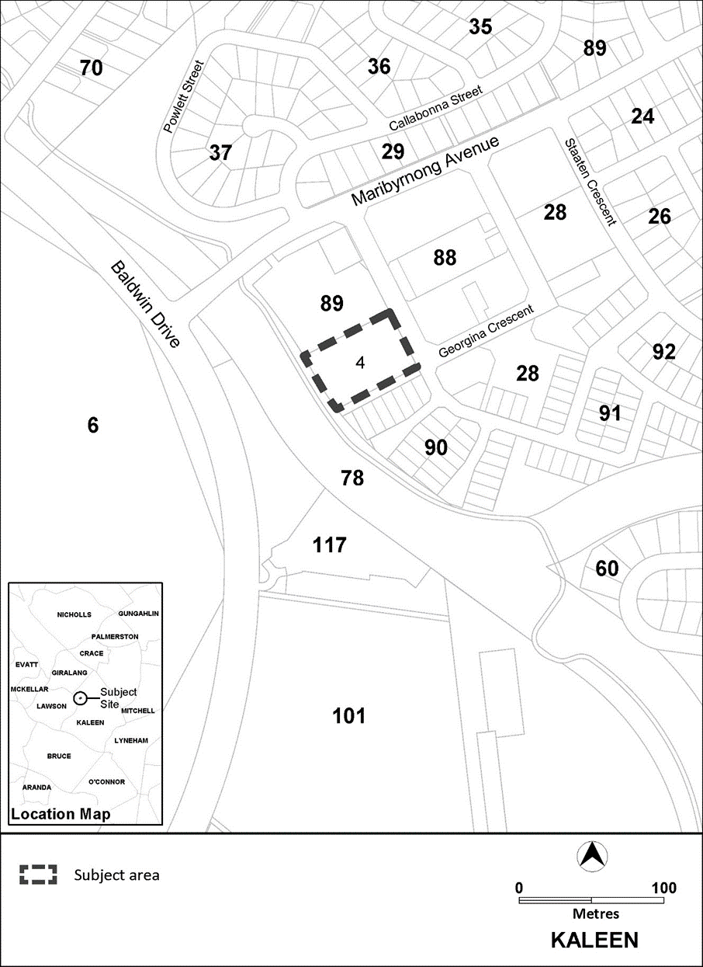
Figure 1 Site Plan

  - Current Territory Plan Provisions
The Territory Plan map for the area subject to this variation is shown in Figure 2.
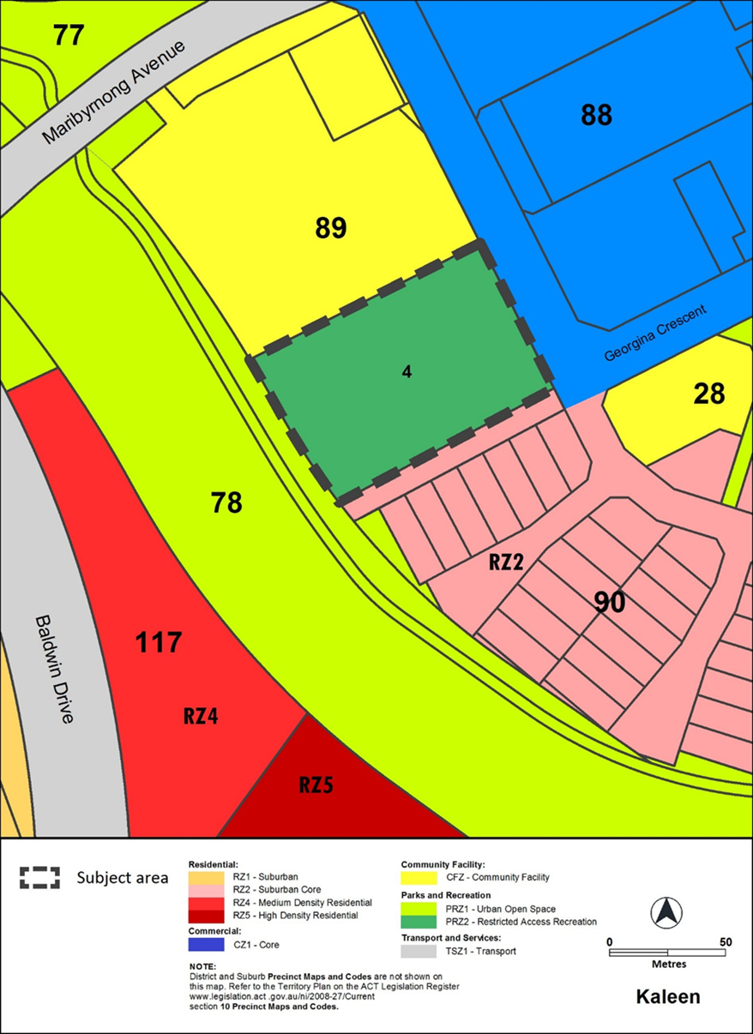
Figure 2 Territory Plan Zones Map

  - Changes to the Territory Plan
Detailed changes to the Territory Plan are noted in section 2 of this document.

  - Consultation on the Draft Variation
Draft Variation 374 (DV374) was released for public comment between 9 September 2020 and 23 October 2020. A consultation notice under section 63 of the Planning and Development Act 2007 (P&D Act) was published on the ACT Legislation Register on 9 September 2020.
A total of four public submissions were received, which included three submissions from individuals and one submission on behalf of the proponent.
Main issues raised by submitters included:
Issue | Number of submissions
Support and conditional support for the draft variation | 3
Noted that there is no masterplan to guide planning and that specific site provisions are the next best thing | 1
Desire to limit dwelling numbers | 1
Reservations about increased traffic flow | 2
Need for pedestrian crossings/parking at the Kaleen Plaza | 3
Desire to reduce maximum building height | 1
Request to increase maximum building height | 1
Support for new development to be all-electric, consistent with ACT Climate Change Strategy 2019-25 | 1
Suggestion to require 30% tree canopy cover for the site consistent with Living Infrastructure Plan’s target | 1
Support for revegetation of the creek immediately behind the sports club | 1
Concerns about an increase in litter and vandalism | 1

The above issues were considered and are detailed in a report on consultation. Changes were informed by the issues raised. The outcomes of consultation were considered by the Minister responsible for planning prior to approval of this variation.
  - Revisions to the Draft Variation Recommended to the Minister
No changes were made to the draft variation recommended to the Minister.
- VARIATION
  - Variation to the Territory Plan Map
The Territory Plan map is varied in all of the following ways:
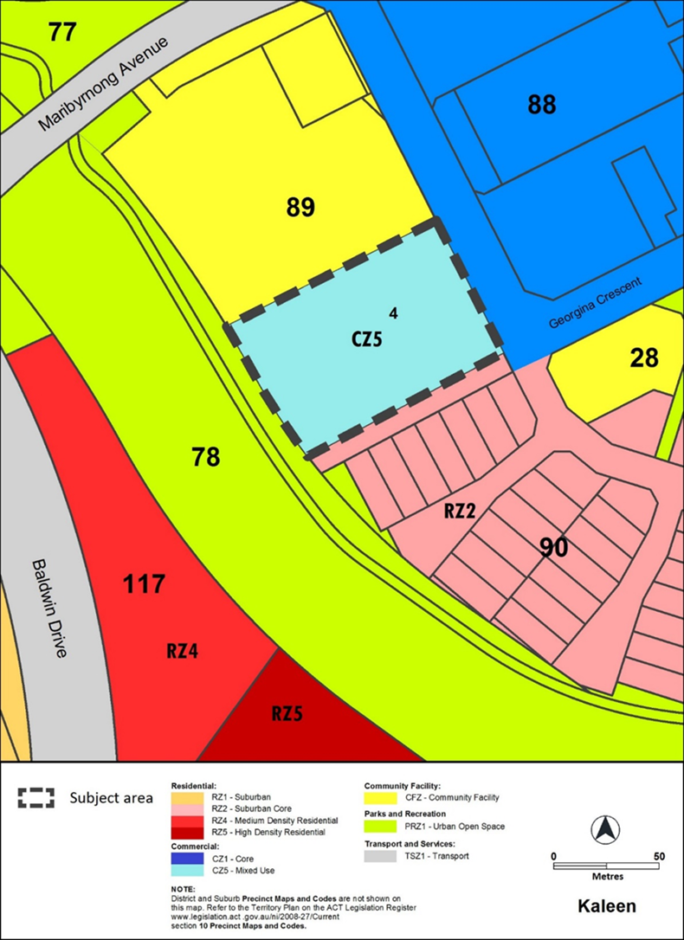

  - Variation to the Territory Plan

- Kaleen Precinct Map
Substitute
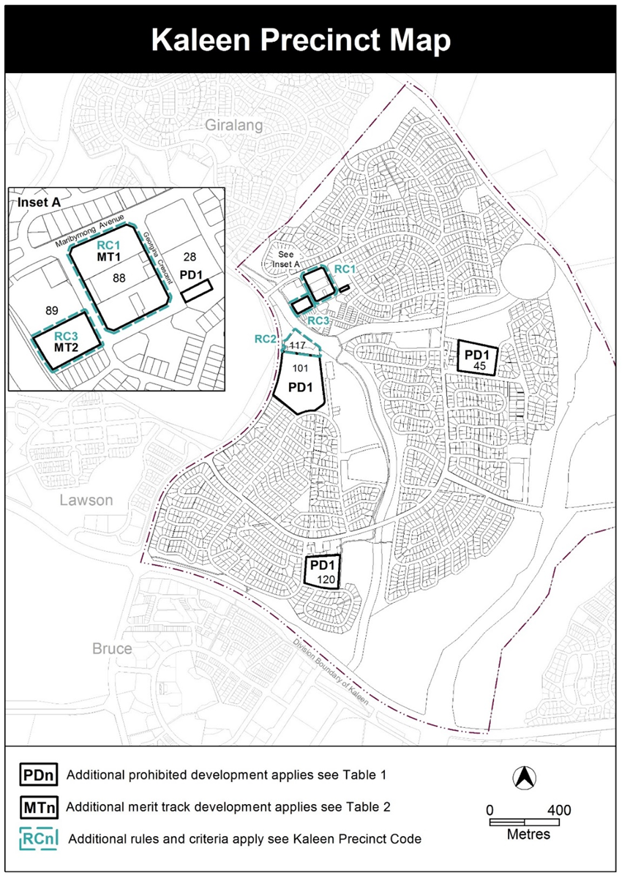
- Assessment Tracks, Table 2 – Additional merit track development, new item MT2
Insert
MT2 | CZ5 | club

- Additional rules and criteria, RC2 – RZ5 zone additional provisions, Element 3: Buildings, 3.1 Building height, Criterion C3
Delete
C3
- Kaleen Precinct Code; Additional rules and criteria
Insert After Rule R5

RC3 – CZ5 zone additional provisions
This part applies to any proposed development on the blocks and parcels identified in the area RC3 shown on the Kaleen Precinct Map.
Element 4: Use
Rules | Criteria
4.1 Indoor recreation facility
R6  The block identified in the area RC3 provides for an indoor recreation facility with a minimum gross floor area of 1400m² that is available for use by members of the public.  The required 1400m² does not include a fitness centre (i.e. gym/gymnasium, yoga/pilates/crossfit venue) or associated amenities. | This is a mandatory requirement. There is no applicable criterion.
4.2 Noise attenuation
R7  Development complies with a noise management plan prepared by a suitably qualified person and endorsed by the Environment Protection Authority (EPA).  The noise management plan will detail the proposed design, siting and construction methods that will be employed to ensure compliance with the Noise Zone Standard as detailed in the Environment Protection Regulation 2005, based on the estimated noise levels when the facility is in use.  Note: A condition of development approval may be imposed to ensure compliance with the endorsed noise management plan. | This is a mandatory requirement. There is no applicable criterion.
4.3 Contamination
R8  An environmental assessment into the site’s suitability from a contamination perspective must be undertaken in accordance with the ACT Contaminated Sites Environment Protection Policy and be endorsed by the Environment Protection Authority prior to construction or a change in use.  This rule does not apply if the Environment Protection Authority has provided written advice that the site has been assessed for contamination to its satisfaction. | This is a mandatory requirement. There is no applicable criterion

Element 5: Building and site controls
Rules | Criteria
5.1 Building heights
R9  This rule applies to areas identified in Figure 3.  The maximum number of storeys and height of building identified in Figure 3 is:  - in area ‘A’ 2 storeys and 8.5m  - in area ‘B’ 4 storeys and 15.5m.  For this rule the building height excludes all of the following:  - roof top plant  - lift overruns  - antennas  - photovoltaic panels  - air conditioning units  - chimneys, flues and vents  - roof top garden  Excluded items, other than roof top gardens, are setback from the building facade of the floor immediately below a minimum distance of 3 metres. | This is a mandatory requirement. There is no applicable criterion.
5.2 Setbacks
R10  Development is setback as identified in Figure 3 and complies with all of the following:  a) setback to frontage along Georgina Crescent is a minimum of 6m  b) all other boundary setbacks are 3m. | This is a mandatory requirement. There is no applicable criterion.

Element 6: Site Design
Rules | Criteria
6.1 Site open space
R11  Not less than 20% of the total site area is allocated to the following:  - for developments with fewer than 20 dwellings, none of which are apartments, one or more of the following:  - communal open space that complies with the following:  - a minimum dimension of 2.5m  - is directly accessible from common entries and pathways; and/or  - private open space that complies with the following:  - a minimum dimension of 2.5m  - is associated with dwellings at the lower floor level  - in all other cases, communal open space that complies with the following:  - a minimum dimension of 2.5m  - is directly accessible from common entries and pathways  not less than 10% of the total site area is planting area. | C11  Open space on the site achieves the following:  - adequate useable space for a range of recreational activities for residents to support active living  - a contribution to on-site infiltration of stormwater run-off  - reasonable accessibility that is designed to be inclusive for all residents  - reasonable connectivity for pedestrians and cyclists to key local destinations and community uses  - if the minimum required planting area cannot be provided on site, an equivalent area is achieved by planting on structures.  One or more of the following matters may be considered when determining compliance with this criterion:  - whether the total area of upper floor level private open space contributes to the function of other open space on the site; and/or  - whether any adjoining or adjacent public open space is readily available for the use of residents.

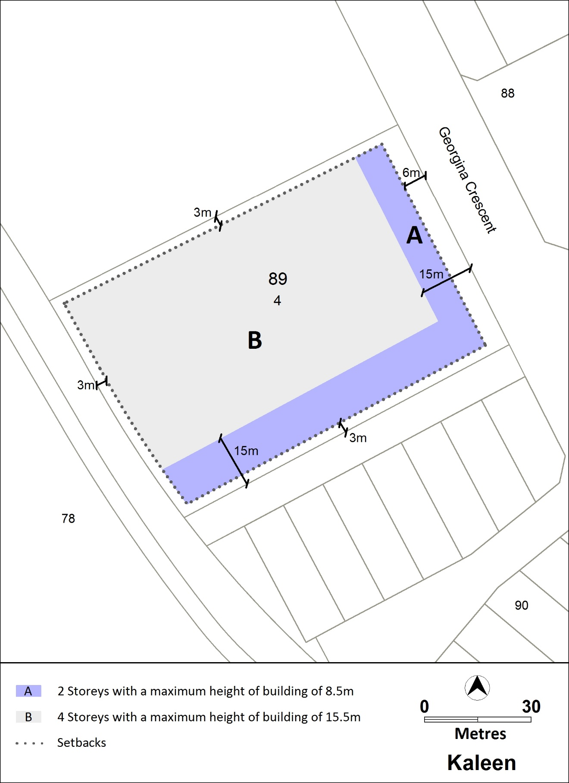
Figure 3: Building heights and boundary setbacks
Interpretation service
