Australian Capital Territory
Discrimination (Seeing Machines Limited) Exemption 2021 (No 1)
Notifiable instrument NI2021-413
made under the
Discrimination Act 1991, s 109 (Grant of exemptions)

1 Name of instrument
This instrument is the Discrimination (Seeing Machines Limited) Exemption 2021 (No 1).
2 Commencement
This instrument commences on the day after it is notified.
3 Exemption decision—Discrimination Act, s 109
The Human Rights Commission exempts Seeing Machines Limited from the operation of sections 10, 13, 20, 23 and 69 of the Discrimination Act 1991 for a period of 3 years.
4 Conditions on exemption
This exemption is subject to the conditions provided in the decision of the Human Rights Commission set out in Schedule 1 of this instrument.

Karen Toohey
Discrimination Commissioner

Dated: 25 June 2021

Schedule 1
Pursuant to section 109 of the Discrimination Act 1991 (ACT), the Human Rights Commission grants Seeing Machines Limited (Seeing Machines) an exemption from the operation of sections 10, 13, 20, 23 and 69 of the Discrimination Act subject to the following terms:
CONDUCT
Seeing Machines may engage in the following conduct in the Australian Capital Territory:

Applicants for employment
- Inform applicants for employment in roles which will require access to Controlled Technology and are subject to permits, licences, approvals or agreements made under US and Australian import and export control laws that they may be adversely affected by the International Traffic in Arms Regulations (ITAR) and the Export Administration Regulations (EAR) controls if they are not an Australian citizen or if they hold dual nationality and/or citizenship from proscribed countries.

Request for information about nationality

- Request information from prospective employees, individual contractors and employees of contractors (contractors) who perform work on Seeing Machines’ premises and who are subject to Seeing Machines’ control and direction for positions related to projects which use Controlled Technology, in relation to the prospective employee or contractor’s citizenship, previous citizenships, race or nationality, or substantive contacts where such contacts are affiliated with countries proscribed by section 126.1 of ITAR, providing this request for information is limited to information for determining whether an application for authorisation would be required to allow the job candidate to have that access and whether in Seeing Machines’ reasonable judgment that application would have significant prospects of success.

Use of nationality information
- Impose a condition on any offer of employment in roles which are likely to require access to Controlled Technology that the person must, pursuant to ITAR controls, be authorised to access that material whether pursuant to an individual approval obtained from the United States’ Department of State or otherwise.
- Take an employee or contractor’s citizenship, previous citizenships, race or nationality, or substantive contacts where such contacts are affiliated with countries proscribed by section 126.1 of ITAR into account in determining whether that person may be offered a role or allocated work that involves access to Controlled Technology;
- Maintain records of the nationalities and citizenships of employees and contractors who have or may have access to Controlled Technology;
- Require present and future employees and contractors involved in projects which access Controlled Technology to notify Seeing Machines of any change to their citizenship status;

- Restrict access to Controlled Technology to particular Seeing Machines employees and contractors based on their citizenship, previous citizenships, race or nationality, or substantive contacts where such contacts are affiliated with countries proscribed by section 126.1 of ITAR;

- Record information relating to security clearances granted to employees of Seeing Machines and employees of contractors who are under the control and direction of Seeing Machines in relation to work requiring access to Controlled Technology;

- Impose limitations or prohibitions on access to Controlled Technology on persons not authorised to access that material;

- Maintain records of the nationalities of persons who have or will have access to Controlled Technology, with distribution limited to only those persons with a need to know, for the purposes of determining their ability to participate in a particular engagement; and

- Establish security systems and access protocols that will prevent the unauthorised re-export or re-transfer of Controlled Technology;

- Disclose, if and when required, citizenship, previous citizenships, race or nationality, or substantive contacts where such contacts are affiliated with countries proscribed by section 126.1 of ITAR, of Seeing Machines’ employees and contractors in the ACT to:
  - the United States’ Department of State;
  - the United States’ Department of Commerce;
  - the Australian Department of Defence; and
  - any other organisation for which, or on whose behalf, or at whose request Seeing Machines undertakes work in respect of which Seeing Machines has directly or indirectly an obligation not to transfer Controlled Technology to persons of certain nationalities.
CONDITIONS
- The exemption applies only to Seeing Machines’ conduct where:
  - it is necessary to enable it to obtain and manage ITAR export licensing or to perform contractual obligations which involve access to Controlled Technology;
  - it has taken all steps that are reasonably available to avoid engaging in conduct which would otherwise be in breach of sections 10, 13, 23 and 69 of the Act, including:
    - reliance on ITAR exemptions, exceptions or other provisions, including clause 126.18 of ITAR, where applicable;
    - where an employment job candidate, employee or contractor is a national or dual national of a country not approved for access to Controlled Technology, then Seeing Machines will either request the United States Department of State, or request the relevant export license holder(s) to request the Department of State to amend the relevant export licenses to enable the person to have access to Controlled Technology, unless Seeing Machines, on reasonable grounds, determines that either:
- the job candidate, employee or contractor is not the best candidate for the position; or
- such an application does not have significant prospects of success.
and
    - in the event that the United States Department of State requires Seeing Machines to provide further information specific to the person, then with the consent of that person, Seeing Machines will work with the person to supply all relevant information to the United States Department of State so that an application for approval may be made in relation to that person.
- Where, pursuant to this exemption, Seeing Machines wishes to reserve the right to make a conditional offer of employment in relation to a position which will or may involve access to Controlled Technology, any advertisement, invitation for expressions of interest, or other promotional information referring to the position must include the information that:
  - the position will or is likely to require access to Controlled Technology and that any person occupying the position must be able to satisfy ITAR-based requirements which may require specific authorisation for that person to access Controlled Technology; and
  - if a job candidate is concerned as to whether or not they will satisfy the requirement in (a), they should contact a nominated employee of Seeing Machines who is able to provide relevant information, including information set out in condition 4 below.
- Seeing Machines must specifically communicate to job candidates for roles, and existing employees and contractors in roles, whether currently or in the future, requiring access to Controlled Technology:
  - express notice that they may be adversely affected by the ITAR requirements if they are not an Australian national, if they hold dual nationality and/or citizenship from proscribed countries, or if they are not of Australian national origin;
  - notice that Seeing Machines has an exemption under the Discrimination Act to enable it to take steps to prevent access to Controlled Technology;
  - a reasonable explanation in plain English of the nature of any such adverse effects;
  - advice that any necessary application for specific authorisation for a person to access Controlled Technology would be made by Seeing Machines, in appropriate cases;
  - information about how they can apply for Australian citizenship; and
  - information regarding their rights under Australian Federal, State and Territory discrimination laws.
Seeing Machines may comply with this Condition 3 through a range of alternatives, including individual written notices, published policy statements, web-based posting or other similar means.
- Where, pursuant to this exemption, an employee or contractor who is not authorised pursuant to ITAR controls to have access to Controlled Technology (including pursuant to any individual clearance), is moved from a job involving access to Controlled Technology to any other work performed by Seeing Machines or any of its related entities, Seeing Machines must, through a duly authorised officer, explain to the person why he or she is being transferred and must otherwise take all reasonable steps to avoid or limit harm or loss to that person.
- Where Seeing Machines uses a system of security passes to reflect the fact of access to Controlled Technology or levels of access to material subject to Australian security restrictions, the passes may be coded but not in such a manner that the nationality can obviously be identified from the coding.
- All information relating to security passes, security clearance levels and access Controlled Technology shall be restricted to the Security Officer, Assistant Security Officer, export control managers, Human Resources managers, legal representatives and other senior managers and to their properly appointed nominees on a "need to know" basis.
- Seeing Machines’ employment or other relevant policies shall be amended as soon as reasonably possible so as to refer to the terms of this exemption, including all conditions attaching to it, and to make clear that the purpose of Seeing Machines’ request for nationality information is made solely for the purposes of compliance with legal and regulatory obligations imposed pursuant to the defence export control laws of Australia and the United States.
- Seeing Machines is required to provide a written report to the ACT Human Rights Commission on 31 July and 28 February each year, from the date of this instrument of exemption, over the period of the exemption, detailing:
  - the steps it has taken to comply with the above conditions;
  - the number of persons affected by this exemption, the nature of the effects, and the steps taken to address any adverse effects;
  - the anti-discrimination training of employees and contractors provided by Seeing Machines; and
  - implementation and compliance generally with the terms of this exemption order.
This decision is a notifiable instrument and must be notified under the Legislation Act.
SIGNED by the ACT Discrimination Commissioner
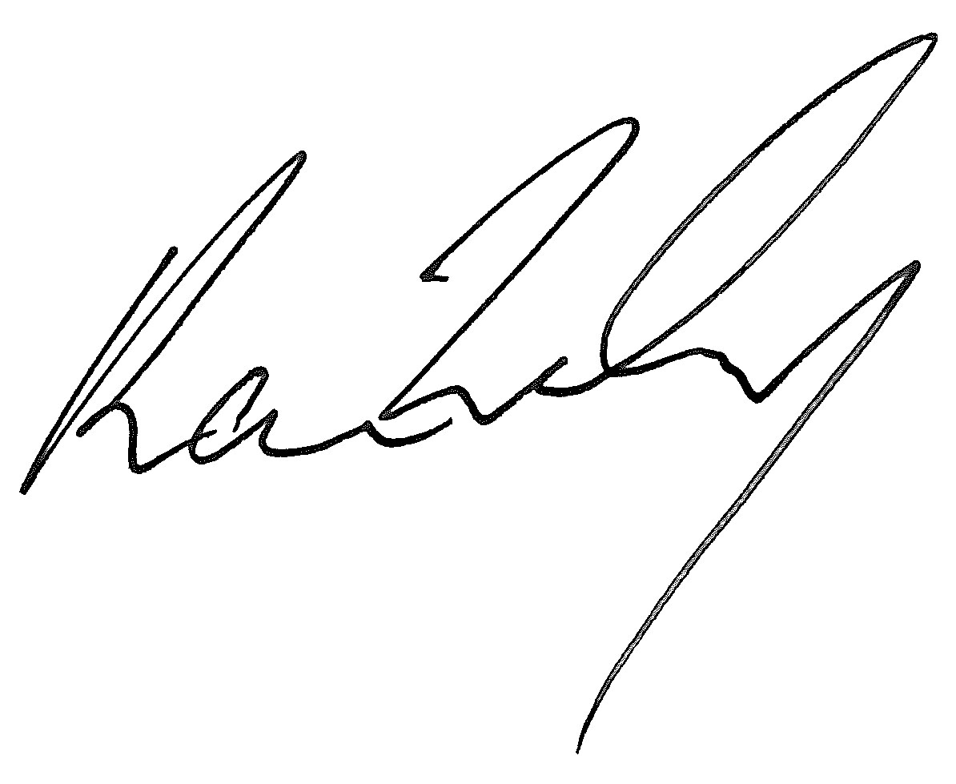
Dated 25 June 2021

