Australian Capital Territory
Planning and Development (Draft Variation No 378) Consultation Notice 2021*
Notifiable instrument NI2021-43
made under the
Planning and Development Act 2007, s 63 (Public consultation—notification) and s 64 (Public consultation—notice of interim effect etc)

- Name of instrument
This instrument is the Planning and Development (Draft Variation No 378) Consultation Notice 2021.
- Draft variation to the Territory Plan
The draft variation 378 proposes to vary the Territory Plan to allow development of a supermarket up to 1000m² at Bruce section 32 blocks 3 and 8.
- Documents available for public inspection
(1) The Authority gives notice that the following documents are available for public inspection and purchase:
(a) the draft variation; and
(b) the background papers relating to the draft variation.
(2) Copies of the documents mentioned in section 3 (1) are available for inspection and purchase at the Access Canberra, Land, Planning and Building Services Shopfront, 8 Darling Street, Mitchell ACT, Monday to Friday (except public holidays) between 8:30am and 4:30pm for the period commencing on the day this notice commences and ending on Friday 19 March 2021 (the consultation period).
(3) Copies of the documents mentioned in section 3 (1) are also available for inspection during the consultation period online at www.act.gov.au/draftvariations.
- Invitation to give written comments
(1) The Authority invites written comments about the draft variation during the consultation period. Comments should include reference to the draft variation and be addressed to the Territory Plan Section of the Environment, Planning and Sustainable Development Directorate (EPSDD). Please also provide your name and contact details to assist in the assessment of the comments provided and to enable the Authority to contact you in relation to your comments, if required.

(2) Written comments should be provided to the Authority by:
(a) email to terrplan@act.gov.au; or
(b) mail to Territory Plan Section, EPSDD, GPO Box 158, Canberra, ACT 2601; or
(c) delivered to the Access Canberra Land, Planning and Building Services Shopfront, 8 Darling Street, Mitchell ACT.
Note All personal information will be managed in accordance with the Information Privacy Act 2014 and the EPSDD Information Privacy Policy which are available through the EPSDD website.
- Public inspection of written comments
(1) Copies of written comments about the draft variation given in response to the invitation in section 4, or otherwise, or received from the National Capital Authority will be available (unless exempted) for public inspection for a period of at least 15 working days starting 10 working days after the day the consultation period ends, at Access Canberra, Land, Planning and Building Services Shopfront, 8 Darling Street, Mitchell ACT, Monday to Friday (except public holidays) between 8:30am and 4:30pm and may be published on the EPSDD website at www.planning.act.gov.au.
(2) You may apply under section 411 of the Planning and Development Act 2007 (the Act) for part of your consultation comments to be excluded from being made available to the public. A request for exclusion under this section must be in writing, clearly identifying what you are seeking to exclude and how the request satisfies the exclusion criteria. Please note that your name and contact details and other personal information will not be made public unless you request otherwise.

- Effect of the draft variation
Section 65 of the Act does not apply in relation to the draft variation and therefore it does not have interim effect as a result of notification of this instrument. Where a draft variation does not have interim effect, the current Territory Plan will continue to apply.
- Obtaining further information
Further information about the draft variation can be obtained through email correspondence with the Territory Plan Section, EPSDD, at mailto:terrplan@act.gov.au. A reference to the draft variation should be included in any email.
- Dictionary
In this instrument:
draft plan variation No 378 Bruce section 32 blocks 3 and 8 - Supermarket means the draft plan variation in Schedule 1.

Lesley Cameron
Delegate of the planning and land authority
27 January 2021

Planning and Development Act 2007

Draft
Variation to the
Territory Plan
378

Bruce section 32 blocks 3 and 8 Supermarket

February 2021

Draft variation for public consultation prepared
under s63 of the Planning and Development Act 2007

This page is intentionally blank.

Contents

1. INTRODUCTION 1
1.1 Summary of the Proposal 1
1.2 Outline of the process for the draft variation 2
1.3 Public Consultation 3
2. EXPLANATORY STATEMENT 4
2.1 Background 4
2.2 Site Description 5
2.3 Current Territory Plan Provisions 6
2.4 Proposed Changes to the Bruce Precinct Map and Code 6
2.5 Reasons for the Proposed Draft Variation 6
2.6 Planning Context 6
2.6.1 National Capital Plan 6
2.6.2 ACT Planning Framework 7
2.7 Interim Effect 7
2.8 Consultation with Government Agencies 8
3. DRAFT VARIATION 10
3.1 Variation to the Territory Plan 10

- INTRODUCTION
  - Summary of the Proposal
The draft variation 378 proposes to vary the Territory Plan to allow development of a supermarket up to 1000m² at Bruce section 32 blocks 3 and 8 (Figure 1).
The land is included in the Commercial CZ5 Mixed Use Development Zone within which a shop (including a supermarket) is a permitted use. However, the Bruce Precinct Map and Code mandatory rule R6 imposes a size limit of 200m² on supermarkets across the RC2 – Commercial Mixed Use Area.
It is proposed to amend the Bruce Precinct Map and Code to allow a supermarket on Bruce section 32 blocks 3 and 8 with a maximum size of 1000m². This is consistent with supermarket sizes permitted in local centres in accordance with the ACT hierarchy of commercial centres.
Further, provision has been made in the proposed amendments to the Bruce Precinct Map and Code for section 32 blocks 3 and 8, to require the replacement of removed Acacias (wattle) at a ratio of 2:1 with a similar species composition as existing in addition to other species favoured by Superb Parrots.
It is also proposed to introduce a criterion to minimise heat island effects across the Bruce RC2 – Commercial Mixed Use Area. This is consistent with Action 6 of Canberra’s Living Infrastructure Plan – Cooling the City.

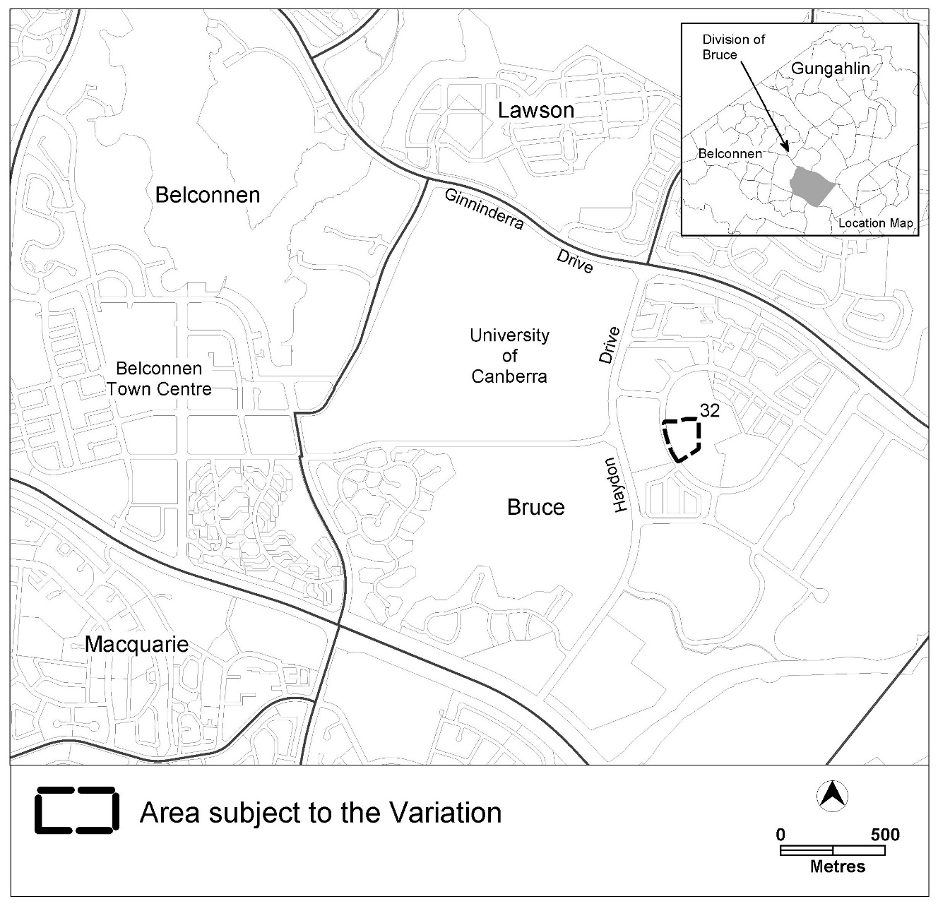
Figure 1 Location map

  - Outline of the process for the draft variation
The Commonwealth’s Australian Capital Territory (Planning and Land Management) Act 1988 allows for the Legislative Assembly to make laws to establish a Territory Planning Authority and for that Authority to prepare and administer a Territory Plan. The Planning and Development Act 2007 (the Act) establishes the planning and land authority as the Authority that prepares and administers the Territory Plan, including continually reviewing and proposing amendments as necessary. The functions of the planning and land authority are administered by the Environment, Planning and Sustainable Development Directorate (EPSDD). The Director-General of EPSDD is the planning and land authority.
The Territory Plan is comprised of a written statement and a map. The written statement contains a number of parts, namely governance; strategic directions; zones (including objectives and development tables and zone or centre development codes); precinct codes; general codes; overlays; definitions; structure plans, concept plans and development codes for future urban areas.
The Territory Plan Map graphically represents the applicable land use zones (under the categories of residential, commercial, industrial, community facility, urban parks and recreation, transport and services and nonurban), precincts and overlays. The zone, precinct and overlay requirements are detailed in the Territory Plan.
Draft variations to the Territory Plan are prepared in accordance with the Act. Following the release of the draft variation under section 63 of the Act, submissions from the public are invited. At the conclusion of the consultation period the EPSDD (planning and land authority) submits a report on consultation and a recommended final variation to the Minister responsible for planning for referral to the Legislative Assembly standing committee responsible for planning. The Minister must consider the findings of the committee before deciding whether to approve the draft variation. If the Minister approves the variation, the variation and associated documents will be tabled in the Legislative Assembly. Unless disallowed by the Legislative Assembly within five sitting days, the variation commences on a day nominated by the Minister.

  - Public Consultation
Written comments about the draft variation are invited from the public by Friday 19 March 2021.
Comments should include reference to the draft variation DV378 and should be addressed to the Territory Plan Section, EPSDD. Please also provide your name and contact details to assist in the assessment of the comments provided, and to enable EPSDD to contact you in relation to your comments, if required. Your personal information will be managed in accordance with the Information Privacy Act 2014 and the EPSDD Information Privacy Policy, which is available for viewing on EPSDD’s website.
Comments can be:
- emailed to terrplan@act.gov.au
- mailed to Territory Plan Section, GPO Box 158, Canberra, ACT 2601
- delivered to the Access Canberra, Land Planning and Building Services Shopfront, 8 Darling Street, Mitchell, ACT
Copies of written comments received with respect to the draft variation will be made available for public inspection for no less than 15 working days starting 10 working days after the closing date for comment. The comments will be available at the Access Canberra customer service centre in Mitchell and will be published on EPSDD’s website. Comments made available will not include personal contact details unless you request otherwise.
A request may be made for parts of a submission to be excluded under section 411 or 412 of the Planning and Development Act 2007. A request for exclusion under these sections must be in writing, clearly identifying what parts of your submission you are seeking to exclude and how the request satisfies the exclusion criteria.
Further Information
The draft variation, and background documents are available online at www.act.gov.au/draftvariations until the closing date for written comments.
Printed copies of the draft variation (this document) and background documents are available for inspection and purchase at the Access Canberra Land, Planning and Building Services shopfront, 8 Darling Street, Mitchell, Monday to Friday (except public holidays) between 8:30am and 4:30pm. Please call 6207 1923 to arrange a copy for purchase.

- EXPLANATORY STATEMENT
  - Background
The 200m² limit on supermarket sizes in the commercial mixed use areas of Bruce is intended to retain the retail hierarchy and to encourage supermarket development within the existing Commercial CZ4 Local Centre Zone. However, the local centre is now fully developed without a supermarket.
Given the population growth in this area in recent years, there is a clear demand for a local centre scale supermarket in this area. The site is located across Thynne Street from the existing Commercial CZ4 Local Centre zoned site and a supermarket on this site would consolidate this area as a fully functioning local centre into the future.

  - Site Description
The draft variation 378 proposes to vary the Territory Plan to allow the development of a supermarket at Bruce section 32 blocks 3 and 8 (Figure 2).

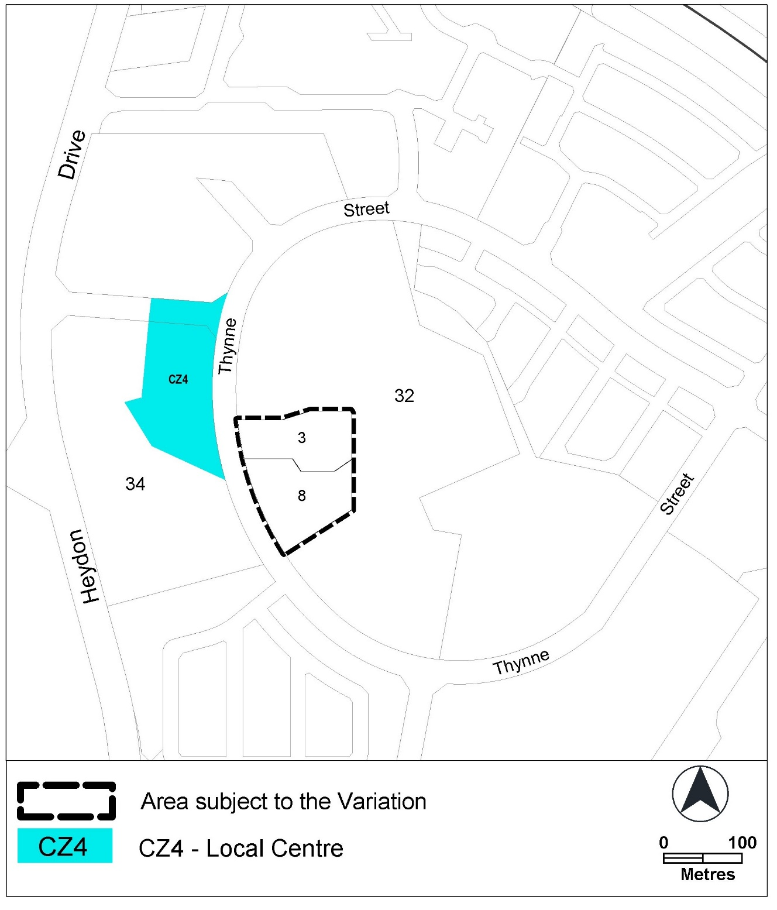Figure 2 Location map

  - Current Territory Plan Provisions
The land is included in the Commercial CZ5 Mixed Use Development Zone within which a shop (including a supermarket) is a permitted use. The Bruce Precinct Map and Code mandatory rule R6 imposes a size limit of 200m² on supermarkets across the RC2 – Commercial Mixed Use Area.

  - Proposed Changes to the Bruce Precinct Map and Code
It is proposed to amend the Bruce Precinct Code to allow a supermarket on Bruce section 32 blocks 3 and 8 of up to 1000m².
Further, provision has been made in the proposed amendments to the Bruce Precinct Map and Code for section 32 blocks 3 and 8, to require the replacement of removed Acacias (wattle) at a ratio of 2:1 with a similar species composition as existing in addition to other species favoured by Superb Parrots.
It is also proposed to introduce a criterion to minimise heat island effects across the Bruce RC2 – Commercial Mixed Use Area.

  - Reasons for the Proposed Draft Variation
The draft variation has been prepared in response to the need for a supermarket to consolidate the Bruce local centre and to meet the needs of the growing population.
It seeks to retain sources of food for the superb parrot in this location and to minimise heat island effects in the Bruce RC2 - Commercial Mixed Use Area generally.

  - Planning Context
    - National Capital Plan
The Australian Capital Territory (Planning and Land Management) Act 1988 established the National Capital Authority (NCA) with two of its functions being to prepare and administer a National Capital Plan (NCP) and to keep the NCP under constant review and to propose amendments to it when necessary.
The NCP, which was published in the Commonwealth Gazette on 21 January 1990 is required to ensure that Canberra and the Territory are planned and developed in accordance with their national significance. The Planning and Land Management Act 1988 also requires that the Territory Plan is not inconsistent with the NCP.

    - ACT Planning Framework
Statement of Strategic Directions
The Statement of Strategic Directions sets out the principles for giving effect to the main objective of the Territory Plan as required by the Planning and Development Act 2007. The proposal is consistent with the Territory Plan’s statement of strategic directions as follows:
2.3 Commercial and retail activity will be concentrated in centres and other planned nodes of intensive activity that are well served by public transport to ensure an efficient pattern of development. Primary emphasis will be placed on strengthening and enhancing existing and new centres and nodes, including improved urban design and encouragement of more mixed-use development.
1.6 The pattern of development is to reflect land capability constraints resulting from topography, soils, geotechnical factors, drainage, natural hazards, microclimate and the sensitivity of ecosystems. Particular attention will be given to the need to conserve soil, water and vegetation; maintain biological diversity; safeguard important ecosystems and ecological processes; and provide and protect wildlife corridors.
The proposal is consistent with the ACT Planning Strategy 2018 as it seeks to implement the following strategic directions:
- Direction 2.2 Enhance the diversity and resilience of our centres to meet the needs of the community, support economic viability and improved liveability.
- Direction 4.3 Strengthen neighbourhoods and support their diverse character by creating strong local activity hubs.
- Direction 3.3 Integrate living infrastructure and sustainable design to make Canberra a resilient city within the landscape.
- Direction 3.5 Protect biodiversity and enhance habitat connectivity to improve landscape resilience.

  - Interim Effect
Section 65 of the Act does not apply in relation to the draft variation and therefore it does not have interim effect as a result of notification of this instrument. Where a draft variation does not have interim effect, the current Territory Plan will continue to apply.
  - Consultation with Government Agencies
The EPSDD is required to, in preparing a draft variation under section 61(b) consult with each of the following in relation to the proposed draft variation:
- the National Capital Authority
- the Conservator of Flora and Fauna
- the Environment Protection Authority
- the Heritage Council
- the Land Custodian, if the draft variation would, if made, be likely to affect unleased land or leased public land – each custodian for the land likely to be affected.

National Capital Authority
The National Capital Authority provided the following comments on 14 August 2020
The proposed draft variation is not inconsistent with the National Capital Plan and the NCA has no concerns.

Response
Noted.

Conservator of Flora and Fauna
The Conservator of Flora and Fauna made the following comments on
24 August 2020
The proposal will involve the removal of wattles within the existing carpark. Breeding Superb Parrots have been recorded repeatedly feeding at the site, and although marginal, the habitat should be maintained.
The proponent has committed to replacement of removed Acacias at a ratio of 2:1 with a similar species composition as existing in addition to other species favoured by Superb Parrots. This commitment should be demonstrated …in the … Development Application.
Response
Noted. Provision has been made in the proposed amendments to the Bruce Precinct Map and Code for section 32 blocks 3 and 8 to require the replacement of removed Acacias (wattle) at a ratio of 2:1 with a similar species composition as existing in addition to other species favoured by Superb Parrots.

Environment Protection Authority
The Environment Protection Authority provided the following comments on
26 August 2020.
The Noise Management Plan (NMP) submitted with the referral documents is supported.

The EPA has no objections to the proposed Territory Plan Variation. Further comments will be provided on the detailed design of the proposed development as detailed in DA201834046 after the DA has been received for review.

Response
Noted.

Heritage Council
The Heritage Council provided the following comments on 21 August 2020.
The April 2020 draft planning report sets out that no places or objects protected under the Heritage Act 2004 will be affected by the TPV or subsequent development.

This reflects prior Council advice on the proposal, issued on 26 February 2019 and 29 April 2020 which set out that no registered or recorded heritage places or objects occur within blocks 3 and 8, and that due to prior disturbance, future development is unlikely to result in damage to unrecorded Aboriginal places or objects.

In light of the above, the Council does not identify any additional heritage assessment or management requirements.

Response
Noted.

- DRAFT VARIATION
  - Variation to the Territory Plan
The Territory Plan is varied in the following way:

Variation to the Bruce Precinct Map and Code
- 3.3 SHOP -CZ5 – gross floor area

Substitute 3.3. as follows

Rules | Criteria
3.3 SHOP – CZ5 – gross floor area
R6  The maximum gross floor area is:  - for SHOP – 500m2  - for supermarket – 200m2 except where identified on Figure 1. | This is a mandatory requirement. There is no applicable criterion.
R6A  This rule applies to the area identified on Figure 1.  Development complies with all of the following:  - one supermarket larger than 200m² is permitted in the area identified in Figure 1  - the maximum gross floor area for the supermarket is 1000m². | This is a mandatory requirement. There is no applicable criterion.

- 4.5 Heat Island

Insert 4.5 as follows

Rules | Criteria
4.5 Heat Island
There is no applicable rule | C10A  This criterion applies to all development except single dwelling housing and dual occupancy housing developments.  Development achieves no net gain of urban heat to the block on which development is occurring.  Compliance with this criterion is demonstrated in a microclimate assessment report by a suitably qualified professional which details building and place design and use of mitigating measures such as:  - use of low thermal mass, high albedo and or high emissivity building materials and or finishes where exposed to solar radiation in summer  - inclusion of canopy trees in appropriate locations to maximise summer time shading and winter time warming  - permeable surfaces in appropriate locations, particularly around canopy trees  - use of water features  - appropriate location and spacing of open space and buildings  - other types of cooling measures such as green roofs, vertical gardens and shade structures.  For the purpose of this criterion a ‘suitably qualified professional’ is a person with qualifications, experience and/or skills, relevant to urban climate science, urban modelling and microclimate assessment.

- Element 4A Environment

Insert 5.1 as follows

Rules | Criteria
5.1 Trees
There is no applicable rule | C10B  This criterion applies to the area identified in Figure 1.  Provide tree species on the site that are favoured by the Superb Parrot consistent with all of the following:  - replacement of the Acacia trees to be removed from the site at a ratio of 2:1 with a similar species composition as the removed trees and other species favoured by Superb Parrots  - provision for deep root planting for shade trees on the site in addition to the deep root planting on the periphery of the site.  Compliance with this criterion is demonstrated in a landscape plan prepared by a qualified professional.

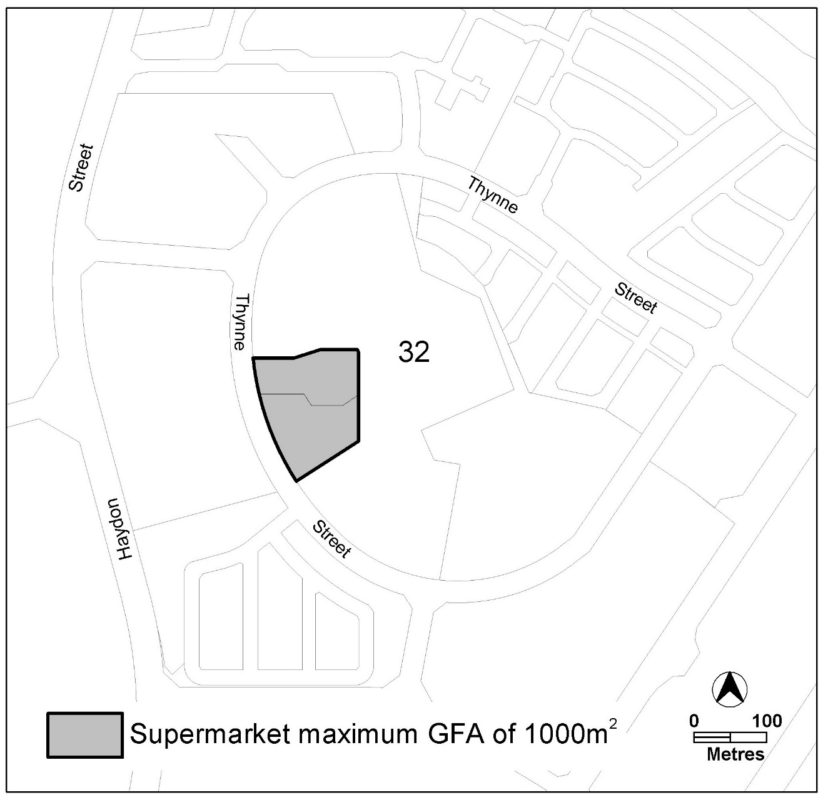
Figure 1 – Supermarket RZ2 Bruce commercial mixed use area.

Interpretation service
