Australian Capital Territory
Planning and Development (Draft Variation No 372) Consultation Notice 2021
Notifiable instrument NI2021-44
made under the
Planning and Development Act 2007, s 63 (Public consultation—notification)

- Name of instrument
This instrument is the Planning and Development (Draft Variation No 372) Consultation Notice 2021.

- Draft variation to the Territory Plan
The planning and land authority (the Authority) has prepared a draft plan variation No 372 – Watson Section 76 (the draft variation) to vary the Territory Plan. The draft variation will rezone section 76 Watson from CZ6 Leisure and Accommodation to RZ4 Medium Density Residential and Parks and Recreation PRZ1 Urban Open Space, make amendments to the North Watson Structure Plan, introduce a Concept Plan for section 76 and make amendments to the Watson Precinct Map and Code.

- Documents available for public inspection
(1) The Authority gives notice that the following documents are available for public inspection and purchase:
(a) the draft variation; and
(b) the background papers relating to the draft variation.
(2) Copies of the documents mentioned in section 3 (1) are available for inspection and purchase at Access Canberra, Land Planning and Building Services Shopfront, 8 Darling Street Mitchell ACT, Monday to Friday (except public holidays) between 8:30am and 4:30pm for the period commencing on the day this notice commences and ending on 19 March 2021 (the consultation period).
(3) Copies of the documents mentioned in section 3 (1) are also available for inspection during the consultation period online at www.act.gov.au/draftvariations.

- Invitation to give written comments
(1) The Authority invites written comments about the draft variation during the consultation period. Comments should include reference to the draft variation and be addressed to the Territory Plan Section of the Environment, Planning and Sustainable Development Directorate (EPSDD). Please also provide your name and contact details to assist in the assessment of the comments provided and to enable the Authority to contact you in relation to your comments, if required.
(2) Written comments should be provided to the Authority by:
(a) email to terrplan@act.gov.au; or
(b) mail to Territory Plan Section, EPSDD, GPO Box 158, Canberra, ACT 2601; or
(c) hand delivery to Access Canberra, Land Planning and Building Services Shopfront, 8 Darling Street Mitchell ACT
Note All personal information will be managed in accordance with the Information Privacy Act 2014 and the EPSDD Information Privacy Policy which are available through the EPSDD website.

- Public inspection of written comments
(1) Copies of written comments about the draft variation given in response to the invitation in section 5, or otherwise, or received from the National Capital Authority will be available (unless exempted) for public inspection for a period of at least 15 working days starting 10 working days after the day the consultation period ends, at Access Canberra, Land Planning and Building Services Shopfront, 8 Darling Street Mitchell, Monday to Friday (except public holidays) between 8:30am and 4:30pm and may be published on the EPSDD website at www.planning.act.gov.au.
(2) You may apply under section 411 of the Planning and Development Act 2007 (the Act) for part of your consultation comments to be excluded from being made available to the public. A request for exclusion under this section must be in writing, clearly identifying what you are seeking to exclude and how the request satisfies the exclusion criteria. Please note that your name and contact details and other personal information will not be made public unless you request otherwise.

- Effect of the draft variation
Section 65 of the Act does not apply in relation to the draft variation and therefore it does not have interim effect as a result of notification of this instrument. Where a draft variation does not have interim effect, the current Territory Plan will continue to apply.
- Obtaining further information
Further information about the draft variation can be obtained through email correspondence with the Territory Plan Section, EPSDD, at terrplan@act.gov.au. A reference to the draft variation should be included in any email.

- Dictionary
In this instrument:
draft plan variation No 372 – Watson Section 76 means the draft plan variation Schedule 1.

Lesley Cameron
Delegate of the planning and land authority
27 January 2021

Schedule 1

Planning and Development Act 2007

Draft
Variation to the
Territory Plan
372

Watson Section 76

February 2021

Draft variation for public consultation prepared
under s60 of the Planning and Development Act 2007

This page is intentionally blank.

Contents
- INTRODUCTION 1
  - Summary of the Proposal 1
  - Outline of the process 2
  - Public Consultation 3
- EXPLANATORY STATEMENT 5
  - Background 5
    - Early planning investigations 5
    - Pre-Community Consultation on a draft planning report 5
  - Site Description 6
  - Current Territory Plan Provisions 8
  - Proposed Changes 9
    - Proposed Changes to the Territory Plan Map 9
    - Proposed Changes to Territory Plan 9
  - Reasons for the Proposed Draft Variation 10
  - Planning Context 11
    - National Capital Plan 11
    - ACT Planning Framework 11
  - Interim Effect 12
  - Consultation with Government Agencies 13
- DRAFT VARIATION 15
  - Variation to the Territory Plan 15

This page is intentionally blank.

INTRODUCTION

Summary of the Proposal
Draft variation to the Territory Plan 372 (DV372) proposes to rezone Watson section 76 block 2 from Commercial CZ6 Leisure and Accommodation to:
- RZ4 Medium Density Residential; and
- Parks and Recreation PRZ1 Urban Open Space.
The site has a Future Urban Area (FUA) overlay. This allows a concept plan to be introduced to inform an estate development plan on important planning considerations. These considerations include maximum building heights, shared paths and public roads, demonstration housing, areas of environmental concern and requirements for a public park.
Building heights are proposed up to a maximum of 4 storeys or 16.5 metres to the southern portion of the site, which is consistent with the surrounding character.
The site is on the 2020-21 to 2023-24 Indicative Land Release Program and can accommodate approximately 200 dwellings. The current CZ6 zone does not allow for residential uses, including medium density residential development. The site is, therefore, proposed to be rezoned to RZ4 Medium Density Residential. Part of the site is proposed to be rezoned to Parks and Recreation PRZ1 Urban Open Space which will enable the development of a one-hectare park and assist in maintaining habitat for the vulnerable Superb Parrot (Polytelis swainsoni).
The proposed provisions will allow for demonstration housing, as announced in the Minister for Planning and Land Management’s 2015 Statement of Planning Intent. Demonstration housing will provide the community and industry with examples of how flexibility and innovation in planning can result in more liveable, inclusive and sustainable communities.
The proposal seeks to remove the dwelling limit in the North Watson Structure Plan. A key aspect of the North Watson Structure Plan is the maximum dwelling limit of 1,300 within an identified boundary, consistent with servicing for the area. It is proposed that the Structure Plan be amended to remove this dwelling limit. The ACT Government will provide appropriate infrastructure to support increased development in the area.

Proposed changes to the Watson precinct code include adding definitions of co- housing and social enterprise. These uses, as well as craft workshop, will be included as additional merit assessable uses and be limited to the area proposed for demonstration housing in the precinct code.

Outline of the process
The Commonwealth’s Australian Capital Territory (Planning and Land Management) Act 1988 allows for the Legislative Assembly to make laws to establish a Territory Planning Authority and for that Authority to prepare and administer a Territory Plan. The Planning and Development Act 2007 (the Act) establishes the planning and land authority as the Authority that prepares and administers the Territory Plan, including continually reviewing and proposing amendments as necessary. The functions of the planning and land authority are administered by the Environment, Planning and Sustainable Development Directorate (EPSDD). The Director-General of EPSDD is the planning and land authority.
The Territory Plan is comprised of a written statement and a map. The written statement contains a number of parts, namely governance; strategic directions; zones (including objectives and development tables and zone or centre development codes); precinct codes; general codes; overlays; definitions; structure plans, concept plans and development codes for future urban areas.
The Territory Plan Map graphically represents the applicable land use zones (under the categories of residential, commercial, industrial, community facility, urban parks and recreation, transport and services and nonurban), precincts and overlays. The zone, precinct and overlay requirements are detailed in the Territory Plan.
Draft variations to the Territory Plan are prepared in accordance with the Act. Following the release of the draft variation under section 63 of the Act, submissions from the public are invited. At the conclusion of the consultation period the EPSDD (planning and land authority) submits a report on consultation and a recommended final variation to the Minister responsible for planning for referral to the Legislative Assembly standing committee responsible for planning. The Minister must consider the findings of the committee before deciding whether to approve the draft variation. If the Minister approves the variation, the variation and associated documents will be tabled in the Legislative Assembly. Unless disallowed by the Legislative Assembly within five sitting days, the variation commences on a day nominated by the Minister.

Public Consultation
Written comments about the draft variation are invited from the public by
19 March 2021.
Comments should include reference to the draft variation and be addressed to the Territory Plan Section, EPSDD. Please also provide your name and contact details to assist in the assessment of the comments provided, and to enable EPSDD to contact you in relation to your comments, if required. Your personal information will be managed in accordance with the Information Privacy Act 2014 and the EPSDD Information Privacy Policy, which is available for viewing on EPSDD’s website.
Comments can be:
- emailed to terrplan@act.gov.au
- mailed to Territory Plan Section, GPO Box 158, Canberra, ACT 2601
- delivered to the Access Canberra, Land Planning and Building Services Shopfront,
8 Darling Street Mitchell ACT

Copies of written comments received with respect to the draft variation will be made available for public inspection for no less than 15 working days starting 10 working days after the closing date for comment. The comments will be available at the Access Canberra, Land, Planning and Building Services Shopfront, 8 Darling Street, Mitchell ACT and will be published on EPSDD’s website. Comments made available will not include personal contact details unless you request otherwise.
A request may be made for parts of a submission to be excluded under section 411 or 412 of the Planning and Development Act 2007. A request for exclusion under these sections must be in writing, clearly identifying what parts of your submission you are seeking to exclude and how the request satisfies the exclusion criteria.

Further Information
The draft variation, and background documents are available online at www.act.gov.au/draftvariations until the closing date for written comments.
Printed copies of the draft variation (this document) and background documents are available for inspection and purchase at the Access Canberra Land, Planning and Building Services shopfront, 8 Darling Street, Mitchell, Monday to Friday (except public holidays) between 8:30am and 4:30pm. Please call 6207 1923 to arrange a copy for purchase.

EXPLANATORY STATEMENT

Background

Early planning investigations

In 2016, the former Land Development Agency prepared a planning report to support a Territory Plan Variation for Watson section 76. Prior to progressing to a draft variation to change the planning policy in the Territory Plan, the ACT Government decided further planning, infrastructure and environmental studies were required to inform planning policy change. At the time section 76 was largely unused vacant land, zoned as Commercial CZ6 Leisure and Accommodation, consistent with the current zoning.
Community engagement was undertaken in 2014 to consider allowing residential use and among other issues, the importance of providing a range of housing options at Watson section 76.
Key issues identified during consultation remain relevant to the current draft variation, including future residential impacts on:
- traffic and parking infrastructure
- future development and design
- preferences for low to medium rise density of 2-3 storeys
- community facilities
- retention of trees and landscapes

Pre-Community Consultation on a draft planning report

In 2018 EPSDD undertook pre-community consultation on a draft planning report for section 76, which proposed adding residential use to the current Commercial CZ6 Leisure and Accommodation zone. There is an FUA overlay on this site and 200 dwellings are identified on the 2020-21 to 2023-24 Indicative Land Release Program.
The planning report has since been updated to respond to key community concerns, agency comments and the outcomes of planning, background and technical studies.

Key community concerns related to the implications of future residential use including impacts on the:
- existing environment and trees
- future traffic, parking and walking and cycling connections
- perceived need for community and commercial facilities
- provision of lower-rise housing of no more than 2 storeys for new residents and people to age-in-place
- the importance of the local character of North Watson.

Site Description
Watson section 76 is currently unleased, undeveloped land, under the custodianship of Transport Canberra and City Services (TCCS) and is approximately nine hectares in size (see Figure 1). The site is bounded by Aspinall Street to the south, and the Federal Highway to the north. There are a number of existing residential units, two to three storeys in height to the west of the site. To the east is the Youth with a Mission facility. There are a number of residential units south of Aspinall Street, which are generally two storeys in height, with a limited number of accompanying on-street parking spaces.
Across the Federal Highway to the north is Non Urban NUZ1 Broadacre zoned land. An informal unsurfaced walking/cycling path also runs along the northern border of the block, parallel with the Federal Highway. In addition, several informal tracks have developed travelling in a north-south direction through the site.
The Watson local centre is approximately one kilometre from the site and includes a pharmacy, supermarket, café, restaurants and a post office. Mount Majura Primary public school and pre-school is located approximately one kilometre from the site.
The block is relatively flat, with a gentle downward slope towards the north-west corner. Non-local native trees and a mix of native and exotic vegetation lines each side of the block, with the densest areas lining the eastern border. There is also a cluster of similar trees in the western half of the site. Tree species on the site include Tasmania Blue Gum (Eucalyptus globulus), Argyle Apple (E. cinerea), Ribbon Gum (E. viminalis), Brittle Gum (E. mannifera) as well as Radiata Pine (Pinus radiata). Other vegetation includes the native Cherry Ballart (Exocarpos cupressiformis) and various wattles, and exotic species including Cotoneaster (Cotoneaster glaucophyllus), Japanese Privet (Ligustrum japonicum), Hawthorn (Crataegus monogyna), and Broad-level Privet (Ligustrum lucidum).

The trees on the western and northern edge of the site are considered important foraging habitat for birds, specifically, the Superb Parrot (Polytelis swainsonii), which is listed as vulnerable in the ACT and is on the National Register, with a limited number of breeding pairs known to be left in Australia.
After detailed site soil testing, contamination from naturally occurring heavy metals has been discovered in part of the north-east of the site. Remediation of the site will be required prior to any future residential development.

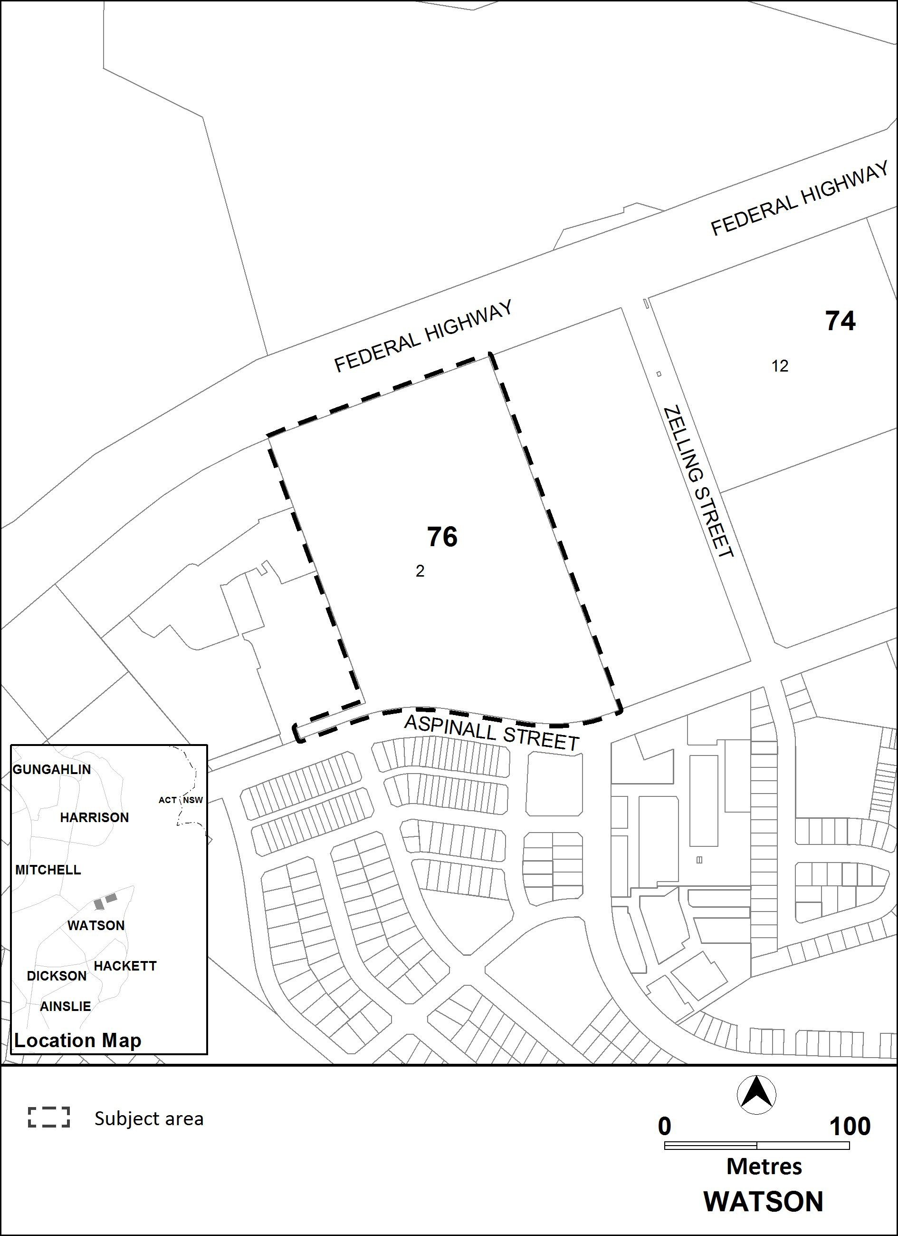
Figure 1 Location map

Current Territory Plan Provisions
The Territory Plan map zone for the area subject to this variation is shown in Figure 2. The subject section is currently zoned Commercial CZ6 Leisure and Accommodation and has a FUA overlay.

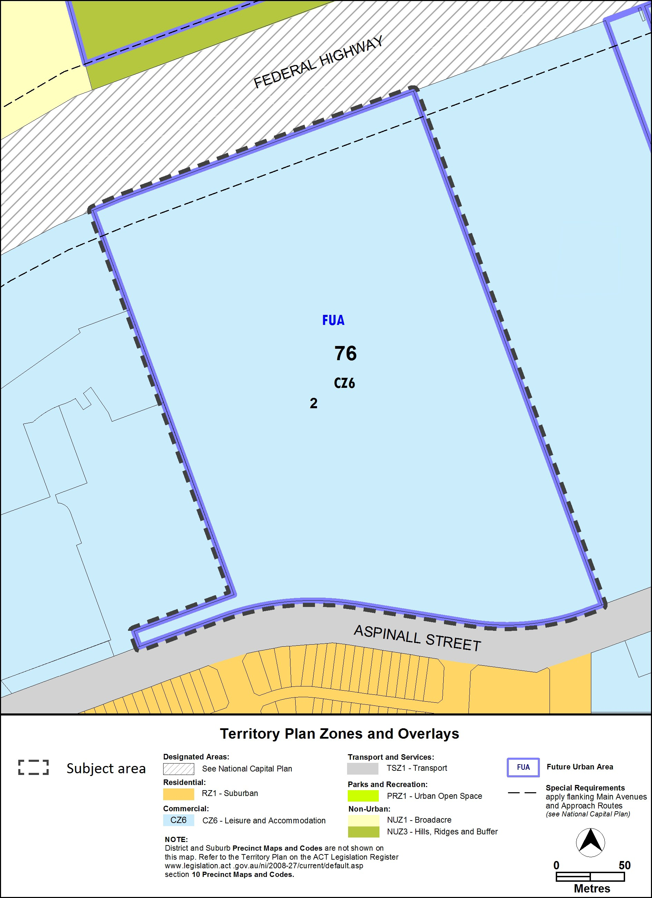
Figure 2 Territory Plan Zones Map

Proposed Changes

Proposed Changes to the Territory Plan Map

The proposed changes to the Territory Plan map are indicated at Part 3 of this document and are detailed as follows:
Rezone the site from Commercial CZ6 Leisure and Accommodation to:
- RZ4 Medium Density Residential; and
- Parks and Recreation PRZ1 Urban Open Space.
The draft variation map indicates the proposed zone boundaries as accurately as possible but may be subject to adjustments following the estate development plan approval process.

Proposed Changes to Territory Plan

It is proposed to amend the North Watson Structure Plan by removing:
- information in the ‘introduction’ section and Figure 1 which are no longer relevant
- the maximum dwelling limit of 1300 dwellings and the two storey building height requirements
Introduce a Concept Plan for Watson section 76 which will:
- set building heights
- provide requirements for a one-hectare park within the PRZ1 urban open space zone
- require the consideration of cultural heritage matters
- provide for demonstration housing
- specify movement connections for a public road and shared paths
- require environmental assessment of the area of naturally occurring contamination on part of the site
Amend the Watson precinct map and code to:
- specify the location of demonstration housing sites close to the location of the park
- include definitions of co-housing and social enterprise and list these uses and a craft workshop as additional merit track development, limited to demonstration housing sites
- introduce a criterion to make sure buildings fit within their environment

Reasons for the Proposed Draft Variation
The reasons for this draft variation are as follows:
- the site is appropriate for residential use, consistent with the surrounding residential uses, is in close proximity to employment and a mix of uses at Gungahlin, Dickson and the City and has access to public transport, including the light rail
- the structure plan currently allows for residential use in the area as identified in Figure 1 of the North Watson Structure Plan
- the dwelling limit of 1300 and Figure 1 in the structure plan can be removed because they are no longer required. The area to which the dwelling limit applied, defined by Figure 1 in the structure plan, has largely been developed and any additional infrastructure that may be required for future housing on this site will be provided in association with that development
- consistent with recent developments in the area, the use of the land for residential purposes will assist to meet the ACT Government’s strategic directions for a compact and efficient city and Direction 1.1 in the ACT Planning Strategy 2018 to deliver 70 per cent of all new housing developments and redevelopment to occur in the existing urban footprint
- provides housing to meet the 2020-21 to 2023-24 Indicative Land Release Program
- responds to the ACT Government’s ACT Housing Strategy 2018 and Housing Choices Discussion Paper, Community Engagement Report, May 2018, for more affordable and diverse housing options to meet the needs of a changing and growing population
- provides more public open space and amenity, including a local neighbourhood park and a walking and cycling path through the site
- requires any site contamination to be remediated prior to any future residential development
- protects important trees and landscape for habitat, including for the vulnerable Superb Parrot in the PRZ1 Urban Open Space Zone
- the introduction of a concept plan will require important planning considerations, such as built form and urban design outcomes, requirements for a park, site connections, cultural heritage, environmental assessments and demonstration housing to be met as a part of the estate development plan approval process.

Planning Context

National Capital Plan

The Australian Capital Territory (Planning and Land Management) Act 1988 established the National Capital Authority (NCA) with two of its functions being to prepare and administer a National Capital Plan (NCP) and to keep the NCP under constant review and to propose amendments to it when necessary.
The NCP, which was published in the Commonwealth Gazette on
21 January 1990 is required to guide Canberra and the Territory to be planned and developed in accordance with their national significance. The Planning and Land Management Act 1988 also requires that the Territory Plan is not inconsistent with the NCP.

ACT Planning Framework

Statement of Strategic Directions
The Statement of Strategic Directions sets out the principles for giving effect to the main objective of the Territory Plan as required by the Planning and Development Act 2007. The proposal is consistent with the Territory Plan’s statement of strategic directions in terms of environmental, economic and social sustainability and spatial planning and urban design principles.
1.18A Development is planned to promote active living through the following six principles:
- providing connectivity between uses and activity nodes
- preserving open space
- encouraging mixed land use and density
- ensuring public places are safe and attractive for all
- providing supportive infrastructure that encourages regular physical activity
- ensuring environments promote social inclusion, and are equitable and where practicable are accessible by all

The proposal is within walking and cycling distances to public transport including rapid buses and the light rail, making it possible to easily access employment hubs at Dickson, the City and Gungahlin Town Centre. Mount Majura Primary and pre-school is within one and half kilometres of the site. The proposal supports better infrastructure for regular exercise such as to the school or the Watson shops. Providing a public park with amenities that benefit a range of ages and abilities whilst preserving landscape and trees will provide a safe, attractive and inclusive place.

1.3 Economic, social and environmental objectives will be pursued in a balanced and integrated way, having regard to both short-term and long- term factors, such that present needs can be met without prejudicing the welfare of future generations, and without serious or irreversible loss of life-supporting natural resources or damage to the environment.
The proposal will result in an integrated outcome by providing housing for a growing population that includes shared spaces for residents to increase social activity. A social enterprise may provide economic employment development opportunities with a focus on social outcomes. The proposal will also protect important tree and landscape areas to support wildlife and provide amenity as our climate continues to change. Providing more housing close to employment, with access to public transport and active travel infrastructure will support increasing economic productivity and better health outcomes.

1.10 Integrated land use and transport planning will seek to maximise accessibility and transport efficiency, prioritise active travel, reduce energy consumption, increase physical activity, support the preferred pattern of development, promote safety, safeguard environmental quality, and minimise greenhouse gas emissions.
The proposal will provide the opportunity for people to access public transport and to live close to employment hubs, including Dickson, Gungahlin and the City. Being close to employment with better connections will encourage a new population to walk and cycle to work and other destinations, reducing the need to use a vehicle.
The proposal is consistent with the ACT Planning Strategy as it will facilitate development that is compact and efficient, diverse, sustainable and resilient, liveable, and accessible, within proximity to services, transport connections and community facilities. Increasing the supply of housing at North Watson, will meet the ACT Planning Strategy’s (2018) Direction 1.1 to deliver 70 per cent of all new housing developments and redevelopment to occur in the existing urban footprint.

Interim Effect
Section 65 of the Planning and Development Act 2007 does not apply in relation to the draft variation, so it does not have interim effect. The current Territory Plan will continue to apply.

Consultation with Government Agencies
The EPSDD is required to, in preparing a draft variation under section 61(b) consult with each of the following in relation to the proposed draft variation:
- the National Capital Authority
- the Conservator of Flora and Fauna
- the Environment Protection Authority
- the Heritage Council
- the Land Custodian, if the draft variation would, if made, be likely to affect unleased land or leased public land – each custodian for the land likely to be affected
Government agencies were consulted about the draft variation in June 2020. Agency comments on this draft variation are provided below.

National Capital Authority
The National Capital Authority (NCA) provided the following comments on 16 June 2020:
The NCA has no objections to the proposed land use and zoning variations to RZ4 and PRZ1.
Any development within this area is subject to Special Requirements and will need to be consistent with Section 4.28 of the National Plan

Response
Noted. The proposal is in accordance with the special requirements of the National Capital Plan.

Conservator of Flora and Fauna
The Conservator of Flora and Fauna made the following comments on 16 June 2020:
The Conservator [considers that] the zoning for Section 76 … conserve[s] the habitat elements on the block that are used by the Superb Parrot.

Response
Noted. Rule R4 in the proposed Concept Plan requires the retention of a portion of the site as public open space for wildlife habitat.

Environment Protection Authority (EPA)
The EPA provided the following comments on 10 July 2020:
The Environment Protection Authority supports the DV372 for Watson ... Sec 76 subject to the following condition/provision:

Potential contamination [Rule] R[7]
This rule applies to … Section 76 Watson as shown in figure [3]. The Development Application for development on the site must be accompanied by an environmental assessment into the site’s suitability from a contamination perspective in accordance with the ACT Contaminated Sites Environment Protection Policy and be endorsed by the Environment Protection Authority. This rule does not apply if the Environment Protection Authority has provided written advice that … Section 76 Watson ha[s] been assessed for contamination to its satisfaction.

This is a mandatory requirement. There is no applicable criterion.

Response
Noted. Rule R8 in the proposed Concept Plan reflects the above wording.

Heritage Council
The Heritage Council provided the following comments on 15 June 2020:
The Council does not object to Draft Variation DV372 [and], no [further] Heritage Act 2004 requirements are identified at this stage.

Response
Noted. Rule R5 of the proposed Concept Plan requires the recommendations of the cultural heritage assessment (that will be provided to the land developer by EPSDD) to be reflected in the Estate Development Plan application.

Land Custodian – Transport Canberra and City Services (TCCS) The land custodian provided the following comment on 19 June 2020: [TCCS] support the draft variation 372.
Response Noted.

DRAFT VARIATION

Variation to the Territory Plan
The Territory Plan is varied in all of the following ways.
Variation to the Territory Plan map
Substitute
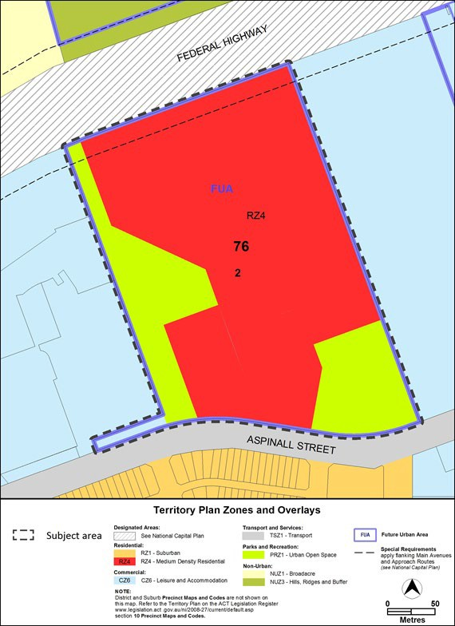

Variation to the Watson Precinct Map and Code

- Watson Precinct Map

Substitute
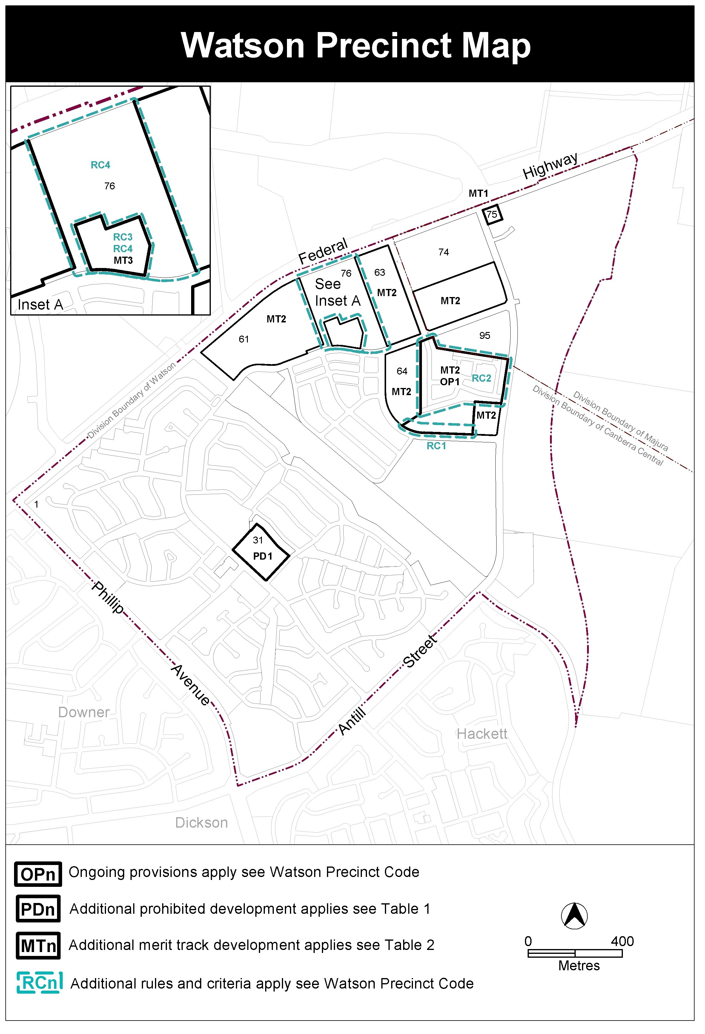

- Introduction, Definitions

Substitute second paragraph with:

Definitions of terms used in this code are listed in part 13 of the Territory Plan or, for terms applicable only to this code listed below.

Co-housing means a development with separate dwellings or private living areas, with some common/shared indoor components such as kitchens, living areas, bedrooms, and laundries. Private living areas must each contain a bedroom and a bathroom as a minimum and may contain a kitchenette. The common/shared indoor components may be provided in a separate building.

Social enterprise is a commercial organisation that exists to create social benefit as its primary purpose and may or may not be for profit and which may include employment and skills development for on-site residents.

- Assessment Tracks, Table 2 – Additional merit track development

Add

Suburb precinct map label | Zone | Development
MT3 | RZ4 | co-housing social enterprise craft workshop

- Additional rules and criteria, RC2 – Residential, Table 2 Fencing materials
Insert after Table 2 Fencing materials

RC3 – Residential
This part applies to blocks and parcels identified in area RC3 shown on the Watson Precinct Map.
Element 3: Use
Rules | Criteria
3.1 Co-housing and social enterprise
R23  Co-housing and social enterprise development can only be undertaken by the Demonstration Housing Project lessee(s) identified on a register published on an ACT Government website. | This is a mandatory requirement. There is no applicable criterion.

RC4 – Residential
This part applies to blocks and parcels identified in area RC4 shown on the Watson Precinct Map.

Element 4: Buildings
Rules | Criteria
4.1 Built form
There is no applicable rule. | C24  The built form will contribute to all of the following:  - context and character of the local area  - existing landscape  - sustainability and resilience for a changing climate  - connectivity, legibility and safety of the area  - diversity and amenity  - community and public domain.  The built form will be of an appropriate density and scale and be of a quality that responds to the surrounding local area, landscape, ecological values and does not negatively impact surrounding neighbours.

Variation to the North Watson Structure Plan

- Introduction

Omit

First two sentences in the second paragraph

To assist in understanding the original application of the principles and policies for the “defined land”, the area identified in this structure plan is the original “defined land” area. Over time, part of the former defined land areas was undefined through statutory processes.

Omit

Third paragraph

Further information on the area subject to this structure plan can be found in the original Territory Plan Variation, available on the ACTPLA website

- Principles and Policies (Refer to Figure 1)

Omit

(Refer to Figure 1)

- Principles and Policies, 3. Maximum Number of Dwellings

Omit

3. Maximum Number of Dwellings
The maximum number of new dwellings within the total area to which this Variation applies excluding accommodation specifically for tourist uses shall not exceed 1300 dwellings.

- Principles and Policies, 5. Building Height

Omit

5. Building Height
Building heights shall be two storeys. Where existing approved development exceeds a building height of two storeys, development compatible with the authorised height may be approved.

- Principles and Policies, 5. Building Height, Figure 1

Omit

Figure 1
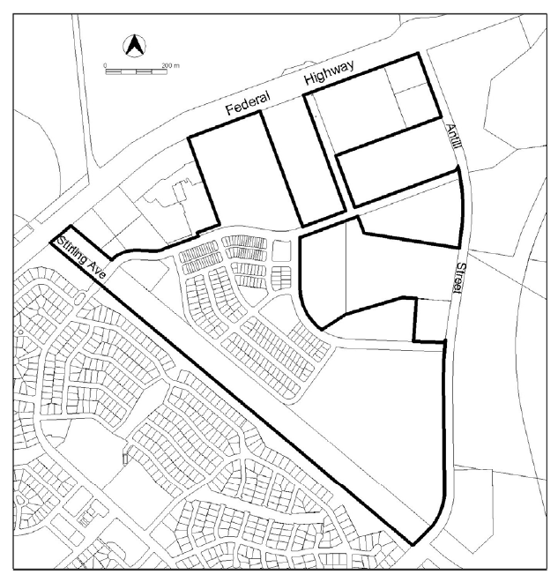

Variation to the Concept Plans

- Concept Plans – Precinct Codes for Section 93 of the Planning and Development Act 2007

Insert the Watson Section 76 Concept Plan at Appendix A.

Interpretation service
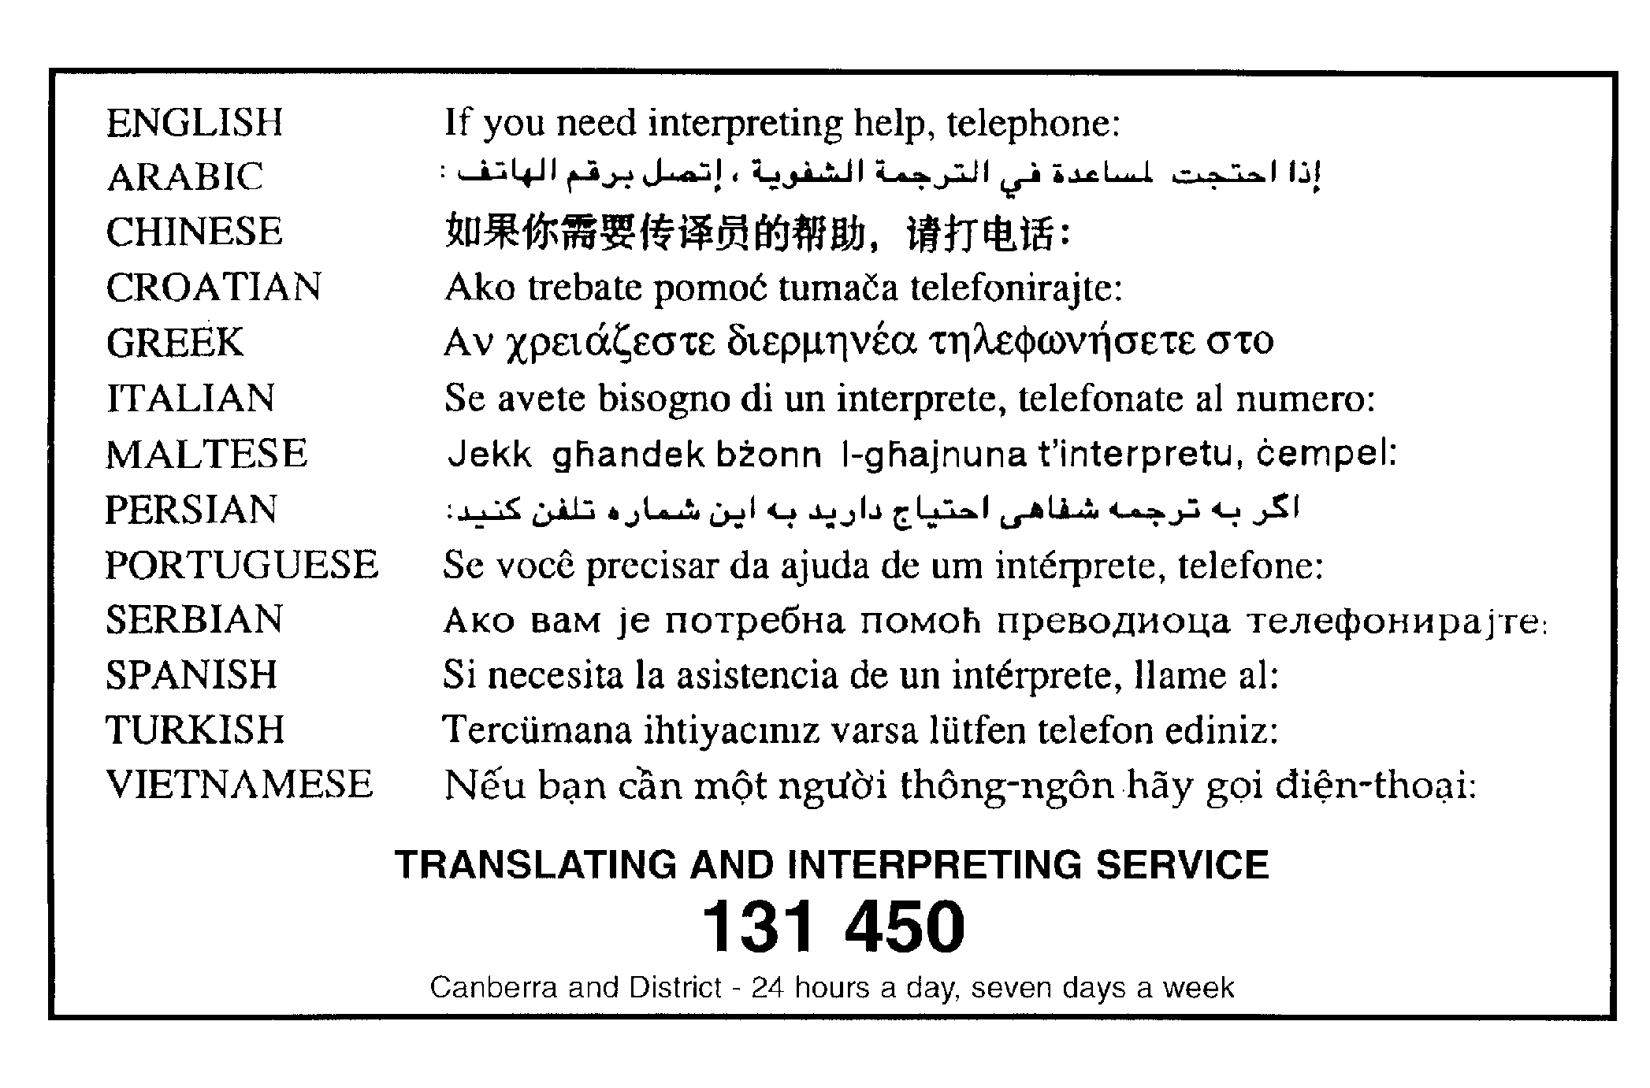

Concept Plan Watson, Section 76

This page is intentionally blank.

Table of Contents
Application 2
Purpose 3
Desired planning outcomes 3
Code hierarchy 3
Part A – Land use 4
1. Land use plan 4
Part B – Subdivision 4
2. Shared Paths 4
3. Public road 4
4. Public open space 4
5. Cultural Heritage 5
6. Demonstration housing 5
7. Environmental assessment 5
Part C – Buildings 6
8. Building heights 6
Figure 1 Location map 2
Figure 2 Shared paths and public road 7
Figure 3 Environmental assessment requirements 8
Figure 4 Building heights 9

Introduction

A Concept Plan is required to provide guidance about the future land uses and provisions for the site and to assess an Estate Development Plan against. Any ongoing provisions will be uplifted into the Territory Plan via a technical amendment after approval of and consistent with the Estate Development Plan for the site. The ongoing provisions of the Concept Plan will form part of the Watson Precinct Map and Code.
There is an opportunity to use Watson section 76 for medium density housing to increase residential development in the existing urban footprint while retaining Superb Parrot habitat and mature trees.

Application
This plan applies to land at Watson section 76 as shown in Figure 1.
This plan contains rules, which provide the quantitative or definitive controls for development, and criteria, which provide qualitative controls for development. In some instances rules are mandatory. Mandatory rules are marked by the words “This is a mandatory requirement. There is no applicable criterion” in the adjacent criteria column. Non-compliance with a mandatory rule will result in the refusal of a development application. In other instances the words “There is no applicable rule” is contained in the rule column. In this case the proposal is assessed against the relevant criterion. Where both rule and criterion apply, compliance with the rule is deemed to satisfy the particular requirement.
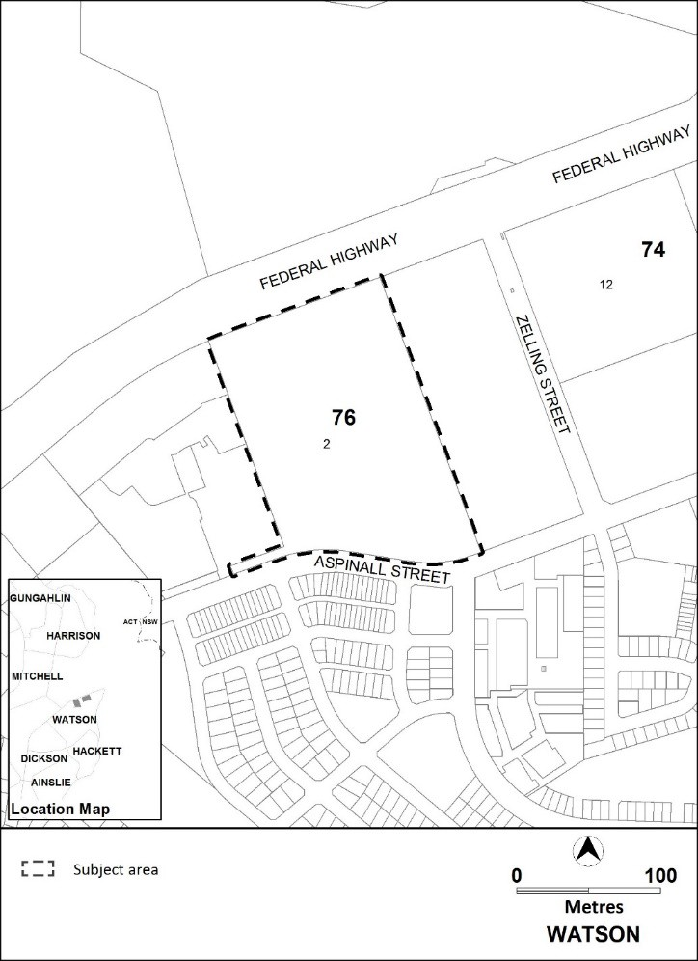

Figure 1 Location map

Purpose
The purpose of this plan is to:
  - guide the design and assessment of estate development plans (subdivision proposals) for the site
  - inform the allocation of final zones at the time when a parcel of land ceases to be part of the future urban area following subdivision
  - guide the development of individual blocks in concert with other relevant codes under the Territory Plan
  - guide the development and management of the public domain, including the urban open space and a public park and active travel connections
  - guide the development of housing to provide housing choices
  - adopt bushfire protection measures appropriate to the site.

Desired planning outcomes
The purpose of the development controls (i.e. rules and criteria) is to:
- provide housing zones, types and densities to meet the changing needs of the community and opportunities for demonstration housing
- allow for zoning to accommodate residential densities and building heights generally close to public transport routes within the urban intensification area
- provide for some community uses such as a social enterprise and craft workshop, or a community activity centre
- provide a safe, compact, and walkable residential precinct with convenient vehicular, pedestrian, cycle and public transport access to recreational, retail/commercial and community facilities
- encourage walking, cycling and the use of public transport
- retain important landscape and trees for the vulnerable Superb parrot, urban heat reduction and general amenity.

Code hierarchy
This concept plan is a precinct code under the Planning and Development Act 2007.
More than one type of code may apply to a particular development proposal. Occasionally inconsistencies between the provisions arise, particularly where a precinct code seeks to apply special provisions in response to particular local circumstances or planning issues.
Where this occurs, a precinct code prevails over a development code and a general code, but only to the extent of the inconsistency.

Part A – Land use
Rules | Criteria

1. Land use plan
R1  Zoning as shown on a land use plan lodged with an Estate Development Plan is consistent with the Territory Plan map. | This is a mandatory requirement. There is no applicable criterion.

Part B – Subdivision
Rules | Criteria

2. Shared Paths
R2  Connections of the shared paths for pedestrians and cyclists is consistent with Figure 2. | This is a mandatory requirement. There is no applicable criterion.

3. Public road
R3  A public road will be provided consistent with Figure 2. | This is a mandatory requirement. There is no applicable criterion.

4. Public open space
R4  This rule applies to land in the PRZ1 Urban Open Space zone. Public open space addresses all of the following:  - a park of at least one hectare to the south- east of the site  - retention of the western portion of the site for wildlife habitat, particularly for the Superb Parrot (Polytelis swainsonii). | This is a mandatory requirement. There is no applicable criterion.

5. Cultural Heritage
R5  The recommendations of the cultural heritage assessment provided by the Environment Planning and Sustainable Development Directorate are reflected in the Estate Development Plan application. | This is a mandatory requirement. There is no applicable criterion.

6. Demonstration housing
There is no applicable rule. | C6  At least two sites will be reserved for demonstration housing, involving innovative housing types and may include tiny houses, within the area identified as MT3 in the Watson precinct map and code.  Demonstration housing is to be endorsed by the planning and land authority in accordance with the list of criteria published on the Environment Planning and Sustainable Development Directorate website.

7. Environmental assessment
R7  This rule applies to section 76 Watson as shown in Figure 3. The Development Application for development on the site must be accompanied by an environmental assessment into the site’s suitability from a contamination perspective in accordance with the ACT Contaminated Sites Environment Protection Policy and be endorsed by the Environment Protection Authority.  This rule does not apply if the Environment Protection Authority has provided written advice that section 76 Watson has been assessed for contamination to its satisfaction. | This is a mandatory requirement. There is no applicable criterion.

Part C – Buildings
Rules | Criteria

8. Building heights
R8  This rule applies to areas shown in Figure 4. Maximum height of building is:  a) for area A: the lesser of 2 storeys and  8.5 metres  b) for area B: the lesser of 4 storeys and  16.5 metres. | This is a mandatory requirement. There is no applicable criterion.

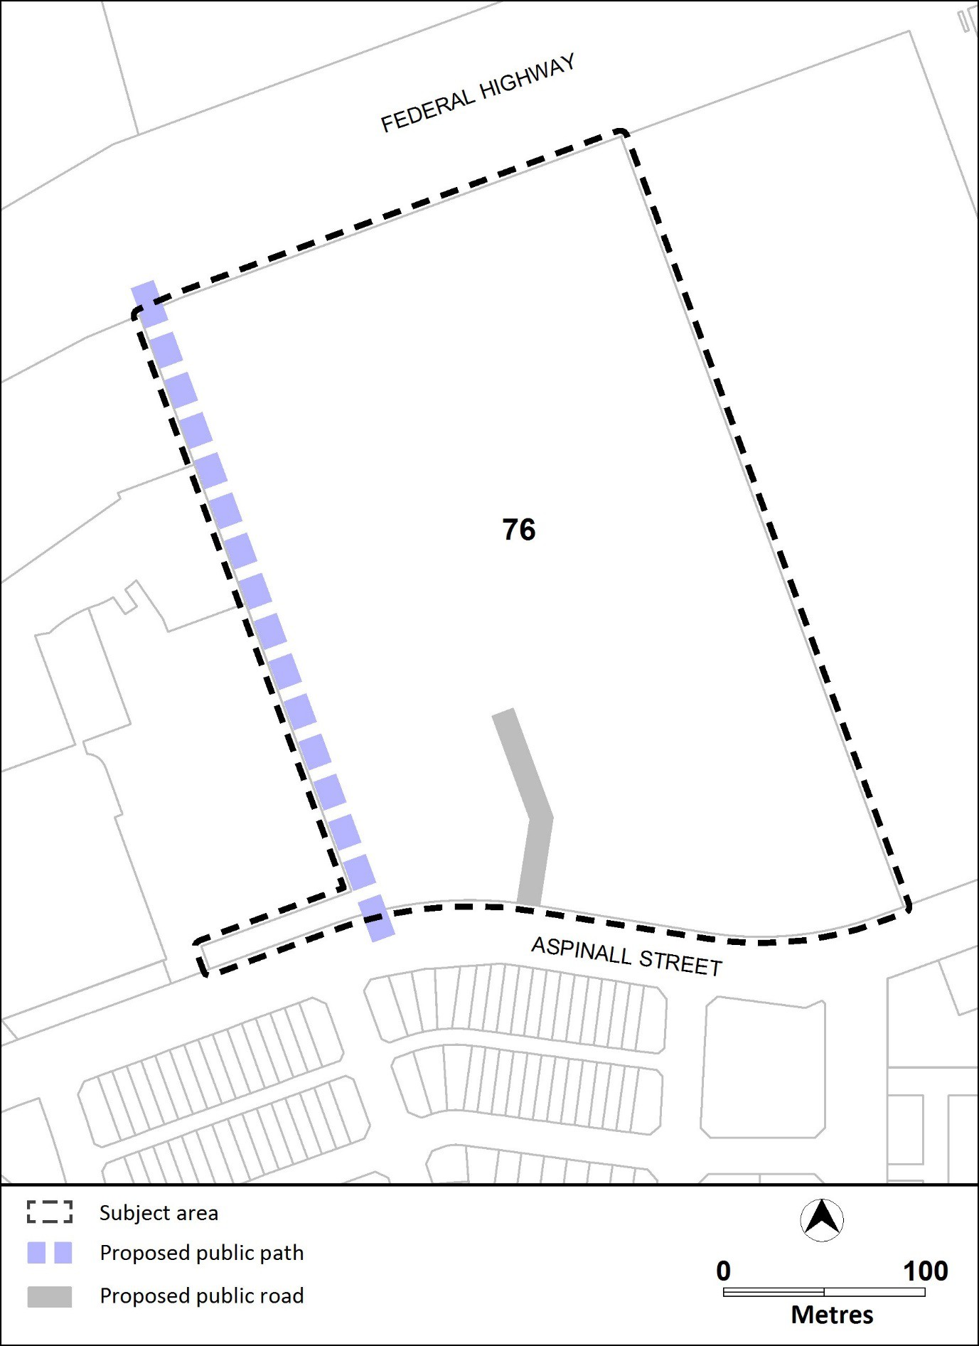

Figure 2 Shared paths and public road

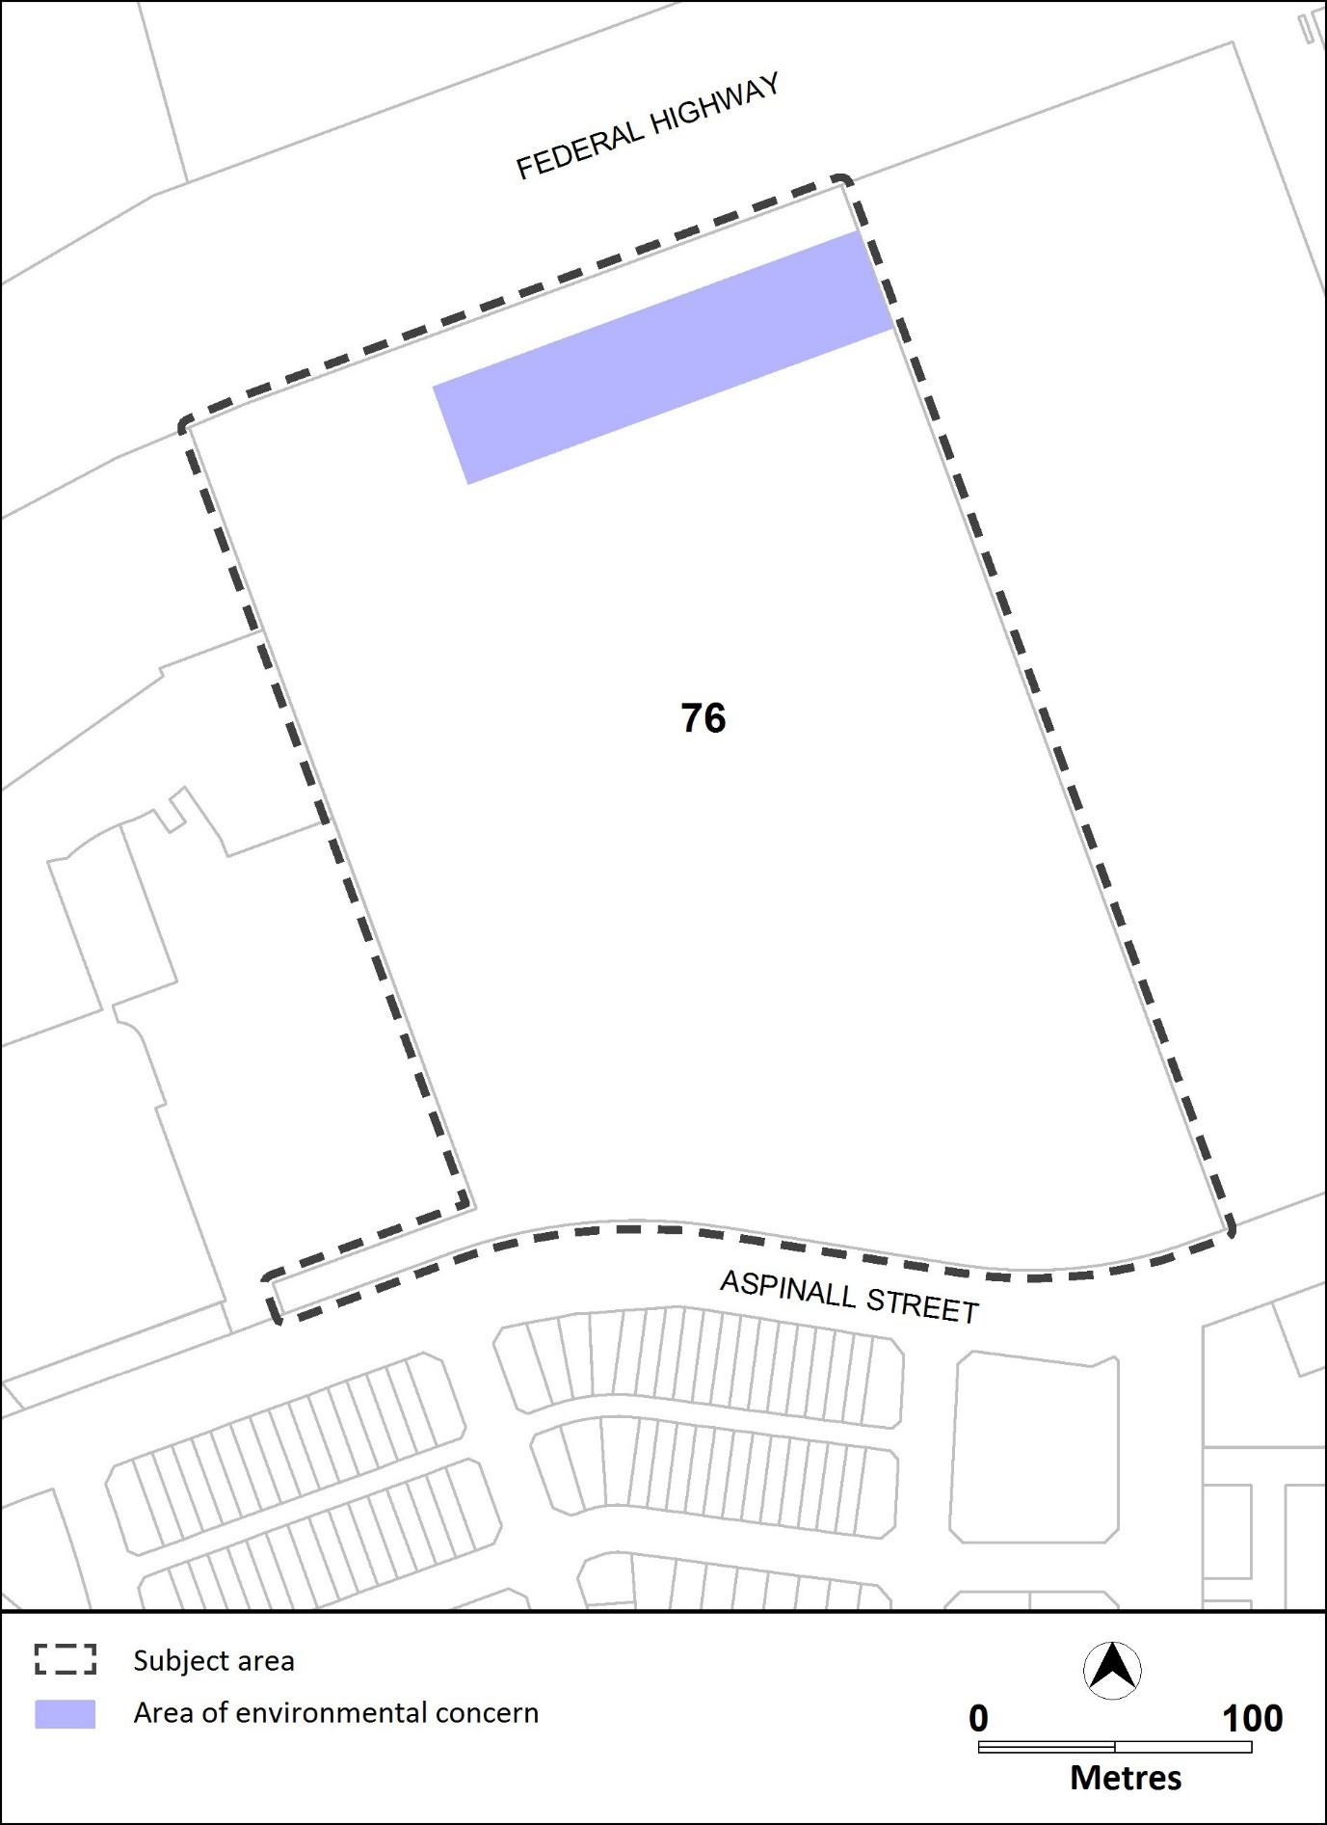

Figure 3 Environmental assessment requirements

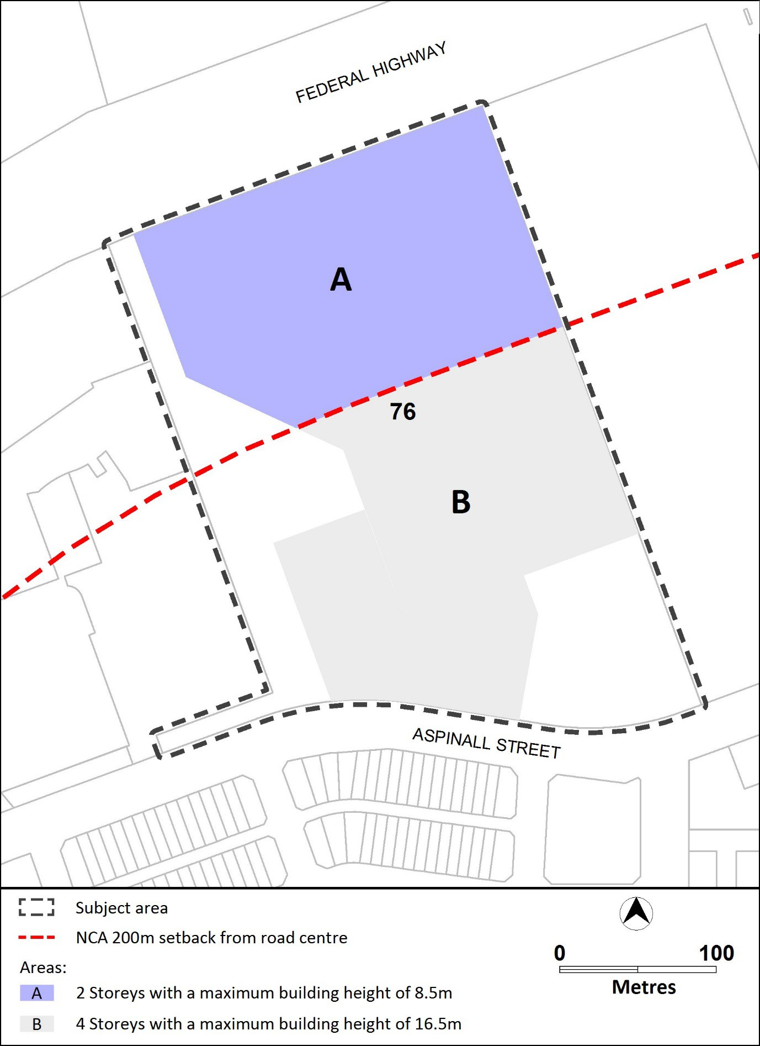

Figure 4 Building heights

