Australian Capital Territory
Heritage (Decision about Provisional Registration of 153 Limestone Avenue “Fassifern House”, Braddon) Notice 2021
Notifiable instrument NI2021–454
made under the
Heritage Act 2004, s34 (Notice of decision about provisional registration)

1 Name of instrument
This instrument is the Heritage (Decision about Provisional Registration of 153 Limestone Avenue “Fassifern House”, Braddon) Notice 2021.
2 Decision about provisional registration
On 22 July 2021, the ACT Heritage Council (the Heritage Council) decided not to provisionally register 153 Limestone Avenue “Fassifern House”, Block 1, Section 6, Braddon (the Place).
3 Description of the Place
The description of the Place is in the schedule.
4 Reasons for the decision
The Heritage Council is not satisfied on reasonable grounds that the Place is likely to have heritage significance as defined by section 10 of the Heritage Act 2004. A detailed statement of reasons, including an assessment against the heritage significance criteria, is provided in the schedule.
5 Date decision takes effect
The decision not to provisionally register the Place takes effect on 23 July 2021 (being the day after the Heritage Council made its decision in writing as set out in the schedule).

Edwina Jans
A/g Secretary (as delegate for)
ACT Heritage Council
22 July 2021

STATEMENT OF REASONS
DECISION NOT TO PROVISIONALLY REGISTER
153 Limestone Avenue “Fassifern House”WamboinName of Place
BLOCK 1 SECTION 6, Braddon
IN THE ACT HERITAGE REGISTER

In accordance with s32 of the Heritage Act 2004, the ACT Heritage Council has decided not to provisionally register 153 Limestone Avenue “Fassifern House”, Braddon. This Statement of Reasons provides an assessment of 153 Limestone Avenue “Fassifern House”, Braddon, and finds that the place does not meet any of the criteria under s10 of the Heritage Act 2004.

This statement refers to the location of the place as required in s34(5)(b)(ii) of the Heritage Act 2004.
LOCATION OF THE PLACE

153 Limestone Avenue “Fassifern House”, Block 1 Section 6, Braddon.

This section refers to the description of the place as required in s34(5)(b)(iii) of the Heritage Act 2004. The boundary of the place and extent of features listed below is illustrated at Image 1.

DESCRIPTION OF THE PLACE

153 Limestone Avenue “Fassifern House”, consisting of the following attributes:
- The original detached dwelling and garage sited on a large corner block with low front brick fence and associated landscaping.

This statement refers to the Council’s reasons for its decision as required in s34(5)(b)(iv) of the Heritage Act 2004.
REASONS FOR DECISION

The Council is not satisfied on reasonable grounds that the place is likely to have heritage significance as defined by s10 of the Heritage Act 2004.

This statement refers to the Council’s assessment of the place against the heritage significance criteria as a part of its reasons for its decision as required in s34(5)(b)(iv) of the Heritage Act 2004.
ASSESSMENT AGAINST THE HERITAGE SIGNIFICANCE CRITERIA

The Council’s assessment against the criteria specified in s10 of the Heritage Act 2004 is as follows.

In assessing the heritage significance of 153 Limestone Avenue “Fassifern House”, Braddon, the Council considered:
- the original nomination and documentary evidence supplied by the nominator;
- the Council’s Heritage Assessment Policy (March 2018);
- existing entries on the ACT Heritage Register;
- aerial imagery from the 1960s;
- images and video from previous real estate listings; and
- the ACT Government building file for Block 1 Section 6 Braddon.

Pursuant to s10 of the Heritage Act, a place or object has heritage significance if it satisfies one or more of the following criteria. Future research may alter the findings of this assessment.
- importance to the course or pattern of the ACT’s cultural or natural history;
The Council has assessed 153 Limestone Avenue “Fassifern House” against criterion (a) and is not satisfied that the place meets this criterion.
153 Limestone Avenue “Fassifern House” is representative of a continuum of housing types in the ACT. It is a subtle variation on existing styles, techniques and materials and is more accurately categorised as an example of an individual design reflecting the needs of its owner for its time rather than something that shows a significant change or a seminal or early example of its type. It is a part of the ACTs mid-century development, a recognisable suburban residence at the local level, but it is not important enough to pass the threshold for inclusion under this criterion.
- has uncommon, rare or endangered aspects of the ACT’s cultural or natural history;
The Council has assessed 153 Limestone Avenue “Fassifern House” against criterion (b) and is not satisfied that the place meets this criterion.
153 Limestone Avenue “Fassifern House” is a mid-century detached partly rendered brick house, which were and still are common in the ACT. While this can be qualified further with descriptors, such as containing modernist characteristics or built with post-war migrant skills, this imposes too many qualifying terms to the degree that the type of place cannot be said to be uncommon, rare or endangered in the ACT.
- potential to yield important information that will contribute to an understanding of the ACT’s cultural or natural history;
The Council has assessed 153 Limestone Avenue “Fassifern House” against criterion (c) and is not satisfied that the place meets this criterion.
There is no evidence to suggest that 153 Limestone Avenue “Fassifern House” was built or designed in such a way that there is a potential to yield important information that is not already widely known. It uses conventional materials and techniques that highlight its good quality private construction, but it is highly unlikely that any of these will reveal information that is not already known about mid-century construction. The place is not likely to fill an important gap in knowledge of the time and so does not pass the basic test to meet this criterion.
- importance in demonstrating the principal characteristics of a class of cultural or natural places or objects;
The Council has assessed 153 Limestone Avenue “Fassifern House” against criterion (d) and is not satisfied that the place meets this criterion.
153 Limestone Avenue “Fassifern House” is a single detached house from the mid-century/post-war era. This was a time of great change in building design, materials and thinking that are best demonstrated by the various modernist houses of the ACT, such as 1 Astley Place, Manning Clarke’s House, 16 Ryrie Street, 24 Arthur Circle, 12 Marawa Place, and 113 Schlich Street as examples. While 153 Limestone Avenue “Fassifern House” may exhibit some features of modernist design, it does not embrace them fully and only applies them to existing styles and materials and cannot be said to be important in demonstrating these characteristics, particularly when compared against other examples in the ACT.

- importance in exhibiting particular aesthetic characteristics valued by the ACT community or a cultural group in the ACT;
The Council has assessed 153 Limestone Avenue “Fassifern House” against criterion (e) and is not satisfied that the place meets this criterion.
153 Limestone Avenue “Fassifern House” may be well known by virtue of it being located on a busy corner and in possession of noticeable colour scheme, but that does not equate to the ACT community valuing any particular aesthetic quality of the place. Further, it cannot be said based on information currently available that the place is aesthetically iconic in the same manner as the Australian Academy of Science building (‘Becker House,’) or the Sydney and Melbourne Buildings which are registered on the ACT Heritage Register.
- importance in demonstrating a high degree of creative or technical achievement for a particular period;
The Council has assessed 153 Limestone Avenue “Fassifern House” against criterion (f) and is not satisfied that the place meets this criterion.
The nomination suggests that 153 Limestone Avenue “Fassifern House” has a high degree of creative and technical achievement for its time by using traditional brick and timber construction methods but using larger windows and taking advantage of solar orientation with strategically placed fireplaces to create a light filled and energy efficient building for its time. However, the 1960s saw notable advances with the introduction of thoroughly modern design and material use. As such, even if 153 Limestone Avenue “Fassifern House” is considered to be an advance in traditional design towards modernist trend, it does not pass the threshold for being at a high degree when compared against others of its time such as 1 Astley Place, Manning Clarke’s House, 16 Ryrie Street, 24 Arthur Circle, 12 Marawa Place, and 113 Schlich Street as a sample of places already on the Register.
- has a strong or special association with the ACT community, or a cultural group in the ACT for social, cultural or spiritual reasons;
The Council has assessed 153 Limestone Avenue “Fassifern House” against criterion (g) and is not satisfied that the place meets this criterion.
The nomination claims that there is a distinctive association with post-Second World war modernist migrant culture. While 153 Limestone Avenue “Fassifern House” may have been built or occupied by people migrating from post-war Europe there is not a clear association with the physical fabric of the place, nor is there evidence that any such association can be shown as strong or special with any identified cultural group in particular.
- has a special association with the life or work of a person, or people, important to the history of the ACT.
The Council has assessed 153 Limestone Avenue “Fassifern House” against criterion (h) and is not satisfied that the place meets this criterion.
153 Limestone Avenue “Fassifern House” was designed by R. B. FitzGerald, who designed several houses in post-war Canberra and is represented in the Registered Blandfordia 4 Precinct. While 153 Limestone Avenue “Fassifern House” contains elements of his design style, notably rounded bay windows and the integration of modernist design characteristics, it is not an exceptional example of his style and there is no evidence of his association with the place being any more special than any other place that he designed.
The original owner of 153 Limestone Avenue “Fassifern House” was Raymond Price, but there is no evidence that the place had a special association with his life or work or that he was widely known to shape the course of the history of the ACT.
The builder of 153 Limestone Avenue “Fassifern House” was Vytautas Genys of ACT Builders. Vytautas migrated to Australia from Lithuania in the 1950s and formed the company with four others in 1954 starting with a contract to build eight cottages in Ainslie. The company had trouble in 1956 but recovered as Vytautas took over as Managing Director with the company soon responsible for several major buildings across the ACT and providing employment for hundreds of people as a successful business before winding up in 2016. While 153 Limestone Avenue “Fassifern House” is one of the early builds for the company, it cannot be said to have a special association with the company as it was not one of the key contracts that help start or then grow the company, nor was it one of their later, larger contracts for institutional buildings. Additionally, 153 Limestone Avenue “Fassifern House” is not the best example of their high-quality mid-century work, which can be seen in other places, such as 46 Vasey Crescent in Campbell.
SITE PLAN

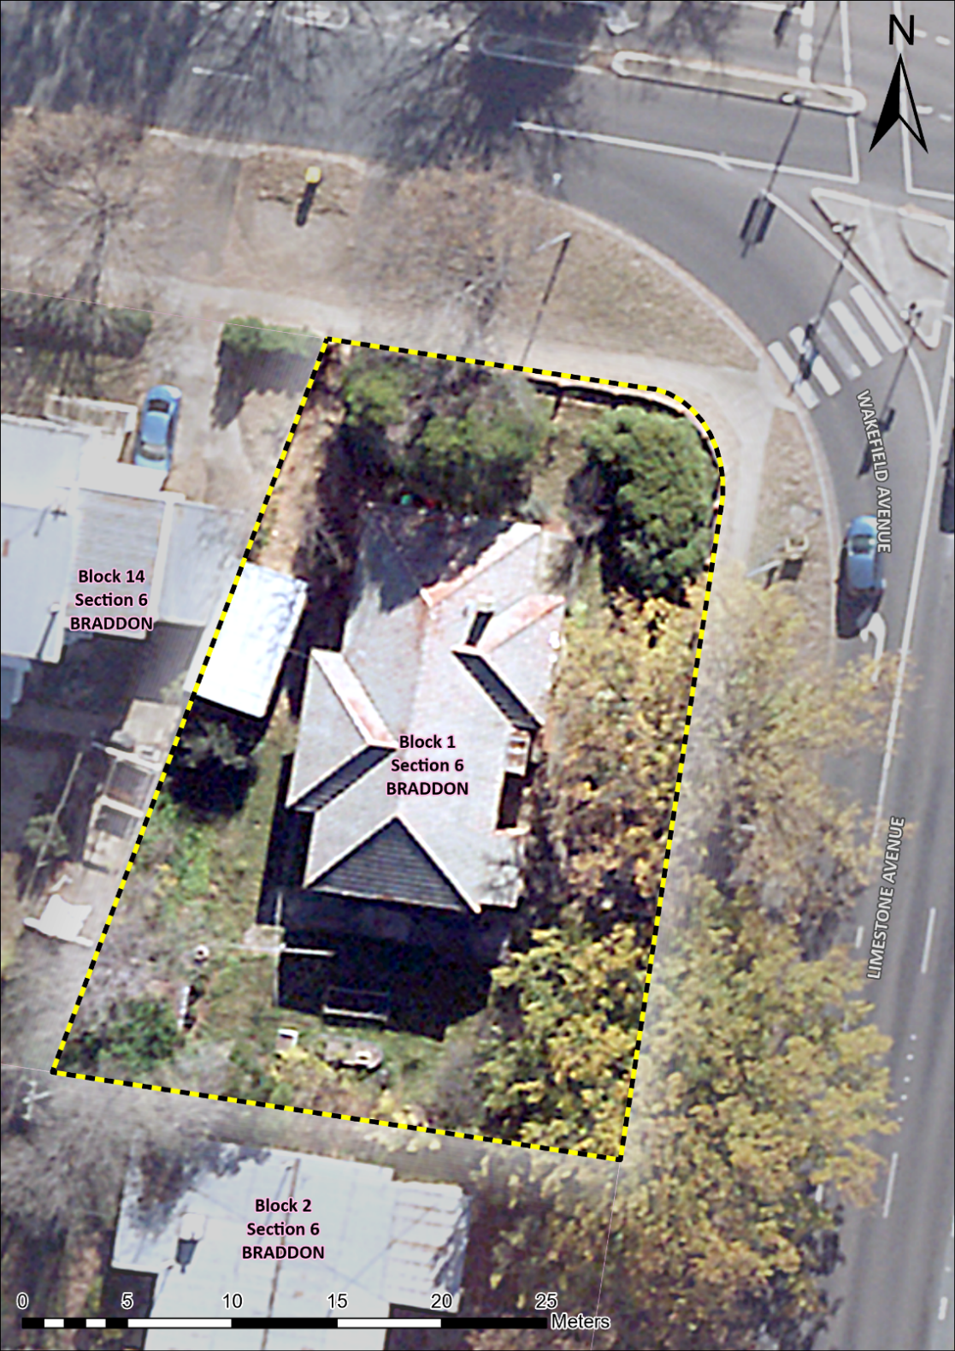
Image 1 153 Limestone Avenue “Fassifern House” site boundary

