Australian Capital Territory

# Nature Conservation (Closed Reserves) Declaration 2021 (No 5)

## Notifiable instrument NI2021–498

made under the

Nature Conservation Act 2014, s 259 (Conservator may close reserve)

### 1 Name of instrument

This instrument is the *Nature Conservation (Closed Reserves) Declaration 2021 (No 5).*

### 2 Commencement

This instrument commences on the day that it is signed.

### 3 Declaration

I declare public access to the reserves specified in column 2 of schedule 1 is prohibited.

### 4 Exceptions

(1) Section 3 does not apply to a conservation officer exercising a function under the Act within the closed reserves.

(2) Section 3 does not apply to Boboyan Road and Brindabella Road.

*Note*  Boboyan Road and Brindabella Road may be subject to closure under other legislation.

### 5 Revocation

This instrument revokes the *Nature Conservation (Closed Reserves) Declaration 2021 (No 4)* [NI2021-486].

Michaela Watts

Delegate of the Conservator of Flora and Fauna

19 August 2021

**Schedule 1 Closed reserves**

(see s 3)

|  |  |
| --- | --- |
| **column 1**  **item** | **column 2**  **reserve** |
| 1 | The areas identified in schedule 2 known as Woodstock Nature Reserve, Swamp Creek Nature Reserve, Uriarra Crossing Recreation Area, Stony Creek Nature Reserve, Cotter Reserve, Kambah Pool Recreation Area, part of Bullen Range Nature Reserve, and Gigerline Nature Reserve. |
| 2 | The area identified in schedule 3 known as Namadgi National Park and Bimberi Wilderness Area. |
| 3 | The area identified in schedule 4 known as Lower Cotter Catchment Reserve. |

**Schedule 2 Murrumbidgee River Corridor Reserves**

(see sch 1 item 2)

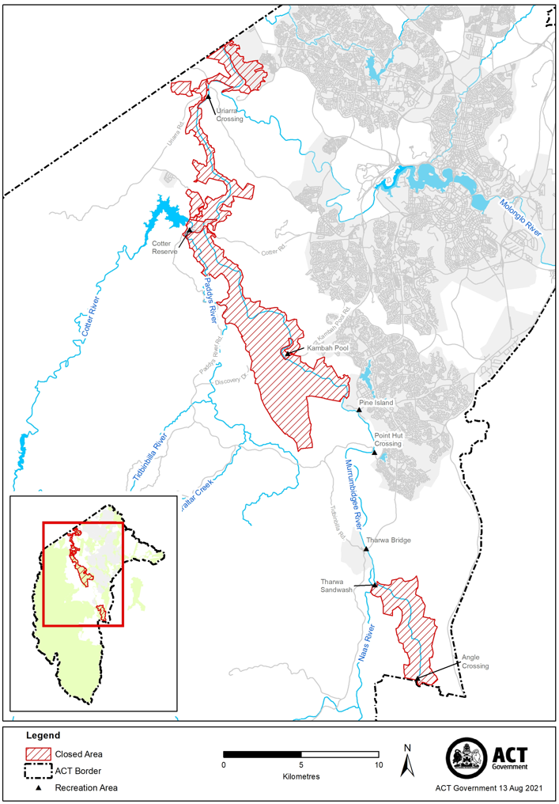

**Schedule 3 Namadgi National Park and Bimberi Wilderness Area**

(see sch 1 item 3)

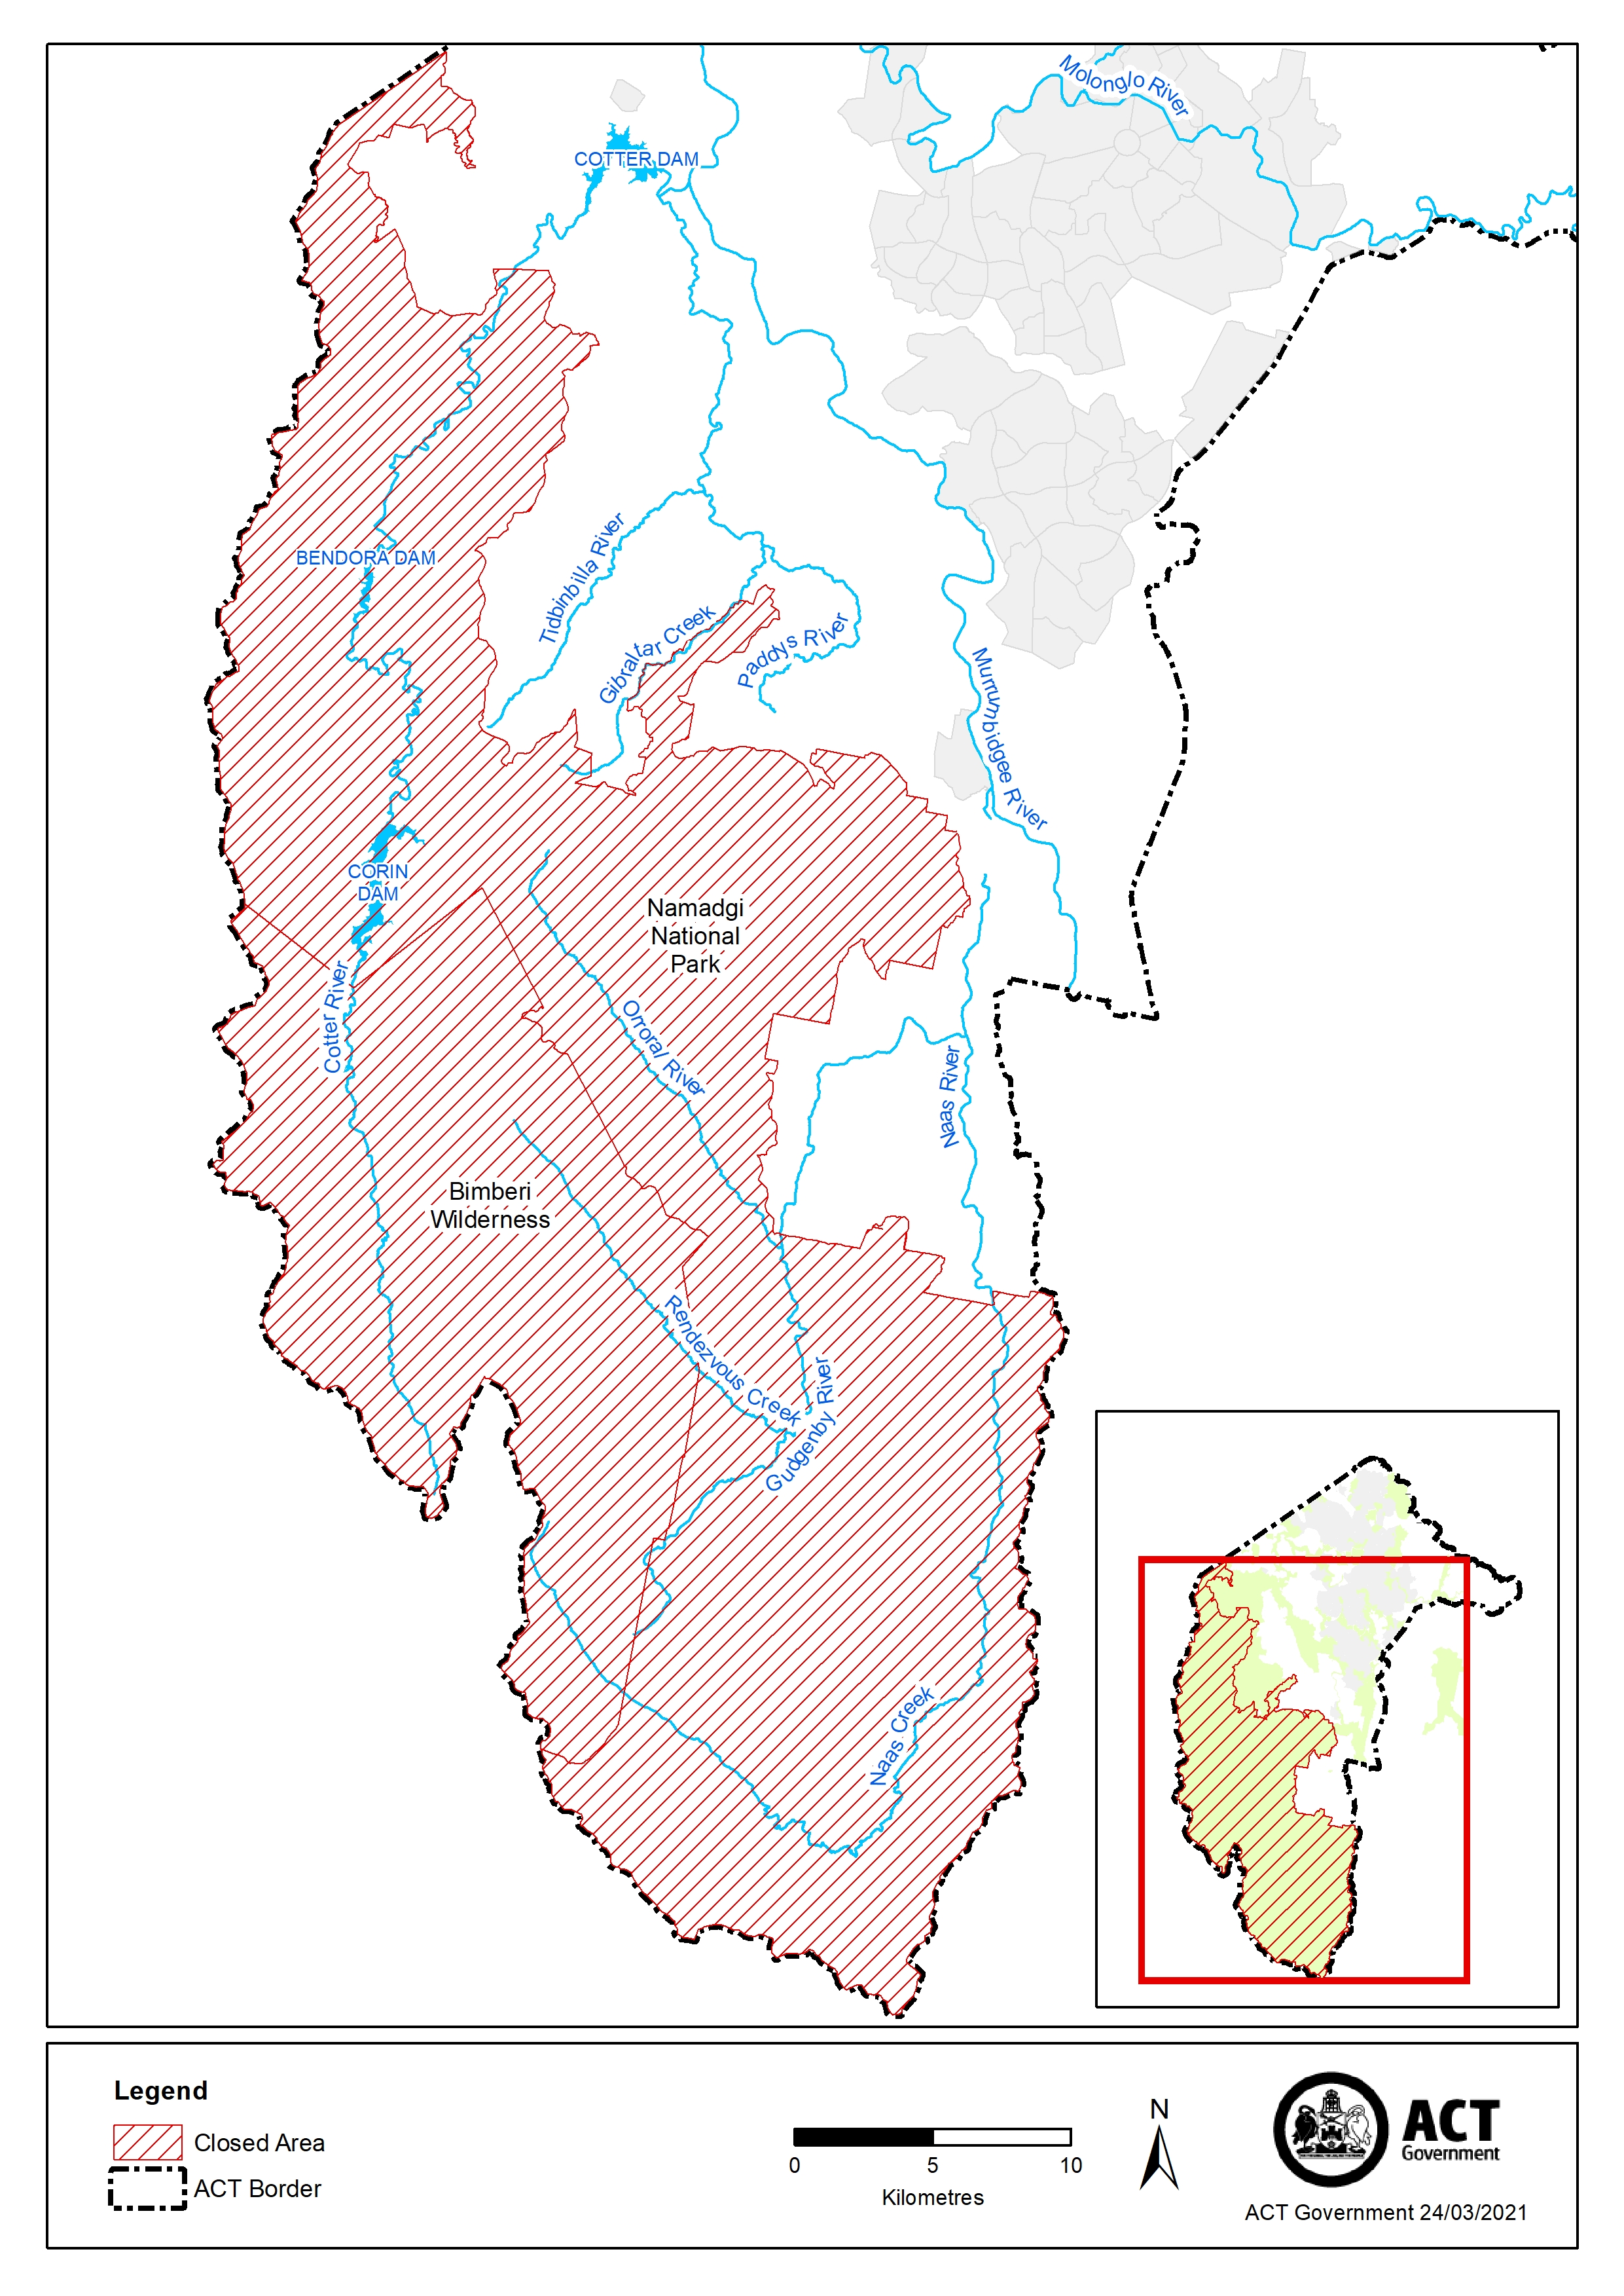

**Schedule 4 Lower Cotter Catchment Reserve**

(see sch 1 item 4)

