Australian Capital Territory
Planning and Development (Technical Amendment—Miscellaneous amendments) Plan Variation 2021 (No 1)

Notifiable instrument NI2021—505
Technical Amendment No 2021-09
made under the
Planning and Development Act 2007, section 89 (Making technical amendments)

- Name of instrument
This instrument is the Planning and Development (Technical Amendment—Miscellaneous amendments) Plan Variation 2021 (No 1).
2 Commencement
This instrument commences on the day after its notification day.
3 Technical amendment
I am satisfied under section 89(1)(a) of the Planning and Development Act 2007 (the Act) that the Miscellaneous amendments plan variation is a technical amendment to the Territory Plan.
4 Dictionary
In this instrument:
Miscellaneous amendments plan variation means the technical amendment to the Territory Plan, variation 2021-09, in the schedule.
Note: No consultation was required in relation to the Miscellaneous plan variation under section 87 of the Act.

Carolyn O’Neill
Delegate of the planning and land authority
19 August 2021

Schedule

Planning & Development Act 2007

Technical Amendment
to the Territory Plan
Variation 2021-09

Miscellaneous amendments

August 2021

This page is left intentionally blank

Table of Contents

1. INTRODUCTION 1
1.1 Purpose 1
1.2 Public consultation 1
1.3 National Capital Authority 1
1.4 Process 1
1.5 Types of technical amendments under the Act 2
2. EXPLANATION 3
2.1 Background 3
2.2 Variation to the Single Dwelling Housing Development Code 3
2.3 Variation to the Strathnairn Precinct Map and Code 3
3. TECHNICAL AMENDMENT 10
3.1 Variation to the Single Dwelling Housing Development Code 10
3.2 Variation to the Strathnairn Precinct Map and Code 12

- INTRODUCTION
  - Purpose
This technical amendment makes the following changes to the Territory Plan
Single Dwelling Housing Development Code
- Italicise defined terms ‘front boundary’ and ‘northern boundary’ in rule R37A
Strathnairn Precinct Map and Code
- Amend legend in figures 19, 20 and 21 of the Strathnairn Precinct Map and Code to include ‘- Articulation elements into front setback permitted where front setback is at least 3 metres’
  - Public consultation
Under section 87(1)(a) of the Planning and Development Act 2007 (the Act) this type of technical amendment is not subject to public consultation.

  - National Capital Authority
The National Capital Authority does not need to be advised of this technical amendment as per 1.2.

  - Process
This technical amendment has been prepared in accordance with section 87 and made in accordance with section 89 of the Act.

  - Types of technical amendments under the Act
The following categories of technical amendments are provided under section 87 of the Act:
- Each of the following territory plan variations is a technical amendment for which no consultation is needed before it is made under section 89:
(a) a variation (an error variation) that –
- would not adversely affect anyone’s rights if approved; and
- has as its only object the correction of a formal error in the plan;
(b) a variation to change the boundary of a zone or overlay under section 90A (Rezoning – boundary changes);
(c) a variation, other than one to which subsection (2)(d) applies, in relation to an estate development plan under section 96 (Effect of approval of estate development plan);
(d) a variation required to bring the territory plan into line with the national capital plan;
(e) a variation to omit something that is obsolete or redundant in the territory plan.
- Each of the following territory plan variations is a technical amendment for which only limited public consultation is needed under section 90:
- a variation (a code variation) that –
- would only change a code; and
- is consistent with the policy purpose and policy framework of the code; and
- is not an error variation;
- a variation to change the boundary of a zone under section 90B (Rezoning – development encroaching on adjoining territory land);
- a variation in relation to a future urban area under section 90C (Technical amendments – future urban areas);
- a variation in relation to an estate development plan under section 96 (Effect of approval of estate development plan) if it incorporates an ongoing provision that was not included in the plan under
section 94(3)(g);
- a variation to clarify the language in the territory plan if it does not change the substance of the plan;
- a variation to relocate a provision within the territory plan if the substance of the provision is not changed.

TA2021-09 has been prepared in accordance with section 87 (1) (a) of the Act.

- EXPLANATION
  - Background
This part of the technical amendment document explains the changes to be made to the Territory Plan, the reasons for the change, and a statement of compliance against the relevant section of the Act.

  - Variation to the Single Dwelling Housing Development Code
Technical amendment TA2021-02 amended rule R37A in the Single Dwelling Housing Development Code. As a result of public consultation, it was agreed that the Territory Plan defined terms ‘front boundary’ and ‘northern boundary’ were to be italicised. The terms were inadvertently not italicised as part of the technical amendment.

Compliance with the Planning and Development Act 2007
Section | Statement
s87(1)(a)  (a) a variation (an error variation) that—  (i) would not adversely affect anyone’s rights if approved; and  (ii) has as its only object the correction of a formal error in the plan; | Compliant.  The change corrects a formal error by italicising defined terms.

  - Variation to the Strathnairn Precinct Map and Code
Figures 19, 20 and 21 of the Strathnairn Precinct Map and Code show additional rules and criteria which apply to blocks in the division of Strathnairn. When these provisions were transferred into the Strathnairn Precinct Map and Code the text ‘- Articulation elements into front setback permitted where front setback is at least 3 metres’ was inadvertently not included in the figure legends.

This technical amendment seeks to rectify this omission by including ‘- Articulation elements into front setback permitted where front setback is at least 3 metres’ in the legend of figures 19, 20 and 21 of the Strathnairn Precinct Map and Code.

Compliance with the Planning and Development Act 2007
Section | Statement
s87(1)(a)  (a) a variation (an error variation) that—  (i) would not adversely affect anyone’s rights if approved; and  (ii) has as its only object the correction of a formal error in the plan; | Compliant.  The change corrects a formal error by adding ‘- Articulation elements into front setback permitted where front setback is at least 3 metres’ to figures 19, 20 and 21 of the Strathnairn Precinct Map and Code.

Current Figure 19 of the Strathnairn Precinct Map and Code

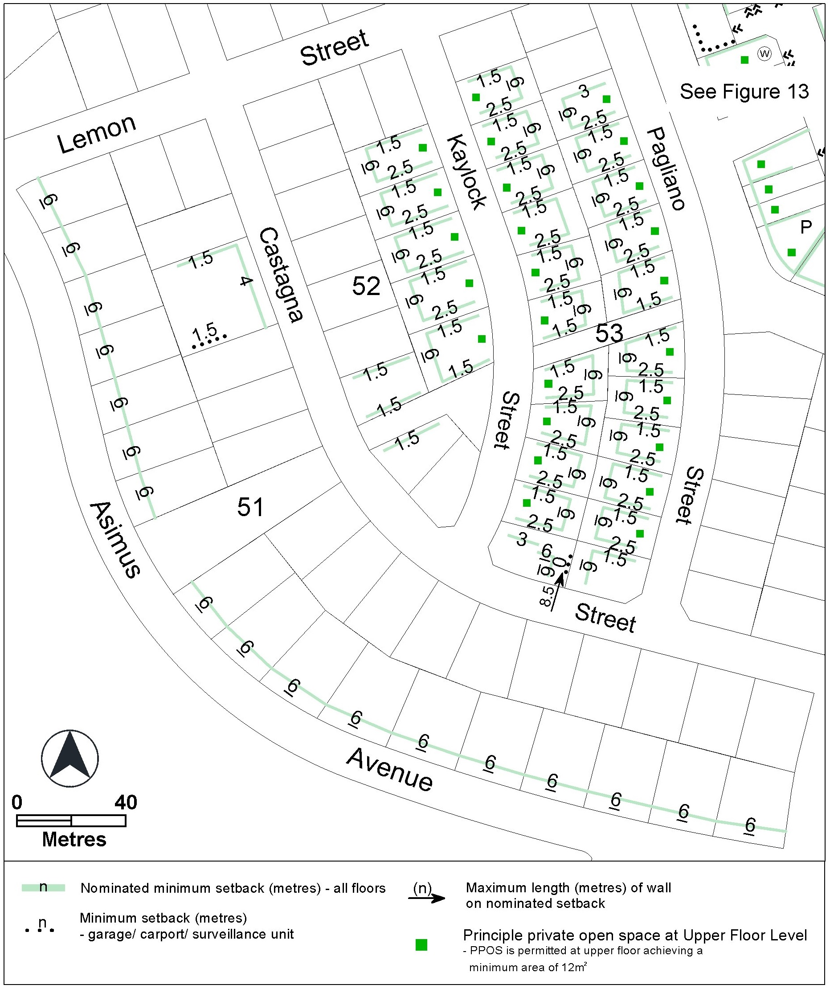

Changes to Figure 19 of the Strathnairn Precinct Map and Code

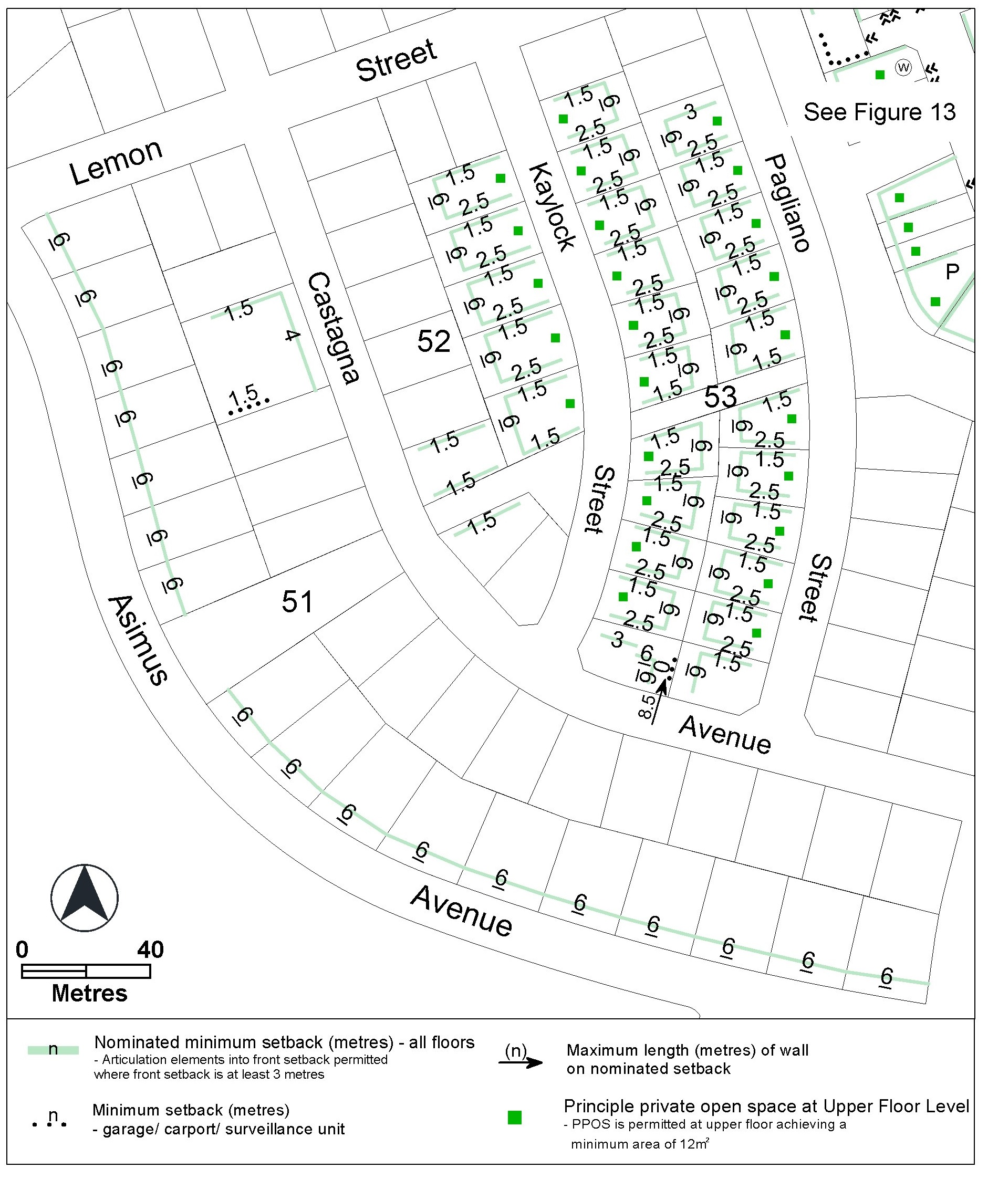

Current Figure 20 of the Strathnairn Precinct Map and Code

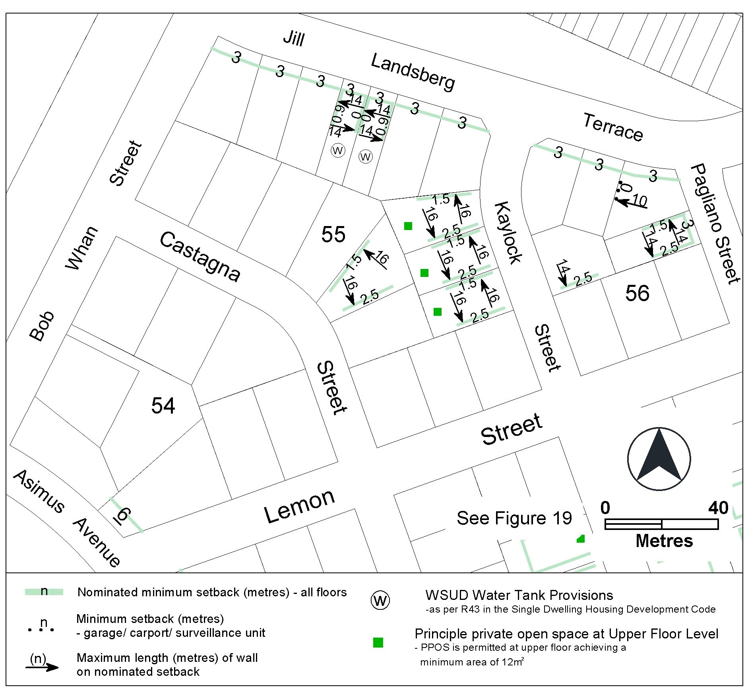

Changes to Figure 20 of the Strathnairn Precinct Map and Code

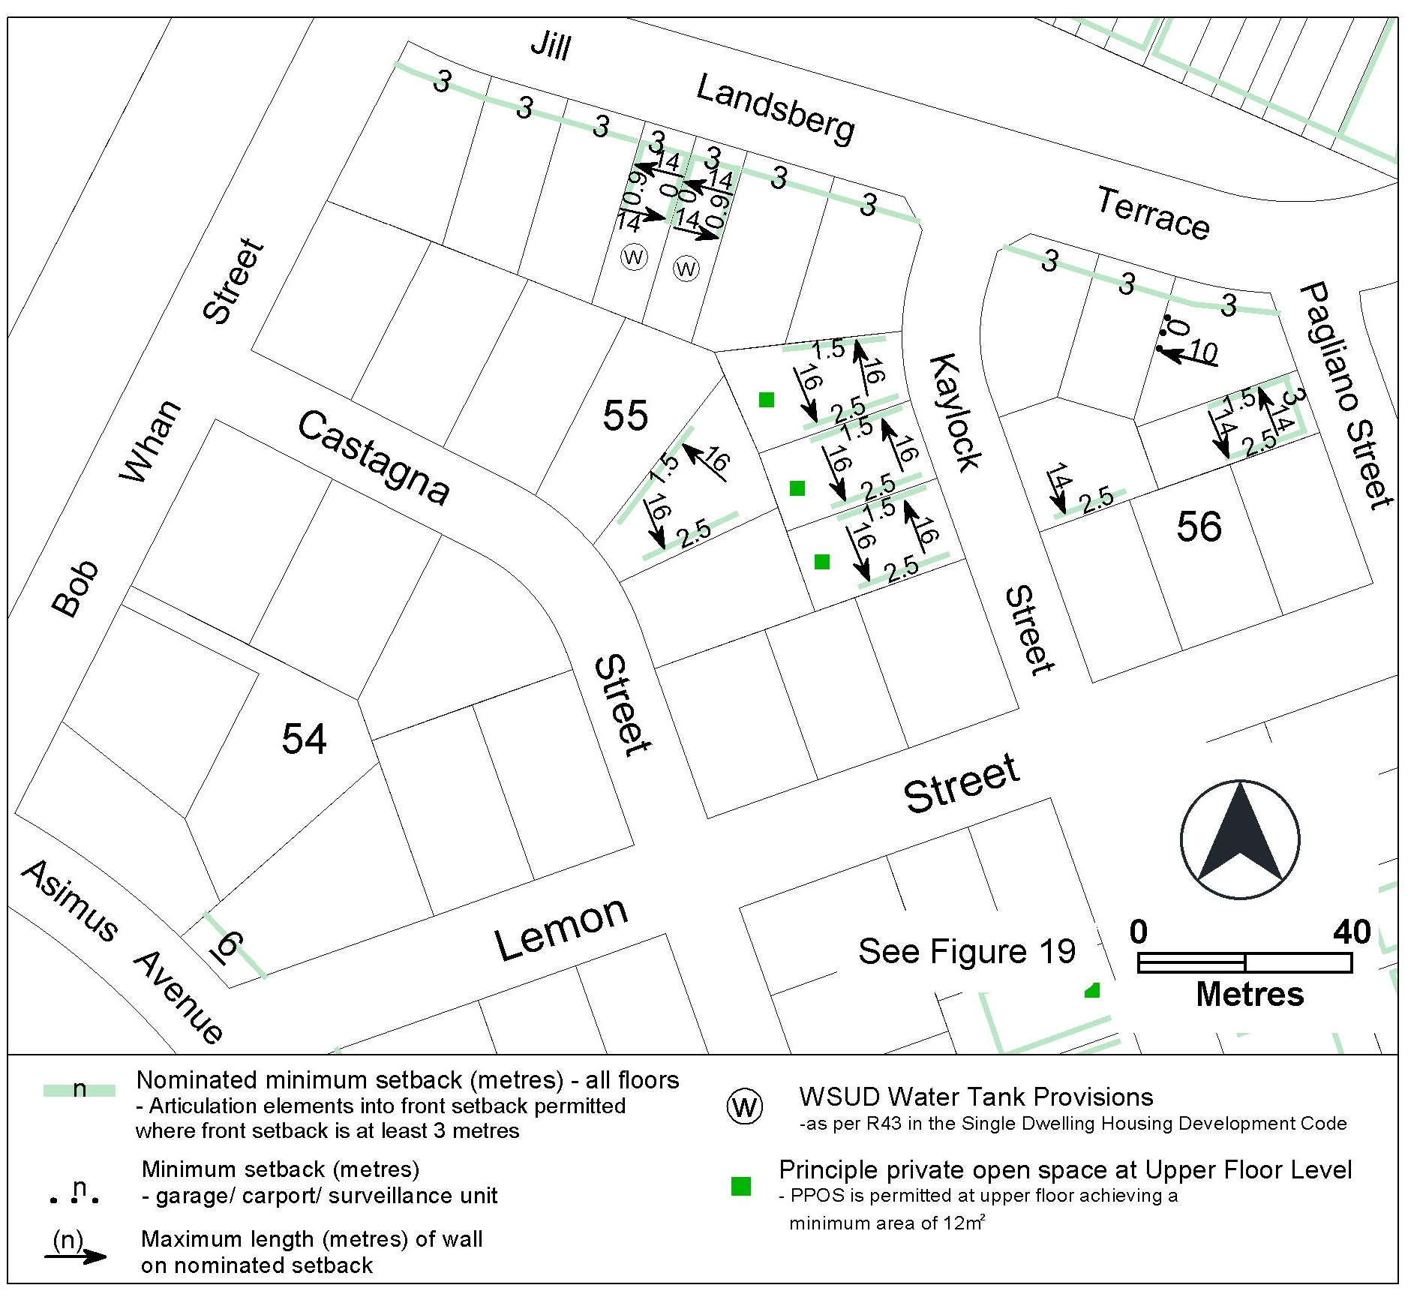

Current Figure 21 of the Strathnairn Precinct Map and Code

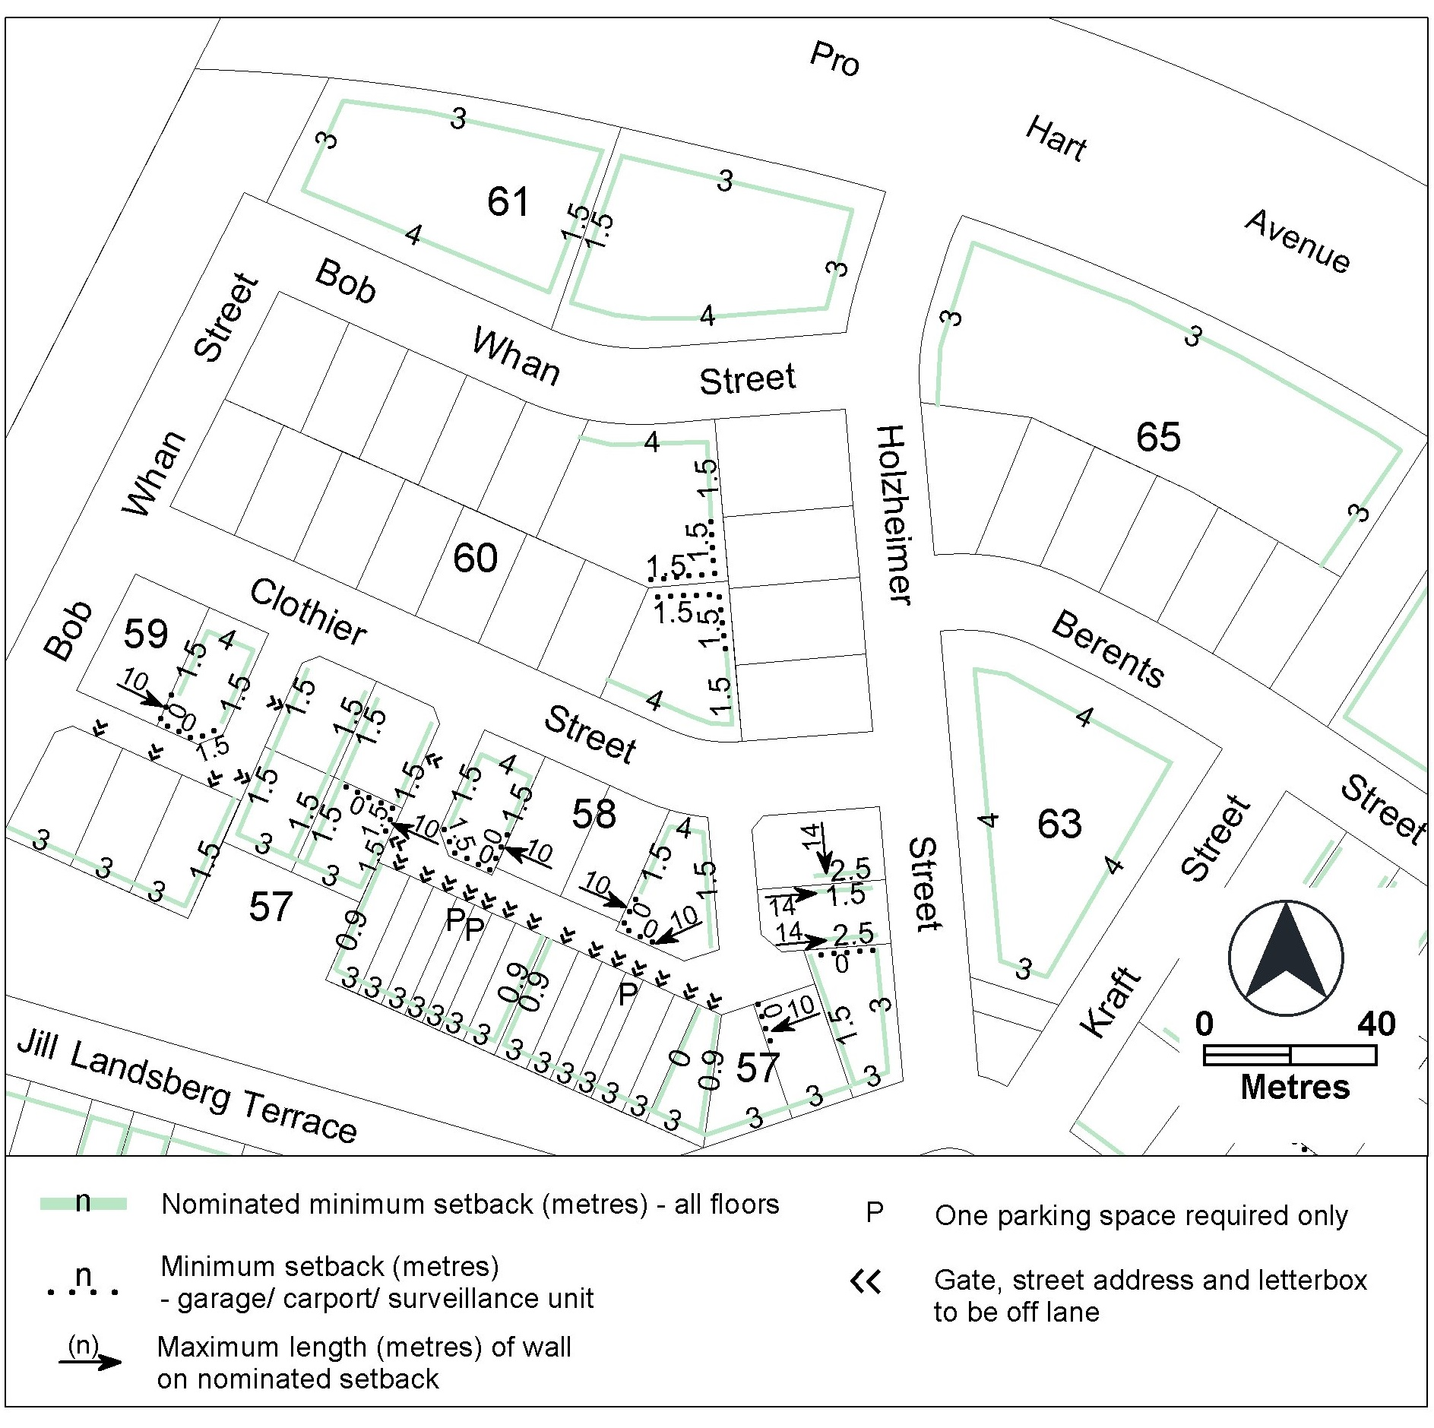

Changes to Figure 21 of the Strathnairn Precinct Map and Code

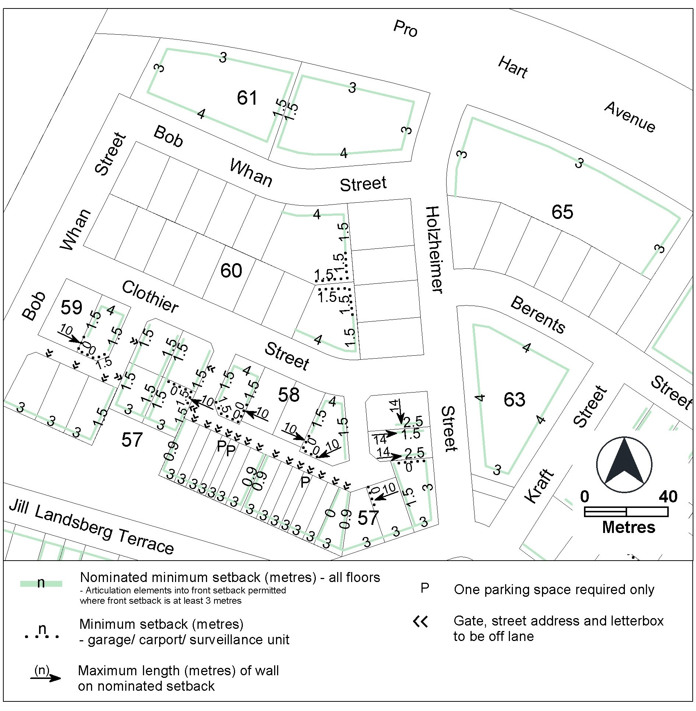

- TECHNICAL AMENDMENT
This section of the technical amendment document provides the actual instructions for implementing the changes to the Territory Plan.

  - Variation to the Single Dwelling Housing Development Code
- Element 5: Amenity, 5.1A Solar access – blocks which were approved on or after 5 July 2013, rule R37A

Substitute rule R37A with

Rules | Criteria
5.1A Solar access – blocks which were approved on or after 5 July 2013
R37A  This rule applies to blocks approved under an estate development plan on or after 5 July 2013 for:  a) new dwellings  b) additions and alterations, only if the addition or alteration affects:  i) habitable room (see 1 below)  ii) habitable room other than a bedroom (see 2 below)  1. Where the front boundary of the block is the northern boundary:  A habitable room is provided with a minimum of 4m² of transparent vertical glazing that:  a) is oriented between 45° east of north and 45° west of north; and  b) is not overshadowed at noon on the winter solstice (21 June) by buildings and structures on the subject block, excluding the eaves of the building.  2. For all other blocks:  A habitable room other than a bedroom is provided with a minimum of 4m² of transparent vertical glazing that:  - is oriented between 45° east of north and 45° west of north; and  - is not overshadowed at noon on the winter solstice (21 June) by:  i) buildings and structures on the subject block, excluding the eaves of the building  ii) the ‘solar fence’ on the northern boundary of the subject block.  For this rule:  - The height of the ‘solar fence’ is:  i) in the primary building zone – 3m  ii) all other parts of the boundary – 2.3m.  - A roofed outdoor area (e.g. an alfresco area) is not considered to be an eave.  Note: Compliance with this rule may be demonstrated through plans, elevations and supporting documentation (e.g. shadow diagrams) showing that the required minimum area of glazing is not overshadowed. | C37A  One or more daytime living areas is provided with reasonable access to direct sunlight between the hours of 9am and 3pm on the winter solstice (21 June).  For this criterion:  Daytime living area means a habitable room other than a bedroom.

  - Variation to the Strathnairn Precinct Map and Code
- Additional rules and criteria, RC1 – Residential Area, Figure 19 Strathnairn residential area 15

Substitute

Figure 19 Strathnairn residential area 15

- Additional rules and criteria, RC1 – Residential Area, Figure 20 Strathnairn residential area 16

Substitute

Figure 20 Strathnairn residential area 16

- Additional rules and criteria, RC1 – Residential Area, Figure 21 Strathnairn residential area 17

Substitute
Figure 21 Strathnairn residential area 17

Interpretation service
