Australian Capital Territory
Heritage (Decision about Registration of Yeddung Dhaura, Forde) Notice 2021
Notifiable instrument NI2021—550
made under the
Heritage Act 2004, s 40 (Decision about registration)

1 Name of instrument
This instrument is the Heritage (Decision about Registration of Yeddung Dhaura, Forde) Notice 2021.
2 Decision about registration
On 16 September 2021, the ACT Heritage Council (the Heritage Council) decided to register Yeddung Dhaura, Block 1 Section 111, Forde (the Place).
3 Registration details of the Place
The registration details of the Place are in the schedule.
4 Reasons for the decision
The Heritage Council is satisfied on reasonable grounds that the Place has heritage significance as it meets one or more of the heritage significance criteria in section 10 of the Heritage Act 2004. A detailed statement of reasons including an assessment against the heritage significance criteria is provided in the schedule.
5 Date registration takes effect
The registration of the Place takes effect on the day after this notice is notified.
6 Revocation
The Heritage (Decision about Provisional Registration of Yeddung Dhaura, Forde) Notice 2021 (NI2021—321) is revoked.

Edwina Jans
A/g Secretary (as delegate for)
ACT Heritage Council
16 September 2021

Schedule
See sections 3 and 4

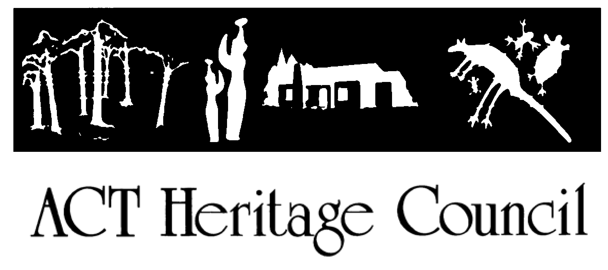
AUSTRALIAN CAPITAL TERRITORY HERITAGE REGISTER

(Registration)

For the purposes of s40 of the Heritage Act 2004, a provisional entry to the heritage register has been prepared by the ACT Heritage Council for the following place:

YEDDUNG DHAURA

BLOCK 1, SECTION 111, FORDE

DATE OF REGISTRATION
16 September 2021 Notifiable Instrument: 2021–
Copies of the Register Entry are available for inspection at ACT Heritage. For further information please contact: The Secretary
ACT Heritage Council GPO Box 158
CANBERRA ACT 2601
Telephone 13 22 81

This statement refers to the location of the place as required in s 12(b) of the Heritage Act 2004.

LOCATION OF THE PLACE

Yeddung Dhaura is contained in Block 1, Section 111, Forde.

This location is classified as urban open space. It is adjacent to several roadways and contains water quality control ponds, therefore pathways, signage and recreational infrastructure have been included in the area for public use. The conservation zone preserved 40% (2514 m²) of the known archaeological deposit in situ, including 86% of the deposit with greater than the average artefact incidence.

This statement refers to the description of the Place as required in s 12(c) of the Heritage Act 2004. The attributes described in this section form part of the heritage significance of the place. For the purposes of s12(c) of the Heritage Act 2004, the boundary of the place is at Image 1.

DESCRIPTION OF THE PLACE

Yeddung Dhaura, formerly known as Bonner Potential Archaeological Deposit 1 (BPAD1), is associated with sub- surface archaeological deposits. These contain artefacts of Aboriginal heritage, as such the place is relevant to the cultural history of the region and Aboriginal cultural values.

This statement refers to the heritage significance of the place as required in s12(d) of the Heritage Act 2004.

STATEMENT OF HERITAGE SIGNIFICANCE

The Yeddung Dhaura campsite is testament to traditional Aboriginal lifeways and the enduring cultural connection to the land of present-day Aboriginal peoples. The material remains demonstrate that the Place was a focal point of community activity in the Gungahlin region, returned to on numerous occasions in the past, and connected through the activities of the Aboriginal peoples to other locations in the landscape. Within the conservation area a substantial portion of remains have been preserved in situ and all previously excavated artefacts have been returned to country within the delineated area.

CONSERVATION OBJECTIVE

The guiding conservation objective is that Yeddung Dhaura shall be conserved and appropriately managed in a manner respecting its heritage significance.

The ACT Heritage Council may adopt heritage guidelines applicable to the place under s 25 of the Heritage Act 2004.

For further information on guidelines applicable to the place, or for advice on proposed works or development, please contact ACT Heritage on 13 22 81.

REASON FOR REGISTRATION

The Council has assessed Yeddung Dhaura, Forde against the heritage significance criteria and is satisfied that the place is likely to have heritage significance when assessed against criteria [a, b, c, d, and g] under s 10 of the Heritage Act 2004.

ASSESSMENT AGAINST THE HERITAGE SIGNIFICANCE CRITERIA

The Council’s assessment against the criteria specified in s 10 of the Heritage Act 2004 is as follows. In assessing the heritage significance of Yeddung Dhaura, Forde, the Council considered:
- the original nomination and documentary evidence supplied by the nominator;
- the Council’s Heritage Assessment Policy (March 2018);
- information provided by a site inspection on 27 April 2021 by ACT Heritage and Council representatives;
- information and comments received from consulting with Representative Aboriginal Organisations (RAOs) under s 31 of the Act;
- the report by ACT Heritage titled, Background Information Yeddung Dhaura, September 2021, containing photographs and information on history, description, condition and integrity; and

Pursuant to s 10 of the Heritage Act, a place or object has heritage significance if it satisfies one or more of the following criteria. Future research may alter the findings of this assessment.

importance to the course or pattern of the ACT’s cultural or natural history;

The Council has assessed Yeddung Dhaura against criterion (a) and is satisfied that the place is likely to meet this criterion.

The location, landscape setting and artefact assemblages relating to the Yeddung Dhaura site provide evidence for the traditional Aboriginal lifeways in the ACT that were disrupted by colonisation. The place is a campsite located close to the headwaters of Ginninderra Creek. Ginninderra Creek is a pathway known to have been used by Aboriginal people and its significance is linked to a number of prominent locations, both in the immediate area as well as downstream. With its proximity to several known stone and ochre sources, the broader area surrounding Yeddung Dhaura was a regional location for the collection of resources. The Place has one of the highest concentrations of excavated stone artefacts in the ACT. Aboriginal peoples returned to this Place on multiple occasions possibly using it as an itinerant campsite when collecting resources and moving in the cultural corridor along the Ginninderra Creek pathway nearby.

has uncommon, rare or endangered aspects of the ACT’s cultural or natural history;

The Council has assessed Yeddung Dhaura against criterion (b) and is satisfied that the place is likely to meet this criterion.

The in situ nature of the remains within the landscape and relatively high density of the stone remnants contained therein make the Yeddung Dhaura assemblage uncommon, with regards to other stone artefact scatters in the ACT. These attributes demonstrate that this area was a focal point for Aboriginal cultural activities in the ACT.

potential to yield important information that will contribute to an understanding of the ACT’s cultural or natural history;

The Council has assessed Yeddung Dhaura against criterion (c) and is satisfied that the place is likely to meet this criterion.

As a result of proposed developmental impacts, Yeddung Dhaura was partially excavated and analysed. These activities helped establish its importance as a campsite. However, a substantial portion of the site has been preserved in situ. Therefore, future research could potentially reveal new information regarding Aboriginal land use and connections across the broader landscape.

importance in demonstrating the principal characteristics of a class of cultural or natural places or objects;

The Council has assessed Yeddung Dhaura against criterion (d) and is satisfied that the place is likely to meet this criterion.

Yeddung Dhaura is a notable example of Aboriginal campsites in the ACT. It is one of only a few known archaeological artefact assemblages in this region with comparably high artefact densities, which implies the relative intensity of Aboriginal presence, and the only one located in proximity to the headwaters of the Ginninderra Creek pathway. Much of the site has been preserved in situ within the nominated area meaning that it is far more intact than other known campsites containing high densities of artefacts, such as Pialligo or Macgregor West.

importance in exhibiting particular aesthetic characteristics valued by the ACT community or a cultural group in the ACT;

The Council has assessed Yeddung Dhaura against criterion (e) and is not satisfied that the place is likely to meet this criterion.

There are no known aesthetic characteristics associated with the significance of this place.

importance in demonstrating a high degree of creative or technical achievement for a particular period;

The Council has assessed Yeddung Dhaura against criterion (f) and is not satisfied that the place is likely to meet this criterion.

Although this place is a good example of campsites in the ACT, the artefact collection is fairly typical of material objects that are found in many other known Aboriginal campsites. The significance of the site lies not in the creative and technical achievement of the artefacts contained therein, but rather in their density, intactness and location.

has a strong or special association with the ACT community, or a cultural group in the ACT for social, cultural or spiritual reasons;

The Council has assessed Yeddung Dhaura against criterion (g) and is satisfied that the place is likely to meet this criterion.

The in situ preservation of material artefacts within this place is significant to the Aboriginal community for the role for demonstrating an enduring physical record and spiritual connection with the traditional Aboriginal way of life, since disrupted by colonisation. Although the precise location of the artefacts was not known to the Aboriginal community prior to the archaeological works they are in fact evidence of a known attachment to this region for the collection of resources and pathways of movement along Ginninderra Creek. Once identified, the preservation of this locality became a priority for the Aboriginal community, who also advocated strongly for a return

to country of the excavated artefacts in order to maintain the on-going social, cultural and spiritual associations to this place in perpetuity.

has a special association with the life or work of a person, or people, important to the history of the ACT.

The Council has assessed Yeddung Dhaura against criterion (h) and is not satisfied that the place is likely to meet this criterion.

There are no known associations between this place and specific achievements of an Aboriginal person or people.

SITE PLAN

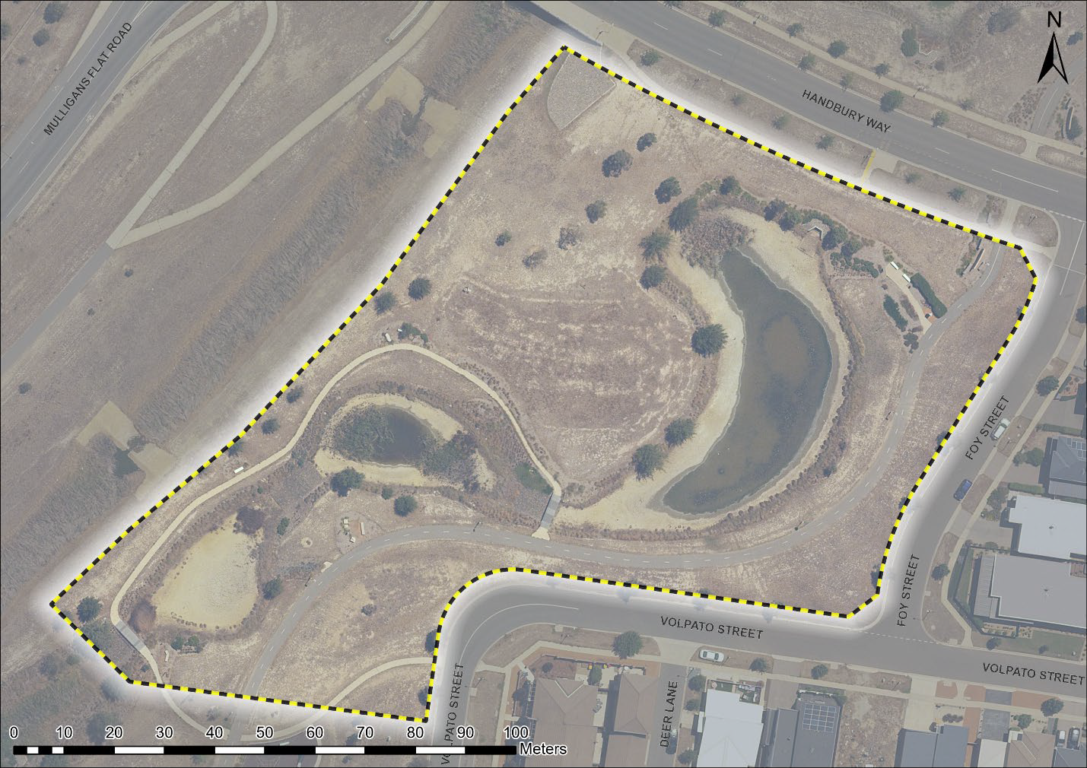

Image 1 Yeddung Dhaura site boundary

