Australian Capital Territory
Heritage (Decision about Provisional Registration of Ashton Homestead, Belconnen) Notice 2021
Notifiable instrument NI2021–675
made under the
Heritage Act 2004, s 34 (Notice of decision about provisional registration)

1 Name of instrument
This instrument is the Heritage (Decision about Provisional Registration of Ashton Homestead, Belconnen) Notice 2021.
2 Decision about provisional registration
On 11 November 2021, the ACT Heritage Council (the Heritage Council) decided not to provisionally register Ashton Homestead, Rural Block 1438, Belconnen (the Place).
3 Description of the Place
The description of the Place is in the schedule.
4 Reasons for the decision
The Heritage Council is not satisfied on reasonable grounds that the Place is likely to have heritage significance as defined by section 10 of the Heritage Act 2004. A detailed statement of reasons, including an assessment against the heritage significance criteria, is provided in the schedule.
5 Date decision takes effect
The decision not to provisionally register the Place takes effect on 12 November 2021 (being the day after the Heritage Council made its decision in writing as set out in the schedule).

Edwina Jans
A/g Secretary (as delegate for)
ACT Heritage Council
11 November 2021

STATEMENT OF REASONS
DECISION NOT TO PROVISIONALLY REGISTER
ASHTON HOMESTEADWamboinName of Place
RURAL BLOCK 1438, BELCONNEN
IN THE ACT HERITAGE REGISTER

In accordance with s 32 of the Heritage Act 2004, the ACT Heritage Council has decided not to provisionally register Ashton Homestead, Belconnen. This Statement of Reasons provides an assessment of Ashton Homestead, Belconnen, and finds that the place does not meet any of the criteria under s 10 of the Heritage Act 2004.

This statement refers to the location of the place as required in s 34 (5) (b) (ii) of the Heritage Act 2004.
LOCATION OF THE PLACE

Ashton Homestead is located within Rural Block 1438, Belconnen.

The location, on the lower slopes of the Mt Painter Nature Reserve, is on public lands associated with the nature reserve. The homestead ruins are situated within a paddock that is currently leased for horse agistment. Immediately to the south and west of the location is a belt of trees.

This section refers to the description of the place as required in s 34 (5) (b) (iii) of the Heritage Act 2004. The boundary of the place and extent of features listed below is illustrated at Image 1.

DESCRIPTION OF THE PLACE

Ashton Homestead, also known as Round Hill Homestead, consisting of the following attributes:
- Stone rubble associated with the walls and foundations of the former homestead.

This statement refers to the Council’s reasons for its decision as required in s 34 (5) (b) (iv) of the Heritage Act 2004.
REASONS FOR DECISION

The Council is not satisfied on reasonable grounds that the place is likely to have heritage significance as defined by s10 of the Heritage Act 2004.

This statement refers to the Council’s assessment of the place against the heritage significance criteria as a part of its reasons for its decision as required in s 34 (5) (b) (v) of the Heritage Act 2004.
ASSESSMENT AGAINST THE HERITAGE SIGNIFICANCE CRITERIA

The Council’s assessment against the criteria specified in s 10 of the Heritage Act 2004 is as follows.

In assessing the heritage significance of Ashton Homestead, Belconnen, the Council considered:
- the original nomination and documentary evidence supplied by the nominator;
- the Council’s Heritage Assessment Policy (March 2018);
- information provided by a site inspection on 20 May and 13 July 2021 by ACT Heritage and Council; and
- the report by ACT Heritage titled, Background Information Ashton Homestead, November 2021, containing photographs and information on history, description, condition and integrity; and

Pursuant to s 10 of the Heritage Act 2004, a place or object has heritage significance if it satisfies one or more of the following criteria. Future research may alter the findings of this assessment.
- importance to the course or pattern of the ACT’s cultural or natural history;
The Council has assessed Ashton Homestead against criterion (a) and is not satisfied that the place meets this criterion.
Ashton Homestead is located on land purchased by Donald McDonald under the provisions of the Robinson Land Acts. It was probably built in 1870/1. However, it is not clear exactly who resided at the property or for how long they were resident. It is claimed that Donald McDonald was involved in dummying of land for other purchasers, which complicates the interpretation of the land ownership. However, this may not be relevant to Ashton homestead and the land on which it is located as historical documents show these were later owned by his son, Roderick McDonald. While Ashton homestead was associated with patterns of rural land use and vernacular building techniques used by European settlers during the second half of the nineteenth century, there is insufficient physical fabric remaining to demonstrate relevance to the course or pattern of the ACT’s cultural or natural history.
Neither the standing structure nor the full extent of the original floor plan is visible. Furthermore, the lack of any materials other than stone on the surface and the fact that there are no plantings or other landscape elements around the remains would appear to indicate that the site was cleared and materials removed at some point in the past.
- has uncommon, rare or endangered aspects of the ACT’s cultural or natural history;
The Council has assessed Ashton Homestead against criterion (b) and is not satisfied that the place meets this criterion.
Ashton Homestead is in a highly ruinous state that retains little resemblance to the original standing structure. Consequentially, there is no evidence for uncommon, rare or endangered aspects of the ACT’s cultural heritage evident in the physical fabric of the place
There are numerous examples of small nineteenth century rural ruins or standing structures similar to Ashton Homestead, scattered throughout the ACT and surrounding region. Some of these are very well-documented and others less so making a comprehensive comparative analysis difficult. That said, there are several ruins of stone buildings built by small-holders already included on the Heritage Register, including Crinigan’s Hut, The Valley, Gungaderra, and Greenhills Ruin. In contrast to Ashton Homestead, and in spite of their ruinous state, these examples generally include evidence for the cultural history of the ACT within the fabric of the homestead or other associated physical remains.
- potential to yield important information that will contribute to an understanding of the ACT’s cultural or natural history;
The Council has assessed Ashton Homestead against criterion (c) and is not satisfied that the place meets this criterion.
While the potential for sub-surface preservation of cultural materials at Ashton homestead is possible, the ruined condition of the building and the lack of any materials on the surface other than stone, suggests that the site is unlikely to contribute any information of value to further understanding the historical context. Although there is potential that archaeological remains exist there is no indication available to us at this time that this information could expand or contribute new data to the current information regarding 19th Century settlers in colonial NSW. It seems likely that any evidence that does remain would merely provide a further example of the material culture typical of European domestic settlement at that time. However, the material culture from this period is better represented by other sites and collections, such as the registered assemblage retrieved from Crinigan’s Hut Ruin. In contrast to the conditions that can be observed at Ashton, that collection was extensive and varied thus providing important new evidence of the everyday lives of people in the pre-Federal Capital era of the region.
- importance in demonstrating the principal characteristics of a class of cultural or natural places or objects;
The Council has assessed Ashton Homestead against criterion (d) and is not satisfied that the place meets this criterion.
Ashton Homestead is not important in demonstrating the principal characteristics of 19th Century vernacular stone architecture built by European settlers, owing to significant deterioration of the structure. Apart from the stone rubble nothing else remains of the homestead. There are no outbuildings or exotic plantings evident that are relatively common to homesteads of that age.
There are many better and more intact examples of stone homesteads located in the ACT the appear on the ACT or Commonwealth Heritage Registers, including: Woden Homestead, Duntroon House, Duntroon Dairy, some buildings within the Lanyon homestead complex, some buildings within the Tuggeranong homestead complex, The Oaks, Mugga Mugga, Blundell’s Cottage, the stone cottage associated with Horse Park Homestead, some buildings associated with Booroomba Station including Blythburn, and Belconnen Farm. Remains of stone buildings built by small-holders within the provisions of the Robertson Land Acts, mostly exist in a ruinous state. However, some examples that retain features of heritage significance including: Crinigan’s Hut, The Valley, Gungaderra, and Greenhills Ruin.
- importance in exhibiting particular aesthetic characteristics valued by the ACT community or a cultural group in the ACT;
The Council has assessed Ashton Homestead against criterion (e) and is not satisfied that the place meets this criterion.

There is no evidence before the Council indicating the community or a cultural group in the ACT values any extant aesthetic qualities of the Ruin. Although the Mt Painter Nature Reserve is publicly accessible and the location of Ashton Homestead is visible from some walking areas, the ruined state of the building means that few people would realise that it is a former homestead. It is difficult to find, obscured by long grass and located in fields used for horse agistment. The ruinous state of the remains obscures significant aesthetic characteristics that the building may once have possessed.
- importance in demonstrating a high degree of creative or technical achievement for a particular period;
The Council has assessed Ashton Homestead against criterion (f) and is not satisfied that the place meets this criterion.
The ruined state of the Ashton Homestead means that there is insufficient physical evidence to demonstrate technical achievement. Stone huts utilising locally available resources were relatively commonly built by 19th Century European settlers. Moreover, the vernacular architecture tended to be of fairly simple design and, while resourceful for the time period, there is no indication that it included significant examples of creative or technical achievements.
- has a strong or special association with the ACT community, or a cultural group in the ACT for social, cultural or spiritual reasons;
The Council has assessed Ashton Homestead against criterion (g) and is not satisfied that the place meets this criterion.
There is no evidence before the Council suggesting a strong or special association between Ashton Homestead and the ACT Community or a cultural group in the ACT. Although it could potentially be argued that Ashton Homestead was significant to the local community in Wanniassa, for inclusion in the Heritage Register, the ACT community is taken to encompass the broad community of the ACT, across the full geographical context, and broad spectrum of society. Moreover, the attachment of the ACT community to the place must be demonstrable and enduring which is not evident in the case of Ashton Homestead.
- has a special association with the life or work of a person, or people, important to the history of the ACT.
The Council has assessed Ashton Homestead against criterion (h) and is not satisfied that the place meets this criterion.
Donald McDonald and his family can be associated with this property through land records and other historical records. However, the information is fragmentary. There is no evidence that suggests that this family shaped or influenced the pattern of development or the course of the history of the ACT to a degree significant enough to meet this criterion.

SITE PLAN

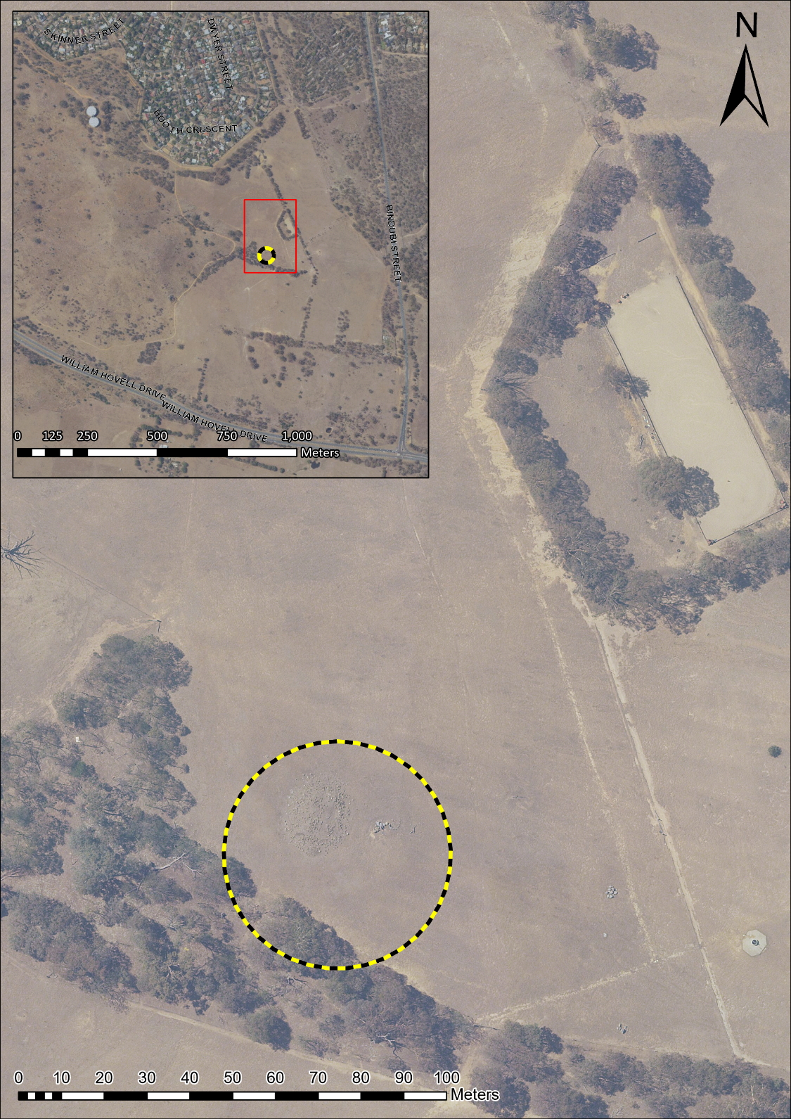
Image 1 Ashton Homestead site boundary

