Australian Capital Territory
Heritage (Decision about Provisional Registration of Former Kingston Post Office, Kingston) Notice 2022
Notifiable instrument NI2022–185
made under the
Heritage Act 2004, s 34 (Notice of decision about provisional registration)

1 Name of instrument
This instrument is the Heritage (Decision about Provisional Registration of Former Kingston Post Office, Kingston) Notice 2022.
2 Commencement
This instrument commences on the day after its notification day.
3 Decision about provisional registration
On 7 April 2022, the ACT Heritage Council (the Heritage Council) decided to provisionally register Former Kingston Post Office, block 21, section 22, Kingston (the Place).
4 Registration details of the Place
The registration details of the Place are in the schedule.
5 Reasons for the decision
The Heritage Council decided to provisionally register the Place because it is satisfied on reasonable grounds that it is likely to have heritage significance as it is likely to meet one or more of the heritage significance criteria in section 10 of the Heritage Act 2004 (the Act). A detailed statement of reasons, including an assessment against the heritage significance criteria, is provided in the schedule.
6 Date of provisional registration
The date of provisional registration is 8 April 2022.
7 Indication of the Heritage Council’s intention
The Heritage Council intends to decide whether to register the Place under division 6.2 of the Act during the period of provisional registration.
8 Invitation to make written comments during public consultation period
(1) The Heritage Council invites written comments about the registration of the Place. Any written comments must be made within 4 weeks after the day this notice is notified.
(2) Written comments can be provided to the Heritage Council by the following methods:
(a) mail to
The Secretary
ACT Heritage Council
GPO Box 158
CANBERRA ACT 2601
(b) email to heritage@act.gov.au
(c) via the consultation website at www.yoursay.act.gov.au.

Edwina Jans
A/g Secretary (as delegate for)
ACT Heritage Council
7 April 2022

Schedule

(See sections 3 and 4)

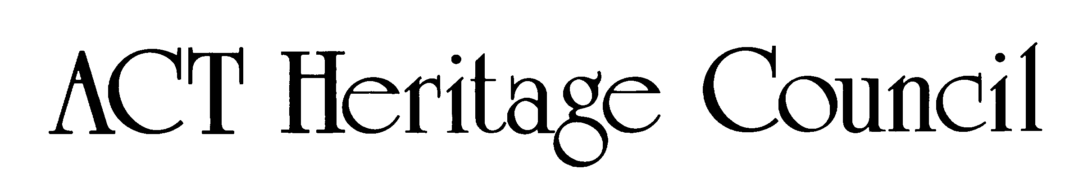
AUSTRALIAN CAPITAL TERRITORY
HERITAGE REGISTER
(Provisional Registration)

For the purposes of s 33 of the Heritage Act 2004, a provisional entry to the heritage register has been prepared by the ACT Heritage Council for the following place:

Former Kingston Post Office

Block 21, Section 22, Kingston
DATE OF DECISION
7 April 2022
DATE OF PROVISIONAL REGISTRATION
8 April 2022 Notifiable Instrument: 2022–
PERIOD OF EFFECT OF PROVISIONAL REGISTRATION
Start Date: 8 April 2022 End Date: 7 September 2022

Copies of the Register Entry are available for inspection at ACT Heritage. For further information please contact:

The Secretary

ACT Heritage Council

GPO Box 158

CANBERRA ACT 2601

Telephone 13 22 81

This statement refers to the location of the place as required in s 12 (b) of the Heritage Act 2004.
LOCATION OF THE PLACE

Former Kingston Post Office, Block 21, Section 22.

19 Jardine Street/82 Giles Street, Kingston.

This statement refers to the description of the place as required in s 12 (c) of the Heritage Act 2004. The attributes described in this section form part of the heritage significance of the place. For the purposes of s 12 (c) of the Heritage Act 2004, the boundary of the place is at Image 1.
DESCRIPTION OF THE PLACE

Former Kingston Post Office, consisting of the following attributes:
- The original Kingston Post Office Building:
  - Punchbowl orange facebrick
  - Cream tiles around major openings, windows and roof line
  - Vent grilles and downpipe heads, consistent with the Kingston Shopping Precinct
  - Inter-war stripped classical overall design with minor art deco embellishments, including:
    - Elements arranged symmetrically;
    - Cylindrical mullions used in the main window, alluding to vestigial classical columns and emphasising verticality;
    - Stepped end bay along the building’s western external wall implying a classical portico;
    - Ornamental metal windows;
    - Coloured glazed terracotta (faience) facing; and,
    - Low relief ornamental details.
  - Scale and massing of the original single storey form
  - The flagpole, either in its current position above the entrance or in its original position extending horizontally from top of the center of the western facade
  - Evidence of the rear wraparound driveway for postal vehicles.

This statement refers to the heritage significance of the place as required in s 12 (d) of the Heritage Act 2004.
STATEMENT OF HERITAGE SIGNIFICANCE

The Former Kingston Post Office from 1947 is significant for its strong associations with the post-World War II development of Canberra, and for its Inter War Stripped Classical style with Art Deco details.

The Former Kingston Post Office building is situated on the corner of Jardine and Giles Streets and adjacent to the Kingston Shopping Centre. While an earlier post office existed in Kingston from the 1920s, with increasing demand the government planned and built the 1947 Kingston Post Office Building. It was also the first official post office constructed in Canberra after the Second World War and operated until 1989. The Former Kingston Post Office was the most important post office outlet for business and for residents of south Canberra during the urban development of the capital, and in particular the post-World War II period. It is the oldest surviving suburban post office building designed for the federal capital.

The 1947 building is a notable example of a building in the Inter-War Stripped Classical Style with Art Deco details. Following the principles of the style, the building features components of symmetrical planning; for example, the corner porches that are placed equidistantly around a central space. The mullions of the large window along the western wall are cylindrical in form, alluding to vestigial classical columns and also emphasise verticality, while the stepped end bay along the building’s western external wall implies a classical portico. The building is decorated with ornamental windows, extensively uses coloured glazed terracotta (faience) facing, and low relief ornamental detail. These are all principal components of the Art Deco Style. Details such as vent grilles and downpipe heads are of an attractive design consistent with the style of the building.

Since its construction, the building has undergone sympathetic renovation, upholding the integrity of the place.
CONSERVATION OBJECTIVE

The guiding conservation objective is that Former Kingston Post Office shall be conserved and appropriately managed in a manner respecting its heritage significance.

The ACT Heritage Council may adopt heritage guidelines applicable to the place under s 25 of the Heritage Act 2004.

For further information on guidelines applicable to the place, or for advice on proposed works or development, please contact ACT Heritage on 13 22 81.
REASON FOR PROVISIONAL REGISTRATION

The Council has assessed the Former Kingston Post Office, Kingston against the heritage significance criteria and is satisfied that the place is likely to have heritage significance when assessed against criterion (a) under s 10 of the Heritage Act 2004.
ASSESSMENT AGAINST THE HERITAGE SIGNIFICANCE CRITERIA

The Council’s assessment against the criteria specified in s 10 of the Heritage Act 2004 is as follows.

In assessing the heritage significance of Former Kingston Post Office, Kingston, the Council considered:
- The original nomination and documentary evidence supplied by the nominator(s) for the Kingston Post Office;
- The Council’s Heritage Assessment Policy (March 2018);
- Information provided by site inspections on 11 September 2019 by ACT Heritage; and
- The report by ACT Heritage titled, Background Information Former Kingston Post Office, April 2022, containing photographs and information on history, description, condition and integrity.

Pursuant to s 10 of the Heritage Act 2004, a place or object has heritage significance if it satisfies one or more of the following criteria. Future research may alter the findings of this assessment.
importance to the course or pattern of the ACT’s cultural or natural history;
The Council has assessed Former Kingston Post Office against criterion (a) and is satisfied that the place is likely to meet this criterion.
The Kingston Shopping Precinct was the first shopping precinct developed for the ACT and was the premier shopping destination in the new capital for many decades, providing a central hub for services, socialising and business development in Canberra. The Former Kingston Post Office was integral to the success of businesses in the Precinct as well as an effective drawcard service to attract people to the area.
The Former Kingston Post Office was the most important outlet for business and residents for South Canberra during the post-war period. In a time of economic recovery, the Kingston area, including the Precinct and the surrounding industrial areas, was one of the main business centres in the ACT and there was a high reliance on the Former Kingston Post Office for delivering and receiving orders, invoices, cheques, legal documents, and various other forms and services that businesses of the day depended on. The high-quality building was the NSW Post Master General’s first significant investment since the start of WWII. The commitment of resources and faith in its establishment of significant services in the ACT is demonstrated in the stripped-classical style of architecture and the solid building material of brick and concrete. The high-quality build is an important contribution to the character of the area recognised by the NCDC stipulating that the rest of the Jardine Street Banking and Commercial Row had to use the same Punchbowl Orange brick as the Post Office as one of the key unifying features.
has uncommon, rare or endangered aspects of the ACT’s cultural or natural history;
The Council has assessed Former Kingston Post Office against criterion (g) and is satisfied that the place is not likely to meet this criterion.
The Former Kingston Post Office is not considered to be uncommon, rare or endangered as a post office, a stripped classical building, or as a government building. All of these types are represented across the ACT and from a wide range of dates.
potential to yield important information that will contribute to an understanding of the ACT’s cultural or natural history;
The Council has assessed Former Kingston Post Office against criterion (g) and is satisfied that the place is not likely to meet this criterion.
As a well-documented built place, it is unlikely that any new information will be garnered from the material fabric of the place that would be considered a significant contribution to our existing knowledge. The Former Kingston Post Office does not have the potential to yield important information that will contribute to an understanding of the ACT’s cultural history.
importance in demonstrating the principal characteristics of a class of cultural or natural places or objects;
The Council has assessed Former Kingston Post Office against criterion (g) and is satisfied that the place is not likely to meet this criterion.
The Former Kingston Post Office is not considered to demonstrate the principal characteristics of a post office as all of these functions have now moved into the new extension and the original post office section retains no evidence of its past use. As a type of architecture, it does demonstrate the principal characteristics of the Inter-War Stripped Classical style with its symmetrical massing and classical composition with a minimum of classical motifs and Art Deco decorative elements; however, as a late and relatively small example of this kind, it is not considered to be important for demonstrating these characteristics. The post office compares to other examples of the Inter-War Stripped Classical Style including the Former Institute of Anatomy and Robert Garran Offices, formerly the Patent Office, Barton. However, it is a later and much smaller example. Also, these other examples are under Commonwealth planning control. The Former Kingston Post Office does not meet the thresholds for inclusion under this criterion as either a post office or an example of the Inter-War Stripped Classical style of architecture.
importance in exhibiting particular aesthetic characteristics valued by the ACT community or a cultural group in the ACT;
The Council has assessed Former Kingston Post Office against criterion (g) and is satisfied that the place is not likely to meet this criterion.
Whilst the Council recognises that the Former Kingston Post Office Building is an example of the Inter-War Stripped Classical Style with Art Deco characteristics, there is insufficient evidence before the Council at this time to indicate that this exhibits outstanding design or aesthetic qualities that are valued by the community or a cultural group. It does contribute to the character of the Kingston Shopping Precinct and may be further referenced in a decision for the Precinct.
importance in demonstrating a high degree of creative or technical achievement for a particular period;
The Council has assessed Former Kingston Post Office against criterion (g) and is satisfied that the place is not likely to meet this criterion.
The Former Kingston Post Office was built in a solid, standard, method of construction for its time. It is a brick and timber frame construction. Its design includes provision for movement and loading of postal vehicles, although these features have not been retained in the extant structure of the original building. While the stripped classical design testifies to its government origins, there is nothing that distinguishes it as a post office or shows any achievement beyond being a well-made, solid building. This means that it is of a standard design for its time and cannot be considered to demonstrate a high degree of creative or technical achievement for its time.

has a strong or special association with the ACT community, or a cultural group in the ACT for social, cultural or spiritual reasons;
The Council has assessed Former Kingston Post Office against criterion (g) and is satisfied that the place is not likely to meet this criterion.
In its heyday, the Former Kingston Post Office had an important role to play in supporting businesses and attracting shoppers to the Kingston Shopping Precinct, which was the premier shopping destination in the ACT in the period immediately after WWII. As such it would certainly have had a strong and special association with the ACT community at that time, but as the city has expanded, the Precinct has been relegated to a smaller role servicing its local neighbourhood. This smaller, local role is consistent with the original planning intention. As a consequence of the local role of both the precinct and the Post Office today, the latter has not maintained a strong or special association to the broader ACT community.
has a special association with the life or work of a person, or people, important to the history of the ACT.
The Council has assessed Former Kingston Post Office against criterion (h) and is satisfied that the place is not likely to meet this criterion.
The Former Kingston Post Office building is associated with the urban development of the ACT immediately following the end of World War II, the National Capital Planning and Development Committee (the NCPDC) and Australia Post.
The Former Kingston Post Office was built in 1947 as Canberra’s first permanent post-war post office. Its predecessor had been located in one of the shops in the Precinct along Giles Street, and before that, the first post office in the Kingston area had opened in 1918 at Eastlake, near to the power station. Development in the ACT was severely restricted during the 1930s and the early years of the Second World War. After the war’s end, the Former Kingston Post Office Building was the first official permanent post office constructed in the ACT. While it was not the first post office established, it is the earliest remaining post-FCT post office and was the first significant post-war project for the NSW Post Master General, making it a testament to the faith in the importance of the developing capital. The building was planned and to process increasing business transactions in the inner south of the city. The Former Kingston Post Office was the most important post office outlet for business and for residents of south Canberra during the urban development of the capital, and in particular the post-World War II period.

SITE PLAN

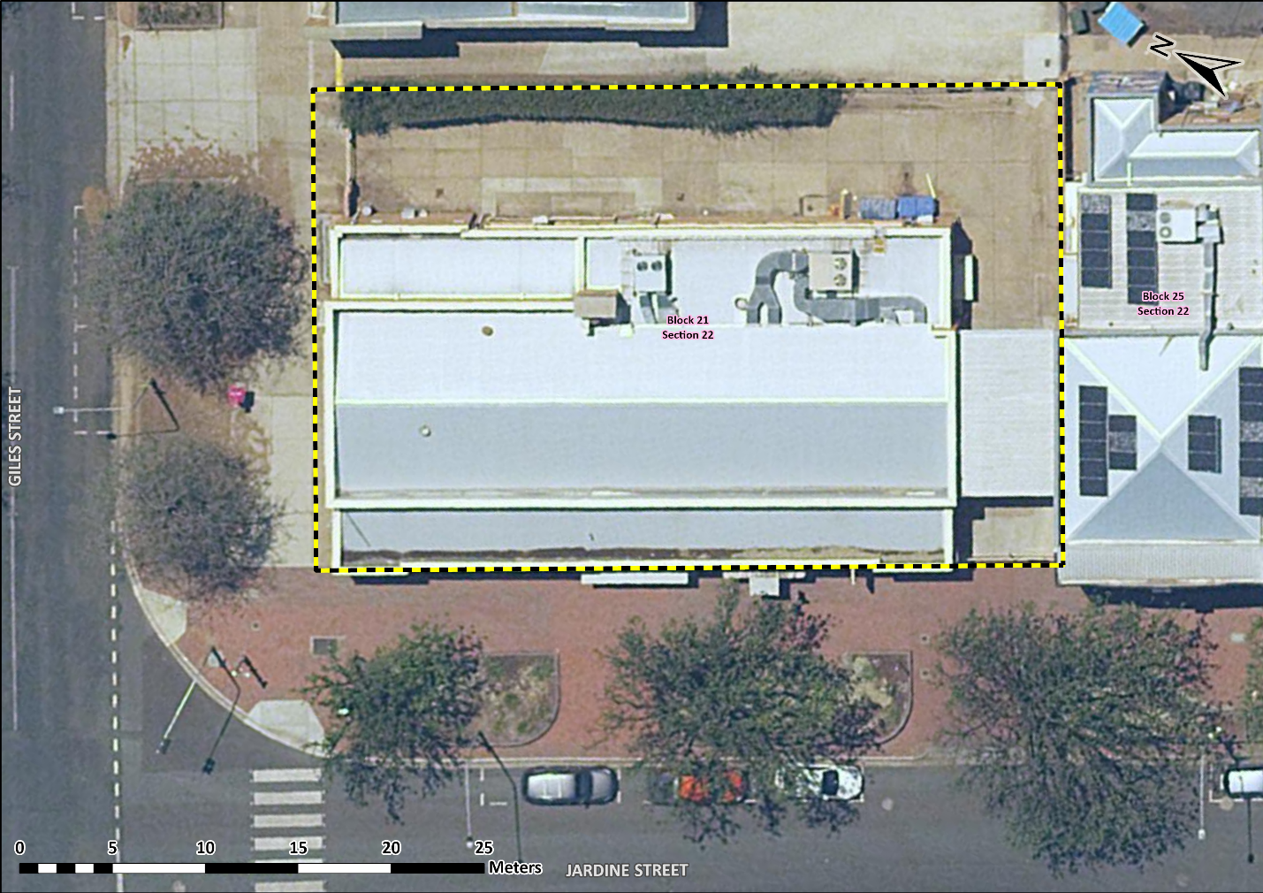
Image 1 Former Kingston Post Office site boundary

