Australian Capital Territory

Nature Conservation (Closed Reserves – Namadgi National Park and Lower Cotter Catchment Reserve) Declaration 2022

Notifiable instrument NI2022–252
made under the
Nature Conservation Act 2014, s 259 (Conservator may close reserve)

1 Name of instrument
This instrument is the Nature Conservation (Closed Reserves – Namadgi National Park and Lower Cotter Catchment Reserve) Declaration 2022.

2 Commencement
This instrument commences on 16 May 2022.

3 Declaration
(1) I declare that public access to those parts of Namadgi National Park indicated in the maps at schedule 1 is prohibited.
Note A second substantial section of Namadgi National Park and the adjoining Bimberi Wilderness Area will also be closed during some of the period of this closure.
(2) I declare that public access to those parts of Lower Cotter Catchment Reserve indicated in the map at schedule 2 is prohibited.

4 Exceptions
Section 3 does not apply to:
- a conservation officer exercising a function under the Act within the areas declared under section 3 (closed reserves); or
- any person accompanied by a conservation officer; or
- a contractor undertaking works within the closed reserves and engaged by the ACT Government to do so.
Ian Walker
Conservator of Flora and Fauna

5 May 2022
Schedule 1 Area of Namadgi National Park closed to public access

(see s 3)
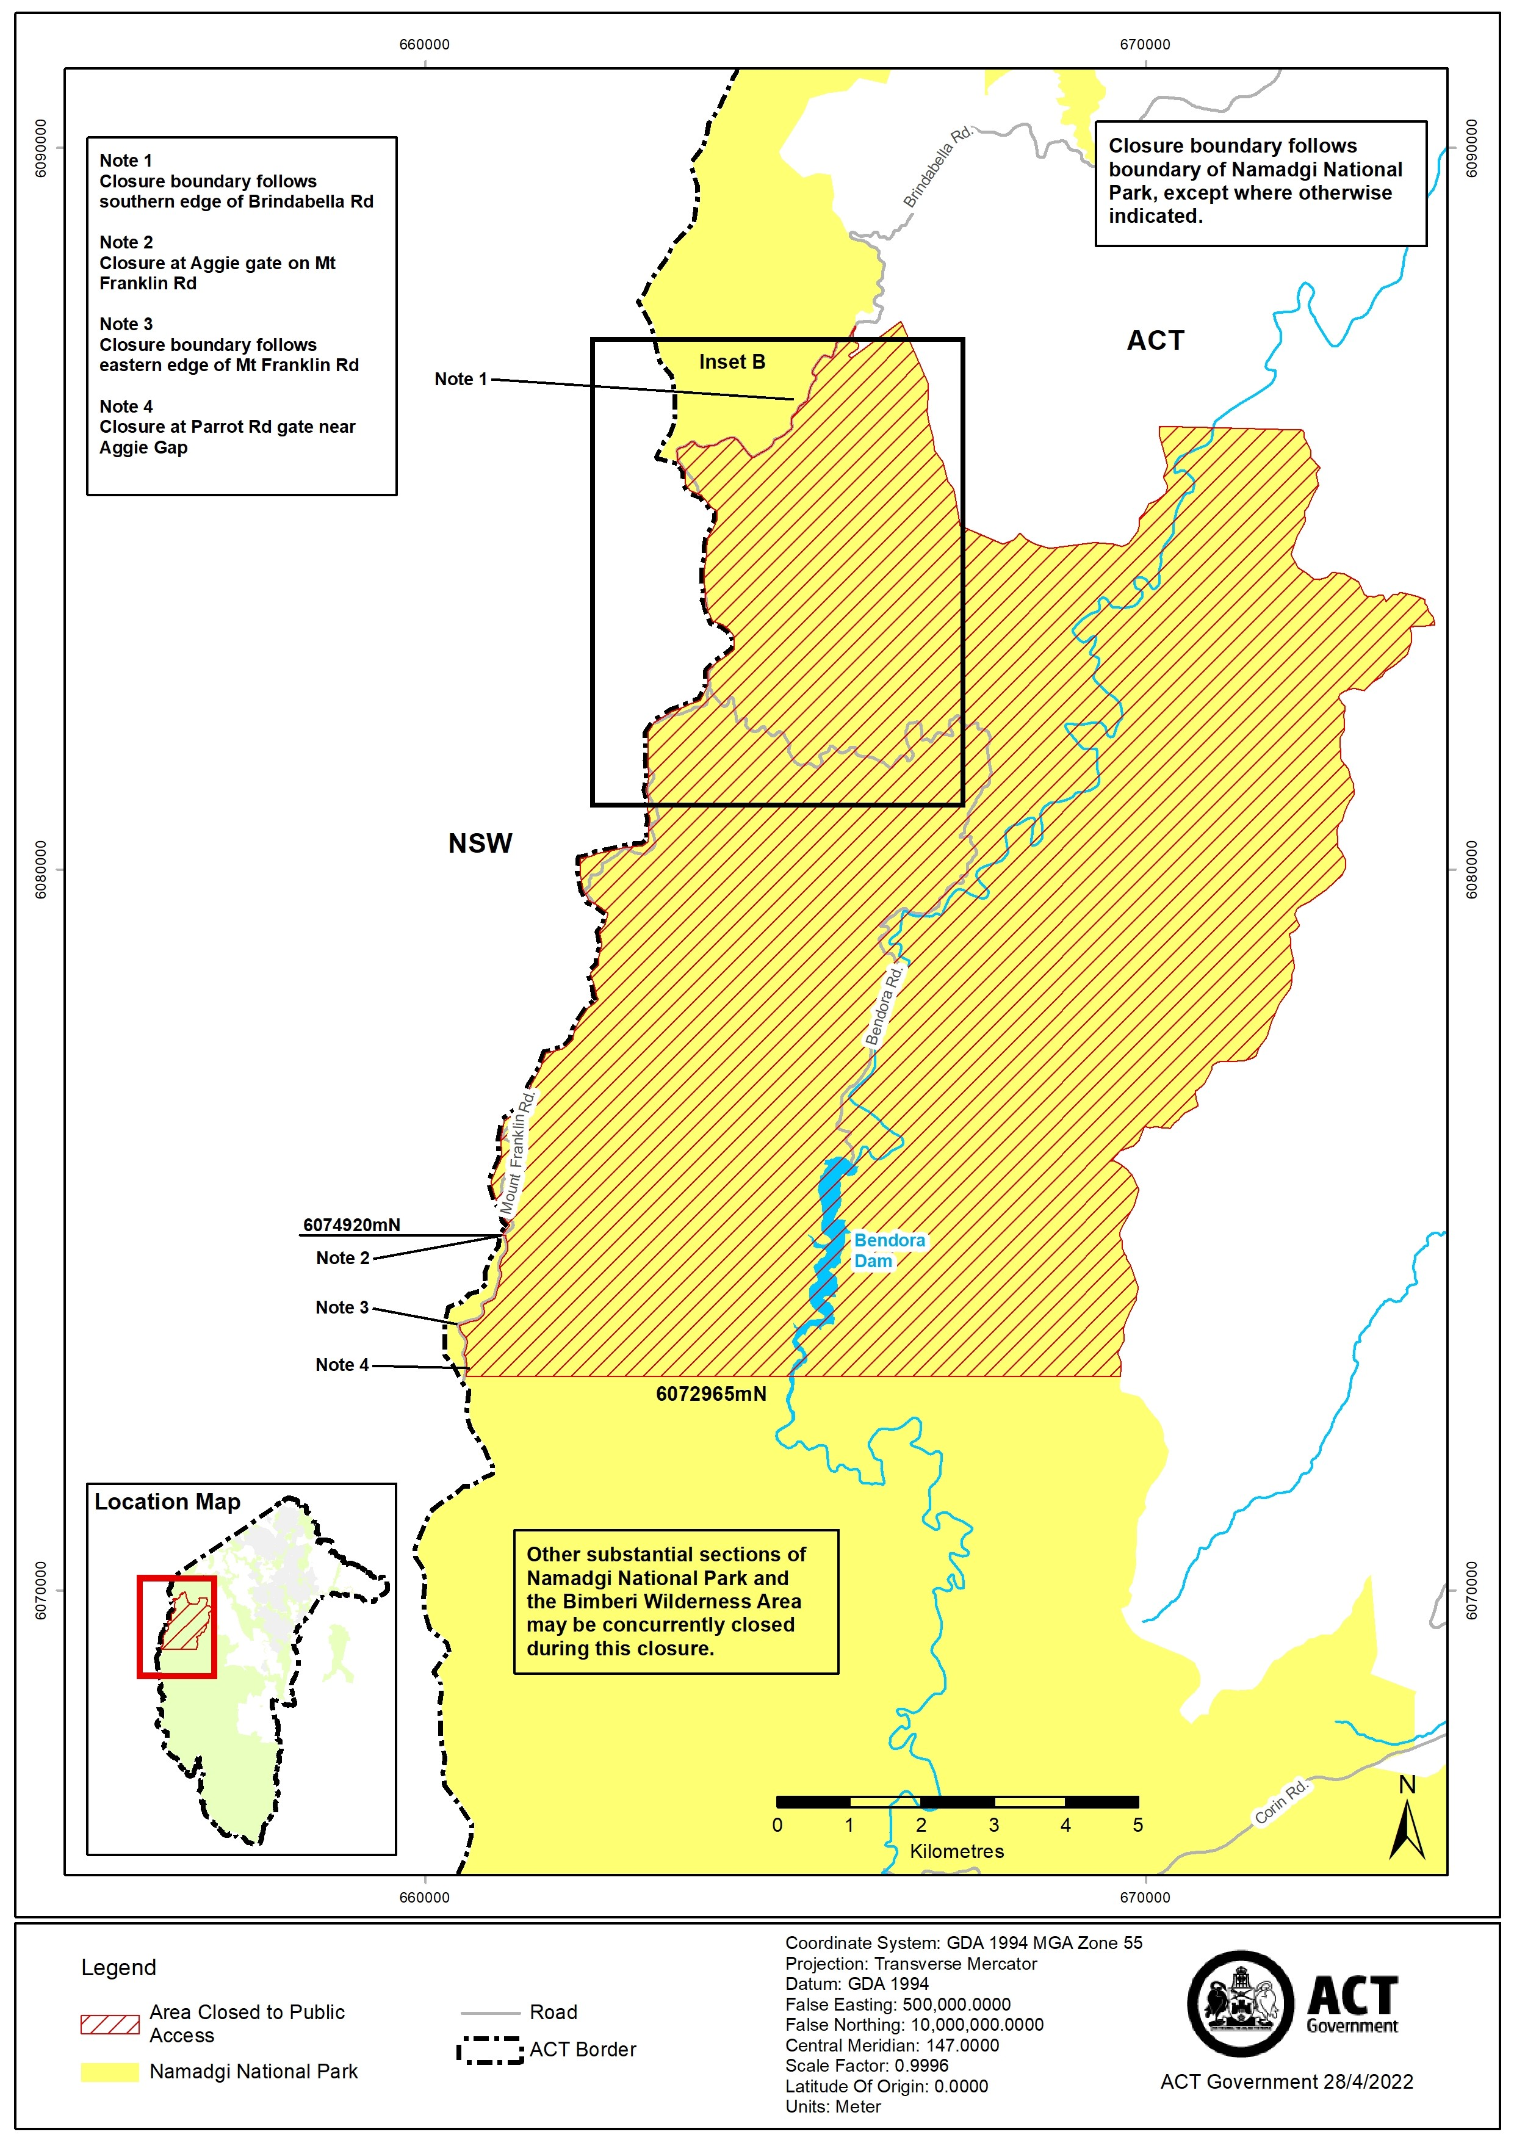

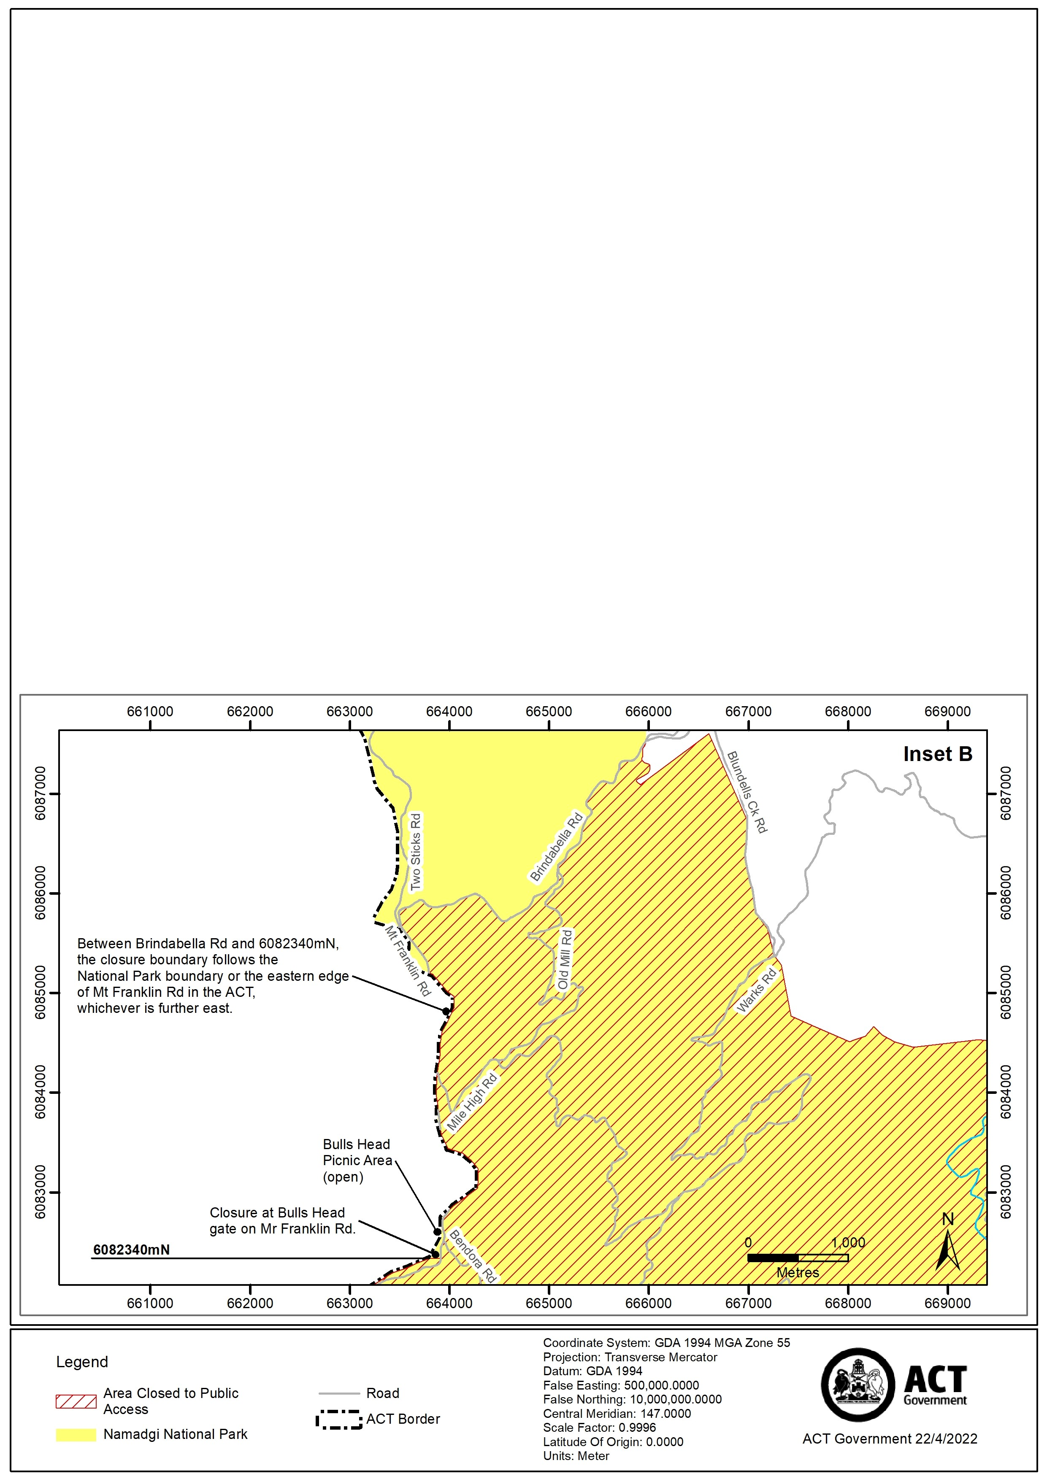

Schedule 2 Area of Lower Cotter Catchment Reserve closed to public access
(see s 3)
