Australian Capital Territory
Planning and Development (Technical Amendment—Phillip) Plan Variation 2022

Notifiable instrument NI2022–365
Technical Amendment No 2022-05
made under the
Planning and Development Act 2007, s 89 (Making technical amendments)

1 Name of instrument
This instrument is the Planning and Development (Technical Amendment–Phillip) Plan Variation 2022.
2 Commencement
This instrument commences on 29 July 2022.
3 Technical amendment
I am satisfied under section 89 (1) (a) of the Planning and Development Act 2007 that the Phillip plan variation is a technical amendment to the Territory Plan.
4 Dictionary
In this instrument:
Phillip plan variation means the technical amendment to the Territory Plan, variation 2022-05, in the schedule.

Lisa Teburea
Delegate of the planning and land authority
25 July 2022

Planning and Development Act 2007

Technical Amendment
to the Territory Plan

2022-05

Phillip section 1 block 18
Rezoning boundary changes

July 2022

Commencement version
under section 89 of the Planning and Development Act 2007
Table of Contents
1. INTRODUCTION 2
1.1 Purpose 2
1.2 Public consultation 2
1.3 National Capital Authority 2
1.4 Process 2
1.5 Types of technical amendments under the Act 3
2. EXPLANATORY STATEMENT 4
2.1 Background 4
2.2 Variation to the Territory Plan Map 5
3. TECHNICAL AMENDMENT 8
3.1 Variation to the Territory Plan Map 8

INTRODUCTION
    - Purpose
This technical amendment proposes changes to the Territory Plan as follows:
Territory Plan Map
- realign zone boundary at Phillip section 1 block 18
- realign the public land Pi Sport and Recreation Reserve and Pe Urban Open Space overlays to match the revised zone boundary
    - Public consultation
Though section 87 of the Planning and Development Act 2007 (the Act) does not require this type of technical amendment to undergo public consultation, a consultation process was undertaken to provide the community an opportunity to make comment on the proposed changes.
TA2022-05 was released for public consultation from 3 June 2022 to 5 July 2022. A total of 39 submissions were received and all were in support of the proposed changes.
    - National Capital Authority
The Australian Capital Territory (Planning and Land Management) Act 1988 established the National Capital Authority (NCA) with two of its functions being to prepare and administer a National Capital Plan (the Plan) and to keep the NCP under constant review and to propose amendments to it when necessary.
The Plan, which was published in the Commonwealth Gazette on 21 January 1990, is required to ensure Canberra and the Territory are planned and developed in accordance with their national significance. The Australian Capital Territory (Planning and Land Management) Act 1988 also requires the Territory Plan not be inconsistent with the Plan. The areas covered by this technical amendment are within urban areas identified in the Plan.
The NCA has been advised of this technical amendment.
    - Process
This technical amendment has been prepared in accordance with section 87 of the Act.

    - Types of technical amendments under the Act
The following categories of technical amendments are provided under section 87 of the Act:
- Each of the following territory plan variations is a technical amendment for which no consultation is needed before it is made under section 89:
(a) a variation (an error variation) that –
- would not adversely affect anyone’s rights if approved; and
- has as its only object the correction of a formal error in the plan;
(b) a variation to change the boundary of a zone or overlay under section 90A (Rezoning – boundary changes);
(c) a variation, other than one to which subsection (2) (d) applies, in relation to an estate development plan under section 96 (Effect of approval of estate development plan);
(d) a variation required to bring the territory plan into line with the national capital plan;
(e) a variation to omit something that is obsolete or redundant in the territory plan.
- Each of the following territory plan variations is a technical amendment for which only limited public consultation is needed under section 90:
- a variation (a code variation) that –
- would only change a code; and
- is consistent with the policy purpose and policy framework of the code; and
- is not an error variation;
- a variation to change the boundary of a zone under section 90B (Rezoning – development encroaching on adjoining territory land);
- a variation in relation to a future urban area under section 90C (Technical amendments – future urban areas);
- a variation in relation to an estate development plan under section 96 (Effect of approval of estate development plan) if it incorporates an ongoing provision that was not included in the plan under section 94 (3) (g);
- a variation to clarify the language in the territory plan if it does not change the substance of the plan;
- a variation to relocate a provision within the territory plan if the substance of the provision is not changed.
TA2022-05 has been prepared in accordance with section 87 (1) (b) and 90A of the Act.

EXPLANATORY STATEMENT
This part of the technical amendment document explains the changes to be made to the Territory Plan, the reasons for the change, and a statement of compliance against the relevant section of the Act.
    - Background
Major improvements are proposed to the Phillip Enclosed Oval. The project will include a new stand-alone community pavilion, canteen and associated facilities, provision of additional car parking spaces, LED lighting to support night-time use and refurbishment of the Michael O’Connor Grandstand. The proposed improvements will bring Phillip District Enclosed Oval in line with other high-quality enclosed facilities in the ACT such as Greenway Oval and Gungahlin Oval.
The PRZ2 Restricted Access Recreation zone boundary within Phillip section 1 block 18 is proposed to be expanded slightly to align with the block boundary. This will enable the oval improvements to be accommodated entirely within the PRZ2 Restricted Access Recreation zone. The objectives of the PRZ2 zone include making provision for a range of sport and recreation facilities and accommodating facilities to meet the recreational needs of the community. If the boundary of the zone is not adjusted to better reflect the intent of the boundary line, the range of facilities planned to be delivered on the site would need to be reduced.
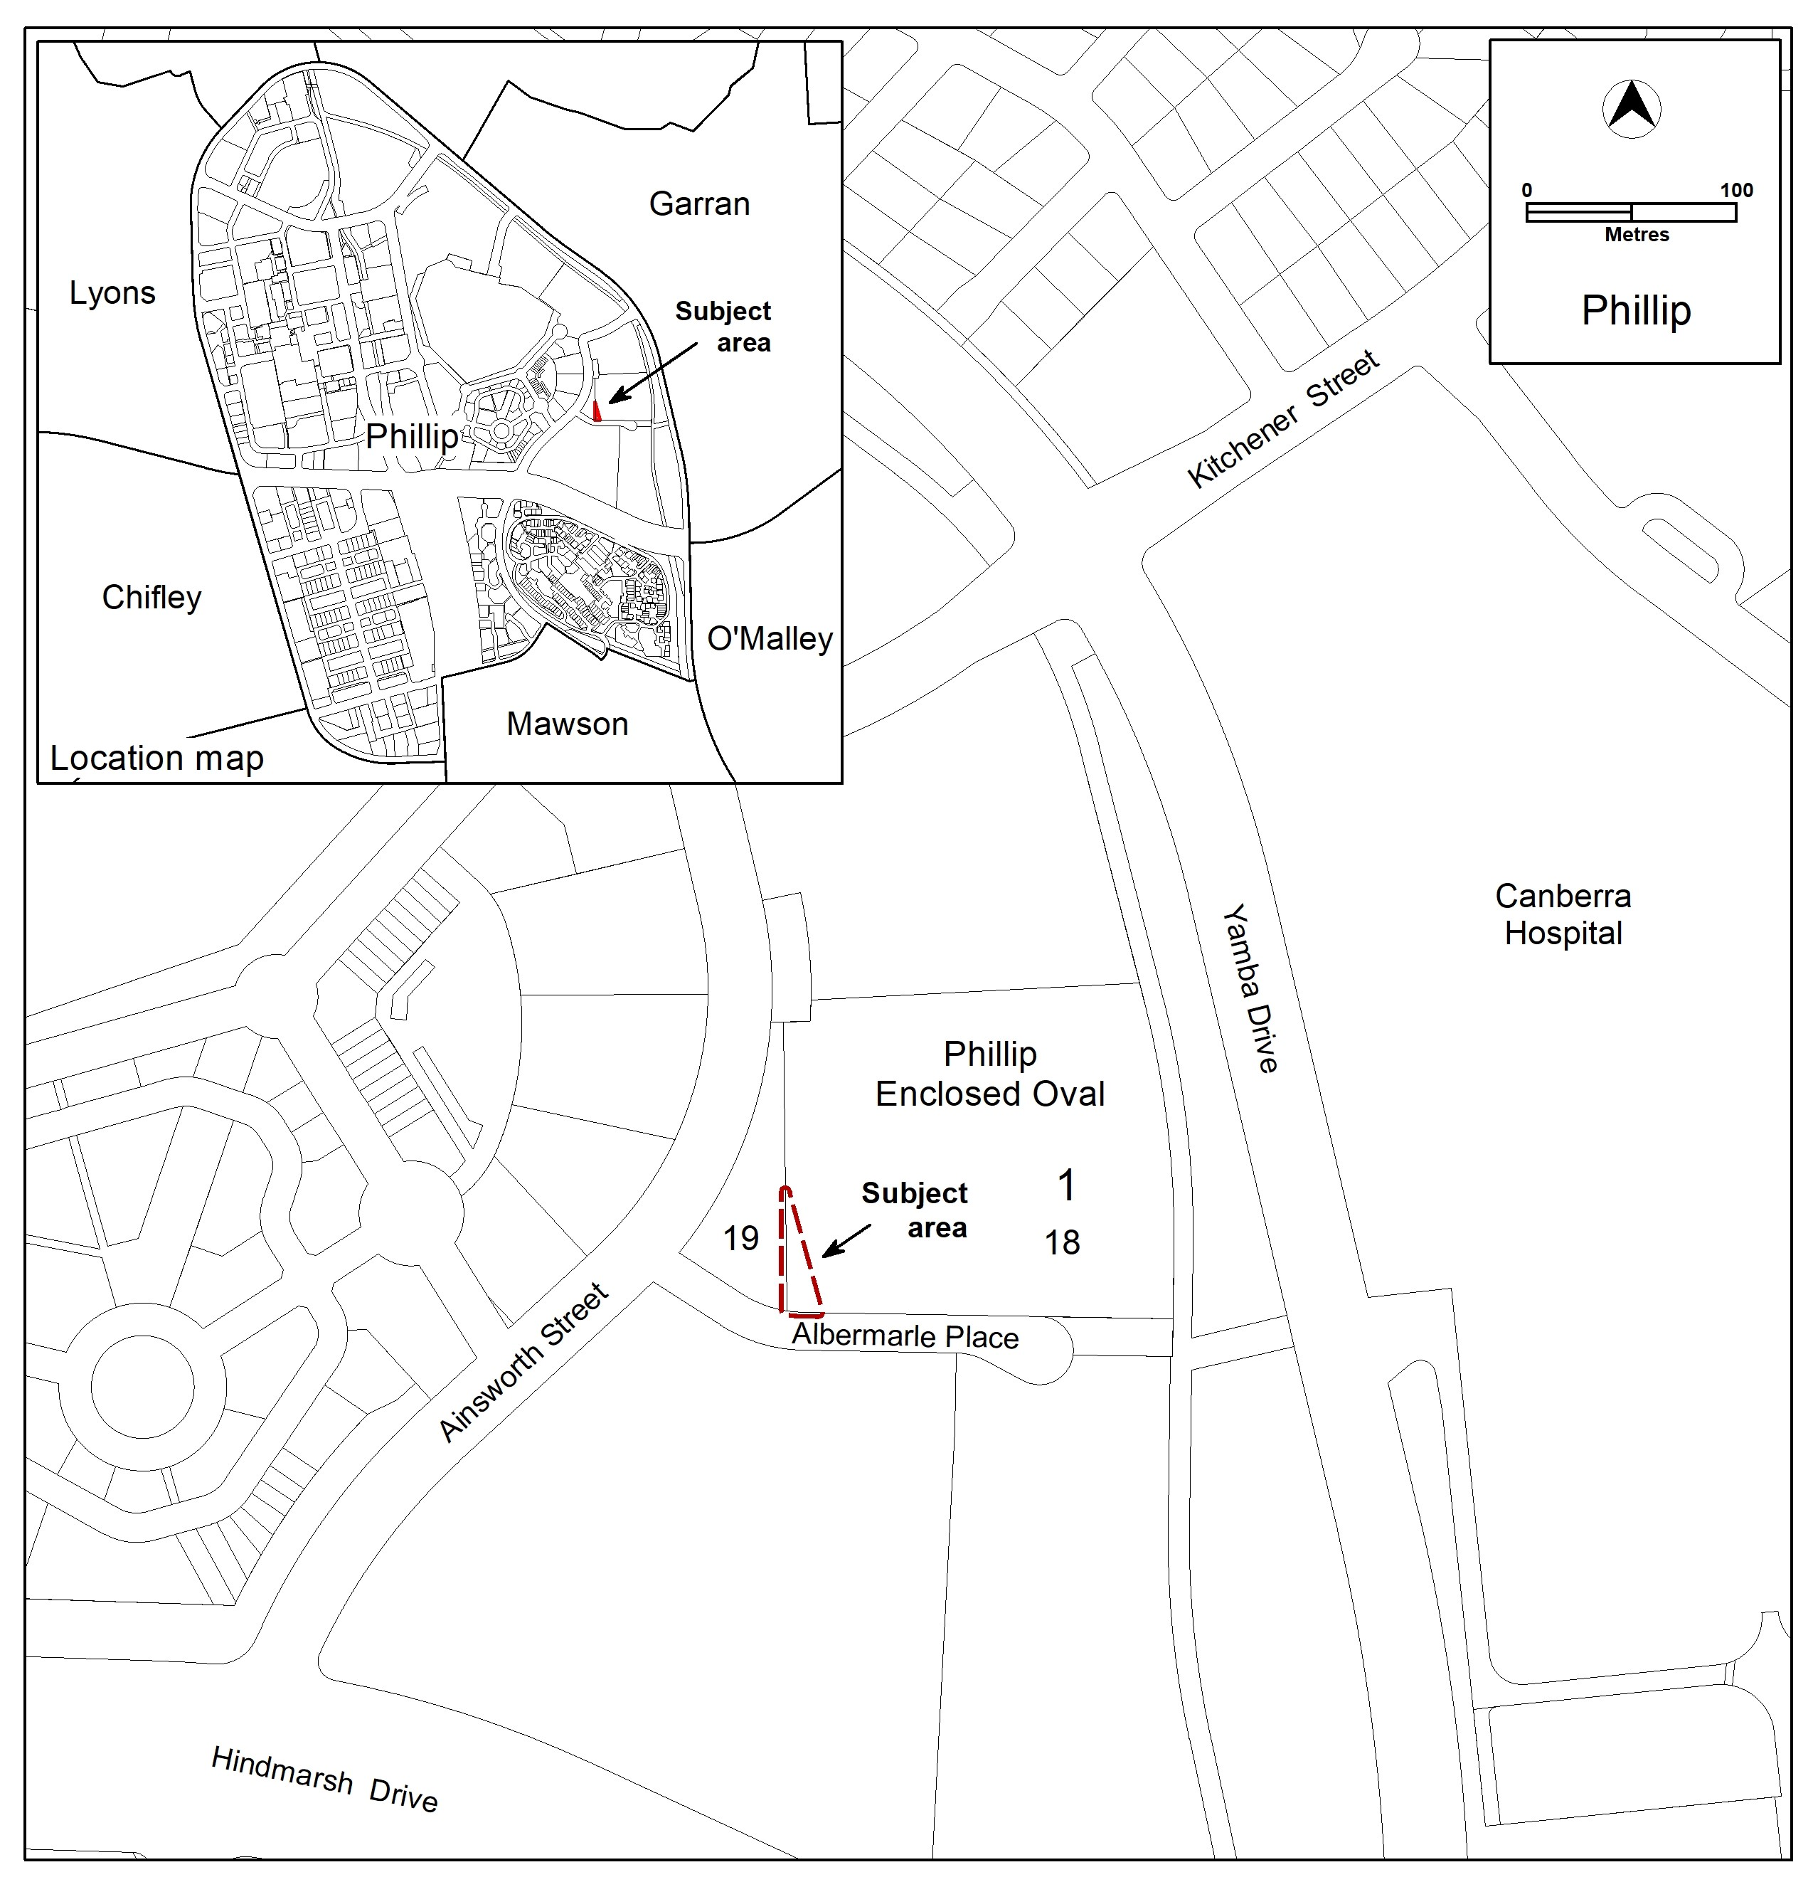
Location map
    - Variation to the Territory Plan Map
In accordance with section 90A of the Act this technical amendment makes changes to zone and overlay boundaries at Phillip section 1 block 18 to:
- realign the zone boundary between the Parks and Recreation PRZ1 Urban Open Space zone and the Parks and Recreation PRZ2 Restricted Access Recreation zone
- realign the public land Pi Sport and Recreation Reserve and Pe Urban Open Space overlays to match the revised zone boundary
The planning and land authority was requested to make changes to the zone and overlay boundaries by the relevant land custodian.
Existing Territory Plan Map
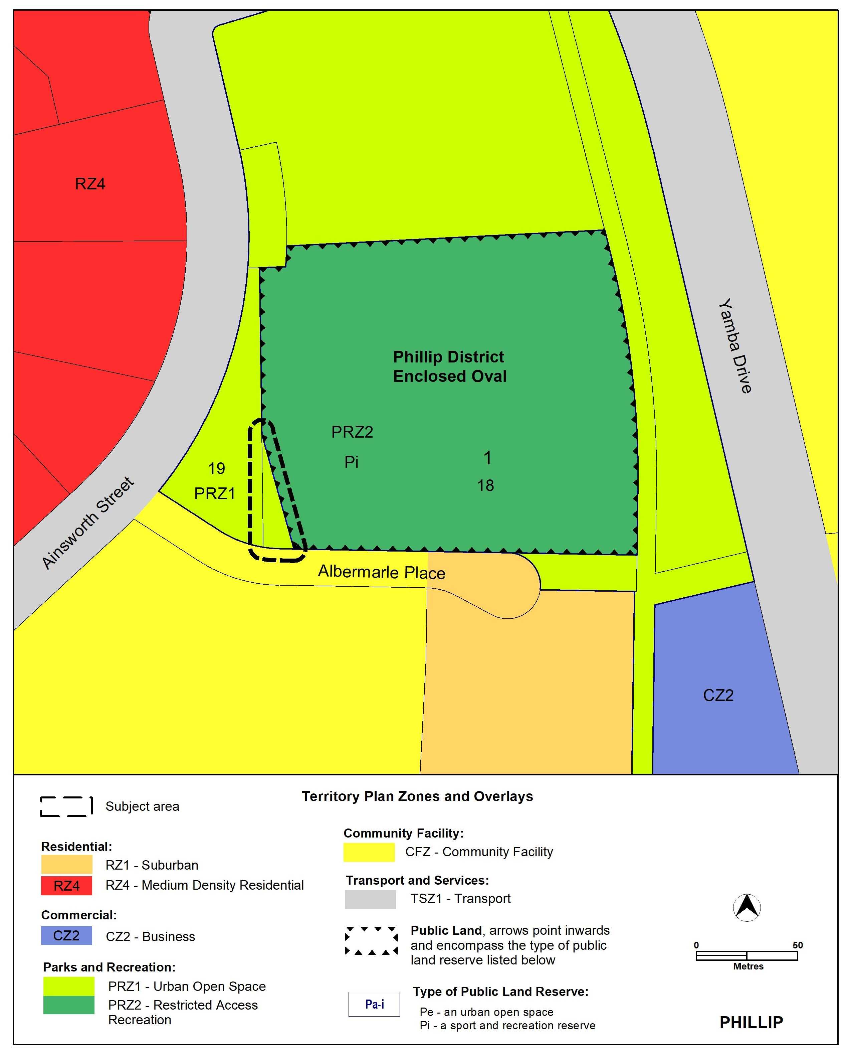

Proposed Territory Plan Map
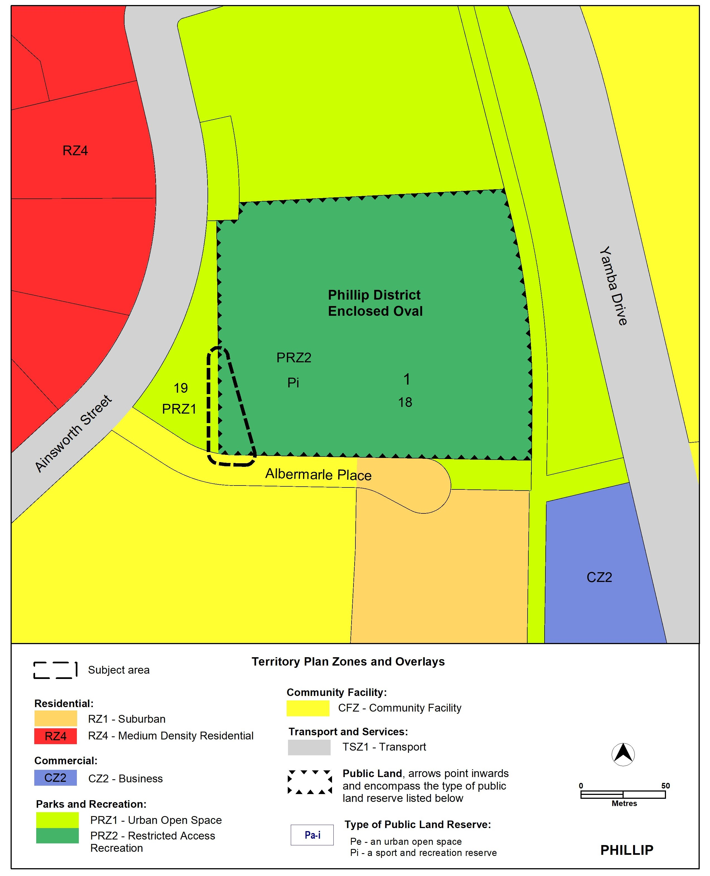

Section | Statement
Section 87 (1) (b) – a variation to change the boundary of a zone or overlay under section 90A (Rezoning boundary changes)
Section 90A  - This section applies to a zone or overlay in relation to land if the land adjoins unleased territory land or land for which the Territory is the registered proprietor (the adjoining territory land). | This technical amendment proposes to adjust the zone boundary and the Public Land Pi Sport and Recreation Reserve and Pe Urban Open Space overlays on land for which the Territory is the registered proprietor at Phillip section 1 block 18.
- The planning and land authority may vary the territory plan under section 89 (Making technical amendments) to change the boundary of the zone or overlay to encroach onto the adjoining territory land if the change is consistent with— (a) the apparent intent of the original boundary line; and (b) the objective for the zone. | The technical amendment will adjust the zone boundaries in line with the block boundary to allow an improved development outcome.  The proposed technical amendment will facilitate the outcomes expressed in the PRZ2 zone objectives to allow for development of ancillary sporting facilities on section 1 block 18, while retaining the functions and objectives of the PRZ1 zone on the adjoining section 1 block 19.  The proposed amendment is considered to be consistent with the apparent intent of the original zone boundary. This technical amendment facilitates the achievement of the zone objectives.  The amendment to the zone boundary results in a small addition to the PRZ2 zone, and a corresponding reduction to the PRZ1 zone.
- The planning and land authority may vary the territory plan under section 89 to change the boundary of an overlay to encroach onto the adjoining territory land if—  (a) the authority is advised to do so by—  (i) the conservator of flora and fauna; or  (ii) the custodian of the land for the overlay; and  (b) the conditions in subsection (2) (a) and (b) are satisfied.  - In this section: overlay means an overlay identified in the territory plan. | The planning and land authority has been advised to make the changes by the land custodian Chief Minister, Treasury and Economic Development Directorate and the Transport and City Services Directorate.  The conditions in subsection (2) (a) and (b) are satisfied as explained above.

TECHNICAL AMENDMENT
This section of the technical amendment document provides the actual instructions for implementing the changes to the Territory Plan.

    - Variation to the Territory Plan Map
- Phillip section 1 block 18
The Territory Plan map is varied as indicated below.

Interpretation service
