Australian Capital Territory

**Gaming Machine (Peripheral Equipment) Approval 2022 (No 6)**

**Notifiable instrument NI2022-427**

made under the

**Gaming Machine Act 2004, section 69 (Approval of gaming machines and peripheral equipment)**

**1 Name of instrument**

This instrument is the *Gaming Machine (Peripheral Equipment) Approval 2022 (No 6)*

**2 Commencement**

This instrument commences the day after the date of notification.

1. **Approval**

I approve the peripheral equipment described in the attached Schedule to this instrument.

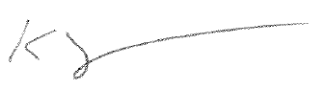

Karl Somers

Delegate

ACT Gambling and Racing Commission

31 August 2022

For further information please contact the approved supplier.

|  |  |
| --- | --- |
| IGT (Australia) Pty Ltd | |
| Subject: Updated ‘Outgrow Link’ Setting Details | |
| System Name | Outgrow LPJS |
| Specification Number | 18.YA014 |
| Application Reference Number | 18-A1369/S01 |