Australian Capital Territory
Planning and Development (Plan Variation 328) Approval 2022

Notifiable instrument NI2022–460
made under the
Planning and Development Act 2007, s 76 (Minister’s powers in relation to draft plan variations)

1 Name of instrument
This instrument is the Planning and Development (Plan Variation 328) Approval 2022.
2 Commencement
This instrument commences on the day after its notification day.
3 Approval of draft plan variation
(1) I approve under section 76 (2) (a) of the Planning and Development Act 2007 the plan variation 328 to the Territory Plan.
(2) In this section:
plan variation 328 to the Territory Plan means the plan variation in the schedule.
Mick Gentleman MLA
Minister for Planning and Land Management
16 September 2022

Planning and Development Act 2007
Variation to the
Territory Plan
328

Oaks Estate: Zone changes and amendments to the Oaks Estate Precinct Map and Code

September 2022

Final variation prepared under section 76 of the
Planning and Development Act 2007

Contents
1. EXPLANATORY STATEMENT 1
1.1 Background 1
1.2 Summary of the proposal 6
1.3 The National Capital Plan 6
1.4 Site Description 7
1.5 Current Territory Plan Provisions 8
1.6 Changes to the Territory Plan 8
1.7 Consultation on the Draft Variation 8
1.8 Revisions to the Draft Variation Recommended to the Minister 10
2. VARIATION TO THE TERRITORY PLAN 11
2.1 Variation to the Territory Plan Map 11
2.2 Variation to the Territory Plan 12

- EXPLANATORY STATEMENT
  - Background
The ACT Government prepared a series of master plans for selected areas that identify the existing character and opportunities and constraints affecting each area. The master plans make recommendations for each area to protect or develop desired character while providing future development opportunities.
The Oaks Estate Master Plan, covering the suburb of Oaks Estate, was developed with input from the local community during 2012 to 2014 and endorsed by the ACT Government in November 2014. The draft variation was prepared as one of the key measures for implementing the recommendations of the Oaks Estate master plan.
A draft variation was prepared in 2015 that intended to implement the outcomes and recommendations of the Oaks Estate master plan into the Territory Plan.
    - Public submissions
Comments were initially invited from the public from 30 January 2015 till 16 March 2015.Thirty-two (32) submissions were received from local residents and others with an interest in the suburb.
The main issues raised in the public consultation relating to the draft variation were:
- concerns about proposed bulk and scale of development in the commercial area – it was suggested that apartments be prohibited and that development be limited to two storeys
- protection of the history and heritage character of the suburb – the inclusion of a range of additional rules to control the built form and reflect the desired character for the suburb were requested
Following public consultation, the draft variation was put on hold while the heritage nomination of the suburb was considered by the ACT Heritage Council and other matters were resolved.
These issues were taken into consideration and addressed in the revised draft variation.

    - Historical context
Oaks Estate is a village suburb of Canberra located to the east of the city, on the border with the New South Wales city of Queanbeyan. The area was first inhabited by Aboriginal people, including the Ngunnawal, Ngarigo and Walgalu. European history in the area began with a large estate, named ‘The Oaks’, established in 1837. After changing ownership numerous times, the estate was eventually subdivided into 300 building allotments in 1887. It was initially developed as part of Queanbeyan and was later amalgamated into the ACT in 1911 following the decision that the boundary should follow the railway line rather than the river.
In the early part of the 20th century, Oaks Estate was a temporary workers’ settlement, housing the builders who constructed the early parts of Canberra. After World War II, migrants from Eastern Europe and the Mediterranean arrived in Oaks Estate, with many establishing home-based businesses and industries.
More detailed information about the historical background of Oaks Estate is contained in the Oaks Estate Master Plan and also in the ACT Heritage Council Statement of Reasons referred to in section 2.1.3 below.
    - Heritage values
Two sites within Oaks Estate are registered on the ACT Heritage Register – being ‘the Oaks’ (section 2 block 15 and 16) and ‘Robertsons’ House’ (section 7 blocks 11 and 12).
At the time the draft variation was originally released for consultation, there were a number of locations within Oaks Estate nominated for inclusion on the Heritage Register. These sites were identified as having potential heritage significance, or otherwise contributing to the character of the suburb. A number of submissions received during consultation on the draft variation were about the heritage character of Oaks Estate and the nomination of the entire suburb for inclusion on the ACT Heritage Register.
In April 2017, the ACT Heritage Council resolved not to register the nominated sites, determining that the suburb was not historically or architecturally significant enough to meet the criteria for listing.
The heritage citation for Robertsons’ House includes section 7 block 11 and block 12 of Oaks Estate. Any proposal to develop surrounding sites would need to consider the heritage citation, and requirements for a buffer to the heritage site was introduced as a provision in the Oaks Estate precinct code in line with previous advice from the ACT Heritage Council. These provisions were incorporated into the 2015 public consultation version of the draft variation and are retained in this version.
    - Commercial zone changes
The CZ5 zoning was introduced in the 2008 Territory Plan, replacing the A9 Residential Mixed Use land use policy from the previous Territory Plan.
The Oaks Estate master plan did not propose changing the Commercial CZ5 Mixed Use zone, and therefore no change of zoning was proposed in the 2015 draft variation placed on public consultation. Some submissions received on that draft variation contended that the CZ5 zone for the commercial area was not appropriate to the area.
Further consideration of the zone objectives and development tables resulted in a change of zoning to the Commercial CZ4 Local Centre zone because it is considered to be a more appropriate zone for the commercial area of Oaks Estate. The CZ4 zone limits heights to 2 storeys and provides for a local centre to serve the needs of the community while enabling the village ambience of Oaks Estate to be maintained.
The variation also includes some of the recommendations of the Oaks Estate Master Plan for certain development opportunities along Railway Street. Allowable merit assessable uses are limited to those listed in the CZ4 development table and any additional permitted or prohibited uses currently listed in the precinct code. The additional permitted and prohibited uses listed in the precinct code take precedence over the CZ4 development table. The revised Oaks Estate precinct map and code is located at Appendix 1 of this document.

    - Contamination studies
A provision is included in the Oaks Estate Precinct Map and Code requiring an environmental assessment into the site’s suitability from a contamination perspective. It is to be undertaken in accordance with the ACT Contaminated Sites Environment Protection Policy and to be endorsed by the Environment Protection Authority prior to development or a change in use.

    - Restrictions on uses
The variation rectifies errors in the uses currently listed as prohibited and/or permitted on certain blocks in the Oaks Estate precinct map and code. This anomaly occurred when the old Territory Plan was superseded by the restructured Territory Plan.
Light industrial use is restricted to the blocks where it is already a permitted use in a lease, and some uses are either prohibited or restricted in accordance with the master plan recommendations. As a result of the change of zone from CZ5 to CZ4, some allowable uses in the CZ4 zone are also prohibited in the relevant tables as these are considered to be incompatible with the village character of Oaks Estate.
The 35% site coverage restriction for residential blocks in the precinct code is in line with the recommendations of the master plan. This will enable the retention of substantial areas of open space on residential blocks for deep root planting, whilst allowing a moderate developable area for a dwelling and other structures.
Additional provisions are included for the residential area of Oaks Estate to maintain its village character. These provisions are included in the precinct code under the new ‘RC2 – Residential Area’ sub-precinct (see Appendix 1). The provisions include controls on the redevelopment of multi-unit sites, site coverage restrictions, landscaping requirements for deep root plantings, and allowances for front fencing.
    - Views and rural surrounds
Views and vistas are protected by existing street alignments, a maximum two storey building height limit and existing zone development controls in the Non-Urban zone development code. The rural surrounds are also protected from inappropriate development through the Non-Urban zones development code.
    - Future development and desired character
The variation makes changes to address the nature of future development and protect the village character.
    - ACT Government Land Release Program
The variation provides certainty regarding development outcomes for the blocks at Oaks Estate which are proposed to be sold as a part of the Government’s Land Release Program.
  - Summary of the proposal
Variation to the Territory Plan 328 implements the recommendations of the endorsed Oaks Estate Master Plan 2014, as well as responding to concerns raised during the consultation periods undertaken in 2015 and 2021. The variation amends to the Oaks Estate Precinct Map and Code to provide opportunities for limited growth and change in the suburb and to preserve the history and character of Oaks Estate.

  - The National Capital Plan
The Australian Capital Territory (Planning and Land Management) Act 1988 established the National Capital Authority (NCA) with two of its functions being to prepare and administer a National Capital Plan (NCP) and to keep the NCP under constant review and to propose amendments to it when necessary.
The NCP, which was published in the Commonwealth Gazette on 21 January 1990 is required to ensure that Canberra and the Territory are planned and developed in accordance with their national significance. The Planning and Land Management Act 1988 also required that the Territory Plan is not inconsistent with the NCP.
In accordance with section 10 of the Australian Capital Territory (Planning and Land Management) Act 1988, the NCP defines the planning principles and policies for Canberra and the Territory, for giving effect to the object of the NCP and sets out the general policies to be implemented throughout the Territory, including the range and nature of permitted land uses.
It also sets out the detailed conditions of planning, design and development for areas that have special significance to the National Capital known as designated areas and identifies special requirements for the development of some other areas.

  - Site Description
The subject area is located between the Molonglo River to the north, the Queanbeyan River to the east and the ACT/NSW border to the south and is directly adjacent to the NSW township of Queanbeyan. The residential area predominantly contains single dwellings, with a number of two to four storey multi-unit developments. The compact commercial area is generally single storey, with some bulkier industrial buildings, and several undeveloped blocks.
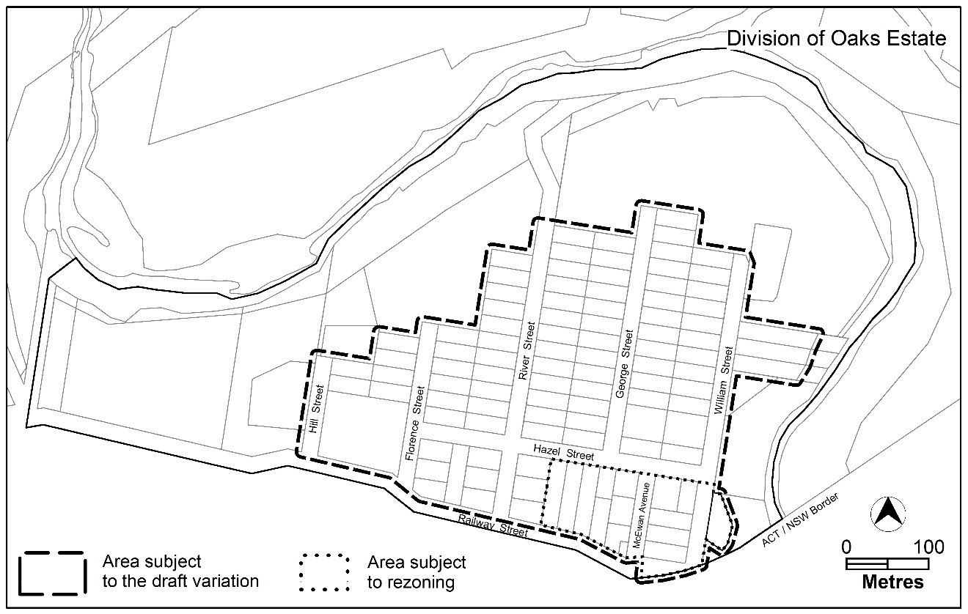
Figure 1: Location map and area subject to the variation and rezoning

  - Current Territory Plan Provisions
The Territory Plan map for the area subject to this variation is shown in Figure 2.
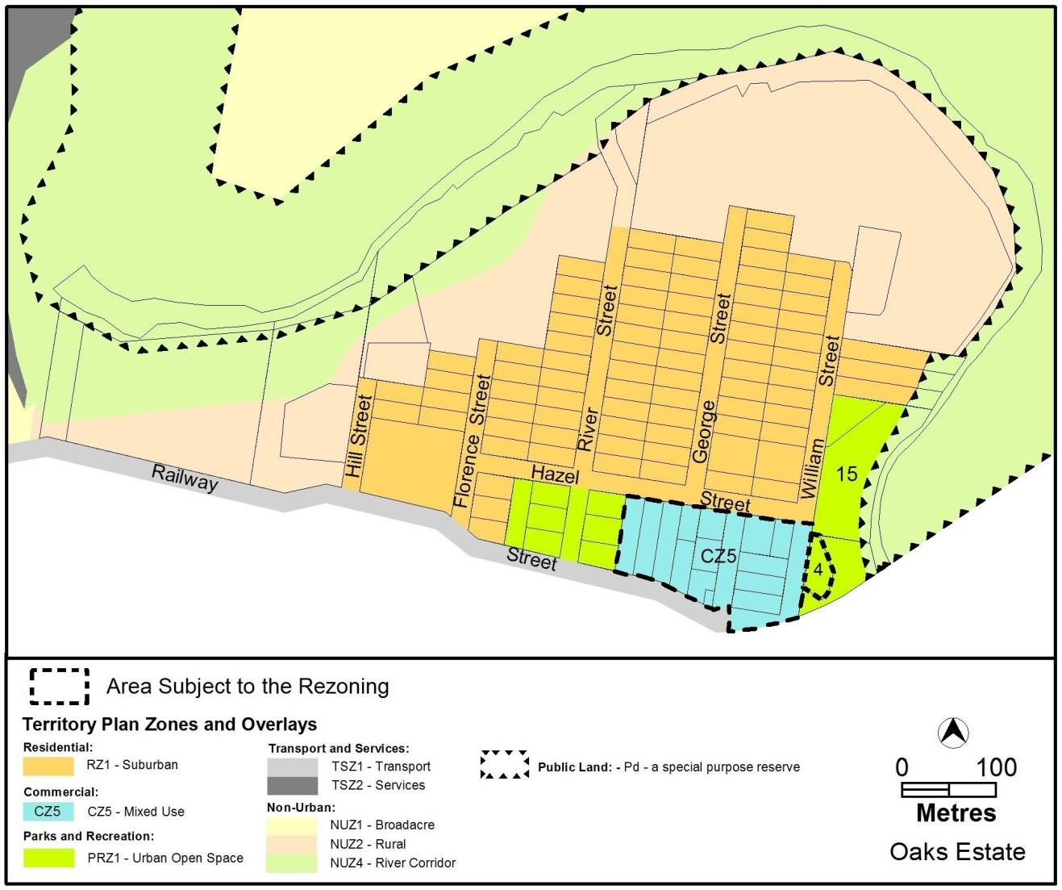
Figure 2 Territory Plan Zones Map

  - Changes to the Territory Plan
Detailed changes to the Territory Plan are noted in section 2 of this document.

  - Consultation on the Draft Variation
The draft variation was initially prepared and released for public consultation in 2015. Changes were made in response to consultation comments.
The draft variation was released for second period of public comment between 7 August 2021 and 26 November 2021. A consultation notice under section 63 of the Planning and Development Act 2007 (P&D Act) was published on the ACT Legislation Register on 7 August 2021. A public notice was placed on the ACT Government public notices website on 9 August 2021.
A total of eight written submissions were received, which included three submissions from individuals, one from a property developer, one from a town planning consultant, one from a heritage conservation organisation and one from a resident’s association.
Main issues raised by submitters included:
Issue | Number of submissions
- Support for whole or part of the draft variation | 2
- Questions the reason for rezoning CZ5 mixed use to CZ4 local centre zone | 5
- Concerns about management of traffic flow and inadequate parking in Oaks Estate | 3
- Request to further consider the village character in the precinct code | 3
- Suggestion that additional community consultation is required | 3
- Need for protection of the Community Facility site for a community hall | 2
- Request for greater flexibility of 2 storey/8.5 metre height limit in the commercial area | 2
- Concern that zone changes are being made to facilitate land release | 2
- Desire to protect heritage values of Oaks Estate | 2
- Questions raised about lack of implementation of recommendations of the Master Plan | 2
- Need for consideration of linkages and a visual connection with the adjacent Queanbeyan Railway Station | 1
- Questions about how the precinct code will provide protection from major environmental threats including bushfire and flooding | 1
- Claims there is an excess of commercially zoned land | 1
- Questions the impacts of the land release program including identified sites, any known proposals and any proposals for affordable or community housing | 1
- Questions why the structure of the Oaks Estate Precinct Code is different to other precinct codes | 1
- Concerns about noise from external sources and possible odour impacts of industrial development on future residents | 1
- Request that front fence provisions are more flexible | 1
- Need to protect PRZ1 Urban Open Space zoned land from car parking | 1

The above issues were considered and are detailed in a report on consultation. Changes were informed by the issues raised. The outcomes of consultation were considered by the Minister responsible for planning prior to approval of this variation.
  - Revisions to the Draft Variation Recommended to the Minister
No changes have been made to the draft variation following the referral of the recommended version to the Minister responsible for planning.

- VARIATION TO THE TERRITORY PLAN
The Territory Plan is varied in all of the following ways:
  - Variation to the Territory Plan Map
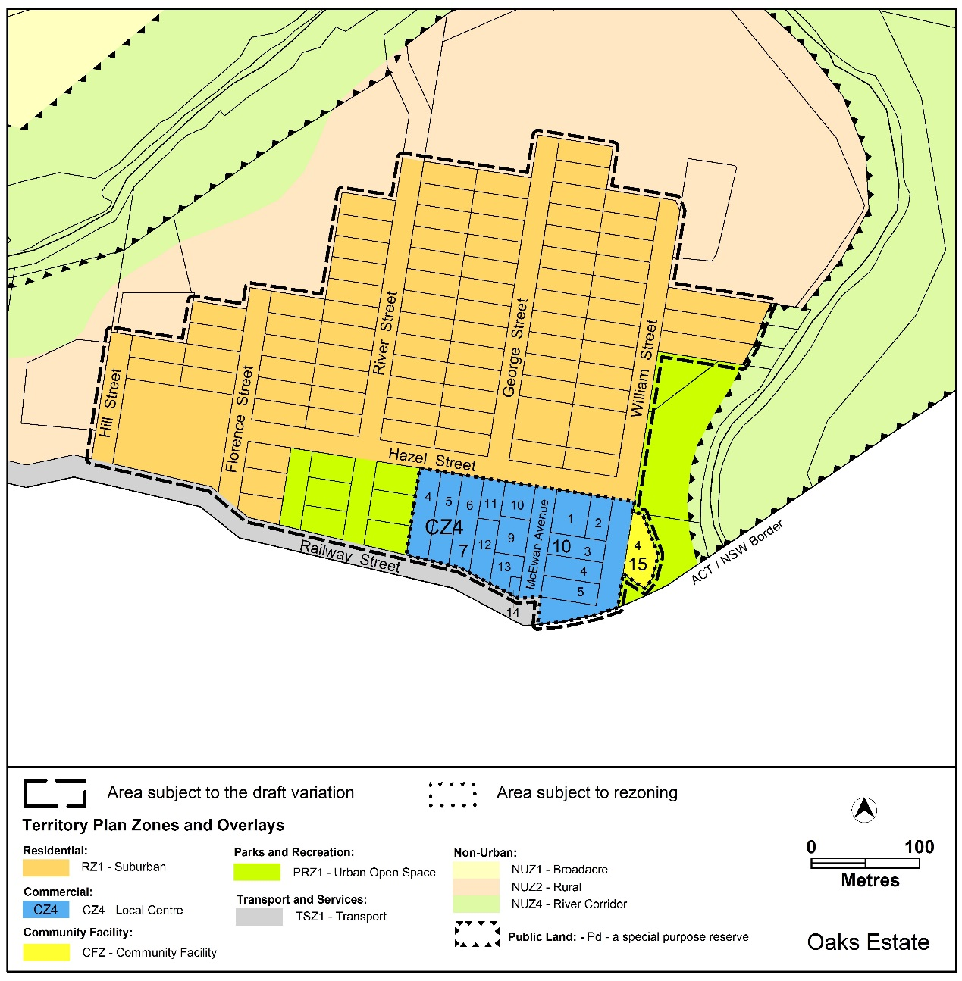Figure 3 Proposed Territory Plan Zones Map

  - Variation to the Territory Plan
Variation to the Oaks Estate Precinct Map and Code
- Part 10. Precinct Maps and Codes; Oaks Estate Precinct Map and Code
Substitute
The Oaks Estate Precinct Map and Code – Appendix 1

Interpretation service
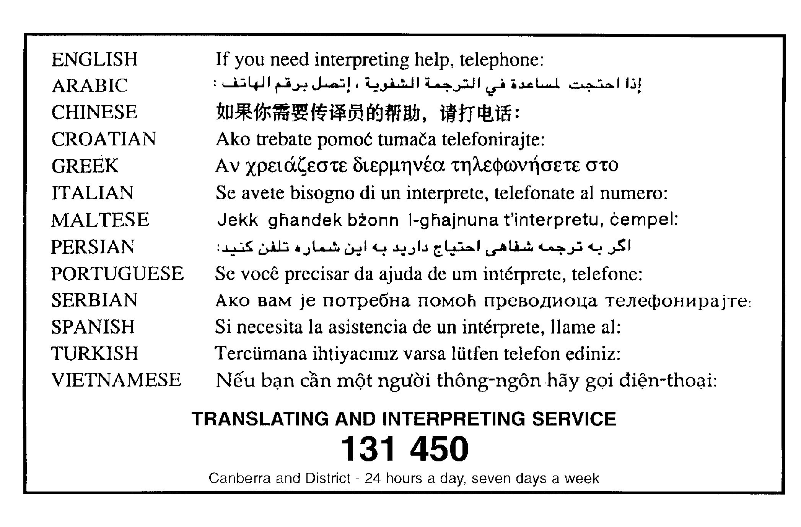

Oaks Estate Precinct Map and Code

This page is intentionally blank.

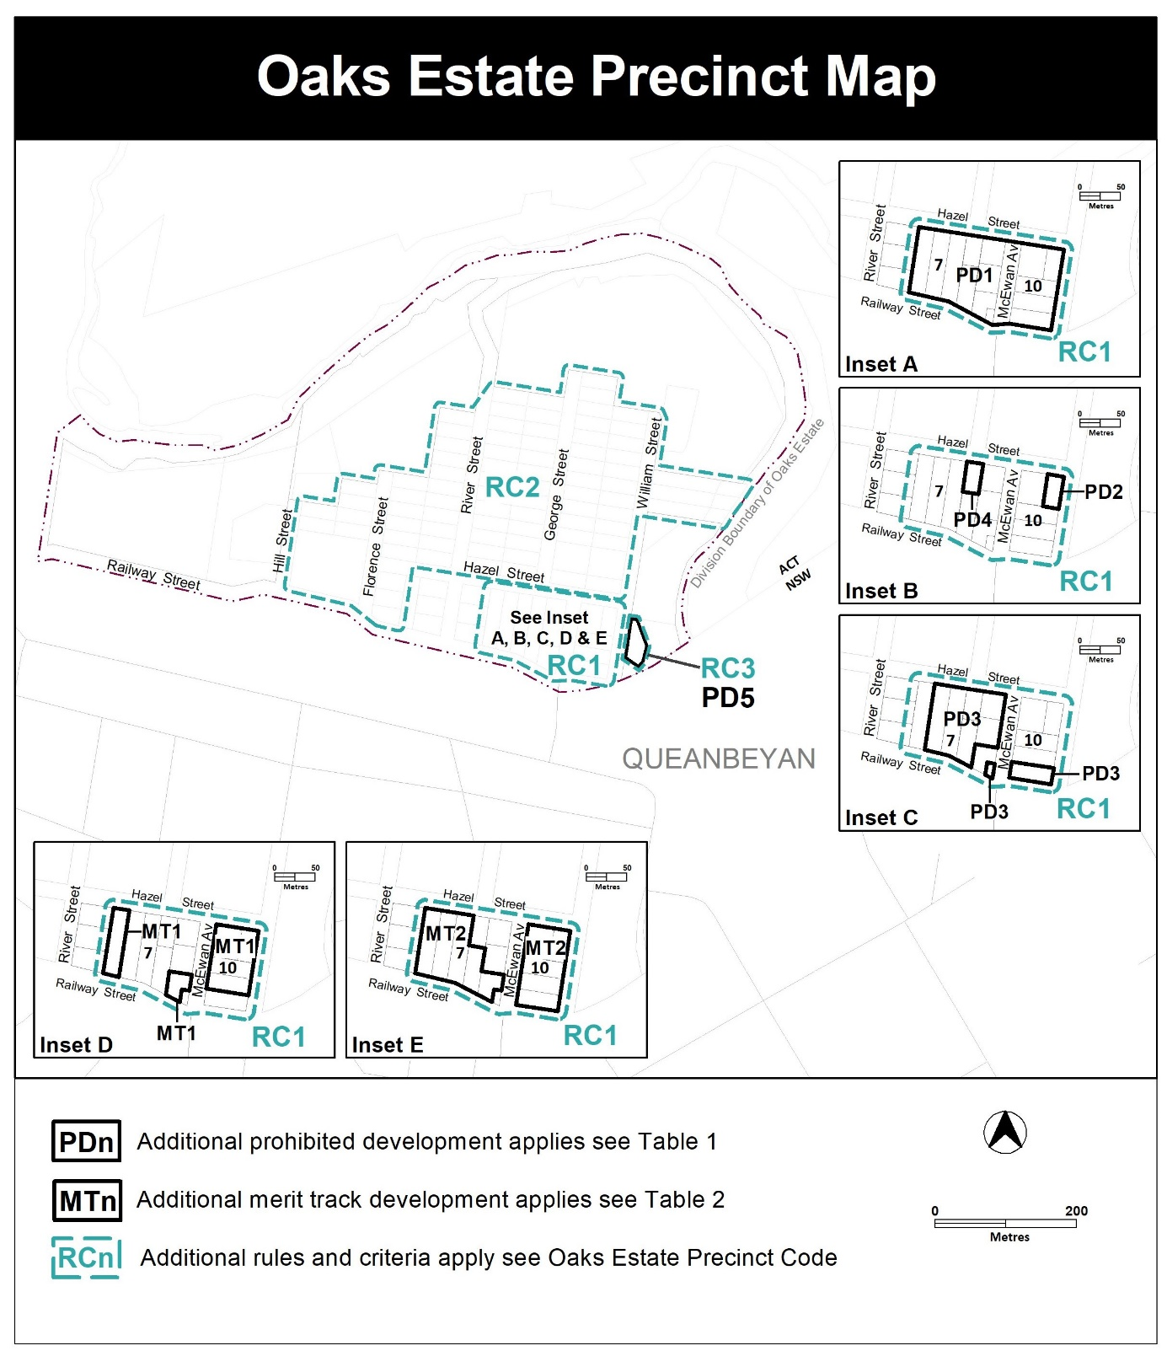

Assessment Tracks

The following tables identify the additional prohibited development and additional merit track development for blocks and parcels shown in the Oaks Estate Precinct Map (identified as PDn or MTn). Development that is exempt from requiring development approval, other prohibited development and the minimum assessment track applicable to each development proposal is set out in the relevant zone development table.

The following tables constitute part of the relevant zone development table.

Table 1 – Additional prohibited development
Additional prohibited development
Suburb precinct map label | Zone | Development
PD1 | CZ4 | indoor entertainment facility  industrial trades  service station  veterinary hospital
PD2 | CZ4 | restaurant  SHOP
PD3 | CZ4 | light industry  industrial trades
PD4 | CZ4 | indoor entertainment facility  light industry  industrial trades  restaurant  service station  SHOP
PD5 | CFZ | retirement village  supportive housing

Table 2 – Additional merit track development
Additional merit track development that may be approved subject to assessment
Suburb precinct map label | Zone | Development
MT1 | CZ4 | warehouse
MT2 | CZ4 | craft workshop

Oaks Estate Precinct Code

Contents
Introduction 2
Additional rules and criteria 4
RC1 – Commercial Local Centre 4
Element 1:Use 4
1.1 Residential use 4
1.2 Railway Street and McEwan Avenue restrictions 4
1.3 Restrictions on use 5
1.4 Contamination 5
Element 2:Buildings 5
2.1 Built form 5
2.2 Building design 6
2.3 Site coverage 6
2.4 Vehicle parking 6
2.5 Landscaping 6
2.6 Active frontage 6
RC2 – Residential Area 8
Element 3:Buildings 8
3.1 Multi-unit sites 8
Element 4:Site 8
4.1 Site coverage 8
4.2 Landscaping 8
4.3 Front setbacks 8
Element 5:Fencing 9
5.1 Front fencing 9
RC3 – Community Hall 9
Element 6:Use 9
6.1 Contamination 9

Figures
Figure 1 – Area A

Introduction
Name
The name of this code is Oaks Estate Precinct Code.
Application
The code applies to the Division of Oaks Estate.
Purpose
This code provides additional planning, design and environmental controls for specific areas or blocks and may also contain references to provisions in other codes.
In conjunction with other relevant codes it will be used by the Authority to assess development applications and offer guidance to intending applicants in designing development proposals and preparing development applications.
Structure
This code contains additional rules and/or criteria for particular blocks or parcels identified as areas RCn on the precinct map, to be read in conjunction with the relevant development code. It may also contain sub-parts.
Each element has one or more rules and, unless the respective rule is mandatory, each rule has an associated criterion. Rules provide quantitative, or definitive, controls. By contrast, criteria are chiefly qualitative in nature.
In some instances rules are mandatory. Such rules are accompanied by the words “This is a mandatory requirement. There is no applicable criterion.” Non-compliance with a mandatory rule will result in the refusal of the development application. Conversely, the words “There is no applicable rule” is found where a criterion only is applicable.
Code hierarchy
Under the Planning and Development Act 2007, where more than one type of code applies to a development, the order of precedence if there is inconsistency of provisions between codes is: precinct code, development code and general code.
If more than one precinct code applies to the site, the most recent precinct code takes precedence to the extent of any inconsistency.
Definitions
Defined terms, references to legislation and other documents are italicised.
Definitions of terms used in this code are listed in part 13 of the Territory Plan or, for terms applicable only to this code, associated with the respective rule.
Acronyms
EPA ACT Environment Protection Authority
ESA ACT Emergency Services Agency
EPSDD Environment, Planning and Sustainable Development Directorate
NCA National Capital Authority
P&D Act Planning and Development Act 2007
TCCS Transport Canberra and City Services Directorate

Additional rules and criteria
This part applies to blocks and parcels identified in the Oaks Estate Precinct Map (RCn). It should be read in conjunction with the relevant zone development code and related codes.
RC1 – Commercial Local Centre
This part applies to blocks and parcels identified in area RC1 shown on the Oaks Estate Precinct Map.
Desired character
- development respects the historical rural village characteristics, scenic rural vistas and heritage values of Oaks Estate
- small scale business opportunities provide services for the local community
- facades are articulated to provide interest to the street frontage
- development addresses each street frontage with pedestrian entrances and/or windows to shops or habitable rooms at the ground level, with upper floor level balconies to one or more habitable rooms
- residential development provides interest through articulation, pitched roofs and use of materials reflective of existing surrounding residential development

- Use
Rules | Criteria
  - Residential use
There is no applicable rule. | Residential development is designed to mitigate the potential impacts on future residents from the operation of existing commercial uses.
There is no applicable rule. | C2  Residential development is permitted to replace commercial/retail uses provided that the centre remains commercially viable after the proposed development.
  - Railway Street and McEwan Avenue restrictions
R3  Commercial uses are required at the ground floor fronting Railway Street and McEwan Avenue.  Commercial uses may include but are not limited to craft workshop, NON RETAIL COMMERCIAL, Restaurant, SHOP. | C3  The ground floor level of buildings is adaptable for commercial uses.
  - Restrictions on use
R4  This rule applies to Blocks 5,6 and 9 Section 7 Oaks Estate:  The maximum gross floor area of SHOP where permitted is 200m². | This is a mandatory requirement. There is no applicable criterion.
  - Contamination
R5  An environmental assessment into the site’s suitability from a contamination perspective must be undertaken in accordance with the ACT Contaminated Sites Environment Protection Policy and be endorsed by the Environment Protection Authority prior to development or a change in use.  This rule does not apply if the Environment Protection Authority has provided written advice that the site has been assessed for contamination to its satisfaction. | This is a mandatory requirement. There is no applicable criterion.

- Buildings
Rules | Criteria
  - Built form
R6  Minimum front setback to Hazel Street is 4m. | C6  Front setbacks:  - reflect existing block patterns  - provide landscaping between the building and the front boundary  - are consistent with the desired character.
R7  Minimum front setback to Railway Street, McEwan Avenue and William Street is:  - for commercial development – 0m  - for residential development – 2m. | This is a mandatory requirement. There is no applicable criterion.
R8  This rule applies to buildings on blocks directly adjoining area A in Figure 1.  Buildings provide a minimum 6m setback to area A. | C8  Development achieves all of the following:  - Development provides reasonable physical and visual separation to Robertsons’ House to protect the heritage character of the site.  - Existing trees on section 7 blocks 11 and 12 Oaks Estate, are not significantly impacted, including any parts of trees that overhang the boundaries of the blocks.
  - Building design
R9  Maximum length of unarticulated street front facade is 10m  Minimum articulation depth: 2m | C9  Development provides an interesting facade to the street compatible with surrounding built form.
  - Site coverage
R10  Maximum site coverage: 45%. | This is a mandatory requirement. There is no applicable criterion.
  - Vehicle parking
R11  Vehicle parking areas are located behind the front building line. | C11  Parking areas are screened from the street by suitable landscaping wholly contained within the leased block boundaries.
  - Landscaping
R12  Development provides a minimum of 15% of the block area for deep root planting. | C12  Development retains sufficient open space for deep root plantings wholly contained within the block boundaries.
  - Active frontage
R13  This rule applies to commercial development located along Railway Street and/or McEwan Avenue.  Frontages and building design comply with all of the following:  - buildings incorporate clear display windows and shop fronts at the ground floor level  - buildings incorporate direct pedestrian access at grade with the verge level for access and egress for persons with disabilities. | C13  Development:  - avoids extensive lengths of blank walls unrelieved by doors, windows or the like  - provides suitable pedestrian access for persons with disabilities.
R14  This rule applies to residential development located along Railway Street, Hazel Street and/or McEwan Avenue (where relevant).  Ground floor street frontages and building design includes windows to habitable rooms.  Street frontages above ground floor include windows to habitable rooms and/or balconies addressing the street. | This is a mandatory requirement. There is no applicable criterion.

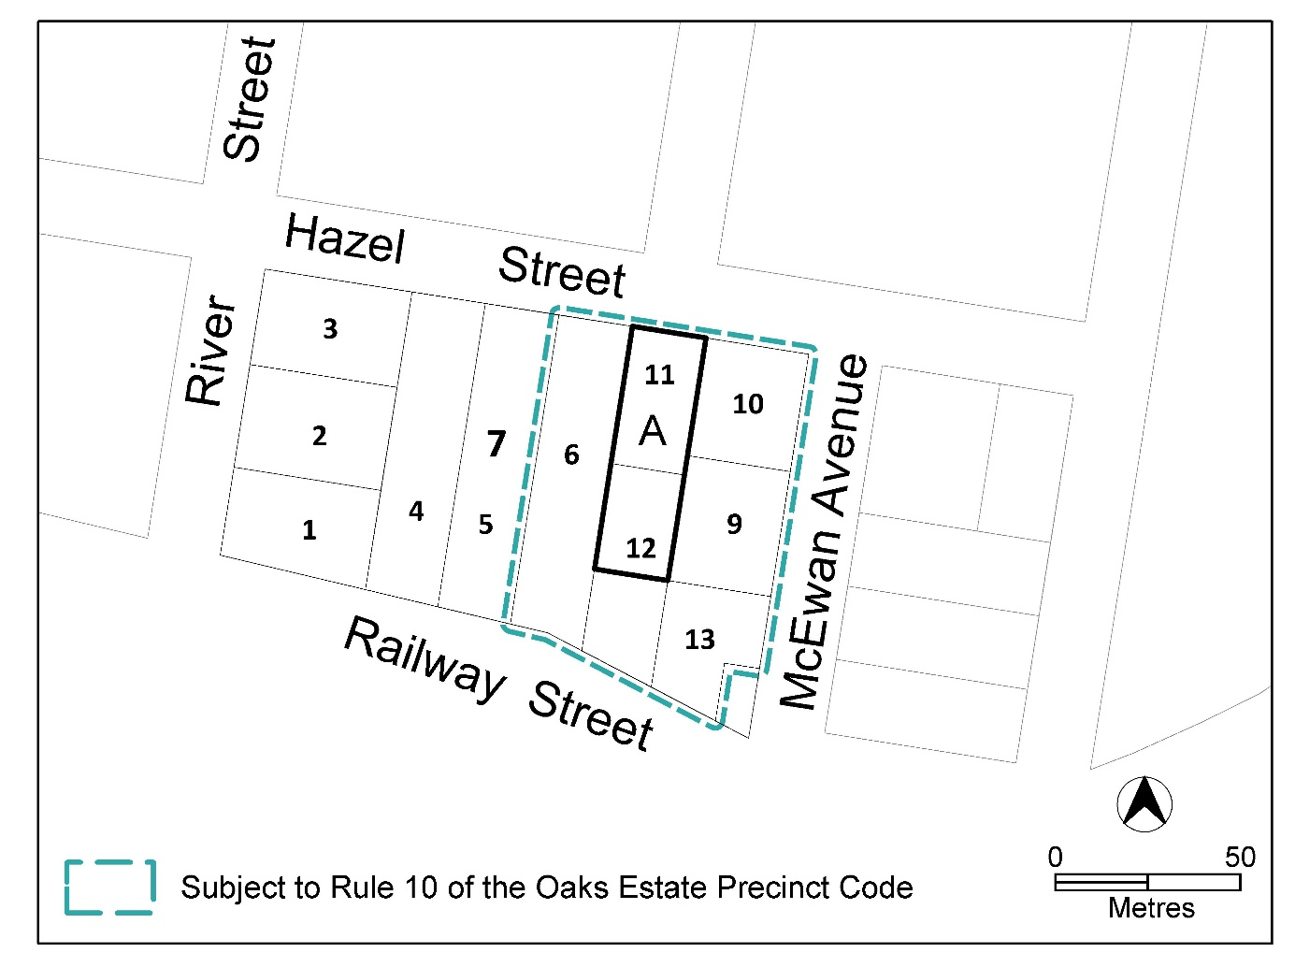
Figure 1 – Area A Robertsons’ House

RC2 – Residential Area
This part applies to blocks and parcels identified in area RC2 shown on the Oaks Estate Precinct Map.
Desired character
- development respects the historical rural village characteristics, scenic rural vistas and heritage values of Oaks Estate
- front boundary setback for development on single dwelling blocks reflect the existing varied setbacks in the area
- front fences reflect the existing character of the area, provide opportunities for views into and out of the site and ensure safe vehicle and pedestrian movement
- Buildings
Rules | Criteria
  - Multi-unit sites
There is no applicable rule. | C16  The redevelopment of multi-unit dwelling sites respects the existing east-west orientation of the blocks and provides a built form width compatible with surrounding residential development.
R17  Maximum unarticulated street front facade length: 10m  Minimum articulation depth: 2m | C17  Front facades of multi-unit development are articulated to provide interest and ensure compatibility with the surrounding built form.

- Site
Rules | Criteria
  - Site coverage
R18  Maximum site coverage of single dwelling blocks: 35%. | This is a mandatory requirement. There is no applicable criterion.
  - Landscaping
R19  Development provides a minimum of 15% of the block area for deep root planting. | C19  Development retains sufficient open space for deep root plantings wholly contained within the block boundaries.
  - Front setbacks
There is no applicable rule. | C20  Front setbacks can differ in depth but must be consistent with the existing variations.

- Fencing
Rules | Criteria
  - Front fencing
R21  Transparent fences setback a minimum 1m to the front boundary are permitted, with a maximum height above datum ground level of 1.2m.  Note: for the purposes of this rule, transparent fences has the same meaning as in the Residential Boundary Fences General Code. | C21  Fencing setback to the front boundary may be reduced to 0m where it complies with all of the following:  - provides opportunities for passive surveillance of the street from the dwelling  - is compatible with the desired character  - does not obstruct sight lines for vehicles and pedestrians on verge areas in accordance with Australian StandardAS2890.1- Off-Street Parking.

RC3 – Community Hall
This part applies to blocks and parcels identified in area RC3 shown on the Oaks Estate Precinct Map.
- Use
Rules | Criteria
  - Contamination
R22  An environmental assessment into the site’s suitability from a contamination perspective must be undertaken in accordance with the ACT Contaminated Sites Environment Protection Policy and be endorsed by the Environment Protection Authority prior to development or a change in use.  This rule does not apply if the Environment Protection Authority has provided written advice that the site has been assessed for contamination to its satisfaction. | This is a mandatory requirement. There is no applicable criterion.

