Australian Capital Territory
Planning and Development (Draft Variation 383) Consultation Notice 2022
Notifiable instrument NI2022—495
made under the
Planning and Development Act 2007, s 63 (Public consultation—notification)

- Name of instrument
This instrument is the Planning and Development (Draft Variation 383) Consultation Notice 2022.

- Draft variation to the Territory Plan
The planning and land authority (the Authority) has prepared a draft plan variation 383 – Kamberra Winery Estate Lyneham section 69 block 8 and section 71 blocks 18, 25, 27 and 28 Zone changes and amendments to the Lyneham Precinct Map and Code (the draft variation) to vary the Territory Plan.
The draft variation proposes to rezone block 8 section 69 and blocks 18 and 27 section 71 Lyneham from Non-Urban NUZ1 Broadacre zone to Commercial CZ5 Mixed Use zone to allow for a mix of commercial and residential uses, and to rezone blocks 25 and 28 section 71 Lyneham from NUZ1 Broadacre Zone to PRZ1 Urban Open Space Zone. The draft variation also proposes to make changes to the Lyneham Precinct Map and Code to introduce specific planning controls and provisions to guide future development on the site.

- Documents available for public inspection
(1) The Authority gives notice that the following documents are available for public inspection and purchase:
(a) the draft variation; and
(b) the background papers relating to the draft variation.
(2) Copies of the documents mentioned in section 3 (1) are available for inspection and purchase at Access Canberra Land, Planning and Building Services Shopfront, 8 Darling Street, Mitchell ACT, Monday to Friday (except public holidays) between 8:30am and 4:30pm for the period commencing on the day this notice commences and ending on 18 November 2022 (the consultation period).
(3) Copies of the documents mentioned in section 3 (1) are also available for inspection during the consultation period online at: www.act.gov.au/draftvariations.

- Invitation to give written comments

- The Authority invites written comments about the draft variation during the consultation period. Comments should include reference to the draft variation and be addressed to the Territory Plan Section of the Environment, Planning and Sustainable Development Directorate (EPSDD). Please also provide your name and contact details to assist in the assessment of the comments provided and to enable the Authority to contact you in relation to your comments, if required.
(2) Written comments should be provided to the Authority by:
(a) email to terrplan@act.gov.au; or
(b) mail to Territory Plan Section, EPSDD, GPO Box 158, Canberra, ACT 2601; or
(c) hand delivery to Access Canberra Land, Planning and Building Services Shopfront, 8 Darling Street, Mitchell ACT.
Note All personal information will be managed in accordance with the Information Privacy Act 2014 and the EPSDD Information Privacy Policy which are available through the EPSDD website.

- Public inspection of written comments
(1) Copies of written comments about the draft variation given in response to the invitation in section 4, or otherwise, or received from the National Capital Authority will be available (unless exempted) for public inspection for a period of at least 15 working days starting 10 working days after the day the consultation period ends, at Access Canberra Land, Planning and Building Services Shopfront, 8 Darling Street, Mitchell ACT, Monday to Friday (except public holidays) between 8:30am and 4:30pm and may be published on the EPSDD website at www.planning.act.gov.au.
(2) You may apply under section 411 of the Planning and Development Act 2007 (the Act) for part of your consultation comments to be excluded from being made available to the public. A request for exclusion under this section must be in writing, clearly identifying what you are seeking to exclude and how the request satisfies the exclusion criteria. Please note that your name and contact details and other personal information will not be made public unless you request otherwise.

- Effect of the draft variation
Section 65 of the Act does not apply in relation to the draft variation and therefore it does not have interim effect as a result of notification of this instrument. Where a draft variation does not have interim effect, the current Territory Plan will continue to apply.

- Obtaining further information
Further information about the draft variation can be obtained through email correspondence with the Territory Plan Section, EPSDD, at mailto:terrplan@act.gov.au. A reference to the draft variation should be included in any email.
- Dictionary
In this instrument:
draft plan variation 383 – Kamberra Winery Estate Lyneham section 69 block 8 and section 71 blocks 18, 25, 27 and 28 Zone changes and amendments to the Lyneham Precinct Map and Code means the draft plan variation in Schedule 1.

Dianne Stewart
Delegate of the planning and land authority
4 October 2022

Planning and Development Act 2007

Draft
Variation to the
Territory Plan
383

Kamberra Winery Estate
Lyneham section 69 block 8 and section 71 blocks 18, 25, 27 and 28

Zone changes and amendments to the Lyneham Precinct Map and Code

October 2022

Draft variation for public consultation prepared
under s60 of the Planning and Development Act 2007

Contents
1. INTRODUCTION 1
1.1 Summary of the Proposal 1
1.2 Outline of the process 2
1.3 Public Consultation 3
2. EXPLANATORY STATEMENT 4
2.1 Background 4
2.2 Site Description 6
2.3 Current Territory Plan Provisions 7
2.4 Proposed Changes 8
2.4.1 Proposed Changes to the Territory Plan Map 8
2.4.2 Proposed Changes to Territory Plan 9
2.5 Reasons for the Proposed Draft Variation 9
2.6 Planning Context 10
2.6.1 National Capital Plan 10
2.6.2 ACT Planning Framework 10
2.7 Interim Effect 12
2.8 Consultation with Government Agencies 13
3. DRAFT VARIATION 24
3.1 Variation to the Territory Plan map 24
3.2 Variation to the Territory Plan 25

- INTRODUCTION
  - Summary of the Proposal
The draft variation proposes to:
- allow the redevelopment of block 8 section 69 and blocks 18 and 27 section 71 Lyneham for a mix of commercial and residential uses. To permit this change in use:
  - the blocks will be rezoned from Non-Urban NUZ1 Broadacre zone to Commercial CZ5 Mixed Use zone
  - introduce new rules and criteria into the Lyneham Precinct Map and Code to guide future Estate Development Plan and individual building Development Applications. The new provisions relate to, among other things: limits on the scale of residential and non-residential uses, setbacks to and protection of the ecological and riparian values of the Sullivans Creek corridor, the location and design of open space areas and internal active travel connections.
- implement the relevant planning recommendations of the City and Gateway Urban Design Framework which include active travel routes, building heights and building setbacks.
- implement the relevant planning recommendations of the ACT Climate Change Strategy 2019-2025 and Canberra’s Living Infrastructure Plan: Cooling the City. These provisions relate to tree canopy cover, urban heat and sustainable building design assessments.
- incorporate minor changes or clarifications to provisions to align the Territory Plan with the National Capital Plan where relevant to the Kamberra site
- rezone blocks 25 and 28 section 71 Lyneham from NUZ1 Broadacre Zone to PRZ1 Urban Open Space Zone.

  - Outline of the process
.The Commonwealth’s Australian Capital Territory (Planning and Land Management) Act 1988 allows for the Legislative Assembly to make laws to establish a Territory Planning Authority and for that Authority to prepare and administer a Territory Plan. The Planning and Development Act 2007 (the Act) establishes the planning and land authority as the Authority that prepares and administers the Territory Plan, including continually reviewing and proposing amendments as necessary. The functions of the planning and land authority are administered by the Environment, Planning and Sustainable Development Directorate (EPSDD). The Director-General of EPSDD is the planning and land authority.
The Territory Plan is comprised of a written statement and a map. The written statement contains a number of parts, namely governance; strategic directions; zones (including objectives and development tables and zone or centre development codes); precinct codes; general codes; overlays; definitions; structure plans, concept plans and development codes for future urban areas.
The Territory Plan Map graphically represents the applicable land use zones (under the categories of residential, commercial, industrial, community facility, urban parks and recreation, transport and services and non-urban), precincts and overlays. The zone, precinct and overlay requirements are detailed in the Territory Plan.
Draft variations to the Territory Plan are prepared in accordance with the Act. Following the release of the draft variation under section 63 of the Act, submissions from the public are invited. At the conclusion of the consultation period the EPSDD (planning and land authority) submits a report on consultation and a recommended final variation to the Minister responsible for planning for referral to the Legislative Assembly standing committee responsible for planning. The Minister must consider any recommendations of the committee before deciding whether to approve the draft variation. If the Minister approves the variation, the variation and associated documents will be tabled in the Legislative Assembly. Unless disallowed by the Legislative Assembly within five sitting days, the variation commences on a day nominated by the Minister.

  - Public Consultation
Written comments about the draft variation are invited from the public by 18 November 2022.
Comments should include reference to the draft variation and be addressed to the Territory Plan Section, EPSDD. Please also provide your name and contact details to assist in the assessment of the comments provided, and to enable EPSDD to contact you in relation to your comments, if required. Your personal information will be managed in accordance with the Information Privacy Act 2014 and the EPSDD Information Privacy Policy, which is available for viewing on EPSDD’s website.
Comments can be provided by:
- email to terrplan@act.gov.au
- mail to Territory Plan Section, GPO Box 158, Canberra, ACT 2601
- hand delivery to the Access Canberra Land, Planning and Building Services Shopfront, 8 Darling Street, Mitchell ACT.
Copies of written comments received with respect to the draft variation will be made available for public inspection for no less than 15 working days starting 10 working days after the closing date for comment. The comments will be available at the Access Canberra, Land, Planning and Building Services Shopfront, 8 Darling Street, Mitchell ACT and will be published on EPSDD’s website. Comments made available will not generally include personal contact details unless you request otherwise.
A request may be made for parts of a submission to be excluded under section 411 or 412 of the Planning and Development Act 2007. A request for exclusion under these sections must be in writing, clearly identifying what parts of your submission you are seeking to exclude and how the request satisfies the exclusion criteria.
Further Information
The draft variation and background documents are available online at: www.act.gov.au/draftvariations until the closing date for written comments.
Printed copies of the draft variation (this document) and background documents are available for inspection and purchase at the Access Canberra Land, Planning and Building Services Shopfront, 8 Darling Street, Mitchell ACT, Monday to Friday (except public holidays) between 8:30am and 4:30pm. Please call 13 22 81 to arrange a copy for purchase.

- EXPLANATORY STATEMENT
  - Background
Block 8 section 69 and blocks 18 and 27 section 71 Lyneham
The blocks face onto the Federal Highway immediately south of the Flemington Road intersection. Block 18 section 71 has been developed as a Tourist Facility incorporating the Kamberra winery complex. Block 8 section 71 remains vacant and undeveloped, consisting of open disturbed grassland with no identified heritage or environmental values.
Block 27 section 71 Lyneham is a narrow, rectangular parcel of undeveloped land fronting onto the Federal Highway. It is being acquired by the Elvin Group. It is included in the parcel of land for development and forms part of the proposed changes in this draft variation.
All three blocks subject to the draft variation are currently zoned Non-Urban NUZ1 Broadacre zone.
The Kamberra site is now considered to be situated within an urban infill growth corridor due to its proximity to the Canberra Metro light rail route from Gungahlin to the City. Two light rail stops are located within walking distance from the site boundary.
Wine production at the site has ceased due to economic drivers in the wine industry and the business model of the company resulting in the discontinuation of the operation as a demonstration winery and associated tourism related activities.
Blocks 25 and 28 Section 71 Lyneham
It is proposed to rezone blocks 25 and 28 section 71 Lyneham from NUZ1 Broadacre Zone to PRZ1 Urban Open Space Zone to formalise the landscape buffer between the Kamberra Winery redevelopment and the Federal Highway.
The City and Gateway Urban Design Framework
The Australian Government through the National Capital Authority (NCA) and the ACT Government share planning responsibility in the ACT. The Framework was jointly prepared by the NCA and ACT Government to set the principles for development and growth in the city centre and along the gateway corridor of Northbourne Avenue and Federal Highway. The Framework provides a long-term vision and principles for this important location, drawing upon the legacy of historic planning and contemporary design.
Implementation of the planning recommendations of the Framework will require amendments to the Territory Plan. This draft variation seeks to implement the relevant planning controls recommended in the Framework for the site such as active travel routes, building heights and building setbacks.

Amendment 86 to the National Capital Plan
In May 2016, the National Capital Authority (NCA) revised its National Capital Plan (NCP) with Amendment 86.
Among other revisions to the NCP, Amendment 86 changed the strategic land use of the Kamberra site from ‘Broadacre Areas’ to ‘Urban Areas’. This change was instrumental in allowing the site to be used more intensively as envisaged in the City and Gateway Urban Design Framework and in this draft variation.

Amendments 91 and 93 to the National Capital Plan
In April and September 2019, the National Capital Authority (NCA) amended its National Capital Plan (NCP) with Amendments 91 (A91) and 93 (A93) respectively. A91 and A93 implemented parts of the Framework which were of interest to the NCA. Prior to this the Kamberra Winery site was subject to the NCA’s Development Control Plan for the site which essentially restricted the block to its current use, which is for a Tourist Facility incorporating the Kamberra winery complex.
The changes made through A91 and A93 allow the Kamberra Winery site to be used more intensely in line with the principles of the Framework.
This draft variation makes minor changes or clarifications to provisions to ensure consistency with the National Capital Plan, particularly Part 4.28 City and Gateway Corridor.

ACT Climate Change Strategy 2019-2025 & Canberra’s Living Infrastructure Plan: Cooling the City
The ACT Climate Change Strategy 2019-2025 (CCS) and Canberra’s Living Infrastructure Plan: Cooling the City (LIP) outlines the high and mid-level principles to reduce greenhouse gas emissions and support community resilience to the effects of climate change.
This draft variation includes environmentally sustainable design measures and living infrastructure provisions which align with the objects of the CCS and LIP.
  - Site Description
The subject site faces onto the Federal Highway to the east, immediately to the south of the intersection with Flemington Road. Block 18 section 71 has been developed as the Kamberra Winery complex, and block 8 section 69 consists of undeveloped vacant land. The site has a combined area of over 12 hectares.
The site is bounded by Flemington Road to the north, the landscape buffer blocks fronting onto the Federal Highway to the east (blocks 25 and 28 section 71 Lyneham), Sullivans Creek and Thoroughbred Park (Canberra racecourse) to the west and the Canberra Veterinary Hospital and Barton Highway to the south. Development to the east of the site across from the Federal Highway is characterised by low and medium density residential development.
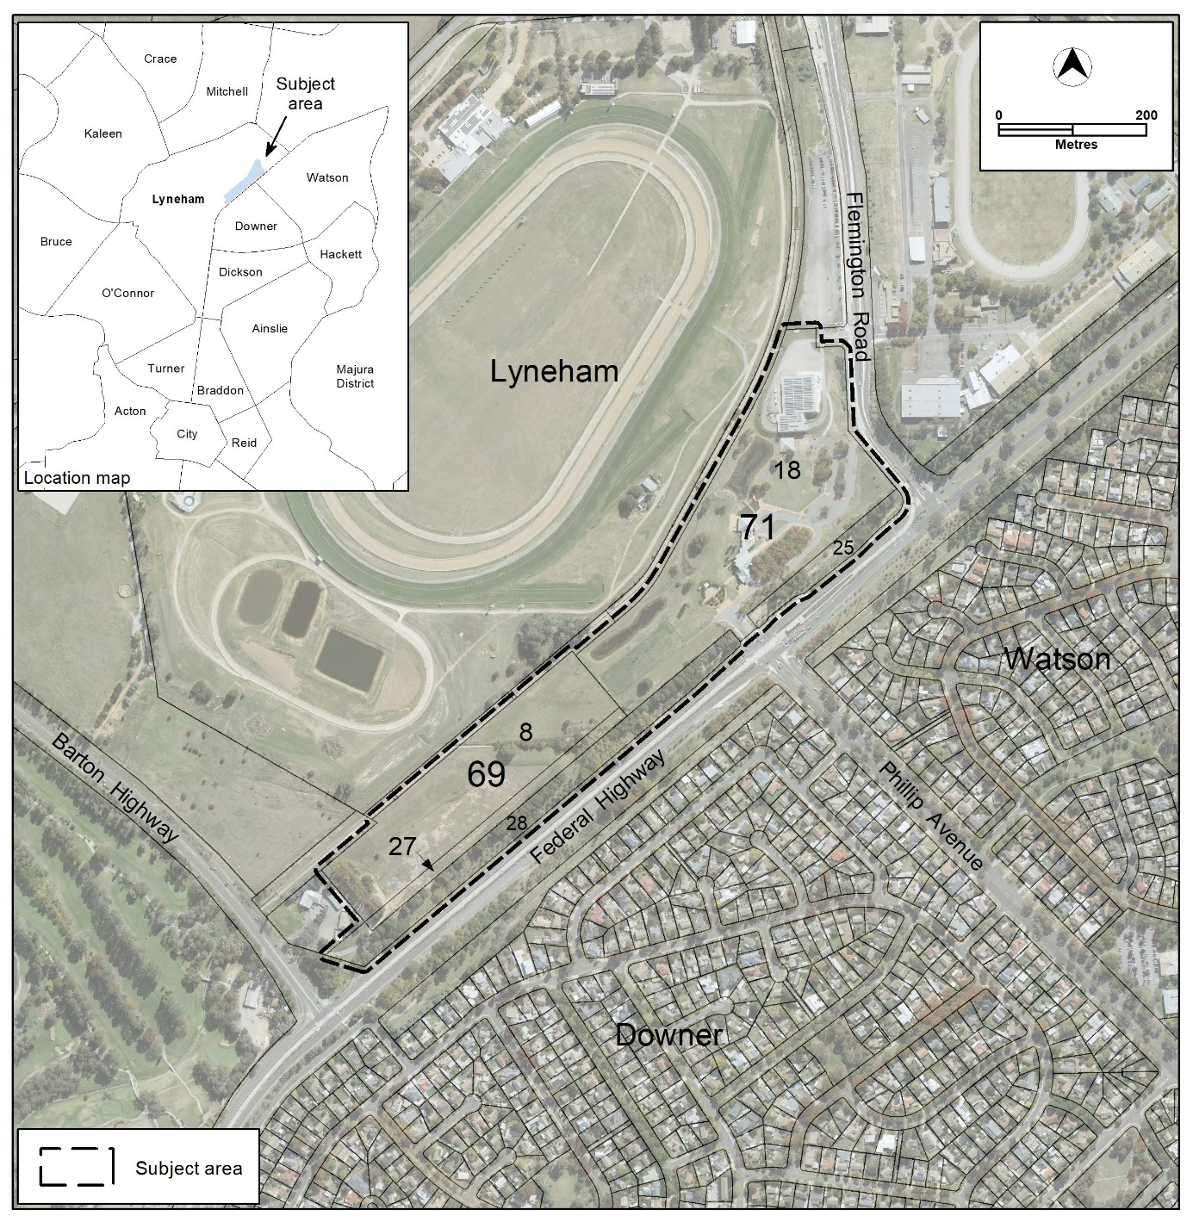
Figure 1 Location map
  - Current Territory Plan Provisions
The Territory Plan map for the area subject to this variation are shown in Figure 2.
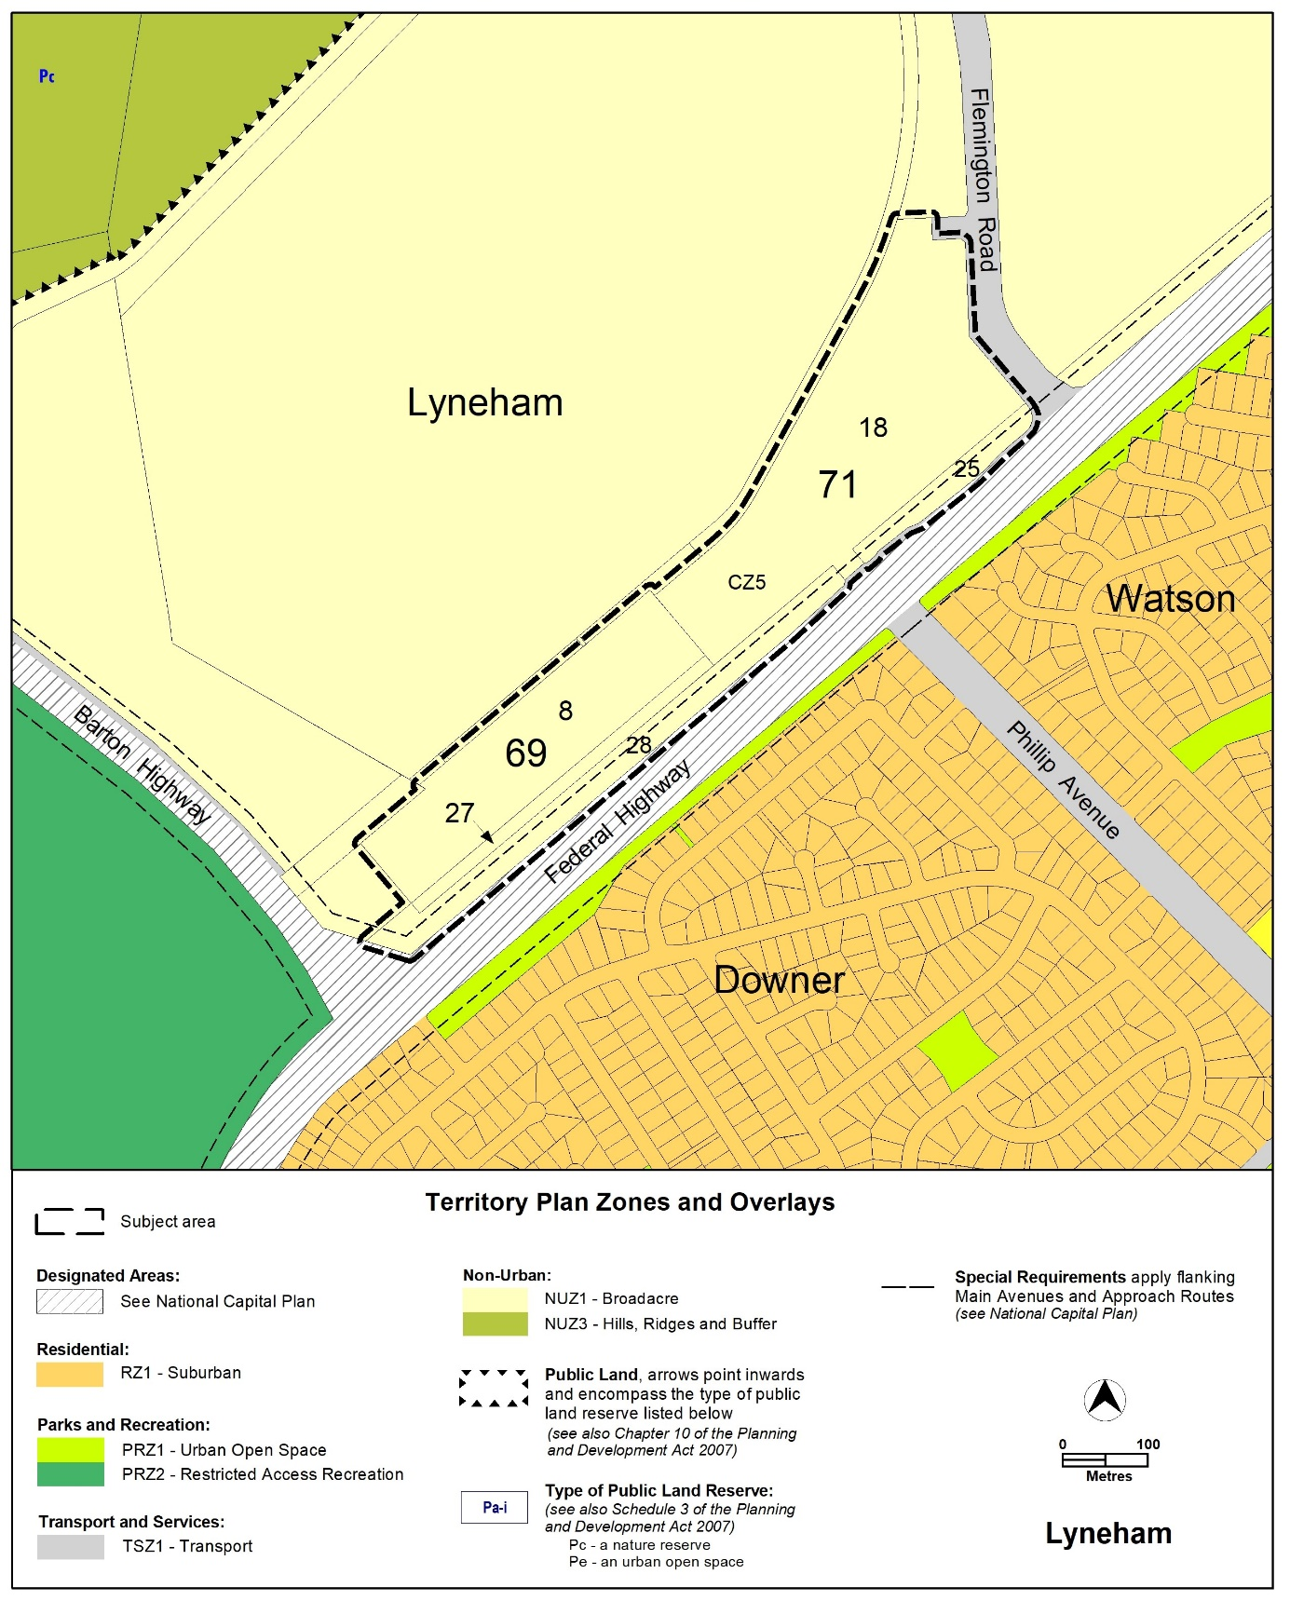
Figure 2 Current Territory Plan Zones Map

  - Proposed Changes
    - Proposed Changes to the Territory Plan Map
The proposed changes to the Territory Plan map are indicated in Figure 4 at Part 3 of this document and are detailed as follows:
- Rezone Lyneham section 69 block 8 and section 71 blocks 18 and 27 from Non-Urban NUZ1 Broadacre zone to Commercial CZ5 Mixed Use zone
- Rezone Lyneham section 71 blocks 25 and 28 from Non-Urban NUZ1 Broadacre zone to PRZ1 Urban Open Space Zone.
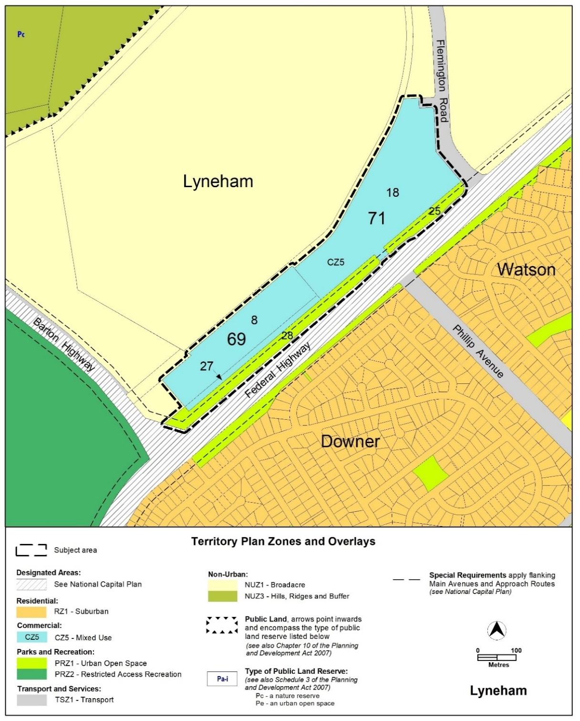
Figure 3 Proposed Territory Plan Zones Map
    - Proposed Changes to Territory Plan
This draft variation proposes to change the Territory Plan in the following ways:
- Introduce new provisions to the Lyneham Precinct Map and Code to require:
  - limits on the number of dwellings
  - limits on non-residential uses
  - a minimum area for community uses and open spaces
  - provision of active travel linkages
  - protection of the Sullivans Creek corridor
  - mitigation and minimisation of the effects of flooding
- implement the key planning policies set out in the City and Gateway Urban Design Framework for the site including active travel routes, building heights and building setbacks
- implement the key planning policies set out in the Climate Change Strategy and Canberra’s Living Infrastructure Plan. These provisions relate to tree canopy cover, urban heat and sustainable building design assessments
- changes to the Territory Plan to align with the National Capital Plan as varied by Amendments A91 and A93.

  - Reasons for the Proposed Draft Variation
The reasons for the draft variation are:
- incorporate the relevant planning policy recommendations of the City and Gateway Framework into the Territory Plan
- incorporate the relevant planning policy recommendations of the ACT Climate Change Strategy 2019-2025 (CCS) and Canberra’s Living Infrastructure Plan: Cooling the City (LIP) to promote development which will be adaptable in a changing climate
- facilitate the redevelopment of the Kamberra Winery site to promote a compact city by allowing additional residents and appropriate services to be located within close proximity to a vital transport corridor
- amend the Territory Plan to align with the National Capital Plan as varied by Amendments A91 and A93.
  - Planning Context
    - National Capital Plan
The Australian Capital Territory (Planning and Land Management) Act 1988 established the National Capital Authority (NCA) with two of its functions being to prepare and administer a National Capital Plan (NCP) and to keep the NCP under constant review and to propose amendments to it when necessary.
The NCP, which was published in the Commonwealth Gazette on 21 January 1990 is required to make sure that Canberra and the Territory are planned and developed in accordance with their national significance. The Planning and Land Management Act 1988 also required that the Territory Plan is not inconsistent with the NCP.
    - ACT Planning Framework
Statement of Strategic Directions
The Statement of Strategic Directions sets out the principles for giving effect to the main objective of the Territory Plan as required by the Planning and Development Act 2007. The proposal is consistent with the Territory Plan’s statement of strategic directions in terms of environmental, economic and social sustainability and spatial planning and urban design principles.
1.9 Urban expansion will be contained in order to minimise impacts on valuable natural and rural areas.
The draft variation facilitates the development of land which is centrally located and on an important transport corridor. The redevelopment of this site is located within the urban area and contributes to limiting urban expansion.
1.10 Integrated land use and transport planning will seek to maximise accessibility and transport efficiency, prioritise active travel, reduce energy consumption, increase physical activity, support the preferred pattern of development, promote safety, safeguard environmental quality, and minimise greenhouse gas emissions.
Light rail, integrated with the bus network, provides frequent, reliable and high-amenity public transport along the light rail corridor. This variation will facilitate redevelopment of the site to allow more residents to live in close proximity to this vital public transport corridor. The variation will also require walking and cycling connections in and around the site which will further increase options for sustainable movement along the corridor.
1.18A Development is planned to promote active living through the following six principles:
- providing connectivity between uses and activity nodes
- preserving open space
- encouraging mixed land use and density
- ensuring public places are safe and attractive for all
- providing supportive infrastructure that encourages regular physical activity
- ensuring environments promote social inclusion, and are equitable and where practicable are accessible by all.
The City and Gateway Urban Design Framework (the Framework) recognises the value of creating spaces that enable workers, residents and visitors to incorporate physical activity into their daily lives. In the Framework it is recommended that public spaces are designed to support safe, healthy and active lifestyles so that it is easy for workers, residents and visitors to be active in the urban environment on a daily basis for greater physical and mental health and wellbeing.
The draft variation will, among other things, require:
- generous setbacks and separation distances between buildings and for these spaces to be landscaped to a high quality
- a mix of dwellings to cater for a diversity of household sizes
- publicly accessible active travel routes, open spaces and pedestrian paths through the site.
2.5 A wide range of housing types will be permitted in identified residential areas close to centres and major transport routes to increase choice; maximise opportunities for affordable housing; and secure some intensification of development consistent with maintaining residential amenity. Outside of these areas, planning policies will protect typically low density, garden character of Canberra’s suburban areas.
The draft variation requires a variety of dwelling types, including requirements for dwellings to contain one, two and three bedrooms and alternative layout requirements. As the site is separated from nearby suburban residential development in Downer and Watson by a landscape buffer and the Federal Highway, the impact on the amenity of residents is considered to be minimal.

2.7 Development will be planned to encourage use of public transport, walking and cycling, including commuter cycling. Routes will be reserved for an enhanced inter-town public transport system. Requirements for vehicle parking will be relate to commercial needs and transport policy objectives.
The subject site is located along the light rail corridor and near the Sullivans Creek active travel route. The draft variation incorporates provisions requiring public pedestrian connections and active travel routes through the site to enhance these connections as well as public open spaces. In recognition of the location of the site and proposed additional connections, vehicle parking requirements will be expressed as a maximum rather than minimum amount. This will encourage more efficient use of the site, a range of dwelling options to create housing choice and encourage public transport use, commuter pedestrians and cyclists.
2.15 Policies will acknowledge Canberra as the national capital and the symbolic heart of Australia and will seek to preserve the landscape features that give the national capital its character and setting; respect and reinforce the key elements of Walter Burley Griffin’s formally adopted plan for Canberra within the proposed urban settlement pattern; enhance and strengthen approaches and backdrops to the city and its national institutions; conserve open space between urban areas as visual separation buffers consistent with the landscape setting; retain areas that are identified as the rural setting surrounding the city; and retain key vistas created by the landscape network within new settlement areas.
The Framework recommends that new development is focused in the city centre and along Northbourne Avenue/Federal Highway to reinforce the corridor’s significance as an important national approach route for the National Capital. It also recommends that the integrity of the Griffin plan’s visual structure is reinforced by strengthening the geometry and form of main avenues.
This variation will allow rejuvenation along the light rail corridor to create a distinctive approach to the National Capital and a sequence of progressively urban places that reinforces Canberra as a city within the landscape.
The draft variation is also consistent with the ACT Planning Strategy 2018 and ACT Transport Strategy 2020.
  - Interim Effect
Section 65 of the Planning and Development Act 2007 does not apply in relation to the draft variation so it does not have interim effect. The current Territory Plan will continue to apply while the variation remains in draft form.
  - Consultation with Government Agencies
The EPSDD is required to, in preparing a draft variation under section 61(b) consult with each of the following in relation to the proposed draft variation:
- the National Capital Authority
- the Conservator of Flora and Fauna
- the Environment Protection Authority
- the Heritage Council
- the Land Custodian, if the draft variation would, if made, be likely to affect unleased land or leased public land – each custodian for the land likely to be affected

National Capital Authority
The National Capital Authority (NCA) provided the following comments on the 4 March 2022:
“Thank you for the opportunity to comment on DV 383: Kamberra Winery Estate – Lyneham section 69 block 8 and section 71 blocks 18 and 27. The NCA notes that the draft variation also includes changes to Blocks 25 and 28 Section 71 Lyneham.”

Response
Noted.
Blocks 25 and 28 Section 71 Lyneham have been included in the title of the draft variation.

“Land use

The NCA does not object to the proposed re-zoning of land to CZ5 Mixed Use and PRZ1 Urban Open Space. These zones are not inconsistent with the Urban Areas land use category under the General Policy Plan – Metropolitan Canberra of the National Capital Plan (the Plan).”

Response
Noted.

“Relationship to the National Capital Plan

The explanatory statement of the draft variation notes that the proposed changes to the Territory Plan, in part are intended to ensure consistency with the Plan (which reflects the NCA’s interests in the City and Gateway Urban Design Framework).

The NCA is concerned that the Special Requirements in the Plan are inconsistently referenced. For example, some provisions of the Plan are replicated in full (for example, R100 concerning minimum floor areas for dwellings), in other cases provisions of the Plan are referenced but not included (for example, references to front boundary setbacks), and in other cases provisions of the Plan are not included or referenced at all (for example, landscaping, lighting, balustrade requirements, and signage).
During the progress of Draft Variation 368: City and Gateway Northbourne Avenue Corridor (DV368), the NCA understood that EPSDD was not seeking to replicate provisions of the Plan in the Territory Plan. Statements in the Northbourne Avenue Precinct Code noted the requirement for development to be not inconsistent with the provisions of the Plan, and the NCA supported the inclusion of a rule requiring submission of material addressing Plan provisions. The NCA notes that there is an introductory paragraph in the Lyneham Precinct Code which states that the development must not be inconsistent with the Plan, however the NCA requests that this be a rule in the code itself to ensure that proponents are aware of the need to ensure proposals are not inconsistent with these requirements. The NCA further suggests that the specific section of the Plan could be included for clarity. This rule could be accompanied by a similar criteria to that for Northbourne Avenue, requiring documentation demonstrating compliance against the Plan. (The NCA notes that Element 11 contains this rule, however is of the view that this may cause confusion as this criteria appears to relate to building controls and design only.)
The NCA also suggests that EPSDD explore criteria that would ensure provisions of the Plan are met. For example, the NCA frequently comments on plans concerning natural ventilation, with a view that what proponents present does not always demonstrate cross ventilation and will not achieve intended outcomes. Criteria could clarify in what circumstances dwellings would achieve natural cross ventilation (including for example through the use of diagrams or reference to external documents).”
Response

Noted.

The location of the statement in the Introduction of the precinct code that development must not be inconsistent with the National Capital Plan (NCP) is considered to be the appropriate location.
The rule in Element 11 has been relocated to the front of the RC2 section of the precinct code for Kamberra Estate to clarify up front that the NCP provisions are to be complied with for all aspects of development. The specific part of the NCP is also included in the wording, to provide further clarity.
The design guideline being prepared as part of the Territory Plan review is considering matters such as demonstrating that adequate cross ventilation can be achieved in a design solution.
“Design quality

In response to DV368, the NCA commented on the extent of design quality provisions within the draft variation, particularly given the focus of this in the City and Gateway Urban Design Framework and Amendment 91 to the Plan. Comments raised in response to DV368 are relevant to DV383.
The NCA has concerns that provisions of the Plan are not adequately considered during design development or during assessment, and that inclusion of design quality criteria in the Territory Plan may assist. This is a key matter where improvements could be made prior to DV383 progressing.
EPSDD’s response to these comments in the past has been that the provisions relating to design quality are consistent with requirements of the Plan, and development will still need to comply with relevant development code provisions. Further, it has been noted that design quality provisions will be considered for inclusion in the future review of the Territory Plan to apply across Canberra.
The NCA is aware that there are high level provisions within development codes (for example, the Commercial Zones Development Code) referring to ensuring that the massing, scale, colours, materials used for buildings result in high quality design outcomes. There appear to be few subsequent, more specific provisions concerning the matter. The provisions of DV383 do not address excellence in design. The few mentions of quality relate to the use of materials and treatments for parking structures, courtyard walls, and public realm design for access arrangements only, or are only briefly mentioned in criteria with little guidance.
Since the commencement of the National Capital Design Review Panel (NCDRP), multiple development proposals within the City and Gateway Corridor have been subject to panel review. Panel advice frequently refers to the need to improve design quality in architecture, landscape design, and the public realm.

The NCA’s preference is that EPSDD should include design quality provisions for the site ahead of a review of the Territory Plan as broader changes may be some time in the future. DV383 provides the opportunity to do so now and start improving outcomes along the corridor. This would better address broad government objectives concerning urban design (for example, section 2.14 of the ACT Government’s Statement of Strategic Directions).”
Response

Noted.

It is preferable to consider design requirements holistically and not specify provisions for specific sites. It is anticipated that the new Territory Plan will have commenced before development applications for individual buildings on the site are submitted.

“Sustainable development

Past engagement with the proponent indicated that development of the site would include a strong commitment to alternative, sustainable development practices. For example, innovative construction methods, high proportion of open space designed with WSUD features, and regenerative development practices.
The draft variation does not appear to contain anything which would commit the proponent to delivering their previously stated objectives.”
Response

Noted.
The criteria under the Environmentally Sustainable Design (ESD) provision in the precinct code requires the proponent to demonstrate that sustainable development measures have been incorporated into the development such as: energy efficiency, including passive design, water efficiency, reducing greenhouse gas emissions, active and sustainable transport, living infrastructure, and urban design, including building materials and finishes.
The Waterways: Water Sensitive Urban Design General Code requires the development to achieve the necessary WSUD targets and provide details of the strategies to be implemented to ensure improved environmental sustainability on the site.

“Floor to ceiling heights
R96 proposes minimum floor-to-ceiling heights for Area A of Figure 4 that vary from National Capital Plan floor-to-ceiling height requirements. Whilst this is not inconsistent with the Plan (Area A is outside the area subject to Special Requirements), it creates a situation whereby buildings on the same site are subject to different floor-to-ceiling requirements and creates an undesirable regulatory framework.
Floor-to-ceiling requirements in the Plan and the City and Gateway Urban Design Framework are intended to improve the quality of new buildings and produce lighter and more liveable indoor spaces. The NCA suggests that floor-to-ceiling height requirements should be consistent across the site to help improve the quality of all living environments.”
Response
Noted and agreed.
The controls have been amended accordingly, so that the same requirements apply across the entire site.
R96 has been renumbered to R97.
“Contextual consideration
The Kamberra Winery site is adjacent to the racecourse, which the NCA understands is trying to progress their own Territory Plan variation. The NCA has previously commented on referrals from EPSDD that with the Yowani, Kamberra Winery, and Thoroughbred Park sites all anticipating higher density residential and commercial development, some coordination is required to improve outcomes for the area.
The NCA has some concern that DV383 does not appear to anticipate development on the adjacent Thoroughbred Park site. For example, DV383 requires a single mid-block link on the Phillip Avenue alignment. The Thoroughbred Park proposal anticipates development further to the south-west; it would seem logical to require connections links in proximity to this. In addition, the length of the Kamberra Winery site would seem to warrant more than one link. The NCA acknowledges that the proponent may include more than one link, but this could be ensured by including a requirement in the DV383.”
Response
Noted.
The provision of an additional mid-block link has been included as a requirement in the relevant controls.

“Other matters

- The Explanatory Statement contains reference to Amendments 91 and 93 to the Plan. It may also be worth referring to Amendment 86 which changed the strategic land use of the site from ‘Broadacre Areas’ to ‘Urban Areas’. This change was critical allowing the site to be used more intensively as envisaged in the City and Gateway Urban Design Framework and DV383.”

Response
Agreed.
The Explanatory Statement has been amended to reference Amendment 86.

- “Pg 4 – The Background section references The City and Gateway Draft Urban Design Framework. This is no longer draft and the title should be updated to reflect this.”
Response
Agreed.
The reference to ‘draft’ in the background section has been removed.

- “Criteria 112 e) – this criteria is not applicable as the site fronts Federal Highway, not Northbourne Avenue. There is no rear road access.”
Response
Agreed.
C112 e) has been removed.

- “Criteria 117 a) – this criteria references Northbourne Avenue and Swinden Street; this should be Federal Highway and Flemington Road frontages.”

Response
Agreed.
Change has been made to reference Federal Highway and Flemington Road frontages. C117a) has been renumbered to C121a).

- “Criteria 102 – the comparable requirement for the Yowani site is framed as a rule. The criteria is of a nature that it could be framed as a rule, which would also maintain consistency between the criteria for both the Yowani and Kamberra Winery sites.”

Response
Agreed.
The provision relating to housing diversity has been re-framed as a rule, consistent with the similar control for Yowani. C102 has also been renumbered to R103.

- “The NCA recommends that Lyneham Precinct Map and Code R40 and R41 is duplicated for the Kamberra Winery site to ensure minimum residential living quality along the corridor is consistent.”
Response
Agreed.
The rules and criteria relating to internal dwelling and building design have been included in the precinct code for Kamberra.

- “Element 9.9 Tree retention and canopy cover – the Special Requirements in the Plan have a number of specific requirements regarding tree planting in the front setback to Federal Highway. The Rules/Criteria should reference this or include details about minimum mature height of trees (15 metres), tree spacing and tree species (should be endemic to the Canberra Region and reaching 20 metres).”
Response
Noted.
The rule requiring demonstrated compliance against the relevant special requirements of the National Capital Plan, namely Part Four (B) – Special Requirements for Territory Land; Section 4.28 City and Gateway Corridor, has been located at the beginning of the provisions for the RC2 Kamberra Estate area in the precinct code. This will require the proponent to demonstrate that the specific requirements regarding tree planting in the front setback to Federal Highway are addressed.

Conservator of Flora and Fauna
The Conservator of Flora and Fauna provided the following comments on the 7 March 2022:
“In accordance with Section 61(b) of the Planning and Development Act 2007 I advise that I have examined Draft Variation No 383, Kamberra Winery Estate, that proposes zone changes and amendments to the Lyneham Precinct Map and Code.
The proposed rule 69 relates to Sullivans Creek and is concerning as it includes a requirement for a setback of only 6 metres (or 1% AEP). This is not consistent with the broader objectives set in the ACT, including:
- Good waterway management (functioning riparian zones provide for water quality improvement);
- Wildlife connectivity (6 metres is too narrow for many species to exist, or even effectively move through);
- Active travel (this width does not leave many options for active travel solutions); and
- Living infrastructure (offers little opportunity for canopy cover, shading etc.).
Ecological connectivity is necessary for the functionality of ecosystems, is key for the survival of animals and plants and is crucial to ensuring genetic diversity and supporting adaptation to a changing climate, allowing species to adapt and shift across the landscape. Additionally, restoring waterways provides a natural buffer against floods.
A 6 metre setback does not preserve the values associated with a riparian zone and will result in several negative outcomes. A requirement for a setback of approximately 20 metres would result in improved outcomes and consistency with the above objectives.”
Response
Noted.
A rule has been introduced to require a setback of 20 metres. An associated criterion has also been introduced, requiring the proponent to demonstrate that all the ecological values related to the restoration and functionality of the riparian zone and wildlife connectivity, sufficient room for active travel, adequate provision of living infrastructure including tree canopy cover, etc can be met, should the proponent wish to provide a lesser setback.

Environment Protection Authority
The Environment Protection Authority (EPA) provided the following comments on 11 August 2022:
The EPA has significant concerns about the potential for a proposed development in this location due to noise from activities at the Thoroughbred Park and EPIC [Exhibition Park In Canberra] sites. Prior to the EPA being able to support sensitive land use activities including residential, hotel and commercial accommodation on the subject site, noise impacts from the EPIC and Thoroughbred Park sites must be fully investigated and resolved.

The EPA would support rules in the Territory Plan requiring an Estate Development Plan to be prepared that only permits sensitive land use activities on areas of the site unimpacted by noise from the surrounding sites. Areas of the site that are determined through independent acoustic assessment to be impacted must be prohibited from sensitive land use activities. Compatible land use activities such as shops, restaurants, bars, offices, gyms, certain community facilities etc would be supported in the noise impacted areas of the site noting those buildings hosting those activities would be required to be designed to ensure those activities comply with noise limits as outlined in schedule 2 of the Environment Protection Regulation, 2005.

The independent acoustic assessment required to inform the estate development plan would need to consider all current and permitted activities at the EPIC and Thoroughbred Park sites and should be supported by those stakeholders following appropriate consultation.

Response
A mandatory rule is proposed to be included in the precinct code that requires the preparation of an acoustic assessment and noise management plan to be endorsed by the EPA. The noise management plan is to include as inputs real world monitoring of the noisy events at EPIC and Thoroughbred Park. This applies to all development on the site and is not limited to an Estate Development Plan (EDP) development application.
Additionally, a rule is proposed to be added in the precinct code that only permits land use activities that are non-sensitive to noise, such as restaurant, shop and drink establishment, within 100m of the boundaries to EPIC and Thoroughbred Park. Residential use and commercial accommodation use within the 100m boundaries are not permitted, unless an independent acoustic assessment, endorsed by EPA, demonstrates they will be unimpacted by noise from these established neighbouring uses.
In relation to contamination, this issue will be addressed by the proposed mandatory rule in the precinct code for an environmental assessment report for the development to be endorsed by the EPA.
To create internal roads in the Kamberra site an EDP will be required. If during the EDP process any specific controls are identified to be applied to particular parts (for instance to prohibit uses that would otherwise be permitted or to require particular additional setback requirements) these can be added to the precinct code following the approval of the EDP through a technical amendment. This could include controls that address matters raised in an acoustic study for the site.

ACT Heritage Council
The Heritage Council provided the following comments on 1 March 2022:
“On 8 February 2022, a Draft Variation to the Territory Plan (DV383) was referred to the ACT Heritage Council (the Council) for entity advice.
DV383 relates to the ‘Kamberra Winery’ site in Lyneham and consists of:
- Rezoning of Block 8 Section 69 and Blocks 18 and 27 Section 71 Lyneham from Non-Urban NUZ1 Broadacre Zone to Commercial CZ5 Mixed Use Zone;
- Rezoning of Blocks 25 and 28 Section 71 Lyneham from Non-Urban NUZ1 Broadacre Zone to Parks and Recreation PRZ1 Urban Open Space Zone;
- Within Block 8 Section 69 and Block 18 Section 71 Lyneham, permitting additional uses, including drink establishment, indoor entertainment facility, craft workshop, produce market, tourist facility, and tourist resort; and
- Introducing various controls and provisions into the Lyneham Precinct Code for estate planning, site, building, environment, use, parking, and active travel considerations.
In relation to heritage, DV383 would include Rule 123 in the Lyneham Precinct Code, which will require an ‘Unanticipated Discovery Protocol’ endorsed by the Council for any future development.
The project’s Planning Report also recognises that, while the original Sullivans Creek alignment has been modified, it does have Aboriginal heritage associations. In this context, prior Council advice on the Planning Report, issued on 12 May 2020, encouraged opportunities to promote the Aboriginal history and heritage of the area as part of the future development, noting the National Capital Plan requirement that: “Development adjacent to Sullivans Creek must assist in enhancing Sullivans Creek as a multi-functional creek corridor that enhances environmental values, improves ecological connectivity and wildlife, and integrates Aboriginal heritage and culture into its design”.
The potential heritage values of the subject area were originally assessed by Navin Officer Heritage Consultants in a 2016 Cultural Heritage Assessment (CHA). This CHA identified an area of archaeological sensitivity within Block 8 Section 69 Lyneham, and set out that if the area retained undisturbed topsoil, Aboriginal places and objects could occur, given its landform context and proximity to the original Sullivans Creek alignment.
Further assessment of this area is described in a 2019 CHA by Navin Officer Heritage Consultants, which concludes that it has been highly disturbed and unlikely to contain Aboriginal places and objects. A 2021 statement from Navin Officer Heritage Consultants also confirms that there are no undisturbed areas of land within the development area.
The Council notes this finding, and observes that historic aerial photographs also show disturbance of the area, particularly associated with the channelling of Sullivans Creek in the early 1970s. However, the Council also notes that the 2016 and 2019 CHAs and the 2021 statement do not set out the views of Representative Aboriginal Organisations (RAOs) regarding the area of archaeological sensitivity and its reassessment; and that no effort to seek RAO views on the proposal has been made since 2016.
Advice:
Following review of DV383, the Council does not object to the proposed Variation to the Territory Plan, subject to the following conditions:
- Prior to seeking development approval for works within Block 8 Section 69 and Blocks 18 and 27 Section 71 Lyneham:
  - Further consultation with RAOs is required regarding the findings and recommendations of the 2016 and 2019 CHAs; and
  - Outcomes of this consultation are to be submitted to the Council, for further advice on any Heritage Act 2004 considerations for proposed development.
- Opportunities to promote the Aboriginal history and heritage of Sullivans Creek in the future development are encouraged, in accordance with the National Capital Plan.”
Response
- A provision has been included in the precinct code that requires further consultation with RAOs regarding the findings and recommendations of the 2016 and 2019 CHAs; and that outcomes of this consultation are to be submitted to the Council, for further advice on any Heritage Act 2004 considerations for proposed development.
- Any development must be in accordance with the special requirements as detailed in the National Capital Plan, including opportunities to promote the Aboriginal history and heritage of Sullivans Creek in the future development.

Land Custodian (TCCS – City Presentation)
The Land Custodian provided the following comments on 30 March 2022:
“TCCS City Presentation is supportive to this proposed Draft Variation 383: Kamberra Winery.”
Response
Noted.
- DRAFT VARIATION
  - Variation to the Territory Plan map
The Territory Plan map is varied as indicated in Figure 4 for the area shown as subject to the draft variation.
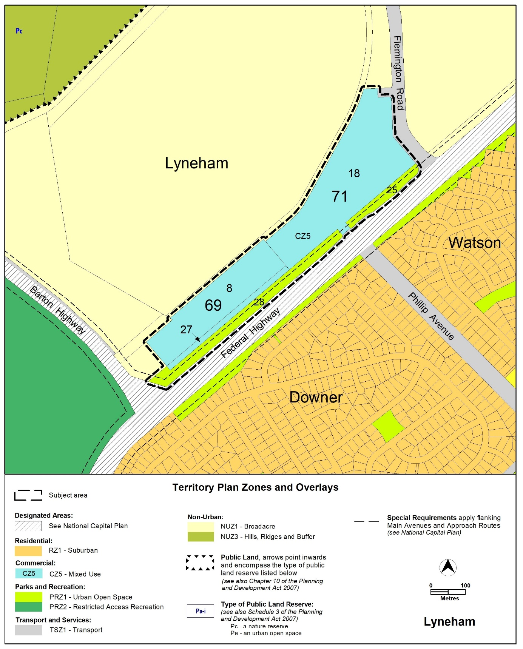
Figure 4 Variation to the Territory Plan map
  - Variation to the Territory Plan
The Territory Plan is varied in all of the following ways:

Lyneham Precinct map and code
- Lyneham Precinct Map

Substitute
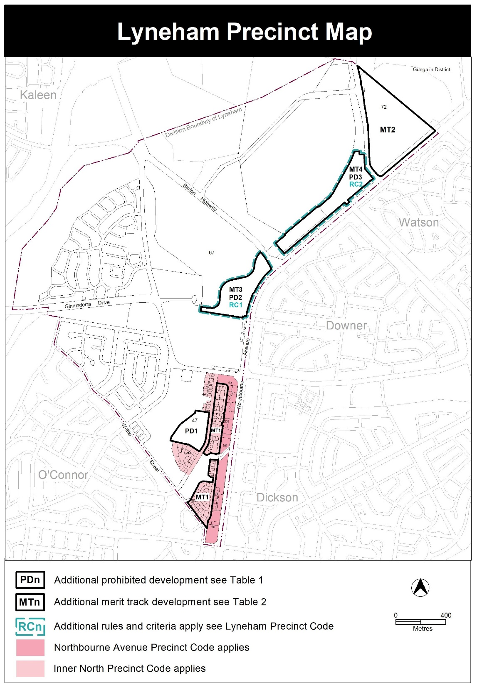
- Table 1: Additional Prohibited Development

Insert
PD3 | CZ5 | bulky goods retailing  department store  secondary residence  single dwelling housing

- Table 2: Additional Merit Track Development

Insert
MT4 | CZ5 | craft workshop  drink establishment  indoor entertainment facility  produce market  tourist facility  tourist resort

- Lyneham Precinct Code

Insert

RC2 – Kamberra Estate
This part applies to blocks and parcels identified in area RC1 shown on the Lyneham Precinct Map.

- National Capital Plan
Rules | Criteria
  - National Capital Plan
R67  This rule applies to development which is subject to the National Capital Plan.  Development applications are supported by written documentation demonstrating compliance against the relevant special requirements of the National Capital Plan, namely Part Four (B) – Special Requirements for Territory Land; Section 4.28 City and Gateway Corridor. | This is a mandatory requirement. There is no applicable criterion.

- Estate planning
Rules | Criteria
  - Sullivans Creek
There is no applicable rule. | C68  This criterion applies to land contained within the setback area to Sullivans Creek identified in R95/C95.  Development complies with all of the following (where relevant):  - maintain or increase flood conveyance capacity and storage volume for Sullivans Creek  - create and maintain opportunity for flora and fauna habitat and movement  - provide a landscape setting to improve visual and environmental amenity  - provide an infrastructure corridor for existing and future utility services  - demonstrated adequate space for active travel routes and open spaces for the use and enjoyment of the local community and commuters  - improve the landscape quality and setting on Sullivans Creek through the use of natural construction materials and vegetation  - development of b) and d) is completed prior to or at the same stage as surrounding residential development.  Note: The planning and land authority may consult, where relevant, with TCCS and other areas of EPSDD (or future relevant agencies) when determining compliance with this criterion.
There is no applicable rule. | C69  This criterion applies to land contained within the setback area to Sullivans Creek specified in R95/C95.  Development is limited to:  - works to mitigate flooding  - works which maintain or increase flood conveyance capacity and storage volume for Sullivans Creek  - landscaping or minor public infrastructure to improve visual and environmental amenity  - high quality and visually interesting screening of utility or flood mitigation works and infrastructure  - works relating to utility infrastructure that take place predominantly or entirely below natural ground level  - works to promote active travel and/or public open areas for recreation and leisure  - communal open space, private open space and courtyard walls required by a development code  - works to increase ‘naturalisation’ of Sullivans Creek through the use of natural construction materials and vegetation.  For the purpose of this criterion ‘naturalisation’ means changing the appearance and functionality to more closely represent natural characteristics.  Note: The planning and land authority may consult, where relevant, with TCCS and other areas of EPSDD (or future relevant agencies) when determining compliance with this criterion.
R70  This rule applies to the following:  - filling within one of the following (whichever is greater):  - 1% AEP (once in 100 year) flood extent for Sullivans Creek  - 20 metres of Sullivans Creek stormwater easement  - compensatory excavation to offset filling specified in a)  - reducing or increasing flood conveyance capacity and storage volume for Sullivans Creek  - increased ‘naturalisation’ of Sullivans Creek through the use of natural construction materials and vegetation.  Development complies with all of the following:  - is endorsed by TCCS  - is prepared by a ‘suitably qualified professional’  For the purpose of this rule ‘naturalisation’ means changing the appearance and functionality to more closely represent natural characteristics.  For the purposes of this rule a ‘suitably qualified professional’ is familiar with analysis of flooding along watercourses and design of development to manage flood risks.  Note: The planning and land authority may consult, where relevant, with TCCS and other areas of EPSDD (or future relevant agencies) when determining compliance with this rule. | C70  If TCCS endorsement is not provided the application will be referred to TCCS for endorsement.
R71  This rule applies to development wholly or partially within 1% AEP (once in 100 year) flood extent for Sullivans Creek.  Development of the RC2 area is consistent with a flood risk study, prepared by a ‘suitably qualified professional’ and endorsed by TCCS, which adequately demonstrates all of the following:  - protections for ongoing safety of the public against impacts of floods are provided  - protections for property against the impacts of floods are provided  - the RC2 area is planned and developed with consideration for flood risks  - where flood impacts on development exceed 20m from the centreline of the Sullivans Creek stormwater easement, identification of a minimum setback for development to inform R95/C95.  For the purpose of this rule a ‘suitably qualified professional’ is familiar with analysis of flooding along watercourses and design of development to manage flood risks.  Note: The planning and land authority may consult, where relevant, with TCCS and other areas of EPSDD (or future relevant agencies) when determining compliance with this rule. | C71  If TCCS endorsement is not provided the application will be referred to TCCS for endorsement.
  - Site access and internal road layout
R72  The following is endorsed by TCCS:  - a transport impact assessment, prepared by a suitably qualified professional  - location, nature and number of new and existing external vehicular site access points to/from the RC2 area  - Sullivans Creek active travel connection.  Plans and drawings clearly demonstrate that the development is consistent with TCCS endorsements for a), b) and c).  Note: TCCS may endorse development or works in addition to items identified in this rule. | C72  If TCCS endorsement is not provided with the application or the plans and drawings are not consistent with rule, the application will be referred to TCCS for endorsement.
There is no applicable rule. | C73  The internal road layout for the RC2 area complies with all of the following:  - incorporates a parallel access street along Sullivans Creek  - prioritises pedestrians and cyclists particularly where the ‘internal pedestrian and bicycle network’, mentioned in C78, intersects with internal roads  - minimise the amount of road in favour of soft landscape areas.
  - Location of non-residential uses
There is no applicable rule. | C74  This criterion applies to development other than RESIDENTIAL USE.  Development is located to comply with all of the following:  - in close proximity to and easily accessible from site access points and the Phillip Avenue light rail stop  - after a) has occurred, along the Federal Highway primarily closer to the Phillip Avenue intersection  Note: this criterion does not preclude RESIDENTIAL USE from occurring in the above areas on the site.
  - Open space areas and travel routes - General
There is no applicable rule. | C75  This criterion applies to:  - ‘Sullivans Creek active travel connections’ identified in Figure 3  - ‘mid-block links’ and ‘end-block links’ identified in Figure 3  - ‘internal pedestrian and bicycle network’ mentioned in C78.  Development within the areas mentioned above comply with all of the following:  - provide safe, efficient and unimpeded public access to pedestrian and cyclists at all times  - identifies and provides the recreational and leisure needs of the local community  - where these areas intersect with roads and vehicular access ways, demonstrate how priority is given to pedestrians and cyclists through traffic calming measures such as slow speed areas, shared spaces and refuge islands  - provides adequate amenity and safety for uses of the area including soft landscaping, shade for warmer weather, access to sunlight (particularly in colder weather), adequate lighting (that does not impact on the amenity of adjoining development) and passive and perceived surveillance at all times  - development within these areas is limited to planting area, surface landscaping, buildings and structures which are consistent with active travel pathways or are open and do not limit accessibility  - all areas provide adequate irrigation for landscaped areas and high-quality fit-for-purpose paving and finishes  - are completed prior to or at the same stage as surrounding residential development.  Note: development within the ‘open space areas’ are to comply with the standards and requirements of the relevant ACT Government agency.
  - Estate open space areas
There is no applicable rule. | C76  Open space areas comply with all of the following:  - not predominantly located within the 1% AEP flood (once in 100 year) flood extent for Sullivans Creek  - demonstrate that the minimum area is adequate to accommodate the current and future residents, workforce and visitors to the site  Note 1: This criterion applies in addition to the rules and criteria for principal private open space, private open space and communal open space in the relevant development code.  Note 2: development within the ‘open space areas’ are to comply with the standards and requirements of relevant ACT Government agency.
  - Mid-block links and end-block links
There is no applicable rule. | C77  This criterion applies to the ‘mid-block links’ and ‘end-block links’ shown in Figure 3.  ‘Mid-block links’ and ‘end-block links’ comply with all of the following:  - are in a location generally in accordance with Figure 3 and aligns with the community path system through the area  - aligns with the light rail station and crossing points to reduce informal light rail crossings for cyclists and pedestrians (where relevant)  - provides unimpeded public pedestrian and bicycle access at all times from the Federal Highway to the Sullivans Creek ‘active travel connection’  - connects with the ‘internal pedestrian and bicycle network’ to provide a safe and efficient pedestrian and bicycle network  - a landscape corridor, which includes a path, approximately 10 metres wide but not less than 6 metres wide at any point to accommodate all likely users, and can accommodate potential future path widening without impacts on planted trees  - vehicular access is not permitted within or along the ‘mid-block links’ and ‘end-block links’.  Development of and within the ‘mid-block links’ and ‘end-block links’ is to be endorsed by TCCS where relevant.

Rules | Criteria
  - Internal pedestrian and bicycle network
There is no applicable rule. | C78  The internal pedestrian and bicycle network through the RC2 area complies with all of the following:  - provides an efficient and legible pedestrian and bicycle network through the site  - predominantly utilises routes which are not also used by vehicles  - aligns with light rail stations and crossing points to reduce informal light rail crossings for cyclists and pedestrians  - allows pedestrians and cyclists to travel between ‘open space areas’, ‘external active travel connections’, ‘mid-block links’, the existing light rail stops, light rail crossing points and community path system in the area  - a landscape corridor, which includes a path, . approximately 10 metres wide but not less than 6 metres wide at any point, and can accommodate potential future path widening without impacts on planted trees  Development of and within the internal pedestrian and bicycle network are to be endorsed by TCCS where relevant.
  - Active travel connection
There is no applicable rule. | C79  This criterion applies to the ‘Sullivans Creek active travel connection’ shown in Figure 3.  The ‘Sullivans Creek active travel connection’ complies with all of the following:  - the ‘Sullivans Creek active travel connection’ is in a location generally in accordance with Figure 3 and aligns with:  - the community path system through the area  - the light rail station and crossing points to reduce informal light rail crossings for cyclists and pedestrians  - provides unimpeded public pedestrian and bicycle access at all times for the length of the active travel connection shown in Figure 3  - exclusively utilises routes which are not also used by vehicles  - connects with the ‘internal pedestrian and bicycle network’ to provide a safe and efficient pedestrian and bicycle network  - is a landscape corridor approximately 10 metres wide but not less than 6 metres wide at the narrowest point and contains all of the following:  - a shared path for pedestrians and cyclists  - the landscape corridor and path are both adequate in width to meet the current and future demand of usage including potential future path widening without impacts on planted trees

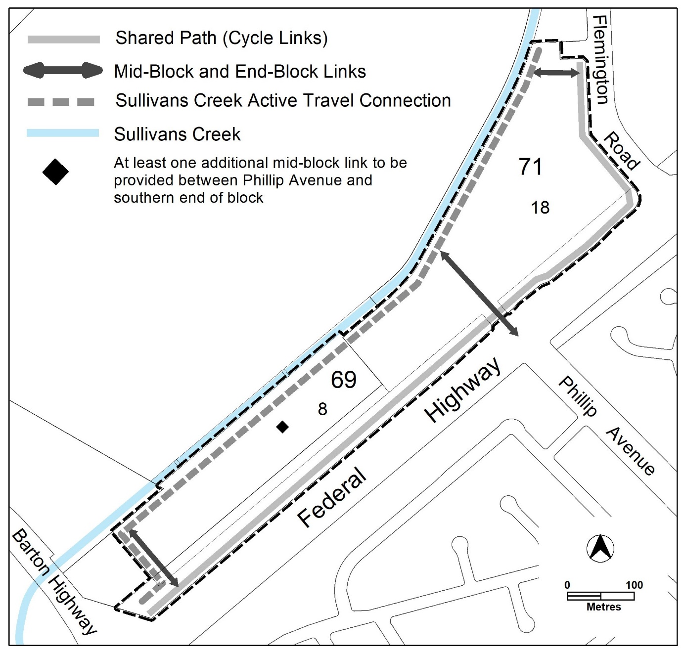

Figure 3 Active Travel Routes

Rules | Criteria
  - Tree retention and canopy cover
There is no applicable rule. | C80  Subdivision, block, building and site design demonstrates the following:  - retention of all existing high and medium quality trees  - where shown that a) cannot be achieved, trees removed are adequately replaced with new tree planting  Note: This criterion does not replace the provisions relating to tree protection in the relevant development code.
R81  Development demonstrates that a minimum of 30% of the RC2 area has or will have canopy tree cover measured at a mature height.  Note: Existing trees which are being retained may contribute towards the 30% requirement. | C81  Development demonstrates that a minimum 30% of the RC2 area has a combination of the following:  - at least half of the area required by this criterion contains canopy tree cover measured at a mature height  - the area of planting on green roofs (including rooftop gardens)  - the area of planting on external green walls, where measurement of the area of planting is taken along the vertical plane of the surface that contains the planting and vegetation.  For this criterion, the area of planting must:  - have a minimum dimension of 2.5m  - include watering (e.g. automatic irrigation) and maintenance systems to ensure survival of vegetation  - comprise vegetation which is easily maintained and is suited to the microclimate in which it is to be installed  - comprise vegetation (density and species selection) which is likely to have a positive summer cooling impact on the immediate urban environment  Note 1: existing trees contribute towards the canopy tree cover mentioned in a).  Note 2: trees planted on green roofs or in roof gardens can count towards canopy tree cover  Note 3: The calculations for the area of planting for this provision do not include any form of impermeable or non-living element (i.e. terraces, pergolas, patios, decks, pools, mechanical plant, (such as ventilation systems and lift over-runs), artificial lawn, gravel substrate and the like)
  - Block address
There is no applicable rule. | C82  The size and subdivision pattern of blocks demonstrates that a building with a high quality and interesting façade can be accommodated which addresses the following:  - open space areas,  - ‘mid-block links’ and ‘end-block links’, and the ‘internal pedestrian and bicycle network’ mentioned in C78  - ‘Sullivans Creek active travel connection’ and block boundaries to the Federal Highway, Flemington Road, and Phillip Avenue extension.
There is no applicable rule. | C83  Dwellings provide a high quality, interesting and visually appealing façade by providing active or passive surveillance through the use of balconies, screened and unscreened windows and access stairs to address the following (where relevant):  - open space areas,  - mid-block links’ and ‘end-block links’ and ‘internal pedestrian and bicycle network’ mentioned in C78  - ‘Sullivans Creek active travel connection’ and block boundaries to the Federal Highway, Flemington Road, and Phillip Avenue extension.  Where a building contains multiple dwellings, which face the areas listed in a) and b), dwellings in a development predominately provide active surveillance rather than passive surveillance of those areas.
  - Educational facilities planning
R84  A statement of acknowledgement from the ‘government agency responsible for future planning of educational enrolments and facilities’ is provided, which confirms that the following information has been provided:  - number and mix of dwellings that will be constructed per year  - estimated number of pre-school, primary, high school and college students per development year  Note: for the purpose of this rule and associated criterion the ‘government agency responsible for future planning of educational enrolments and facilities’ is the Education Directorate or a future relevant agency that is responsible for these functions. | C84  If a statement of acknowledgement is not provided the application will be referred to the government agency responsible for future planning of educational enrolments and facilities.
10.12 Dwelling Yield
R85  This rule applies to multi-unit housing only.  Minimum number of dwellings across the RC2 area – 2,000  Maximum number of dwellings across the RC2 area – 2500, or alternatively 250,000m² GFA | This is a mandatory requirement. There is no applicable criterion.
R86  Demonstrate the following has already or will be provided across the RC2 area:  - not less than 800 two-bedroom dwellings  - not less than 300 three or more bedroom dwellings | This is a mandatory requirement. There is no applicable criterion.
10.13 Retail GFA
R87  This rule does not apply to take-away food shop.  Total maximum gross floor area for all SHOP (including supermarket) across the RC2 area – 10,000m². | C87  SHOP complies with all of the following:  - limited to a scale appropriate to providing convenience shopping and personal services for the local workforce and residents  - demonstrates that the amount of SHOP gross floor area provided across the RC2 area does not have a material adverse impact on surrounding local, group and town centres.
R88  Total maximum gross floor area for all supermarkets across the RC2 area– 1500m². | C88  Supermarkets comply with all of the following:  - limited to a scale appropriate to providing convenience shopping and personal services for the local workforce and residents  - demonstrate that surrounding commercial centres are not adversely impacted  - demonstrate that the amount of supermarket gross floor area provided across the RC2 area does not have a material adverse impact on surrounding local, group and town centres.
10.14 Commercial GFA
R89  Total maximum gross floor area across the RC2 area for all NON-RETAIL COMMERCIAL USE – 30,000m². | This is a mandatory requirement. There is no applicable criterion
There is no applicable rule. | C90  This criterion applies if there is less than 1,000m² of NON-RETAIL COMMERCIAL USE across the RC2 area.  Demonstrate that at least 1,000m² of gross floor area of NON-RETAIL COMMERCIAL USE can and will be provided on site:  - directly through purpose-built buildings or spaces within buildings for NON-RETAIL COMMERCIAL USE  - providing ‘fully adaptable’ buildings or spaces within buildings for NON-RETAIL COMMERCIAL USE  - a combination of a) and b).  For the purposes of this rule ‘fully adaptable spaces’ demonstrate:  - ability to cater for a wide variety of NON-RETAIL COMMERCIAL USE  - ability to have compliant, efficient and convenient services, goods and waste facilities and areas  - commercial grade and flexible façade design.
10.15 Food and Entertainment GFA
R91  Total maximum gross floor area for all take-away food shop, restaurant and drink establishment across the RC2 area – 10,000m².  Note: This rule also applies where take-away food shop, restaurant and drink establishment are considered an ancillary use. | C91  Take-away food shop, restaurant and drink establishment complies with all of the following:  - limited to a scale appropriate to providing convenience shopping and personal services for the local workforce and residents  - demonstrate that the amount of combined take-away food shop, restaurant and drink establishment gross floor area provided across the RC2 area does not have a material adverse impact on surrounding local, group and town centres.
10.16 Community Use GFA
R92  Development must demonstrate that a minimum gross floor area of 1500m² of COMMUNITY USE has already and/or will be provided across the RC2 area (including indicative location/s). | This is a mandatory requirement. There is no applicable rule.

- Restrictions on use

Rules | Criteria
  - Ground Floor Uses
R93  Uses other than RESIDENTIAL USE are located at ground floor level. | C93  Uses other than RESIDENTIAL USE located at upper floor levels comply with all of the following:  - may only occur where the floor below and the ground floor level of the building have a use other than RESIDENTIAL USE  - where it is demonstrated that buildings in areas mentioned in C74 already have or will have a use other than RESIDENTIAL USE at ground floor  - provide at least two of the following:  - direct, inviting and legible pedestrian access  - a passive and active surveillance of nearby internal and external public areas  - an interesting and activated address and façade to all nearby internal and external public areas which represents its non-residential nature.

- Building controls and design
Rules | Criteria
  - Front boundary setback – Flemington Road
R94  The minimum front boundary setback to Flemington Road is 6m.  Note: The front boundary setback to the Federal Highway is contained within the National Capital Plan. | This is a mandatory requirement. There is no applicable criterion.
  - Sullivans Creek setback
R95  This rule does not apply to development mentioned in C68.  The minimum setback from the centre line of the Sullivans Creek stormwater easement to development provides all of the following:  - adequate space for development in C69  - a minimum setback (whichever is greater):  - 20 metres  - as recommended by the TCCS endorsed flood risk study mentioned in R70 | C95  This criterion does not apply to development mentioned in C68.  The minimum setback from the centreline of the Sullivans Creek stormwater easement to development may be less than 20 metres, provided that it is demonstrated that all of the following can be achieved within the nominated setback:  - adequate space for development in C69  - appropriate waterway management practices to facilitate the functioning of riparian zones  - adequate space to support and enhance wildlife connectivity  - adequate space for active travel routes  - provision of adequate living infrastructure (including provision of adequate tree canopy cover for shading)  - recommendations of the TCCS endorsed flood risk study mentioned in R70 (if less than 20 metres)  Compliance with this criterion is to be endorsed by the Conservator of Flora and Fauna.
  - Building separation
R96  This rule applies to Area A shown in Figure 4.  For this rule Area A applies to land contained with the site that is greater than 200m from the centreline of the Federal Highway.  Minimum separation distances between:  - a dwelling and another dwelling or use other than RESIDENTIAL USE both on the subject block – Table 3  - a dwelling or use other than RESIDENTIAL USE on the subject block to a dwelling or use other than RESIDENTIAL USE on an adjacent block – half the minimum separation distance stated in Table 3, measured from the common boundary or boundaries between the blocks.  For the purpose of this rule and associated criterion, building separation is measured to the outer face of external walls, external windows or outer edge of balconies where relevant.  Notes:  1. This rule replaces building separation requirements in the relevant development code.  2. Building separation provisions for the area outside Area A are contained within the National Capital Plan. | C96  Building separation may be reduced where the building complies with all of the following:  - reasonable levels of visual and acoustic privacy  - suitable areas for soft landscaping and deep root planting between buildings.

Table 3 Minimum building separation
Number of storeys | Between windows in habitable rooms/unscreened balconies | Between windows in habitable rooms/unscreened balconies and windows in non-habitable rooms | Between windows in non-habitable rooms
Up to 4 storeys | 12 metres | 9 metres | 6 metres
5 to 8 storeys | 18 metres | 12 metres | 9 metres

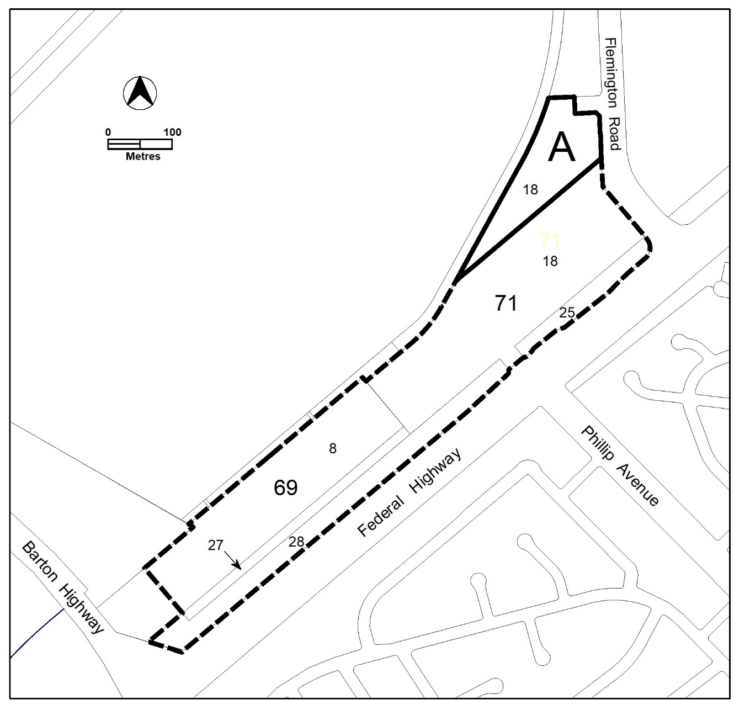

Figure 4 Area A not covered by the National Capital Plan

Rules | Criteria
  - Floor to ceiling heights
R97  This rule applies to Area A in Figure 4.  For this rule Area A applies to land contained with the site that is greater than 200m from the centreline of the Federal Highway.  Minimum finished floor level to ceiling heights are as follows:  - Minimum 2.7 metres for all habitable rooms (with the exception of kitchens, which are permitted to have a minimum 2.4 metre floor-to-ceiling height), and 2.4 metres for all non-habitable rooms.  - For two-storey units, 2.4 metres minimum for second storey if 50 percent or more of the apartment has 2.7 metre minimum ceiling heights.  - For two-storey units with a two-storey void living space, 2.4 metre minimum ceiling heights.  - non-residential development – 3.3m  Attic spaces are permitted, with a 1.8 metre minimum wall height at edge of room with a 30 degree minimum ceiling slope. | This is a mandatory requirement. There is no applicable criterion.
  - Building address
There is no applicable rule. | C98  This criterion applies to a frontage of a building which faces one or more of the following:  - the internal pedestrian and bicycle network connections mentioned in C78  - an external block boundary to the Federal Highway, Sullivans Creek and/or Flemington Road.  The building frontage complies with all of the following:  - provides passive surveillance of the area it faces  - provides a high quality and interesting façade which activates and addresses the area  - is suitable and responds to the characteristics of the area it faces  - provides direct pedestrian and bicycle access from the building, all ground floor dwellings and communal open space to all adjoining ‘open space areas’, ‘mid-block links’, ‘internal pedestrian and cycle network connections and/or ‘external active travel routes’.
  - Building Length
R99  Buildings are no more than 55m in length and width at their longest/widest point. | C99  Buildings exceeding 55m in length and/or width comply with all the following:  - strong design justification  - provide continuous active street frontage  - at least every 55 metres of building, provide a pedestrian link between 5 and 10 metres wide.
  - Pedestrian shelters
R100  Awnings, canopies or colonnades are provided at each active travel entrance to a building and each active travel path along a building edge. | C100  Awnings, canopies or colonnades achieve all of the following:  - provide protection from natural elements along buildings and building entrances  - are integrated with the design of the building.
  - Internal dwelling and building design
R101  Habitable rooms comply with the following:  - master bedrooms have a minimum area of 10m² and other bedrooms 9m² (excluding wardrobe space)  - bedrooms have a minimum dimension of 3m (excluding wardrobe space)  - living rooms or combined living/dining rooms have a minimum width of:  i) 3.6m for studio and 1 bedroom apartments  ii) 4m for 2 or more bedroom  apartments  The width of cross-over or cross-through dwellings are at least 4m internally to avoid deep narrow dwelling layouts. | C101  Habitable rooms are of a size suitable to accommodate the daily activities of their occupants and visitors.
R102  Habitable rooms limit depth to a maximum of 2.5m x the ceiling height. In open plan layouts (where the living, dining and kitchen are combined) the maximum habitable room depth is 8m, measured from an external window. | C102  Habitable room depth may increase where finished floor level to ceiling height is above the minimum permitted, provided reasonable solar access to each habitable room is maintained.
R103  The minimum gross floor area for a dwelling is:  - Studio – 40m²  - 1 bedroom – 50m²  - 2 bedroom – 70m²  - 3 bedroom – 100m²  - each additional bedroom after the 3rd – 12m²  - Each bathroom after the first – 5m²  The minimum area mentioned in a), b), c) and d) includes one bathroom. | This is a mandatory requirement. There is no applicable criterion.
  - Housing diversity
There is no applicable rule. | C104  Buildings contain a variety of dwelling designs such as dual aspect apartments, shallow apartment layouts, and two storey dwellings such as two-level apartment / townhouses.
R105  No dwelling type comprises more than 40 percent of all dwellings.  Note: Studio and 1 bedroom apartments comprise one category. | This is a mandatory requirement. There is no applicable criterion.

- Site controls and design
Rules | Criteria
  - Landscape design – Deep soil zones
There is no applicable rule. | C106  Deep soil zones are provided and comply with all of the following:  - are unimpeded by buildings or structures above and below ground¹  - have adequate dimensions to allow for the growth of healthy trees. incorporate any protected trees²  - allow for the development of healthy root systems and provide anchorage and stability for mature trees  - co-located near deep soil zones on adjacent blocks and sites where possible.  Note 1: Deep soil zones exclude basements, services, swimming pools, tennis courts and impervious surfaces including car parks, driveways, podium and roof areas  Note 2: An individual assessment of each existing tree, the Tree Protection Zone, the site, and appropriate protection requirements will be required to substantiate this criterion
  - Courtyard Walls
There is no applicable rule. | C107  This criterion applies to courtyard walls for dwellings which have their private open space at ground floor level fronting the Federal Highway and ‘Sullivans Creek active travel route’.  Courtyard walls comply with all of the following:  - not higher than 1.8m above datum ground level  - non-transparent components not higher than 1m above datum ground level  - constructed of high-quality materials, specifically excluding pre-coloured metal, unfinished timber panels, chain-link, barbed or razor wire  - integrated with landscaping  - designed and constructed to match or compliment the design of the associated building  - not occupy more than 40% of the façade at ground floor level.  Note: This criterion replaces the relevant rules and criterion relating to courtyard walls in the relevant development code.

- Amenity

Rules | Criteria
  - Solar Access – apartments
R108  This rule applies to apartments only.  Not more than 15% of apartments within a development receive less than 1 hour of direct sunlight between 9am and 3pm on the winter solstice (21 June).  Note: This rule applies in addition to the relevant provisions relating to solar access for apartments in the relevant development code.’ | This is a mandatory requirement. There is no applicable criterion.
R109  This rule applies to all dwellings.  Habitable rooms have an operable window in an external wall with a total minimum glass area of not less than 15% of the gross floor area of the relevant habitable room.  Note: connecting habitable rooms to operable windows in external walls via a corridor, also known as a ‘snorkel’ arrangement, does not satisfy the requirement of this rule. | This is a mandatory requirement. There is no applicable criterion.
  - Solar Access to adjoining development
R110  This rule applies to buildings of more than three storeys.  Buildings do not reduce the hours of direct sunlight between 9am-4pm on the winter solstice to any habitable room in any adjoining residential or COMMERCIAL ACCOMMODATION developments to less than 2 hours. | C110  Reasonable solar access for adjoining residential or COMMERCIAL ACCOMMODATION developments is achieved.
  - Principal private open space
R111  This rule applies to multi-unit housing and RESIDENTIAL USE components of commercial mixed use.  Each dwelling has at least one area of principal private open space that complies with all of the following:  - minimum area and dimensions as specified in Table 4  - maintains visual privacy of the occupants from adjoining public streets and public open space  - is directly accessible from, and adjacent to, a habitable room other than a bedroom  - is not located to the south, south-east or south-west of the dwelling, unless it achieves one or more of the following:  - not less than 3 hours of direct sunlight onto 50% of the minimum required area between the hours of 9am and 3pm on the winter solstice (21 June)  - located at an upper floor level and overlooks a public street, public open space including ‘open space areas’ | This is a mandatory requirement. There is no applicable criterion.

Table 4 Principal private open space area requirements
Type | dwellings wholly or partially at lower floor level or on a podium or similar structure |  | dwellings located entirely on an upper floor level
 | minimum area | minimum dimension | minimum area | minimum dimension
studio apartment | 18m² | 4m | 4m² | nil
1 bedroom dwelling | 24m² | 4m | 8m² | 2m
2 bedroom dwelling | 24m² | 4m | 10m² | 2m
3 or more bedroom dwelling | 36m² | 6m | 12m² | 2m

Rules | Criteria
  - External facilities
There is no applicable rule. | C112  This criterion applies to apartments.  Development complies with all of the following:  - storage units and plant equipment (including air-conditioning plant) are not permitted on balconies  - clothes drying facilities are only permitted on balconies when they are screened from view of streets and public areas including ‘open space areas’
  - Noise – dwellings
There is no applicable rule. | C113  This criterion applies to dwellings on the block and dwellings on adjoining blocks.  Transfer of noise between noise sources and habitable rooms, particularly bedrooms, are minimised through the siting, design and layouts of buildings.  For the purpose of this criterion noise sources include, but are not limited to, garage doors, driveways, service areas, plant rooms, building services, mechanical equipment, communal open space and circulation areas.
14.6 Noise attenuation – external sources
R114  An acoustic assessment and Noise Management Plan (NMP) shall be prepared and endorsed by the EPA that provides appropriate acoustic protection from external noise sources including Exhibition Park in Canberra (EPIC) and Thoroughbred Park.  The NMP shall include as inputs real world monitoring of events at EPIC and Thoroughbred Park including Summernats, Royal Canberra Show, music festivals, race days and events. | This is a mandatory requirement. There is no applicable criterion.
R115  Residential use and commercial accommodation use is not permitted within 100m of the eastern boundary across from Exhibition Park in Canberra (EPIC), and 100m from the Thoroughbred Park boundary.  The following uses are permitted within this 100m area if they are located in buildings designed to comply with noise limits as outlined in schedule 2 of the Environment Protection Regulation, 2005:  a) Shop  b) Office  c) Restaurant  d) Drink establishment  e) Indoor recreation  f) Community facilities | C115  Residential and commercial accommodation use may be permitted if an independent acoustic assessment demonstrates sensitive land use activities on the site are unimpacted by noise from Exhibition Park in Canberra (EPIC) and Thoroughbred Park.  The acoustic assessment must be endorsed by EPA and take into consideration all current and permitted activities at Exhibition Park in Canberra (EPIC) and Thoroughbred Park.

- Parking and vehicular access

Rules | Criteria
  - Vehicular access
There is no applicable rule | C115  Vehicular access to individual development, including crossovers and driveways, are designed and constructed to be co-located/shared with adjoining current or future development.
There is no applicable rule. | C116  Vehicular access arrangements comply with all of the following:  - ensure pedestrian and bicycle priority and desire lines and paths are maximised  - the width of the vehicular access is minimised  - materials integrate with relevant landscaping  - contain high quality public realm treatments that add visual interest, including tree planting, landscaping, materials, footpaths and lighting  .  Note: This criterion, particularly b), does not replace TCCS requirements, standards and endorsements relating to waste collection and service vehicles.
There is no applicable rule. | C117  Pedestrian and cyclist access to blocks are clearly separated from vehicular access and be distinguishable through surface materials, level changes, landscaping and/or slow-speed shared pedestrian road zones.
  - Parking
R118  This rule applies to multi-unit housing.  The maximum parking provision rate is:  - studio or one-bedroom dwelling – 1 space maximum  - two-bedroom dwelling – 1.3 spaces maximum  - three or more bedroom dwelling – 1.5 spaces  - every 8 dwellings – 1 visitor space  Notes:  1. Minimum and maximum parking provision rates contained within the relevant development or general codes do not apply.  2. Parking calculations are rounded up to the nearest whole number. | This is a mandatory requirement. There is no applicable criterion.
There is no applicable rule. | C119  Visitor car parking spaces are allocated for visitors of occupants of the residential parts of the development.  Visitor car parking spaces are conveniently located for visitors to the development and are not allocated to any other purpose, including private spaces for dwellings or workers of the commercial components of the development.
There is no applicable rule. | C120  Adequate spaces and areas, suitably screened from public view, are provided for the loading and unloading of service vehicles.
  - Parking structures
R121  Vehicle parking is only permitted in a basement. On-grade, podium or other above ground vehicle parking is not permitted. | C121  On grade, podium or other above ground parking is only permitted where the following is met:  - the parking area is located away from the Federal Highway and Flemington Road and is suitably screened through use of buildings, communal open space area, private open space and/or landscaping.  - on-grade car parking only:  - is incorporated into the landscape design for the block  - incorporates the use of materials, including permeable or light coloured paving, to prevent an increase of surface temperature  - includes shade trees planted at least every 5 vehicle spaces to reduce car park surface temperature.

- Environment

Rules | Criteria
  - Erosion and sediment control
R122  For sites less than 3,000m², the development complies with the Environment Protection Authority Environment Protection Guidelines for Construction and Land Development in the ACT.  Note: If no evidence of compliance with the above guideline is provided, the application may be referred to the relevant agency in accordance with the requirements of the Planning and Development Act 2007. | This is a mandatory requirement. There is no applicable criterion.
  - Environmental assessment
R123  An environmental assessment report for the development is endorsed by the Environment Protection Authority.  Note: A condition of development approval may be imposed to ensure compliance with the endorsed site assessment report. | This is a mandatory requirement. There is no applicable criterion.
  - Environmentally sustainable design
There is no applicable rule. | C124  The development incorporates measures recommended by an environmentally sustainable design (ESD) assessment undertaken by a ‘suitably qualified professional’.  The assessment must consider ESD principles and best practice ESD, which at a minimum must include:  - energy efficiency, including passive design  - water efficiency  - reducing greenhouse gas emissions  - active and sustainable transport,  - living infrastructure  - urban design, including building materials and finishes.  All recommended measures determined by the assessment are:  - not inconsistent with the relevant development and general codes of the Territory Plan  - identified on plans and endorsed by the relevant authority to ensure delivery and retention as a feature of the development.  For the purpose of this criterion a ‘suitably qualified professional’ is a person with qualifications, experience and/or skills relevant to ESD. Note: The Planning and Land Authority may consult with EPSDD Climate Change and Energy Division (or future relevant agency responsible for the same functions) when determining compliance with this criterion.
  - Microclimate
There is no applicable rule. | C125  The development incorporates mitigation measures recommended by a microclimate assessment undertaken by a ‘suitably qualified professional’ The assessment must identify the urban heat risk factors that apply to the site and recommend appropriate urban heat mitigation measures.  All recommended measures determined by the assessment are:  - not inconsistent with the relevant development and general codes of the Territory Plan  - identified on plans and endorsed by the relevant authority to ensure delivery and retention as a feature of the development.  For the purpose of this criterion a ‘suitably qualified professional’ is a person with qualifications, experience and/or skills, relevant to urban climate science, urban heat modelling and microclimate assessment.  Note: The Planning and Land Authority may consult with EPSDD Climate Change and Energy Division (or future relevant agency responsible for the same functions) when determining compliance with this criterion.
  - Permeability
R126  This rule applies to at least one of the following:  - development on sites greater than 2000m² involving works that have potential to alter the stormwater regime for the site  - development within existing urban areas that increase the impervious area of the site by 100m² or more.  Development achieves all of the following:  - minimum of 30% of the site area to be permeable.  - generally equitable distribution of permeability across the RC2 area.  This rule and associated criterion overrides rules and/or criteria that require a percentage of an individual development site area to be permeable.  Note: Compliance with this rule and associated criteria is demonstrated through a report from a ‘suitably qualified professional’ consistent with the methods specified in the ACT Practice Guidelines for Water Sensitive Urban Design. | C126  It is demonstrated that the development of the RC2 area achieves all of the following:  - increases permeable surfaces and living infrastructure though green spaces  - plants that require irrigation are supported by sustainable water systems such as onsite stormwater harvesting to achieve microclimate benefits  - promotes evapotranspiration to mitigate extreme temperatures, improve air humidity and overall human comfort  - equitable distribution of a), b) and c) across both the public and private realms of the RC2 area.
  - Heritage
R127  An ‘Unanticipated Discovery Protocol’ which includes assessment and management of any unexpected heritage discoveries during construction is endorsed by the ACT Heritage Council.  Note: A condition of development approval may be imposed to ensure compliance with this rule. | C127  If an ‘Unanticipated Discovery Protocol’ endorsed by ACT Heritage council is not provided the application will be referred to the ACT Heritage Council.
R128  Development applications must be accompanied by evidence demonstrating that further consultation with Representative Aboriginal Organisations regarding the findings and recommendations of the 2016 and 2019 Cultural Heritage Assessments has been undertaken.  Outcomes of this consultation will be submitted to the ACT Heritage Council, for further advice on any Heritage Act 2004 considerations for proposed development. | This is a mandatory requirement. There is no applicable criterion.

- Waste management

Rules | Criteria
  - Post occupancy waste management
R129  Facilities for waste disposal, recycling and composting:  - complies with the Development Control Code for Best Practice Waste Management in the ACT 2019  - are fully enclosed and suitably screened from public view.  Note: This rule does not replace the provisions relating to post occupancy waste management endorsement in the relevant development code. | This is a mandatory requirement. There is no applicable criterion.

Interpretation service
