Australian Capital Territory
Liquor (Temporary Alcohol-Free Place) Declaration 2022 (No 1)
Notifiable instrument NI2022-575
made under the
Liquor Act 2010, s 198 (alcohol-free places)

1 Name of instrument
This instrument is the Liquor (Temporary Alcohol-Free Place) Declaration 2022(No 1).
2 Commencement
This instrument commences at 7am on 26 November 2022.
3 Declaration
I declare the following locations as temporary alcohol-free areas:
  - The area shown on the attached map in Attachment 1 that is within the heavy black line on the map and is a public place.
  - Any unleased land adjoining a public place within the heavy black line on the map in Attachment 1.
But excluding:
  - The areas designated for Spilt Milk 2022, highlighted by shading in red within the bold red line on the map at Attachment 2.
  - licensed premises or permitted premises; or
  - premises where food is sold for consumption at the premises; or
  - at a place that is within 50m from premises mentioned in paragraph (d) or (e) by a person using furniture or other facilities provided by the proprietor or lessee of the premises.
4 Expiry
This instrument expires at 7am on 27 November 2022.

Derise Cubin
Commissioner for Fair Trading
11 November 2022
Attachment 1

SPILT MILK 2022 ALCOHOL FREE ZONE
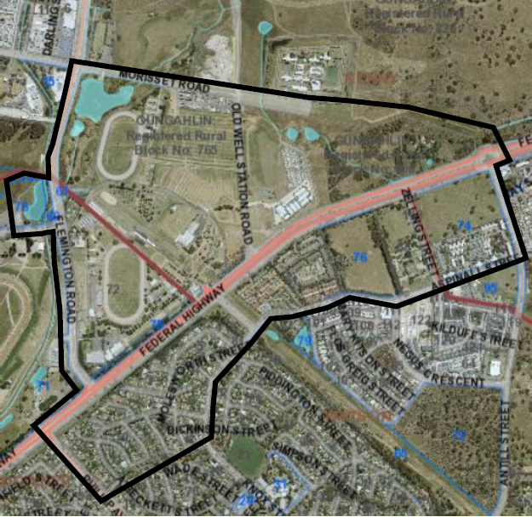

Attachment 2

