Australian Capital Territory
Heritage (Decision about Provisional Registration of Belconnen Library and Pedestrian Plaza, Belconnen) Notice 2022
Notifiable instrument NI2022–72
made under the
Heritage Act 2004, s 34 (Notice of decision about provisional registration)

1 Name of instrument
This instrument is the Heritage (Decision about Provisional Registration of Belconnen Library and Pedestrian Plaza, Belconnen) Notice 2022.
2 Decision about provisional registration
On 10 February 2022, the ACT Heritage Council (the Heritage Council) decided to provisionally register Belconnen Library and Pedestrian Plaza, blocks 11, 12, 22 and 38, section 54, Belconnen (the Place).
3 Registration details of the Place
The registration details of the Place are in the schedule.
4 Reasons for the decision
The Heritage Council decided to provisionally register the Place because it is satisfied on reasonable grounds that it is likely to have heritage significance as it is likely to meet one or more of the heritage significance criteria in section 10 of the Heritage Act 2004 (the Act). A detailed statement of reasons, including an assessment against the heritage significance criteria, is provided in the schedule.
5 Date of provisional registration
The date of provisional registration is 11 February 2022 (being the day after the Heritage Council entered into the heritage register the registration details for the Place together with an indication that the registration is provisional).
6 Indication of the Heritage Council’s intention
The Heritage Council intends to decide whether to register the Place under division 6.2 of the Act during the period of provisional registration.
7 Invitation to make written comments during public consultation period
(1) The Heritage Council invites written comments about the registration of the Place. Any written comments must be made within 4 weeks after the day this notice is notified.
(2) Written comments can be provided to the Heritage Council by the following methods:
(a) mail to
The Secretary
ACT Heritage Council
GPO Box 158
CANBERRA ACT 2601
(b) email to heritage@act.gov.au
(c) via the consultation website at www.yoursay.act.gov.au.

Edwina Jans
A/g Secretary (as delegate for)
ACT Heritage Council
10 February 2022

Schedule

(See sections 3 and 4)

AUSTRALIAN CAPITAL TERRITORY
HERITAGE REGISTER
(Provisional Registration)

For the purposes of s33 of the Heritage Act 2004, a provisional entry to the heritage register has been prepared by the ACT Heritage Council for the following place:

BELCONNEN LIBRARY AND PEDESTRIAN PLAZA

BLOCKS 11, 12, 22, AND 38 SECTION 54, BELCONNEN
DATE OF DECISION
10 February 2022
DATE OF PROVISIONAL REGISTRATION
11 February 2022 Notifiable Instrument: 2022–
PERIOD OF EFFECT OF PROVISIONAL REGISTRATION
Start Date: 11 February 2022 End Date: 10 July 2022

Extended Period (if applicable) Start Date ________ End Date ________

Copies of the Register Entry are available for inspection at ACT Heritage. For further information please contact:

The Secretary

ACT Heritage Council

GPO Box 158

CANBERRA ACT 2601

Telephone 13 22 81

This statement refers to the location of the place as required in s12(b) of the Heritage Act 2004.
LOCATION OF THE PLACE

Belconnen Library and Pedestrian Plaza, section 54 blocks 11, 12, 22, and 38, Suburb of Belconnen, District of Belconnen, ACT.

This statement refers to the description of the Belconnen Library and Pedestrian Plaza as required in s12(c) of the Heritage Act 2004. The attributes described in this section form part of the heritage significance of the place. For the purposes of s12(c) of the Heritage Act 2004, the boundary of the place is at Image 1.
DESCRIPTION OF THE PLACE

Belconnen Library consisting of the following attributes:
- The off-white sandblasted exposed aggregate concrete surfaces of the original walls and fascias, including original internal concrete surfaces;
- The use of frameless glazing throughout;
- The high level of finish, most notably where different surfaces abut presented as flush surfaces with sharp, clean lines;
- The double height foyer with plate glass entry;
- The linking bridge over the foyer and the corner terrace open to the outside with original steel railings;
- The separated access to the community rooms and bathrooms allowing for after hours entry;
- The open-plan reading room;
- The white ribbed ceiling with original ducting and integrated light fixtures;
- The raised ceiling sections creating voids with clerestory windows around the perimeter that act as light wells (noted as “roof light” in Gibson’s drawings);
- The plain smooth surfaces arranged to juxtapose curved and right-angled surfaces/corners
- The internal display wall on the north side of the foyer;
- The external cantilevered overhangs providing shelter for pedestrian paths;
- The overall horizontal form emphasised by the long, uninterrupted, deep eaves along the vertical plane of the square building boundary, the horizontal slit windows and Corbusian window motifs.

The pedestrian plaza, consisting of the following attributes:
- cast concrete retaining walls with angular projections to break up long uninterrupted blank walls;
- the mature original tree from the Emu Bank homestead forming a prominent feature along the eastern boundary;
- the angular amphitheatre stairs;
- the two original ramps;
- original concrete walls and rectangular plinths around garden beds;
- the central flagpole;
- the terraced planter beds with soft landscaping;
- Access to Chandler Street as well as the underpass to the east and the wide footpath leading to Margaret Timpson Park and Belconnen Mall to the west;

Artworks, sculptures and landscaping within the Library and Plaza add to the character of the place and are considered to be complimentary to the heritage significance of the place provided as they do not conflict with any of the features noted in the description of the place above.

This statement refers to the heritage significance of the place as required in s12(d) of the Heritage Act 2004.
STATEMENT OF HERITAGE SIGNIFICANCE

The Belconnen Library and Pedestrian Plaza, built 1982, were designed by Robin Gibson & Partners for the National Capital Development Commission (NCDC). It was a pivotal link in the NCDC’s design of the Belconnen Town Centre which was a key component of the NCDC’s Y-plan to expand Canberra into several satellite towns supporting a core in the City. The design by Gibson had to incorporate several wider area planning principles dictated by the NCDC while also being complimentary to existing designs of the nearby Cameron Offices and the Revival Centre. This was achieved with a modern design that has proven to be effective as a library and flexible enough to incorporate changes to the library system over time. The simple and effective layout of the building within the context of the Plaza and the wider connected network of pedestrian movement has been retained and as the Belconnen Town Centre develops as the NCDC had planned several decades earlier, the place is being shown to reinforce the original planning ideals laid down in the 1970s.
CONSERVATION OBJECTIVE

The guiding conservation objective is that Belconnen Library and Pedestrian Plaza shall be conserved and appropriately managed in a manner respecting its heritage significance.

The ACT Heritage Council may adopt heritage guidelines applicable to the place under s2Al5 of the Heritage Act 2004.

For further information on guidelines applicable to the place, or for advice on proposed works or development, please contact ACT Heritage on 13 22 81.
REASON FOR PROVISIONAL REGISTRATION

The Council has assessed the Belconnen Library and Pedestrian Plaza, Belconnen, against the heritage significance criteria and is satisfied that the place is likely to have heritage significance when assessed against criterion (a) under s10 of the Heritage Act 2004.
ASSESSMENT AGAINST THE HERITAGE SIGNIFICANCE CRITERIA

The Council’s assessment against the criteria specified in s10 of the Heritage Act 2004 is as follows.

In assessing the heritage significance of Belconnen Library, Belconnen, the Council considered:
- the original nomination and documentary evidence supplied by the nominator;
- the Council’s Heritage Assessment Policy (March 2018);
- information provided by a site inspections on 7 April 2020, 8 April 2021 and 23 April 2021 by ACT Heritage; and
- the report by ACT Heritage titled, Background Information Belconnen Library and Pedestrian Plaza, February 2022, containing photographs and information on history, description, condition and integrity.

Pursuant to s10 of the Heritage Act, a place or object has heritage significance if it satisfies one or more of the following criteria. Future research may alter the findings of this assessment.
importance to the course or pattern of the ACT’s cultural or natural history;
The Council has assessed the Belconnen Library and Pedestrian Plaza against criterion (a) and is satisfied that the place is likely to meet this criterion.
The Belconnen Library and Pedestrian Plaza is associated with the development of the Belconnen Town centre as an essential community resource serving the Belconnen area since development during the 1970s and 1980s. It set the intent of the town centre planning around the provision of community services. These principles have proved of enduring value, as departures from original schemes for the location of the commercial centre have been rectified in more recent attention to higher density accommodation provision in the immediate vicinity of the Library, better movement connections and commercial development during the 2010s.
Its modernist style of architecture and incorporation into concepts of community-based public space are illustrative of the NCDC’s planning philosophies of town centres serving integrated and balanced communities. The NCDC’s philosophy of commissioning the best architects from around Australia to achieve a broad representation of the country’s architectural talent resulted in Robin Gibson’s only ACT building that also helped to demonstrate leading edge of public architecture.
The library formed an integral part of the Belconnen Town Centre with the NCDC planners expending a great deal of time and effort balancing the needs of the community with that of the Canberra Public Library Service, the Belconnen Mall, the Revival Centre, the Bus Interchange, the Cameron Offices and the surrounding business, educational and residential areas via the pedestrian network and linked Plaza.
The planning of the Belconnen Town Centre did not initially develop as intended, leading to weak connections and a reliance on cars that worked against the Library’s need for co-location to attract users with multi-purpose visits. The Belconnen Mall moved development sites to the west of Benjamin Way and the dense residential and commercial development envisaged along Emu Bank was altered due to community action calling for the waterfront to be left undeveloped, this reduction in density, in turn, led to a greater reliance on cars, exacerbating the poor pedestrian access to the area.
From the mid-2010s, the character of the Belconnen Town Centre has slowly been changing with higher density buildings being developed and the pedestrian and other transport connections reconsidered to better accommodate a growing population. Section 54 is at the heart of planning for the area, which already includes better connections to Emu Bank through the underpass and increasing density from nearby multistorey buildings and recognition of the need to improve movement through the Town Centre. All of these improvements are reinforcing the original design intent of the Library and Plaza that has been retained since its inception under the NCDC in the 1970s.
has uncommon, rare or endangered aspects of the ACT’s cultural or natural history;
The Council has assessed the Belconnen Library and Pedestrian Plaza against criterion (b) and is not satisfied that the place is likely to meet this criterion.
As noted in criterion (a) above, the Council recognises the role of the Belconnen Library and Pedestrian Plaza in the development of the Belconnen community. The place is also a well-preserved example of Late Twentieth Century International Design, an important style of architecture in the development of the ACT and its public buildings. However, regardless of the aspect of the ACT’s cultural history, whether it is libraries or Late Twentieth Century International style buildings or public buildings/spaces, the Belconnen Library and Pedestrian Plaza are not considered to be sufficiently rare, uncommon, or endangered to the degree required to meet thresholds against this criterion.
potential to yield important information that will contribute to an understanding of the ACT’s cultural or natural history;
The Council has assessed the Belconnen Library and Pedestrian Plaza against criterion (c) and is not satisfied that the place is likely to meet this criterion.
The Council acknowledges the potential of all sound examples of modern architecture to act as teaching sites and sources of information on the history of the ACT. However, any information the Belconnen Library and Pedestrian Plaza is likely to yield on the architect, the style of architecture, or the planning history of the ACT, is already present in the building itself, and the readily accessible documentary record.
importance in demonstrating the principal characteristics of a class of cultural or natural places or objects;
The Council has assessed the Belconnen Library and Pedestrian Plaza against criterion (d) and is not satisfied that the place is likely to meet this criterion.
The Belconnen Library and Pedestrian Plaza are common public places and good examples of their types; however, the Council does not consider that they are important in demonstrating the characteristics of their type; i.e. a particularly fine or pivotal example which is beyond the ordinary so as to pass the threshold for inclusion under this criterion.
It demonstrates and is a good example of the Late Twentieth Century International Style of architecture as evidenced by it being awarded the RAIA ACT Chapter Canberra Medallion in 1982 and then the Australian Institute of Architects ACT Chapter 25 Year Award for Enduring Architecture in 2010.
As a public building, the Library has proven to be flexible enough to adapt to changing trends in library services and has not required any major alterations to accommodate them (e.g. computer cataloguing, RFID systems, various internal refurbishments in response to changes in libraries best practice, etc.). The Plaza has had little change and, while use data is lacking, appears to continue to be an effective space for movement through the area, although it does not appear to be used much for passive recreation.
importance in exhibiting particular aesthetic characteristics valued by the ACT community or a cultural group in the ACT;
The Council has assessed Belconnen Library and Pedestrian Plaza against criterion (e) and is not satisfied that the place is likely to meet this criterion.
There is insufficient evidence that Belconnen Library and Pedestrian Plaza exhibits design or aesthetic qualities that are valued by the ACT community or a cultural group in the ACT. The Council acknowledges that Belconnen Library and Pedestrian Plaza is valued by the Australian Institute of Architects (AIA) and other architects for reasons relating to its design and aesthetic qualities, however, they do not constitute a cultural group or represent of the ACT community as a whole. The Council-endorsed Heritage Assessment Policy interprets a cultural group as a ‘group of people within a society with a shared ethnic or cultural background’ or ‘a group of people connected through the same way of living, which has been transmitted from one generation to another’. While the Library is clearly valued for its amenity value and is an attractive place the evidence of broader community values specifically related to particular aesthetic values have not been identified to a strong enough level to meet this criterion.
importance in demonstrating a high degree of creative or technical achievement for a particular period;
The Council has assessed Belconnen Library and Pedestrian Plaza against criterion (f) and is not satisfied that the place is likely to meet this criterion.
The Belconnen Library and Pedestrian Plaza uses conventional building techniques and a suite of design cues for the Late Twentieth Century International style of architecture that were already well established at the time. While it does have some creative elements, such as the method of separating and accessing the community room and the integration of the pedestrian plaza design, these are not considered to be a high enough degree, in that they are not a formative use or so innovative or outside of normal use, that the place meets the threshold for inclusion under this criterion.
has a strong or special association with the ACT community, or a cultural group in the ACT for social, cultural or spiritual reasons;
The Council has assessed the Belconnen Library and Pedestrian Plaza against criterion (g) and is not satisfied that the place is likely to meet this criterion.
There is insufficient evidence that Belconnen Library and Pedestrian Plaza has a strong or special association with the ACT community, or a cultural group in the ACT for social, cultural or spiritual reasons. The Council acknowledges that Belconnen Library and Pedestrian Plaza is valued by the Australian Institute of Architects (AIA) and other architects, however, they do not constitute a cultural group or can be representative of the ACT community as a whole. The Council-endorsed Heritage Assessment Policy interprets a cultural group as a ‘group of people within a society with a shared ethnic or cultural background’ or ‘a group of people connected through the same way of living, which has been transmitted from one generation to another’. While the Library is clearly valued for its amenity value, particularly for the provision of community rooms and a meeting place, and is an important service in general the evidence of broader community or a cultural group having a strong or special association have not been identified to a strong enough level to meet this criterion.
has a special association with the life or work of a person, or people, important to the history of the ACT.
The Council has assessed the Belconnen Library and Pedestrian Plaza against criterion (h) and is not satisfied that the place is likely to meet this criterion.
While Robin Gibson is an important Australian architect, his work is most closely associated with his hometown of Brisbane and greater Queensland. The Belconnen Library and Pedestrian Plaza is representative of the NCDC bringing in a broad range of architects reflecting talent from other states and is the only public building designed by Robin Gibson in the ACT however, there is no evidence to suggest that his association with the place was any more special than with any of his other works and that this association was any more important than any other fine architects that were commissioned by the NCDC at the time leading to a lasting impact on the history of the ACT.
SITE PLAN

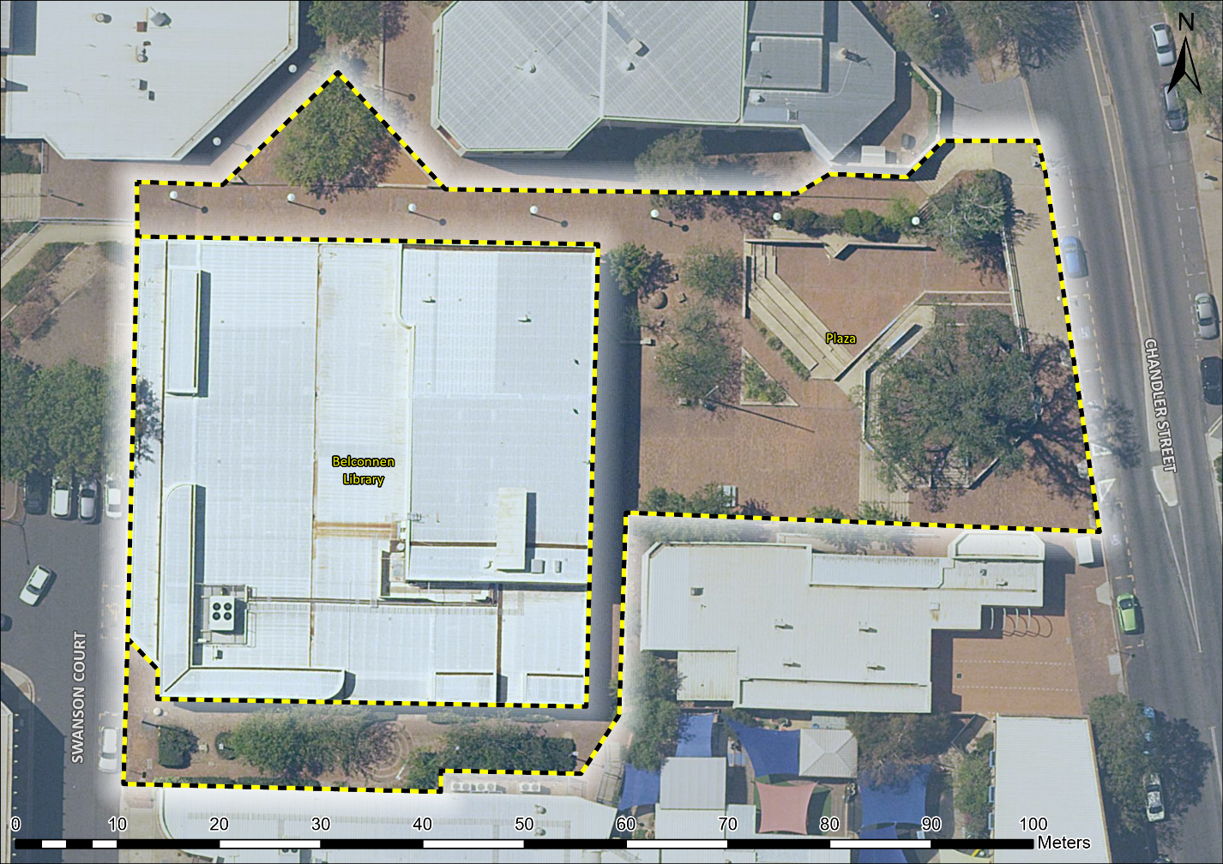
Image 1 Belconnen Library and Pedestrian Plaza site boundary

