Australian Capital Territory
Heritage (Decision about Provisional Registration of the Former Kippax Health Centre, Holt) Notice 2022
Notifiable instrument NI2022–74
made under the
Heritage Act 2004, s 34 (Notice of decision about provisional registration)

1 Name of instrument
This instrument is the Heritage (Decision about Provisional Registration of the Former Kippax Health Centre, Holt) Notice 2022.
2 Decision about provisional registration
On 10 February 2022, the ACT Heritage Council (the Heritage Council) decided not to provisionally register the Former Kippax Health Centre, Block 71, Section 51, Holt (the Place).
3 Description of the Place
The description of the Place is in the schedule.
4 Reasons for the decision
The Heritage Council is not satisfied on reasonable grounds that the Place is likely to have heritage significance as defined by section 10 of the Heritage Act 2004. A detailed statement of reasons, including an assessment against the heritage significance criteria, is provided in the schedule.
5 Date decision takes effect
The decision not to provisionally register the Place takes effect on 11 February 2022 (being the day after the Heritage Council made its decision in writing as set out in the schedule).

Edwina Jans
A/g Secretary (as delegate for)
ACT Heritage Council
10 February 2022

STATEMENT OF REASONS
DECISION NOT TO PROVISIONALLY REGISTER
THE FORMER KIPPAX HEALTH CENTREWamboinName of Place
BLOCK 71 SECTION 51, Holt
IN THE ACT HERITAGE REGISTER

In accordance with s32 of the Heritage Act 2004, the ACT Heritage Council has decided not to provisionally register the Former Kippax Health Centre, Holt. This Statement of Reasons provides an assessment of the Former Kippax Health Centre, Holt, and finds that the place does not meet any of the criteria under s10 of the Heritage Act 2004.

This statement refers to the location of the place as required in s34(5)(b)(ii) of the Heritage Act 2004.
LOCATION OF THE PLACE

Former Kippax Health Centre, 20 Kippax Place, Block 71 (formerly Block 22) Section 51, Holt

This section refers to the description of the place as required in s34(5)(b)(iii) of the Heritage Act 2004. The boundary of the place and extent of features listed below is illustrated at Image 1.

DESCRIPTION OF THE PLACE

Former Kippax Health Centre, consisting of the following attributes:
- The original brick health centre building;
- The internal courtyard; and
- The surrounding hard and soft landscaping.

This statement refers to the Council’s reasons for its decision as required in s34(5)(b)(iv) of the Heritage Act 2004.
REASONS FOR DECISION

The Council is not satisfied on reasonable grounds that the place is likely to have heritage significance as defined by s10 of the Heritage Act 2004.

This statement refers to the Council’s assessment of the place against the heritage significance criteria as a part of its reasons for its decision as required in s34(5)(b)(iv) of the Heritage Act 2004.
ASSESSMENT AGAINST THE HERITAGE SIGNIFICANCE CRITERIA

The Council’s assessment against the criteria specified in s10 of the Heritage Act 2004 is as follows.

In assessing the heritage significance of the Former Kippax Health Centre, Holt, the Council considered:
- the original nomination and documentary evidence supplied by the nominator;
- the Council’s Heritage Assessment Policy (March 2018);
- information provided by a site inspection on 22 April 2021 by ACT Heritage; and
- the report by ACT Heritage titled, Background Information Kippax health Centre, February 2022, containing photographs and information on history, description, condition and integrity; and
- an independent cultural heritage assessment produced by Duncan Marshall in December 2021.

Pursuant to s10 of the Heritage Act, a place or object has heritage significance if it satisfies one or more of the following criteria. Future research may alter the findings of this assessment.
- importance to the course or pattern of the ACT’s cultural or natural history;
The Council has assessed the Former Kippax Health Centre against criterion (a) and is not satisfied that the place meets this criterion.
In the period before the 1970s, health services in Canberra were focused on local and private general practitioners, as well as hospital services. Early hospital services in Canberra were available from 1914, and a major development was the opening in 1943 of the initial buildings that eventually became the Royal Canberra Hospital at Acton.
By 1970, alternative ideas for the delivery of some health services were considered.
“The [National Capital Development] Commission and the Department of Health in a joint exercise, engaged the British consultant firm of Llewelyn-Davies and Partners to advise on the future health care needs for Canberra up to a population of half a million. The object of this study was not only to prepare a future health care plan but also to integrate health care requirements more closely with the planning and development of Canberra.” (NCDC 1971, p. 31)
This was part of a broader experimental approach to a wide range of city and community planning matters, including health and social policy issues in Canberra.
The 1970 report Future Health Care Services in Canberra and the Australian Capital Territory (Llewelyn-Davies, Weeks, Forestier-Walker and Bor 1970) outlined a novel vision for Australia based on the principles of social medicine where welfare and medicine were inextricably linked (Canberra Times 1992). Overall, the report’s main recommendations were:
- establishing a health authority to plan, implement and manage a coordinated health system;
- health professionals and the public to contribute and participate in developing the system;
- there should be a ‘proper relationship’ between hospital and community-based services;
- future health care should be based on community health teams (private and public general practitioners along with related health professionals);
- community health teams (ie. primary care, including general practitioners and related health personnel) should be housed in health centres serving 20-50,000 people located at convenient locations, that is group centres, starting with pilot centres which would be evaluated;
- the primary health services centres should have the public access areas all on the first floor for ease of access;
- no set catchment of a set of services or design was proposed, so that each centre could cater for the needs of the area or for appropriate allocation of resources; and
- major hospitals set up as a campus with associated facilities such as laundry and sterilisation services with an aim to efficiency and reducing the need for hospital space to acute needs only. (NCDC 1971, p. 31)
This vision underpinned the British National Health Service, and promoted government-run centres offering comprehensive social and health services with an emphasis on teamwork, health prevention, and free services unless private doctors rented space in the health centres (Canberra Times 1992).
While the development of health centres in Canberra was a focus of this activity, in fact it was part of a broader Commonwealth Government community health initiative which included the provision of such centres in other parts of Australia as well. Related national health initiatives of the time included universal national health insurance (initially called Medibank and later Medicare), as well as cooperation with the states to develop services.
The NCDC and Department of Health used the report as the basis for developing health services in Canberra. The first temporary centres opened in 1973 were in Melba and Scullin, and these drew overseas visitors keen to learn from the health services experiment. In 1974 the NCDC reported it was,
“proceeding with the construction of health-care facilities for ACT Health Services and the Department of Health. The basis of this plan was the 1971 [sic] study by Llewelyn Davies and Partners, and their recommendations included the provision of community health centres within urban groups of 20,000-50,000 persons.
A brief has been prepared for a health centre at Narrabundah and sites have been identified for others in inner Canberra, the Woden-Weston, Belconnen and Tuggeranong districts. The proposed centres are close to group centres and public transport routes.
Construction of the first two permanent health centres at Phillip and Kippax began in December 1973. The Phillip Community Health and Welfare Centre to the west of the Woden Town Square will be bigger than the normal district health centre because it will serve a large population. It will also incorporate central administration facilities for the Woden-Weston Creek district, the welfare branch of the Department of the Capital Territory and an education clinic.
The Kippax Health Centre, Belconnen, will provide services for an estimated population of 20,000 in the suburbs of Higgins, Latham, Holt and Macgregor.
Both centres are expected to be completed late in 1974 and should be operational by early 1975.
Design work on the Kambah Health Centre, to be in the Kambah Group Centre in Tuggeranong, is well advanced, and the centre is expected to open during 1976.
This centre will operate like the Kippax Health Centre, but will incorporate a pharmacy and dispensary area. However, a temporary demountable health centre at The Village, Kambah, is expected to open in August 1974 to meet the needs of early residents of Tuggeranong.” (NCDC 1974, p. 56)
While the overall history of health centres in Canberra is complex and not fully researched, it appears that at least 16 health centres were established, though over time some closed, and 8 centres continue to operate. The Kippax Health Centre opened in 1975, by which time six centres were in operation (Department of Health 1975, p. 149). The centres including Kippax were controversial, with both supporters and critics, especially regarding the role of salaried government doctors versus private doctors.
With a change in the Commonwealth Government, services at some of the centres began to be wound back or changed from 1976.
As indicated, the Former Kippax Health Centre is associated with a novel approach to the delivery of health and social services in Australia in the early 1970s as part of a community health initiative.
In addition, as part of the NCDC development of Canberra from the 1970s, health centres were to be provided, especially associated with the new towns which were part of the broader Y-Plan for the city. The Kippax Health Centre from 1975 was the first permanent health centre constructed in Canberra. However, interim centres were provided in Melba and Scullin from 1973, and other permanent centres opened in 1975, 1976 and later years.
As early as 1977, demand for services was less than anticipated, and by 1987 it was proposed to end public health services with private doctors expected to provide such services. There were also ongoing funding pressures on the health system. However, the provision of salaried doctors appears to have continued until 1995. At this time, the closure of the Kippax Health Centre was also proposed in response to a lack of need for it, although this did not actually happen.
Ultimately, the Kippax Health Centre operated until 2005. The long-term pressures leading to the closure of the centre appear to have been changing demand, the role of private doctors, perhaps including the development of private health clinics and centres, as well as government funding issues. While the formal health centre closed, some private health services continued to be provided in the building until 2021.
On the other hand, several early health centres continue to operate in Canberra, including City, Phillip and Weston Creek. It is also noted that a 1987 discussion paper found that the Melba and Narrabundah centres were the best examples displaying the community-health philosophy, although both no longer operate.
The Former Kippax Health Centre is associated with the early phase in the delivery of a novel, important and enduring approach to health and social services in Canberra, and probably in Australia more broadly. It was also the first permanent health centre in Canberra, though preceded by interim centres and other permanent centres had also been planned and followed soon after. In the history of health centres in Canberra, there is nothing of particular note about the Kippax example.
Importantly, as noted there are other examples from this early phase of health centres, City, Phillip and Weston Creek, which continue to provide these services, and accordingly have a longer and continuous connection to this history. Accordingly, these other centres would seem to have a much stronger claim to importance under this criterion. The Former Kippax Health Centre does not have this continuous connection, has not provided health centre services since 2005, and it would not seem to meet the threshold of importance required.
- has uncommon, rare or endangered aspects of the ACT’s cultural or natural history;
The Council has assessed the Former Kippax Health Centre against criterion (b) and is not satisfied that the place meets this criterion.
There are two contexts to consider under this criterion – the Former Kippax Health Centre as an example of a health centre, and the building as an example of the Late Twentieth-Century Sydney Regional style.
Health centres do not seem to be uncommon, rare or endangered in the ACT. While the overall history of health centres in Canberra is complex and not fully researched, it appears that at least 16 health centres were established in the period since 1973. While some have changed or closed over the years, there are currently 8 centres which continue to operate. In addition, there has also been a growth in the development of private health or medical centres in Canberra over the years, perhaps influenced by the government health centres. However, such private health centres focus on the provision of various medical services, sometimes more limited services, but do not have social services as well.
With regard to the Late Twentieth-Century Sydney Regional style, there are several prominent Canberra examples of this style, as well as possibly a large number of additional houses. However, the full context of examples is not currently well understood. None the less, at the current time, the Former Kippax Health Centre does not appear to be uncommon, rare or endangered as an example of this style.
- potential to yield important information that will contribute to an understanding of the ACT’s cultural or natural history;
The Council has assessed the Former Kippax Health Centre against criterion (c) and is not satisfied that the place meets this criterion.
There is no evidence before the Council that the building has the potential to yield information that will contribute significantly to a wider understanding of the cultural history of the ACT. Any information the place may provide has already been obtained from the documentary and physical evidence and it is unlikely that any further significant evidence could be gained from the physical fabric of the place.
- importance in demonstrating the principal characteristics of a class of cultural or natural places or objects;
The Council has assessed the Former Kippax Health Centre against criterion (d) and is not satisfied that the place meets this criterion.
The Former Kippax Health Centre can be considered against two classes of place: as an example of a particular architectural style, and as an example of a health centre building.
The building displays a number of the features of the Late Twentieth-Century Sydney Regional style. Key features include asymmetrical massing, roof following the slope of the land, tiled skillion roof and stained or oiled timber. Other features are timber post-and-beam construction, exposed roof beam, painted brick walling, timber awning sash and slatted timber screen.
There are two outstanding known examples of this style in Canberra – the AIA (former RAIA) Headquarters in Red Hill (Ancher, Mortlock, Murray & Woolley, 1976) and the Cater House in Red Hill (Allen, Jack and Cottier, 1965). Both are included in the ACT Heritage Register. In addition, there are a number of other Canberra examples which are difficult to comparatively analyse given limited and readily available information about them. None the less, comparators appear to include at least 93 Brereton Street, Garran (Ken Woolley, 1975) and 38 Mirning Crescent, Aranda (Roger Pegrum, 1971-2).
The Former Kippax Health Centre is not as strong an example of the style as the AIA Headquarters or Cater House. In the materials and finish, perhaps masked by subsequent changes, it has the appearance of an example subject to budget constraints. Other changes also detract from the elegant simplicity of the original.
The ACT Heritage Council Heritage assessment policy (2018) requires that a class of place must be important in the ACT’s cultural or natural history, having made a strong, noticeable or influential contribution. The Late Twentieth-Century Sydney Regional style arguably meets this test on the basis of the large number of examples to be found in Canberra, especially the Pettit & Sevitt Housing in various suburbs. However, for a place to be considered important in demonstrating the principal characteristics of the type, and therefore pass the threshold for inclusion under this criterion, it would need to notable compared to other examples or be of particular importance in the evolution or adoption of the style.
The Former Kippax Health Centre demonstrates the defining characteristics of the class to meet the basic test of the criterion. However, it is not considered to be important in demonstrating the principal characteristics of the Late Twentieth-Century Sydney Regional style because it:
- is not notable because of its condition compared to other examples, such as the AIA Headquarters;
- does not demonstrate high integrity or good condition at this time; and
- is not a notable or pivotal example of the Late Twentieth-Century Sydney Regional style, did not appear to influence subsequent examples, and does not encapsulates a key evolutionary stage in the development of the class.
The Former Kippax Health Centre is an example of a health centre building. However, there is no known type profile for this class of place which would enable a meaningful assessment. Apparent characteristics of such health centres would appear to include location near group centres to service a number of suburbs, services provided on a single level for accessibility, space for a variety of services, and flexible rooms capable of accommodating a variety of services depending on changing needs. But there is currently insufficient information about the design requirements for health centres, what were principal and incidental characteristics, and how requirements may have changed through time. Such information is needed to provide a baseline understanding of the class, enable a comparative analysis with other examples, and would inform an assessment under this criterion.
In this context, it is not possible to assess any related potential value at this time. It is also noted that the Phillip Health Centre is already included in the ACT Heritage Register, although not for any value under this criterion.
- importance in exhibiting particular aesthetic characteristics valued by the ACT community or a cultural group in the ACT;
The Council has assessed the Former Kippax Health Centre against criterion (e) and is not satisfied that the place meets this criterion.
The Former Kippax Health Centre is an example of the Late Twentieth-Century Sydney Regional style and it may be appreciated for aesthetic characteristics associated with this style by the architectural profession. However, there is no current evidence that it is valued for such characteristics by the wider ACT community or a cultural group.
- importance in demonstrating a high degree of creative or technical achievement for a particular period;
The Council has assessed the Former Kippax Health Centre against criterion (f) and is not satisfied that the place meets this criterion.
The only achievement to assess is that related to the Late Twentieth-Century Sydney Regional style of the building. Another possible consideration arises regarding the Former Kippax Health Centre as an early example of a health centre.
The Former Kippax Health Centre demonstrates creative achievement in its architecture but there is nothing to suggest the high degree of achievement required by the criterion. The style was well-developed during the 1960s and many Australian exemplars date from this period. In the case of Canberra, there are earlier and good examples such as the Cater House date from 1965. While the Former Kippax Health Centre is a competent display of the style, it lacks the innovation or other creative qualities required by the criterion.
With regard to the Former Kippax Health Centre being an early example of a health centre, there is nothing to suggest this demonstrates creative or technical achievement, let alone a high degree of achievement. The planning of the health centre seems straightforward and ordinary, and there is no apparent complex planning problem resolved through any high degree of design creativity. Similarly, the provision of flexible rooms and a single level building are unremarkable features.
- has a strong or special association with the ACT community, or a cultural group in the ACT for social, cultural or spiritual reasons;
The Council has assessed the Former Kippax Health Centre against criterion (g) and is not satisfied that the place meets this criterion.
Although the building was apparently an important community facility for a number of Belconnen suburbs especially in the period 1975-2005, there is no substantial research into or evidence that could be found of a current strong or special association with the ACT community, or a cultural group in the ACT for social, cultural or spiritual reasons. Indeed, the ultimate closure of the health centre occurred in 2005 and no evidence has been found of public comment or community concern, although there were prior periods where community concern was evident, such as in 1995. At that time, such concerns arose in the local community, but not in the wider ACT community.
In addition, more recent master planning proposals for Kippax involving demolition of the building have not resulted in a strong community reaction. There have been community concerns for the provision of services, but these are not strongly focused on the existing building and its retention.
In summary, the Former Kippax Health Centre has in the past been a focus of substantial local community involvement, such as through participation in management of the then health centre as well as community use. To an extent, such associations linger for some community members although the health centre use ended many years ago. None the less, these associations are at a local level, and do not meet the requirements of the criterion.
- has a special association with the life or work of a person, or people, important to the history of the ACT.
The Council has assessed the Former Kippax Health Centre against criterion (h) and is not satisfied that the place meets this criterion.
There is one association with the building that is considered under this criterion – with the prominent architect Ken Woolley.
Every architect has an association with the buildings they design, and the criterion requires there to be a special association. However, in the case of the Former Kippax Health Centre, there is nothing to suggest a special association with Woolley. The building was not an early example of his work, it does not appear to be a seminal example, and did not achieve wider acknowledgement such as through winning any design awards.
In addition, it is worth noting the building is not mentioned in the 1999 monograph of Woolley’s selected and current works, although the monograph includes eight other Canberra works. The Centre is also not mentioned in the entry for Woolley in the Encyclopedia of Australian Architecture (2012).

SITE PLAN

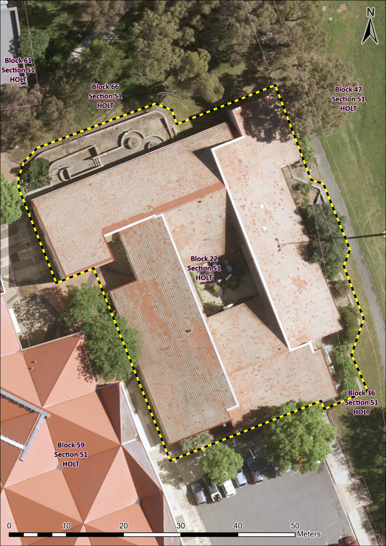
Image 1 the Former Kippax Health Centre site boundary within Block 71 (formerly Block 22) Section 51, Holt.

