Australian Capital Territory
Planning and Development (Technical Amendment—Code Amendments) Plan Variation 2023 (No 2)

Notifiable instrument NI2023–156
Technical amendment No 2023-02
made under the
Planning and Development Act 2007, s 89 (Making technical amendments)

1 Name of instrument
This instrument is the Planning and Development (Technical Amendment–Code Amendments) Plan Variation 2023 (No 2).
2 Commencement
This instrument commences on the day after its notification day.
3 Technical amendment
I am satisfied under the Planning and Development Act2007, section 89 (1) (a), that the Code amendments plan variation is a technical amendment to the Territory Plan.
4 Dictionary
In this instrument:
Code amendments plan variation means the technical amendment to the Territory Plan, variation 2023-02, as set out in the schedule.
Freya O’Brien
Delegate of the planning and land authority
28 March 2023

Planning and Development Act 2007

Technical Amendment
to the Territory Plan

2023-02

Changes to the
West Belconnen Concept Plan

March 2023

Commencement version
under section 89 of the Planning and Development Act 2007

Table of Contents
1. INTRODUCTION 1
1.1 Purpose 1
1.2 Public consultation 1
1.3 National Capital Authority 1
1.4 Process 1
1.5 Types of technical amendments under the Act 2
2. EXPLANATORY STATEMENT 3
2.1 Background 3
2.2 Changes to the West Belconnen Concept Plan 3
3. TECHNICAL AMENDMENT 6
3.1 Variation to the West Belconnen Concept Plan 6

- INTRODUCTION
    - Purpose
This technical amendment makes the following changes to the Territory Plan:
West Belconnen Concept Plan
- Amend Figure 1 to realign the 500m landfill clearance zone
    - Public consultation
Under section 87(2)(b) of the Planning and Development Act 2007 (the Act) this type of technical amendment is subject to limited public consultation.
TA2023-02 was released for public consultation from 20 January 2023 to 10 March 2023.
No submissions were received.
    - National Capital Authority
The Australian Capital Territory (Planning and Land Management) Act 1988 established the National Capital Authority (NCA) with two of its functions being to prepare and administer a National Capital Plan (the Plan) and to keep the NCP under constant review and to propose amendments to it when necessary.
The Plan, which was published in the Commonwealth Gazette on 21 January 1990, is required to ensure Canberra and the Territory are planned and developed in accordance with their national significance. The Australian Capital Territory (Planning and Land Management) Act 1988 also requires the Territory Plan not be inconsistent with the Plan. The areas covered by this technical amendment are within urban areas identified in the Plan.
The National Capital Authority has been advised of this technical amendment.
    - Process
This technical amendment has been prepared in accordance with section 87 of the Planning and Development Act 2007 (the Act).
Comments received from the public and the National Capital Authority will be taken into account before the planning and land authority “makes” the technical amendment under section 89 of the Act. The planning and land authority must then notify the public of its decision.

    - Types of technical amendments under the Act
The following categories of technical amendments are provided under section 87 of the Act:
- Each of the following territory plan variations is a technical amendment for which no consultation is needed before it is made under section 89:
(a) a variation (an error variation) that –
- would not adversely affect anyone’s rights if approved; and
- has as its only object the correction of a formal error in the plan;
(b) a variation to change the boundary of a zone or overlay under section 90A (Rezoning – boundary changes);
(c) a variation, other than one to which subsection (2)(d) applies, in relation to an estate development plan under section 96 (Effect of approval of estate development plan);
(d) a variation required to bring the territory plan into line with the national capital plan;
(e) a variation to omit something that is obsolete or redundant in the territory plan.
- Each of the following territory plan variations is a technical amendment for which only limited public consultation is needed under section 90:
- a variation (a code variation) that –
- would only change a code; and
- is consistent with the policy purpose and policy framework of the code; and
- is not an error variation;
- a variation to change the boundary of a zone under section 90B (Rezoning – development encroaching on adjoining territory land);
- a variation in relation to a future urban area under section 90C (Technical amendments – future urban areas);
- a variation in relation to an estate development plan under section 96 (Effect of approval of estate development plan) if it incorporates an ongoing provision that was not included in the plan under section 94 (3) (g);
- a variation to clarify the language in the territory plan if it does not change the substance of the plan;
- a variation to relocate a provision within the territory plan if the substance of the provision is not changed.
TA2023-02 has been prepared in accordance with section 87(2)(a) of the Act.
- EXPLANATORY STATEMENT
    - Background
This part of the technical amendment document explains the changes to be made to the Territory Plan, the reasons for the change, and a statement of compliance against the relevant section of the Act.
    - Changes to the West Belconnen Concept Plan
Figure 1 is being amended to realign the landfill clearance zone. Figure 1 shows the landfill clearance zone which extends 500m from the boundary of rural block 1586 and containing most of the landfill site. A review of the extent of the landfill site has been undertaken and is detailed in the West Belconnen Resource Management Centre – Waste Cells Investigation report (26 October 2022). The report recommends that the landfill clearance zone be realigned to match the extent of the landfill site, rather than its current delineation which is based on the block boundary. The ACT Environment Protection Authority (EPA) supports the proposed realignment of the landfill clearance zone, which will continue to provide a buffer of 500m around the landfill site.

Existing Figure 1

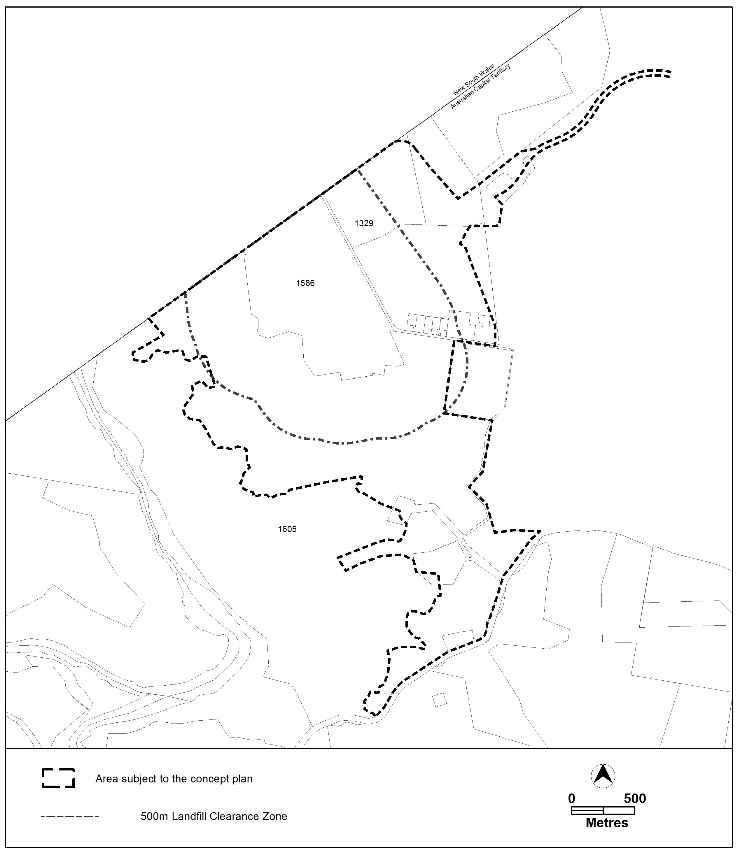

Proposed Figure 1

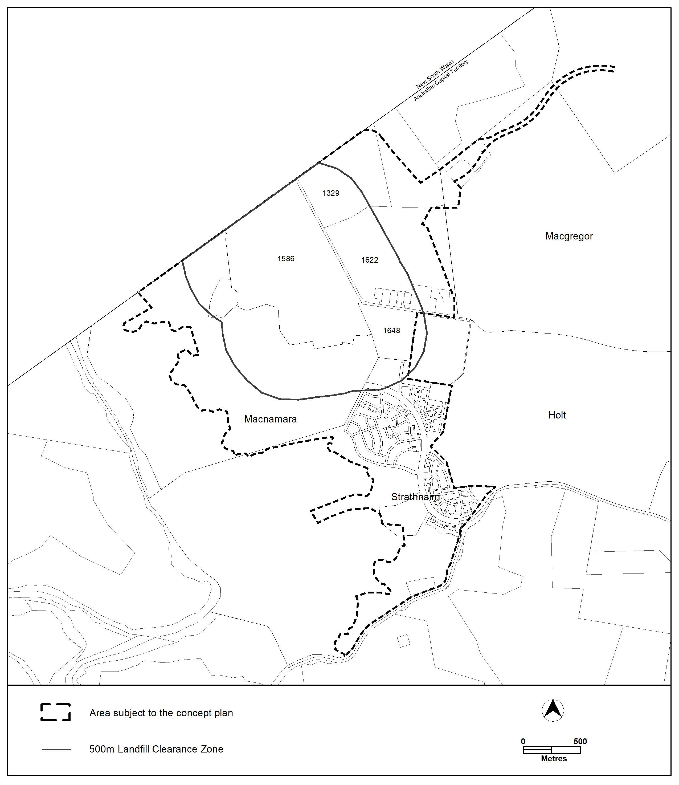

Section | Statement
s87(2)(a)  (a) a variation (a code variation) that—  (i) would only change a code; and  (ii) is consistent with the policy purpose and policy framework of the code; and  (iii) is not an error variation | Compliant.  The change is being made to Figure 1 in the West Belconnen Concept Plan to realign the landfill clearance zone. The change is consistent with the policy intent of restricting development within the clearance zone. The change is supported by the ACT EPA.
- TECHNICAL AMENDMENT
This section of the technical amendment document provides the actual instructions for implementing the changes to the Territory Plan.

    - Variation to the West Belconnen Concept Plan
- Figure 1 Clearance Zone Map A

substitute

Figure 1 Clearance Zone Map A

Interpretation service

