Australian Capital Territory

Nature Conservation (Key's Matchstick Grasshopper) Conservation Advice 2023

Notifiable instrument NI2023–222
made under the
Nature Conservation Act 2014, s 90C (Conservation advice)

1 Name of instrument
This instrument is the Nature Conservation (Key's Matchstick Grasshopper) Conservation Advice 2023.

2 Commencement
This instrument commences on the day after its notification day.

3 Conservation advice for Key's Matchstick Grasshopper
Schedule 1 sets out the conservation advice for Key's Matchstick Grasshopper (Keyacris scurra).

Arthur Georges
Chair, Scientific Committee
14 April 2023
Schedule 1
(see s 3)

Conservation Advice
Key’s Matchstick grasshopper –
Keyacris scurra

Conservation Status
The species Keyacris scurra (Rehn 1952) is recognised as threatened in the following jurisdictions:
National Endangered, Environment Protection and Biodiversity Conservation Act 1999
ACT Endangered, Nature Conservation Act 2014
NSW Endangered, Biodiversity Conservation Act 2016
VIC Threatened, The Flora and Fauna Guarantee Act 1988

ELIGIBILITY
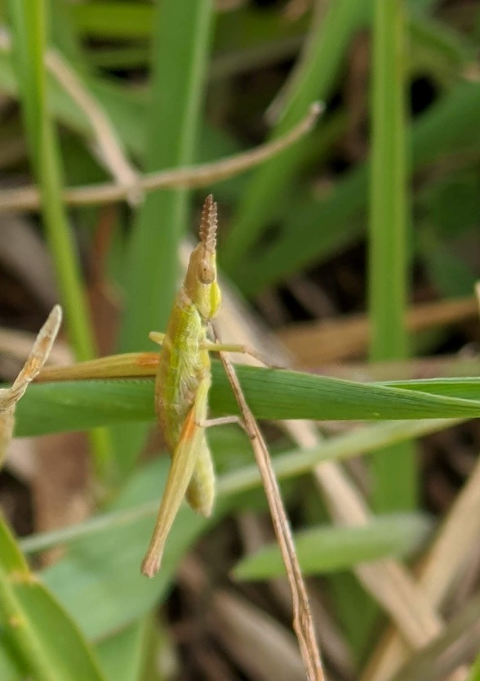
The Key’s Matchstick Grasshopper is listed as Endangered in the ACT Threatened Native Species List under Criterion B – B2ab(ii,iii,iv,v)c(iv) primarily due to a restricted geographical range at the national level (Attachment A). Other supporting factors include severe fragmentation; historical and inferred ongoing decline across the entire distribution in abundance (25.4% over the last ten years), habitat availability and quality; and ongoing threats including poorly understood management requirements (NSW Threatened Species Scientific Committee (NSW TSSC) 2020).

DESCRIPTION AND ECOLOGY
The Key’s Matchstick Grasshopper is a very small (18–25 mm), wingless, morabine grasshopper, found in native grasslands, particularly Natural Temperate Grassland. Individuals are most often greyish brown in colour, although colour morphs may vary with habitat through to bright green (Farrow 2018). They have a characteristic slanted face with short sword like antennae. Adults are similar in appearance to Giant Green Slantface (Acrida conica) nymphs, however, may be distinguished by the lack of wing buds at all life stages. The Key’s Matchstick Grasshopper is more active in the evening, climbing onto grasses (Farrow 2018). As it is flightless, it does not move more than about 200–300 m over the course of its lifetime (Key 1987).
  - Key’s Matchstick Grasshopper
  - (Hannah Zurcher – EPSDD)

The Key’s Matchstick Grasshopper lays eggs at the beginning of summer, that hatch between December and January. Males mature by May, however females overwinter as nymphs and mating occurs from September through to the end of November. Eggs are laid in soil (Rowell and Crawford 1995), and clutches have low fecundity with an average of 25 eggs per female (White 1977). It is probable that Kangaroo Grass (Themeda triandra) is the main host plant that provides protection from predators (White 1956), especially during reproduction. Generation length is one year as adults die after eggs are laid.
Key’s Matchstick Grasshopper is herbivorous and feeds on a range of native and exotic species, preferring smaller ephemeral plants (particularly Asteraceae) but will consume larger perennial species if the former are not available (Blackith and Blackith 1966) but does not feed on Kangaroo Grass. There may be differences in diet between adults and nymphs (Unsicker et al. 2008). While this might explain the range of plant life in the sites in which it is found, it is also likely that a diversity of suboptimal food plants confers significant survival advantages (Miura and Ohsaki 2004).
Although no work has been undertaken to identify predators of the Key’s Matchstick Grasshopper, parasitic wasps (Scelio spp.) in south-eastern Australia have been shown to regulate some populations of acridid grasshoppers (Baker et al. 1996). Morabine grasshoppers are known to be parasitised by Braconidae (Blackith 1967a). There is also the possibility of parasitism by tachinid species such as Myothyria fergusoni, although this is often highly variable (Blackith 1967b). Predators of the Key’s Matchstick Grasshopper are likely to include birds, such as magpies (Cracticus tibicen) (Calver 1985) and the local Wolf Spiders (specifically Lycosa godeffroyi), which are known to eat other ACT grassland grasshoppers (A. Rowell pers. obs. 2016).
There are two different chromosomal races of the Key’s Matchstick Grasshopper, but there is a reasonable amount of genetic diversity within larger populations (those with available habitat 100–500 m from the survey site). In smaller populations (those restricted to much smaller patches of un-mowed land, with limited habitat outside 50 m from the survey site), there is a high degree of inbreeding. Separate populations across the range of the species do not exhibit a great amount of gene flow. The genetic diversity of populations is not related to habitat availability or quality (Hoffman 2021).

Distribution and Habitat
The Morabinae are an endemic Australian grasshopper subfamily, with members found across the whole range of rainfall and temperature in Australia (Key 1987). The historic distribution of Key’s Matchstick Grasshopper, as with many other Kangaroo Grass associated grassland species, ranged from central-west NSW to northern Victoria (NSW TSSC 2020). Based on all records available for the period 2009–2019 the Area of Occupancy (AOO) is 124 km² nationally (using a 2x2 km grid cell). The current distribution of Key’s Matchstick Grasshopper has similarly contracted with the significant loss of Kangaroo Grass dominated Natural Temperate Grassland. Current known locations of the Key’s Matchstick Grasshopper outside the ACT include Bungendore, Cooma in NSW and Omeo in Victoria (Hoffmann et al. 2021).
Sites known to host current populations of Key’s Matchstick Grasshopper in the ACT include Gibraltar Saddle in Namadgi National Park, Mulligans Flat, Hall Cemetery, and Kambah Pool (NSW TSSC 2020, Hoffmann et al. 2021). The Key’s Matchstick Grasshopper has also been recorded in the ACT at Gungahlin, Kaleen, Crace Grasslands, Kaleen, Murrumbidgee River, Tuggeranong Hill, Paddys River, Tidbinbilla and Royalla (Canberra.naturemapr.org 2021). Sightings have recently occurred for the first time at the Lawson grasslands (E. Cook pers. comm.). The distribution of the species in the ACT is shown in Map 1.
While the Key’s Matchstick Grasshopper is often found in grassland dominated by Kangaroo Grass (White 1956), it is also found in locations dominated by other native grass species. Occupation of habitats dominated by species of grass other than Kangaroo Grass may be a result of range fragmentation, or the species’ adaptation to cooler temperatures. The restriction of the species to relatively small areas may be because of habitat preference or interactions with other species (Key 1987).
Map 1: Distribution of Key’s Matchstick Grasshopper records and habitat in the ACT
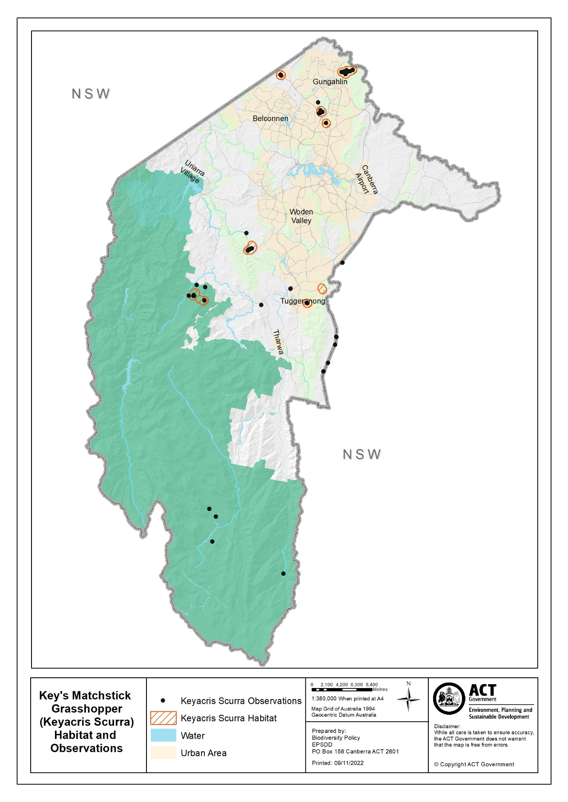
The Key’s Matchstick Grasshopper has been found on a range of native and introduced plants (Blackith and Blackith, 1966). Native plants include Early Nancy (Wurmbea dioica), Golden Lily (Bulbine bulbosa), Red Beard Orchid (Calochilus paludosus), Australian Buttercup (Ranunculus lappaceus), Sheep’s Burr (Acaena ovina), Small Poranthera (Poranthera microphylla), Creamy Candles (Stackhousia monogyna), Guinea Flower (Hibbertia sericea), Common Everlasting (Chrysocephalum apiculatum), Rough Everlasting (Ozothamnus retusus), Showy Copper-wire Daisy (Podolepis jaceoides) and Billy Buttons (Craspedia variabilis).
Introduced food plants include common pasture and weeds, such as Silver hairgrass (Aira caryophyllea), dock/sorrel (Rumex spp.), clover (Trifolium spp.), Vervain (Salvia verbenaca), Great Mullein (Verbascum thapsus) and Lavender (Lavandula stoechas) (Blackith and Blackith, 1966).

Threats
The Key’s Matchstick Grasshopper is known primarily from areas of Natural Temperate Grassland, a Critically Endangered ecological community under the Nature Conservation Act 2014 (NC Act). The main threats include:
- habitat loss of Natural Temperate Grassland
- habitat degradation of native plant species through inappropriate management strategies that reduce grassland structure or allow colonisation of native grasslands by exotic plant species
- habitat fragmentation compounded by the flightless nature of adults that restricts movement between fragments and recolonisation
- inappropriate large-scale fire regimes in autumn/winter that may endanger nymphs
- climate change effects combined with the species’ limited mobility makes it less able to adapt by moving to accommodate habitat change.
The Key’s Matchstick Grasshopper is threatened by inappropriate management of vegetation, further complicated by potential competition between necessary habitat and feed species. While it appears that Kangaroo Grass is necessary for some aspect of their life cycle, their dietary preferences are overwhelmingly for forbs, and Kangaroo Grass-dominated grassland can crowd out the herbaceous plants on which they feed. Their restriction to cemeteries and other minimally maintained land such as railway cuttings suggests that, regardless of dietary preferences, the Key’s Matchstick Grasshopper is threatened by frequent mowing and extensive maintenance regimes. Similarly, weed invasion may also crowd out their food or breeding plants.
Eggs are vulnerable to increased summer temperatures, and an unexpectedly intense localised grass fire event may pose a significant threat to populations as well as disrupting habitat. Changes in temperature may also impact life stage cues (White 2018). Increases in humidity may reduce the success rate of moulting and lead to increased mortality (White 2018).
The Key’s Matchstick Grasshopper is currently only extant in fragmented areas of remnant grassland within the ACT. This heightens the risk of population loss or collapse due to a single threatening event. While inbreeding rates do not limit heterozygosity except for in exceptionally small populations (Hoffmann et al. 2021), changes to environment or populations could easily reduce population sizes.

Major Conservation Objective
The priority management objective is to maintain in the long term, viable, wild populations of the Key’s Matchstick Grasshopper as a component of the indigenous biological resources of the ACT and region.

Conservation Priorities
The long-term conservation of the Key’s Matchstick Grasshopper depends on protecting its native grassy habitat. Conservation priorities should include to:
- conserve important ACT populations such as the populations at Mulligans Flat and Hall Cemetery
- manage the species and its habitat to maintain the potential for evolutionary development in the wild, particularly through:
  - avoiding overgrazing of Kangaroo Grass during drought
  - avoiding or at least reducing controlled burns during at-risk life stages
  - fencing suitable habitat and not regularly mowing, especially at cemetery sites
  - removing weeds
- enhance the long-term viability of populations through management of adjacent grassland to increase habitat area and connect populations
- promote awareness of the species in grassland monitoring programs to inform possible targeted surveys and encourage the recording of all sightings on Canberra Nature Map
- add the species to the list of threatened species included in the Natural Temperate Grassland Action Plan (ACT Government 2017b)
- collaborate with research institutions and non-government organisations to encourage citizen science, volunteering and knowledge exchange with the Ngunnawal community
- explore the implications of climate change for population persistence and conduct climate sensitive management actions where feasible. Systematic monitoring and collection of population data, including reproduction and survival data when available, should be used to assess population viability and species distribution. For species whose physiological limits are known, biophysical models can provide a predictive understanding of the habitats required for persistence in the face of climate change through an integration of data on climate and other environmental variables with measures of morphology, behaviour, physiology and life history of the species. Opportunities to address knowledge gaps for this species to establish climate change ready management actions may include university and interjurisdictional research collaborations.

Other Relevant Advice, plans or Prescriptions
- ACT Native Grassland Conservation Strategy (ACT Government 2017a)
- ACT Natural Temperate Grassland Action Plan (ACT Government 2017b)
- NSW Conservation Assessment – Key’s Matchstick Grasshopper (NSW TSSC 2020)

Listing Background
The Key’s Matchstick Grasshopper is listed as an Endangered species under the Environment Protection and Biodiversity Conservation Act 1999 (EPBC Act), effective 10 October 2022, under Criterion 2 B2ab(ii,iii,iv,v)c(iv). In 2023, the ACT Scientific Committee recommended the Key’s Matchstick Grasshopper be listed in the Endangered category in the ACT Threatened Native Species List, under the Nature Conservation Act 2014, to align with the EPBC Act listing.

Action Plan Decision
The ACT Scientific Committee recommends that the Minister for the Environment should make the decision to not have an action plan for the species in the ACT under the Nature Conservation Act 2014 at this time. As a listed threatened species the Key’s Matchstick Grasshopper is managed under the Natural Temperate Grassland Action Plan (ACT Government 2017b) with a key objective of this plan to conserve biodiversity, including by maintaining and improving threatened species habitat structure. The species should be added to the list of threatened species included in this Action Plan.

References
ACT Government 2017a. ACT Native Grassland Conservation Strategy and Action Plans. Environment, Planning and Sustainable Development Directorate, Canberra.
ACT Government 2017b. Natural Temperate Grassland Action Plan 2017. Environment, Planning and Sustainable Development Directorate, Canberra.
Baker GL, Dysart RJ and Pigott RG 1996. Parasitism of grasshopper and locust eggs (Orthoptera: Acrididae) by Scelio species (Hymenoptera: Scelionidae) in southern Australia. Australian Journal of Zoology 44(4): 427–43.
Blackith RE 1967a. A hymenopterous primary parasite of morabine grasshoppers. Australian Journal of Zoology 15(1): 93–102. https://doi.org/10.1071/ZO9670093
Blackith RE 1967b. A tachinid parasite of Australian grasshoppers. Australian Journal of Zoology 15(4): 745–758. https://doi.org/10.1071/ZO9670745
Blackith RE and Blackith RM 1966. The food of morabine grasshoppers. Australian Journal of Zoology 14(5): 877–894. https://doi.org/10.1071/ZO9660877
Calver MC 1985. Some aspects of the population ecology of the grasshopper Acrida conica Fabricius. PhD dissertation. Murdoch University, Perth.
Canberra.naturemapr.org (CNM) 2021. Canberra Nature Map. Accessed 28 July 2021 from: https://canberra.naturemapr.org/species/7136
Farrow R 2018. Insects of South-eastern Australia. CSIRO, Melbourne.
Hoffmann AA, White VL, Jasper M, Yagui H, Sinclair SJ and Kearney MR 2021. An endangered flightless grasshopper with strong genetic structure maintains population genetic variation despite extensive habitat loss. Ecology and Evolution 11(10): 5364–5380. https://doi.org/10.1002/ece3.7428
Key KHL 1987. Speciation in the Australian Morabine Grasshoppers — taxonomy and ecology. In: White M.J.D. (eds) Genetic Mechanisms of Speciation in Insects. Springer, Dordrecht. https://doi.org/10.1007/978-94-010-2248-4_3
Miura K and Ohsaki N 2004. Diet mixing and its effect on polyphagous grasshopper nymphs. Ecological Research 19(3): 269–274. https://doi.org/10.1111/j.1440-1703.2004.00635.x
NSW Threatened Species Scientific Committee (NSW TSSC) 2020. Conservation Assessment of Keyacris scurra (Rehn 1952) Key’s Matchstick Grasshopper. NSW Government, Sydney.
https://www.environment.nsw.gov.au/-/media/OEH/Corporate-Site/Documents/Animals-and-plants/Scientific-Committee/Determinations/2020/keyacris-scurra-keys-matchstick-grasshopper-final-determination-conservation-assessment.pdf?la=en&hash=AAD360A21E03ACC3462609A44F0F4C9FA110263C
Rowell A and Crawford I 1995. A survey of the morabine grasshopper Keyacris scurra (Rehn) in the ACT. CSIRO.
White MJD 1956. Adaptive Chromosomal Polymorphism in an Australian Grasshopper. Evolution 10(3): 298–313. https://doi:10.2307/240601
White MJD 1977. Animal Cytology and Evolution. Cambridge University Press, Cambridge.
White V 2018. The diversity of Aussie Grasshoppers: Part two. The University of Melbourne. Accessed February 2021 from: https://blogs.unimelb.edu.au/pearg/2018/10/15/the-diversity-of-aussie-grasshoppers-part-two/
Unsicker SB, Oswald A, Köhler G and Weisser WW 2008. Complementarity effects through dietary mixing enhance the performance of a generalist insect herbivore. Oecologia 156(2): 313–324.

Further Information
Further information on the related Action Plan or other threatened species and ecological communities can be obtained from: Environment, Planning and Sustainable Development Directorate (EPSDD). Phone: (02) 132281, EPSDD Website: https://www.environment.act.gov.au/

Attachment A: National Assessment (NSW TSSC 2020)

