Australian Capital Territory

Nature Conservation (Pilotbird) Conservation Advice 2023

Notifiable instrument NI2023–225
made under the
Nature Conservation Act 2014, s 90C (Conservation advice)

1 Name of instrument
This instrument is the Nature Conservation (Pilotbird) Conservation Advice 2023.

2 Commencement
This instrument commences on the day after its notification day.

3 Conservation advice for Pilotbird
Schedule 1 sets out the conservation advice for Pilotbird (Pycnoptilus floccosus).

Arthur Georges
Chair, Scientific Committee
14 April 2023
Schedule 1
(see s 3)

Conservation Advice
Pilotbird – Pycnoptilus floccosus

Conservation Status
The Pilotbird – Pycnoptilus floccosus Gould, 1851 – is recognised as threatened in the following jurisdictions:
National Vulnerable, Environment Protection and Biodiversity Conservation Act 1999
ACT Vulnerable, Nature Conservation Act 2014
NSW not yet listed, Biodiversity Conservation Act 2016
VIC not yet listed, Flora and Fauna Guarantee Act 1988

ELIGIBILITY
The Pilotbird is listed as Vulnerable in the ACT Threatened Native Species List under IUCN Criterion A —A2bc due to a major decline in abundance at the national level (Attachment A). The species likely underwent a significant population decline of 30– 50% over the last 11 years (three generations) caused by the widespread 2019–2020 bushfires across south-eastern Australia (Loyn et al. 2021). The cause of the reduction in numbers (and greater than 50 percent decline in habitat) has not ceased because the risk of frequent, large extent, high intensity wildfires are projected to increase (DAWE 2022, Attachment A).

DESCRIPTION AND ECOLOGY
The Pilotbird is about 18 cm in length, with a wingspan of 23cm and weighs an average 27 g. Male and female birds are similar in appearance and are a deep rufous-brown with: a cinnamon forehead; amber eyes; slender pointed bills; long, broad, wedge-tipped tails with rufous tail coverts; and large, strong feet. The throat, breast and underbelly are cinnamon and scalloped brown and their lower underparts are dull white and flanks are brown. Juvenilles resemble adults but have darker foreheads and underparts, and a prominent pale gape (Higgins and Peter 2002).
Two Pilotbird subspecies have been described – the Upland Pilotbird (Pycnoptilus floccosus floccosus) and the Lowland Pilotbird (Pycnoptilus floccosus sandlandi). The upland subspecies (that occurs in the ACT) is larger and darker than the lowland subspecies (Schoode and Mason 1999).
Pilotbird (Roger Williams – Canberra Nature Map)
Pilotbirds are terrestrial, largely sedentary and are typically seen in wet gullies hopping over the forest floor and foraging on damp ground or scratching among leaf-litter using their feet and bills, often in the wake of Superb Lyrebirds (Menura novaehollandiae) (Firth 1984, Higgins and Peter 2002). Pilotbirds forage mostly in pairs for insects, worms and occasionally eat seeds and small berries often in the company of White-browed Scrubwrens (Sericornis frontalis frontalis) (Firth 1984, Higgins and Peter 2002). Pilotbirds are secretive and are usually detected by a loud call which is a sparking, vivacious song that carries well through the forest (Firth 1984, Taylor and Day 2006).
Breeding takes places between August and January. Adults build a domed nest on or near the ground in which they usually lay two grey-green to purple-brown eggs (Zwart 1973) that are incubated by the female for 20–22 days. Young are fed insects by both parents and can continue to be fed by their parents for up to two months after fledging (Higgins and Peter 2002). Juveniles forage together in groups with adults until the young males leave to stake their own territories. The generation length is 3.7 years (Bird et al. 2020).

Distribution and Habitat
The Upland Pilotbird subspecies occurs above 600 m in the Brindabella Ranges in the ACT, through the Snowy Mountains in New South Wales and north‐east Victoria. The Lowland Pilotbird sub-species occurs from the Blue Mountains in the north, around the wetter forests of eastern Australia, to the Dandenong Ranges near Melbourne (Higgins and Peter 2002, Loyn et al. 2021).
Figure 1: Modelled Distribution of Pilotbird (Source: DAWE 2022)
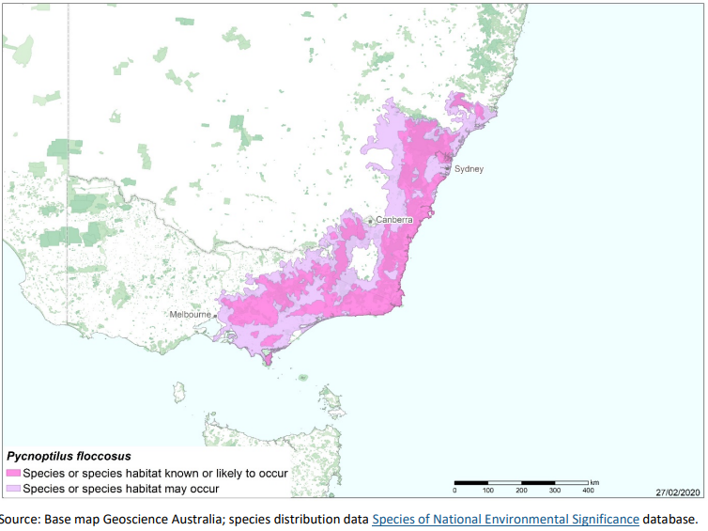
In the ACT, the Pilotbird is generally found in the Cotter Valley in the Brindabella Ranges with records mainly from Blundells Creek, Bendora Road, Warks Road and Tidbinbilla. Pilotbird reporting rates remained steady at a low level in 2018–19 with 38 birds recorded in the ACT and reporting rates and abundance declining from both the 10-year and 30-year averages (COG 2020). Figure 2 shows the distribution in the ACT region of records from 1982 to 2017 (Canberrabirds.org.au 2022).
Pilotbirds live on the ground occupying small territories in dense forests with heavy undergrowth only sometimes ascending into shrubs but no more than 1–2 m from the ground (Firth 1984, Higgins and Peter 2002).
Figure 2: Distribution of Pilotbird records in the ACT region – 1982–2017
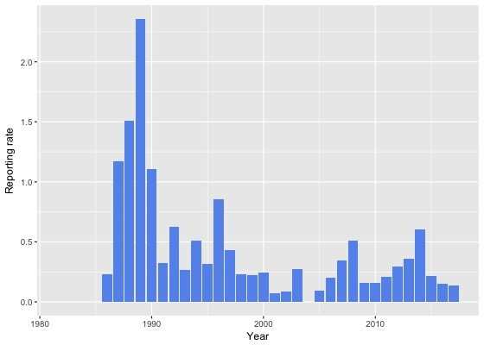
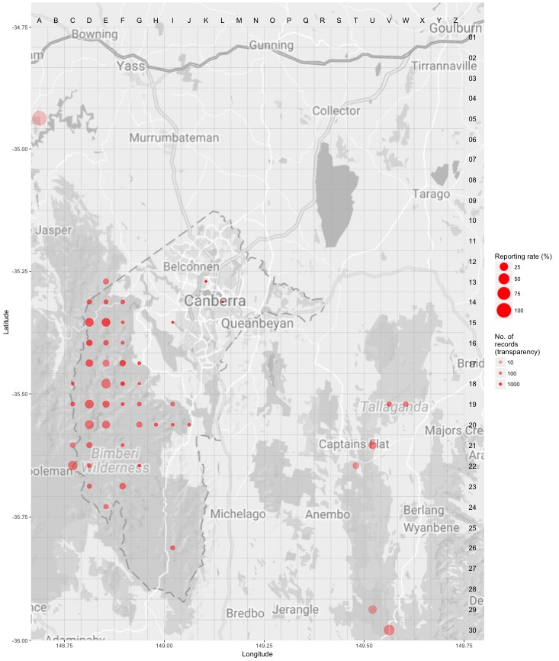
Source: Canberrabirds.org.au. (2022). Note: Reporting rate (%) is the proportion of all surveys in which the species was present. These data were collected by volunteer birdwatchers using various survey methods and, on some occasions, more than one person may have recorded bird sightings on the same day, which may skew the data.
Habitat critical to the survival of the Pilotbird includes wet sclerophyll forests in temperate zones in moist gullies with dense undergrowth, and dry sclerophyll forests and woodlands occupying dry slopes and ridges (Higgins and Peter 2002). Any breeding or foraging habitat should be considered habitat critical to the survival of the species (DAWE 2022). Areas that are not currently occupied by the species because they have been burnt (either during the 2019–2020, or in future fires), but which should become suitable again in the future, should also be considered habitat critical to survival (DAWE 2022).

Threats
There were no known substantive threats to the Pilotbird until a combination of extended drought and
exceptional heat provided the conditions for widespread, high intensity bushfires that burnt large parts of the species’ habitat in January 2020 (Loyn et al. 2021). Predation by feral Cats and Foxes is also a potential threat to the species, especially following fire (DAWE 2022) as cats take advantage of recently burnt areas (McGregor et al. 2016), to hunt in open habitats, which they prefer (McGregor et al. 2015).
Baker et al. (1997), studied the long-term effects of high intensity wildfire on 20 passerine species in wet sclerophyll forest in the Brindabella Ranges and found that most of the species studied returned to pre-fire numbers within three years however Pilotbird numbers were still impacted up to at least six years later.
While the 2020 bushfire impacted a significant area of the entire distribution of the species including the southern forests in Namadgi National Park, there was a significant portion of the species habitat in the ACT that was not impacted by these fires, including the northern Namadgi forests in the Lower Cotter Catchment and Tidbinbilla Nature Reserve.

Major Conservation Objective
The primary objective in the ACT is to maintain a viable, wild population of Pilotbirds by protecting habitat through a fire and forest management regime that reduces the risk of extensive, intense fires and allows full population recovery and recolonisation of burnt areas between fires.

Conservation PRIORITIES
Conservation and management priorities in the ACT should be to:
- ensure habitat is protected from disturbance and fragmentation
- identify and map likely core habitat areas to assist in operational planning
- ensure fire management (fire risk reduction, fire suppression and post-fire management activities) considers impacts on key breeding locations, foraging, roosting and nesting habitat
- protect nearby unburnt habitat areas after fires to provide ongoing refuge from cats and foxes for known populations
- promote and support the inclusion of this species in bird community surveys, monitoring and research in the ACT
- increase community awareness and encourage community and indigenous-based conservation action
- explore the implications of climate change for population persistence and conduct climate sensitive management actions where feasible. Systematic monitoring and collection of population data, including reproduction and survival data when available, should be used to assess population viability and species distribution. For species whose physiological limits are known, biophysical models can provide a predictive understanding of the habitats required for persistence in the face of climate change through an integration of data on climate and other environmental variables with measures of morphology, behaviour, physiology and life history of the species. Opportunities to address knowledge gaps for this species to establish climate change ready management actions may include university and interjurisdictional research collaborations.

Other Relevant Advice, plans or Prescriptions
- Commonwealth Conservation Advice – Pilotbird (DAWE 2022)
- Namadgi National Park Plan of Management (ACT Government 2010)
- Tidbinbilla Plan of Management (ACT Government 2012)

Listing Background
The Pilotbird is listed as a Vulnerable species under the Environment Protection and Biodiversity Conservation Act 1999 (EPBC Act), effective 2 March 2022. It is assessed as Vulnerable under Criterion 1 (A2bc) of the EPBC Act. In 2022, under the Nature Conservation Act 2014, the ACT Scientific Committee recommended the Pilotbird be listed in the Vulnerable category in the ACT Threatened Native Species List to align with the EPBC Act listing.

Action Plan Decision
The ACT Scientific Committee does not recommend that the Minister for the Environment should make the decision to have an action plan for the species in the ACT under the Nature Conservation Act 2014 at this time. The key habitat areas of wet dense forest gullies preferred by the species are specifically identified in fire management planning (ACT Government 2019) to be protected from the impact of fire by every practical measure. The species occurs within Namadgi National Park and Tidbinbilla Nature Reserve and its habitat is protected in these areas.

References
ACT Government 2010. Namadgi National Park Plan of Management 2010. Land Management and Planning Division, Department of Territory and Municipal Services, Canberra. https://www.legislation.act.gov.au/di/2010-192/
ACT Government 2012. Tidbinbilla Plan of Management 2012. Territory and Municipal Services Directorate, Canberra. https://www.legislation.act.gov.au/di/2012-193/
ACT Government 2019. Ecological Guidelines for Fire, Fuel and Access Management Operations. Environment Planning and Sustainable Development Directorate, ACT Government, Canberra. https://www.environment.act.gov.au/__data/assets/pdf_file/0009/1483830/Ecological-Guidelines-2019-ver-1.3.pdf
Baker GB, Dettmann EB and Wilson SJ 1997. Fire and its impact on avian population dynamics. Pacific Conservation Biology 3(1): 206–212. https://www.researchgate.net/profile/G-Baker-5/publication/288726946_Fire_and_its_impact_on_avian_population_dynamics/links/57a47fdd08ae455e85385e49/Fire-and-its-impact-on-avian-population-dynamics.pdf
Bird JP, Martin R, Akçakaya HR, Gilroy J, Burfield IJ, Garnett ST, Symes A, Taylor J, Şekercioğlu ÇH and Butchart SHM 2020. Generation lengths of the world's birds and their implications for extinction risk. Conservation Biology 34(5): 1252–1261.
BirdLife International. 2016. Pycnoptilus floccosus The IUCN Red List of Threatened Species 2016. Accessed 2 May 2022 from: https://www.iucnredlist.org/species/22704513/93973392
Canberrabirds.org.au 2022. Canberra Birds Pilotbird Pycnoptilus floccosus data sheet. Accessed 2 May 2022 from: https://canberrabirds.org.au/wp-content/bird_data/506_Pilotbird.html
COG 2020. Annual Bird Report: 1 July 2018 to 30 June 2019. Canberra Bird Notes 45(1): 1–106. https://canberrabirds.org.au/wp-content/uploads/2020/04/CBN-451-ABR.pdf
Department of Agriculture, Water and the Environment (DAWE) 2022. Conservation Advice for Pycnoptilus floccosus (Pilotbird). Department of Agriculture, Water and the Environment (Commonwealth), Canberra. http://www.environment.gov.au/biodiversity/threatened/species/pubs/525-conservation-advice-02032022.pdf
Frith HJ (ed.) 1984. Birds in the Australian High Country (Revised edition). Angus and Robertson, Sydney.
Gould J 1851. Descriptions of new birds. Proceedings of the Zoological Society of London 1850(18): 91–95. https://www.biodiversitylibrary.org/page/12858725#page/139/mode/1up
Higgins PJ and Peter M (eds.) 2002. Handbook of Australian, New Zealand and Antarctic Birds. Volume 6. Pardalotes to Spangled Drongo. Oxford University Press, Melbourne.
Loyn RH, Legge SM, Ehmke G, Woinarski JCZ, Dutson G and Garnett ST 2021. Upland Pilotbird Pycnoptilus floccosus floccosus and Lowland Pilotbird Pycnoptilus floccosus sandlandi. In ST Garnett and GB Baker (eds) The Action Plan for Australian Birds 2020. CSIRO Publishing, Melbourne.
McGregor HW, Legge S, Jones ME and Johnson CN 2015. Feral Cats Are Better Killers in Open Habitats, Revealed by Animal-Borne Video. PLoS ONE 10(8): e0133915. https://journals.plos.org/plosone/article?id=10.1371/journal.pone.0133915
McGregor HW, Legge S, Jones ME and Johnson CN 2016. Extraterritorial hunting expeditions to intense fire scars by feral cats. Scientific Reports 6: 22559. https://www.nature.com/articles/srep22559
Schoode R and Mason IJ 1999. The Directory of Australian Birds: Passerines. CSIRO Publishing,
Taylor M and Day N 2006. Field Guide to Birds of the ACT. National Parks Association of the ACT Inc, Canberra.
Zwart MH 1973. Breeding and behaviour of pilotbirds. Emu 73(3): 124–128.

Further Information
Further information on other threatened species and ecological communities can be obtained from the Environment, Planning and Sustainable Development Directorate (EPSDD): Phone: (02) 132281, EPSDD Website: https://www.environment.act.gov.au/

Attachment A: Listing Assessment (DAWE 2022)
