Australian Capital Territory

Nature Conservation (Southern Greater Glider) Conservation Advice 2023

Notifiable instrument NI2023–226
made under the
Nature Conservation Act 2014, s 90C (Conservation advice)

1 Name of instrument
This instrument is the Nature Conservation (Southern Greater Glider) Conservation Advice 2023.

2 Commencement
This instrument commences on the day after its notification day.

3 Conservation advice for Southern Greater Glider
Schedule 1 sets out the conservation advice for Southern Greater Glider (Petauroides volans).

4 Revocation
The Nature Conservation (Greater Glider) Conservation Advice 2019 (NI2019-232) is revoked.

Arthur Georges
Chair, Scientific Committee
14 April 2023
Schedule 1
(see s 3)

Conservation Advice
Southern Greater Glider
Petauroides volans

Conservation Status
The Southern Greater Glider Petauroides volans (Kerr, 1792) is recognised as threatened in the following jurisdictions:
National Endangered, Environment Protection and Biodiversity Conservation Act 1999
ACT Endangered, Nature Conservation Act 2014
NSW Endangered, Biodiversity Conservation Act 2016
VIC Vulnerable, Advisory List of Threatened Fauna in Victoria 2013
QLD Endangered, Nature Conservation Act 1992

CRITERIA
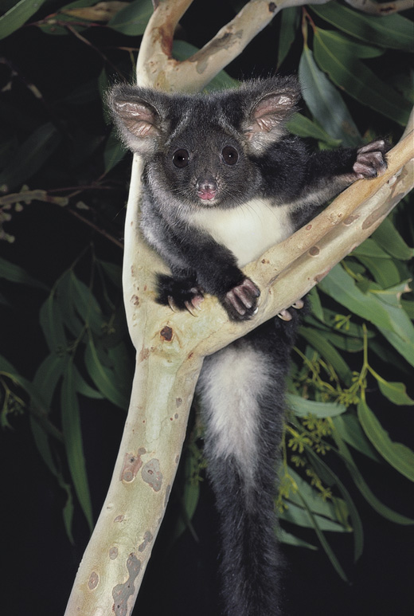
The Southern Greater Glider (southern and central) is listed as Endangered in the ACT Threatened Native Species List under IUCN Criterion A — A2(a)(b)(c), A4(b)(c) at the national level (Attachment A). The main factors that make the species eligible for listing in the Endangered category are an overall rate of population decline exceeding 50 percent over a 21-year period (three generations), including population reduction and habitat destruction following the 2019–20 bushfires (Department of Climate Change, Energy, the Environment and Water (DCCEEW) 2022).

DESCRIPTION AND ECOLOGY
The Southern Greater Glider is an arboreal nocturnal marsupial and is the largest gliding possum in Australia, with a head-body length of 35−46 cm and a long furry tail measuring 45−60 cm. The Greater Glider has thick fur that increases its apparent size. Its fur colour is white or cream below and varies from dark grey, dusky brown to light mottled grey and cream above. It has large furry ears, a short snout and a non-prehensile tail (McKay 2008).
Greater Glider (Pavel German - AustralianNature.com)
Females give birth to single young from March to June, sexual maturity is reached in the second year, longevity has been estimated at 15 years (Tyndale-Biscoe and Smith 1969; McKay 2008; Harris and Maloney 2010) and generation length is likely to be 7−8 years (Burbidge and Woinarski 2016).

Taxonomy AND SYSTEMATICS
Jackson & Groves (2015) split the previously regarded single species genus into three separate species: Petauroides minor (northern), P. armillatus (central), and P. volans (southern) which was confirmed by genetic analysis (McGregor et al. 2020; Arbogast et al. in DCCEEW 2022). Further analysis of the southern and central taxa is required before they are formally split. The listed entity in this Conservation Advice is referred to as the Southern Greater Glider, including two lineages, with the point of contact between them in the vicinity of Coffs Harbour in NSW (KN Armstrong pers comm. in DCCEEW 2022) and the ACT population falling within the distribution of the southern lineage.
From a systematics point of view this population structure needs to be recognised by management and measures taken by relevant range jurisdictions to ensure both lineages of this species are protected.

Distribution and Habitat
The Southern Greater Glider is restricted to eastern Australia, occurring from around Proserpine in central Queensland through to central Victoria (Wombat State Forest), ranging from sea level to 1200 m above sea level. The Southern Greater Glider has a high degree of site fidelity with enough den trees, occupying very small home ranges of 1–3 hectares limiting its capacity for movement and dispersal (Henry 1984; Kelh and Borsboom 1984 and Kavanagh and Whelan 2004).
Map 1 Modelled distribution of the Southern Greater Glider (southern and central lineages)
(Source: DEECCW 2022)
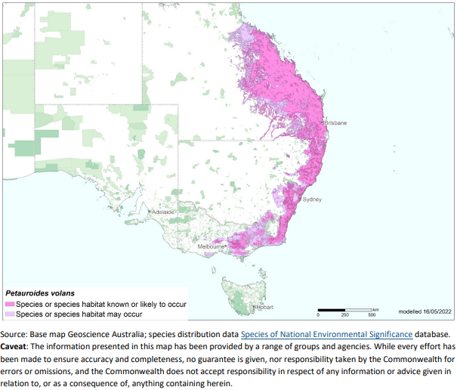
The species prefers taller, montane, moist eucalypt forests with relatively large old trees and abundant large hollows where it shelters during the day (Woinarski et al. 2014) and favours forests with a diversity of eucalypt species, due to seasonal variation in its food-tree species (Kavanagh 1984). Ribbon-gum forest (u52) appears to be the preferred habitat in Namadgi National Park and Southern Greater Gliders were observed eating the foliage of Ribbon Gum (Eucalyptus viminalis) and Narrow-leaved Peppermint (E. radiata) during the 2019 surveys (Hawkins and Baines in prep.). Southern Greater Gliders were seldom recorded in, and were not observed feeding on, the other canopy tree species that were common along spotlighting transects (Alpine Ash (E. delegatensis), Snow Gum (E. pauciflora), Brown Barrel (E. fastigata), Mountain Gum (E. dalrympleana) and Candlebark (E. rubida)), however, some of these species may provide important habitat components, particularly Mountain Gum which is a major provider of tree hollows (Hawkins and Baines in prep.).
In the Australian Capital Territory (ACT), the species has been recorded in the Namadgi National Park and Tidbinbilla Nature Reserve (Lintermans 1993). Systematic nocturnal surveys were carried out in parts of Namadgi in the 1980s, with Southern Greater Gliders recorded in several areas, including low densities along Smokers Trail (S. Davey pers. comm. in Hawkins and Baines in prep.), Warks Rd, Blundell’s Creek Road and regularly recorded in spotlight counts in Tidbinbilla Nature Reserve (M. Lintermans pers. Comm.). In a post-fire fauna study undertaken by the ACT Government (Carey et al. 2003), spotlight sightings were recorded in the Warks Road and Moonlight Hollow Road area of the Lower Cotter catchment, including 13 Southern Greater Gliders in a one-kilometre section near Warks Camp.
In a follow up study of arboreal mammals in 2014 (including surveys of 10 transects covering over 140km) three Southern Greater Gliders were observed on the Camelback Fire Trail at Tidbinbilla; four on the Bendora Return and Moonlight Hollow transects (including the Warks Road area); and one on each of the Honeysuckle and Mount Franklin Road transects (Snape et al. 2015).
Long term spotlighting transects were established in 2019 for monitoring large glider populations (including Southern Greater Gliders and Yellow-bellied Gliders) in Namadgi National Park. Transect locations were stratified so that they represented different fire histories and habitats known to be suitable for large glider species. During the 2019 surveys, 20 Southern Greater Gliders were detected at five sites, all in the north of Namadgi National Park and eight were opportunistically recorded near Honeysuckle Campground (Hawkins and Baines in prep.).
The understanding of the species’ distribution in the ACT remains incomplete and habitat suitability modelling is currently being undertaken to improve this understanding. The potential distribution of Southern Greater Gliders within u52 vegetation communities in relation to fire severity history and key climatic and environmental variables is being mapped for Namadgi National Park. The outcomes of this mapping will inform both future survey locations and management actions. The areas of known high density populations (northern Brindabella Range) were not affected by the 2020 Orroral fire. Conversely, most surveys within the Orroral fire footprint in the period 2004–2019 did not detect any Southern Greater Gliders. However, the fire did burn two locations (Mt Franklin Rd South, and Honeysuckle Creek) where Southern Greater Gliders were recorded in 2014. While the species has been historically detected at these latter locations, they are not considered core habitat for the species.

Threats
Threats to the Southern Greater Glider are outlined in the Commonwealth Conservation Advice (DCCEEW 2022) and those relevant to the ACT include:
- frequent and/or intense bushfires, especially those resulting in the loss of hollow-bearing and feed trees, post-fire starvation, dehydration and predation
- inappropriate prescribed burning
- climate change reducing habitat suitability
- increases in the frequency, intensity and duration of heatwaves associated with climate change.
Cumulative effects of these are a major threat to large native hollow-bearing trees on which the species relies (TSSC 2016). Some of the main threats in the Commonwealth advice (DCCEEW 2022) including land clearing and timber harvesting might not be relevant to the ACT as the populations occur wholly within Namadgi National Park. Currently, prescribed burning in the species habitat is directed to be undertaken appropriately under ecological guidelines (ACT Government 2019) and emphasis on improving fire management in key areas that will be strongholds under climate change is essential. McLean et al. (2018) found that wildfires severely affected the density of Southern Greater Gliders and NSW NPWS (2020) found they were not likely to survive in canopies that experienced high severity fires in the 2019–2020 Currowan Fire. Similarly, Smith and Smith (2022) could not find any Southern Greater Gliders in post-fire surveys in the Greater Blue Mountains World Heritage Area where all the eucalypt foliage had been killed by fire of high to extreme severity. Southern Greater Gliders are potentially most vulnerable to canopy fire given they seek refugia in hollows and have a very restricted home range. If they can survive a fire, sourcing quality foliage soon after fire becomes a problem (NSW NPWS 2020) as the presence of suitable eucalypt trees with live foliage appears to be a critical factor in the species survival post fire (Smith and Smith 2022).

Major Conservation Objective
The priority management objective should be to maintain and/or increase population size and extent, if possible, through appropriate management of Southern Greater Glider habitat and connectivity to habitat in NSW.

Conservation PriOrities
Recommended management actions are provided in the Commonwealth Conservation Advice (DCCEEW 2022. As the most suitable habitat for this species in the ACT is in reserved areas, priorities for the conservation of the Southern Greater Glider and its habitat in the ACT should be to:
- identify and map critical habitat and populations of the Southern Greater Glider in the ACT, to inform fire management consistent with ecological guidelines (ACT Government 2019), for example, prescribed burns under high or extreme fire weather danger conditions should not be undertaken near high-density populations of this species (Mclean et al. 2018)
- collate existing observational records and undertake regular surveys of populations to monitor persistence and to identify any changes in density or distribution over time
- based on existing knowledge, identify and protect critical elements of the Southern Greater Glider habitat including feed trees and hollow-bearing trees that are important den trees (Mclean et al. 2018), especially from high to extreme severity fires
- formulate a strategy for the development of an emergency protocol for rescue/management of surviving individuals following fires impacting the canopy with high to extreme severity; such an emergency protocol needs to consider the short life span of gliders without access to foliage (ca 4 days), safe access to rescue areas post fire, and options for relocating/housing animals until foliage recovers post fire
- undertake collaborative research on the impacts of prescribed fire on patch occupancy and the abundance and size structure of critical habitat tree species, as to inform ecological guidelines for prescribed fire activities undertaken in Southern Greater Glider habitat with particular reference to habitat characteristics that provide life-saving refuges during heatwaves
- undertake collaborative research to improve understanding of drivers of distribution within Namadgi National Park so that core habitat and high priority conservation areas can be managed appropriately; this research should include studies of habitat requirements such as the relationships between population densities and types of hollow-bearing trees and mix of food-tree species that must be retained to ensure viable populations, particularly with consideration of food and resource availability after a large-scale fire, and for survival during heatwaves
- explore the implications of climate change for population persistence and distribution of this species in the ACT and accordingly plan management, identifying key areas of current and future habitat that may provide thermal refugia; modelling in support of this priority will require systematic monitoring and collection of population data, including reproduction and survival data when available, should be used to assess population viability and species distribution
- undertake collaborative research on the biological and environmental factors necessary to inform biophysical models to provide a predictive understanding of the habitats required for persistence in the face of climate change; such biophysical models require integration of data on climate and other environmental variables with measures of morphology, behaviour, physiology and life history of the species
- maintain active involvement in national research networks for sharing relevant knowledge on Southern Greater Glider ecology as to inform best practice management of the species in the ACT.

CONSERVATION ISSUES
As this species resides within protected areas in the ACT, and because of its particular vulnerability to canopy fires, the key issues of concern centre on fire and its management.
Fire Management
Fires that impact the canopy, whether by wildfire or controlled burns, should be minimized to the degree possible in areas occupied by greater gliders. Should such fires occur, then post-fire management should take into account the critical value of hollow bearing trees to this species, which may require modification of standard practices that involve the removal of such trees post fire. Animals surviving severe canopy fire that removes access to foliage are at severe risk of starvation within a few days. Greater Gliders are difficult to maintain in captivity, so rescue efforts should focus on translocation to areas adjacent to the fire affected areas where sufficient foliage persists, providing the opportunity for passive re-establishment in the fire affected areas as foliage regenerates.
Climate Change
Climate change impacts appear inevitable and will affect the likelihood of persistence, within the ACT, of many species. Most vulnerable in this regard are those species that are likely to be affected by increased severity and frequency of wildfire and those impacted by the severity and frequency of heatwaves, such as the Southern Greater Glider. In the case of heatwaves, greater gliders have a unique physiology to cope with eating toxic eucalypt leaves which leaves them vulnerable to hyperthermia at temperatures greater than 20°C. They accommodate these temperatures by drawing upon energy and water reserves to keep cool. Increased night-time temperatures (higher than 20°C), and higher mean annual temperatures (night-time and day- time temperatures) have been directly linked to greater glider decline in the south of their range (Eyre et al. 2022).
Capacity must be developed to model the impact on the Southern Greater Glider and its habitat under likely climate change scenarios if we are to anticipate and manage the impacts of climate change. This will require a combination of research and the development of in-house capacity for the collection of relevant data and its application in climate change modelling.
Ngunnawal Community Engagement
The ACT Government should facilitate the inclusion of the Ngunnawal people in the conservation of this species and its habitat as part of Ngunnawal Country, both in regard to integration of indigenous knowledge into planning and providing opportunity for members of the Ngunnawal community to engage in on ground activities. Reference to the draft Cultural Resource Management Plan (ACT Government in prep.) would be useful to inform culturally appropriate resource management including of native species that aligns with achieving conservation outcomes for the species.

Other Relevant Advice, plans or Prescriptions
- Commonwealth Conservation Advice — Greater Glider (southern and central) (DCCEEW 2022)
- The Action Plan for Australian Mammals 2012 (Woinarski et al. 2014)

Listing Background
The Greater Glider (including all Petauroides taxa) was listed as Vulnerable under the Environment Protection and Biodiversity Conservation Act 1999 (EPBC Act) on 5 May 2016. The Greater Glider was listed as Vulnerable under the Nature Conservation Act 2014 in the ACT Threatened Native Species List on 11 May 2019 to align with the EPBC Act listing.
The Northern Greater Glider (Petauroides minor) and the Southern Greater Glider (Petauroides volans – southern and central) were reassessed by the Commonwealth Threatened Species Scientific Committee (TSSC) after the 2019–2020 bushfires and were found eligible to be listed as Vulnerable and Endangered, respectively, under the EPBC Act on 5 July 2022. In response, the ACT Scientific Committee recommended the Southern Greater Glider be transferred to the Endangered category in the ACT Threatened Native Species List under the Nature Conservation Act 2014 to align with the EPBC Act listing.
When the taxonomic split of the Southern Greater Glider (Petauroides volans (southern and central)) is formally recognised by the Australian Faunal Directory a listing reassessment of the two separate taxa may be undertaken under the EPBC Act.

Action Plan Decision
The ACT Scientific Committee does not recommend that the ACT Minister for the Environment make the decision to have an action plan for the species in the ACT under the Nature Conservation Act 2014 at this time. The species occurs within Namadgi National Park and Tidbinbilla Nature Reserve and its habitat is protected.
The Commonwealth Minister for the Environment decided that there should be a national recovery plan for the species. This national recovery plan needs to be considered in the context of the population structure of the Southern Greater Glider, that is, in the context of the status of the distinct southern lineage (separate from the central lineage) which is represented in the ACT. The ACT Government and research agencies should maintain an active involvement with other jurisdictions in planning and implementing the national recovery plan and should develop an implementation plan if required to address elements specific to the ACT.

References
ACT Government 2019. Ecological Guidelines for Fire, Fuel and Access Management Operations. Environment Planning and Sustainable Development Directorate, ACT Government, Canberra. https://www.environment.act.gov.au/__data/assets/pdf_file/0009/1483830/Ecological-Guidelines-2019-ver-1.3.pdf
Atlas of Living Australia (ALA) 2018. Atlas of Living Australia. http://www.ala.org.au/
BOM (Bureau of Meteorology) and CSIRO (2020). State of the Climate 2020. Sixth edition. Available on the internet at: State of the Climate 2020: Bureau of Meteorology (bom.gov.au)
Burbidge AA and Woinarski J 2016. Petauroides volans. The IUCN Red List of Threatened Species 2016. http://dx.doi.org/10.2305/IUCN.UK.2016-1.RLTS.T40579A21963210.en
Carey A, Evans M, Hann P, Lintermans M, MacDonald T, Ormay P, Sharp S, Shorthouse D, Webb, N 2003. Wildfires in the ACT 2003: Report on initial impacts on natural ecosystems. Technical Report 17. Environment ACT, Canberra.
Department of Climate Change, Energy, the Environment and Water (DCCEEW) 2022. Conservation Advice for Petauroides volans (Greater Glider (southern and central)). Department of Climate Change, Energy, the Environment and Water (Commonwealth), Canberra.
http://www.environment.gov.au/biodiversity/threatened/species/pubs/254-conservation-advice-05072022.pdf.
Eyre TJ, Smith GC, Venz MF, Mathieson MT, Hogan LD, Starr, C, Winter, J and McDonald, K 2022. Guide to greater glider habitat in Queensland, report prepared for the Department of Agriculture, Water and the Environment, Canberra. Department of Environment and Science, Queensland Government, Brisbane.
Gaia Research Pty Ltd 2021. Monitoring Arboreal Mammals in Muramarang National Park, NSW. Report prepared by G Daly for NSW National Parks and Wildlife Service, Ulladulla.
Harris JM and Maloney S 2010. Petauroides volans (Diprodontia: Pseudocheiridae). Mammalian Species 42(1): 207–219. https://academic.oup.com/mspecies/article/42/866/207/2642969
Jackson S and Groves C 2015. Taxonomy of Australian Mammals. CSIRO Publishing, Clayton South.
Kavanagh R P 1984. Seasonal changes in habitat use by gliders and possums in southeastern New South Wales. In Possums and Gliders (eds A. P. Smith & I. D. Hume) 527–543. Surrey Beatty and Sons, Chipping Norton.
Hawkins B and Baines G in prep. Surveys for Greater Gliders and Yellow-bellied Gliders in Namadgi National Park 2019–2020. Environment, Planning and Sustainable Development Directorate, ACT Government, Canberra.
Henry SR 1984. Social organisation of the greater glider (Petauroides volans) in Victoria, in AP Smith & ID Hume (eds.), Possums and Gliders. Surrey Beatty and Sons, Chipping Norton. 221–228.
Kavanagh RP and Wheeler RJ 2004. Home range of the greater glider Petauroides volans in tall montane forest of south-eastern New South Wales, and changes following logging. In RL Goldingay & SM Jackson (eds.) The Biology of Australian Possums and Gliders. Surrey Beatty and Sons, Sydney. 413–425.
Kavanagh R, McLean C and Stanton M 2021. Greater glider and yellow-bellied glider population responses to the 2019-2020 wildfires in north-eastern NSW and south-eastern NSW. A report to the Department of Agriculture, Water and Environment (Commonwealth), Canberra.
Kearney MR, Wintle BA, and Porter WP 2010. Correlative and mechanistic models of species distribution provide congruent forecasts under climate change. Conservation Letters 3(3): 203–213.
Kehl J and Borsboom A 1984. Home range, den tree use and activity patterns in the greater glider (Petauroides volans). In AP Smith ID Hume (eds.) Possums and Gliders. Surrey Beatty and Sons, Chipping Norton. 229–236.
Kerr R 1792. The animal kingdom, or zoological system, of the celebrated Sir Charles Linnaeus: Class 1. Mammalia. J Murray & R Faulder, London.
Legge S, Woinarski JCZ, Garnett ST, Geyle H, Lintermans M, Nimmo DG, Rumpff L, Scheele BC, Southwell DG, Ward M, Whiterod NS, Ahyong ST, Blackmore CJ, Bower DS, Brizuela-Torres D, Burbidge AH, Burns PA, Butler G, Catullo R, Dickman CR, Doyle K, Ensbey M, Ehmke G, Ferris J, Fisher D, Gallagher R, Gillespie GR, Greenlees MJ, Hayward-Brown B, Hohnen R, Hoskin CJ, Hunter D, Jolly C, Kennard M, King A, Kuchinke D, Law B, Lawler I, Lawler S, Loyn R, Lunney D, Lyon J, MacHunter J, Mahony M, Mahony S, McCormack RB, Melville J, Menkhorst P, Michael D, Mitchell N, Mulder E, Newell D, Pearce L, Raadik TA, Rowley J, Sitters H, Spencer R, Valavi R, Ward M, West M, Wilkinson DP and Zukowski S 2021. Estimates of the impacts of the 2019-2020 fires on populations of native animal species. NESP Threatened Species Recovery Hub project 8.3.2 report. Brisbane, Australia.
Lindenmayer DB, Cunningham RB and Donnelly CF 2017b. Decay and Collapse of Trees with Hollows in Eastern Australian Forests: Impacts on Arboreal Marsupials. Ecological Applications 7(2): 625–641.
Lindenmayer DB, Wood J, MacGregor C, Foster C, Scheele B, Tulloch A and O'Loughlin LS 2018b. Conservation conundrums and the challenges of managing unexplained declines of multiple species. Biological Conservation 221(1): 279–292.
Lindenmayer DB, Blanchard W, Blair D, McBurney L, Taylor C, Scheele BC, Westgate MJ, Robinson N and Foster C 2020. The response of arboreal marsupials to long-term changes in forest disturbance. Animal Conservation 24(2): 246–258.
Lindenmayer D, Blair D, McBurney L, Banks S and Bowd E. 2021. Ten years on – a decade of intensive biodiversity research after the 2009 Black Saturday wildfires in Victoria's Mountain Ash Forest. Australian Zoologist 41(2): 220–230.
Lintermans M 1993. The vertebrate fauna of the Gudgenby region, Australian Capital Territory: A review. Technical Report 1. ACT Parks and Conservation Service, Canberra.
McGregor DC, Padovan A, Georges A, Krockenberger A Yoon H and Youngentob KN 2020. Genetic evidence supports three previously described species of greater glider, Petauroides volans, P. minor, and P. armillatus. Scientific Reports 10, 19284. Available on the internet at: https://doi.org/10.1038/s41598-020-76364-z.
McLean CM, Kavanagh RP, Penman T and Bradstock R 2018. The threatened status of the hollow dependent arboreal marsupial, the greater glider (Petauroides volans), can be explained by impacts from wildfire and selective logging. Forest Ecology and Management 415–416: 19–25.
NSW NPWS 2020. Post-fire fauna surveys in coastal national parks of the Shoalhaven Area, NSW National Parks and Wildlife Service, South Coast Branch; Murramarang National Park, Meroo National Park, Conjola National Park and Corramy Regional Park. Report prepared by P Craven and G Daly for National Parks and Wildlife Service (NPWS) South Coast Branch.
McKay G M 2008. Greater Glider Petauroides volans. In The Mammals of Australia. Third edition. (Eds S Van Dyck & R Strahan), 240–242. Reed New Holland, Sydney.
Smith P and Smith J 2018. Decline of the greater glider (Petauroides volans) in the lower Blue Mountains, New South Wales. Australian Journal of Zoology 66(2): 103−114.
Smith P and Smith J 2020. Future of the greater glider (Petauroides volans) in the Blue Mountains, New South Wales. Proceedings of the Linnean Society of New South Wales 142(1): 55−66.
Smith P and Smith J 2022. Impact of the 2019–20 drought, heatwaves and mega-fires on Greater Gliders (Petauroides volans) in the Greater Blue Mountains World Heritage Area, New South Wales. Australian Zoologist 42(2): 164–181.
Snape M, Stevenson B and Evans M 2015. Arboreal mammal spotlight survey 2014. Technical Report 30. Environment and Planning Directorate, ACT Government, Canberra.
Threatened Species Scientific Committee (TSSC) 2016. Approved Conservation Advice for Petauroides volans (Greater Glider). Department of the Environment. Australian Government, Canberra.
Tyndale-Biscoe CH and Smith RFC 1969. Studies on the marsupial glider, Schoinobates volans (Kerr). II. Population structure and regulatory mechanisms. Journal of Animal Ecology 38(3): 637–650. https://www.jstor.org/stable/3040
Wagner B, Baker PJ, Stewart SB, Lumsden LF, Nelson JL, Cripps JK, Durkin LK, Scrogge M and Nitschke CR 2020. Climate change drives habitat contraction of a nocturnal arboreal marsupial at its physiological limits. Ecosphere 11(10): e03262.
Woinarski JCZ, Burbidge AA and Harrison PL 2014. The Action Plan for Australian Mammals 2012. CSIRO Publishing, Collingwood.
Youngentob KN, Lindenmayer DB, Marsh KJ, Krockenberger AK and Foley WJ 2021. Food intake: an overlooked driver of climate change casualties? Trends in Ecology and Evolution 36(8): 676−678.

Further Information
Further information on this species or other threatened species and ecological communities can be obtained from Environment, Planning and Sustainable Development Directorate (EPSDD).
Phone: (02) 132281, EPSDD Website: https://www.environment.act.gov.au/

Attachment A: National Listing Assessment (DCCEEW 2022)

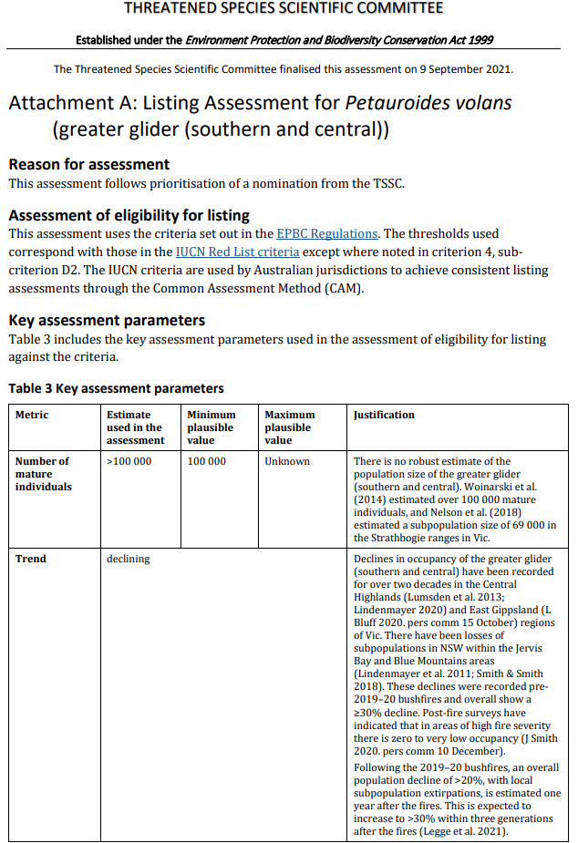
Threatened Species Scientific Committee

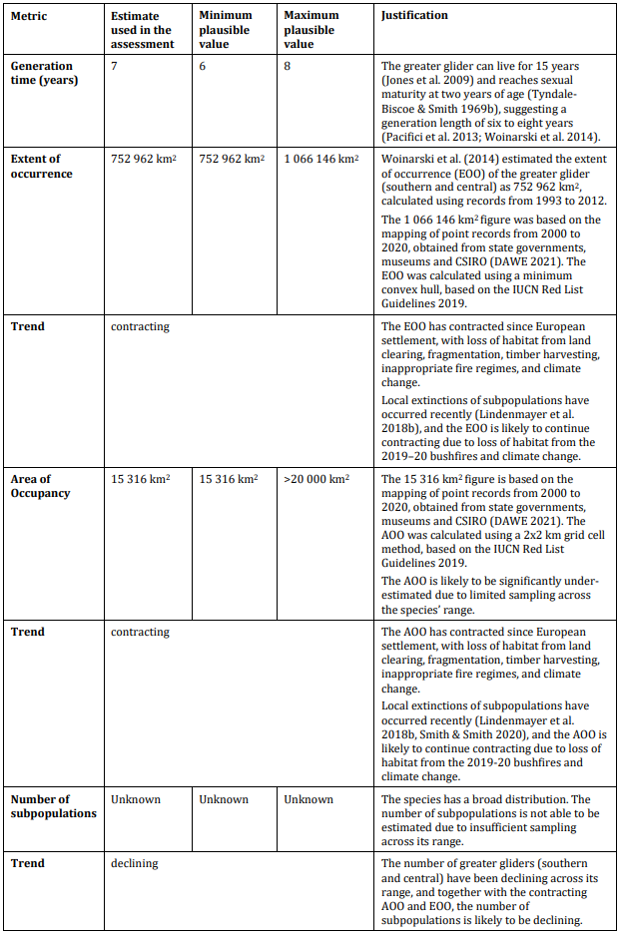
Threatened Species Scientific Committee

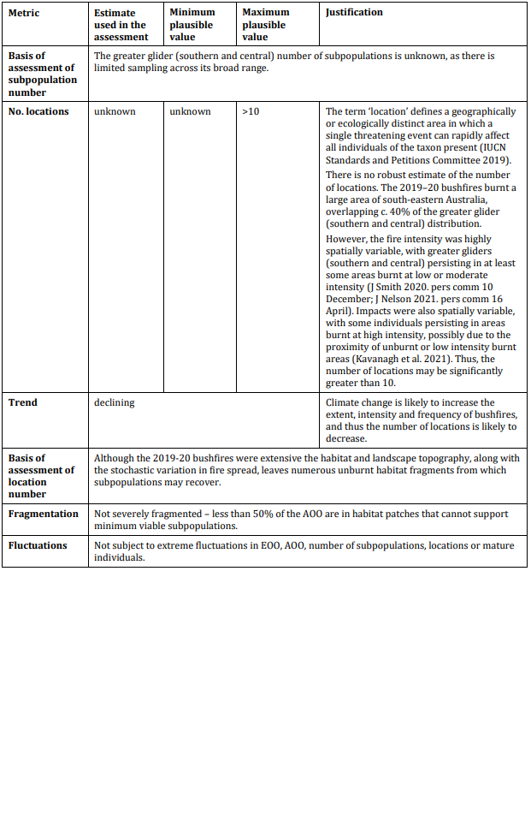
Threatened Species Scientific Committee

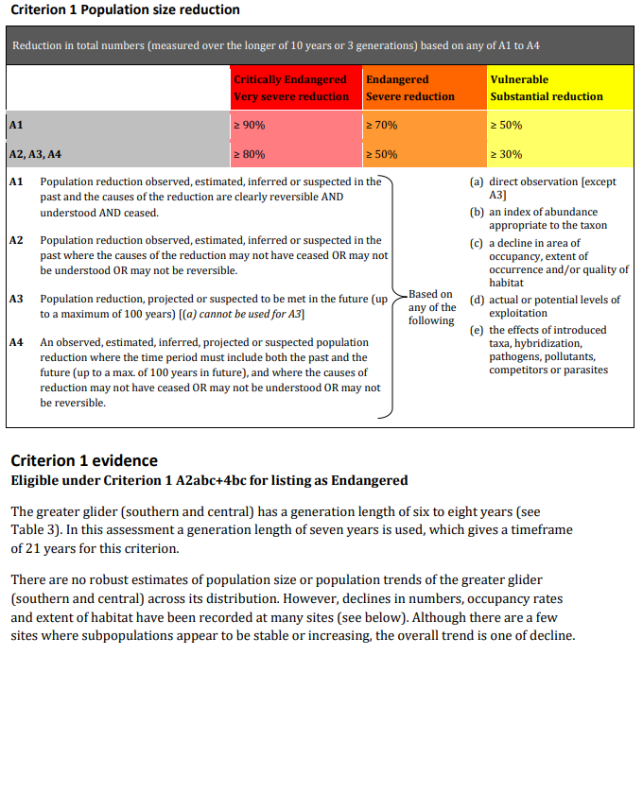
Threatened Species Scientific Committee

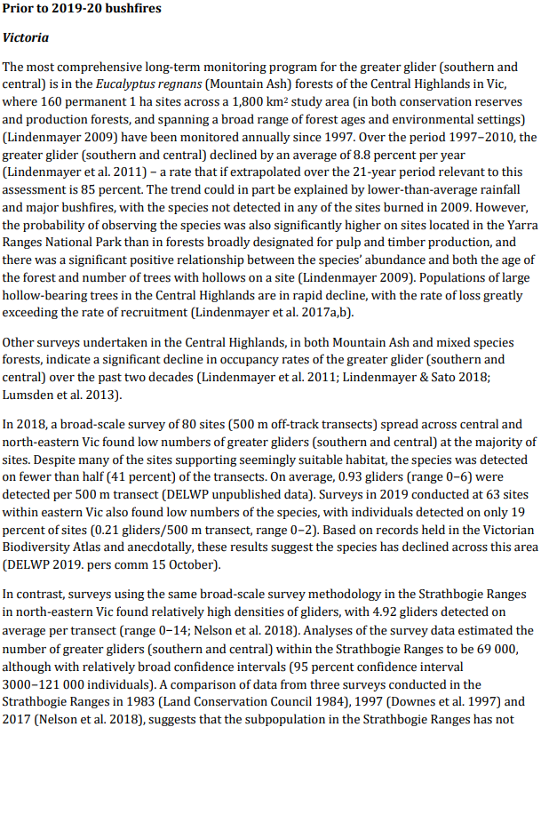
Threatened Species Scientific Committee

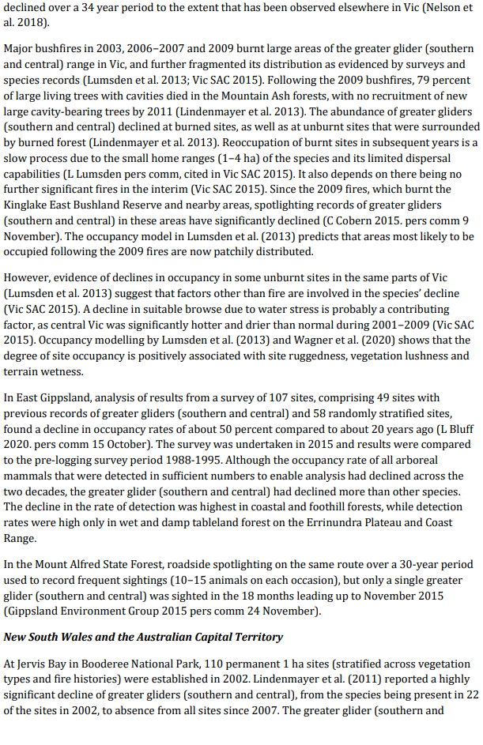
Threatened Species Scientific Committee

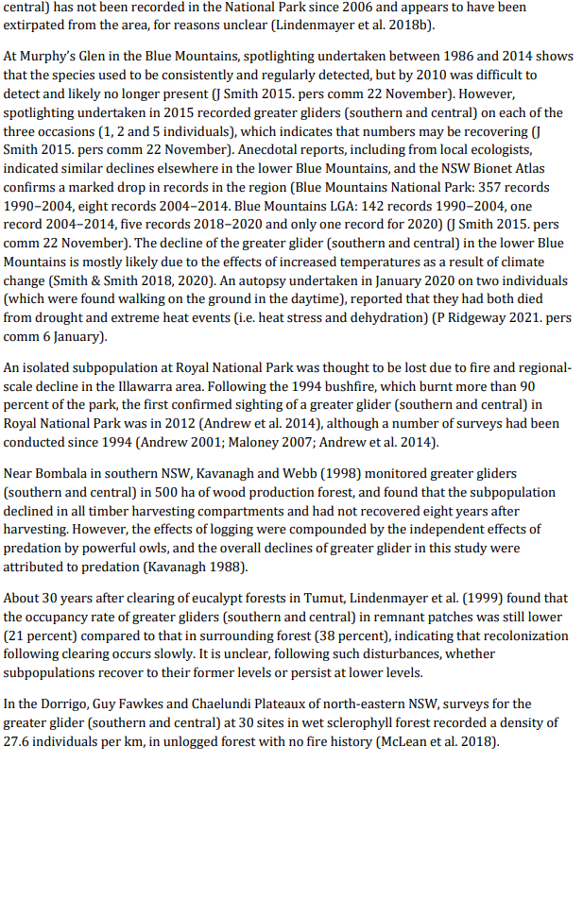
Threatened Species Scientific Committee

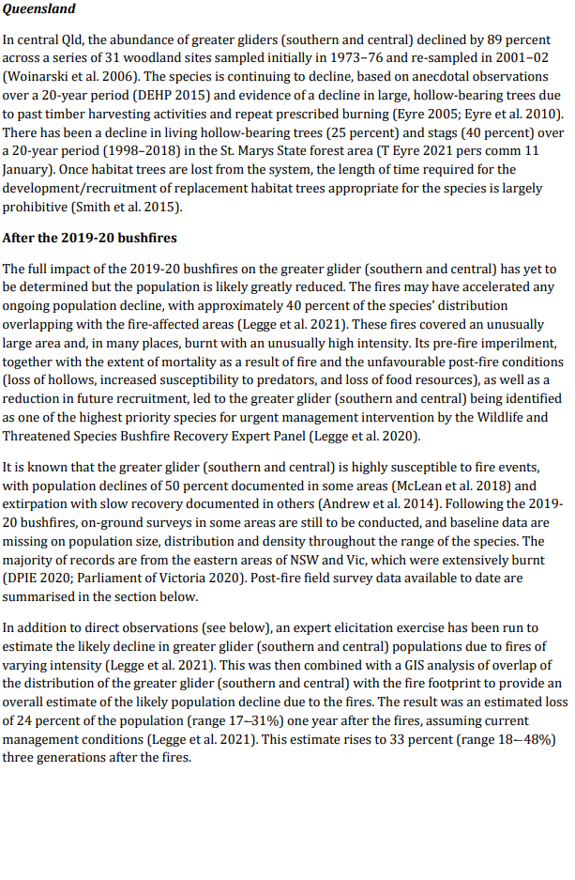
Threatened Species Scientific Committee

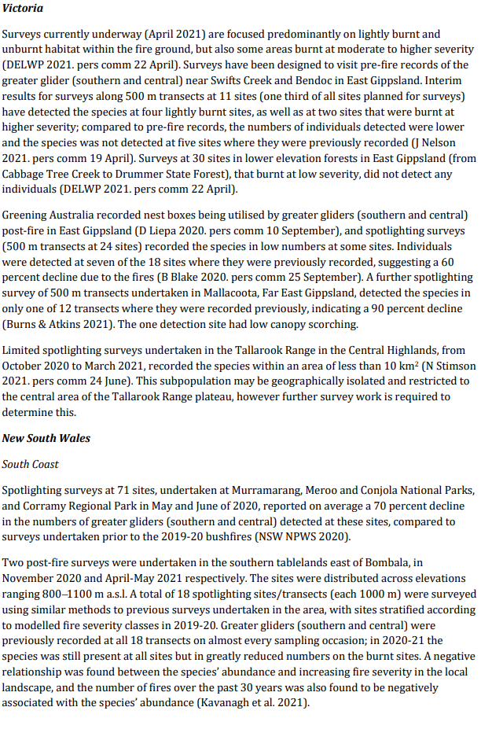
Threatened Species Scientific Committee

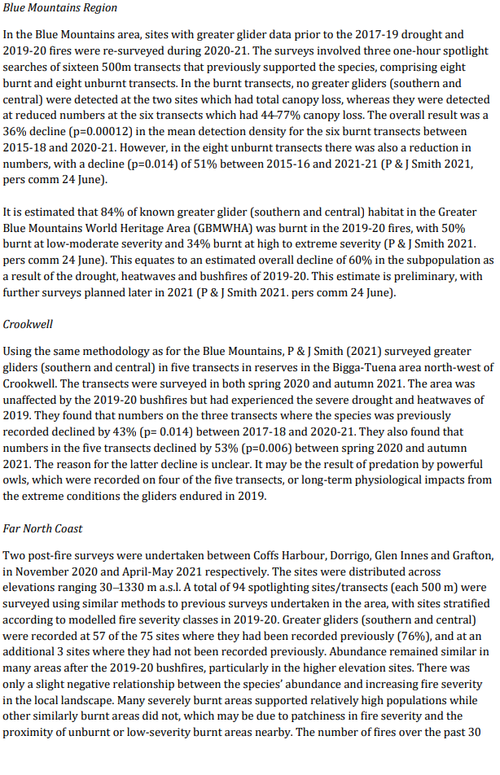
Threatened Species Scientific Committee

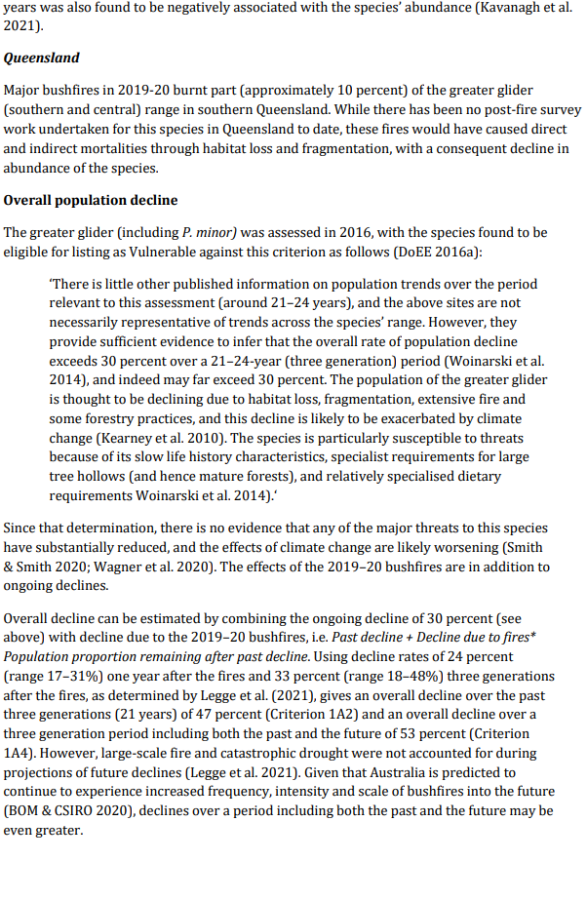
Threatened Species Scientific Committee

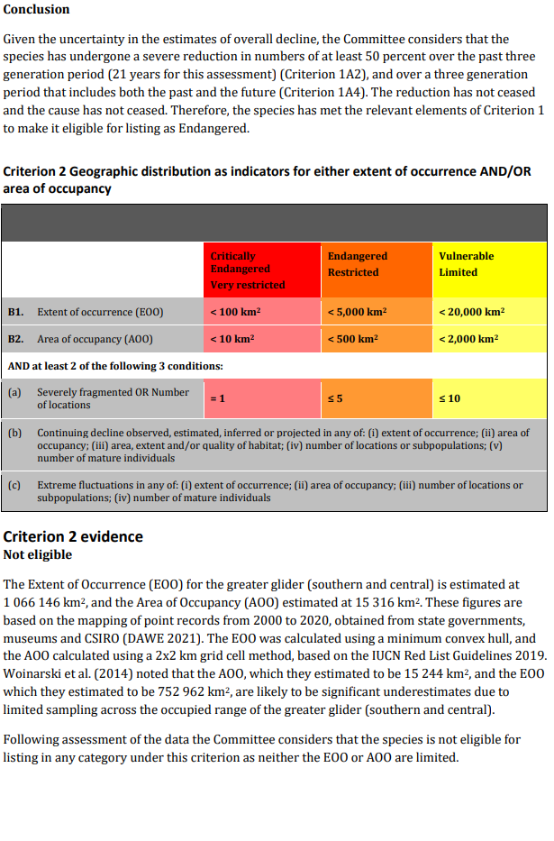
Threatened Species Scientific Committee

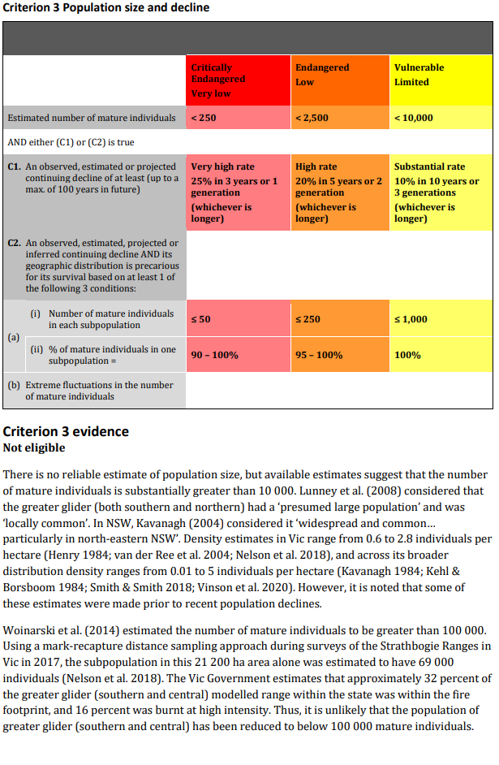
Threatened Species Scientific Committee

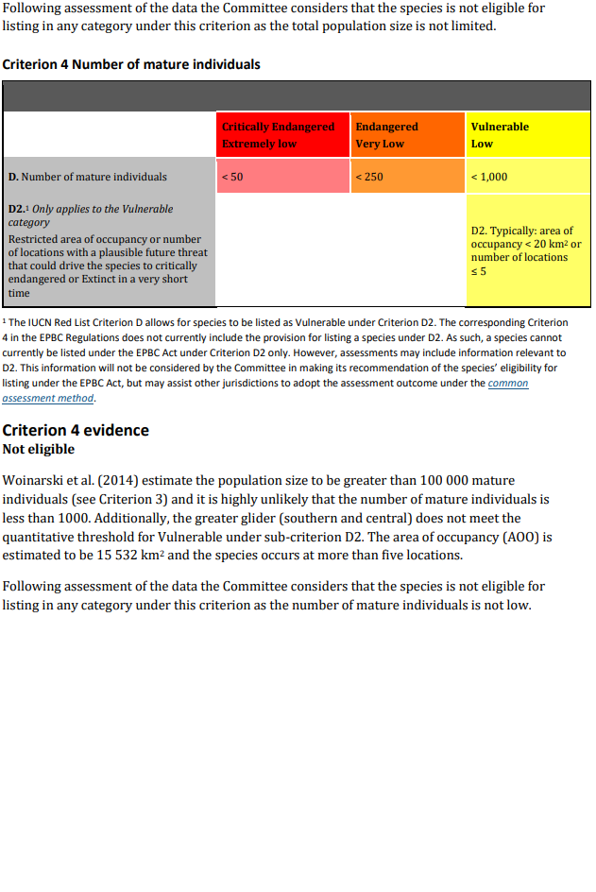
Threatened Species Scientific Committee

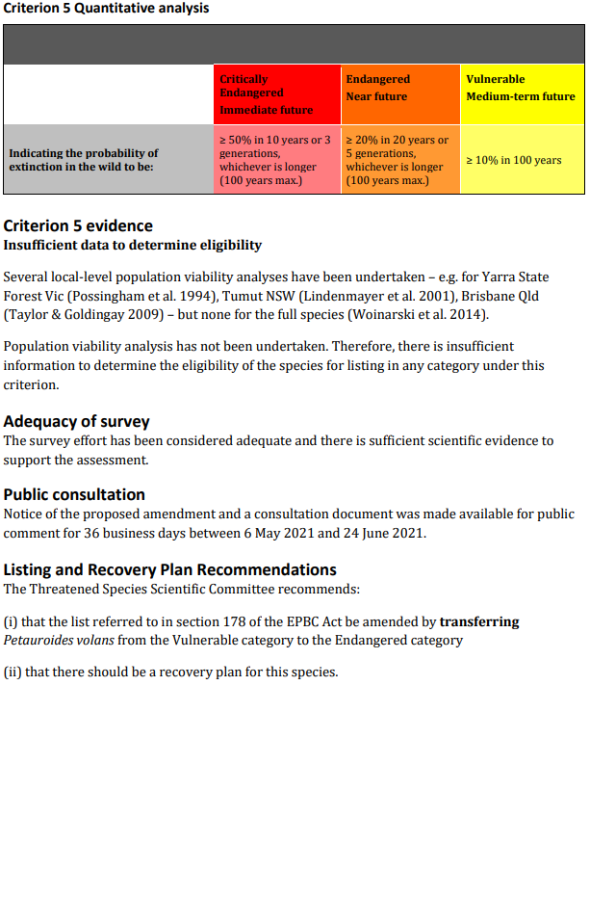
Threatened Species Scientific Committee

