Australian Capital Territory
Planning and Development (Technical Amendment—Fyshwick) Plan Variation 2023

Notifiable instrument NI2023—231
Technical Amendment No 2023-04
made under the
Planning and Development Act 2007, s 89 (Making technical amendments)

- Name of instrument
This instrument is the Planning and Development (Technical Amendment—Fyshwick) Plan Variation 2023.
2 Commencement
This instrument commences on the day after its notification day.
3 Technical amendment
I am satisfied under the Planning and Development Act 2007, section 89 (1) (a), that the Fyshwick plan variation is a technical amendment to the Territory Plan.
4 Dictionary
In this instrument:
Fyshwick plan variation means the technical amendment to the Territory Plan, variation 2023-04, as set out in the schedule.
Freya O’Brien
Delegate of the planning and land authority
28 April 2023

Planning & Development Act 2007

Technical Amendment
to the Territory Plan
Variation 2023-04

Territory land adjoining
Fyshwick section 38 block 11
Change zone boundary – Development encroachment

April 2023

Commencement version under section 89 of the Planning and Development Act 2007

Table of Contents
1. INTRODUCTION 1
1.1 Purpose 1
1.2 Public consultation 1
1.3 National Capital Authority 1
1.4 Process 1
1.5 Types of technical amendments under the Act 2
2. EXPLANATION 3
2.1 Background 3
2.2 Variation to the Territory Plan Map 4
3. TECHNICAL AMENDMENT 8
3.1 Territory Plan Map 8

- INTRODUCTION
  - Purpose
This technical amendment makes the following changes to the Territory Plan:
Territory Plan Map
- Change the zone boundary of Territory land (Fyshwick section 47 part block 11) adjoining Fyshwick section 38 block 11 for a depth of approximately 6.4 metres along most of the block boundary to expand the Commercial CZ3 Services zone.

  - Public consultation
Under section 87(2)(b) of the Planning and Development Act 2007 (the Act) this type of technical amendment is subject to limited public consultation.
TA2023-04 was released for public consultation from 17 February 2023 to 20 March 2023.
No submissions were received.

  - National Capital Authority
The Australian Capital Territory (Planning and Land Management) Act 1988 established the National Capital Authority (NCA) with two of its functions being to prepare and administer a National Capital Plan (the Plan) and to keep the NCP under constant review and to propose amendments to it when necessary.
The Plan, which was published in the Commonwealth Gazette on 21 January 1990, is required to ensure Canberra and the Territory are planned and developed in accordance with their national significance. The Australian Capital Territory (Planning and Land Management) Act 1988 also requires the Territory Plan not be inconsistent with the Plan. The areas covered by this technical amendment are within urban areas identified in the Plan.
The National Capital Authority has been advised of this technical amendment.

  - Process
This technical amendment has been prepared in accordance with section 87 and made in accordance with section 89 of the Act.
  - Types of technical amendments under the Act
The following categories of technical amendments are provided under section 87 of the Act:
- Each of the following territory plan variations is a technical amendment for which no consultation is needed before it is made under section 89:
(a) a variation (an error variation) that –
- would not adversely affect anyone’s rights if approved; and
- has as its only object the correction of a formal error in the plan;
(b) a variation to change the boundary of a zone or overlay under section 90A (Rezoning – boundary changes);
(c) a variation, other than one to which subsection (2)(d) applies, in relation to an estate development plan under section 96 (Effect of approval of estate development plan);
(d) a variation required to bring the territory plan into line with the national capital plan;
(e) a variation to omit something that is obsolete or redundant in the territory plan.
- Each of the following territory plan variations is a technical amendment for which only limited public consultation is needed under section 90:
- a variation (a code variation) that –
- would only change a code; and
- is consistent with the policy purpose and policy framework of the code; and
- is not an error variation;
- a variation to change the boundary of a zone under section 90B (Rezoning – development encroaching on adjoining territory land);
- a variation in relation to a future urban area under section 90C (Technical amendments – future urban areas);
- a variation in relation to an estate development plan under section 96 (Effect of approval of estate development plan) if it incorporates an ongoing provision that was not included in the plan under
section 94(3)(g);
- a variation to clarify the language in the territory plan if it does not change the substance of the plan;
- a variation to relocate a provision within the territory plan if the substance of the provision is not changed.
TA2023-04 has been prepared in accordance with section 87(2)(b) and section 90B of the Act.
- EXPLANATION
This part of the technical amendment document explains the changes to be made to the Territory Plan, the reasons for the change, and a statement of compliance against the relevant section of the Act.
  - Background
The planning and land authority has received a development proposal to subdivide Fyshwick section 38 block 11 and undertake works to install utility services, roads and landscaping. Fyshwick section 38 block 11 was rezoned from Industrial IZ1 General Industrial zone to Commercial CZ3 Services Zone by Variation 377, allowing for a mix of uses, including commercial, light industrial, residential and cultural uses. The site is located at the western end of Fyshwick.
In order to achieve a development outcome that is workable and feasible, the proposal will result in part of the development encroaching into the railway corridor (Fyshwick section 11 block 47). This land is currently zoned Transport and Services TSZ2. The encroachment will be for a depth of approximately 6.4 metres, with an area of approximately 2215m².
Residential use is prohibited in the TSZ2 zone. Therefore, the development triggers the requirement for a technical amendment under section 90B of the Act for rezoning where a development encroaches onto adjoining Territory land. Under the Act, section 90B permits the changing of the boundary of a zone where development is deemed to be encroaching onto adjoining Territory land, provided that the change is consistent with a development proposal under section 137AC of the Act. Section 137AC requires the planning and land authority to make a declaration for development encroaching on adjoining Territory land if development is prohibited provided that the proposal satisfies the criteria in section 137AC (2) of the Act.
The proposal was assessed by the planning and land authority and deemed to comply with the requirements under section 137AC. The declaration was approved by a delegate of the planning and land authority on 9 December 2022 and the notifiable instrument (NI2022-626) took effect on the legislation register on 16 December 2022.
The encroachment into the TSZ2 zone is considered to be a minor component of the development which allows a more logical and appropriate development. This is a positive and appropriate outcome because it does not detract from the amenity of the surrounding area and promotes better land management.

  - Variation to the Territory Plan Map
In accordance with section 90B of the Planning and Development Act 2007 this technical amendment will:
- Change the zone boundary by moving the Commercial CZ3 Services zone boundary approximately 6.4 metres into Fyshwick section 47 block 11 along the block boundary of Fyshwick section 38 block 11 into land that is currently zoned Transport and Services TSZ2.
Existing Territory Plan Map
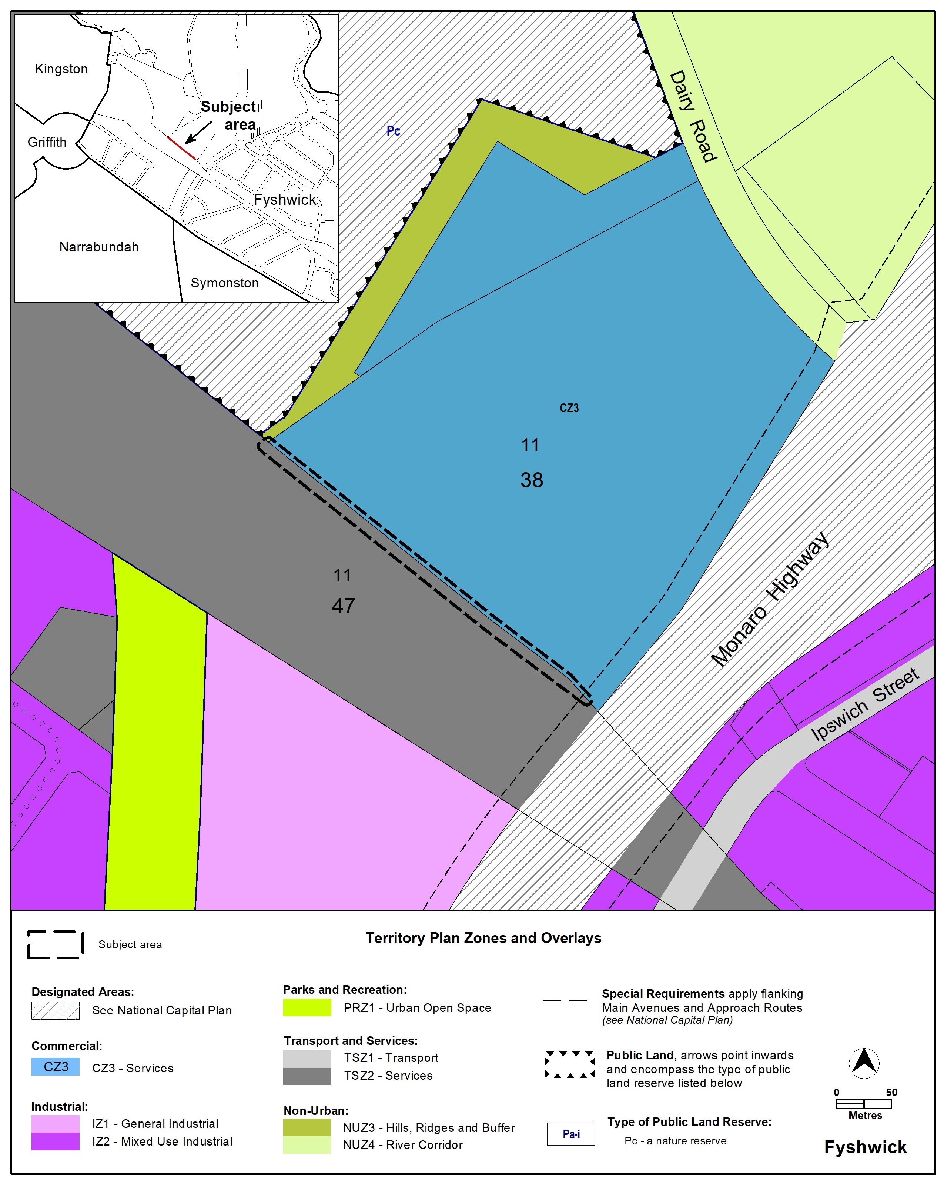

Proposed Territory Plan Map
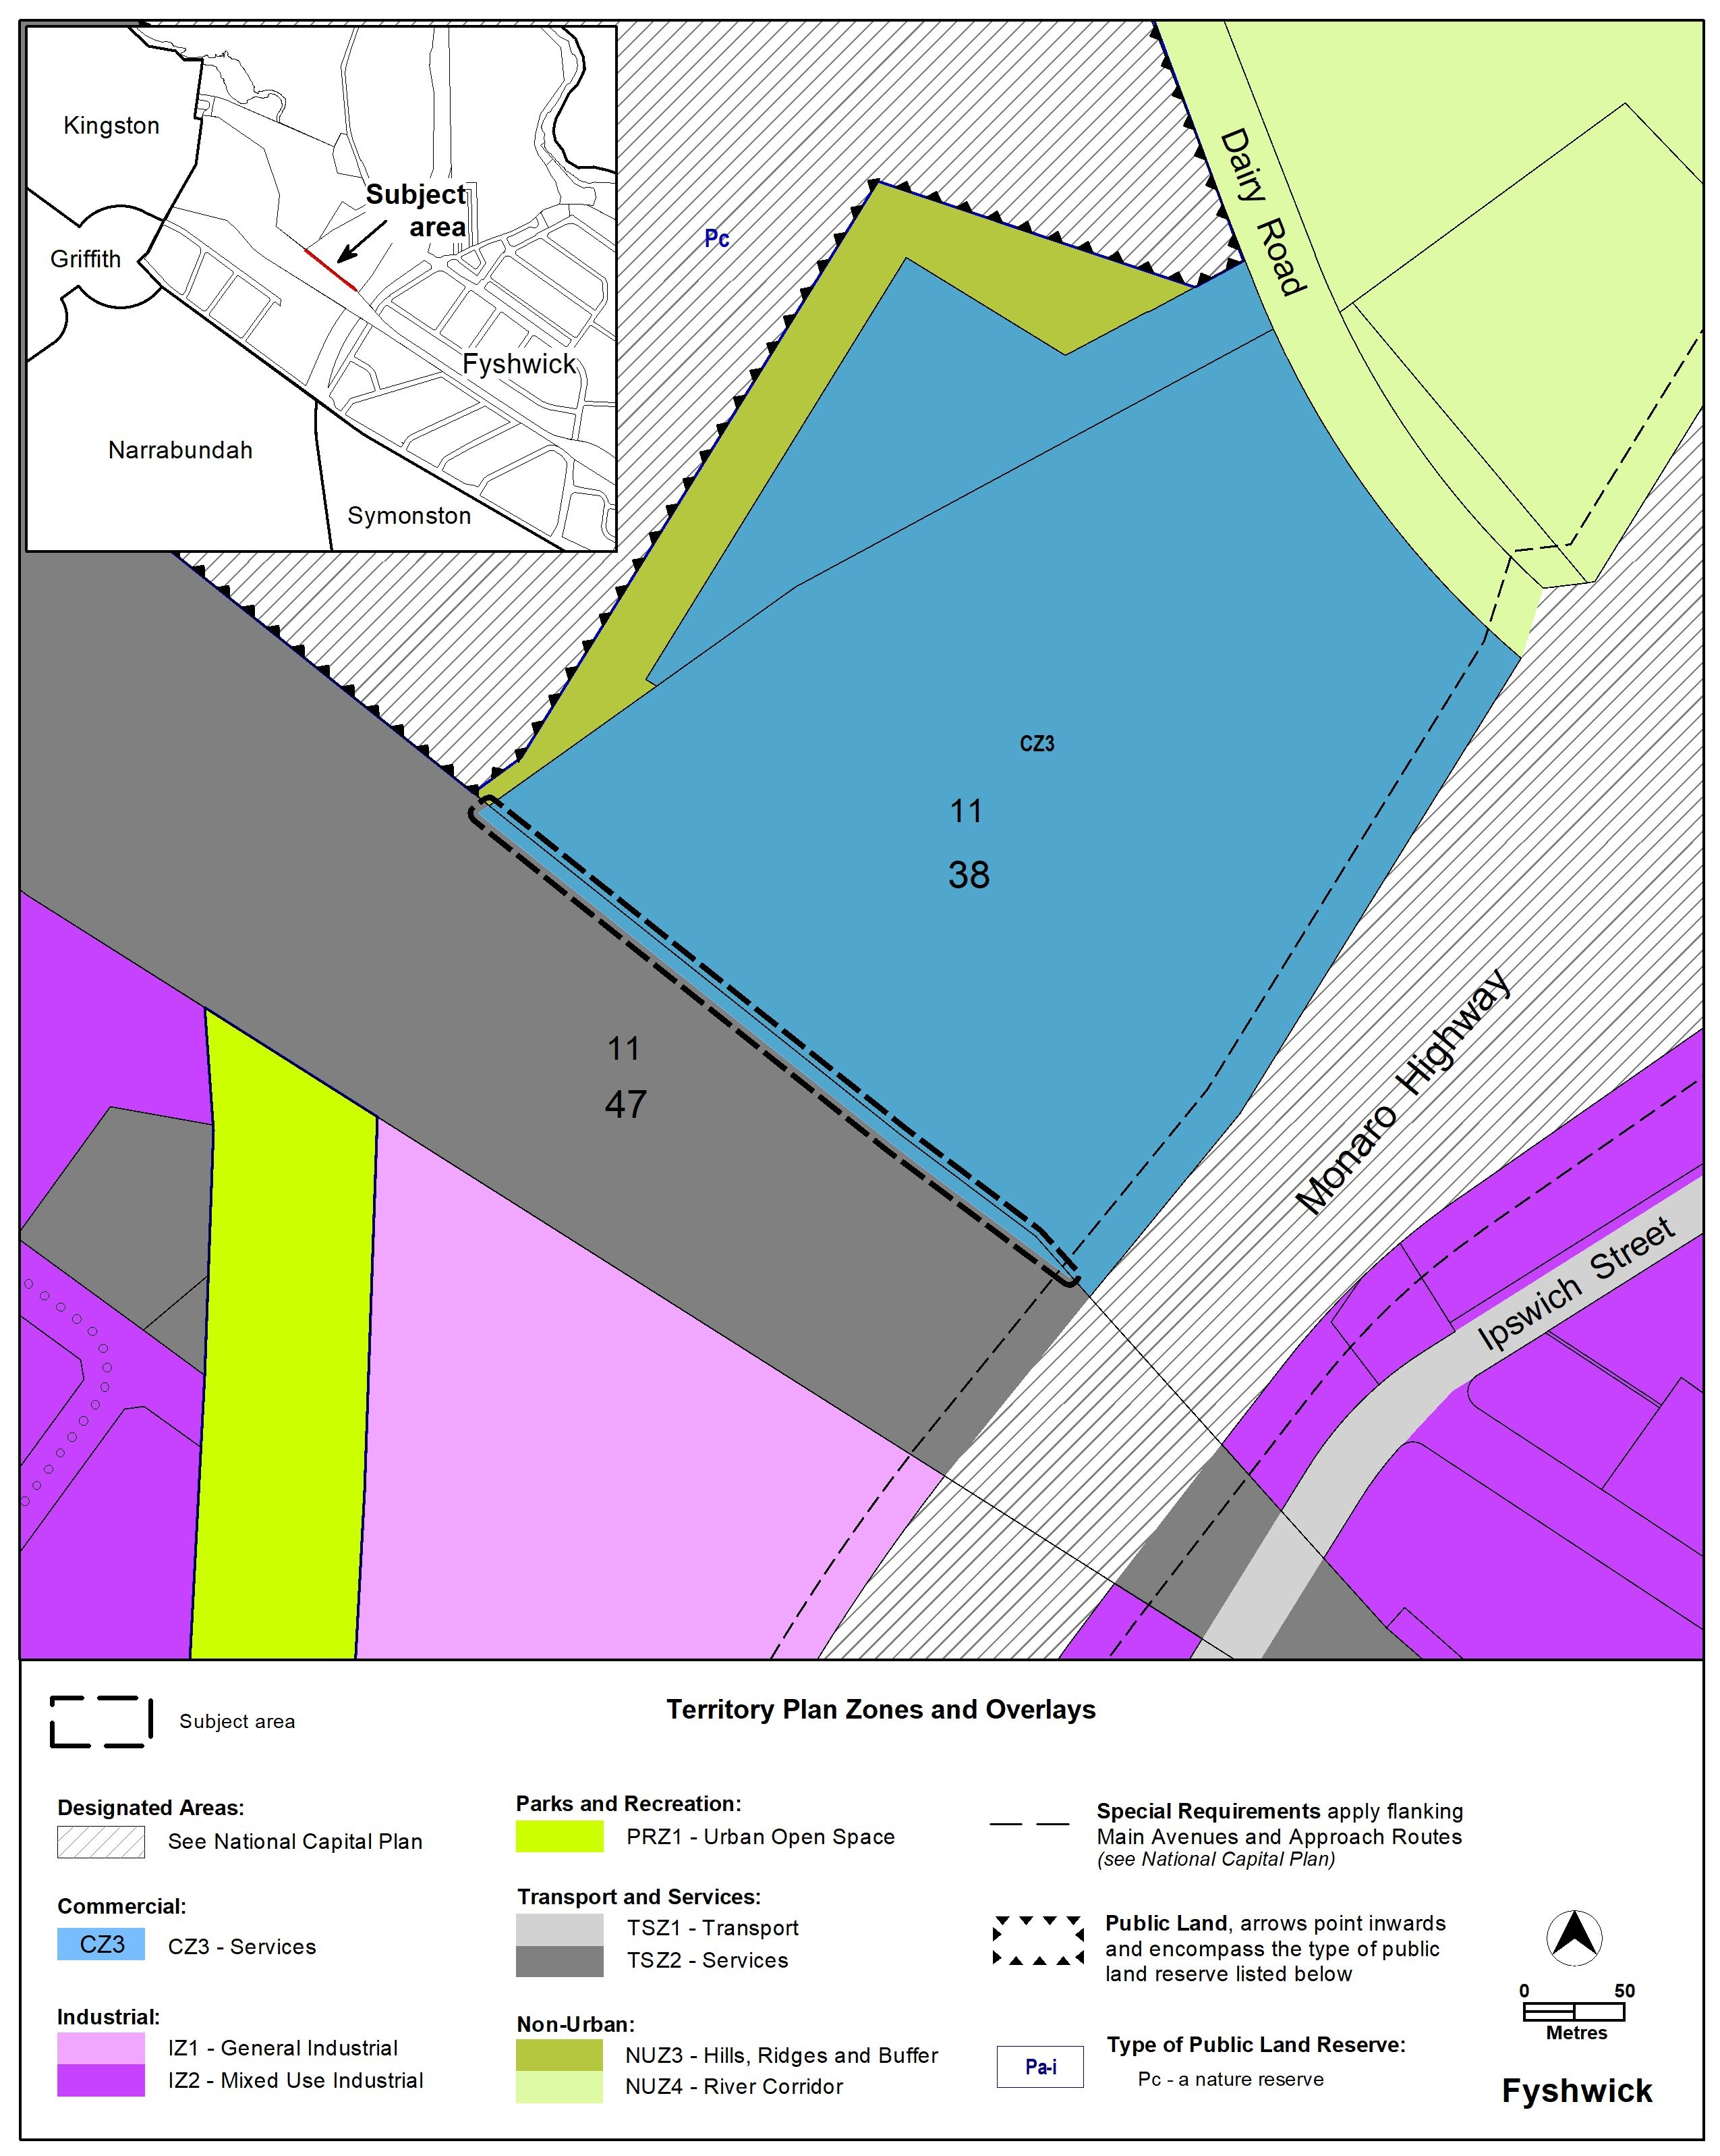

Section | Statement
s87 (2) (b)  a variation to change the boundary of a zone under section 90B (Rezoning – development encroaching on adjoining territory land) | Compliant. The adjoining TSZ2 land is Territory land.
90B Rezoning – development encroaching on adjoining territory land  - The planning and land authority may vary the territory plan under section 89 (Making technical amendments) to change the boundary of a zone consistent with a development proposal under section 137AC (Declaration for development encroaching on adjoining territory land if development prohibited) if the authority makes a declaration that the proposal satisfies the criteria in section 137AC (2)  - However, the planning and land authority must not vary the territory plan under section 89 to change the boundary of the zone if the adjoining territory land is designated as a future urban area under the territory plan  - In this section:  adjoining territory land—see section 137 AC (1) (a). | The planning and land authority made the declaration under section 137AC  (NI2022-626).  The land is not designated as future urban area under the Territory Plan

- TECHNICAL AMENDMENT
This section of the technical amendment document provides the actual instructions for implementing the changes to the Territory Plan.
  - Territory Plan Map
- Territory land adjoining Fyshwick section 38 block 11
The Territory Plan map is varied as indicated below.

Interpretation service
