Australian Capital Territory
Planning and Development (Plan Variation 383) Approval 2023

Notifiable instrument NI2023-243
made under the
Planning and Development Act 2007, s 76 (Minister’s powers in relation to draft plan variations)

1 Name of instrument
This instrument is the Planning and Development (Plan Variation 383) Approval 2023.
2 Commencement
This instrument commences on the day after its notification day.
3 Approval of draft plan variation
(1) I approve under the Planning and Development Act 2007, section 76 (2) (a), plan variation 383 to the Territory Plan.
(2) In this section:
plan variation 383 to the Territory Plan means the plan variation set out in the schedule.

Mick Gentleman MLA
Minister for Planning and Land Management
8 /5/2023

Planning and Development Act 2007

Variation to the
Territory Plan
383

Kamberra Winery Estate
Lyneham Section 69 Block 8 and Section 71 Blocks 18, 25, 27 and 28 - Zone Changes and Amendments to the Lyneham Precinct Map and Code

Final variation prepared under s76 of the
Planning and Development Act 2007

Contents
1. EXPLANATORY STATEMENT 1
1.1 Background 1
1.2 Summary of the Proposal 3
1.3 The National Capital Plan 3
1.4 Site Description 4
1.5 Current Territory Plan Provisions 6
1.6 Changes to the Territory Plan 7
1.7 Consultation on the Draft Variation 7
1.8 Revisions to the Draft Variation Recommended to the Minister 7
2. VARIATION 8
2.1 Variation to the Territory Plan Map 8
2.2 Variation to the Territory Plan 9

- EXPLANATORY STATEMENT
  - Background
Block 8 section 69 and blocks 18 and 27 section 71 Lyneham
The blocks face onto the Federal Highway immediately south of the Flemington Road intersection. Block 18 section 71 has been developed as a Tourist Facility incorporating the Kamberra winery complex. Block 8 section 71 remains vacant and undeveloped, consisting of open disturbed grassland with no identified heritage or environmental values.
Block 27 section 71 Lyneham is a narrow, rectangular parcel of undeveloped land fronting onto the Federal Highway and is being acquired by the Elvin Group. It is included in the parcel of land for development and forms part of the proposed changes in this variation.
All three blocks subject to the variation are currently zoned Non-Urban NUZ1 Broadacre.
The Kamberra site is now considered to be situated within an urban infill growth corridor due to its proximity to the Canberra Metro light rail route from Gungahlin to the City. Two light rail stops are located within walking distance from the site boundary.
Wine production at the site has ceased due to economic drivers in the wine industry and the business model of the company resulting in the discontinuation of the operation as a demonstration winery and associated tourism related activities.
Blocks 25 and 28 Section 71 Lyneham
The variation rezones blocks 25 and 28 section 71 Lyneham from NUZ1 Broadacre to PRZ1 Urban Open Space to formalise the landscape buffer between the Kamberra Winery redevelopment and the Federal Highway.
The City and Gateway Urban Design Framework
The Australian Government through the National Capital Authority (NCA) and the ACT Government share planning responsibility in the ACT. The Framework was jointly prepared by the NCA and ACT Government to set the principles for development and growth in the city centre and along the gateway corridor of Northbourne Avenue and Federal Highway. The Framework provides a long-term vision and principles for this important location, drawing upon the legacy of historic planning and contemporary design.

Implementation of the planning recommendations of the Framework will require amendments to the Territory Plan. This variation implements the relevant planning controls recommended in the Framework for the site such as active travel routes, building heights and building setbacks.
Amendment 86 to the National Capital Plan
In May 2016, the National Capital Authority (NCA) revised its National Capital Plan (NCP) with Amendment 86.
Among other revisions to the NCP, Amendment 86 changed the strategic land use of the Kamberra site from ‘Broadacre Areas’ to ‘Urban Areas’. This change was instrumental in allowing the site to be used more intensively as envisaged in the City and Gateway Urban Design Framework and in this variation.
Amendments 91 and 93 to the National Capital Plan
In April and September 2019, the National Capital Authority (NCA) amended its National Capital Plan (NCP) with Amendments 91 (A91) and 93 (A93) respectively. A91 and A93 implemented parts of the Framework which were of interest to the NCA. Prior to this the Kamberra Winery site was subject to the NCA’s Development Control Plan for the site which essentially restricted the block to its current use, for a Tourist Facility incorporating the Kamberra winery complex.
The changes made through A91 and A93 allow the Kamberra Winery site to be used more intensely in line with the principles of the Framework.
This variation makes minor changes or clarifications to provisions to make consistent with the National Capital Plan, particularly Part 4.28 City and Gateway Corridor.
ACT Climate Change Strategy 2019-2025 & Canberra’s Living Infrastructure Plan: Cooling the City
The ACT Climate Change Strategy 2019-2025 (CCS) and Canberra’s Living Infrastructure Plan: Cooling the City (LIP) outlines the high and mid-level principles to reduce greenhouse gas emissions and support community resilience to the effects of climate change.
This variation includes environmentally sustainable design measures and living infrastructure provisions which align with the objects of the CCS and LIP.

  - Summary of the Proposal
The variation proposes to:
- allow the redevelopment of block 8 section 69 and blocks 18 and 27 section 71 Lyneham for a mix of commercial and residential uses. To permit this change in use:
  - the blocks are rezoned from Non-Urban NUZ1 Broadacre zone to Commercial CZ5 Mixed Use zone
  - new rules and criteria into the Lyneham Precinct Map and Code are introduced to guide future Estate Development Plan and individual building development applications. The new provisions relate to, among other things: limits on the scale of residential and non-residential uses, setbacks to and protection of the ecological and riparian values of the Sullivans Creek corridor, the location and design of open space areas and internal active travel connections.
- implement the relevant planning recommendations of the City and Gateway Urban Design Framework which include active travel routes, building heights and building setbacks.
- implement the relevant planning recommendations of the ACT Climate Change Strategy 2019-2025 and Canberra’s Living Infrastructure Plan: Cooling the City. These provisions relate to tree canopy cover, urban heat and sustainable building design assessments.
- incorporate minor changes or clarifications to provisions to align the Territory Plan with the National Capital Plan where relevant to the Kamberra site
- rezone blocks 25 and 28 section 71 Lyneham from NUZ1 Broadacre zone to PRZ1 Urban Open Space zone.

  - The National Capital Plan
The Australian Capital Territory (Planning and Land Management) Act 1988 established the National Capital Authority (NCA) with two of its functions being to prepare and administer a National Capital Plan (NCP) and to keep the NCP under constant review and to propose amendments to it when necessary.
The NCP, which was published in the Commonwealth Gazette on 21 January 1990 is required to ensure that Canberra and the Territory are planned and developed in accordance with their national significance. The Planning and Land Management Act 1988 also requires that the Territory Plan is not inconsistent with the NCP.
In accordance with section 10 of the Australian Capital Territory (Planning and Land Management) Act 1988, the NCP defines the planning principles and policies for Canberra and the Territory, for giving effect to the object of the NCP and sets out the general policies to be implemented throughout the Territory, including the range and nature of permitted land uses.
It also sets out the detailed conditions of planning, design and development for areas that have special significance to the National Capital known as designated areas and identifies special requirements for the development of some other areas.

  - Site Description
The subject site (Figure 1 site plan) faces onto the Federal Highway to the east, immediately to the south of the intersection with Flemington Road. Block 18 section 71 has been developed as the Kamberra Winery complex, and block 8 section 69 consists of undeveloped vacant land. The site has a combined area of over 12 hectares.
The site is bounded by Flemington Road to the north, the landscape buffer blocks fronting onto the Federal Highway to the east (blocks 25 and 28 section 71 Lyneham), Sullivans Creek and Thoroughbred Park (Canberra racecourse) to the west and the Canberra Veterinary Hospital and Barton Highway to the south. Development to the east of the site across from the Federal Highway is characterised by low and medium density residential development.
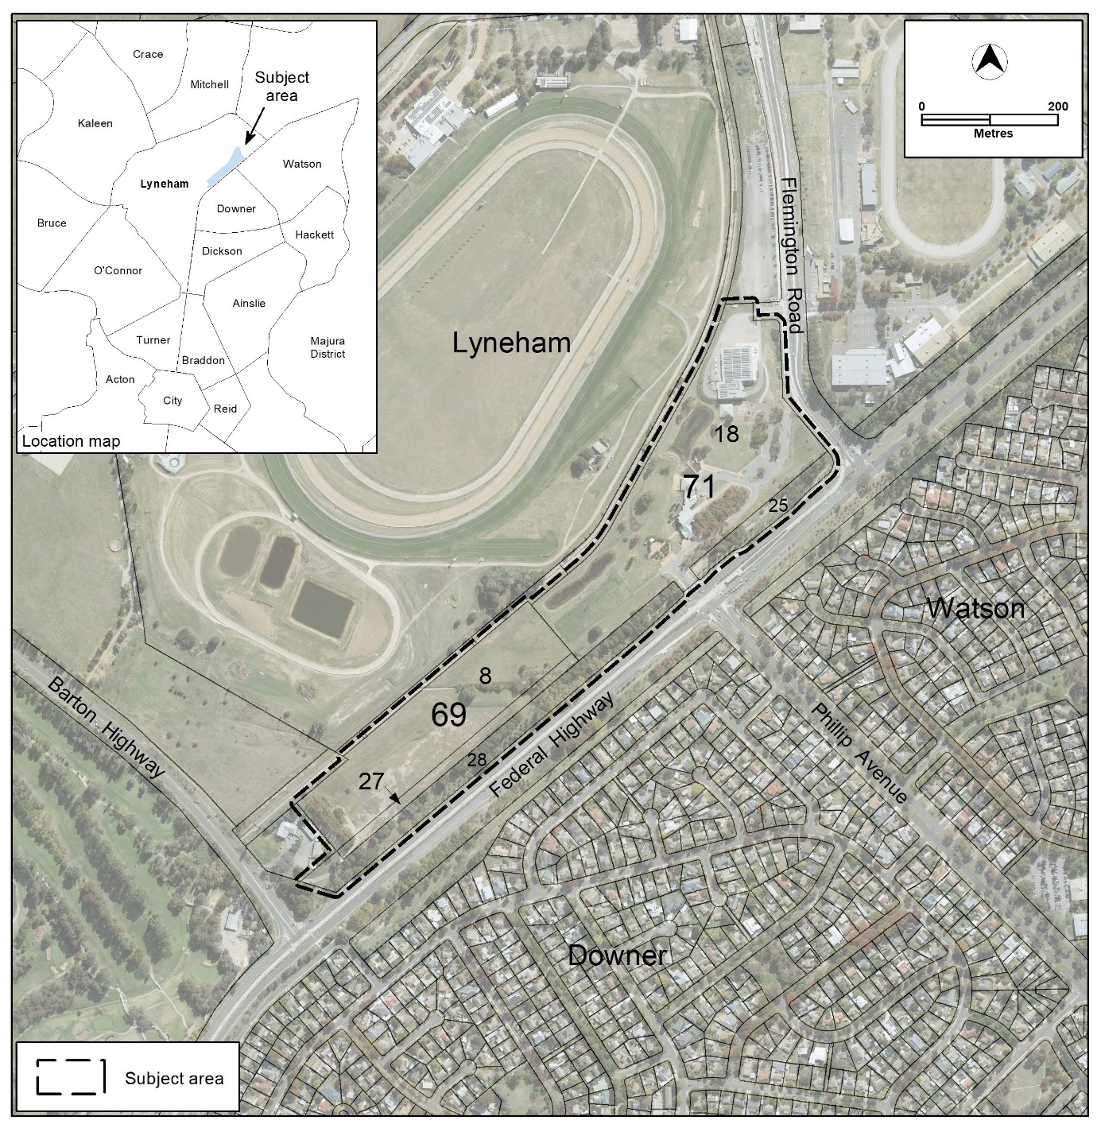
Figure 1 Site Plan

  - Current Territory Plan Provisions
The Territory Plan map for the area subject to this variation is shown in Figure 2.
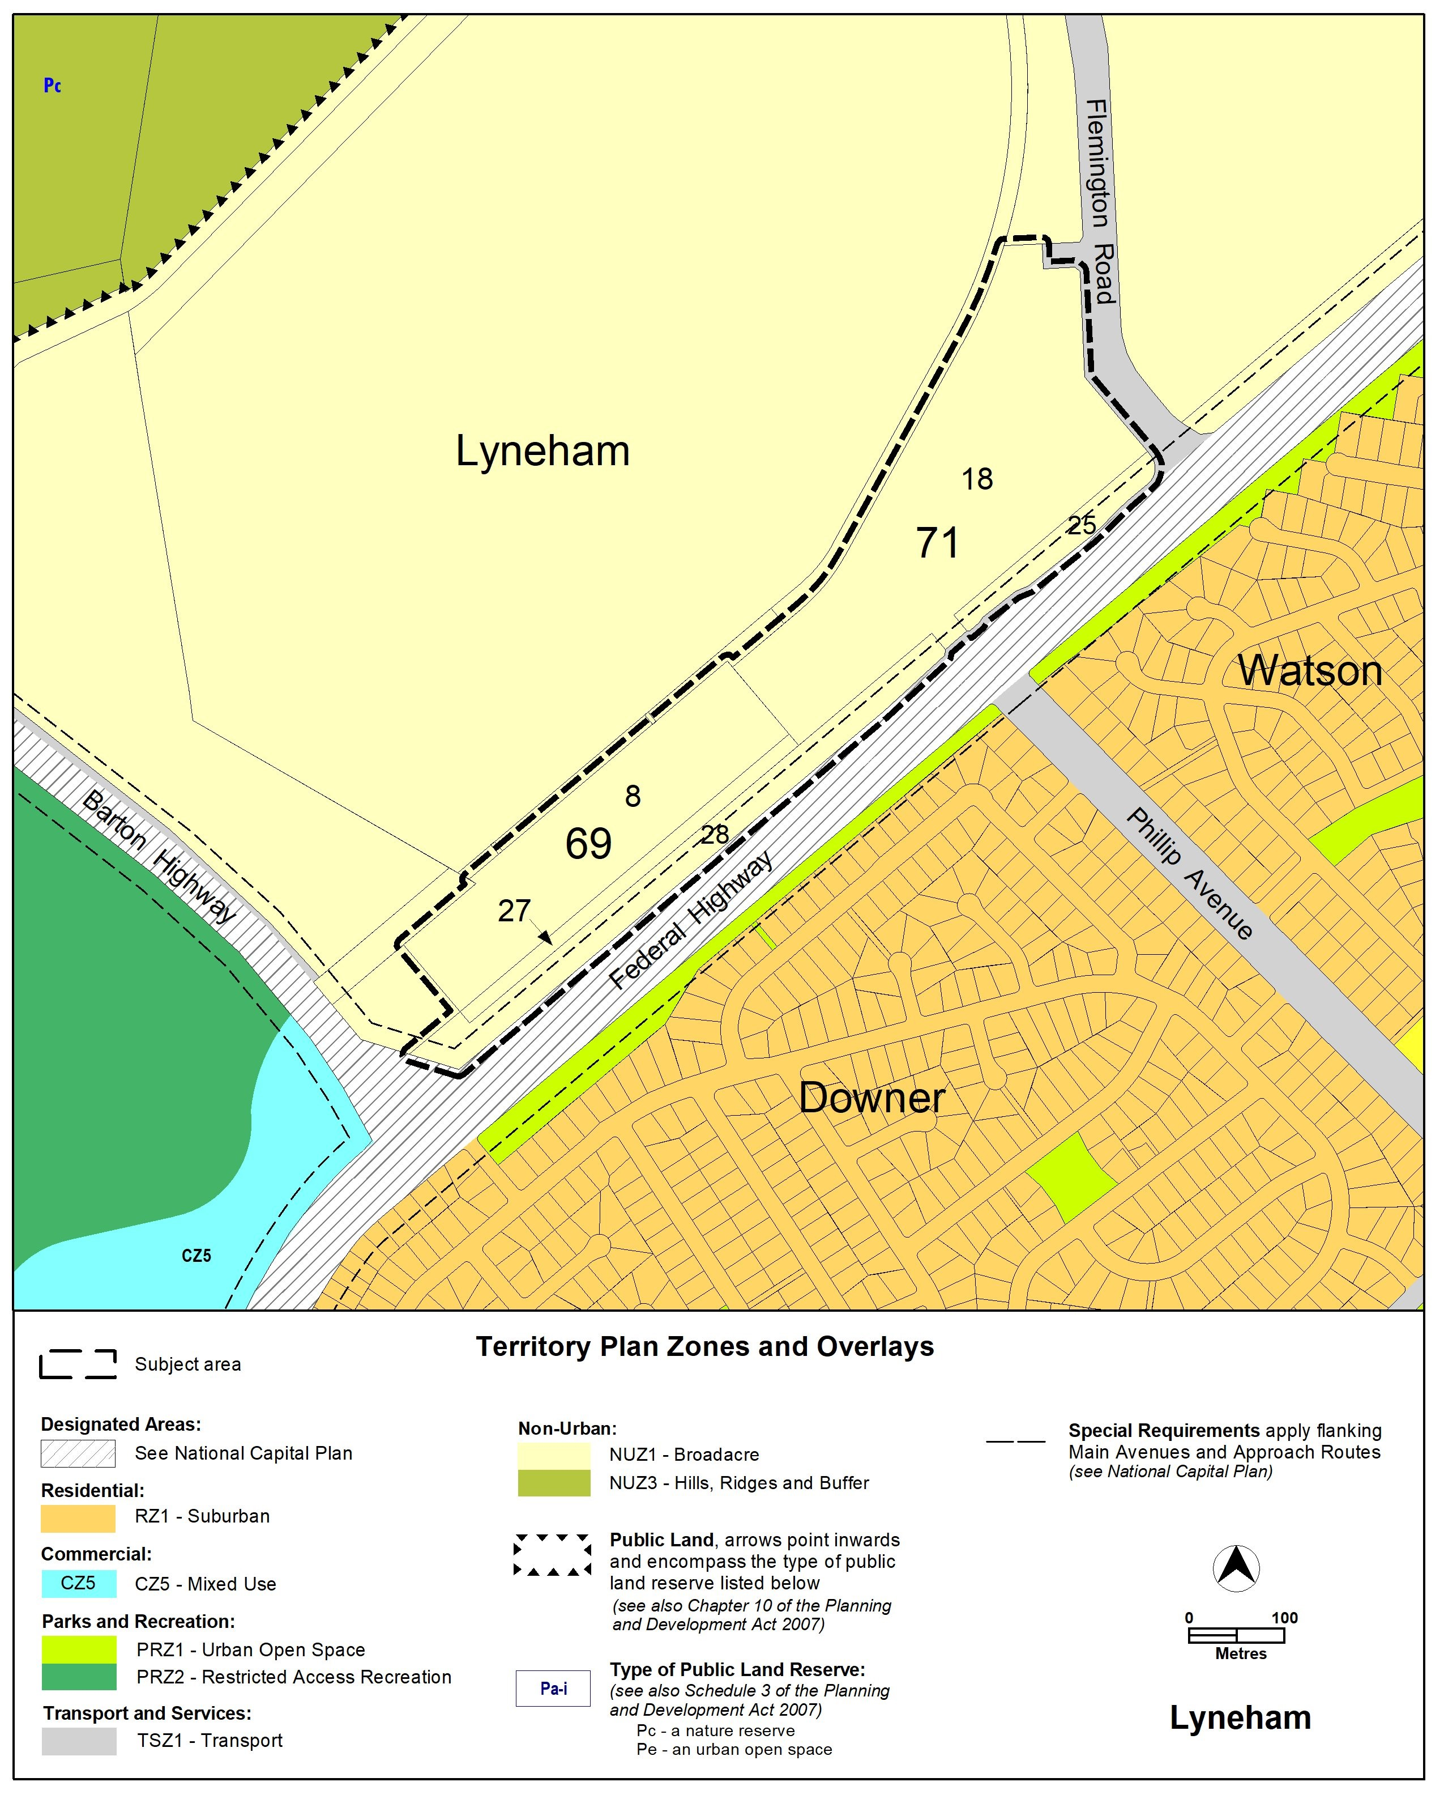Figure 2 Territory Plan Zones Map

  - Changes to the Territory Plan
Detailed changes to the Territory Plan are noted in section 2 of this document.

  - Consultation on the Draft Variation
Draft Variation 383 (DV383) was released for public comment between 7 October 2022 and 18 November 2022. A consultation notice under section 63 of the Planning and Development Act 2007 (P&D Act) was published on the ACT Legislation Register on 7 October 2022.
A total of 823 written submissions were received, which included 797 form letter emails raising concerns about the loss of live music venues. Some of these emails had additional comments included, which were recorded and counted as separate individual submissions. Three submissions were from live music promoters or organisers, two submissions were from individuals who raised a range of issues relating to the broader planning and sustainability aspects of the proposal and one submission was from the planning consultant for the lessee.
Main issues raised by submitters included:
- Support for the draft variation and some submitters indicated support with conditions
- Concerns
  - about loss of a live music venue
  - viability of a live music venue and protections for existing noise generating activities
  - noise attenuation controls
  - proposed setback to Sullivans Creek
- considerations about traffic, parking and noise pollution

The above issues were considered and are detailed in a report on consultation. Changes were informed by the issues raised. The outcomes of consultation were considered by the Minister responsible for planning prior to approval of this variation.
  - Revisions to the Draft Variation Recommended to the Minister
No changes were made to the planning provisions or the zoning changes for the site of the draft variation recommended to the Minister. Corrections were made to the numbering of the provisions and instructions about how to insert the provisions into the Territory Plan. Territory Plan maps were updated to show zoning changes made by Variation 370 for the East Yowani Estate at Lyneham.
- VARIATION
  - Variation to the Territory Plan Map
The Territory Plan map is varied in all of the following ways:
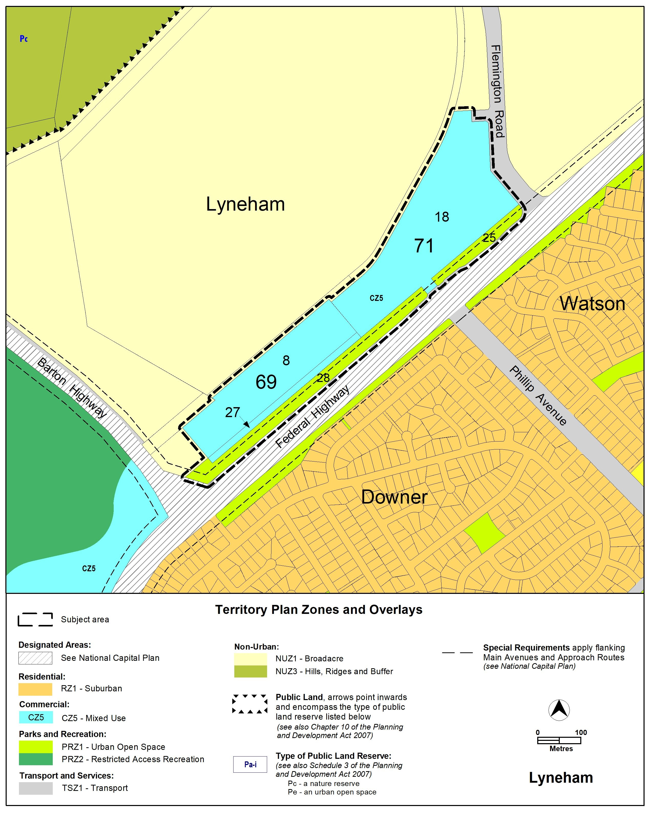

  - Variation to the Territory Plan

Variation to the Lyneham Precinct Map and Code
- Lyneham Precinct Map

Substitute
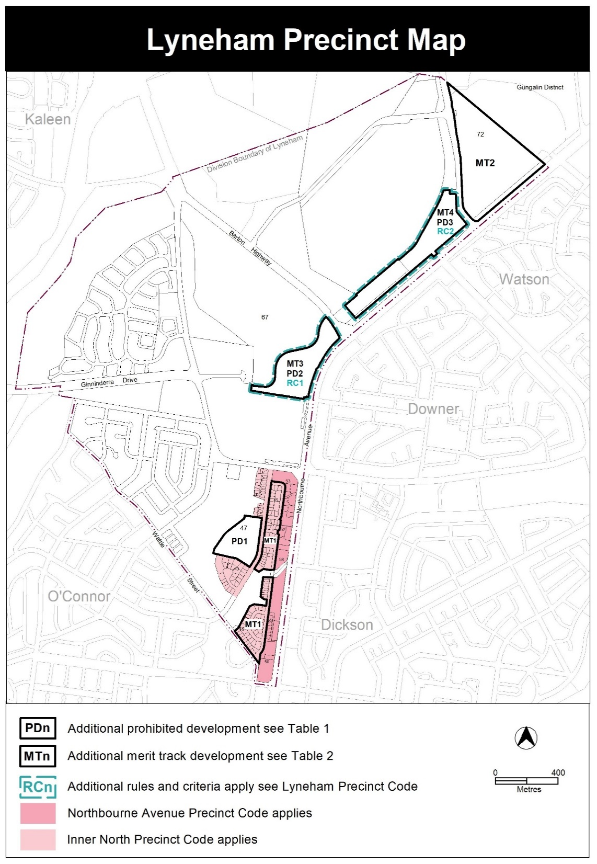

- Assessment Tracks, Table 1 – Additional prohibited development

Insert
PD3 | CZ5 | bulky goods retailing  department store  secondary residence  single dwelling housing

- Assessment Tracks, Table 2 – Additional Merit Track Development

Insert
MT4 | CZ5 | craft workshop  drink establishment  indoor entertainment facility  produce market  tourist facility  tourist resort

- Additional Rules and Criteria
New RC2 – Kamberra Estate
Insert
RC2 – Kamberra Estate
This part applies to blocks and parcels identified in area RC2 shown on the Lyneham Precinct Map.

- National Capital Plan
Rules | Criteria
  - National Capital Plan
R67  This rule applies to development which is subject to the National Capital Plan.  Development applications are supported by written documentation demonstrating compliance against the relevant special requirements of the National Capital Plan, namely Part Four (B) – Special Requirements for Territory Land; Section 4.28 City and Gateway Corridor. | This is a mandatory requirement. There is no applicable criterion.

- Estate planning
Rules | Criteria
  - Sullivans Creek
There is no applicable rule. | C68  This criterion applies to land contained within the setback area to Sullivans Creek identified in R95/C95.  Development complies with all of the following (where relevant):  - maintain or increase flood conveyance capacity and storage volume for Sullivans Creek  - create and maintain opportunity for flora and fauna habitat and movement  - provide a landscape setting to improve visual and environmental amenity  - provide an infrastructure corridor for existing and future utility services  - demonstrated adequate space for active travel routes and open spaces for the use and enjoyment of the local community and commuters  - improve the landscape quality and setting on Sullivans Creek through the use of natural construction materials and vegetation  - development of b) and d) is completed prior to or at the same stage as surrounding residential development.  Note: The planning and land authority may consult, where relevant, with TCCS and other areas of EPSDD (or future relevant agencies) when determining compliance with this criterion.
There is no applicable rule. | C69  This criterion applies to land contained within the setback area to Sullivans Creek specified in R95/C95.  Development is limited to:  - works to mitigate flooding  - works which maintain or increase flood conveyance capacity and storage volume for Sullivans Creek  - landscaping or minor public infrastructure to improve visual and environmental amenity  - high quality and visually interesting screening of utility or flood mitigation works and infrastructure  - works relating to utility infrastructure that take place predominantly or entirely below natural ground level  - works to promote active travel and/or public open areas for recreation and leisure  - communal open space, private open space and courtyard walls required by a development code  - works to increase ‘naturalisation’ of Sullivans Creek through the use of natural construction materials and vegetation.  For the purpose of this criterion ‘naturalisation’ means changing the appearance and functionality to more closely represent natural characteristics.  Note: The planning and land authority may consult, where relevant, with TCCS and other areas of EPSDD (or future relevant agencies) when determining compliance with this criterion.
R70  This rule applies to the following:  - filling within one of the following (whichever is greater):  - 1% AEP (once in 100 year) flood extent for Sullivans Creek  - 20 metres of Sullivans Creek stormwater easement  - compensatory excavation to offset filling specified in a)  - reducing or increasing flood conveyance capacity and storage volume for Sullivans Creek  - increased ‘naturalisation’ of Sullivans Creek through the use of natural construction materials and vegetation.  Development complies with all of the following:  - is endorsed by TCCS  - is prepared by a ‘suitably qualified professional’  For the purpose of this rule ‘naturalisation’ means changing the appearance and functionality to more closely represent natural characteristics.  For the purposes of this rule a ‘suitably qualified professional’ is familiar with analysis of flooding along watercourses and design of development to manage flood risks.  Note: The planning and land authority may consult, where relevant, with TCCS and other areas of EPSDD (or future relevant agencies) when determining compliance with this rule. | C70  If TCCS endorsement is not provided the application will be referred to TCCS for endorsement.
R71  This rule applies to development wholly or partially within 1% AEP (once in 100 year) flood extent for Sullivans Creek.  Development of the RC2 area is consistent with a flood risk study, prepared by a ‘suitably qualified professional’ and endorsed by TCCS, which adequately demonstrates all of the following:  - protections for ongoing safety of the public against impacts of floods are provided  - protections for property against the impacts of floods are provided  - the RC2 area is planned and developed with consideration for flood risks  - where flood impacts on development exceed 20m from the centreline of the Sullivans Creek stormwater easement, identification of a minimum setback for development to inform R95/C95.  For the purpose of this rule a ‘suitably qualified professional’ is familiar with analysis of flooding along watercourses and design of development to manage flood risks.  Note: The planning and land authority may consult, where relevant, with TCCS and other areas of EPSDD (or future relevant agencies) when determining compliance with this rule. | C71  If TCCS endorsement is not provided the application will be referred to TCCS for endorsement.
10.2 Site access and internal road layout
R72  The following is endorsed by TCCS:  - a transport impact assessment, prepared by a suitably qualified professional  - location, nature and number of new and existing external vehicular site access points to/from the RC2 area  - Sullivans Creek active travel connection.  Plans and drawings clearly demonstrate that the development is consistent with TCCS endorsements for a), b) and c).  Note: TCCS may endorse development or works in addition to items identified in this rule. | C72  If TCCS endorsement is not provided with the application or the plans and drawings are not consistent with rule, the application will be referred to TCCS for endorsement.
There is no applicable rule. | C73  The internal road layout for the RC2 area complies with all of the following:  - incorporates a parallel access street along Sullivans Creek  - prioritises pedestrians and cyclists particularly where the ‘internal pedestrian and bicycle network’, mentioned in C78, intersects with internal roads  - minimise the amount of road in favour of soft landscape areas.
10.3 Location of non-residential uses
There is no applicable rule. | C74  This criterion applies to development other than RESIDENTIAL USE.  Development is located to comply with all of the following:  - in close proximity to and easily accessible from site access points and the Phillip Avenue light rail stop  - after a) has occurred, along the Federal Highway primarily closer to the Phillip Avenue intersection  Note: this criterion does not preclude RESIDENTIAL USE from occurring in the above areas on the site.
10.4 Open space areas and travel routes - General
There is no applicable rule. | C75  This criterion applies to:  - ‘Sullivans Creek active travel connections’ identified in Figure 3  - ‘mid-block links’ and ‘end-block links’ identified in Figure 3  - ‘internal pedestrian and bicycle network’ mentioned in C78.  Development within the areas mentioned above comply with all of the following:  - provide safe, efficient and unimpeded public access to pedestrian and cyclists at all times  - identifies and provides the recreational and leisure needs of the local community  - where these areas intersect with roads and vehicular access ways, demonstrate how priority is given to pedestrians and cyclists through traffic calming measures such as slow speed areas, shared spaces and refuge islands  - provides adequate amenity and safety for uses of the area including soft landscaping, shade for warmer weather, access to sunlight (particularly in colder weather), adequate lighting (that does not impact on the amenity of adjoining development) and passive and perceived surveillance at all times  - development within these areas is limited to planting area, surface landscaping, buildings and structures which are consistent with active travel pathways or are open and do not limit accessibility  - all areas provide adequate irrigation for landscaped areas and high-quality fit-for-purpose paving and finishes  - are completed prior to or at the same stage as surrounding residential development.  Note: development within the ‘open space areas’ are to comply with the standards and requirements of the relevant ACT Government agency.
10.5 Estate open space areas
There is no applicable rule. | C76  Open space areas comply with all of the following:  - open space areas that are located within the 1% AEP (1 in 100 year) flood extent for Sullivans Creek are not used for activities that can put vulnerable users (such as children’s playgrounds) at risk from flooding  - not predominantly located in areas which limit the useability of open space such as, but not limited to, regulated tree protection areas  - demonstrate that the minimum area is adequate to accommodate the current and future residents, workforce and visitors to the site  Note 1: This criterion applies in addition to the rules and criteria for principal private open space, private open space and communal open space in the relevant development code.  Note 2: development within the ‘open space areas’ are to comply with the standards and requirements of the relevant ACT Government agency.
10.6 Mid-block links and end-block links
There is no applicable rule. | C77  This criterion applies to the ‘mid-block links’ and ‘end-block links’ shown in Figure 3.  ‘Mid-block links’ and ‘end-block links’ comply with all of the following:  - are in a location generally in accordance with Figure 3 and aligns with the community path system through the area  - aligns with the light rail station and crossing points to reduce informal light rail crossings for cyclists and pedestrians (where relevant)  - provides unimpeded public pedestrian and bicycle access at all times from the Federal Highway to the Sullivans Creek ‘active travel connection’  - connects with the ‘internal pedestrian and bicycle network’ to provide a safe and efficient pedestrian and bicycle network  - a landscape corridor, which includes a path, approximately 10 metres wide but not less than 6 metres wide at any point to accommodate all likely users, and can accommodate potential future path widening without impacts on planted trees  - vehicular access is not permitted within or along the ‘mid-block links’ and ‘end-block links’.  Development of and within the ‘mid-block links’ and ‘end-block links’ is to be endorsed by TCCS where relevant.
10.7 Internal pedestrian and bicycle network
There is no applicable rule. | C78  The internal pedestrian and bicycle network through the RC2 area complies with all of the following:  - provides an efficient and legible pedestrian and bicycle network through the site  - predominantly utilises routes which are not also used by vehicles  - aligns with light rail stations and crossing points to reduce informal light rail crossings for cyclists and pedestrians  - allows pedestrians and cyclists to travel between ‘open space areas’, ‘external active travel connections’, ‘mid-block links’, the existing light rail stops, light rail crossing points and community path system in the area  - a landscape corridor, which includes a path, approximately 10 metres wide but not less than 6 metres wide at any point, and can accommodate potential future path widening without impacts on planted trees  Development of and within the internal pedestrian and bicycle network are to be endorsed by TCCS where relevant.
10.8 Active travel connection
There is no applicable rule. | C79  This criterion applies to the ‘Sullivans Creek active travel connection’ shown in Figure 3.  The ‘Sullivans Creek active travel connection’ complies with all of the following:  - the ‘Sullivans Creek active travel connection’ is in a location generally in accordance with Figure 3 and aligns with:  - the community path system through the area  - the light rail station and crossing points to reduce informal light rail crossings for cyclists and pedestrians  - provides unimpeded public pedestrian and bicycle access at all times for the length of the active travel connection shown in Figure 3  - exclusively utilises routes which are not also used by vehicles  - connects with the ‘internal pedestrian and bicycle network’ to provide a safe and efficient pedestrian and bicycle network  - is a landscape corridor approximately 10 metres wide but not less than 6 metres wide at the narrowest point and contains all of the following:  - a shared path for pedestrians and cyclists  - the landscape corridor and path are both adequate in width to meet the current and future demand of usage including potential future path widening without impacts on planted trees

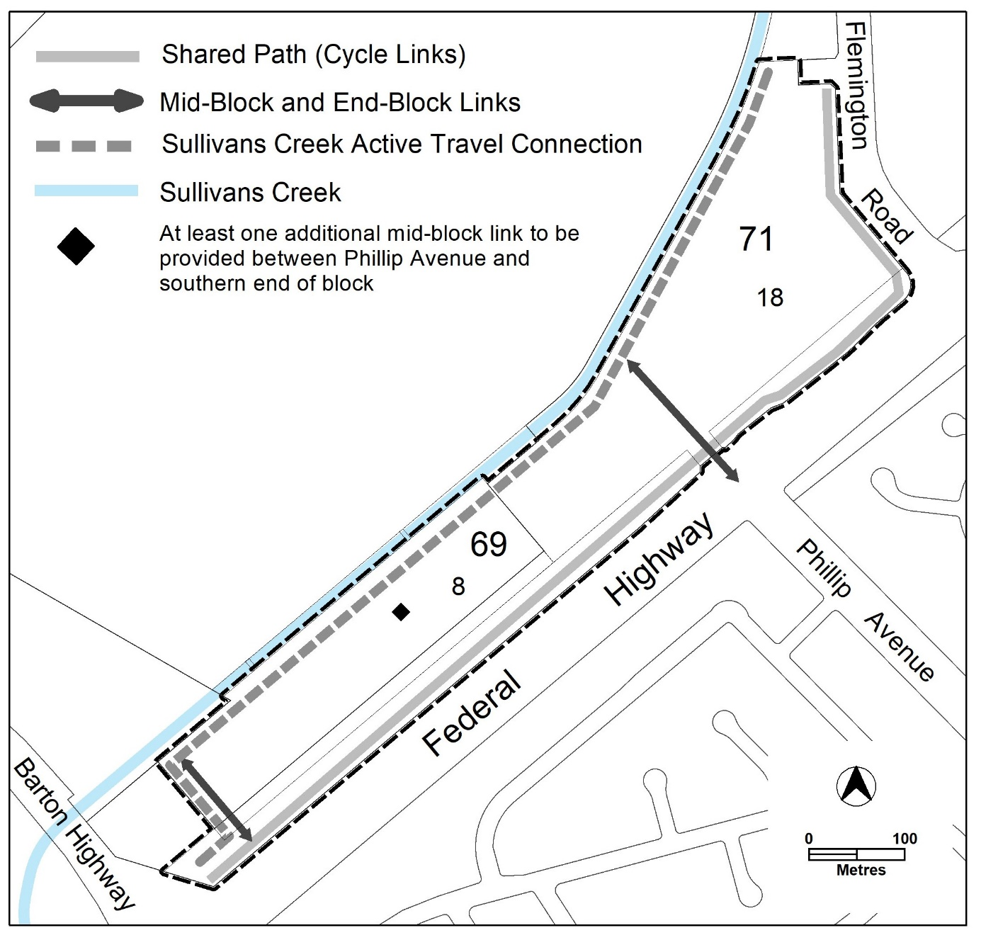

Figure 3 Active Travel Routes

Rules | Criteria
10.9 Tree retention and canopy cover
There is no applicable rule. | C80  Subdivision, block, building and site design demonstrates the following:  - retention of all existing high and medium quality trees  - where shown that a) cannot be achieved, trees removed are adequately replaced with new tree planting  Note: This criterion does not replace the provisions relating to tree protection in the relevant development code.
R81  Development demonstrates that a minimum of 30% of the RC2 area has or will have canopy tree cover measured at a mature height.  Note: Existing trees which are being retained may contribute towards the 30% requirement. | C81  Development demonstrates that a minimum 30% of the RC2 area has a combination of the following:  - at least half of the area required by this criterion contains canopy tree cover measured at a mature height  - the area of planting on green roofs (including rooftop gardens)  - the area of planting on external green walls, where measurement of the area of planting is taken along the vertical plane of the surface that contains the planting and vegetation.  For this criterion, the area of planting must:  - have a minimum dimension of 2.5m  - include watering (e.g. automatic irrigation) and maintenance systems to ensure survival of vegetation  - comprise vegetation which is easily maintained and is suited to the microclimate in which it is to be installed  - comprise vegetation (density and species selection) which is likely to have a positive summer cooling impact on the immediate urban environment  Note 1: existing trees contribute towards the canopy tree cover mentioned in a).  Note 2: trees planted on green roofs or in roof gardens can count towards canopy tree cover  Note 3: The calculations for the area of planting for this provision do not include any form of impermeable or non-living element (i.e. terraces, pergolas, patios, decks, pools, mechanical plant, (such as ventilation systems and lift over-runs), artificial lawn, gravel substrate and the like)
10.10 Block address
There is no applicable rule. | C82  The size and subdivision pattern of blocks demonstrates that a building with a high quality and interesting façade can be accommodated which addresses the following:  - open space areas,  - ‘mid-block links’ and ‘end-block links’, and the ‘internal pedestrian and bicycle network’ mentioned in C78  - ‘Sullivans Creek active travel connection’ and block boundaries to the Federal Highway, Flemington Road, and Phillip Avenue extension.
There is no applicable rule. | C83  Dwellings provide a high quality, interesting and visually appealing façade by providing active or passive surveillance through the use of balconies, screened and unscreened windows and access stairs to address the following (where relevant):  - open space areas,  - mid-block links’ and ‘end-block links’ and ‘internal pedestrian and bicycle network’ mentioned in C78  - ‘Sullivans Creek active travel connection’ and block boundaries to the Federal Highway, Flemington Road, and Phillip Avenue extension.  Where a building contains multiple dwellings, which face the areas listed in a) and b), dwellings in a development predominately provide active surveillance rather than passive surveillance of those areas.
10.11 Educational facilities planning
R84  A statement of acknowledgement from the ‘government agency responsible for future planning of educational enrolments and facilities’ is provided, which confirms that the following information has been provided:  - number and mix of dwellings that will be constructed per year  - estimated number of pre-school, primary, high school and college students per development year  Note: for the purpose of this rule and associated criterion the ‘government agency responsible for future planning of educational enrolments and facilities’ is the Education Directorate or a future relevant agency that is responsible for these functions. | C84  If a statement of acknowledgement is not provided the application will be referred to the government agency responsible for future planning of educational enrolments and facilities.
10.12 Dwelling Yield
R85  This rule applies to multi-unit housing only.  Minimum number of dwellings across the RC2 area – 2,000  Maximum number of dwellings across the RC2 area – 2500, or alternatively 250,000m² GFA | This is a mandatory requirement. There is no applicable criterion.
R86  Demonstrate the following has already or will be provided across the RC2 area:  - not less than 800 two-bedroom dwellings  - not less than 300 three or more bedroom dwellings | This is a mandatory requirement. There is no applicable criterion.
10.13 Retail GFA
R87  This rule does not apply to take-away food shop.  Total maximum gross floor area for all SHOP (including supermarket) across the RC2 area – 10,000m². | C87  SHOP complies with all of the following:  - limited to a scale appropriate to providing convenience shopping and personal services for the local workforce and residents  - demonstrates that the amount of SHOP gross floor area provided across the RC2 area does not have a material adverse impact on surrounding local, group and town centres.
R88  Total maximum gross floor area for all supermarkets across the RC2 area– 1500m². | C88  Supermarkets comply with all of the following:  - limited to a scale appropriate to providing convenience shopping and personal services for the local workforce and residents  - demonstrate that surrounding commercial centres are not adversely impacted  - demonstrate that the amount of supermarket gross floor area provided across the RC2 area does not have a material adverse impact on surrounding local, group and town centres.
10.14 Commercial GFA
R89  Total maximum gross floor area across the RC2 area for all NON-RETAIL COMMERCIAL USE – 30,000m². | This is a mandatory requirement. There is no applicable criterion
There is no applicable rule. | C90  This criterion applies if there is less than 1,000m² of NON-RETAIL COMMERCIAL USE across the RC2 area.  Demonstrate that at least 1,000m² of gross floor area of NON-RETAIL COMMERCIAL USE can and will be provided on site:  - directly through purpose-built buildings or spaces within buildings for NON-RETAIL COMMERCIAL USE  - providing ‘fully adaptable’ buildings or spaces within buildings for NON-RETAIL COMMERCIAL USE  - a combination of a) and b).  For the purposes of this rule ‘fully adaptable spaces’ demonstrate:  - ability to cater for a wide variety of NON-RETAIL COMMERCIAL USE  - ability to have compliant, efficient and convenient services, goods and waste facilities and areas  - commercial grade and flexible façade design.
10.15 Food and Entertainment GFA
R91  Total maximum gross floor area for all take-away food shop, restaurant and drink establishment across the RC2 area – 10,000m².  Note: This rule also applies where take-away food shop, restaurant and drink establishment are considered an ancillary use. | C91  Take-away food shop, restaurant and drink establishment complies with all of the following:  - limited to a scale appropriate to providing convenience shopping and personal services for the local workforce and residents  - demonstrate that the amount of combined take-away food shop, restaurant and drink establishment gross floor area provided across the RC2 area does not have a material adverse impact on surrounding local, group and town centres.
10.16 Community Use GFA
R92  Development must demonstrate that a minimum gross floor area of 1500m² of COMMUNITY USE has already and/or will be provided across the RC2 area (including indicative location/s). | This is a mandatory requirement. There is no applicable rule.

- Restrictions on use

Rules | Criteria
11.1 Ground Floor Uses
R93  Where uses other than RESIDENTIAL USE occur, these are located at ground floor level. | C93  Where uses other than RESIDENTIAL USE are located at upper floor levels, these comply with all of the following:  - may only occur where the floor below and the ground floor level of the building have a use other than RESIDENTIAL USE  - where it is demonstrated that buildings in areas mentioned in C74 already have or will have a use other than RESIDENTIAL USE at ground floor  - provide at least two of the following:  - direct, inviting and legible pedestrian access  - a passive and active surveillance of nearby internal and external public areas  - an interesting and activated address and façade to all nearby internal and external public areas which represents its non-residential nature.

- Building controls and design
Rules | Criteria
12.1 Front boundary setback – Flemington Road
R94  The minimum front boundary setback to Flemington Road is 6m.  Note: The front boundary setback to the Federal Highway is contained within the National Capital Plan. | This is a mandatory requirement. There is no applicable criterion.
12.2 Sullivans Creek setback
R95  This rule does not apply to development mentioned in C68.  The minimum setback from the centre line of the Sullivans Creek stormwater easement to development provides all of the following:  - adequate space for development in C69  - a minimum setback (whichever is greater):  - 20 metres  - as recommended by the TCCS endorsed flood risk study mentioned in R70 | C95  This criterion does not apply to development mentioned in C68.  The minimum setback from the centreline of the Sullivans Creek stormwater easement to development may be less than 20 metres, provided that it is demonstrated that all of the following can be achieved within the nominated setback:  - adequate space for development in C69  - appropriate waterway management practices to facilitate the functioning of riparian zones  - adequate space to support and enhance wildlife connectivity  - adequate space for active travel routes  - provision of adequate living infrastructure (including provision of adequate tree canopy cover for shading)  - recommendations of the TCCS endorsed flood risk study mentioned in R70 (if less than 20 metres)  Compliance with this criterion is to be endorsed by the Conservator of Flora and Fauna.
12.3 Building separation
R96  This rule applies to Area A shown in Figure 4.  For this rule Area A applies to land contained with the site that is greater than 200m from the centreline of the Federal Highway.  Minimum separation distances between:  - a dwelling and another dwelling or use other than RESIDENTIAL USE both on the subject block – Table 3  - a dwelling or use other than RESIDENTIAL USE on the subject block to a dwelling or use other than RESIDENTIAL USE on an adjacent block – half the minimum separation distance stated in Table 3, measured from the common boundary or boundaries between the blocks.  For the purpose of this rule and associated criterion, building separation is measured to the outer face of external walls, external windows or outer edge of balconies where relevant.  Notes:  1. This rule replaces building separation requirements in the relevant development code.  2. Building separation provisions for the area outside Area A are contained within the National Capital Plan. | C96  Building separation may be reduced where the building complies with all of the following:  - reasonable levels of visual and acoustic privacy  - suitable areas for soft landscaping and deep root planting between buildings.

Table 3 Minimum building separation
Number of storeys | Between windows in habitable rooms/unscreened balconies | Between windows in habitable rooms/unscreened balconies and windows in non-habitable rooms | Between windows in non-habitable rooms
Up to 4 storeys | 12 metres | 9 metres | 6 metres
5 to 8 storeys | 18 metres | 12 metres | 9 metres

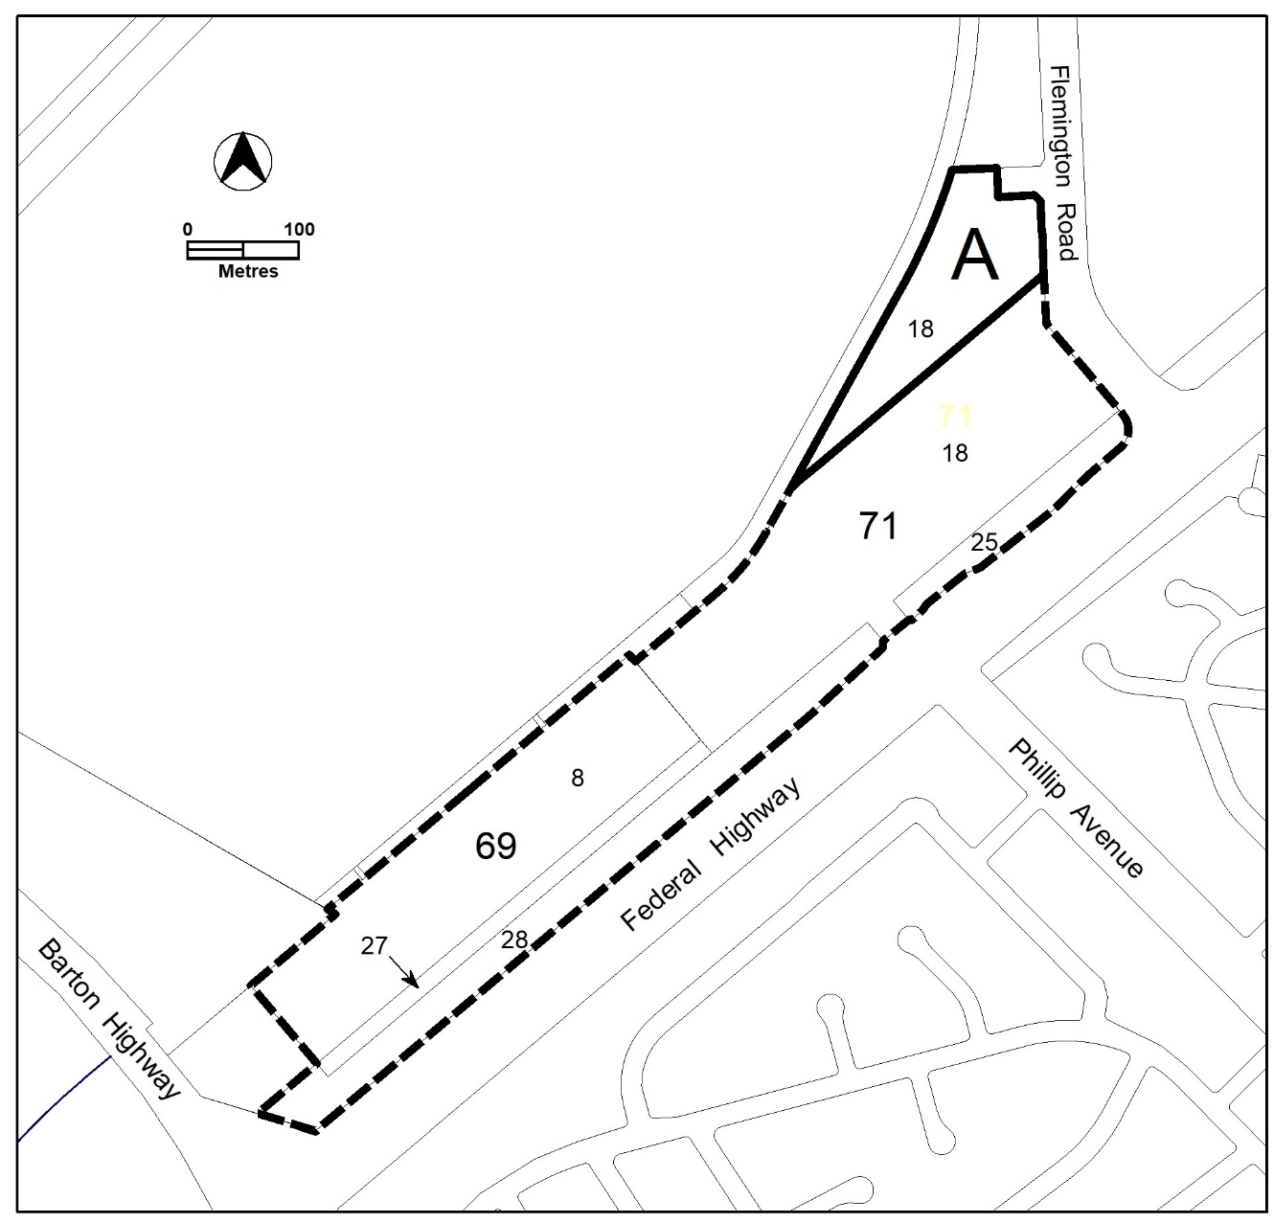

Figure 4 Area A not covered by the National Capital Plan

Rules | Criteria
12.4 Floor to ceiling heights
R97  This rule applies to Area A in Figure 4.  For this rule Area A applies to land contained with the site that is greater than 200m from the centreline of the Federal Highway.  Minimum finished floor level to ceiling heights are as follows:  - Minimum 2.7 metres for all habitable rooms (with the exception of kitchens, which are permitted to have a minimum 2.4 metre floor-to-ceiling height), and 2.4 metres for all non-habitable rooms.  - For two-storey units, 2.4 metres minimum for second storey if 50 percent or more of the apartment has 2.7 metre minimum ceiling heights.  - For two-storey units with a two-storey void living space, 2.4 metre minimum ceiling heights.  - non-residential development – 3.3m  Attic spaces are permitted, with a 1.8 metre minimum wall height at edge of room with a 30 degree minimum ceiling slope. | This is a mandatory requirement. There is no applicable criterion.
12.5 Building address
There is no applicable rule. | C98  This criterion applies to a frontage of a building which faces one or more of the following:  - the internal pedestrian and bicycle network connections mentioned in C78  - an external block boundary to the Federal Highway, Sullivans Creek and/or Flemington Road.  The building frontage complies with all of the following:  - provides passive surveillance of the area it faces  - provides a high quality and interesting façade which activates and addresses the area  - is suitable and responds to the characteristics of the area it faces  - provides direct pedestrian and bicycle access from the building, all ground floor dwellings and communal open space to all adjoining ‘open space areas’, ‘mid-block links’, ‘internal pedestrian and cycle network connections and/or ‘external active travel routes’.
12.6 Building Length
R99  Buildings are no more than 55m in length and width at their longest/widest point. | C99  Buildings exceeding 55m in length and/or width comply with all the following:  - strong design justification  - provide continuous active street frontage  - at least every 55 metres of building, provide a pedestrian link between 5 and 10 metres wide.
12.7 Pedestrian shelters
R100  Awnings, canopies or colonnades are provided at each active travel entrance to a building and each active travel path along a building edge. | C100  Awnings, canopies or colonnades achieve all of the following:  - provide protection from natural elements along buildings and building entrances  - are integrated with the design of the building.

12.8 Internal dwelling and building design
R101  Habitable rooms comply with the following:  - master bedrooms have a minimum area of 10m² and other bedrooms 9m² (excluding wardrobe space)  - bedrooms have a minimum dimension of 3m (excluding wardrobe space)  - living rooms or combined living/dining rooms have a minimum width of:  i) 3.6m for studio and 1 bedroom apartments  ii) 4m for 2 or more bedroom  apartments  The width of cross-over or cross-through dwellings are at least 4m internally to avoid deep narrow dwelling layouts. | C101  Habitable rooms are of a size suitable to accommodate the daily activities of their occupants and visitors.
R102  Habitable rooms limit depth to a maximum of 2.5m x the ceiling height. In open plan layouts (where the living, dining and kitchen are combined) the maximum habitable room depth is 8m, measured from an external window. | C102  Habitable room depth may increase where finished floor level to ceiling height is above the minimum permitted, provided reasonable solar access to each habitable room is maintained.
R103  The minimum gross floor area for a dwelling is:  - Studio – 40m²  - 1 bedroom – 50m²  - 2 bedroom – 70m²  - 3 bedroom – 100m²  - each additional bedroom after the 3rd – 12m²  - Each bathroom after the first – 5m²  The minimum area mentioned in a), b), c) and d) includes one bathroom. | This is a mandatory requirement. There is no applicable criterion.
12.9 Housing diversity
There is no applicable rule. | C104  Buildings contain a variety of dwelling designs such as dual aspect apartments, shallow apartment layouts, and two storey dwellings such as two-level apartment / townhouses.
R105  No dwelling type comprises more than 40 percent of all dwellings.  Note: Studio and 1 bedroom apartments comprise one category. | This is a mandatory requirement. There is no applicable criterion.

Element 13: Site controls and design
Rules | Criteria
13.1 Landscape design – Deep soil zones
There is no applicable rule. | C106  Deep soil zones are provided and comply with all of the following:  - are unimpeded by buildings or structures above and below ground¹  - have adequate dimensions to allow for the growth of healthy trees. incorporate any protected trees²  - allow for the development of healthy root systems and provide anchorage and stability for mature trees  - co-located near deep soil zones on adjacent blocks and sites where possible.  Note 1: Deep soil zones exclude basements, services, swimming pools, tennis courts and impervious surfaces including car parks, driveways, podium and roof areas  Note 2: An individual assessment of each existing tree, the Tree Protection Zone, the site, and appropriate protection requirements will be required to substantiate this criterion
13.2 Courtyard Walls
There is no applicable rule. | C107  This criterion applies to courtyard walls for dwellings which have their private open space at ground floor level fronting the Federal Highway and ‘Sullivans Creek active travel route’.  Courtyard walls comply with all of the following:  - not higher than 1.8m above datum ground level  - non-transparent components not higher than 1m above datum ground level  - constructed of high-quality materials, specifically excluding reflective metal fencing unfinished timber panels, chain-link, barbed or razor wire  - integrated with landscaping  - designed and constructed to match or compliment the design of the associated building.  Note: This criterion replaces the relevant rules and criterion relating to courtyard walls in the relevant development code.

Element 14: Amenity

Rules | Criteria
14.1 Solar Access – apartments
R108  This rule applies to apartments only.  Not more than 15% of apartments within a development receive less than 1 hour of direct sunlight between 9am and 4pm on the winter solstice (21 June).  Note: This rule applies in addition to the relevant provisions relating to solar access for apartments in the relevant development code.’ | This is a mandatory requirement. There is no applicable criterion.
R109  This rule applies to all dwellings.  Habitable rooms have an operable window in an external wall with a total minimum glass area of not less than 15% of the gross floor area of the relevant habitable room.  Note: connecting habitable rooms to operable windows in external walls via a corridor, also known as a ‘snorkel’ arrangement, does not satisfy the requirement of this rule. | This is a mandatory requirement. There is no applicable criterion.
14.2 Solar Access to adjoining development
R110  This rule applies to buildings of more than three storeys.  Buildings do not reduce the hours of direct sunlight between 9am-4pm on the winter solstice to any habitable room in any adjoining residential or COMMERCIAL ACCOMMODATION developments to less than 2 hours. | C110  Reasonable solar access for adjoining residential or COMMERCIAL ACCOMMODATION developments is achieved.
14.3 Principal private open space
R111  This rule applies to multi-unit housing and RESIDENTIAL USE components of commercial mixed use.  Each dwelling has at least one area of principal private open space that complies with all of the following:  - minimum area and dimensions as specified in Table 4  - maintains visual privacy of the occupants from adjoining public streets and public open space  - is directly accessible from, and adjacent to, a habitable room other than a bedroom  - is not located to the south, south-east or south-west of the dwelling, unless it achieves one or more of the following:  - not less than 3 hours of direct sunlight onto 50% of the minimum required area between the hours of 9am and 4pm on the winter solstice (21 June)  - located at an upper floor level and overlooks a public street, public open space including ‘open space areas’ | This is a mandatory requirement. There is no applicable criterion.

Table 4 Principal private open space area requirements
Type | dwellings wholly or partially at lower floor level or on a podium or similar structure |  | dwellings located entirely on an upper floor level
 | minimum area | minimum dimension | minimum area | minimum dimension
studio apartment | 18m² | 4m | 4m² | nil
1 bedroom dwelling | 24m² | 4m | 8m² | 2m
2 bedroom dwelling | 24m² | 4m | 10m² | 2m
3 or more bedroom dwelling | 36m² | 6m | 12m² | 2m

Rules | Criteria
14.4 External facilities
There is no applicable rule. | C112  This criterion applies to apartments.  Development complies with all of the following:  - storage units and plant equipment (including air-conditioning plant) are not permitted on balconies  - clothes drying facilities are only permitted on balconies when they are screened from view of streets and public areas including ‘open space areas’
14.5 Noise – dwellings
There is no applicable rule. | C113  This criterion applies to dwellings on the block and dwellings on adjoining blocks.  Transfer of noise between noise sources and habitable rooms, particularly bedrooms, are minimised through the siting, design and layouts of buildings.  For the purpose of this criterion noise sources include, but are not limited to, garage doors, driveways, service areas, plant rooms, building services, mechanical equipment, communal open space and circulation areas.
14.6 Noise attenuation – external sources
R114  A development application must be accompanied by a section plan that demonstrates that sensitive land uses such as residential uses on the site can be adequately attenuated from noise emanating from Exhibition Park in Canberra (EPIC) and Thoroughbred Park. The section plan must be endorsed by the EPA and planning and land authority prior to the development application being lodged.  The section plan must include  - an acoustic assessment that includes as inputs real world monitoring of events at EPIC and Thoroughbred Park including Summernats, Royal Canberra Show, music festivals, race days and events. This must take into consideration all current and permitted activities at Exhibition Park in Canberra (EPIC) and Thoroughbred Park.  - details on the location, use, design and materials of building/s containing sensitive land uses to demonstrate that noise attenuation can be adequately achieved to protect the occupants from excessive noise intrusion, including low frequency noise typically emanating from outdoor music festivals and the like.  - demonstration that the indicative buildings detailed in b) are capable of compliance against Territory Plan requirements  - how development on the site (including proposed uses) will assist in ameliorating noise transmission to sensitive uses on the site.  Development on the site must be consistent with the endorsed section plan.  For this rule, sensitive uses are:  - residential dwellings  - retirement village  - supportive housing  - community housing | This is a mandatory requirement. There is no applicable criterion.
R115  The following uses are permitted if they are located in buildings designed to comply with noise limits as outlined in schedule 2 of the Environment Protection Regulation, 2005:  - Shop  - Office  - Restaurant  - Drink establishment  - Indoor recreation facility  - Community facilities  - Commercial accommodation unit | This is a mandatory requirement. There is no applicable criterion.

Element 15: Parking and vehicular access

Rules | Criteria
15.1 Vehicular access
There is no applicable rule | C116  Vehicular access to individual development, including crossovers and driveways, are designed and constructed to be co-located/shared with adjoining current or future development.
There is no applicable rule. | C117  Vehicular access arrangements comply with all of the following:  - ensure pedestrian and bicycle priority and desire lines and paths are maximised  - the width of the vehicular access is minimised  - materials integrate with relevant landscaping  - contain high quality public realm treatments that add visual interest, including tree planting, landscaping, materials, footpaths and lighting.  Note: This criterion, particularly b), does not replace TCCS requirements, standards and endorsements relating to waste collection and service vehicles.
There is no applicable rule. | C118  Pedestrian and cyclist access to blocks are clearly separated from vehicular access and be distinguishable through surface materials, level changes, landscaping and/or slow-speed shared pedestrian road zones.
15.2 Parking
R119  This rule applies to multi-unit housing.  The maximum parking provision rate is:  - studio or one-bedroom dwelling – 1 space maximum  - two-bedroom dwelling – 1.3 spaces maximum  - three or more bedroom dwelling – 1.5 spaces  - every 8 dwellings – 1 visitor space  Notes:  1. Minimum and maximum parking provision rates contained within the relevant development or general codes do not apply.  2. Parking calculations are rounded up to the nearest whole number. | This is a mandatory requirement. There is no applicable criterion.
There is no applicable rule. | C120  Visitor car parking spaces are allocated for visitors of occupants of the residential parts of the development.  Visitor car parking spaces are conveniently located for visitors to the development and are not allocated to any other purpose, including private spaces for dwellings or workers of the commercial components of the development.
There is no applicable rule. | C121  Adequate spaces and areas, suitably screened from public view, are provided for the loading and unloading of service vehicles.
15.3 Parking structures
R122  Vehicle parking is only permitted in a basement. On-grade, podium or other above ground vehicle parking is not permitted. | C122  On grade, podium or other above ground parking is only permitted where the following is met:  - the parking area is located away from the Federal Highway and Flemington Road and is suitably screened through use of buildings, communal open space area, private open space and/or landscaping.  - on-grade car parking only:  - is incorporated into the landscape design for the block  - incorporates the use of materials, including permeable or light coloured paving, to prevent an increase of surface temperature  - includes shade trees planted at least every 5 vehicle spaces to reduce car park surface temperature.

Element 16: Environment

Rules | Criteria
16.1 Erosion and sediment control
R123  For sites less than 3,000m², the development complies with the Environment Protection Authority Environment Protection Guidelines for Construction and Land Development in the ACT.  Note: If no evidence of compliance with the above guideline is provided, the application may be referred to the relevant agency in accordance with the requirements of the Planning and Development Act 2007. | This is a mandatory requirement. There is no applicable criterion.
16.2 Environmental assessment
R124  An environmental assessment report for the development is endorsed by the Environment Protection Authority.  Note: A condition of development approval may be imposed to ensure compliance with the endorsed site assessment report. | This is a mandatory requirement. There is no applicable criterion.
16.3 Environmentally sustainable design
There is no applicable rule. | C125  The development incorporates measures recommended by an environmentally sustainable design (ESD) assessment undertaken by a ‘suitably qualified professional’.  The assessment must consider ESD principles and best practice ESD, which at a minimum must include:  - energy efficiency, including passive design  - water efficiency  - reducing greenhouse gas emissions  - active and sustainable transport,  - living infrastructure  - urban design, including building materials and finishes.  All recommended measures determined by the assessment are:  - not inconsistent with the relevant development and general codes of the Territory Plan  - identified on plans and endorsed by the relevant authority to ensure delivery and retention as a feature of the development.  For the purpose of this criterion a ‘suitably qualified professional’ is a person with qualifications, experience and/or skills relevant to ESD. Note: The Planning and Land Authority may consult with EPSDD Climate Change and Energy Division (or future relevant agency responsible for the same functions) when determining compliance with this criterion.
16.4 Microclimate
There is no applicable rule. | C126  The development incorporates mitigation measures recommended by a microclimate assessment undertaken by a ‘suitably qualified professional’ The assessment must identify the urban heat risk factors that apply to the site and recommend appropriate urban heat mitigation measures.  All recommended measures determined by the assessment are:  - not inconsistent with the relevant development and general codes of the Territory Plan  - identified on plans and endorsed by the relevant authority to ensure delivery and retention as a feature of the development.  For the purpose of this criterion a ‘suitably qualified professional’ is a person with qualifications, experience and/or skills, relevant to urban climate science, urban heat modelling and microclimate assessment.  Note: The Planning and Land Authority may consult with EPSDD Climate Change and Energy Division (or future relevant agency responsible for the same functions) when determining compliance with this criterion.
16.5 Permeability
R127  This rule applies to at least one of the following:  - development on sites greater than 2000m² involving works that have potential to alter the stormwater regime for the site  - development within existing urban areas that increase the impervious area of the site by 100m² or more.  Development achieves all of the following:  - minimum of 30% of the site area to be permeable.  - generally equitable distribution of permeability across the RC2 area.  This rule and associated criterion overrides rules and/or criteria that require a percentage of an individual development site area to be permeable.  Note: Compliance with this rule and associated criteria is demonstrated through a report from a ‘suitably qualified professional’ consistent with the methods specified in the ACT Practice Guidelines for Water Sensitive Urban Design. | C127  It is demonstrated that the development of the RC2 area achieves all of the following:  - increases permeable surfaces and living infrastructure though green spaces  - plants that require irrigation are supported by sustainable water systems such as onsite stormwater harvesting to achieve microclimate benefits  - promotes evapotranspiration to mitigate extreme temperatures, improve air humidity and overall human comfort  - equitable distribution of a), b) and c) across both the public and private realms of the RC2 area.
16.6 Heritage
R128  An ‘Unanticipated Discovery Protocol’ which includes assessment and management of any unexpected heritage discoveries during construction is endorsed by the ACT Heritage Council.  Note: A condition of development approval may be imposed to ensure compliance with this rule. | C128  If an ‘Unanticipated Discovery Protocol’ endorsed by ACT Heritage council is not provided the application will be referred to the ACT Heritage Council.
R129  Development applications must be accompanied by evidence demonstrating that further consultation with Representative Aboriginal Organisations regarding the findings and recommendations of the 2016 and 2019 Cultural Heritage Assessments has been undertaken.  Outcomes of this consultation will be submitted to the ACT Heritage Council, for further advice on any Heritage Act 2004 considerations for proposed development. | This is a mandatory requirement. There is no applicable criterion.

Element 17: Waste management

Rules | Criteria
17.1 Post occupancy waste management
R130  Facilities for waste disposal, recycling and composting:  - complies with the Development Control Code for Best Practice Waste Management in the ACT 2019  - are fully enclosed and suitably screened from public view.  Note: This rule does not replace the provisions relating to post occupancy waste management endorsement in the relevant development code. | This is a mandatory requirement. There is no applicable criterion.

Interpretation service
