Australian Capital Territory
Heritage (Decision about Provisional Registration of Jerilderie Court, Reid) Notice 2023
Notifiable instrument NI2023–637
made under the
Heritage Act 2004, s34 (Notice of decision about provisional registration)

1 Name of instrument
This instrument is the Heritage (Decision about Provisional Registration of Jerilderie Court, Reid) Notice 2023.
2 Decision about provisional registration
On 10 October 2023, the ACT Heritage Council (the Heritage Council) decided not to provisionally register Jerilderie Court, Block 1, Section 9, Reid (the Place).
3 Description of the Place
The description of the Place is in the schedule.
4 Reasons for the decision
The Heritage Council is not satisfied on reasonable grounds that the Place is likely to have heritage significance as defined by section 10 of the Heritage Act 2004. A detailed statement of reasons, including an assessment against the heritage significance criteria, is provided in the schedule.
5 Date decision takes effect
The decision not to provisionally register the Place takes effect on 11 October 2023 (being the day after the Heritage Council made its decision in writing as set out in the schedule).
Stuart Jeffress
A/g Secretary (as delegate for)
ACT Heritage Council
10 October 2023

Schedule
(see s 3 and 4)
STATEMENT OF REASONS
DECISION NOT TO PROVISIONALLY REGISTER
Jerilderie CourtWamboinName of Place
BLOCK 1 SECTION 9, Reid
IN THE ACT HERITAGE REGISTER

In accordance with s32 of the Heritage Act 2004, the ACT Heritage Council has decided not to provisionally register Jerilderie Court, Reid. This Statement of Reasons provides an assessment of Jerilderie Court, Reid, and finds that the place does not meet any of the criteria under s10 of the Heritage Act 2004.

This statement refers to the location of the place as required in s34(5)(b)(ii) of the Heritage Act 2004.
LOCATION OF THE PLACE

Jerilderie Court, Block 1 Section 9, Reid.

This section refers to the description of the place as required in s34(5)(b)(iii) of the Heritage Act 2004. The boundary of the place and extent of features listed below is illustrated at Image 1.

DESCRIPTION OF THE PLACE

Jerilderie Court, consisting of the following attributes:
- All buildings and landscaping contained within Section 9, Reid.

This statement refers to the Council’s reasons for its decision as required in s34(5)(b)(iv) of the Heritage Act 2004.
REASONS FOR DECISION

The Council is not satisfied on reasonable grounds that the place is likely to have heritage significance as defined by s10 of the Heritage Act 2004.

This statement refers to the Council’s assessment of the place against the heritage significance criteria as a part of its reasons for its decision as required in s34(5)(b)(iv) of the Heritage Act 2004.
ASSESSMENT AGAINST THE HERITAGE SIGNIFICANCE CRITERIA

The Council’s assessment against the criteria specified in s10 of the Heritage Act 2004 is as follows.

In assessing the heritage significance of Jerilderie Court, Reid, the Council considered:
- the original nomination and documentary evidence supplied by the nominator;
- the Council’s Heritage Assessment Policy (March 2018);
- information provided by a site inspection on 13 June 2023 by ACT Heritage; and
- the report by ACT Heritage titled, Background Information Jerilderie Court, October 2023, containing photographs and information on history, description, condition and integrity.

Pursuant to s10 of the Heritage Act, a place or object has heritage significance if it satisfies one or more of the following criteria. Future research may alter the findings of this assessment.
- importance to the course or pattern of the ACT’s cultural or natural history;
The Council has assessed Jerilderie Court against criterion (a) and is not satisfied that the place meets this criterion.
Commissioned by the National Capital Development Commission (NCDC) in 1976 as social housing in a medium density residential accommodation scheme, Jerilderie Court marks a change in housing provision in the ACT from housing public servants and workers that had predominated housing in the previous decades to what is generally considered as public or social housing for the rest of Australia; that is, providing housing for those who cannot afford it without assistance.
Prior to this the government provision of public housing for a broad sector of the community was an important and distinct historical theme within the context of the ACT. Of particular significance was the early and very direct intervention of the newly formed NCDC in a massive and urgent campaign to provide accommodation for a huge influx of public servants, but this had changed by the early 1970s as private residences started to overtake government housing.
While Jerilderie Court does mark an important change in direction for public housing in the ACT, it has not been a particularly successful implementation of this change.
- has uncommon, rare or endangered aspects of the ACT’s cultural or natural history;
The Council has assessed Jerilderie Court against criterion (b) and is not satisfied that the place meets this criterion.
Jerilderie Court is associated with social housing and the NCDC administration of the ACT, which is evident in the architecturally designed medium-density built form. However, Jerilderie Court is similar, as part of the government/public housing scheme, to the Northbourne Housing Precinct, but its smaller size and budget make it a less realised version of the design intent that underlies both places. Additionally, it can be compared to Swinger Hill as a medium density housing estate of various types of housing choices, against which it does not meet the higher standards of the private development. There are several other government/public housing schemes as well as medium-density developments that Jerilderie Court can be compared to, such as the Griffith Flats, which overall make it part of a common theme and not an uncommon, rare or endangered aspect of the ACT’s cultural history.
- potential to yield important information that will contribute to an understanding of the ACT’s cultural or natural history;
The Council has assessed Jerilderie Court against criterion (c) and is not satisfied that the place meets this criterion.
The Council acknowledges that further research of Jerilderie Court may provide some level of information that contributes to an understanding of the cultural history of the ACT. However there is insufficient evidence required to meet this criterion that would demonstrate that it has provided, or is likely to provide, information that will contribute information that is important enough for a significant contribution to our understanding of the ACTs cultural history through its use or potential use as a research site, teaching site, type locality or benchmark site.
- importance in demonstrating the principal characteristics of a class of cultural or natural places or objects;
The Council has assessed Jerilderie Court against criterion (d) and is not satisfied that the place meets this criterion.
Jerilderie Court can most readily be placed under one of two distinct class of place as medium-density government housing, or as a Late Twentieth-Century Sydney Regional style of architecture.
Jerilderie Court is considered to be less important in the ACT’s history than other examples such as the Griffith Flats or the Northbourne Housing Precinct that have been more successful as public housing. The Radburn planning of the complex, the oblique orientation of the buildings to the section and the creation of pockets of private space were not conducive to the needs of public housing, particularly when compared to their successful integration in private housing precincts such as Urambi Village or Wybalena Grove, creating issues with passive surveillance and security. It was a well-intentioned design that tried to de-institutionalise public housing, but in doing so ultimately did not cater for its intended tenants. As such, an unsuccessful public housing development cannot be considered to be important in demonstrating the principle characteristics of its type.
The Late Twentieth-Century Sydney Regional style of architecture was an important and popular style in the ACT at the time and has certainly made an impact in the history of the ACT. Jerilderie Court was designed with Radburn principles in the Sydney Regional style, separating vehicles and pedestrians and focusing inwards towards an internal common area with a zig-zag spine that creates internal pockets of semi-private spaces. However, Jerilderie Court is not a particularly strong example of the type, nor is it particularly early or influential. The application of design principles was a failure for its intended purpose and the internal facing of the design led to many tenants adding their own privacy screens. The architectural style is fairly common for the time in the ACT and is exemplified by the AIA Headquarters in Red Hill and the Swinger Hill Precinct. Jerilderie Court is not important in demonstrating the architectural style considering the other examples.
- importance in exhibiting particular aesthetic characteristics valued by the ACT community or a cultural group in the ACT;
The Council has assessed Jerilderie Court against criterion (e) and is not satisfied that the place meets this criterion.
While Jerilderie Court may be valued by the Australian Institute of Architects, who awarded the place their 1978 C S Daley Medal and 2005 25-year enduring architecture award, the Council’s Heritage Assessment Policy defines a cultural group as a ‘group of people within a society with a shared ethnic or cultural background’ or ‘a group of people connected through the same way of living, which has been transmitted from one generation to another’. The Council therefore does not consider the Australian Institute of Architects to be a cultural group for the purposes of the criterion. In addition, there is insufficient evidence before the Council to demonstrate that Jerilderie Court exhibits other outstanding design or aesthetic qualities which are valued by the ACT community or a cultural group.
- importance in demonstrating a high degree of creative or technical achievement for a particular period;
The Council has assessed Jerilderie Court against criterion (f) and is not satisfied that the place meets this criterion.
The architecturally designed Jerilderie Court has a level of creative achievement in its combination of economy of design to achieve density and cost savings while incorporating solar passive design features and integrated landscape. Awarded the AIA 1978 C S Daley Medal and 2005 25-year enduring award that noted the high quality of living environment provided. It has a north aspect on an otherwise northwest facing block with a variety of common and private spaces, designed to enhance the environment and setting with an orientation that creates the zig-zag internal street and separated parking for a car-free central area. However, as a design solution for public housing this fails to create the privacy and security needed.
While noting the recognition of the architecture, this does not necessarily equate to significant design for the ACT. Orienting buildings obliquely to the block for solar orientating was not a new technique, nor was combining different accommodation types or other methods of economical design incorporated into Jerilderie Court. Additionally, the Radburn planning of the group was not an ideal solution for privacy and security reasons. Jerilderie Court displays some creative achievement, but does not demonstrate a sufficiently high degree of creative or technical achievement for the time and does not meet the threshold required for this criterion.
- has a strong or special association with the ACT community, or a cultural group in the ACT for social, cultural or spiritual reasons;
The Council has assessed Jerilderie Court against criterion (g) and is not satisfied that the place meets this criterion.
The Council recognises that the place currently provides public housing for some members of the ACT Community and therefore may be valued by its current or past tenants as a place which represents home. The Council also acknowledges that the Australian Institute of Architects may value the place for its architectural associations as demonstrated through its listing on the Register of Significant Twentieth Century Architecture and award of the 1978 C S Daley Medal and 2005 25-year award.
However, the Council’s Heritage Assessment Policy defines a cultural group as a ‘group of people within a society with a shared ethnic or cultural background’ or ‘a group of people connected through the same way of living, which has been transmitted from one generation to another’. The Council therefore does not consider the current or past tenants or the Australian Institute of Architects to be a cultural group for the purposes of the criterion.
There is no other evidence that suggests that the place is highly valued by the broader ACT Community for reasons of strong or special religious, spiritual, cultural, education or social associations.
- has a special association with the life or work of a person, or people, important to the history of the ACT.
The Council has assessed Jerilderie Court against criterion (h) and is not satisfied that the place meets this criterion.
Jerilderie Court was designed by Philip Cox in 1975 and was one of his earlier commissions in the ACT. Cox is widely recognised as a significant architect in Australia and has contributed several buildings in the ACT while his office has maintained a presence here since the mid-1970s.
Jerilderie Court has associations with the National Capital Development Commission (NCDC), followed by various government departments responsible for its ongoing management, as well as with Philip Cox. The association with the various government agencies is related to their regular activities which are directly linked to the development of the ACT and would therefore meet the basic test for assessment against this criterion. However, the association with various government departments or any individuals that worked there does not pass the threshold test for meeting this criterion as the relationship was of an ordinary nature as part of their day to day work with no indication that the association is any stronger than for any other place they worked on.
While Philip Cox received the 1978 C S Daley Medal for his design and then the 2005 25 year enduring architecture award, Jerilderie Court does not feature in any Cox Architecture promotional, bibliographic, or professional publications and Philip Cox has gone on record in several publications to note that the design was a failure for its intended purpose. On the other hand, amongst his many designs in the ACT, places like the Family Court, Indoor Sport Centre, Irish Embassy, Kambah Health Centre, National Athletics Stadium and National Tennis Centre may have stronger claims of a special association.

SITE PLAN

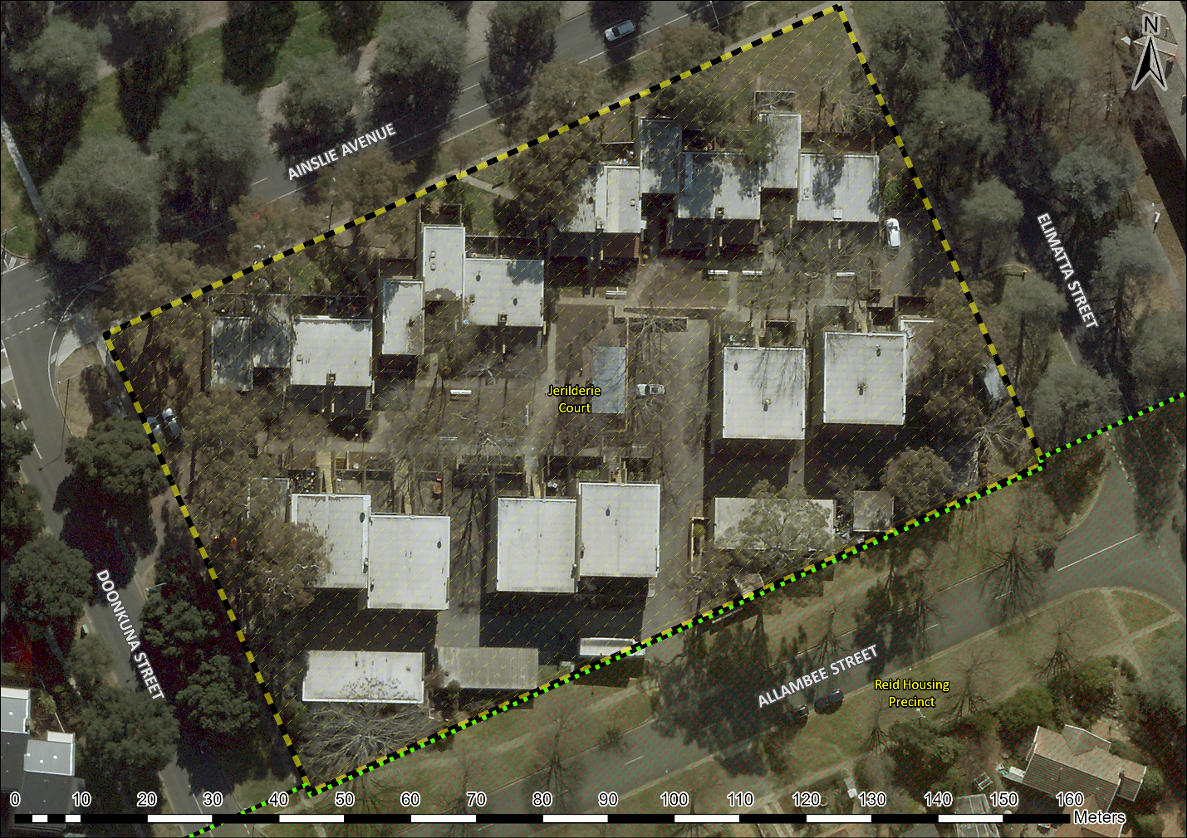
Image 1 Jerilderie Court site boundary encompassing all of Block 1, Section 9, Reid.

