Australian Capital Territory
Heritage (Decision about Registration of Former Kingston Post Office, Kingston) Notice 2023
Notifiable instrument NI2023–801
made under the
Heritage Act 2004, s 40 (Decision about registration)

1 Name of instrument
This instrument is the Heritage (Decision about Registration of Former Kingston Post Office, Kingston) Notice 2023.
2 Commencement
This instrument commences on the day after its notification day.
3 Decision about registration
On 5 December 2023, the ACT Heritage Council (the Heritage Council) decided to register the Former Kingston Post Office, Kingston (the Place).
4 Registration details of the Place
The registration details of the Place are in the schedule.
5 Reasons for the decision
The Heritage Council is satisfied on reasonable grounds that the Place has heritage significance as it meets one or more of the heritage significance criteria in section 10 of the Heritage Act 2004. A detailed statement of reasons including an assessment against the heritage significance criteria is provided in the schedule.
6 Date registration takes effect
The registration of the Place takes effect on 5 December 2023.
7 Revocation
The Heritage (Decision about Provisional Registration of Former Kingston Post Office, Kingston) Notice 2023 (NI2023-492) is revoked.

Stuart Jeffress
A/g Secretary (as delegate for)
ACT Heritage Council
5 December 2023

Schedule

(See sections 3 and 4)

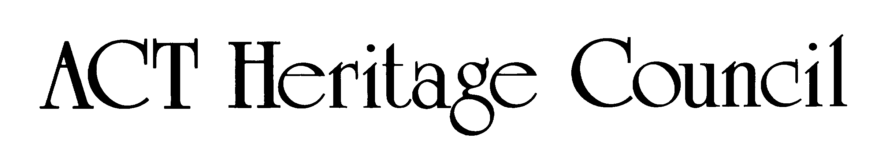
AUSTRALIAN CAPITAL TERRITORY
HERITAGE REGISTER
(Registration)

For the purposes of s40 of the Heritage Act 2004, an entry to the heritage register has been prepared by the ACT Heritage Council for the following place:

Former Kingston Post Office

Block 21, Section 22, Kingston
DATE OF REGISTRATION
5 December 2023 Notifiable Instrument: NI2023–

Copies of the Register Entry are available for inspection at ACT Heritage. For further information please contact:

The Secretary

ACT Heritage Council

GPO Box 158

CANBERRA ACT 2601

Telephone 13 22 81

This statement refers to the heritage significance of the place as required in s12(d) of the Heritage Act 2004.
STATEMENT OF HERITAGE SIGNIFICANCE

The Former Kingston Post Office is significant for its strong associations with the post-World War II development of Canberra. An earlier post office existed in Kingston from the 1920s, but with increasing demand for its services after WWII, in 1947 the government planned and in 1951 built the current building on the other side of Jardine Street where the shopping precinct would eventually expand with a new row of banking and commercial services buildings that referenced the Post Office in their design. The choice of a high-quality design is also a significant reminder of the investment made by the Post Master General in the post-war growth of Canberra. It was the first official post office constructed in Canberra after WWII and operated until 1989. The Former Kingston Post Office was the most important post office outlet for business and for residents of south Canberra during the post-WWII period of urban development of the capital. It is the oldest surviving post office building designed for the federal capital.

This statement refers to the location of the place as required in s12(b) of the Heritage Act 2004.
LOCATION OF THE PLACE

Former Kingston Post Office, Block 21 Section 22, 19 Jardine Street, Kingston.

This statement refers to the description of the place as required in s12(c) of the Heritage Act 2004. The attributes described in this section form part of the heritage significance of the place. For the purposes of s12(c) of the Heritage Act 2004, the boundary of the place is at Image 1.
DESCRIPTION OF THE PLACE

Former Kingston Post Office, consisting of the following attributes:

The original Kingston Post Office Building, as indicated in Image 1, including:
  - Punchbowl orange facebrick;
  - Detailing including horizontally emphasized hood mouldings above windows, tiled surround to portico openings, spandrel panels to main window and stepped detail capping the parapets;
  - Vent grilles and rainwater heads;
  - Inter-war stripped classical overall design with minor art deco embellishments, including:
    - Elements arranged symmetrically;
    - Cylindrical mullions used in the main window, alluding to vestigial classical columns and emphasising verticality;
    - Stepped end bays to the building’s western elevation referencing a classical portico;
    - Vertically arranged metal framed windows divided into horizontal panes;
    - Coloured glazed terracotta (faience) facing;
    - Scale and stepped massing of the original single storey section; and
  - The flagpole, either in its current position above the entrance or in its original position extending horizontally from top of the centre of the western façade.

NOTE: The rest of the physical material of the place, e.g. the extension and vehicular access as well as the non-original interiors/fabric, are not considered to be significant heritage features. The larger registered boundary is considered an appropriate heritage curtilage for conserving the scale and massing of the original building while allowing controlled complementary development.
CONSERVATION OBJECTIVE

The guiding conservation objective is that the Former Kingston Post Office shall be conserved and appropriately managed in a manner respecting its heritage significance.

The ACT Heritage Council may adopt heritage guidelines applicable to the place under s25 of the Heritage Act 2004.

For further information on guidelines applicable to the place, or for advice on proposed works or development, please contact ACT Heritage on 13 22 81.
REASON FOR REGISTRATION

The Council has assessed the Former Kingston Post Office against the heritage significance criteria and is satisfied that the place has heritage significance when assessed against criterion (a) under s10 of the Heritage Act 2004.
ASSESSMENT AGAINST THE HERITAGE SIGNIFICANCE CRITERIA

The Council’s assessment against the criteria specified in s10 of the Heritage Act 2004 is as follows.

In assessing the heritage significance of Former Kingston Post Office, the Council considered:
- the original nomination and documentary evidence supplied by the nominator;
- the Council’s Heritage Assessment Policy (March 2018);
- information provided by a site inspection on 11 September 2019 by ACT Heritage; and
- the report by ACT Heritage titled, Background Information Former Kingston Post Office, December 2023, containing photographs and information on history, description, condition and integrity;
- information and comments received during the public consultation period under s37 of the Act on the provisional registration of Former Kingston Post Office, consisting of 27 submissions. Council considered all submissions in their original format and decided to register the Former Kingston Post Office with minor amendments based on those submissions.

Pursuant to s10 of the Heritage Act, a place or object has heritage significance if it satisfies one or more of the following criteria. Future research may alter the findings of this assessment.

importance to the course or pattern of the ACT’s cultural or natural history;
The Council has assessed the Former Kingston Post Office against criterion (a) and is satisfied that the place meets this criterion.
The Kingston Shopping Precinct was the premier shopping destination in the new capital for many decades, providing a central hub for services, socialising and business development in Canberra. The Former Kingston Post Office was integral to the continuing success of businesses in the Precinct during the period of growth following WWII, as it was needed to process a predicted increase in business transactions, as well as being an effective drawcard service to attract people to the area. Its predecessor had outgrown its location in one of the shopfronts in the Precinct along Giles Street, and before that, the first post office in the Kingston area had opened in a house in 1918 at Eastlake, near to the power station, but neither was suitable to the task and a purpose-built facility was needed.
Development in the ACT was severely restricted during the 1930s and the early years of the Second World War. After the end of the War, the Former Kingston Post Office Building was the first official purpose-built post office constructed in the ACT. While it was not the first post office established, it is the oldest surviving post office building designed for the federal capital and was the first significant post-war project for the NSW Post Master General, making it a testament to the faith in the importance of the developing capital.
The high-quality building was the NSW Post Master General’s first significant investment since the start of WWII. The commitment of resources and faith in its establishment of significant services in the ACT is demonstrated in the Inter-war Stripped Classical style of architecture and the solid building material of brick and concrete. While other important buildings of the time were using modernist designs, classicism was still seen as prestigious and emblematic of permanent and institutional buildings as evidenced by such examples as Old Parliament House (J. S. Murdoch’s design that influenced elements of his concept plans for early Kingston Shopping Precinct along Giles and Kennedy Streets), the Former Institute of Anatomy, the Former Patent Office as well as the Late Twentieth-Century Stripped Classical examples that followed such as the National Library. The high-quality build is an important contribution to the character of the area recognised later by the NCDC stipulating that the rest of the Jardine Street Banking and Commercial Row had to use the same Punchbowl Orange brick as the Post Office as one of the key unifying features. The choice of architectural style and the materials used are significant, not just as evidence of the post-war recovery and investment in the region, but also for its enduring effect on the surrounding architecture that has continued to this day with nearby modern developments referencing the original post office following community consultation.
In a time of economic recovery, the Kingston area, including the Precinct and the surrounding industrial areas, was one of the main business centres in the ACT and there was a high reliance on the Former Kingston Post Office for delivering and receiving orders, invoices, cheques, legal documents, and various other services that businesses and community of the day depended on. It was also relied upon by the community for social purposes as a place that people congregated around, not just for business, but also personal communications interstate as well as packages, and various other aspects of everyday life that, unlike today, required a central physical location.
has uncommon, rare or endangered aspects of the ACT’s cultural or natural history;
The Council has assessed the Former Kingston Post Office against criterion (b) and is satisfied that the place does not meet this criterion.
The Former Kingston Post Office is not considered to be uncommon, rare or endangered as a post office, a stripped classical building, or as a government building. Careful consideration was given to what aspects of the ACT’s cultural history the Former Kingston Post Office has and all are represented across the ACT and from a wide range of dates. Council also considered other aspects that may be present, including technological features, designs to accommodate postal work and as a post-war purpose-built stand-alone post office building, among others; however, the place was considered not to have these aspects any more, or that it used so many descriptive qualifiers such that it became too specific to be appropriate as a category to compare uncommonness or rarity.
potential to yield important information that will contribute to an understanding of the ACT’s cultural or natural history;
The Council has assessed the Former Kingston Post Office against criterion (c) and is satisfied that the place does not meet this criterion.
As a well-documented built place, it is unlikely that any new information will be garnered from the material fabric of the place that would be considered a significant contribution to our existing knowledge. The Former Kingston Post Office does not have the potential to yield important information that will contribute to an understanding of the ACT’s cultural history.
importance in demonstrating the principal characteristics of a class of cultural or natural places or objects;
The Council has assessed the Former Kingston Post Office against criterion (d) and is satisfied that the place does not meet this criterion.
The Former Kingston Post Office is not considered to demonstrate the principal characteristics of a post office as all of these functions have now moved into the new extension and the original interior post office section retains no evidence of its past use. As a type of architecture, it does demonstrate the principal characteristics of the Inter-War Stripped Classical style (although it was built post-war, the style was most prevalent and synonymous with the inter-war period) with its symmetrical massing and classical composition with a minimum of classical motifs and Art Deco decorative elements; however, as a late (i.e. it was built after the style was falling out of favour) and relatively small (for a style that is exemplified by large institutional buildings that allow a greater expression of the style) example of this kind it is not considered to be important for demonstrating these characteristics. Significant examples of the Inter-War Stripped Classical style include the Former Institute of Anatomy, the Robert Garran Offices, formerly the Patent Office, Barton and Old Parliament House. The Former Kingston Post Office does not meet the threshold for inclusion under this criterion as either a post office or an example of the Inter-War Stripped Classical style of architecture.
importance in exhibiting particular aesthetic characteristics valued by the ACT community or a cultural group in the ACT;
The Council has assessed the Former Kingston Post Office against criterion (e) and is satisfied that the place does not meet this criterion.
Whilst the Council recognises that the Former Kingston Post Office Building is an example of the Inter-War Stripped Classical Style with Art Deco characteristics, there is insufficient evidence before the Council at this time to indicate that this exhibits outstanding design or aesthetic qualities that are valued by the community or a cultural group. It does contribute to the character of the Kingston Shopping Precinct, but there is not enough existing evidence of the building being aesthetically valued in and of itself.
importance in demonstrating a high degree of creative or technical achievement for a particular period;
The Council has assessed the Former Kingston Post Office against criterion (f) and is satisfied that the place does not meet this criterion.
The Former Kingston Post Office was built in a solid, standard, method of construction for its time. It is a brick and timber frame construction. Its design includes provision for movement and loading of postal vehicles, although these features have not been retained in the extant structure of the original building. While the stripped classical design testifies to its government origins, there is nothing that distinguishes it as a post office or shows any special achievement beyond being a well-made building of considered and classical design. There is no evidence at this time that the design meets the threshold demonstrating a high degree of creative or technical achievement for the period.
has a strong or special association with the ACT community, or a cultural group in the ACT for social, cultural or spiritual reasons;
The Council has assessed the Former Kingston Post Office against criterion (g) and is satisfied that the place does not meet this criterion.
In its heyday, the Former Kingston Post Office had an important role to play in supporting businesses and attracting shoppers to the Kingston Shopping Precinct, which was the premier shopping destination in the ACT in the period immediately after WWII. As such it would certainly have had a strong and special association with the ACT community as a social and economic hub at that time, but as the city has expanded, the Precinct has been relegated to a smaller role servicing its local neighbourhood. This smaller, local role is consistent with the original planning intention. The original post office building has also not been functioning as a post office since 1989, when that role was moved into the extension. As a consequence of the local role of both the precinct and the original post office building today, the latter does not have a strong or special association to the broader ACT community.
has a special association with the life or work of a person, or people, important to the history of the ACT.
The Council has assessed the Former Kingston Post Office against criterion (h) and is satisfied that the place does not meet this criterion.
The Former Kingston Post Office building is associated with the National Capital Planning and Development Committee (the NCPDC), the Department of Works & Housing (including D. G. Edward, Bruce Litchfield and David Limburg as the architects most closely associated with the design and documentation), the NSW Post Master General (PMG) and Australia Post, but not in a way that could be considered a special association, i.e. above the ordinary carrying out of their duties, that would satisfy the threshold for meeting this criterion.
The NCPDC was the advisory body to the Minister for the Interior that helped the planning and development of the ACT. They had a role in the development of the Post Office, but there is nothing to suggest that it was a special association above and beyond their usual involvement in any other planning and development issue in the ACT at the time. Similarly, the Department of Works & Housing and the architects assigned to the design, drawing and project management of the Former Kingston Post Office were involved as a part of their regular work duties with no indication that they were involved in any way that could be considered special and not a regular part of their job. This includes D. G. Edward, Bruce Litchfield and David Limburg as the architects most closely associated with the design and drawing of the place.
The PMG and more recently the Australian Postal Corporation as the owner and developer of the Post Office certainly have an association with the place and are important to the history of the ACT. To meet this criterion, that association would have to be special, i.e. above and beyond the ordinary, however, there is no evidence that the association is special.

SITE PLAN

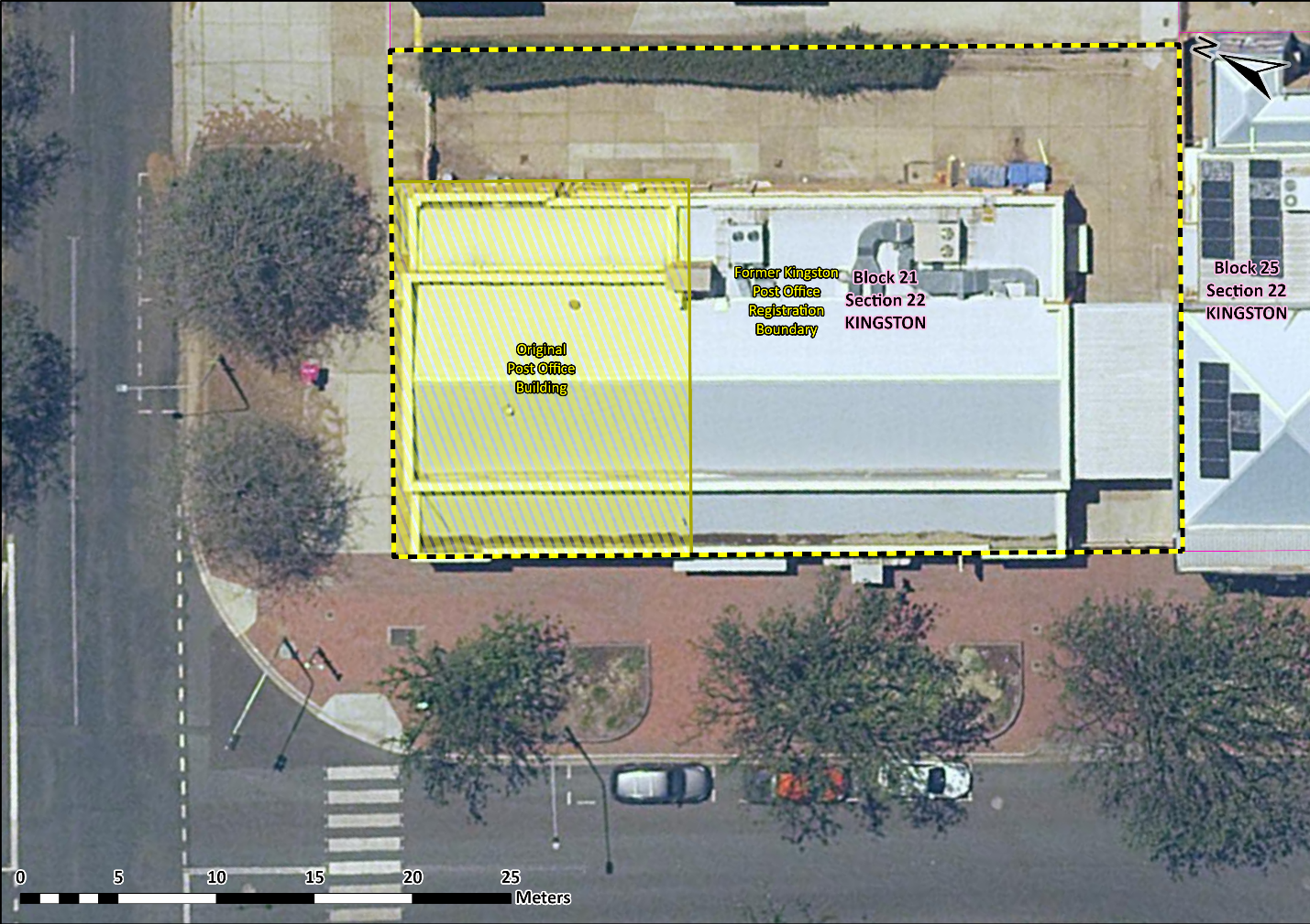
Image 1 The Former Kingston Post Office boundary – the shaded/hatched area contains the original post office building and the features that make up the significance of the place as noted in the description of the place; while the larger black/yellow dashed line along the block boundary indicates the registered curtilage.

