Australian Capital Territory
Urban Forest (Tree Management Plans) Guidelines 2023 (No 1)
Notifiable Instrument NI2023-823
made under the
Urban Forest Act 2023, section 88 (Tree management plans—guidelines)

1 Name of instrument
This instrument is the Urban Forest (Tree Management Plans) Guidelines 2023 (No 1).
2 Commencement
This instrument commences on 1 January 2024.
3 Approval
I approve the guidelines for tree management plans in the attached schedule 1.
4 Revocation
This instrument revokes the Tree Protection (Guidelines for Tree Management Plans) Determination 2010 NI2010-586.

Bren Burkevics
Conservator of Flora and Fauna

14 December 2023

Schedule 1 Specifications
FOR THE DEVELOPMENT OF TREE MANAGEMENT PLANS

Contents
Application of these specifications 2
Part 1 - Tree Management Plans relating to works 3
1. Application of Part 1 Specifications 3
2. Qualifications of author of Tree Management Plan 3
3. Outline of the Tree Management Plan 3
4. Detail of the Tree Management Plan 4
a. Introduction and Methodology 4
b. Tree Protection Plan (TPP) 4
c. Stages (where applicable) 5
d. Compliance (where applicable) 6
e. Acknowledgement of Responsibility 6
Part 2 - Tree Management Plans for events or land use 7
1. Application of Part 2 Specifications 7
2. Qualifications of author of Tree Management Plan 7
3. Outline of the Tree Management Plan 7
4. Detail of the Tree Management Plan 7
Additional parts to a Tree Management Plan 9
Definitions 9
Appendix A – Tree Protection Signage 11
Appendix B – Restricted Activity Acknowledgement for Events or Land Use 13

Application of these specifications

- A Tree Management Plan is required in response to managing a protected tree from potential damage, see division 5.1 of the Urban Forest Act 2023. These specifications are a Notifiable Instrument under section 88 of the Act.
- These specifications provide instruction for the requirements of a Tree Management Plan (TMP). Mandatory specifications are referred to as must, all other specifications may be included but are not mandatory.
- These specifications are established by the Urban Forest Act 2023 (the Act) and apply to activities that have potential to impact protected trees on public, private and neighbouring land.

Part 1 - Tree Management Plans relating to works

Application of Part 1 Specifications
- The following information provides specifications for TMPs submitted to the Decision-Maker through Development Applications or in response to works being undertaken in proximity to a protected tree, including, but not limited to, the following:
- Site access paths
- Demolition
- Installation of hoarding and scaffold
- Building and construction
- Utility installation, relocation, or access
- Traffic management and loading zones
- Other activities associated with construction such as storage, plant and equipment use, nature strip or footpath reinstatement.
- Major pruning

- The location of the protected tree(s) is not limited to the site on which works are occurring. If the works will encroach on the tree protection zone (TPZ) of a protected tree on a neighbouring lease, or public land (such as a nature strip), protection measures for these neighbouring trees must be considered and included in the TMP.
- The guidelines are intended to assist applicants to provide TMPs that meet the requirements of the Act, enabling adequate protection measures and an efficient assessment process. Whilst these guidelines will aid in efficiencies, each TMP is reviewed under individual circumstances and the Decision-Maker reserves the right to request further information if deemed necessary (as per Section 79 of the Act).

Qualifications of author of Tree Management Plan

- A TMP may be prepared by the applicant when no or low impact to the TPZ is expected.
- In all other cases, a TMP may be prepared by a certified project arborist (minimum Australian Qualification Framework (AQF) Level 5 in Arboriculture) or person with equivalent experience, unless otherwise agreed by the Decision-Maker.

Outline of the Tree Management Plan
- The document must be clearly titled ‘Tree Management Plan’ and must be a final version. Draft documents will not be accepted. Arboricultural Impact Assessments (AIA) are not required as part of the TMP and will not be accepted as an alternative to a TMP. The potential impacts of a proposal are to be identified prior to the TMP being prepared.

- Tree Management Plans must clearly contain the following sections within the document:
- Introduction
- Method
- Protected tree schedule (PTS)
- Tree protection plan (TPP) – including site plan and protection measures
- Stages (if applicable)
- Compliance (if applicable)
- Declaration
- Clear and definitive language must be used throughout the report. Critical tree protection specifications containing language such as ‘should’ or ‘may’ will not be accepted.
Note: for example: the tree protection zone (TPZ) fencing will be erected prior to any works commencing, including demolition of existing structures or vegetation.
The use of the word ‘may’ in place of ‘will’ implies the fencing is optional when it is mandatory.

Detail of the Tree Management Plan
Details of what each section in 3. b. must contain, are listed below.

Introduction and Methodology
- Site detail, client details, lessee details (including whether the lessee is a homeowner or non-homeowner)
- Contact details and qualifications of person preparing the TMP.
- Purpose of TMP including what works are being undertaken on the site and potential impact – eg. Impact on public land, verges, street trees or neighbouring blocks.
- Methodology including site attendance, date, time and what inspection methods or diagnostics were carried out
- Protected Tree Schedule (PTS), including trees on neighbouring land or leases, for each tree:
 | Example 1 | Example 2
Identifier (alpha/numerical) | T1 | T4
Photograph/s | Insert image or reference to appendix | See Appendix A – T4
Species (botanical and/or common name) | Eucalyptus melliodora | Ulmus parvifolia (Chinese Elm)
Hollows present (Y/N) | Yes – 2 hollows | No
Height (m) | 18m | 10m
Canopy width (m)i | 13m | 10m
Circumference at 1.4m (m); or  Diameter at 1.4m (m) | 1.3m | Multi trunked 1m
Existing damage or health concerns/factors, including evidence and a tree rating*  VALID/TRAQ/QTRA rating (if applicable/certified) | N/A | Nil, VALID Rating: Acceptable
Protection Status (Public, Regulated, Registered, Not Protected)  For Public Trees – identify as park tree, street tree, verge tree or other | Public – verge tree | Regulated
Listed weed species (yes/no) | no | No
Comment
Table 1. Protected Tree Schedule example

Tree Protection Plan (TPP)
All notations on the TPP must correspond with PTS (see 4. a), be site specific (not generic) and:
- Include a site plan showing the location of all trees, using identifiers from the PTS, showing the TPZ and SRZ.
- All plans must include a scale and legend.
- Where a site plan includes more than one (1) tree, clear sequential identifiers must be used.
- Show and/or describe all tree protection and tree care measures, including (but not limited to):
- Fencing
- Surface protection/anti-compaction devices
- Mulch
- Irrigation
- Trunk guard
- Cleaning bins (for contaminated wastewater disposal)
- Tree protection signage (see Appendix A for example)
- Conditions
- Indicate changes to any of the above measures, as applicable through from demolition to landscape phase of a project.
- Show or describe all Restricted Activities.
- Show all existing and proposed services within the TPZ of a protected tree.
- Show existing and proposed building envelope, driveways and any structures that are or will be within the TPZ of a protected tree.
- Encroachments into the TPZ – distance must be clearly shown on the site plan between proposed incursion and tree. Consideration must also be made to the proposed location of temporary encroachments such as site sheds, waste, portable toilets, cleaning areas, vehicle movement.
- Reference any requests or prior approval for Tree Removal or other Tree Activities
- Completed canopy contribution table (if applicable*)
Canopy Contribution Table
Number of protected tree removals (approved via TAA)
Number of protected tree removals (proposed through Planning)
Number of retained protected trees
Proposed number of replants, assuming all removals are approved
Type of replant proposed (no.) for non-homeowners only
Conifer
Introduced under 10m
Introduced 10-15m
Introduced 15m+
Native under 10m
Native 10-15m
Native 15m+
*this table is only required if there are approved or proposed protected tree removals.

Stages (where applicable)
Required for TMPs associated with larger scale projects, staged over a considerable period of time. For example knock down rebuilds, multi-unit developments, commercial building upgrades or redevelopments.
Detail of the tree protection and management provisions at each stage must be broken down. These stages usually include (but are not limited to); demolition and earthworks, construction, landscape phase and consolidation of landscape. Each stage can involve different contractors and it is for this reason it is necessary to separate the TMP into stages. The TMP for each stage is to meet the requirements as outlined in Section 4. b. Tree Protection Plan. If multiple stages are covered by the same protection measures, this can be noted in the TMP.
Note: an Arboricultural Impact Assessment (undertaken prior to construction) is not an alternative to a TMP. A TMP is a plan that will be put in place to manage the protection of the trees, not a tree assessment.

Compliance (where applicable)
Compliance measures that may be incorporated in a TMP include:
- A schedule of inspections to be conducted at project stages by qualified project arborist (or equivalent person).
- Records kept of each inspection, including date, attendees, any notes and/or photos taken by the project arborist (or equivalent person).

Acknowledgement of Responsibility
A statement that the applicant associated with the TMP acknowledges that all tree protection measures and the tree protection plan provided under Section 4. b. must be installed on site prior to any demolition or other works commencing.
The applicant is responsible for taking reasonable steps to tell each person carrying out works adjacent to the projected tree(s) that a TMP is in place. ie. A copy of the TMP must be available on site and form part of site induction, or be directly provided to any contractor carrying out works.

Part 2 - Tree Management Plans for events or land use

Application of Part 2 Specifications
      - The following information provides guidelines for TMPs submitted to the Decision-Maker in response to activities taking place in proximity to a protected tree that may cause damage. Including, but not limited to the following:
- events
- public land use licenses or permits
- ongoing land use for other activities.
      - Uses or activities that may cause damage include, but are not limited to: tents/yurts/teepees, food vans, lighting, fixtures on trees, signage, digging, trenching, pre-existing irrigation, pegs, stays, ropes, straps, swings, wet weather plans and soil compaction.
      - The location of the protected tree(s) is not limited to the site on which land use is occurring. If a tree on a neighbouring (private) lease, or other public land (such as a nature strip) is close enough to be impacted by the land use, it must be included in the TMP.
      - The guidelines are intended to assist applicants to provide TMPs that meet the requirements of the Act. Whilst these guidelines will aid in efficiencies, each TMP is reviewed under individual circumstances and the Decision-Maker reserves the right to request further information if deemed necessary.

Qualifications of author of Tree Management Plan

      - A TMP may be prepared by the applicant when no or low impact to the TPZ is expected.
      - In all other cases, a TMP may be prepared by a certified project arborist (minimum Australian Qualification Framework (AQF) Level 5 in Arboriculture) or person with equivalent experience, unless otherwise agreed by the Decision-Maker.

Outline of the Tree Management Plan
      - The document must be clearly titled ‘Tree Management Plan’ and must be a final version. Draft documents will not be accepted. Arboricultural Impact Assessments (AIA) are not required as part of the TMP and will not be accepted. The potential impacts of a proposal are to be identified prior to the TMP being prepared.

      - Tree Management Plans must clearly contain the following sections within the document:
- Introduction
- Tree Protection Plan
- Tree Care/Maintenance Plan
- Restricted Activity Declaration
      - Clear and definitive language must be used throughout the report. Critical tree protection specifications containing language such as ‘should’ or ‘may’ will not be accepted.

Note: for example the tree protection zone (TPZ) fencing will be erected prior to any event commencing, including access for set up of temporary structures.
The use of the word ‘may’ in place of ‘will’ implies the fencing is optional when it is essential.

Detail of the Tree Management Plan
Details of what each segment listed in Section 3. b. must contain, are listed below.

      - Introduction
- Site detail, event/host contact details (ie. person who will be on site for the duration of the activity).
- Contact details and qualifications (if applicable) of person preparing the TMP.
- Purpose of TMP including event/activity detail such as date, duration, number of attendees
- Summary of protected trees, eg. 10 trees are located in the park, the event will take place in an area within the TPZ of 3 trees, see site plan.
Note: Protected trees under the Act include all public trees.
- Public Unleased Land Permit – or application reference if not yet obtained.
- Protected Tree Schedule (PTS):
 | Example 1 | Example 2
Identifier (alpha/numerical) | T1 | T4
Comment

      - Tree Protection Plan (TPP)
All notations on the TPP must correspond with PTS (see 4. a) and:
- Reference to any requests or prior Fix My Street requests such as pruning.
- Site plan using aerial image, identifying location of equipment, hardstand, entry and exit points etc (where applicable). Site plan should also include any proposed fencing and signage.
- Where a site plan includes more than one (1) trees, clear sequential identifiers must be used.
- Show and/or describe all tree protection measures, including (but not limited to):
- Fencing
- Surface protection/compaction devices
- Trunk guard
- Tree protection signage (see Appendix A for example)
- Tree Protection measures throughout stages of land use, if differing. eg. Event bump in, during event, event bump out.
- Post land use/event inspection and follow up tree protection measures, such as aerating compacted soil following heavy traffic compaction.
      - Restricted Activity Acknowledgement
A statement that the applicant (land user) understands the responsibilities associated with the Tree Management Plan. Example provided at Appendix B.

Additional parts to a Tree Management Plan
A Tree Management Plan may also contain:
- reference to or a copy of an existing reports for the site or tree
- example images or detail of TPZ fencing, signage etc
- additional plans
- any other supporting document that the applicant deems relevant to the Tree Management Plan.

Definitions

“the Act” means the Urban Forest Act 2023

“Conservator” means the Conservator of Flora and Fauna.

“damage” includes to kill, destroy, poison, ringbark, fell, remove, remove a hollow or anything else done to or in relation to a protected tree that is likely to cause it to die, significantly reduce its life expectancy or significantly and adversely affect its health, stability or general appearance. The meaning of ‘damage’ is consistent with the meaning of damage as defined in s 14 of the Urban Forest Act 2023

“decision-maker” means the delegate responsible for making decisions about impacts on protected trees.

“guidelines” mean specifications, and this legislative instrument being Urban Forest Act (Tree Management Plans) Guidelines 2023 (no).

“homeowner” means the person is the lessee of the land and the person provides written evidence that they have been living on the land for at least two years or they intend to live on the land for at least two years.

“impact” means damage or the potential to damage

“must” means a mandatory element of a Tree Management Plan under this instrument. If a mandatory element is not included, a Tree Management Plan may be rejected and require resubmission.

“may” means elements that can be included in a Tree Management Plan, but are not mandatory in all. These are usually situation specific.

“non-homeowner” means all other leaseholders that are not homeowners. eg. investors, developers, businesses.

“project arborist” means the person responsible for carrying out the tree assessment, report preparation, specification of tree protection measures and monitoring of the tree throughout the project. Usually someone with qualifications of AQF5 or above in arboriculture, or equivalent experience.

“responsible authority” means the delegate as appointed by the Conservator of Flora and Fauna or the delegate as appointed by the responsible directorate’s decision-maker.

“responsible person” means the person accepting liability for the activities being undertaken on the land and for the protection and / or damage of the protected tree/s.

“restricted activities” means activities that could lead to damage of a protected tree.

“specifications” means guidelines and this legislative instrument being Urban Forest Act (Tree Management Plans) Guidelines 2023 (No 1).

“SRZ” means structural root zone and refers to the area around the base of a tree required for the tree’s stability in the ground. Defined by AS4970-2009,0 the SRZ calculation is as follows:
SRZ radius = (DRC x 50) 0.42 x 0.64, where DRC = trunk diameter, in metres, measured above root crown (DRC = Diameter Above Root Crown).

“TAA” means a Tree Activity Application and refers to the application used when proposing or requesting to damage a protected tree.

“TMP” means tree management plan and refers to a plan developed in accordance with section 88 of the Urban Forest Act 2023.

“TPP” means tree protection plan and refers to a map or drawing that depicts the site and the protected trees and includes tree protection zones and strategies.

“TPZ” means tree protection zone and refers to the area of ground surrounding the trunk of a tree that must be protected and where certain activities are prohibited. See Part 2 Section 13 of the Act.

“tree rating” means a rating assigned to a tree by the TMP author based on the health, vigour, form, age and landscape value of a tree. A tree rating provided in a TMP may not be accepted by the decision-maker.

“use” means carrying out an activity on the public land that excludes some or all members of the public from the place, as defined by s 41 (1) of the Public Unleased Land Act 2013.

“work/s” means construction, building, landscaping or any other works that may be associated with a building application or development application.

Appendix A – Tree Protection Signage
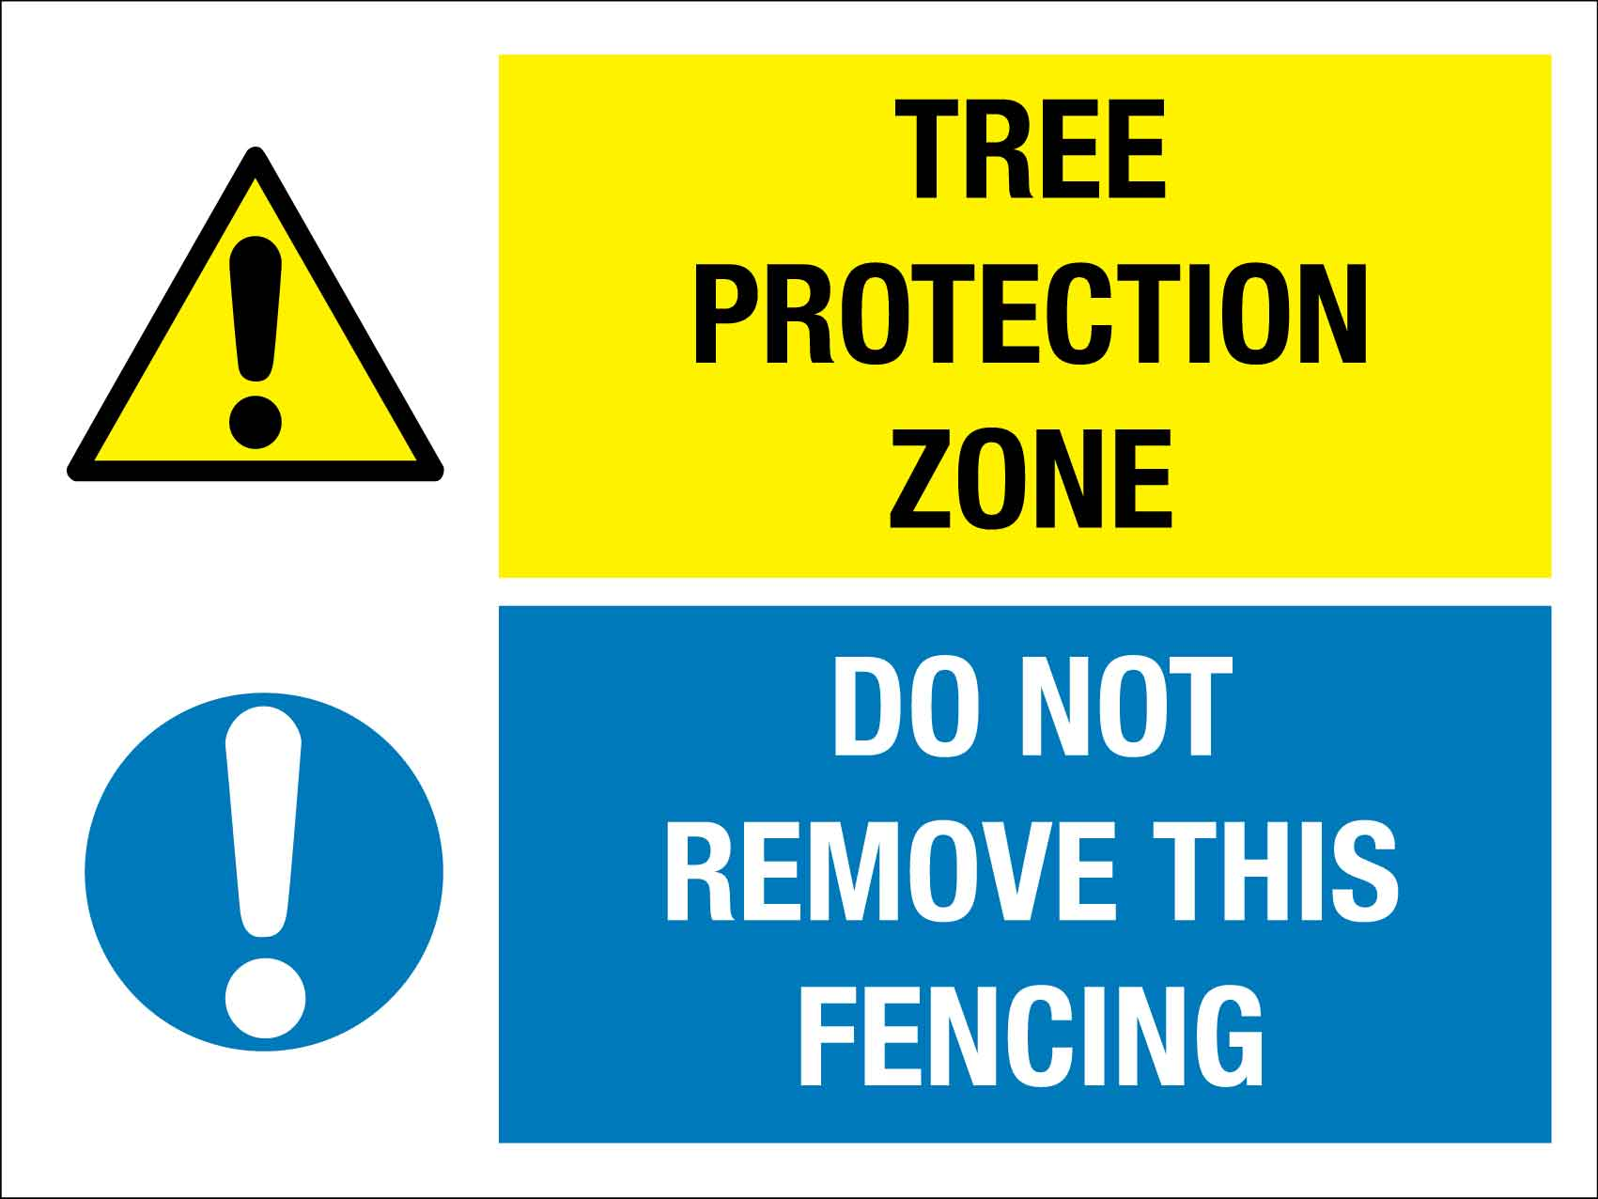

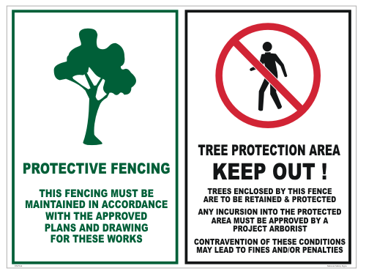

Appendix B – Restricted Activity Acknowledgement for Events or Land Use
An acknowledgement must include the following:
- Under no circumstance are nails, screws or other tree damaging fixtures to be used on any part of a tree. No signage or event infrastructure can be affixed to trees at any time.
- Event organisers are not permitted to carry out any tree maintenance activities, including pruning or removal of trees, without an approved tree damaging activity application. Forms to undertake a tree damaging activity (on leased land) can be completed online - Tree Activity Application. Activities requested for public trees must be lodged via Fix My Street.
- Nothing is to be attached to trees without approval from the Tree Protection Unit. For temporary lights installed in trees, the boughs of the tree must be capable of supporting the weight of any cables or lights. Light installation shall be attached with Velcro strapping with no more than 1.5 wraps around each of the attachment points, leaving a minimum of two finger gap between bark layer and Velcro strap. Lighting must be avoided in the lower limbs and ends of limbs (approximately 2.0m from end). If services are required, details of the proposal need to be discussed with the Tree Protection Unit.
- Vehicle movement, parking of vehicles, placement of heavy event infrastructure and excavation is not permitted within the TPZ of trees. The placement of pegs and stakes within the TPZ should be avoided and, if necessary, will require consultation with the Tree Protection Unit.
- Protective sheath or other trunk protection (such as TrunkGuard) wrapped around the trunk and/or branches needs to be used if anything is to be tied to the tree.
- It may be necessary to set up a protection fence, ground matting, load bearing boards or deep mulch around trees during the event to avoid damage and compaction. Protective and perimeter fencing is to be stabilised with concrete blocks. This must be discussed with the Tree Protection Unit, for inclusion in the site plan.
- Compaction of the soil will cause unnecessary stress for the trees by inhibiting the infiltration of water and affecting levels of oxygen in the soil. This may lead to die back and the need to either carry out crown pruning or complete removal of affected trees, ultimately affecting the character of the park. To avoid compaction vehicles must travel on existing hardstand surfaces including footpaths and existing carparks or roads. Any structures must be placed on hardstand areas within the park. If this cannot be achieved, a site meeting must be arranged with the Tree Protection Unit to identify the best practice and/or possible location to minimise compaction.

