Australian Capital Territory
Corrections Management (Transitional Release AMC-based Employment) Operating Procedure 2023
Notifiable instrument NI2023–84
made under the
Corrections Management Act 2007, s14 (Corrections policies and operating procedures)

1 Name of instrument
This instrument is the Corrections Management (Transitional Release AMC-based Employment) Operating Procedure 2023.
2 Commencement
This instrument commences on the day after its notification day.
3 Operating Procedure
I make this operating procedure to facilitate the effective and efficient management of corrections services.

Ray Johnson ^{APM}
Commissioner
ACT Corrective Services
15 February 2023

OPERATING PROCEDURE | Transitional Release AMC-based Employment
OPERATING PROCEDURE NO. | D26.7
SCOPE | Transitional Release
STATEMENT OF PURPOSE
To provide instructions to Transitional Release Staff on detainee engagement in AMC-based work when participating in the program.
Detainees engaged in stage one of Transitional Release must participate in AMC-based employment and detainees engaged in stage two must participate in AMC-based employment or Transitional Release Centre (TRC) work crew (where positions are available). Detainees in receipt of an AMC pension are exempt from engaging in employment. Refer to the D26.5 Transitional Release Staged Approach to Reintegration Operating Procedure for more information.
PROCEDURES
- Access to work
  - Detainees engaged in Transitional Release must have access to AMC-based employment in line with the Detainee Work Policy 2019 and Detainee Work Operating Procedure 2019.
  - Detainees accommodated at the Transitional Release Centre (TRC) may have access to the following AMC-based employment positions which will be administered by the AMC Employment Team:
- Stores
- Grounds

- Remuneration
  - All detainees at the TRC engaged in AMC-based work must receive remuneration in line with the Detainee Work Policy 2019 and Detainee Work Operating Procedure 2019.
  - Detainees within the AMC may be paid more than detainees at the TRC because they complete other duties and tasks internally within the AMC.
  - Any detainee engaged in community-based work does not receive remuneration from AMC-based employment and cannot be directed to undertake any work for the AMC, except for keeping their room and common areas tidy.

- Work hours and expectations
  - All detainees at the TRC engaged in AMC-based work are expected to engage in work Monday to Thursday 0800 hours to 1130 hours and 1300 hours to 1500 hours
  - Detainees may receive an approved absence from these work hours to engage in rehabilitation and reintegration needs as identified in their Transitional Release Case Plan. This absence is to be approved by the Transitional Release Team Leader. The detainee will continue to be paid for any approved absence.
  - Transitional Release staff must advise the employment supervisors when any detainee will not be attending their AMC-based employment.
  - If there are enough detainees from the AMC working at Stores, detainees from the TRC may not be required to work on Thursday afternoons. This decision is made by the Stores Supervisor who must also communicate this to AMC Employment.
  - Detainees working in Stores will not be required to work on weekends. Detainees working on grounds may work Saturdays if required.
  - Detainees working in stores will be required to undertake cleaning as part of their job, including but not limited to:
- toilet cleaning
- vacuuming
- emptying of bins
  - Detainees working on grounds are not supervised continuously. Each week the Grounds Supervisor must advise the detainees of the work required to be completed for the week ahead. The detainees then undertake these duties using their own initiative.

RELATED DOCUMENTS
- Transitional Release Policy
- Transitional Release Staged Approach to Reintegration Operating Procedure
- Transitional Release Community-based Employment Operating Procedure
- Detainee Work Policy 2019
- Detainee Work Operating Procedure 2019

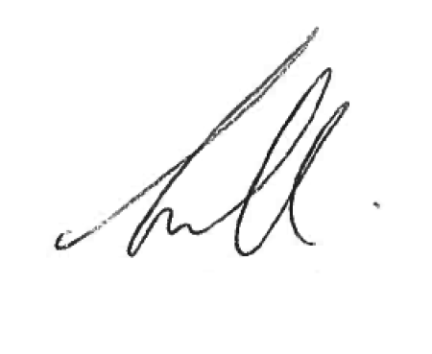
Narelle Pamplin
Assistant Commissioner Offender Reintegration
ACT Corrective Services
25 January 2023

Document details
Criteria | Details
Document title: | Transitional Release AMC-based Employment Operating Procedure 2023
Document owner/approver: | Assistant Commissioner Offender Reintegration, ACT Corrective Services
Date effective: | The day after the notification date
Review date: | 3 years after the notification date
Responsible Officer: | Senior Director Offender Reintegration
Compliance: | This operating procedure reflects the requirements of the Corrections Management (Policy Framework) Policy 2022

Version Control
Version no. | Date | Description | Author
V1 | November-22 | First Issued | L Spulak

