Australian Capital Territory
Corrections Management (Transitional Release Escorts) Operating Procedure 2023
Notifiable instrument NI2023–90
made under the
Corrections Management Act 2007, s14 (Corrections policies and operating procedures)

1 Name of instrument
This instrument is the Corrections Management (Transitional Release Escorts) Operating Procedure 2023*.
2 Commencement
This instrument commences on the day after its notification day.
3 Operating Procedure
I make this operating procedure to facilitate the effective and efficient management of corrections services.

Ray Johnson ^{APM}
Commissioner
ACT Corrective Services
15 February 2023

OPERATING PROCEDURE | Transitional Release Escorts
OPERATING PROCEDURE NO. | D26.6
SCOPE | Transitional Release
STATEMENT OF PURPOSE
To provide instructions to all staff working in Transitional Release about how escorts are to be conducted with detainees on approved temporary leave as part of the program
FLOW CHART
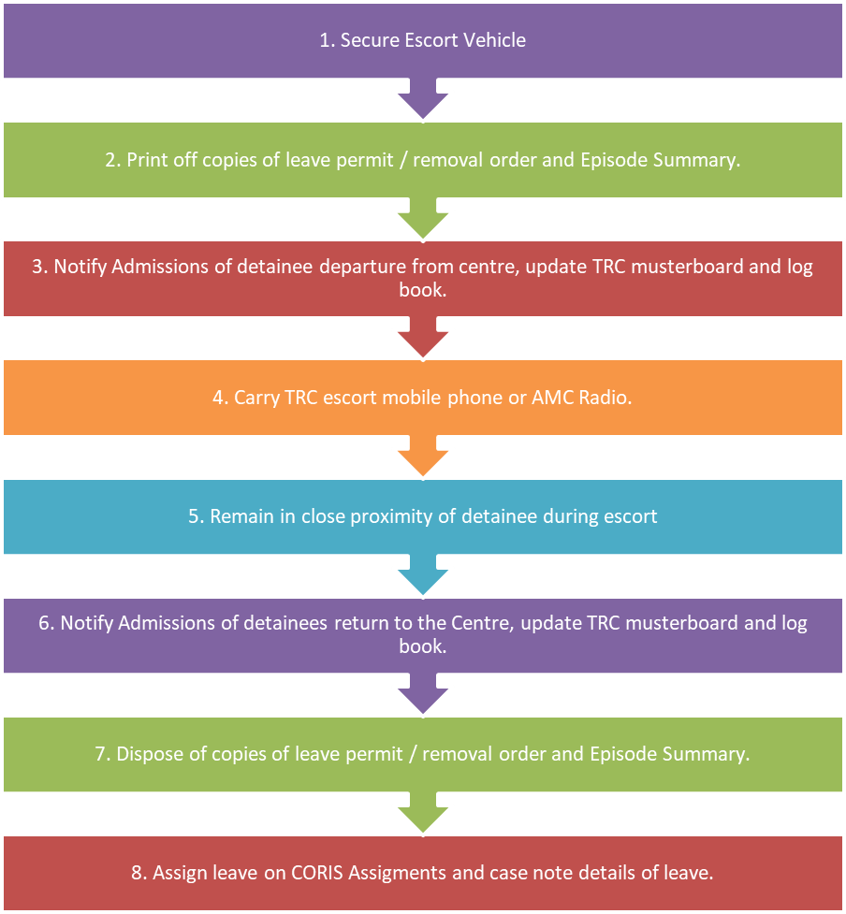
PROCEDURES
- Clothing
  - Custodial Officers must wear official ACTCS uniforms when escorting detainees on leave related to employment and for hospital appointments.
  - For all other forms of leave, Custodial Officer must wear civilian clothing.
  - Detainees must be allowed to change into civilian clothing appropriate for the purpose of their external leave.

- Prior to Escort
  - The escorting staff member must check the vehicle is available and has adequate fuel. If the Transitional Release Centre (TRC) vans are in use, staff must contact the AMC Control Room to request use of an AMC escort vehicle. NOTE: Personal vehicles must NOT be used during escorts.
  - Hard copies of the detainee’s episode summary and current approved leave permits are found in the detainee’s blue folder at the TRC officer’s station. Uploaded documents can be found on CORIS under external documents. These documents must be carried by the staff member for the duration of the escort.
  - The detainee must ensure they have what is required for the purpose of the escort. For example, if opening a bank account, the detainee will require identification and proof of residency.
  - The escorting staff member must notify AMC Admissions of the detainee’s departure, intended destination and return time by phone or radio prior to leaving the TRC to ensure muster count is correct.
  - For detainees accommodated in TRC, the escorting staff member must record the detainee’s departure in the TRC logbook and update the muster book and board located at the TRC officer’s station.
  - The escorting staff member must carry the TRC Escort Mobile Phone or AMC Radio whilst they are out of the centre on an escort.
- The use of the mobile phone is preferred on community escorts for discretion.
- Whilst escorting a detainee to employment or the hospital, the AMC radio and the TRC escort mobile phone must be carried. Both items are located at the TRC officer’s station.
  - The detainee must not use the mobile or radio.

- During the Escort
  - The escorting staff member must remain in close proximity and within eyesight or hearing distance of the detainee for the duration of the escort.
  - For escorts where the detainee must be provided with a level of privacy (i.e. medical appointments, counselling etc), the escorting officer must remain within eyesight of the room where the detainee is.
  - The escort must only be to the location stated on the Leave Permit and within the approved time frame without deviation. For example, stopping for fuel or drive through take-away is not permitted
  - Unscheduled interactions with members of the general public known to the detainee are to be brief and closely monitored by the escorting staff member.
  - The escorting staff member must allow the detainee to represent themselves and conduct their business independently. For example, the escorting staff member must not speak on the detainee’s behalf.
  - Escorting staff members must not use personal funds to purchase food, beverages or any other items for the detainee whilst out on escort.
  - The detainee must not use their own personal funds to pay for any escorting staff member’s goods.
  - If the detainee’s behaviour becomes disruptive during the escort, the staff member must:
- immediately terminate the escort
- advise the Transitional Release Team Leader (TL) by mobile phone, and
- return the detainee to the TRC (or AMC for TRP participants) immediately.
Examples of disruptive behaviour includes the detainee being rude, abusive or dismissive.
  - If the detainee absconds during an escort, the escorting staff member must not attempt to apprehend the detainee. The escorting staff member must immediately notify the AMC Master Control Room (MCR) and then the Transitional Release Team Leader. The MCR must initiate a response in accordance with the Incident Response Operating Procedure.
  - In the case of a vehicle accident or breakdown, the escorting staff member must seek appropriate medical attention in the first instant (if required) and notify the MCR and then the Transitional Release TL as soon as practical.
  - Refer to the Vehicle Accident or Breakdown Operating Procedure for information about what is to occur if a detainee or staff member needs medical attention or how to transport a detainee back to the centre if the car is unable to be driven

- On completion for escort
  - Upon return to the TRC (or AMC for TRP participants), the detainee must remain in the eyesight of the escorting officer and immediately report to the TRC Office’s station 9or Admissions for TRP participants). At this time the detainee may be searched and/or drug tested (in accordance with the Searching Policy and the Drug Testing in Correctional Centres Policy respectively) before returning to their accommodation area and changing back into prison-issued clothing.
  - All items brought back to the centre by the detainee, must have prior approval from the Assistant Commissioner Custodial Operations or Senior Director Operations in line with the Transitional Release – Leaves (excluding community-based employment) Operating Procedure.
  - The escorting staff member must notify AMC Admissions verbally, by phone or radio, immediately of the return of the detainee for inclusion in any occurring muster count.
  - For detainees accommodated in TRC, the escorting staff member must record the detainee’s return from the escort in the TRC logbook and update the muster board.
  - The copies of the leave permit and episode summary must be securely destroyed.
  - The escorting officer must place the TRC Escort mobile phone on to charge.
  - The escorting staff member must case note the details of the escort on CORIS in accordance with the Case Note Policy 2021. Information about the detainee’s behaviour and personal interactions whilst under escort must be included in this case note and any follow up action that is to be completed by the escorting staff member.
  - The escorting staff member must report any concerns, issues and/or observations to the Transitional Release TL, who must make a decision about any action required in line with relevant AMC policies and procedures.

- Recording escorts in CORIS
  - Find the detainee in CORIS by searching by PID, Name or through quick entry.
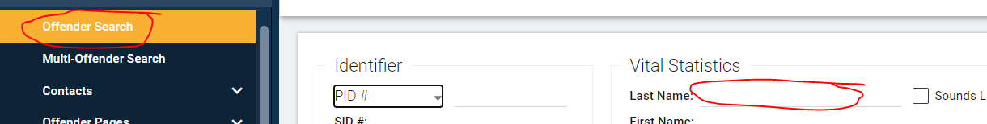
  - Once the detainee has been located, click on the Transfers – Escorts tab and click on Escorts
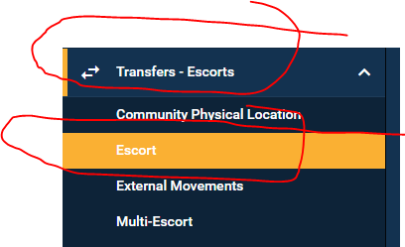

  - Fill out the following details:
- Start Date/Time: enter information as per the booking, including travel time
- Return Date/Time: enter information as per the booking, including travel time
- Escort Type: choose External Escort – Other
- Destination: choose TRC
- Special Transportation Instructions: enter details of the escort and activities
- Scroll down and hit SAVE

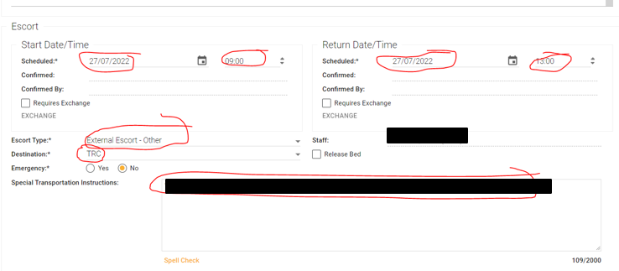

- Recording escorts as an appointment in CORIS
  - Locate the detainee in the system and click on Appointments.
  - Fill out the following details:
- Start Date/Time: enter information as per the booking, including travel time
- Return Date/Time: enter information as per the booking, including travel time
- Please note you can make this recurring as an appointment but not as an escort
- Appointment Type: choose TRC – Field Visit
- Agency Location: Alexander Maconochie Centre
- Staff: you are able to assign the staff member who will be going on the escort. They will be sent a calendar invite and notification
- Area: enter the appointment location as per the booking
- Internal Location: TRC Programs
- Comments: Enter the details of the escort
- Scroll down and hit SAVE

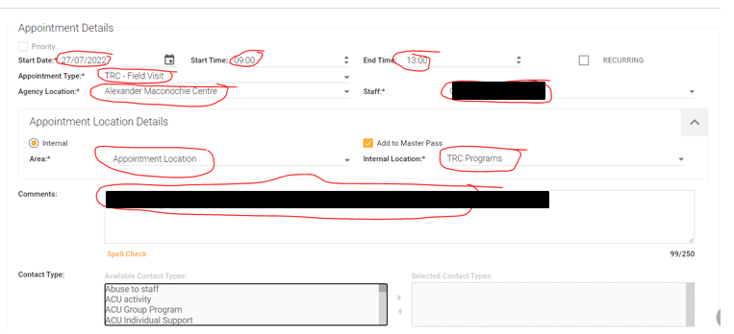

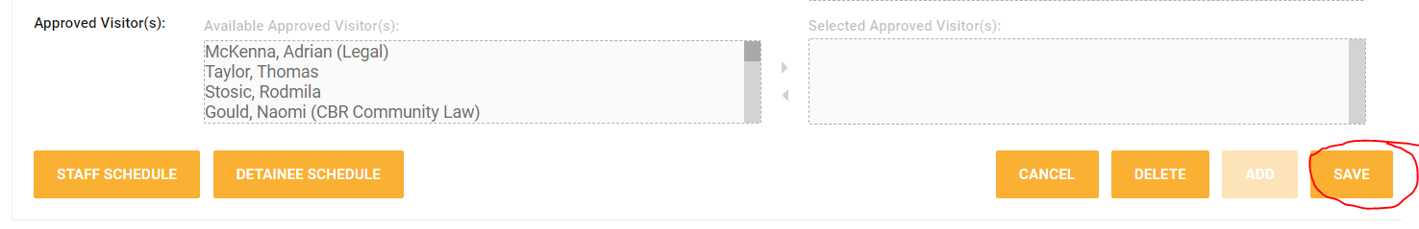
- Running escort reports on CORIS
  - You can run reports for the day, so you know that activities are listed in CORIS.
  - Select Appointments
  - Select Detainee (with person selected)
  - Select Detainee pages
  - Select Detainee appointments
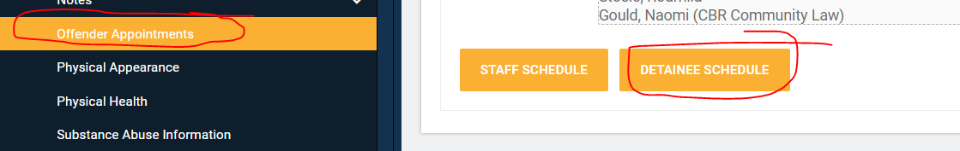
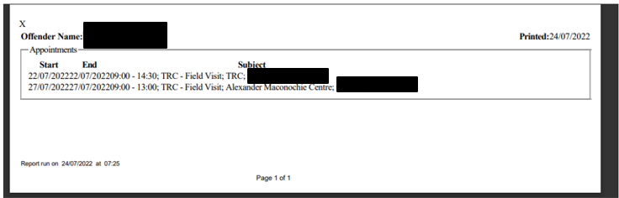
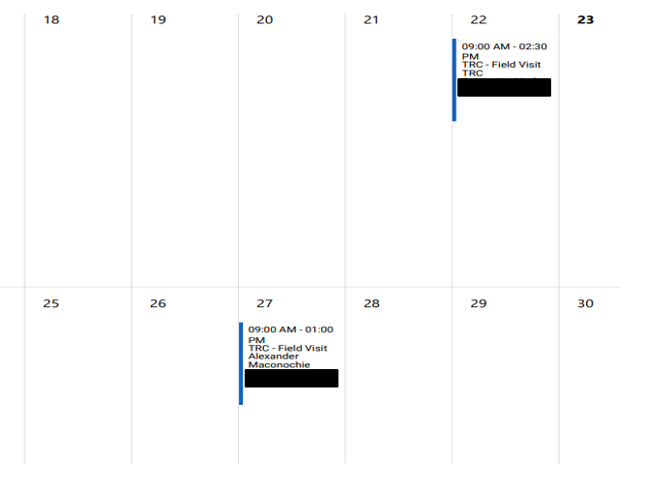

- Escorts:
  - Once entered in escorts, the appointment is easily viewable on the AMC daily escort plan. To view the daily escorts (this will show the whole AMC):
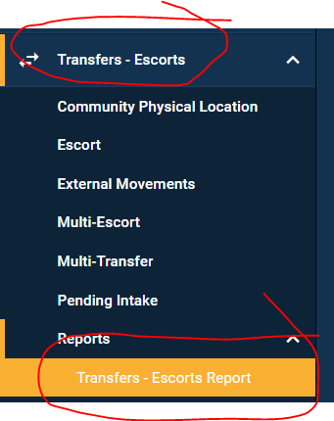
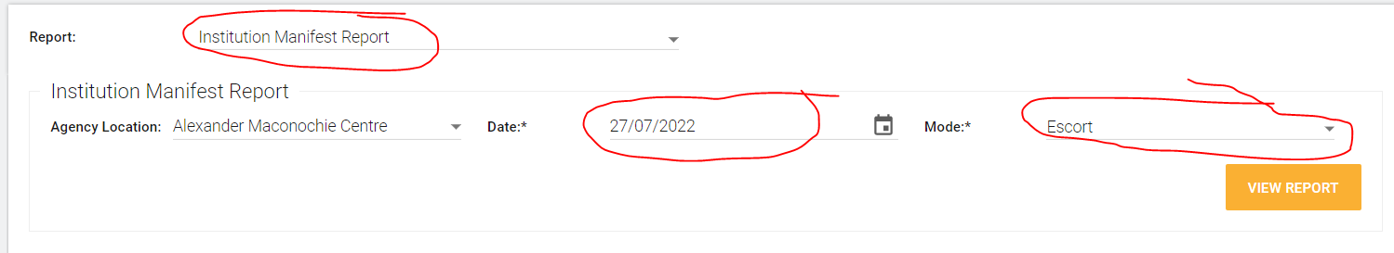
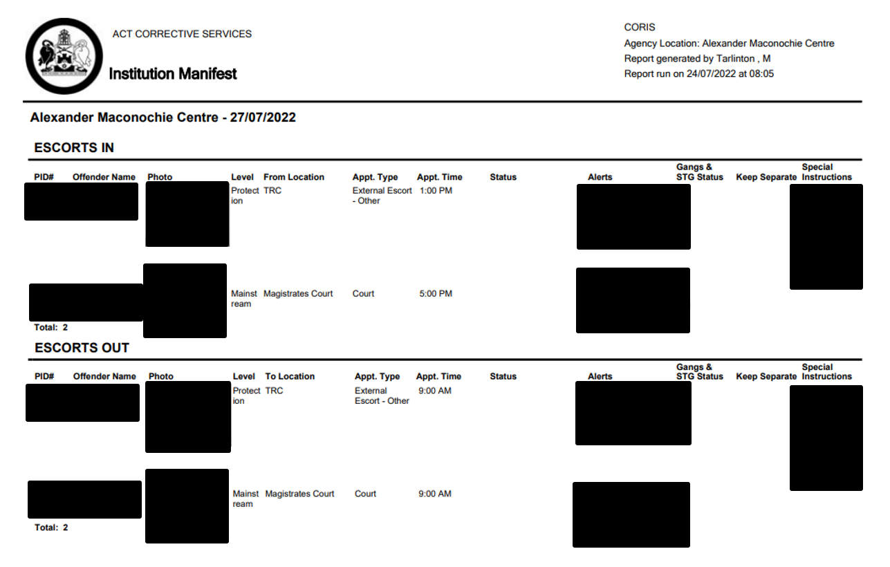
RELATED DOCUMENTS
- Transitional Release Policy
- Incident Response Operating Procedure
- Vehicle Accident or Breakdown Operating Procedure
- Transitional Release Leaves (excluding community-based employment) Operating Procedure
- Case Note Policy 2021

Narelle Pamplin
Assistant Commissioner Detainee Reintegration
ACT Corrective Services
25 January 2023

Document details
Criteria | Details
Document title: | Transitional Release Escorts Operating Procedure 2022
Document owner/approver: | Senior Director Detainee Reintegration, ACT Corrective Services
Date effective: | The day after the notification date
Review date: | 3 years after the notification date
Responsible Officer: | Senior Director Detainee Reintegration
Compliance: | This operating procedure reflects the requirements of the Corrections Management (Policy Framework) Policy 2022

Version Control
Version no. | Date | Description | Author
V1 | September-22 | First Issued | L Spulak
V2 | December-22 | Continual revision | J Papadopoulo

