Australian Capital Territory

Nature Conservation (Closed Reserves) Declaration 2024 (No 1)

Notifiable instrument NI2024–216
made under the
Nature Conservation Act 2014, s 259 (Conservator may close reserve)

1 Name of instrument
This instrument is the Nature Conservation (Closed Reserves) Declaration 2024 (No 1).

2 Commencement
This instrument commences on 25 May 2024.

3 Declaration
I declare that public access to the following areas (closed reserves):
(a) those parts of Stony Creek Nature Reserve indicated in the map at schedule 1; and
(b) those parts of Bullen Range Nature Reserve indicated in the map at schedule 2; and
(c) those parts of Gigerline Nature Reserve indicated in the map at schedule 3; and
(d) those parts of Rob Roy Range Nature Reserve indicated in the map at schedule 4; and
(e) those parts of Swamp Creek Nature Reserve indicated in the map at schedule 5; and
(f) those parts of Sherwood Forest Special Purpose Reserve indicated in the map at schedule 6; and
(g) those parts of Molonglo River Reserve (part of nature reserve section) indicated in the map at schedule 7; and
(h) those parts of Tidbinbilla “nature reserve” (national park and special purpose reserve sections) indicated in the map at schedule 8
is prohibited during the closure periods specified at schedule 9.

4 Exceptions
Section 3 does not apply to:
(a) a conservation officer exercising a function under the Act; or
(b) a person accompanied by a conservation officer exercising a function under the Act; or
(c) a contractor undertaking vertebrate pest animal control works within a closed reserve and engaged by the ACT Government to do so.

5 Expiry
This instrument expires on 7 June 2024.

6 Definitions
closure period, for a reserve specified in column 1 of schedule 9, means the period:
- commencing on the corresponding date (start date) specified in column 2 of schedule 9; and
- ending on the corresponding date (end date) specified in column 3 of schedule 9.

Bren Burkevics
Conservator of Flora and Fauna

30 April 2024
Schedule 1 Area of Stony Creek Nature Reserve closed to public access

(see s 3)

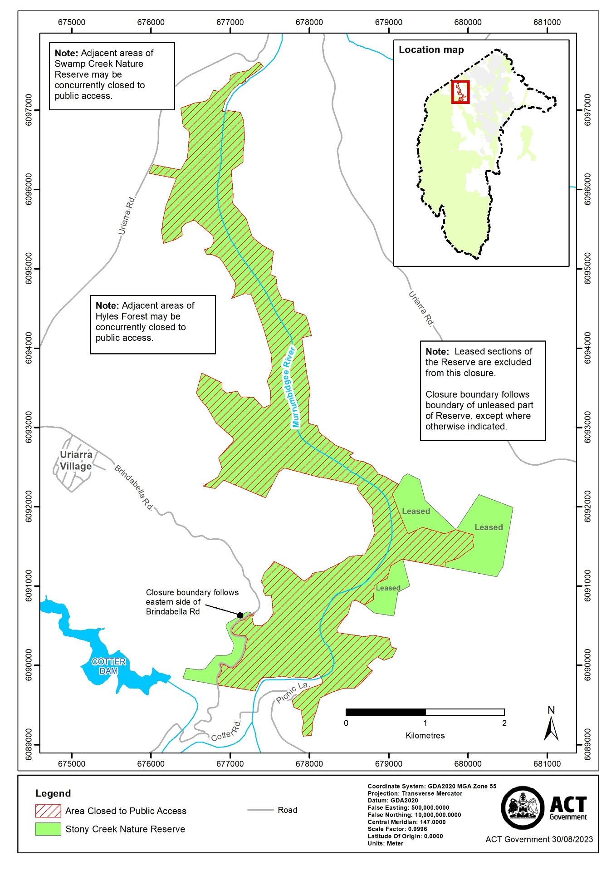
Schedule 2 Area of Bullen Range Nature Reserve closed to public access

(see s 3)

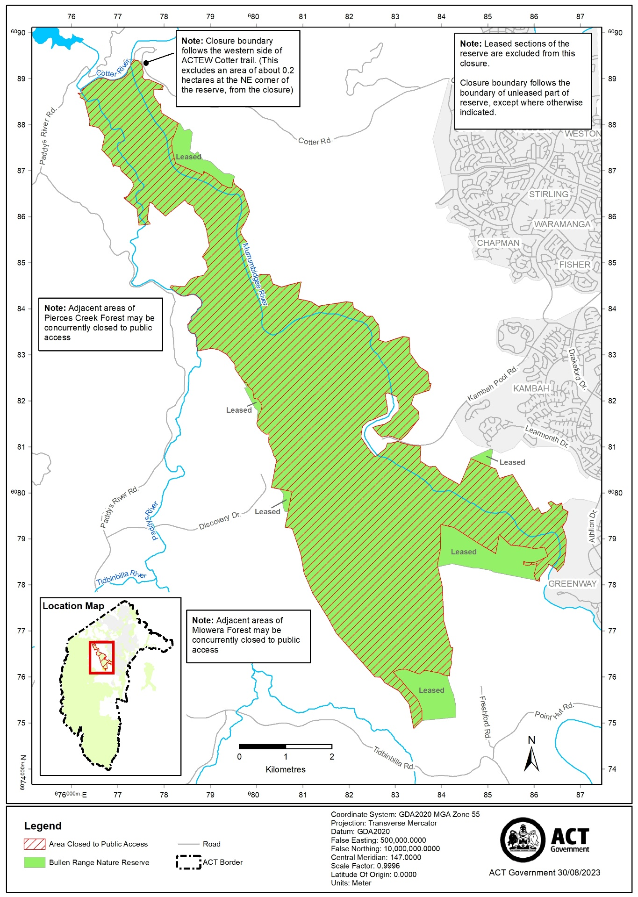
Schedule 3 Area of Gigerline Nature Reserve closed to public access

(see s 3)

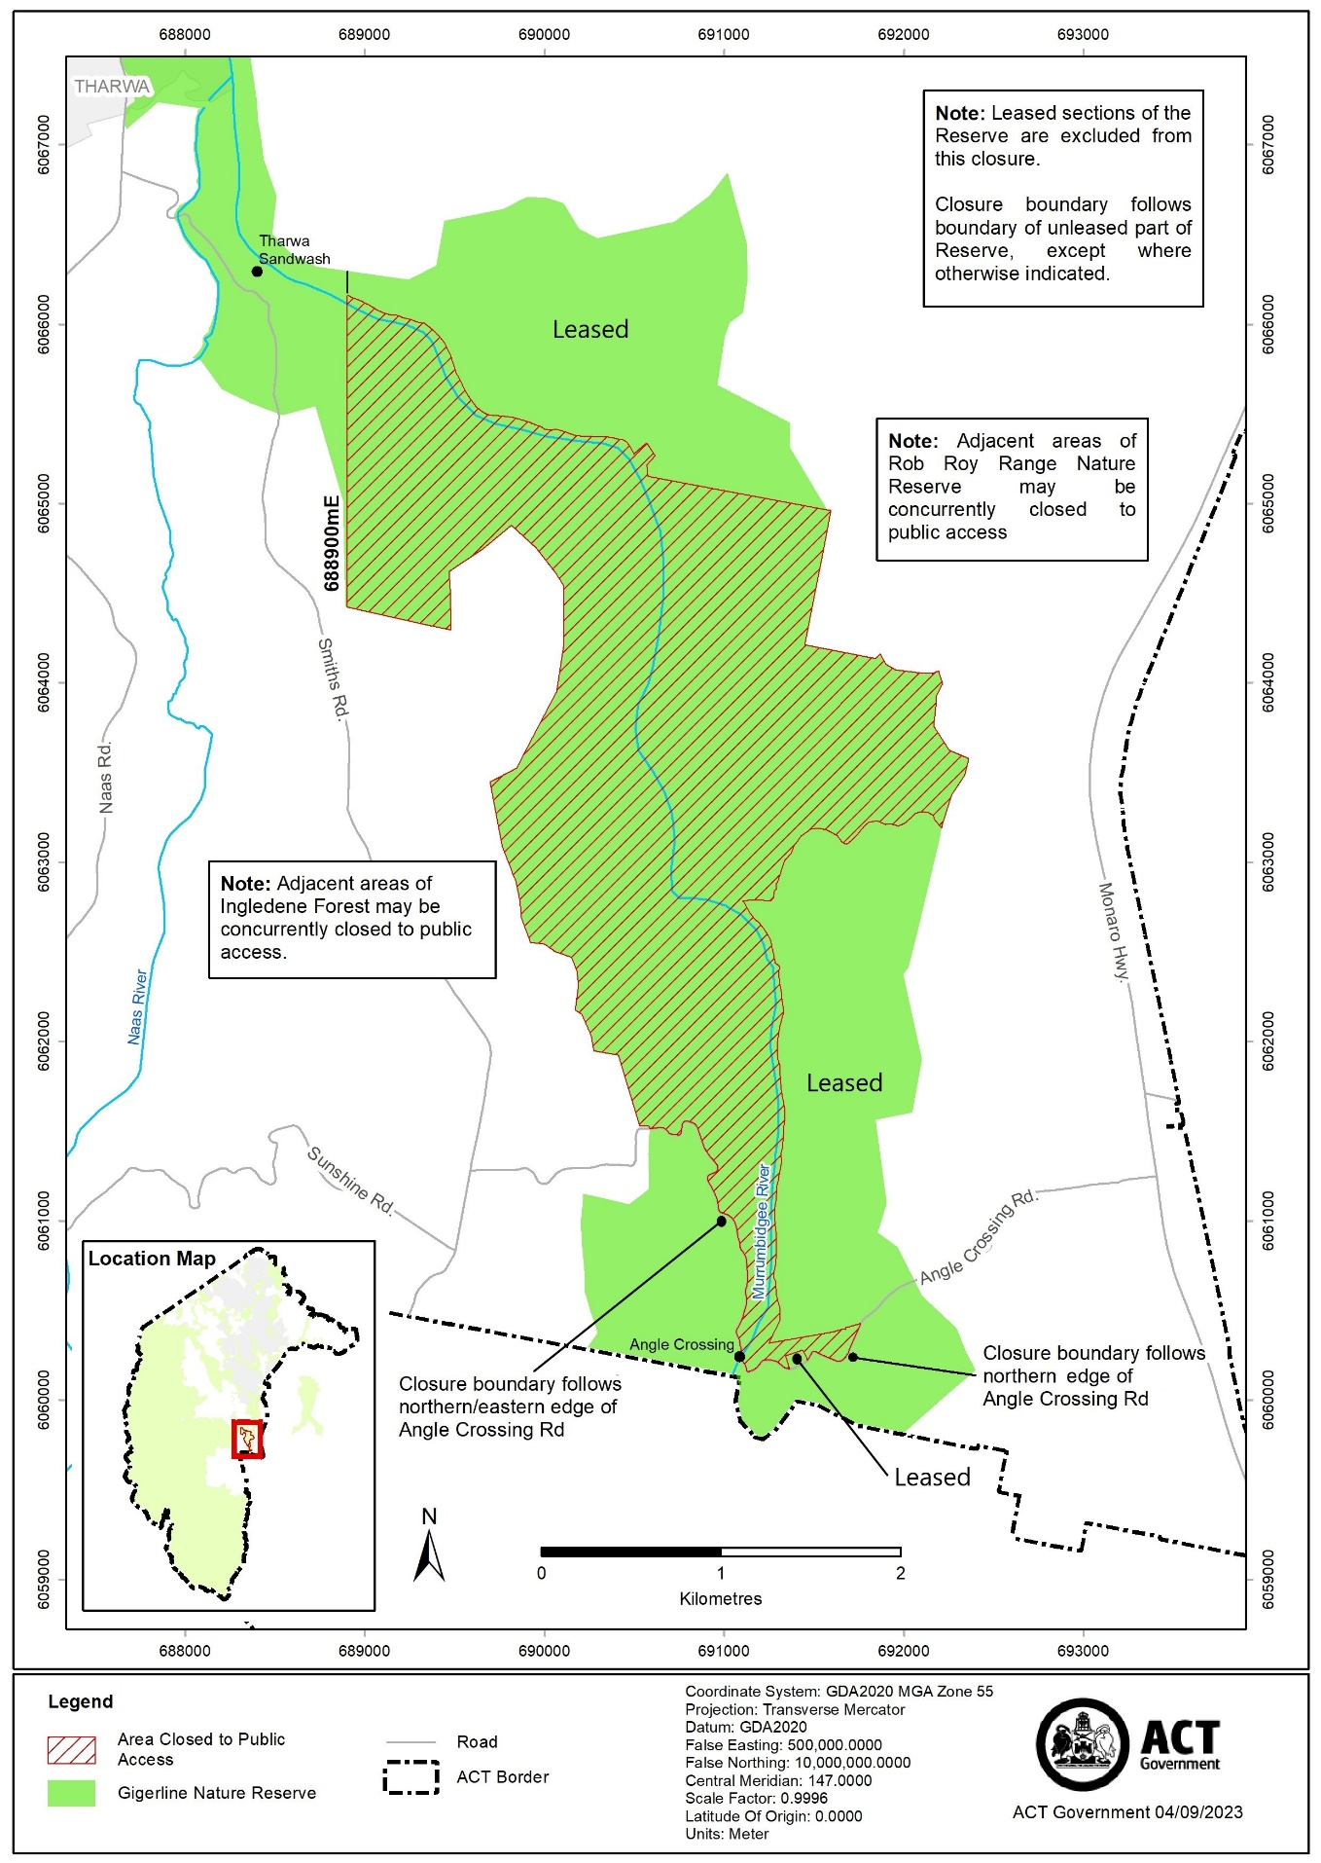
Schedule 4 Area of Rob Roy Range Nature Reserve closed to public access

(see s 3)

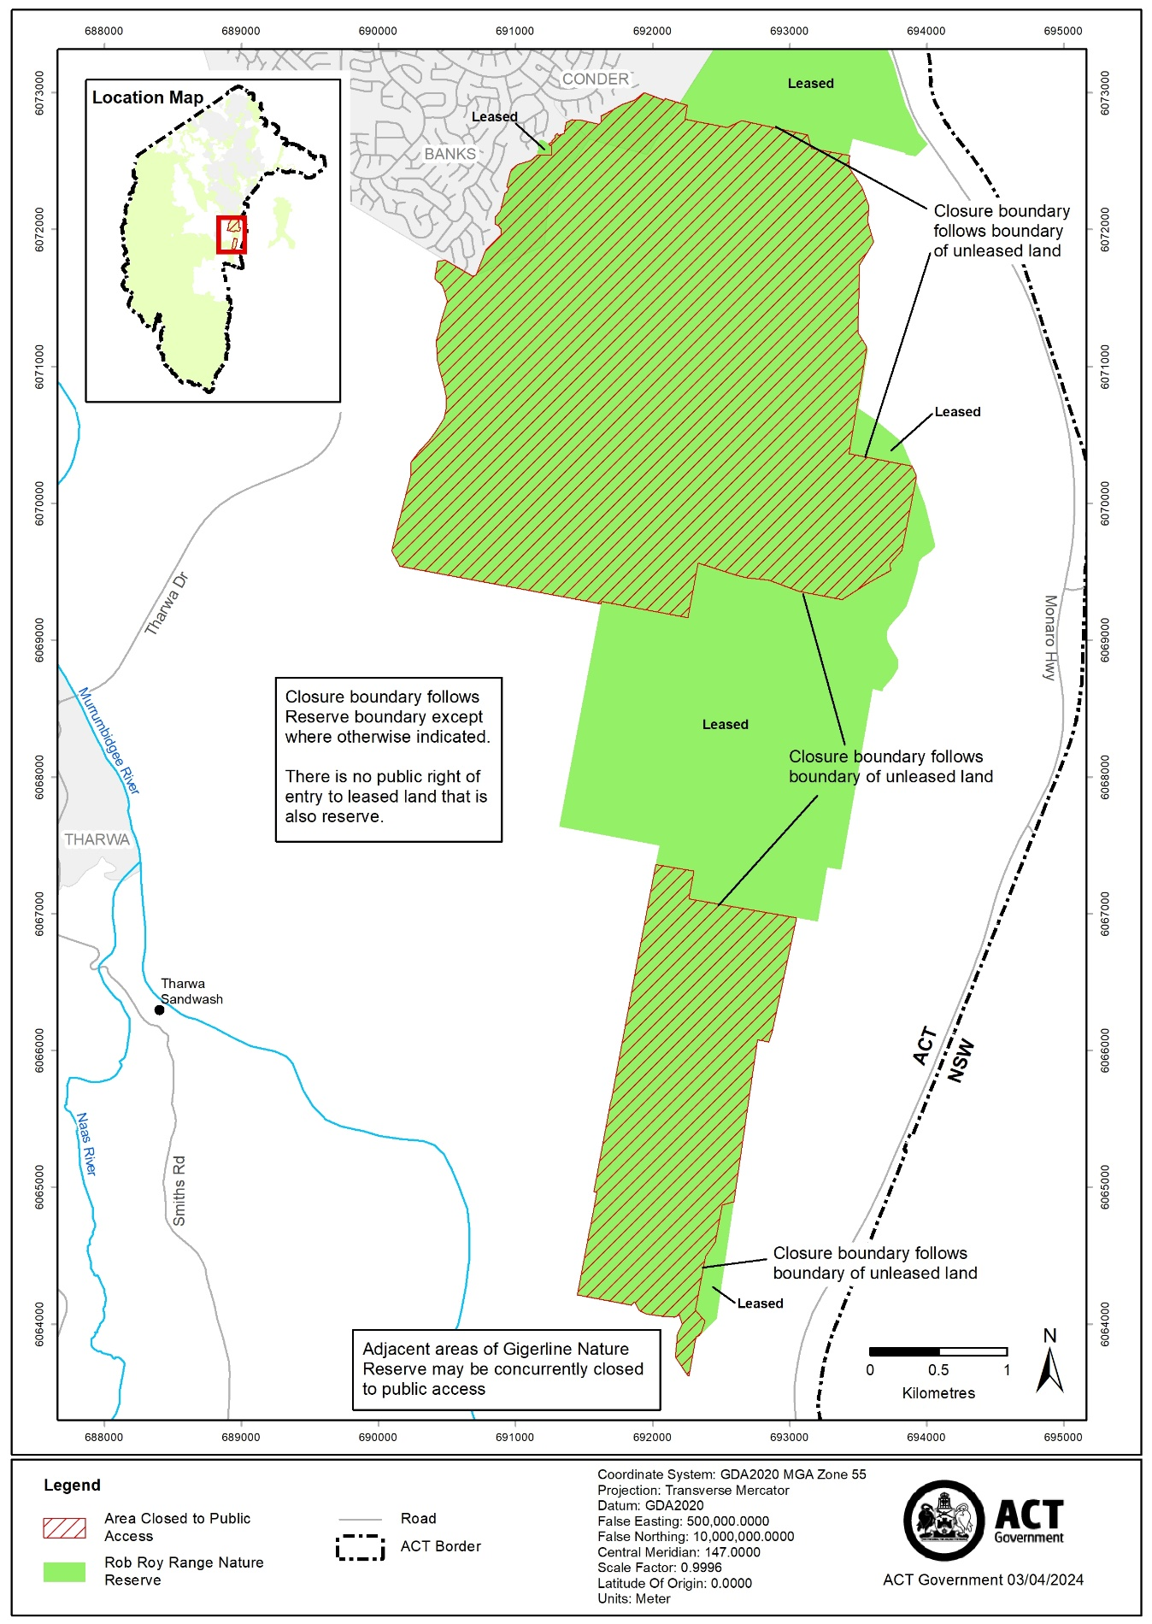
Schedule 5 Area of Swamp Creek Nature Reserve closed to public access

(see s 3)

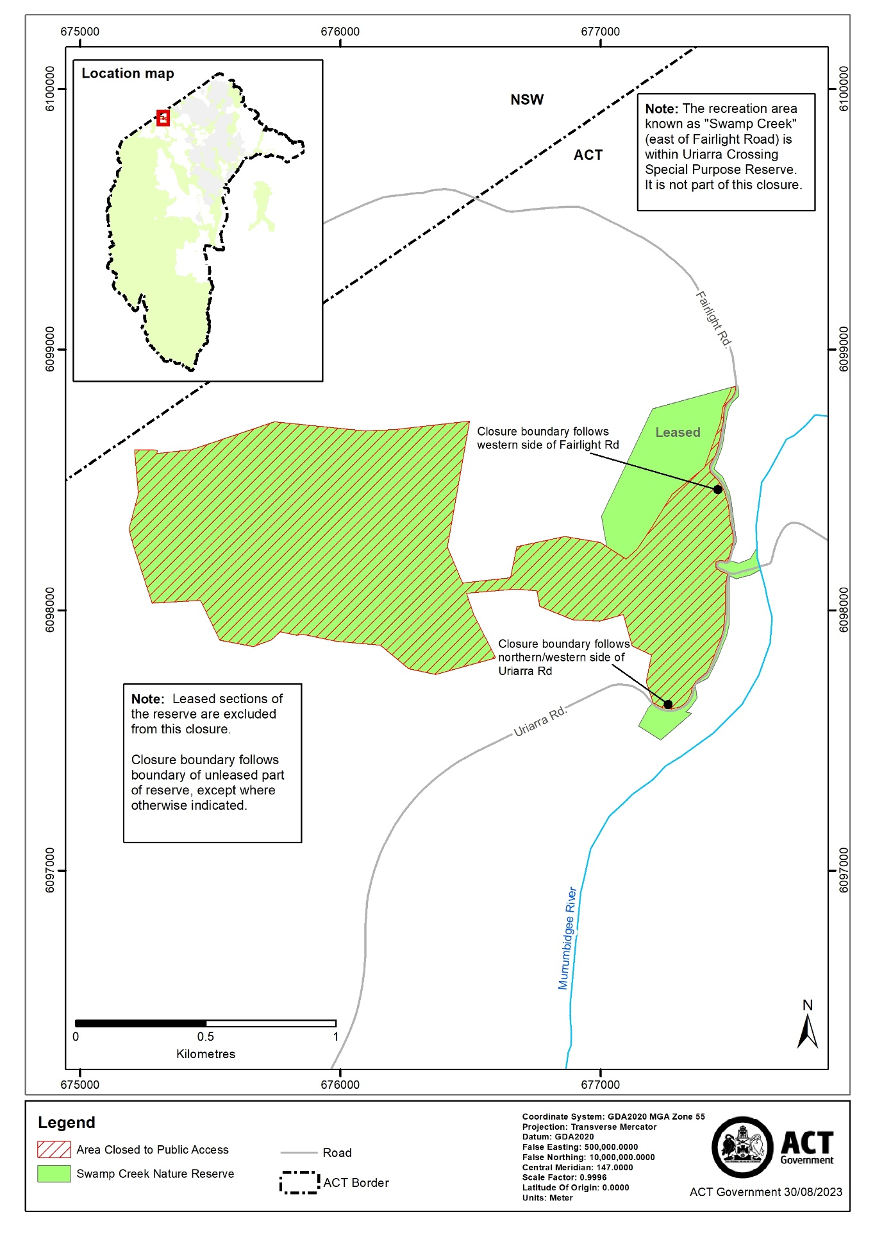
Schedule 6 Area of Sherwood Forest Special Purpose Reserve closed to public access

(see s 3)

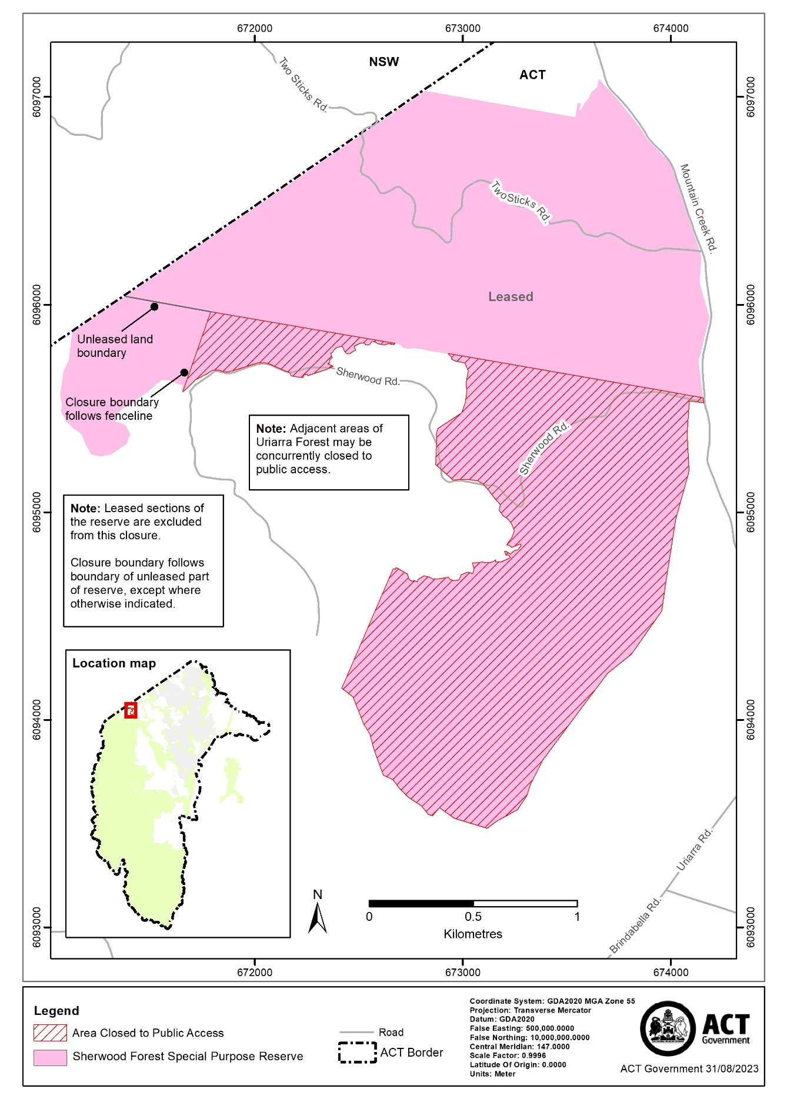

Schedule 7 Area of Molonglo River Reserve closed to public access

(see s 3)

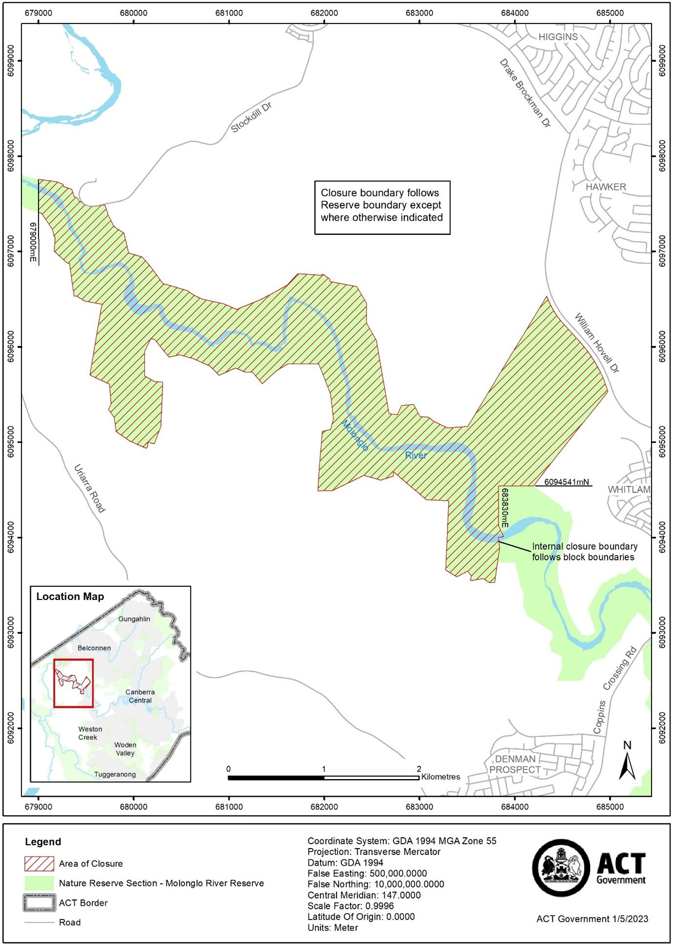
Schedule 8 Area of Tidbinbilla “nature reserve” closed to public access

(see s 3)

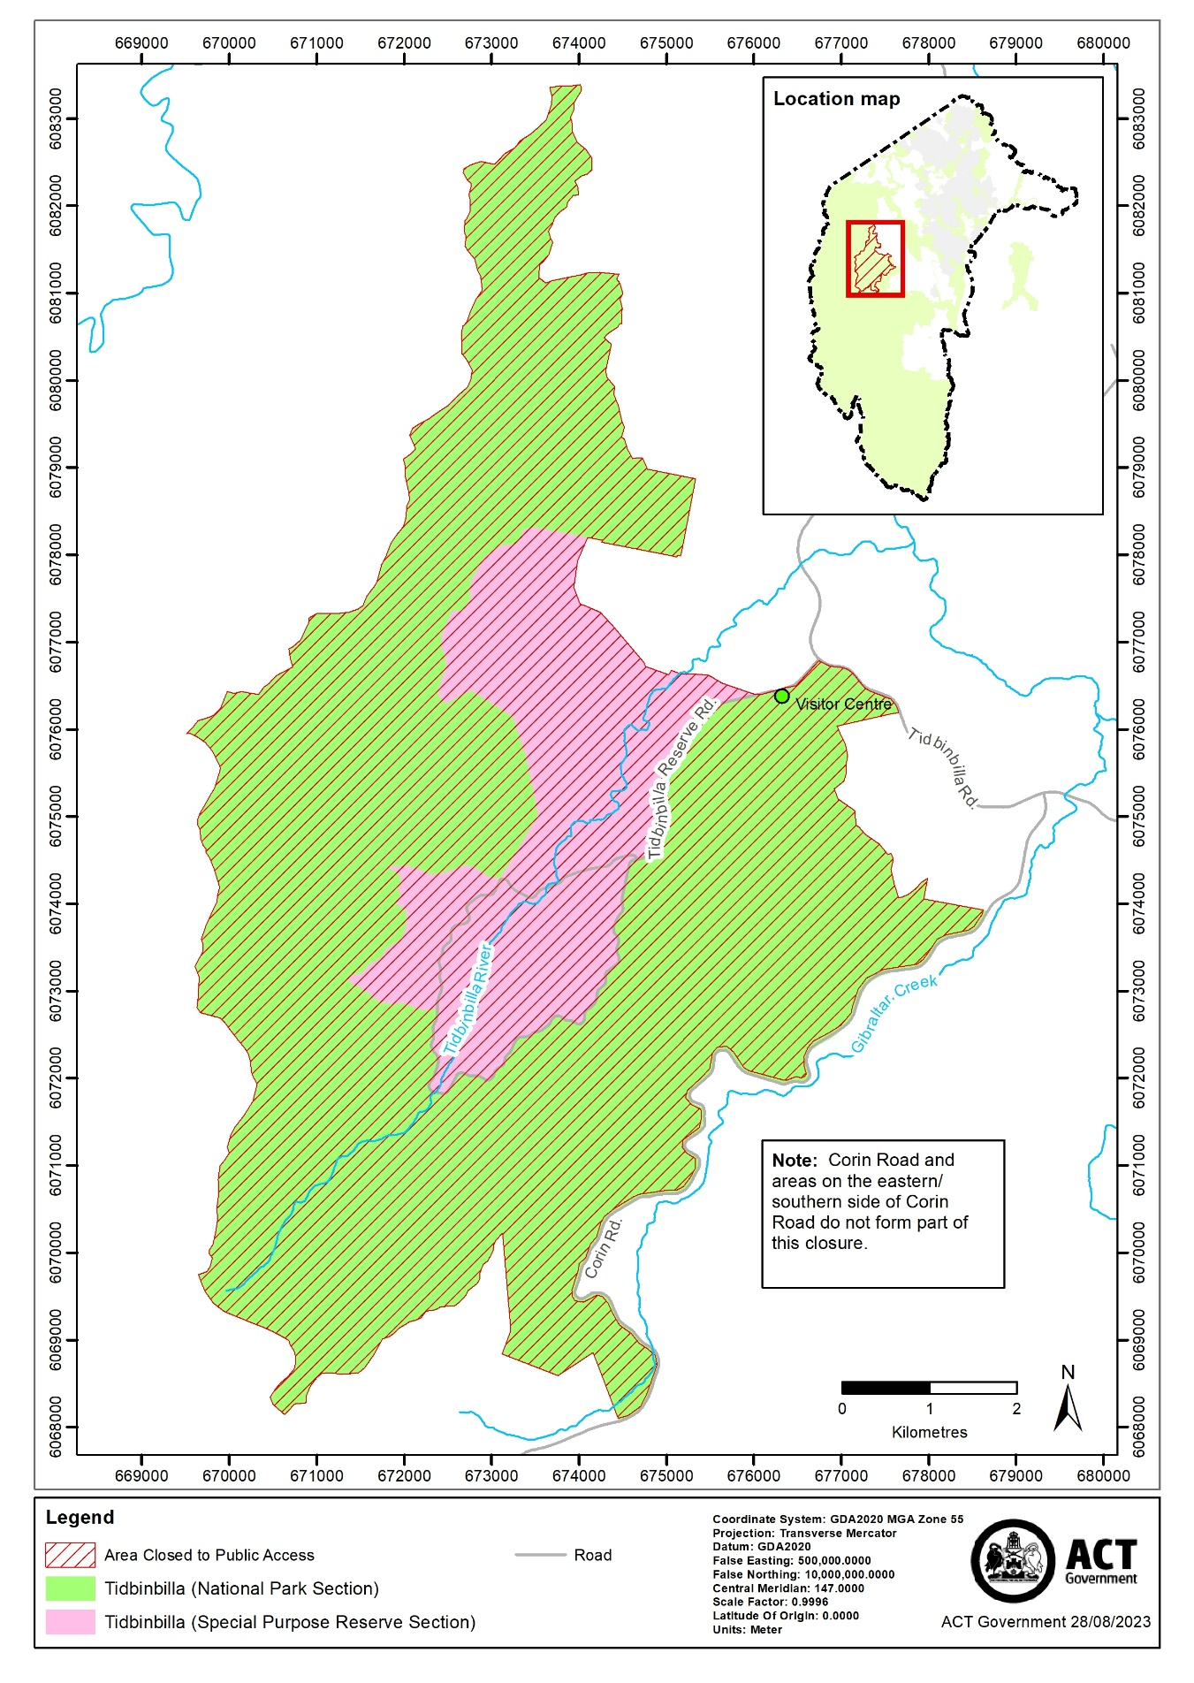
Schedule 9 Closure periods

(see s 3)

column 1 – Reserve | column 2 – Start date | column 3 - End date
Stony Creek Nature Reserve  (refer map at schedule 1) | 25 May 2024 | 31 May 2024
Bullen Range Nature Reserve  (refer map at schedule 2) | 25 May 2024 | 07 June 2024
Gigerline Nature Reserve  (refer map at schedule 3) | 25 May 2024 | 07 June 2024
Rob Roy Range Nature Reserve  (refer map at schedule 4) | 25 May 2024 | 07 June 2024
Swamp Creek Nature Reserve  (refer map at schedule 5) | 03 June 2024 | 07 June 2024
Sherwood Forest Special Purpose Reserve  (refer map at schedule 6) | 03 June 2024 | 07 June 2024
Molonglo River Reserve (part of nature reserve section)  (refer map at schedule 7) | 03 June 2024 | 07 June 2024
Tidbinbilla “nature reserve” (national park  and special purpose reserve sections)  (refer map at schedule 8) | 04 June 2024 | 05 June 2024

Note Closure periods are inclusive of the start dates and end dates above and cover 24 hours on every applicable day.

