Australian Capital Territory
Heritage (Decision about Provisional Registration of Early Kingston Shops, Kingston) Notice 2024
Notifiable instrument NI2024–268
made under the
Heritage Act 2004, s 34 (Notice of decision about provisional registration)

1 Name of instrument
This instrument is the Heritage (Decision about Provisional Registration of Early Kingston Shops, Kingston) Notice 2024.
2 Decision about provisional registration
On 28 May 2024, the ACT Heritage Council (the council) decided to provisionally register Early Kingston Shops, Blocks 1, 3-10, and 23-24, Section 21 and (part) road verge, Kingston (the place).
3 Registration details of the place
The registration details of the place are in the schedule.
4 Reasons for the decision
The council decided to provisionally register the place because it is satisfied on reasonable grounds that it is likely to have heritage significance as it is likely to meet one or more of the heritage significance criteria the Heritage Act 2004, section 10. A detailed statement of reasons, including an assessment against the heritage significance criteria, is provided in the schedule.
5 Date of provisional registration
The date of provisional registration is 29 May 2024 (being the day after the council entered into the heritage register the registration details for the place together with an indication that the registration is provisional).
6 Indication of the council’s intention
The council intends to decide whether to register the place under the Act, division 6.2 during the period of provisional registration.
7 Invitation to make written comments during public consultation period
(1) The council invites written comments about the registration of the place. Any written comments must be made within 4 weeks after the day this notice is notified.
(2) Written comments can be provided to the council by the following methods:
(a) mail to
The Secretary
ACT Heritage Council
GPO Box 158
CANBERRA ACT 2601
(b) email to heritage@act.gov.au

Fiona Moore
Secretary (as delegate for)
ACT Heritage Council
28 May 2024

Schedule

(See sections 3 and 4)



AUSTRALIAN CAPITAL TERRITORY
HERITAGE REGISTER
Provisional Registration
For the purposes of s33 of the Heritage Act 2004, a provisional entry to the heritage register has been prepared by the ACT Heritage Council for the following place:

Early Kingston Shops
Blocks 1, 3-10, and 23-24, Section 21 and (part) road verge, Kingston.
DATE OF DECISION
28 May 2024
DATE OF PROVISIONAL REGISTRATION
29 May 2024 Notifiable Instrument: 2024–
PERIOD OF EFFECT OF PROVISIONAL REGISTRATION
Start Date: 30 May 2024 End Date: 28 February 2024
Extended Period (if applicable) Start Date ________ End Date ________
Copies of the Register Entry are available for inspection at ACT Heritage. For further information please contact:
The Secretary
ACT Heritage Council
GPO Box 158
CANBERRA ACT 2601
Telephone 13 22 81

Preamble
There are three nominations for various parts of the larger Kingston shopping precinct. These are the Kingston Shops, the Jardine Street Banking and Commercial Row, and the Site of A J Ryan's Radio and Electrical Store. After consideration of the potential heritage significance of the three nominations, the Council is proposing to include the Early Kingston Shops on the Heritage Register. This constitutes a part of the original Kingston Shops nomination and it is the current intention of Council that the remainder of the three nominations will not be included on the Register.
The decision is to provisionally register a part of the original Kingston Shops nomination; namely the shops along Giles and Kennedy Streets (Section 21, Blocks 1, 23-24, and 3-10 and associated streetscape; but excluding Block 11 due to a lack of integrity) that date back to the original development of the shops as they had the most significant impact on the development of the ACT. This will be referred to as the “Early Kingston Shops”.
It should be noted that the Former Kingston Post Office has also been separately registered.
The rest of the larger precinct is not proposed for provisional registration as the significance for the more recent shops does not extend beyond a local level as required for the ACT Heritage Register. This includes the Jardine Street Banking and Commercial Row consisting of Section 22 Blocks 25-32; and Section 21, Blocks 11-16, 19-22, and 25-27.
While the Site of A J Ryan's Radio and Electrical Store is located within the provisional registration as part of the original 1920s development, it is not proposed to register values associated with early radio broadcasting in Canberra.
The final decision will be made after consideration of public consultation submissions and the extent of the registered place may change. If the final decision involves registering only a portion of the larger precinct, such as currently proposed, then a separate decision not to register the rest of the larger nominated area will be made.

Statement of Heritage Significance
The Early Kingston Shops from 1925 were the first shopping precinct developed in the ACT and were significant as the premier shopping destination in the new capital until the 1950s. These shops were essential for goods and services, as a social hub and for employment. For the first public servants and those constructing Canberra, the Early Kingston Shops were the first commercial amenities in the new capital city. The community no longer had to order goods and groceries from canvassers going door-to-door, or make the trip into Queanbeyan; instead, they had a central shopping precinct that sold almost everything they needed. This amenity contributed to the popularity of the place in the burgeoning community, which in turn reinforced its centralised role, making the Early Kingston Shops the preeminent shopping precinct during the early formation of the capital. As important as Kingston was in the early days of the ACT, post-war development slowly moved the population to the north and later planning developments moved the focus away from Kingston. The Early Kingston Shops have heritage significance for their role as the premier shopping destination in the new capital.
This statement refers to the heritage significance of the place as required in s12(d) of the Heritage Act 2004.
NAME AND LOCATION OF THE place

Location of the Place
Early Kingston Shops, Blocks 1, 3-10, and 23-24, Section 21, Kingston. These are the remaining blocks of the original 1920s shops along Giles and Kennedy Streets.
This statement refers to the name and location of the place as required in s12(a) and s12(b) of the Heritage Act 2004.

Description of the Place
DESCRIPTION OF THE place
The Early Kingston Shops is a row of small, predominantly single storey shops forming an L shape along Giles and Kennedy Streets. The shop frontages are based on a module of about 6 metres with four shops to the width of a standard block. Each shopfront comprises masonry piers framing a predominantly glazed frontage. A deep, continuous, cantilevered awning runs above the shops providing shelter and fostering a sense of intimacy between passers-by and the shops. There is little consistent treatment of the predominantly modern shopfront glazing below awning level, and successive tenancies having made modifications over the years to suit changing tastes, functions and commercial interests.
Above awning level, each block of four shops reads as an individual parapeted façade with small step ups at block side boundaries responding to the gently sloping ground contours. The parapets comprise off-white, rendered and painted masonry with string coursing and moulded capping with a subtle step up in the parapet at the centre of each group. Clerestory windows are centred in the bays formed by the brick piers between each shop and some blocks have raised decorative (cartouche) panels between the windows.
Early Kingston Shops, has the following attributes of significance:
- Ongoing retail and commercial uses;
- Simple, repeated original design elements, guided by J. S. Murdoch’s concept drawing, which allowed Kingston to develop quickly and gain an early competitive advantage over other shopping precincts;
- Cohesive original architectural composition of 1920s shop buildings, consisting of:
  - Continuous façade presenting as one building per block, with a unifying parapet design comprising painted and rendered masonry with corbel and string lines;
  - Each shop presenting as an individual, narrow frontage with original masonry piers framing predominantly transparent glazed shopfronts and a single entry point (the existing glazed shopfronts are not original or attributes, but the general form of glazed shopfronts with a single entry point is an attribute);
  - Original rectangular clerestory windows (some blocks with cartouche panels between windows) above awnings, with glazed shopfronts centred below;
  - Continuous awnings of a consistent width, cantilevered over Giles and Kennedy Street footpaths to provide shelter to shoppers (the existing awnings have generally been modernised and are not attributes, but the general form of the continuous awnings is an attribute);
  - Original parapets and the general form of awnings stepping up in response to ground levels;
  - a regular pattern of openings separated by original masonry columns which form a consistent structural frame in association with original parapets and clerestory windows above;
- The general form of a hard landscaped pedestrian footpath along Giles and Kennedy Streets, although not the existing fabric, sheltered by cantilevered awnings; and
- The general form of the combination of low level soft and hard landscaping between the edge of the awning and the road, although not the existing fabric, creating a pleasant environment for shoppers and an open urban pedestrian experience in the public realm.
This statement refers to the description of the place as required in s12(c) of the Heritage Act 2004. The attributes described in this section form part of the heritage significance of the place. For the purposes of s12(c) of the Heritage Act 2004, the boundary of the place is at Figure 1 and Figure 2.

Conservation Objective
CONSERVATION OBJECTIVE
The guiding conservation objective is that the Early Kingston Shops shall be conserved and appropriately managed in a manner respecting its heritage significance.
The ACT Heritage Council may adopt heritage guidelines applicable to the place under s25 of the Heritage Act 2004.
For further information on guidelines applicable to the place, or for advice on proposed works or development, please contact ACT Heritage via email at heritage@act.gov.auor via 13 22 81.

Reason for Provisional Registration
REASON FOR PROVISIONAL REGISTRATION
The Council has assessed the Early Kingston Shops against the heritage significance criteria and is satisfied that the place is likely to have heritage significance when assessed against criterion (a) under s10 of the Heritage Act 2004. A place is considered to have heritage significance if it meets one or more of the criteria.
Table 1 Criteria that the Council consider have been met.
Criterion | (a) | (b) | (c) | (d) | (e) | (f) | (g) | (h)
Met | Yes | No | No | No | No | No | No | No
This statement refers to the heritage significance of the place as required in s12(d) of the Heritage Act 2004.

Assessment Against the Heritage Significance Criteria
ASSESSMENT AGAINST THE HERITAGE SIGNIFICANCE CRITERIA
This statement refers to the heritage significance of the place as required in s12(d) of the Heritage Act 2004.
The Council’s assessment against the criteria specified in s10 of the Heritage Act 2004 is as follows.
In assessing the heritage significance of the Early Kingston Shops, the Council considered:
- the information and documentary evidence in the nomination for the Early Kingston Shops, the Kingston Post Office, and the Site of AJ Ryan’s Radio and Electrical Store;
- the Council’s Heritage Assessment Policy (March 2018);
- information provided by site inspections on 10 and 11 September 2019, 27 July 2020 by ACT Heritage and 5 and 16 February 2024 by the Heritage Council;
- the report by ACT Heritage titled, Background Information Early Kingston Shops, May 2024, containing photographs and information on history, description, condition and integrity; and
Pursuant to s10 of the Heritage Act 2004, a place or object has heritage significance if it satisfies one or more of the following criteria. Future research may alter the findings of this assessment.

(a) importance to the course or pattern of the ACT’s cultural or natural history;
MEETS CRITERION
The Council has assessed the Early Kingston Shops against criterion (a) and is satisfied that the place is likely to meet this criterion.
The Early Kingston Shops were the first shopping precinct developed in the ACT and were the premier shopping destination in the new capital until the late 1950s, providing a much needed service as well as a central hub of socialising and the starting point for business prospects in the ACT.
The Early Kingston Shops came about through actions of the Federal Capital Advisory Committee (FCAC) in the absence of the Chair, John Sulman. When he returned and learnt of the new shopping area, Sulman insisted that his objections be recorded in the minutes as he thought that it was contrary to then current planning principles. Subsequent planners have worked with the success of the Early Kingston Shops and later expansions. But it was this quick start that established it as the premier shopping district in the early days of the ACT. This lasted until the National Capital Development Commission (NCDC) was formed in 1958 and changed the trajectory of Canberra's growth. The shops at Eastlake (officially changed to Kingston in 1928) developed as a precinct with its less stringent planning rules, the established catchment from the surrounding suburbs and industry as well as securing the large attractor store of J.B Young.
The oversight that allowed the Early Kingston Shops to be approved with little government control and restrictions was an attractive incentive to prospective businesses and allowed it to be built quickly and in a manner that favoured the owners. This gave them an edge over the other shopping areas at Civic and Manuka which had more restrictive controls and set building designs. This resulted in the Early Kingston Shops being fully built and trading while the other areas were still mostly under construction. It was this initial advantage that created extra demand in the Early Kingston Shops for other services resulting in the first bank, the first post office and petrol station, all being located in Kingston. The Early Kingston Shops also boasted the major ‘attractor’ shop of J.B. Young’s that remained as a feature for over six decades, until 1986; was the first location of the 2CA radio station and A.J Ryan’s Radio and Electrical store; the Eastlake/Kingston Post Office (that kept moving into larger premises in the area to keep up with demand under finally settling in the purpose-built building in Section 22) and Harry Notaras’ Highgate Café and other places important for socialising in the burgeoning capital.
The Early Kingston Shops were originally only meant as a local shopping area, but as its importance grew beyond what the FCAC and then the Federal Capital Commission (FCC, formed in 1925) had envisaged, it was realised that the growth of the Early Kingston Shops was important for the growth of the ACT and it was expanded with better pedestrian access and lighting. In the post-war period it was significantly expanded with the new post office, the Green Square development (1953) and the Jardine St Banking and Commercial Row (1954). However, this later expansion was quickly overshadowed by the introduction of the NCDC in 1958 and their rapid development of the ACT under which the newly expanded precinct was relegated to a local hub, rather than the centre of business, retail and social lives that it had been in the preceding three decades. While the expansion in the 1950s of Green Square and the Jardine Street Banking and Commercial Row was a concession to the important role the place had in the city, the rapid expansion focused on the City and the Y-Plan meant that the expanded area did not live up to expectations of the previous planners and, as such, is not being registered alongside the original 1920s shops.

(b) has uncommon, rare or endangered aspects of the ACT’s cultural or natural history;
Does not meet criterion.
The Council has assessed the Early Kingston Shops against criterion (b) and is not satisfied that the place is likely to meet this criterion.
The Early Kingston Shops does not have uncommon, rare or endangered aspects of the ACT’s cultural history. Neighbourhood or local-level shopping centres are a common feature across the ACT and the fact that it had different planning controls to other examples is not considered to be enough of a difference to meet threshold under this criterion. The FCC style architecture is representative of the time but is not a strong enough example of the style to be considered under this criterion.

(c) potential to yield important information that will contribute to an understanding of the ACT’s cultural or natural history;
Does not meet criterion.
The Council has assessed the Early Kingston Shops against criterion (c) and is not satisfied that the place is likely to meet this criterion.
As a well-documented built place, with all significant changes recorded in the ACT Building files and Development Applications, it is unlikely that new information will be garnered from the material fabric of the place that would be considered a significant contribution to our existing knowledge. The Early Kingston Shops does not have the potential to yield important information that will contribute to an understanding of the ACT’s cultural history.

(d) importance in demonstrating the principal characteristics of a class of cultural or natural places or objects;
Does not meet criterion.
The Council has assessed the Early Kingston Shops against criterion (d) and is not satisfied that the place is likely to meet this criterion.
The Early Kingston Shops may demonstrate the main characteristics of a shopping precinct as a class of cultural places, but there is no evidence it is important for demonstrating those traits.
A detailed analysis of the main characteristics of shopping precincts as a class of cultural places may show that the Early Kingston Shops demonstrates the characteristics of the class, but the Council is not convinced such an analysis would show that it is important in demonstrating these characteristics. As a type of place this class can include many variations, but at a minimum the Early Kingston Shops has a concentration of purely commercial spaces (shopfronts closely spaced, evidence of activity is seen in shopfronts/displays and signage) that prioritises pedestrian activity and amenity (wide footpaths that are mostly covered by an awning, various resting spots/seating, adjacent parking, service areas for shops separate to pedestrian areas/Highgate Lane).
However, the analytical context is not sufficiently developed to enable the importance of the Early Kingston Shops to be established under this criterion.

(e) importance in exhibiting particular aesthetic characteristics valued by the ACT community or a cultural group in the ACT;
Does not meet criterion.
The Council has assessed the Early Kingston Shops against criterion (e) and is not satisfied that the place is likely to meet this criterion.
The Early Kingston Shops has a distinct character and feel that is likely valued by many of the people who shop and work there, or have done so in the past. The particular aesthetic is a small scale, pedestrian friendly shopping area representative of the wider Australian shopping area vernacular with large awnings supporting underhung signs and small businesses. However, there is no evidence that there is a particular aesthetic that is valued by the wider ACT community or a cultural group as defined in the Council’s Heritage Assessment Policy.

(f) importance in demonstrating a high degree of creative or technical achievement for a particular period;
Does not meet criterion.
The Council has assessed the Early Kingston Shops against criterion (f) and is not satisfied that the place is likely to meet this criterion.
The Early Kingston Shops were built by whoever purchased the various blocks and was then developed in a solid, albeit standard, method of construction in a very short time. This resulted in a fairly consistent façade treatment loosely following J. S. Murdoch’s sketch design with well-built buildings that have matured into a pleasant shopping precinct with a distinctive character. However, the Early Kingston Shops is of a standard design for its time and is not considered to demonstrate a high degree of creative or technical achievement for its time.

(g) has a strong or special association with the ACT community, or a cultural group in the ACT for social, cultural or spiritual reasons;
Does not meet criterion.
The Council has assessed the Early Kingston Shops against criterion (g) and is not satisfied that the place is likely to meet this criterion.
In its heyday, the Early Kingston Shops would have been considered to have a strong and special association with the ACT community as the premier shopping destination, but as the city has expanded, the Early Kingston Shops and the larger precinct has been relegated to a smaller role servicing its local neighbourhood, as per the original planning intention and the later NCDC planning.
Some of the community having fond memories of the place, particularly J.B Young’s but also other stores as opposed to the Early Kingston Shops as a whole, as evidenced in various social media comments with many noting nostalgia for shopping there, special moments or experiences, memories of their parents taking them, or various people working there. This seems to be representative of early residents remembering the place for special occasion shopping, or as a general meeting place due to the pedestrian friendly nature of the place and limited other shopping areas; however, there is no indication that this nostalgia translates to a wider current association with the ACT Community.

(h) has a special association with the life or work of a person, or people, important to the history of the ACT.
Does not meet criterion.
The Council has assessed the Early Kingston Shops against criterion (h) and is not satisfied that the place is likely to meet this criterion.
The Early Kingston Shops came about through actions of the FCC in the absence of the Chair, John Sulman. When he returned and learnt of the new shopping area, Sulman insisted that his objections be recorded in the minutes as he thought that it was contrary to [then] current planning principles. Subsequent planners have worked with the success of the Early Kingston Shops and later expansions, but all associated with this aspect of the place have done so as a part of their normal work and are not considered to have a special association with the place.
The J.B. Young store went to great effort to secure the largest site in Canberra’s first shopping precinct to augment their Queanbeyan store as well as other stores across NSW after that. They paid the largest amount of all the lots that were up for auction and then quickly built a stores shed so that they could start trading out of the back before the main building had been completed. The general merchants sold a wide variety of goods from meat and produce to carpets, suits and firearms. They had a large and loyal staff and were known to have people work their entire careers in the store. J.B. Young was a supporter of local events, often sponsoring sporting days or other social events. While the store was an important contributor to the success of the Early Kingston Shops and holds nostalgia for some people in the community, there is no evidence of a special association of the store with this location, mindful of the historical context of the original Queanbeyan store and the more than twenty later stores such as in the City, Manuka, Jameson, other locations in the ACT or regionally in NSW.
A.J. Ryan’s Radio and Electrical Store solved a lack of demand, due to no radio reception in early Canberra, by creating their own station, 2CA out the back of the store. From its beginnings in 1931, 2CA grew rapidly and by 1935 the transmitter had been moved out to Radio Hill near present day Fyshwick and, in 1937, it was boosted again with the transmitter being moved to its current position near the Barton Highway and the studio being relocated to new facilities in City and later into Mitchell. The story of 2CA is an important part of the ACT’s history, and it began out the back of one of the original Kingston shops, however there is no remaining evidence of A.J. Ryan’s Radio and Electrical Store and the former 2CA studio and transmitter left, so this criterion is not considered to be met due to a lack of integrity. However, the Council does encourage other ways of recognising and commemorating this important part of the ACT’s history.
Much of the Early Kingston Shops’ history has been associated with prominent Canberrans or businesses including, but not limited to Harry Notaras, Cusack’s, Woolworths, S.O. Taylor’s, Redpath Shoes, Ogilvie’s Bakery, and many others. While these people and businesses are a part of the ACT’s history, it has not been demonstrated that their connection to the Early Kingston Shops is strong or special and that they could be considered to be important to the cultural history of the ACT.
SITE PLAN
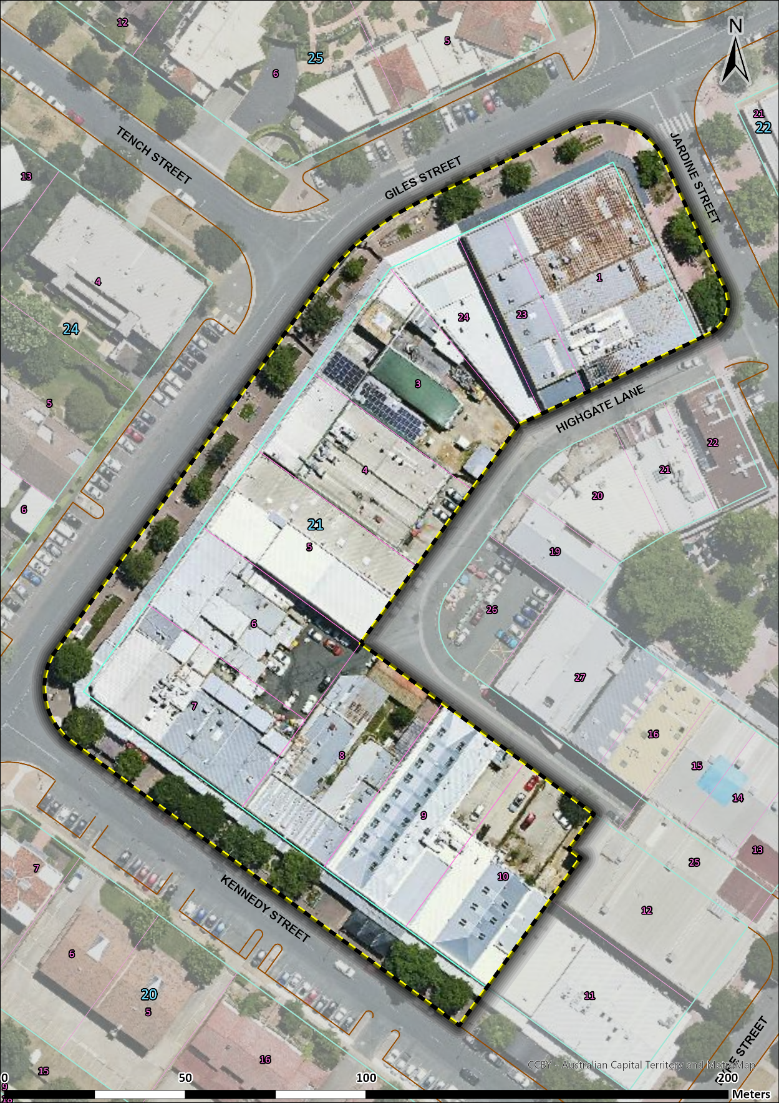
Figure 1 - Registration boundary for the Early Kingston Shops, cadastral map overlain on November 2023 aerial imagery – The boundary encompasses all of Blocks 1, 3-10, and 23-24, Section 21, Kingston, and extends to the kerb.
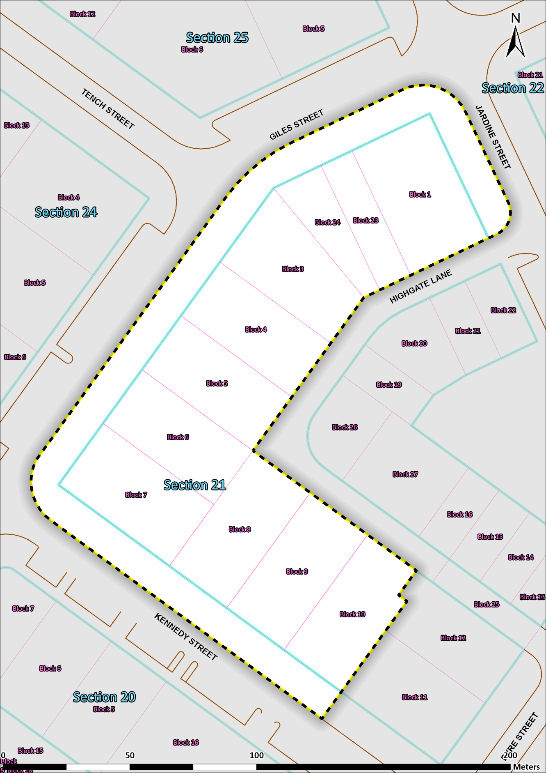
Figure 2 – Registration boundary for the Early Kingston Shops, cadastral map only – The boundary encompasses all of Blocks 1, 3-10, and 23-24, Section 21, Kingston, and extends to the kerb.

