Australian Capital Territory
Gaming Machine (Peripheral Equipment) Approval 2024 (No 7)
Notifiable instrument NI2024-282
made under the
Gaming Machine Act 2004, section 69 (Approval of gaming machines and peripheral equipment)

1 Name of instrument
This instrument is the Gaming Machine (Peripheral Equipment) Approval 2024 (No 7)

2 Commencement
This instrument commences the day after the date of notification.

- Approval
I approve the peripheral equipment described in the attached Schedule to this instrument.

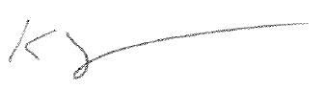
Karl Somers
Delegate
ACT Gambling and Racing Commission
02 May 2024

For further information please contact the approved supplier.

Aristocrat Technologies Australia Pty Ltd
Subject: New Link Progressive Jackpot System
System Name: | Diamond Age Link
Specification Numbers: | 1.YA017
Jackpot Theme: | Diamond Age
Application Reference Number | 01-A2489/S01

