Australian Capital Territory
Heritage (Decision about Provisional Registration of the Former CML Building, City) Notice 2024
Notifiable instrument NI2024–364
made under the
Heritage Act 2004, s 34 (Notice of decision about provisional registration)

1 Name of instrument
This instrument is the Heritage (Decision about Provisional Registration of the Former CML Building, City) Notice 2024.
2 Decision about provisional registration
On 2 July 2024, the ACT Heritage Council (the council) decided not to provisionally register the Former CML Building, Block 2 Section 5, City (the place).
3 Description of the place
The description of the place is in the schedule.
4 Reasons for the decision
The council is not satisfied on reasonable grounds that the place is likely to have heritage significance as defined by the Heritage Act 2004, section 10. A detailed statement of reasons, including an assessment against the heritage significance criteria, is provided in the schedule.
5 Date decision takes effect
The decision not to provisionally register the Place takes effect on 3 July 2024 (being the day after the council made its decision in writing as set out in the schedule).
Mary Clare Swete Kelly
A/g Secretary (as delegate for)
ACT Heritage Council
2 July 2024
Schedule
(See sections 3 and 4)


STATEMENT OF REASONS
DECISION NOT TO PROVISIONALLY REGISTER
the Former CML BuildingWamboinName of Place
BLOCK 2, SECTION 5, CITY
IN THE ACT HERITAGE REGISTER

In accordance with s 32 of the Heritage Act 2004, the ACT Heritage Council has decided not to provisionally register the Former CML Building. This Statement of Reasons provides an assessment of the Former CML Building and finds that the place does not meet any of the criteria under s10 of the Heritage Act 2004.

This statement refers to the location of the place as required in s 34(5)(b)(ii) of the Heritage Act 2004.
LOCATION OF THE PLACE

Former CML Building, Block 2, Section 5, (17-21 University Avenue), City.

This section refers to the description of the place as required in s 34(5)(b)(iii) of the Heritage Act 2004. The boundary of the place and extent of features listed below is illustrated at Image 1.

DESCRIPTION OF THE PLACE
The Former CML Building is a steel and concrete framed, brick clad L-shaped structure. The supporting columns are located around the perimeter of the internal space with a services core in the centre. The columns at ground level are square paired columns with the glazing set back to create a colonnade (now partially filled in) along University Avenue and Marcus Clark Street, and are single round columns through the rest of the structure. The building is clad in brown manganese bricks with light grey mortar. The long ribbon windows are an unusual feature, being bronze tinted and slanted outwards at 45 degrees in bespoke aluminium frames that were designed in-house at Civil and Civic. The top of the slanted windows join up with the precast concrete sun control panels that are roughcast with quartz stone. The protruding sun control panels also form a flat surface for window cleaning access. The main section, the northeast wing, of the building is eight storeys including the main lobby entrance at ground level with an additional plant room on the roof that is set back from the edge. The smaller part, southwest wing, of the building is three storeys and has a rooftop garden consisting of five rectangular planter boxes, two sections of built in seating and large areas of flat hard surfacing.

This statement refers to the Council’s reasons for its decision as required in s 34(5)(b)(iv) of the Heritage Act 2004.
REASONS FOR DECISION

The Council is not satisfied on reasonable grounds that the place is likely to have heritage significance as defined by s 10 of the Heritage Act 2004.

This statement refers to the Council’s assessment of the place against the heritage significance criteria as a part of its reasons for its decision as required in s 34(5)(b)(iv) of the Heritage Act 2004.
ASSESSMENT AGAINST THE HERITAGE SIGNIFICANCE CRITERIA

The Council’s assessment against the criteria specified in s10 of the Heritage Act 2004 is as follows.

In assessing the heritage significance of the Former CML Building the Council considered:
- the original nomination and documentary evidence supplied by the nominator;
- the Council’s Heritage Assessment Policy (March 2018);
- information provided by an external site inspection on 19 September 2023 by ACT Heritage; and
- the report by ACT Heritage titled, Background Information the Former CML Building, July 2024, containing photographs and information on history, description, condition and integrity;
- further submissions from the nominator and the owner/developer on the heritage significance of the place; and
- Development Application #202241098 and submissions from the public that were also addressed to the Heritage Council.

Pursuant to s 10 of the Heritage Act, a place or object has heritage significance if it satisfies one or more of the following criteria. Future research may alter the findings of this assessment.
- importance to the course or pattern of the ACT’s cultural or natural history;
The Council has assessed the Former CML Building against criterion (a) and is not satisfied that the place meets this criterion.
The Former CML Building was constructed as a part of the Darwin Place development in the 1960s, which was a continuation of the National Capital Development Commission’s (NCDC’s) Hobart Place planning from the late 1950s to early 1960s. The idea behind these precincts was that the NCDC set a number of planning controls that varied the heights and massing of the buildings, controlled landscaping between them and other conditions that would create a harmony of architectural styles while still allowing the private developers of the buildings individual expression. This resulted in the buildings along University Avenue, including the Former CML Building, having a prominent light-coloured horizontal aesthetic with building massing, footprints and heights being mirrored. The Former CML Building design fits with the architectural style of the precinct and is fitting for its time and the intended function of the area as a commercial zone. It is a reflection of the planning for the area, but the contribution of the building is not sufficient to represent the holistic planning of the precinct in a significant way.
The building is also a part of the Lend Lease story of buying at auction and then leasing back to those who were competing at the auction after building with Civil & Civic, which was the construction arm of Lend Lease. They were responsible for most of the buildings in the Hobart/Darwin Place precinct, and also for a great deal of the city from the 1950s onwards. While they have made a significant contribution to the development of the ACT, the Former CML Building is not considered to be a significant part of that contribution.
The Former CML building was sold to the Colonial Mutual Life Assurance Society who used it as their Canberra branch for a number of years and leased the rest of the building as commercial and professional offices, initially to government departments, including Health, and later to various smaller businesses. While it was used as the main ACT branch for CML, it was built as a general office building to be leased out to a variety of clients and is similar to many other office building of the time. Accordingly, it is not significant for this role.
- has uncommon, rare or endangered aspects of the ACT’s cultural or natural history;
The Council has assessed the Former CML Building against criterion (b) and is not satisfied that the place meets this criterion.
The Former CML Building can be considered to have several aspects of the ACT’s cultural history, including as a mid-century modern office building, an example of NCDC planning and as an example of the Lend Lease business practices.
There are many mid-century modern buildings in the ACT due to the rapid expansion of the ACT under the NCDC for that time period. The building is in the Late Twentieth-Century International Style, the predominant style with the Darwin/Hobart Place precinct with many examples throughout the ACT.
While the Former CML Building is a result of the NCDC’s planning, the contribution of the building is not sufficient to be representative of the precinct planning in a significant way. Without the surrounding buildings to demonstrate the integral civic design and sympathetic aesthetic features across the precinct, one building cannot reasonably represent this aspect of the ACT’s history.
The Commissioner of the NCDC, Sir John Overall noted in his 1995 memoir that the City was covered in Civil & Civic signs in the 1960s and they are still active. This included the other buildings in Hobart and Darwin Places. While a comprehensive list and analysis of all Civil & Civic buildings in the ACT is not available, it is reasonable to assume that this aspect of the ACT’s cultural history is not uncommon, rare or endangered.
- potential to yield important information that will contribute to an understanding of the ACT’s cultural or natural history;
The Council has assessed the Former CML Building against criterion (c) and is not satisfied that the place meets this criterion.
There is no evidence before the Council that the building has the potential to yield information that will contribute significantly to a wider understanding of the cultural history of the ACT. Any information the place may provide has already been obtained from the documentary and physical evidence and it is unlikely that any further significant evidence could be gained from the physical fabric of the place.
- importance in demonstrating the principal characteristics of a class of cultural or natural places or objects;
The Council has assessed the Former CML Building against criterion (d) and is not satisfied that the place meets this criterion.
The Former CML Building demonstrate several characteristics of two different classes of place in the ACTs cultural history: as an mid-century modern office building in the Late Twentieth-Century International Style, and as an example of NCDC planning for private office development.
The Former CML Building demonstrates several characteristics of the Late Twentieth-Century International Style as detailed in the Background document. The key question then is if these are expressed in way that makes this example important enough to pass the threshold to meet this criterion; i.e. is it an important example of the style for the ACT? While it has a few characteristics of the style, it is not a key example of the style or an exemplar. There are many other examples in the ACT: Former MLC Building (Bates, Smart & McCutcheon, 1958 and 1963 – ACT Heritage Register); Former ANZ Bank Building (Stuart McIntosh, 1963 – ACT Heritage Register); Former Victorian Employees Federation Building, now the Mantra Macarthur Canberra, corner Northbourne and Macarthur Avenues (McConnel Smith and Johnson, 1970); Cameron Offices (John Andrews International, 1970-76 – Commonwealth Heritage Register); Edmund Barton Building (Harry Seidler and Associates, 1974 – Commonwealth Heritage Register); University of Canberra Student Residence Group 2 (John Andrews International, 1975 – ACT Heritage Register); National Press Club (McConnel Smith and Johnson, 1976); Benjamin Offices (McConnel Smith and Johnson, 1978-79); and Belconnen Library (Robin Gibson and Partners, 1982 – Provisionally Registered on the ACT Heritage Register).
The Former CML Building also demonstrates the principles of urban design adopted for the Hobart and Darwin Places commercial precincts by the NCDC in its early years with its scale, height and massing as well as unifying aesthetic characteristics that carry across the precinct of light colours and horizontality. However, the contribution of the building is not sufficient to represent the holistic planning of the precinct principles that were designed to work at a large precinct level in a significant way.
- importance in exhibiting particular aesthetic characteristics valued by the ACT community or a cultural group in the ACT;
The Council has assessed the Former CML Building against criterion (e) and is not satisfied that the place meets this criterion.
The Former CML Building is an example of the Late Twentieth Century International style and is appreciated for aesthetic characteristics associated with this style by part of the community, including the architectural profession, as represented by the Australia Institute of Architects, and the National Trust of Australia (ACT). It also contributes to the urban environment in proximity to the Hobart/Darwin Places precinct. However, the Council does not consider the architectural community or the National Trust to be a cultural group for the purposes of this criterion. The Council’s Heritage Assessment Policy interprets a cultural group as a ‘group of people within a society with a shared ethnic or cultural background’ or ‘a group of people connected through the same way of living, which has been transmitted from one generation to another’. There is no evidence that the building is valued for in aesthetic characteristics by the wider ACT community or a cultural group.
- importance in demonstrating a high degree of creative or technical achievement for a particular period;
The Council has assessed the Former CML Building against criterion (f) and is not satisfied that the place meets this criterion.
The nomination for the Former CML Building noted the creative and unusual way of arranging the windows. The bronze-coloured ribbon windows that slope outwards at 45 degrees and concrete sunshades (that also incorporate walkways for window cleaning) create a striking appearance externally and airiness within the offices. Along with the roof garden, these possibly take inspiration from Le Corbusier’s three points of architecture. While the Council acknowledges that these are an unusual feature, the use of Corbusian features some 40 years after their development is not a case of high creativity in the 1960s. In addition, while the window design is unusual, there is no evidence at this time to support this being highly creative or being an important innovation in window design that had a significant impact on future designs.
- has a strong or special association with the ACT community, or a cultural group in the ACT for social, cultural or spiritual reasons;
The Council has assessed the Former CML Building against criterion (g) and is not satisfied that the place meets this criterion.
There is insufficient evidence that the Former CML Building has a strong or special association with the ACT community, or a cultural group in the ACT for social, cultural or spiritual reasons. The Council acknowledges that place is valued by the Australian Institute of Architects (AIA) and other architects, however, they do not constitute a cultural group or can be representative of the ACT community as a whole. The Council’s Heritage Assessment Policy defines a cultural group as a ‘group of people within a society with a shared ethnic or cultural background’ or ‘a group of people connected through the same way of living, which has been transmitted from one generation to another’.
- has a special association with the life or work of a person, or people, important to the history of the ACT.
The Council has assessed the Former CML Building against criterion (h) and is not satisfied that the place meets this criterion.
The Former CML Building has associations with the Colonial Mutual Life Assurance Society, Lend Lease, the NCDC and the architects Towell Rippon & Associates.
The Colonial Mutual Life Assurance Society were the main lessee and had naming rights of the building as they used it to set up their Canberra Branch. While the CML was a moderately prominent company in the ACT, there is no evidence it was important in the history of the ACT.
There is no special association apparent with Lend Lease, Civil and Civic or their founder Dick Dusseldorp. This would appear to be just one of many buildings developed by Lend Lease and built by Civil & Civic, including many in the 1960s in Canberra as noted in the nomination. For example, the CML Building is not the earliest or a prominent example of Civil & Civics’ work from this early period. The former Australian Academy of Science/Shine Dome is both earlier and a much more prominent example.
The siting and other conditions of the building were controlled by the NCDC using the same controls as the rest of the Darwin/Hobart Places precinct. There are many Canberra buildings which were developed in the context of NCDC planning controls, and there is nothing to suggest a special association of the NCDC with this building.
With regard to the association with architects Towell Rippon & Associates, Towell had been known to Dusseldorp through the Snowy Hydro Scheme and then Dusseldorp commissioned him to design his house in 1958. Towell, Jansen & Rippon designed project homes in the early 1960s for Lend Lease. In 1967 the firm, now Towell Rippon & Associates, were chosen out four other architects who submitted designs for the CML Building. The firm ended up opening a Canberra office in the CML Building after its completion. However, the firm only completed two office buildings in Canberra, including the CML Building, and it is not considered to have played an important role in the history of the ACT.
SITE PLAN

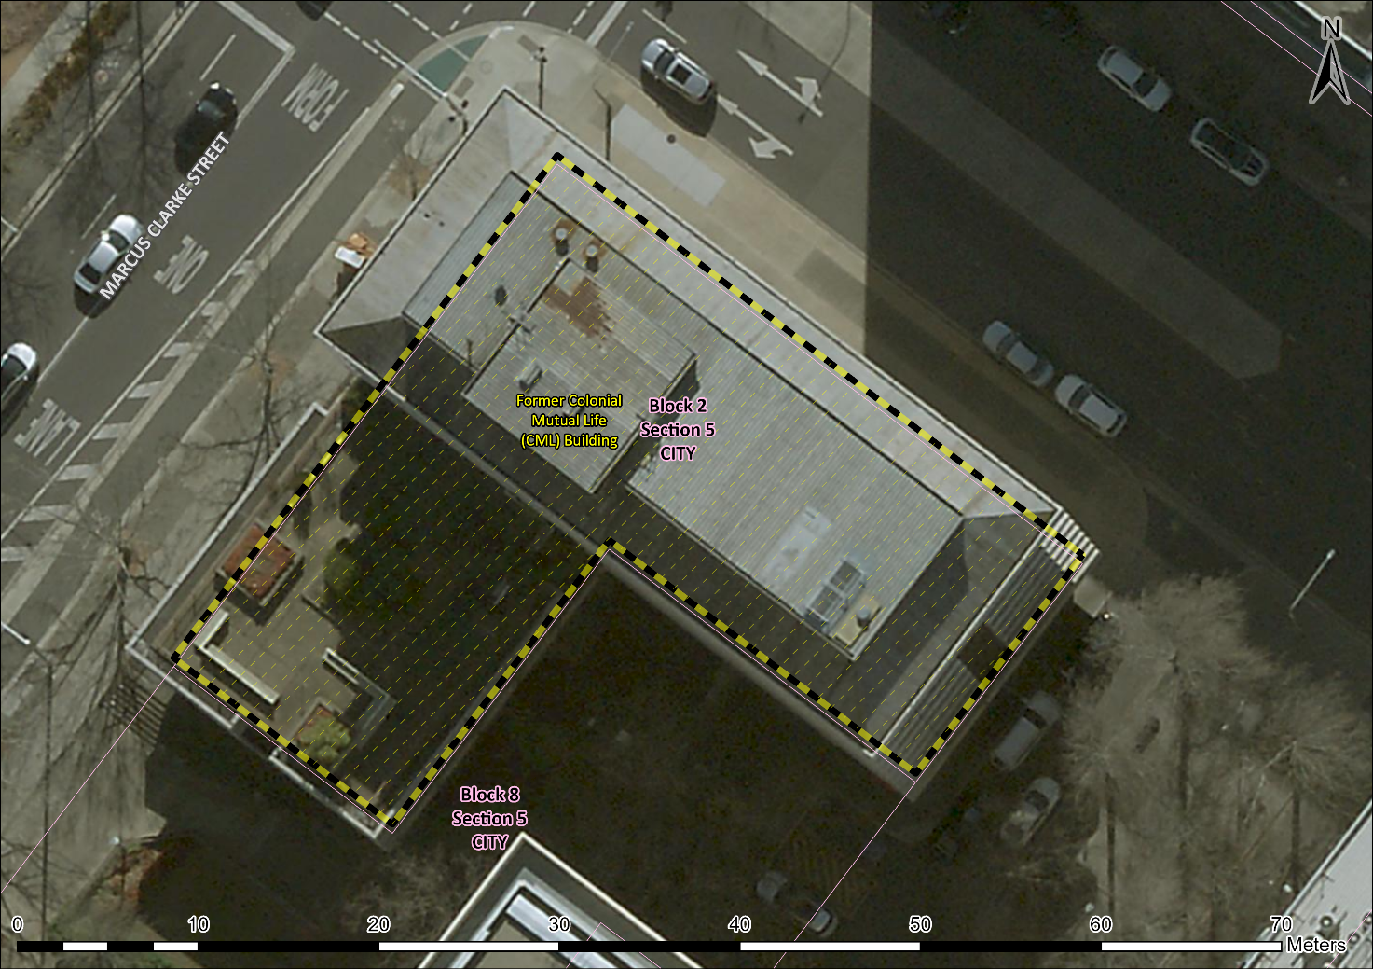
Image 1 Former CML Building site boundary (note that the oblique aerial imagery and protruding sun shading distort the image, however the boundary conforms to the building footprint and the block boundary)

