Australian Capital Territory
Heritage (Decision about Registration of West Portal Cafeteria, Parkes) Notice 2024
Notifiable instrument NI2024—570
made under the
Heritage Act 2004, s 40 (Decision about registration)

1 Name of instrument
This instrument is the Heritage (Decision about Registration of West Portal Cafeteria, Parkes) Notice 2024.
2 Commencement
This instrument commences on the day after its notification day.
3 Decision about registration
On 24 September 2024, the ACT Heritage Council (the Heritage Council) decided to register West Portal Cafeteria, Block 15 Section 3, Parkes (the Place).
4 Registration details of the Place
The registration details of the Place are in the schedule.
5 Reasons for the decision
The Heritage Council is satisfied on reasonable grounds that the Place has heritage significance as it meets one or more of the heritage significance criteria in section 10 of the Heritage Act 2004. A detailed statement of reasons including an assessment against the heritage significance criteria is provided in the schedule.
6 Date registration takes effect
The registration of the Place takes effect on 24 September 2024.
7 Revocation
This instrument revokes Heritage (Decision about Provisional Registration of West Portal Cafeteria, Parkes) Notice 2024 (NI2024-269).
Mary Clare Swete Kelly
A/g Secretary (as delegate for)
ACT Heritage Council
24 September 2024

Schedule

(See sections 3 and 4)


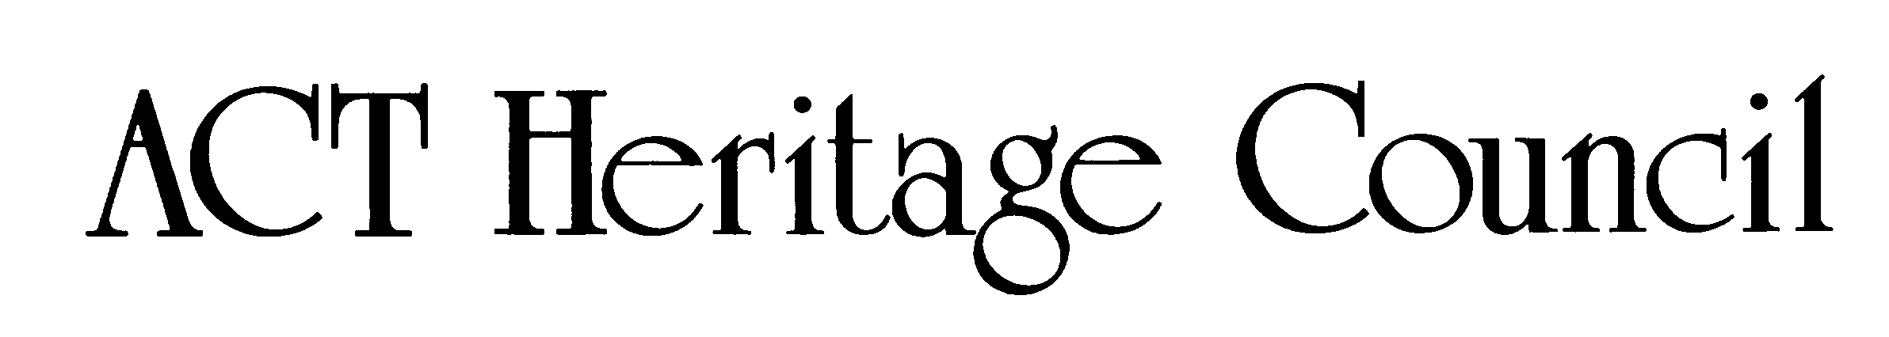
AUSTRALIAN CAPITAL TERRITORY
HERITAGE REGISTER
Final Registration
For the purposes of s40 of the Heritage Act 2004, an entry to the heritage register has been prepared by the ACT Heritage Council for the following place:

WEST PORTAL CAFETERIA
BLOCK 15 SECTION 3, PARKES
Date of Registration
24 September 2024 Notifiable Instrument: 2024-
Copies of the Register Entry are available for inspection online at https://www.environment.act.gov.au/heritage and at ACT Heritage. For further information please contact:

The Secretary
ACT Heritage Council

Email
heritage@act.gov.au
Post
GPO Box 158
CANBERRA ACT 2601
Telephone
13 22 81

Statement of Heritage Significance
The West Portal Cafeteria, which was designed by O’Mahony, Neville and Morgan and opened in 1969, is a rare example of a large government cafeteria with moderate-high integrity, significant architecture and high-quality finishes. The building location and design was influenced by the Griffins’ Plan, Holford, the transfer of the public service to the federal capital, and the achievements of the National Capital Development Commission. The West Portal Cafeteria has a strong association with the original Anzac Park Portal Buildings and the Parliament House Vista heritage area. The building displays a number of architectural features which together with its use of materials such as glass, stone, copper and timber, deliberately contrast with the surrounding multi-storey buildings in scale and style. The building demonstrates the provision of large-scale food services for public servants by the government, an aspect of the way of life during the 1950s-1980s, planned and supported by the NCDC. The setback within a landscape setting screens the building from Constitution Avenue and serves to focus and reinforce the visual outlook from the building across Parkes Way, which originally had views to Lake Burley Griffin.
The cafeteria is significant as the physical embodiment of the Commonwealth’s policy to provide food services to public servants working in Canberra at that time being a substantial feature of Australian Government employment. It served public servants relocated from Melbourne and Sydney to work in the national capital in the Anzac Park West and East Portal Buildings, being one of at least eight cafeterias in the ACT at that time. In this context, it is also associated with the development and growth of Canberra as the focus of the Commonwealth Government. (Criterion (a))
The building is rare as one of 3 remaining freestanding food services buildings of the NCDC era in Canberra, and the most intact. (Criterion (b))
The architecture of the cafeteria displays a high degree of creative achievement. This includes the free-standing pavilion form employing high quality materials such as copper, timber, glass and stone, the solid battered stone base and broad floating roof framing the continuous glazed walls and terrace on 3 sides of the dining room, the elegant roof form with its use of curves, angles, the contrasting fleche and copper finish, and the extensive use of timber and glass in the dining room together with coffered ceiling and skylight. The cafeteria employs a range of urban design features such as elevated siting and consideration of views into and out of the site from several locations, although views to and from Lake Burley Griffin are now obscured by vegetation. (Criterion (f))
This statement refers to the heritage significance of the place as required in s12(d) of the Heritage Act 2004.

Location of the Place
West Portal Cafeteria, Block 15, Section 3, Parkes, also known as:
- Anzac Park West Cafeteria
- Anzac West Canteen
- the Anzac Park Portal Café
- the Food Services Building Anzac Park West
- the Anzac West Restaurant.
The curtilage extends from the service road to the north of the building, joins the Anzac Park West underground car park retaining wall on the east and runs parallel to the southern side approximately 7 metres out from the building and follows the pedestrian footpath on the western side of the site.
This statement refers to the name and location of the place as required in s12(a) and s12(b) of the Heritage Act 2004.

Description of the Place
The West Portal Cafeteria is a free-standing, single-storey pavilion within a landscaped setting, with a striking copper-tiled roof and small slender spire (fleche). The design incorporates high-quality materials, a peaceful setting and thoughtful landscaping designed to illustrate the passing of the seasons.
West Portal Cafeteria and the Cafeteria, consisting of the following attributes:
- low, flat copper-tiled roof with a concave curved perimeter roof and vertical lantern spire
- broad overhanging timber eaves with curved outer edge
- solid, battered stone base
- open terrace
- central coffered ceiling and skylight and timber perimeter of slatted cedar battens
- internal timber wall separating the dining room from the former kitchen and conveniences
- sympathetic landscape setting, reflective of the original landscape plan of open grass and mature trees to the west, with trees to the northern edge, and tightly clipped low hedging in planter boxes
- stone planter boxes providing landscaping feature
- glazed walls to 3 sides of the dining area
- centrally-placed entrances to east and west elevations
This statement refers to the description of the place as required in s12(c) of the Heritage Act 2004. The attributes described in this section form part of the heritage significance of the place. For the purposes of s12(c) of the Heritage Act 2004, the registration boundary of the place is at Figure 1.

Conservation objective
The guiding conservation objective is that West Portal Cafeteria shall be conserved and appropriately managed in a manner respecting its heritage significance.
The ACT Heritage Council may adopt heritage guidelines applicable to the place under s25 of the Heritage Act 2004.
For further information on guidelines applicable to the place, or for advice on proposed works or development, please contact ACT Heritage via email at heritage@act.gov.auor via 13 22 81.

Reason for registration
The Council has assessed the West Portal Cafeteria against the heritage significance criteria and is satisfied that the place has heritage significance when assessed against criteria (a), (b) and (f) under s10 of the Heritage Act 2004. A place is considered to have heritage significance if it meets one or more of the criteria.
Table 1 Criteria that the Council consider have been met.
Criterion | (a) | (b) | (c) | (d) | (e) | (f) | (g) | (h)
Met | Yes | Yes | No | No | No | Yes | No | No
This statement refers to the heritage significance of the place as required in s12(d) of the Heritage Act 2004.

Assessment against the heritage significance criteria
This section refers to the heritage significance of the place as required in s12(d) of the Heritage Act 2004.
The Council’s assessment against the criteria specified in s10 of the Heritage Act 2004 is as follows.
In assessing the heritage significance of West Portal Cafeteria, the Council considered:
- the original nomination and documentary evidence supplied by the nominator
- the Council’s Heritage Assessment Policy (March 2018)
- the original nomination and documentary evidence supplied by the nominator
- the Council’s Heritage Assessment Policy (March 2018)
- information provided by a site inspection on 22 March 2024 by ACT Heritage
- the report by ACT Heritage titled, Background Information West Portal Cafeteria, May 2024, containing photographs and information on history, description, condition and integrity
- information and comments received during the public consultation period under s37 of the Act on the provisional registration of West Portal Cafeteria, consisting of:
  - one submission in support of the registration.
Pursuant to s10 of the Heritage Act 2004, a place or object has heritage significance if it satisfies one or more of the following criteria. Future research may alter the findings of this assessment. The Council’s assessment against the criteria specified in s10 of the Heritage Act 2004 is as follows.

(a) importance to the course or pattern of the ACT’s cultural or natural history.
MEETS CRITERION.
The Council has assessed West Portal Cafeteria against criterion (a) and is satisfied that the place meets this criterion.

West Portal Cafeteria has a clear association with the cultural history of the development and growth of the federal capital and the public service under the Menzies Government and later. The cafeteria is representative of the Australian Government's efforts to establish Canberra as the location for Australian Government administration in the 1950s, 60s and 70s, an era in the early development of Australia’s capital city and the establishment of the public service. It is considered to have significant heritage value because of its high quality, intactness and its ability to demonstrate the architectural achievement associated with the 1960s under the NCDC, beyond the ordinary of its era.

The cafeteria was designed through a collaboration between NCDC and private practice architects, for the purpose of serving public servants relocated from Melbourne to work in the federal capital in the Anzac Park West and East Portal Buildings. The West Portal Cafeteria is the physical embodiment of the federal government’s policy of provision of services for public servants working in Canberra at that time. The cafeteria is representative of the government policy of the day, showing highly considered design and urban planning related to its past use, associated with the growth and development of Canberra, as well as showing the conditions of the public service. The cafeteria, through its relationship to the NCDC, represents significant public service infrastructure important to the formation of Canberra as the nation’s capital, as the most intact surviving example of large, freestanding government cafeterias.

The cafeteria is significant as part of social history of the provision of food services to public servants as a substantial feature of Australian Government employment, being one of at least 8 cafeterias in the ACT in 1970 and at least 74 nationwide. Once a common feature of federal government office blocks, the only remnants of government cafeterias today are the Russell Canteen (now a childcare centre), the ‘Lobby’ adjacent to the National Rose Gardens, and Barton Cafeteria. Of these, West Portal Cafeteria is the most intact example of the early food services provision of the era.

(b) has uncommon, rare or endangered aspects of the ACT’s cultural or natural history.
MEETS CRITERION.
The Council has assessed West Portal Cafeteria against criterion (b) and is satisfied that the place meets this criterion.

Constructed in 1969 as part of the NCDC policy to serve public servants relocated from Melbourne and Sydney, the West Portal Cafeteria was designed to complement the immediately adjacent Anzac Park West Offices/West Portal Building which was completed in 1967. Food Services facilities were part of the way of life of public servants in Canberra under the NCDC, but became increasingly rare as the growth of the national capital progressed. As one of 3 remaining freestanding Food Services buildings of the NCDC era, it is the most intact former government cafeteria in Canberra. Nor are there similar facilities that are known to have survived outside of Canberra (Martin, 2022).

The unique contribution of government cafeterias to the public service made an influential contribution to the ACT’s cultural history. The Russell and West Portal cafeterias influenced the design and construction of the Barton Cafeteria in the 1980s. The West Portal Cafeteria embodies the post WW2 period of expansion and development under the NCDC’s implementation of the food services policy adopted by federal cabinet in 1946. Few examples of its kind exist because they have been demolished or substantially altered (e.g. Guardian House, Woden, and Russell Canteen). Accordingly, the West Portal Cafeteria is a rare surviving example of a government cafeteria from this period.

(c) potential to yield important information that will contribute to an understanding of the ACT’s cultural or natural history.
Does not meet criterion.
The Council has assessed West Portal Cafeteria against criterion (c) and is not satisfied that the place meets this criterion.
There is no evidence before the Council that the building has the potential to yield information that will contribute significantly to a wider understanding of the cultural history of the ACT. Any information the place may provide has already been obtained from the documentary and physical evidence and it is unlikely that any further significant evidence could be gained from the physical fabric of the place.

(d) importance in demonstrating the principal characteristics of a class of cultural or natural places or objects.
Does not meet criterion.
The Council has assessed West Portal Cafeteria against criterion (d) and is not satisfied that the place meets this criterion.
The cafeteria has been assessed in two classes of cultural places, in terms of its architectural style and as a government cafeteria.
The West Portal Cafeteria does not represent any particular class of architectural style. It demonstrates influences of Organic Architecture, and it has also been suggested of the Late 20th Century Stripped Classical Style Architecture, however it does not have the key indicators of these styles.
With regard to the class of government cafeterias, there is no current contextual study available to define the principal characteristics of this class, and it is therefore not possible to assess the values of the cafeteria under this criterion.

(e) importance in exhibiting particular aesthetic characteristics valued by the ACT community or a cultural group in the ACT.
Does not meet criterion.
The Council has assessed West Portal Cafeteria against criterion (e) and is not satisfied that the place meets this criterion.
The West Portal Cafeteria has an elegant architectural design and may have some landmark qualities given its prominent siting for many decades adjacent to one of Canberra’s major roadways, Parkes Way. However, there is no current evidence that it is valued for its aesthetic characteristics by the wider ACT community or a cultural group.

(f) importance in demonstrating a high degree of creative or technical achievement for a particular period.
MEETS CRITERION.
The Council has assessed West Portal Cafeteria against criterion (f) and is satisfied that the place meets this criterion.
The architecture of the cafeteria displays a high degree of creative achievement. This includes the free-standing pavilion form employing high quality materials such as copper, timber, glass and stone, the solid battered stone base and broad floating roof framing the continuous glazed walls and terrace on 3 sides of the dining room, the elegant roof form with its use of curves, angles, the contrasting fleche and copper finish, and the extensive use of timber and glass in the dining room together with coffered ceiling and skylight. The cafeteria employs a range of urban design features such as elevated siting and consideration of views into and out of the site from several locations, although views to and from Lake Burley Griffin are now obscured by vegetation.
There are a number of possible design influences on the cafeteria, such as Oriental pavilion architecture, the work of other architects practising in Canberra such as Peter Muller and Enrico Taglietti, as well as designs in the Late Twentieth Century Organic style. However, the cafeteria is a distinctive design best considered outside of the latter style.
The West Portal Cafeteria demonstrates the creative design achievements under the NCDC during a key period of Canberra’s development as the national capital. The building is representative of the commitment of the NCDC at that time to the creation of high-quality architectural and urban design. Its design and materials display a higher quality compared to other cafeterias of the period, such as at Russell and The Lobby.

(g) has a strong or special association with the ACT community, or a cultural group in the ACT for social, cultural or spiritual reasons.
Does not meet criterion.
The Council has assessed West Portal Cafeteria against criterion (g) and is not satisfied that the place meets this criterion.
Although there is clear evidence of an association with the cafeteria and the history of the public service for the National Capital, the building does not meet thresholds for this criterion. An ordinary person could not recognise the association between the building and the community. Although enduring and symbolically representative of its past, the threshold is not met.
The cafeteria is associated with public servants who worked in the Anzac Park East and West Buildings over a moderately lengthy period. However, there is no current evidence of social, cultural or spiritual association with the wider public service or ACT community, or with any cultural group.

(h) has a special association with the life or work of a person, or people, important to the history of the ACT.
Does not meet criterion.
The Council has assessed West Portal Cafeteria against criterion (h) and is not satisfied that the place meets this criterion.
The cafeteria is associated with its designers, Gareth Roberts and Tom O’Mahony. Roberts is a person of some importance in the cultural life of Australia, particularly given his senior design roles with the NCDC from 1958-68, and in his later academic and public career. To some extent, all of the government architecture in Canberra from this period is probably associated with Roberts. This was a boom period for development in the national capital, so the range of buildings is probably reasonably large.
In so far as every architect is associated with the buildings he or she designs, it is not considered sufficient to regard this as a special association. There must be an additional quality to the association. In the case of Roberts, there is no evidence of such an additional quality and therefore no heritage value under this criterion.
The career of O’Mahony is not well documented or analysed. He is known to have been involved in the design of at least several major buildings – all libraries – and one of these was highly regarded for its design (Fisher Library). However, in several of these cases he was only part of a larger design team. In any event, the Fisher Library or National Library would be regarded as having a special association with O’Mahony but not the cafeteria. The libraries were large, prominent buildings, and in the case of the Fisher Library, award winning architecture. There is no evidence of a special association in the case of the cafeteria.
The association of the cafeteria with the public servants who used it from the various government agencies in the Anzac Park East and West Buildings is not a special association. The cafeteria was an amenity for these public servants. It is also not established that these public servants were important in the history of ACT, mindful of the much larger population of public servants in Canberra.

Registration Boundary
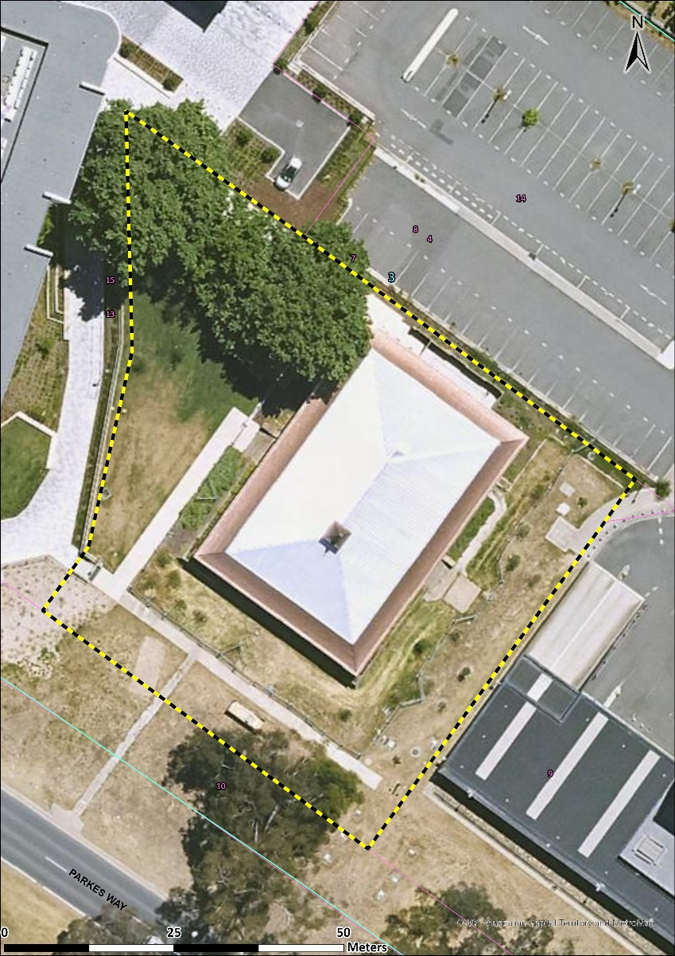
Image 1 West Portal Cafeteria – area of heritage significance.

