Australian Capital Territory
Heritage (Decision about Provisional Registration of the Early Brickworks Housing Precinct, Yarralumla, Banks, Hutchins, and Hooker Streets) Notice 2024
Notifiable instrument NI2024–571
made under the
Heritage Act 2004, s 34 (Notice of decision about provisional registration)

1 Name of instrument
This instrument is the Heritage (Decision about Provisional Registration of the Early Brickworks Housing Precinct, Yarralumla, Banks, Hutchins, and Hooker Streets) Notice 2024.
2 Commencement
This instrument commences on the day after its notification day.
3 Decision about provisional registration
On 24 September 2024, the ACT Heritage Council (the council) decided not to provisionally register the Early Brickworks Housing Precinct, Yarralumla, Banks, Hutchins, and Hooker Streets, blocks 1-7, 9-10, 13 and 20, section 64, Yarralumla (the place).
4 Description of the place
The description of the place is in the schedule.
5 Reasons for the decision
The council is not satisfied on reasonable grounds that the place is likely to have heritage significance as defined by the Heritage Act 2004, section 10. A detailed statement of reasons, including an assessment against the heritage significance criteria, is provided in the schedule.
6 Date decision takes effect
The decision not to provisionally register the place takes effect on 25 September 2024 (being the day after the council made its decision in writing as set out in the schedule).
Mary Clare Swete Kelly
A/g Secretary (as delegate for)
ACT Heritage Council
24 September 2024

Schedule

(See sections 3 and 4)




Statement of Reasons
Decision Not to Provisionally Register
Early Brickworks Housing Precinct, Yarralumla, Banks, Hutchins and Hooker Streets
Blocks 1-7, 9-10, 13 & 20, Section 64, Yarralumla
on the ACT Heritage Register
In accordance with s 32 of the Heritage Act 2004, the ACT Heritage Council has decided not to provisionally register the Early Brickworks Housing Precinct, Yarralumla, Banks, Hutchins and Hooker Streets (the Precinct). This Statement of Reasons provides an assessment of the Yarralumla Housing Precinct and finds that Blocks 1-7, 9-10, 13 & 20, Section 64, Yarralumla, does not meet any of the criteria under s 10 of the Heritage Act 2004.

Preamble
A nomination for the Early Brickworks Housing Precinct, Yarralumla, Banks, Hutchins and Hooker Streets was made in 1993. In 2002 following concerns regarding the impending sale of 35 Hutchins Street (Block 11 Section 64) the ACT Heritage Council commissioned an assessment of the cottages at 41, 39, 37, 35 and 33 Hutchins Street (Blocks 4, 7, 11, 12 and 16 Section 64). In 2003, the Early Canberra Brickworks Housing Precinct (Blocks 8, 11, 12 & 16 Section 64) was entered to the then interim ACT Heritage Place Register. The outstanding houses within the section remained nominated. This decision seeks to finalise the process for the remaining nominated area.

Reasons for decision
The Council is not satisfied on reasonable grounds that the place has Territory level heritage significance as defined by s10 of the Heritage Act 2004. Nevertheless, the Council does note that there may be elements of local significance in the character of the Precinct and some individual buildings.
This statement refers to the Council’s reasons for its decision as required in s 34(5)(b)(iv) of the Heritage Act 2004.

Location of the place
Early Brickworks Housing Precinct, Yarralumla Banks, Hutchins and Hooker Streets, includes Blocks 1-7, 9-10, 13 & 20 Section 64, 14 Hooker Street, 16 Hooker Street, 18 Hooker Street, 18 Banks Street, 20 Banks Street, 22 Banks Street, 24 Banks Street, 26 Banks Street, 28 Banks Street, 39 Hutchins Street, 41 Hutchins Street, and 43 Bentham Street Yarralumla.
This statement refers to the location of the place as required in s 34(5)(b)(ii) of the Heritage Act 2004.

Description of the place
hatever features are relevant to the heritage of the place;
The Precinct under consideration is Section 64, bounded by Hooker Street to the north, Banks Street to the west, Bentham Street to the south and Hutchins Street to the east. The buildings are all residential, with a predominance of single storey detached dwellings of red brick and timber, with hipped tile roofs and standard setbacks. Second storey extensions have generally been set back towards the rear of the blocks, maintaining a single storey streetscape. Some shared crossovers exist however in many cases additional crossovers have been introduced. There is a visible pattern of hedges to front gardens with a combination of landscaping and vehicle accommodation.
This section refers to the description of the place as required in s 34(5)(b)(iii) of the Heritage Act 2004. The boundary of the place and extent of features listed below is illustrated at Figure 1.

Assessment against the heritage significance criteria
This statement refers to the Council’s assessment of the place against the heritage significance criteria as a part of its reasons for its decision as required in s 34(5)(b)(iv) of the Heritage Act 2004.
The Council’s assessment against the criteria specified in s 10 of the Heritage Act 2004 is as follows.
In assessing the heritage significance of Yarralumla Housing Precinct, the Council considered:
- the original nomination and documentary evidence supplied by the nominator
- the Council’s Heritage Assessment Policy (March 2018)
- Heritage Assessment, Yarralumla Houses: Section 64 (Blocks 4, 7,8,11, 12 & 16), Eric Martin and Associates 2002
- the physical evidence and surrounding context as ascertained from an onsite visit in August 2004, July 2010 and July 2024 by ACT Heritage
- the report by ACT Heritage titled, Background Information Yarralumla Housing Precinct, August 2024, containing photographs and information on history, description, condition and integrity.
Pursuant to s 10 of the Heritage Act 2004, a place or object has heritage significance if it satisfies one or more of the following criteria. Future research may alter the findings of this assessment.
The Council’s assessment against the criteria specified in s10 of the Heritage Act 2004 is as follows.
- importance to the course or pattern of the ACT’s cultural or natural history.
Does not meet criterion.
The Council has assessed Early Brickworks Housing Precinct, Yarralumla, Banks, Hutchins and Hooker Streets against criterion (a) and is not satisfied that the place meets this criterion.
The Council acknowledges that the Precinct does display a number of Garden City qualities but it is an undistinguished example, diminished by the degradation of these qualities. Better examples of Garden City planning can be found in the Garden City Heritage Precincts of Alt Crescent, Barton, Blandfordia 4 and 5, Braddon, Corroboree Park, Forrest, Kingston/Griffith, Reid and Wakefield Gardens.
The construction of the cottages between 1921 and 1927 in Westridge was an attempt to provide improved accommodation for married Brickworks and Yarralumla Nursery workmen and their families, and illustrates the early infrastructure associated with the permanent settlement of Canberra’s population.
No. 41 Hutchins Street (Block 4) has been suggested as the location of the first post office in south Canberra, echoing the first post office in Braddon, north Canberra. This is of potential historic interest, however this has not been substantiated through research to date. In any event, the historical integrity of this house is either very low or no longer exists.
Although the subdivision has historical links to the Brickworks and the Garden City development of the FCC, substantial changes have been made to individual blocks which affect the Precinct and the remaining elements, while of local significance, do not meet the threshold required to meet this criterion.

(b) has uncommon, rare or endangered aspects of the ACT’s cultural or natural history.
Does not meet criterion.
The Council has assessed Early Brickworks Housing Precinct, Yarralumla, Banks, Hutchins and Hooker Streets against criterion (b) and is not satisfied that the place meets this criterion.
Despite being an early example of Garden City planning in Canberra the Precinct does not demonstrate the intactness, integrity or extensiveness required to meet the threshold for this criterion. Whilst the history of the area relates to the Brickworks and Yarralumla Nursery, this is not substantially evident in the built fabric and form to the extent required to demonstrate the threshold of significance required.
The brick cottages built in 1921 are in the Lithgow style (Littleton, NSW), as is the Braddon housing built at the same period, and reflect the character of the working-class level of housing of that time. The remaining timber cottages, built in 1926, echo those built in Ainslie (around the Corroboree Park area) and reflect the intention of the Australian Government to attract workers to Canberra. The mixing of timber and brick construction in Section 64 is an exception to the Building & Services Ordinance 1924 which expressly prohibited such a mixing in Canberra.
The cottages still existing on Section 64 once represented a distinctive design character however, the loss of many of the original cottages, development and individual alterations have diminished that character.
Only two of the remaining eleven dwellings within Section 64 (18 Hooker Street and 22 Banks Street) reflect the mixing of timber and brick construction. Whilst of some historic interest and local significance as evidence of a particular design process and character, this in itself does not meet the threshold of sufficient distinction in the way the criterion intends.
The remaining eight houses within the section have been highly compromised by significant alterations and additions and many have been demolished and new residences constructed.

(c) potential to yield important information that will contribute to an understanding of the ACT’s cultural or natural history.
Does not meet criterion.
The Council has assessed Early Brickworks Housing Precinct, Yarralumla, Banks, Hutchins and Hooker Streets against criterion (c) and is not satisfied that the place meets this criterion.

The Early Brickworks Housing Precinct, Yarralumla, Banks, Hutchins and Hooker Streets provides a further example of Garden City planning which is well-studied and documented in Canberra. The area has been significantly disturbed by demolition and development and no longer has the capacity to contribute to a better understanding of the aspect of natural or cultural history to which it was relevant.

(d) importance in demonstrating the principal characteristics of a class of cultural or natural places or objects.
Does not meet criterion.
The Council has assessed Early Brickworks Housing Precinct, Yarralumla, Banks, Hutchins and Hooker Streets against criterion (d) and is not satisfied that the place meets this criterion.
Whilst the Precinct is known to demonstrate some features of the class of Garden City planning and development, its physical features do not demonstrate the majority of the defining characteristics of this class to a representative level required to meet the threshold of significance under this criterion. Its remaining physical features and characteristics, while of local significance, are not sufficient alone to demonstrate the level of significance as required by the criterion.

(e) importance in exhibiting particular aesthetic characteristics valued by the ACT community or a cultural group in the ACT.
Does not meet criterion.
The Council has assessed Early Brickworks Housing Precinct, Yarralumla, Banks, Hutchins and Hooker Streets against criterion (e) and is not satisfied that the place meets this criterion.
There is no identified cultural group which values the aesthetic characteristics of the Precinct. The Precinct has lost its visual appeal through ongoing degradation of its physical fabric which has diminished the aesthetic characteristics of the Garden City planning of the Section.

(f) importance in demonstrating a high degree of creative or technical achievement for a particular period.
Does not meet criterion.
The Council has assessed Early Brickworks Housing Precinct, Yarralumla, Banks, Hutchins and Hooker Streets against criterion (f) and is not satisfied that the place meets this criterion.
Section 64 Yarralumla is the second section of public housing built in Canberra in the 1920s. It is the first development commissioned by the Federal Capital Advisory Committee (FCAC) and built by the Works and Railways in Canberra. At the same time, the FCAC developed the Braddon Group of houses (then Neighbourhood No 1), building the first 20 brick cottages in the Capital City.
The seven brick cottages in Yarralumla (then Westridge) were the 21st – 27th permanent houses to be built in early Canberra, and the first houses to be built in south Canberra.
The construction of the cottages between 1921 and 1927 was an attempt to provide better decent accommodation for married workmen their wives and their families and reflects the will to organise permanently the settlement of the population of Canberra.
The development of the remaining housing within Section 64 neither demonstrates a high degree of technical or creative achievement nor an exceptionally fine level of application of existing techniques or approaches. The cottages were constructed to provide accommodation for workers associated with the development of the early infrastructure of the growing capital city.
The integrity of the remaining cottages has been compromised by alterations and additions and in some instances the demolition of original dwellings and construction of new residences. Of the remaining timber cottages number 18 Hooker Street is close to original condition and is of local significance, however is not considered significant in itself to the threshold for registration under the Act.

(g) has a strong or special association with the ACT community, or a cultural group in the ACT for social, cultural or spiritual reasons.
Does not meet criterion.
The Council has assessed Early Brickworks Housing Precinct, Yarralumla, Banks, Hutchins and Hooker Streets against criterion (g) and is not satisfied that the place meets this criterion.
Whilst there is an association between the Precinct and early workers of the Brickworks and Yarralumla Nursery, this is not ‘a cultural group’ as intended by this criterion as a present-day community.

(h) has a special association with the life or work of a person, or people, important to the history of the ACT.
Does not meet criterion.
The Council has assessed Early Brickworks Housing Precinct, Yarralumla, Banks, Hutchins and Hooker Streets against criterion (h) and is not satisfied that the place meets this criterion.
The development of the Yarralumla Housing Precinct, a distinctive area then known as Westridge, was initially to provide better permanent houses for Brickworks staff and management and for staff of Yarralumla Nursery.
The population of the Yarralumla Housing Precinct attests to the involvement of the community in the development of the infrastructure in the new capital city.
Whilst the establishment of the housing has an association with the development of infrastructure in the new capital city, the nature and strength of this association is compromised by the lack of integrity of the remaining housing within Section 64. Blocks 8, 11, 12 and 16 Section 64 have already been entered to the ACT Heritage Register. The remaining houses within the section have been highly compromised by significant alterations and additions and most have been demolished and new residences constructed.

Decision boundary
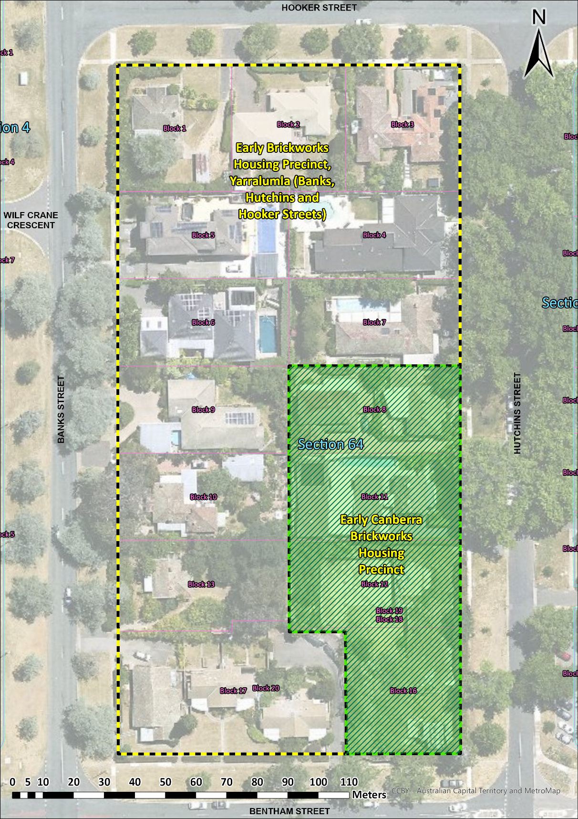

Figure 1 Section 64 Yarralumla. The area of the previously registered Early Canberra Brickworks Housing Precinct is bordered in green.

