Australian Capital Territory
Heritage (Decision about Provisional Registration of Belconnen Library, Belconnen) Notice 2024
Notifiable instrument NI2024–70
made under the
Heritage Act 2004, s 34 (Notice of decision about provisional registration)

1 Name of instrument
This instrument is the Heritage (Decision about Provisional Registration of Belconnen Library, Belconnen) Notice 2024.
2 Decision about provisional registration
On 13 February 2024, the ACT Heritage Council (the Heritage Council) decided to provisionally register the Belconnen Library, Blocks 11, 12, 22, and 38, Section 54, Belconnen (the Place).
3 Registration details of the Place
The registration details of the Place are in the schedule.
4 Reasons for the decision
The Heritage Council decided to provisionally register the Place because it is satisfied on reasonable grounds that it is likely to have heritage significance as it is likely to meet one or more of the heritage significance criteria in section 10 of the Heritage Act 2004 (the Act). A detailed statement of reasons, including an assessment against the heritage significance criteria, is provided in the schedule.
5 Date of provisional registration
The date of provisional registration is 14 February 2024 (being the day after the Heritage Council entered into the heritage register the registration details for the Place together with an indication that the registration is provisional).
6 Indication of the Heritage Council’s intention
The Heritage Council intends to decide whether to register the Place under Division 6.2 of the Act during the period of provisional registration.
7 Invitation to make written comments during public consultation period
(1) The Heritage Council invites written comments about the registration of the Place. Any written comments must be made within 4 weeks after the day this notice is notified.
(2) Written comments can be provided to the Heritage Council by the following methods:
(a) mail to
The Secretary
ACT Heritage Council
GPO Box 158
CANBERRA ACT 2601
(b) email to heritage@act.gov.au

Stuart Jeffress
A/g Secretary (as delegate for)
ACT Heritage Council
13 February 2024

Schedule

(See sections 3 and 4)

AUSTRALIAN CAPITAL TERRITORY
HERITAGE REGISTER
(Provisional Registration)

For the purposes of s33 of the Heritage Act 2004, a provisional entry to the heritage register has been prepared by the ACT Heritage Council for the following place:

BELCONNEN LIBRARY

BLOCKS 11, 12, 22, AND 38 SECTION 54, BELCONNEN
DATE OF DECISION
13 February 2024
DATE OF PROVISIONAL REGISTRATION
14 February 2024 Notifiable Instrument: 2024–
PERIOD OF EFFECT OF PROVISIONAL REGISTRATION
Start Date: 14 February 2024 End Date: 13 July 2024

Extended Period (if applicable) Start Date ________ End Date ________

Copies of the Register Entry are available for inspection at ACT Heritage. For further information please contact:

The Secretary

ACT Heritage Council

GPO Box 158

CANBERRA ACT 2601

Telephone 13 22 81

This statement refers to the heritage significance of the place as required in s12(d) of the Heritage Act 2004.
STATEMENT OF HERITAGE SIGNIFICANCE

The Belconnen Library, designed in 1979 by Robin Gibson & Partners for the National Capital Development Commission (NCDC), is significant as the ACT’s only Gibson design. This occurred during the peak of his career when he was chosen by the NCDC in accordance with its philosophy of commissioning the best architects from around Australia to achieve a broad representation of the country’s architectural talent in the developing capital city. The Belconnen Library has all the hallmarks of a Gibson design including his material palette, modular grid, use of light and shade, considered glazing and wider area pedestrian focused design. The library is an excellent representation of Gibson’s work and design philosophy.

The Belconnen Library is also a good example of the Late Twentieth Century International Style of architecture reflected by attributes such as its sculptural qualities with curvilinear forms, sharpness and precision, control of sun and shade and cantilevered forms. Gibson subtly adapted the style to Australian conditions by controlling sun and shade with deep recesses and overhangs. This is an important variation of the style which was generally applied without regard to local conditions.

This statement refers to the location of the place as required in s12(b) of the Heritage Act 2004.
LOCATION OF THE PLACE

Belconnen Library, section 54 blocks 11, 12, 22, and 38, Suburb of Belconnen, District of Belconnen, ACT.

This statement refers to the description of the Belconnen Library as required in s12(c) of the Heritage Act 2004. The attributes described in this section form part of the heritage significance of the place. For the purposes of s12(c) of the Heritage Act 2004, the boundary of the place is at Image 1.
DESCRIPTION OF THE PLACE

The Belconnen Library is a low rectangular concrete and glass modernist building with recessed windows, continuous concrete parapets and deep overhangs. It has a horizontal aesthetic and an unusual large, curved wall prominently featured at the main corner leading to the entrance. It has a sandblasted concrete finish, recessed window frames, internally located round columns (except for the double-height main corner where the round column is prominently situated at the edge with the rounded shape continuing into the precast concrete parapet panel corner). Internally, it has structural ceiling channels running the length of the building with integrated lights and services. The internal space is open and flexible with corner skylights with designer pendant lighting. The front of the library has a second floor accessed by a walkway that can be accessed separately to the main library space and a double-height foyer accessed via the large plate glass entrance. The building is designed and sited to allow for a pedestrian-friendly environment, open views to the surrounding area, yet also controlling sun and shade.

Belconnen Library has the following attributes of significance:
- The off-white sandblasted exposed aggregate concrete surfaces of the original walls and fascias, including original internal concrete surfaces;
- The use of frameless glazing throughout;
- The high level of finish, most notably where different surfaces abut presented as flush surfaces with sharp, clean lines;
- The double height foyer with plate glass entry;
- The linking bridge over the foyer and the corner terrace open to the outside with original steel railings (the later additions to the balustrade to enclose the bridge are not part of the significant attributes of the place);
- The separated access to the community rooms and bathrooms allowing for after hours entry;
- The open-plan reading room;
- The white ribbed ceiling with original ducting and integrated light fixtures;
- The raised ceiling sections creating voids with clerestory windows around the perimeter that act as light wells (noted as “roof light” in Gibson’s drawings) and associated designer pendant lighting;
- The plain smooth surfaces arranged to juxtapose curved and right-angled surfaces/corners
- The internal display wall on the north side of the foyer;
- The external cantilevered overhangs creating 3m wide covered walkways to the north and east sides of the building as part of the pedestrian plaza;
- The overall horizontal form emphasised by the long, uninterrupted, deep eaves along the vertical plane of the square building boundary, and the horizontal slit windows/Corbusian window motifs;
- The free-standing civic building, designed to be approached and appreciated from all sides in its urban setting.

The curtilage at Image 1 allows for an area of open space to maintain the approach and setting, scale and massing of the Belconnen Library. The artworks, sculptures and landscaping within the curtilage are not a part of the heritage significance of the place.
CONSERVATION OBJECTIVE

The guiding conservation objective is that Belconnen Library shall be conserved and appropriately managed in a manner respecting its heritage significance.

The ACT Heritage Council may adopt heritage guidelines applicable to the place under s2Al5 of the Heritage Act 2004.

For further information on guidelines applicable to the place, or for advice on proposed works or development, please contact ACT Heritage on 13 22 81.
REASON FOR PROVISIONAL REGISTRATION

The Council has assessed the Belconnen Library, Belconnen, against the heritage significance criteria and is satisfied that the place is likely to have heritage significance when assessed against criteria (a) and (d) under s10 of the Heritage Act 2004.
ASSESSMENT AGAINST THE HERITAGE SIGNIFICANCE CRITERIA

The Council’s assessment against the criteria specified in s10 of the Heritage Act 2004 is as follows.

In assessing the heritage significance of Belconnen Library, Belconnen, the Council considered:
- the original nomination and documentary evidence supplied by the nominator;
- the Council’s Heritage Assessment Policy (March 2018);
- information provided by site inspections on 7 April 2020, 8 April 2021 and 23 April 2021 by ACT Heritage;
- comments received during an earlier round of public consultation on a decision to provisionally register the place that was repealed before a final decision could be made; and
- the report by ACT Heritage titled, Background Information Belconnen Library, February 2024, containing photographs and information on history, description, condition and integrity.

Pursuant to s10 of the Heritage Act, a place or object has heritage significance if it satisfies one or more of the following criteria. Future research may alter the findings of this assessment.
importance to the course or pattern of the ACT’s cultural or natural history;
The Council has assessed the Belconnen Library against criterion (a) and is satisfied that the place is likely to meet this criterion.
The NCDC’s philosophy of commissioning the best architects from around Australia to achieve a broad representation of the country’s architectural talent in the developing capital city resulted in Robin Gibson’s only ACT building which was illustrative of the NCDC intentionally engaging those at the leading edge of public architecture. Robin Gibson and Partners was widely recognised as a leading architectural firm in Australia in the mid to late 20th century and the company was at its peak at the time that the Belconnen Library was commissioned by the NCDC.
The Belconnen Library has all the hallmarks of a Gibson design with round columns behind glass walls, sandblasted concrete, continuous concrete parapets, deep overhangs, design of horizontal effect, recessed/frameless windows, structural channels internally in a grid with combined services and lighting, skylights and minimal internal walls; unusually it has a prominent curved wall, but that too is in accordance with Gibson’s pedestrian focused design and the movement of people through the area as it was designed to be approached, and appreciated, from all sides in its urban setting.
Gibson was particularly concerned about texture and would employ repeatable patterns across his works to achieve a crisp, clear form; which is clear in how the Library is finished. Less obvious though, is his focus on designs based on how people use a place. His holistic design starts in the surrounding plaza that controls pedestrian access and views, and also considers views from inside the Library. He allowed a flexible internal space that took into account the movement of books as well as people, while the external form of the building allowed a great deal of control over the light and varying environmental conditions of the site.
The library is an excellent representation of Gibson’s work and design philosophy. It is the result of the NCDC’s practice of using the best of Australia’s architects to design a thoroughly modern capital which widely represented the work of the best Australian architects. As such, the place meets this criterion for its role in the development of the ACT.
The modernist style of architecture used in the Belconnen Library and the consideration in the design of concepts relating to community-based public space are also illustrative of the NCDC’s planning philosophies for Canberra’s town centres, which had enduring influence on the development of Canberra.
has uncommon, rare or endangered aspects of the ACT’s cultural or natural history;
The Council has assessed the Belconnen Library against criterion (b) and is not satisfied that the place is likely to meet this criterion.
The place is one of a number of libraries in the ACT and is also a well-preserved example of Late Twentieth Century International Design, an important style of architecture in the development of the ACT and its public buildings. However, regardless of the aspect of the ACT’s cultural history, whether it is libraries or Late Twentieth Century International style buildings or public buildings/spaces, the Belconnen Library is not considered to be sufficiently rare, uncommon, or endangered to the degree required to meet thresholds against this criterion. There are a number of current and former library buildings in the ACT, including the registered Woden Library, Dickson Library and the North Building of Civic Square; and other examples of the Late Twentieth-Century International architectural style such as the Edmund Barton Building, the Former ANZ Bank Building and the R G Menzies Library at the ANU.
potential to yield important information that will contribute to an understanding of the ACT’s cultural or natural history;
The Council has assessed the Belconnen Library against criterion (c) and is not satisfied that the place is likely to meet this criterion.
The Council acknowledges the potential of all sound examples of modern architecture to act as teaching sites and sources of information on the history of the ACT. However, any information the Belconnen Library is likely to yield on the architect, the style of architecture, or the planning history of the ACT, is already present in the building itself, and the readily accessible documentary record.
importance in demonstrating the principal characteristics of a class of cultural or natural places or objects;
The Council has assessed the Belconnen Library against criterion (d) and is satisfied that the place is likely to meet this criterion.
The Belconnen Library demonstrates, and is a good example of, the Late Twentieth Century International Style of architecture. Gibson’s use of large areas of concrete, bold shapes and plate glass can be confused with the Brutalist style, but as discussed in the Background Document, his use of sharpness of finish and materials, transparency and spatial awareness are more strongly associated with the International style which he has subtly adapted to Australian conditions by controlling sun and shade with deep recesses and overhangs. It is Gibson’s ability to design a uniquely Australian version of an architectural style that generally ignored a building’s location that makes the Library stand out from the earlier post-war International and many contemporary designs. It is a distinction that makes this an important example of the style and it was this kind of approach that the NCDC was seeking when it brought in leading architects from across Australia.
The Library was awarded the RAIA ACT Chapter Canberra Medallion in 1982 and then the Australian Institute of Architects ACT Chapter 25 Year Award for Enduring Architecture in 2010; and Robin Gibson received an Order of Australia in 1983 for services to architecture. It was this pedigree of high quality architect that the NCDC was using to develop Canberra with modern buildings of the highest calibre, designed by architects from all States and Territories, and to create a palette of architectural expression of excellence. The NCDC placed the Library in a central pedestrian hub in their planning for the Belconnen town centre (although the planning was not ultimately realised) that had planned to link the buildings from that era/new suburb. It is an important example of what the NCDC was trying to achieve.

importance in exhibiting particular aesthetic characteristics valued by the ACT community or a cultural group in the ACT;
The Council has assessed Belconnen Library against criterion (e) and is not satisfied that the place is likely to meet this criterion.
There is insufficient evidence that Belconnen Library exhibits design or aesthetic qualities that are valued by the ACT community or a cultural group in the ACT. The Council acknowledges that Belconnen Library is valued by the Australian Institute of Architects (AIA) and other architects for reasons relating to its design and aesthetic qualities, however, they do not constitute a cultural group or represent of the ACT community as a whole. The Council’s Heritage Assessment Policy defines a cultural group as a ‘group of people within a society with a shared ethnic or cultural background’ or ‘a group of people connected through the same way of living, which has been transmitted from one generation to another’. While the Library is clearly valued for its amenity value and is an attractive place the evidence of broader community values specifically related to particular aesthetic values has not been identified to a strong enough level to meet this criterion.
importance in demonstrating a high degree of creative or technical achievement for a particular period;
The Council has assessed Belconnen Library against criterion (f) and is not satisfied that the place is likely to meet this criterion.
The Belconnen Library uses conventional building techniques and a suite of design characteristics of the Late Twentieth Century International style of architecture that were already well established at the time. While it does have some creative elements, such as the method of separating and accessing the community room and the integration of the pedestrian plaza design, these are not considered to be of a high enough degree, in that they are not a formative use or so innovative or outside of normal use, such that the place meets the threshold for inclusion under this criterion.
has a strong or special association with the ACT community, or a cultural group in the ACT for social, cultural or spiritual reasons;
The Council has assessed the Belconnen Library against criterion (g) and is not satisfied that the place is likely to meet this criterion.
There is insufficient evidence that Belconnen Library has a strong or special association with the ACT community, or a cultural group in the ACT for social, cultural or spiritual reasons. The Council acknowledges that Belconnen Library is valued by the Australian Institute of Architects (AIA) and other architects, however, they do not constitute a cultural group or can be representative of the ACT community as a whole. The Council’s Heritage Assessment Policy defines a cultural group as a ‘group of people within a society with a shared ethnic or cultural background’ or ‘a group of people connected through the same way of living, which has been transmitted from one generation to another’. While the Library is clearly valued for its amenity value, particularly for the provision of community rooms and a meeting place, and is an important service in general the evidence of broader community or a cultural group having a strong or special association has not been identified to a strong enough level to meet this criterion.

has a special association with the life or work of a person, or people, important to the history of the ACT.
The Council has assessed the Belconnen Library against criterion (h) and is not satisfied that the place is likely to meet this criterion.
Robin Gibson is an important Australian architect whose work is most closely associated with his hometown of Brisbane, particularly in the Queensland Cultural Centre (QCC), and greater Queensland. The Library was designed when Gibson’s practice was at its peak and he was known to have the majority of his focus on the Queensland Cultural Centre; entrusting his staff to deal with the day-to-day business of other commissions; and this is likely to be the case here, with Gibson forming the base idea and governing philosophies of the Library design, letting his staff work out the details and then having final oversight of the finished product. While it was certainly a Gibson design, and he was in full control of the project, it is unlikely that his association with the Library was more special than any of his other projects that were not part of the QCC at the time.
The Library is representative of the NCDC bringing in a broad range of architects reflecting talent from other states and is the only public building designed by Robin Gibson in the ACT however, there is no evidence to suggest that his association with the place was any more special than with any of his other works and that this association was any more important than any other fine architects that were commissioned by the NCDC at the time leading to a lasting impact on the history of the ACT.
SITE PLAN

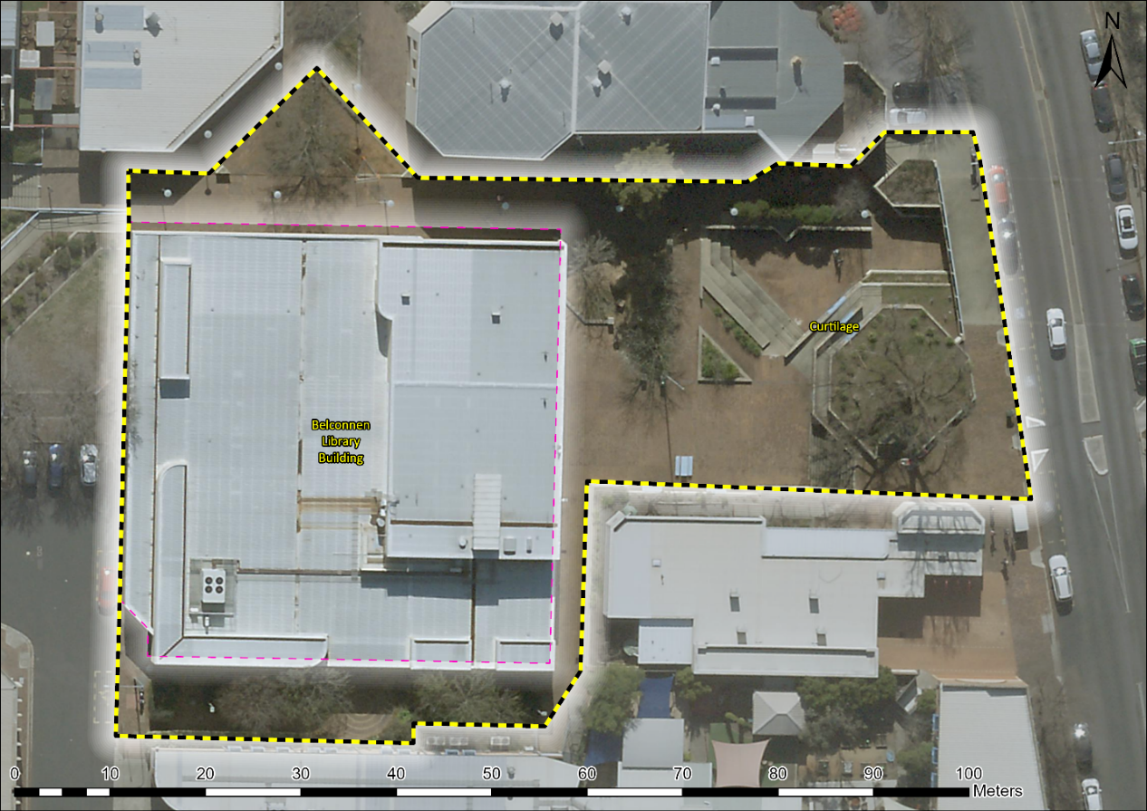
Image 1 Belconnen Library building and wider curtilage incorporating the plaza and surrounding pedestrian access.

