Australian Capital Territory

Heritage (Decision about Registration of Griffith Flats, Griffith) Notice 2024

**Notifiable instrument NI2024–71**

made under the

Heritage Act 2004, s 40 (Decision about registration)

**1 Name of instrument**

This instrument is the *Heritage (Decision about Registration of Griffith Flats, Griffith) Notice 2024*.

**2 Commencement**

This instrument commences on the day after its notification day.

**3 Decision about registration**

On 13 February 2024, the ACT Heritage Council (the ***Heritage Council***) decided to register Griffith Flats, Block 1, Section 21, Griffith (the ***Place***).

**4 Registration details of the Place**

The registration details of the Place are in the schedule.

**5 Reasons for the decision**

The Heritage Council is satisfied on reasonable grounds that the Place has heritage significance as it meets one or more of the heritage significance criteria in section 10 of the *Heritage Act 2004*. A detailed statement of reasons including an assessment against the heritage significance criteria is provided in the schedule.

**6 Date registration takes effect**

The registration of the Place takes effect on 13 February 2024.

**7 Revocation**

The *Heritage (Decision about Provisional Registration of Griffith Flats, Griffith) Notice 2023* (NI2023-636) is revoked.

Stuart Jeffress

A/g Secretary (as delegate for)

ACT Heritage Council

13 February 2024

**Schedule**

**(See sections 3 and 4)**





AUSTRALIAN CAPITAL TERRITORY

HERITAGE REGISTER

(Registration)

For the purposes of s40 of the *Heritage Act 2004*, an entry to the heritage register has been prepared by the ACT Heritage Council for the following place:

**GRIFFITH FLATS**

**BLOCK 1 SECTION 21, GRIFFITH**

DATE OF REGISTRATION   
13 February 2024 Notifiable Instrument: NI2024–

Copies of the Register Entry are available for inspection at ACT Heritage. For further information please contact:

The Secretary

ACT Heritage Council

GPO Box 158

CANBERRA ACT 2601

Telephone 13 22 81

This statement refers to the location of the Griffith Flats as required in s12(b) of the *Heritage Act 2004*.

LOCATION OF THE PLACE

Griffith Flats, Block 1, Section 21, Griffith. The block is bounded by Oxley Street to the north, Dawes Street to the east, Canberra Avenue to the south and Eyre Street to the west.

This statement refers to the description of the Griffith Flats as required in s12(c) of the *Heritage Act 2004*. The attributes described in this section form part of the heritage significance of the place. For the purposes of s12(c) of the *Heritage Act 2004*, the boundary of the place is at Image 1.

DESCRIPTION OF THE PLACE

The Griffith Flats, previously known as the Canberra Flats, consist of 48 two-bedroom units on a rectangular site bounded by Canberra Avenue, Eyre Street, Oxley Street and Dawes Street. The units are housed in eight two-storey blocks, each facing a road frontage with the central area between the blocks containing mature trees, the two original laundry buildings as well as facilities for car parking, leisure and clothes drying.

Griffith Flats, consisting of the following attributes of significance:

* The Garden City planning of the eight free-standing buildings and their relationship to the central open space, their relationship to one another and the broader relationship to the landscape setting;
* The original form and fabric of the buildings; and
* The non-original carport structure is not an attribute of significance.

This statement refers to the heritage significance of the Griffith Flats as required in s12(d) of the *Heritage Act 2004*.

STATEMENT OF HERITAGE SIGNIFICANCE

The Griffith Flats from 1948 represent a well-preserved example of Canberra’s medium density government housing designed for public servants and as such contribute to our understanding and appreciation of the broad pattern and evolution of the ACT’s history and heritage. The development of the Griffith Flats arose from the Australian Government’s urgent need to provide permanent housing for the planned post-war influx of public servants into Canberra. The flats were the first to be built under the government’s community flats project, stemming from the National Capital Planning and Development Commission’s seven-year development plan for Canberra. The Griffith Flats also illustrate the Australian Government’s response to the post-war scarcity of building materials. The complex was the first of only four such developments in the post-war era and it is in remarkably intact condition. The architecture is appropriate to its designed function and clearly of the immediate post-war period, exhibiting elements of the Inter-war Georgian Revival Style.

CONSERVATION OBJECTIVE

The guiding conservation objective is that Griffith Flats shall be conserved and appropriately managed in a manner respecting its heritage significance.

The ACT Heritage Council may adopt heritage guidelines applicable to the place under s25 of the *Heritage Act 2004*.

For further information on guidelines applicable to the place, or for advice on proposed works or development, please contact ACT Heritage on 13 22 81.

REASON FOR REGISTRATION

The Council has assessed the Griffith Flats, Griffith against the heritage significance criteria and is satisfied that the place has heritage significance when assessed against criteria (a) and (d) under s10 of the *Heritage Act 2004*.

ASSESSMENT AGAINST THE HERITAGE SIGNIFICANCE CRITERIA

The Council’s assessment against the criteria specified in s10 of the *Heritage Act 2004* is as follows.

In assessing the heritage significance of The Griffith Flats, Griffith, the Council considered:

* the original nomination and documentary evidence supplied by the nominator;
* the Council’s Heritage Assessment Policy (March 2018);
* information provided by a site inspection on 13 June 2023 by ACT Heritage; and
* the report by ACT Heritage titled, Background Information Griffith Flats, December 2023, containing photographs and information on history, description, condition and integrity;
* information and comments received during the public consultation period under s37 of the Act on the provisional registration of The Griffith Flats, consisting of:
  + one submission expressing support for the registration.

Pursuant to s10 of the Heritage Act,a place or object has heritage significance if it satisfies one or more of the following criteria. Future research may alter the findings of this assessment.

importance to the course or pattern of the ACT’s cultural or natural history;

The Council has assessed Griffith Flats against criterion (a) and is satisfied that the place meets this criterion.

The Griffith Flats were the first of the Australian Government’s medium-density flats that came to characterise the post-war housing efforts that created the distinctly Canberran phenomena of government housing (as opposed to social housing in the rest of the country). The flats were explicitly designed to accommodate public servants relocating to Canberra after WWII however the Property and Tenancy Register and Electoral Rolls indicate a wider variety of residents in practice. The Griffith Flats reflect a way of life unique to Canberra at the time, whereby public servants initially stayed at a government hostel and then occupied a government flat while waiting for a government house to be allocated to them. It was intended that this housing would provide accommodation for these workers upon their arrival in the ACT, after which they would hopefully settle independently as detached houses became available. The Griffith Flats have a clear association with the post-war housing efforts of the National Capital Planning and Development Commission (NCPDC) which is identifiable in documentary evidence of NCPDC minutes, archived architectural and planning drawings and in the physical material of the place that reflects government designed accommodation of the time.

The Griffith Flats laid the groundwork for later efforts that would take up an entire section of a suburb and include a variety of accommodation types with shared facilities in a high quality, yet economical, design in order to get key workers in the growing capital city such as public servants, consular officials and other professions required for the new capital. The Griffith Flats are highly intact with respect to their original design and are in good condition. They remained as government housing for many years until the need for government housing, as it was originally intended in the ACT, was waning and they were transitioned to social housing. The flats were one of the earliest complexes to be turned over to social housing after self-government in 1989. They were allocated for aged persons’ housing at a time when there was a significant shortage of such housing. They are currently more generic social housing. Despite changes in the function of the housing there is a long association with the original purpose and continuity in the broader context as government provisioned housing.

The architectural style and construction of the Griffith Flats reflect the Australian Government’s response to the post-war scarcity of building materials and urgent need for accommodation of a more than temporary nature. The architecture is appropriate to its designed function and clearly of the immediate post war period, exhibiting elements of the Inter-war Georgian Revival Style.

The Griffith Flats are the first of four medium density complexes constructed in the post-war era and are well-preserved. Others that followed in a similar style were Braddon Court (1951), Reid Court (1951) and the first phase of Ainslie Flats (1952), culminating in the Northbourne Housing Precinct. Many are still standing but are not as close to their original condition as the Griffith Flats.

The significance of the Griffith Flats can be seen across a broad range of themes relating to the ACT’s significant identity and character. These include Canberra as the nation’s capital, the transfer of the seat of government, the ACT economy, Canberra as a planned environment, the early Australian Government, the Garden City movement and Australian Government urban planning.

has uncommon, rare or endangered aspects of the ACT’s cultural or natural history;

The Council has assessed Griffith Flats against criterion (b) and is satisfied that the place does not meet this criterion.

The Griffith Flats are clearly associated with post-war government housing efforts, an important aspect of the ACT’s history, by their design and continuing association with government housing and its transition to social housing in the ACT.

Government Housing, while not common outside of the ACT, is found throughout most of the ACT’s pre-1989 suburbs and covers a wide range of time periods. As a type of place in the ACT they are not uncommon, rare or endangered. Surviving examples of medium density, notably flats or precincts and particularly in the central areas, are being redeveloped as prime locations for densification (e.g., Northbourne Flats, Bega Flats, Stuart Flats). This suggests that they may in time become endangered or are at risk of becoming rare. Compared to other examples of government housing the Griffith Flats are an early representation that also retains a high level of integrity and intactness. Many internal features, such as internal doors, windows, some fixtures, stair railings, etc., are still original and the external presentation is largely unchanged, including landscaping and shared areas. However, although some aspects of this criterion are clearly met, the Council is not satisfied that its potential rarity and intactness is high enough to meet the thresholds required to meet this criterion.

potential to yield important information that will contribute to an understanding of the ACT’s cultural or natural history;

The Council has assessed Griffith Flats against criterion (c) and is satisfied that the place does not meet this criterion.

The Griffith Flats are unlikely to contain physical evidence of a defined research interest that is not currently visible in its built fabric or available via other documentary evidence.

The Council acknowledges that further research of the Griffith Flats may provide a low level of information that contributes to an understanding of the cultural history of the ACT, however there is insufficient evidence required meet this criterion that would demonstrate that it has provided, or is likely to provide, information that will contribute information that is important enough for a significant contribution to our understanding of the ACTs cultural history through its use or potential use as a research site, teaching site, type locality or benchmark site.

importance in demonstrating the principal characteristics of a class of cultural or natural places or objects;

The Council has assessed Griffith Flats against criterion (d) and is satisfied that the place meets this criterion.

The Griffith Flats represent the class of place defined as medium-density government housing. Medium-density government housing is important part of the ACT’s cultural history as they are representative of post-war densification and government policy. The Griffith Flats are a seminal example of the class of place that set the standard for later designs, particularly Ainslie Flats and Braddon and Reid Courts. Later similar designs expanded on the idea of a cluster of buildings taking up an entire section of a suburb with common areas with different types of accommodation, styles and architectural expression. The Griffith Flats are a highly intact example of the class that presents a well-mannered front with an economical design that has held up well over time.

Griffith Flats meet this criterion as medium-density government housing. The Council also considered if it would additionally meet the criterion as an example of Inter-war Georgian Revival Style architecture, however there is no evidence that the Griffith Flats architectural style was influential, rare or otherwise exceptional.

importance in exhibiting particular aesthetic characteristics valued by the ACT community or a cultural group in the ACT;

The Council has assessed Griffith Flats against criterion (e) and is satisfied that the place does not meet this criterion.

While the Griffith Flats provide an attractive streetscape that contributes to the character of suburb, it does not feature prominently in publications, tours, artworks, commercial products or other areas where its aesthetic characteristics may be shown to have value by the ACT community or a cultural group in the ACT. There is insufficient evidence before the Council to demonstrate that the Griffith Flats exhibit outstanding design or aesthetic qualities which are valued by the ACT community or a cultural group.

importance in demonstrating a high degree of creative or technical achievement for a particular period;

The Council has assessed Griffith Flats against criterion (f) and is satisfied that the place does not meet this criterion.

The Griffith Flats were designed with a standard reinforced concrete structure, facebrick cladding and internal timber framing in a common architectural style for the time. It was designed to be economical to build using tried and tested techniques to make up for shortages in materials and skilled workers to quickly deliver much needed medium-density housing. It does not meet the basic test for assessment against this criterion as it was more about having a good solid design rather than a creative or technical achievement.

has a strong or special association with the ACT community, or a cultural group in the ACT for social, cultural or spiritual reasons;

The Council has assessed Griffith Flats against criterion (g) and is satisfied that the place does not meet this criterion.

The Griffith Flats are associated with past residents, including a wide cross section of the community; however, it cannot be said that it has a particular social, cultural or spiritual association with the ACT community or a cultural group. There are no past residents’ associations or a clear link between the place and any cultural group.

has a special association with the life or work of a person, or people, important to the history of the ACT.

The Council has assessed Griffith Flats against criterion (h) and is satisfied that the place does not meet this criterion.

The Griffith Flats have associations with the NCPDC and the Architecture department of the Department of the Interior for its planning and development followed by various government departments responsible for their ongoing management. However, these associations are related to the regular activities of the various agencies which had direct responsibility for development of the ACT, and there is no apparent special association.

SITE PLAN

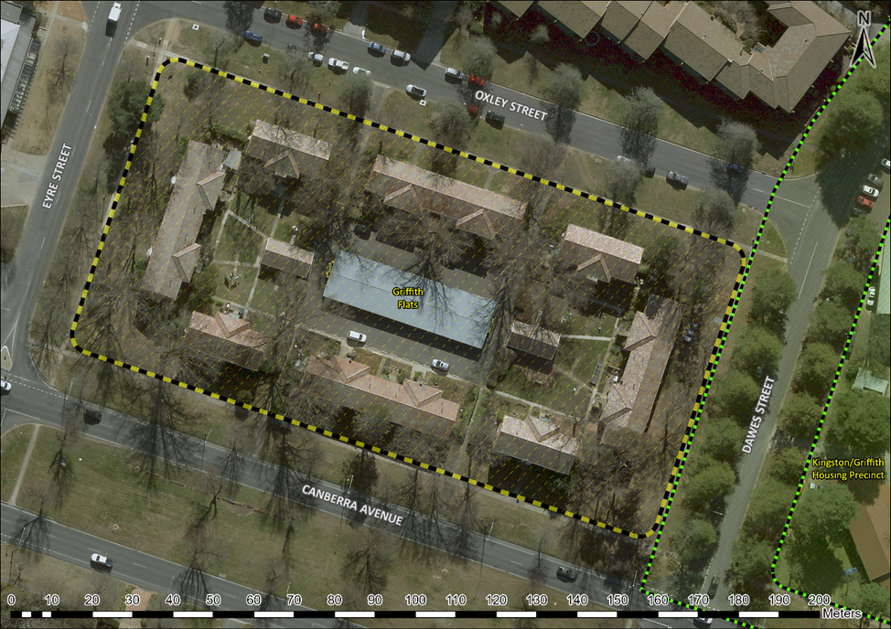

Image 1 Griffith Flats site boundary