Australian Capital Territory
Planning (Whitlam FUA Uplift) Minor Plan Amendment 2025
Notifiable instrument NI2025–119
made under the
Planning Act 2023, s 85 (Making minor plan amendments)

1 Name of instrument
This instrument is the Planning (Whitlam FUA Uplift) Minor Plan Amendment 2025.
2 Commencement
This instrument commences on the day after its notification day.
3 Minor plan amendment
I am satisfied under the Planning Act 2023, section 85 (1) (a) that Minor Plan Amendment 2025-01 is a minor plan amendment to the Territory Plan.
4 Dictionary
In this instrument:
Minor Plan Amendment 2025-01 means the minor plan amendment in schedule 1.
Freya O’Brien
Delegate of the territory planning authority
28 February 2025

Schedule 1
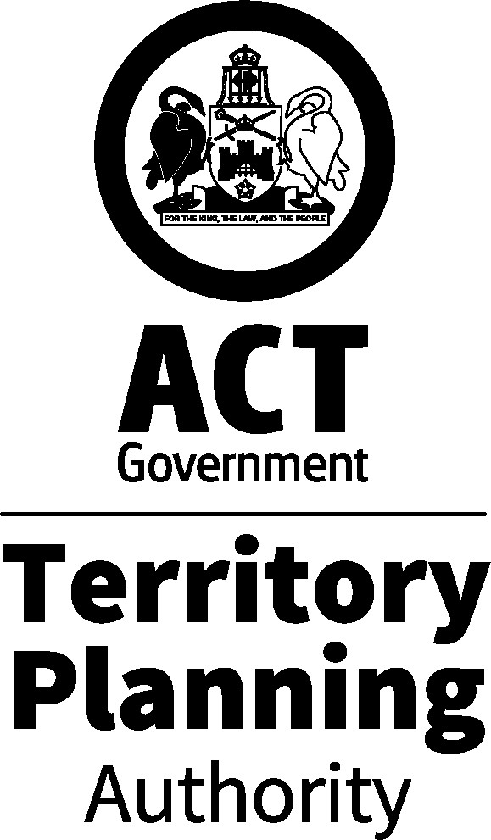

MINOR PLAN AMENDMENT TO THE TERRITORY PLAN
2025–01
Whitlam FUA uplift

This minor plan amendment was prepared
under part 5.3 of the Planning Act 2023
Contents
1.0 INTRODUCTION 1
1.1 Outline of the process 1
1.2 Summary of the proposal 1
2.0 PROPOSED TERRITORY PLAN CHANGES 2
2.1 Part B – Territory Plan Maps 2
3.0 TERRITORY PLAN AMENDMENT 5
3.1 Amendment to the Territory Plan Maps (Part B) 5
INTERPRETATION SERVICE 6

- INTRODUCTION
  - Outline of the process
Minor plan amendment 2025-01 (MA2025-01) to the Territory Plan is minor plan amendment (MA) prepared under section 84 (1) (c) of the Planning Act 2023 (the Act).

Section 84 of the Planning Act outlines the different types of MAs, some which require limited consultation to be undertaken and some which do not require consultation to be undertaken. This MA is consistent with the provisions under section 84 (1) (c) of the Act and therefore no consultation is needed.

Under Section 85 of the Act a MA can only be made if the MA is not inconsistent with the planning strategy or any relevant district strategy.

The MA is not inconsistent with the planning strategy or the Molonglo Valley district strategy.

The National Capital Authority will be advised of this MA.

For more information on the content of the Territory Plan and minor plan amendment processes please refer to the planning website www.planning.act.gov.au/professionals/our-planning-system/the-territory-plan/amendments-to-the-territory-plan.

  - Summary of the proposal
MA2025-01 proposes to:
- remove part of the future urban area overlay from land in the division of Whitlam and add ongoing provisions consistent with the approved estate development plan.

- PROPOSED TERRITORY PLAN CHANGES
MA2025-01 proposes changes to parts of the following Territory Plan documents:
- Part B – Territory Plan Maps

  - Part B – Territory Plan Maps
The Territory Plan map is varied to identify the zones and overlays that apply to land ceasing to be in a future urban area.

Whitlam - Location map
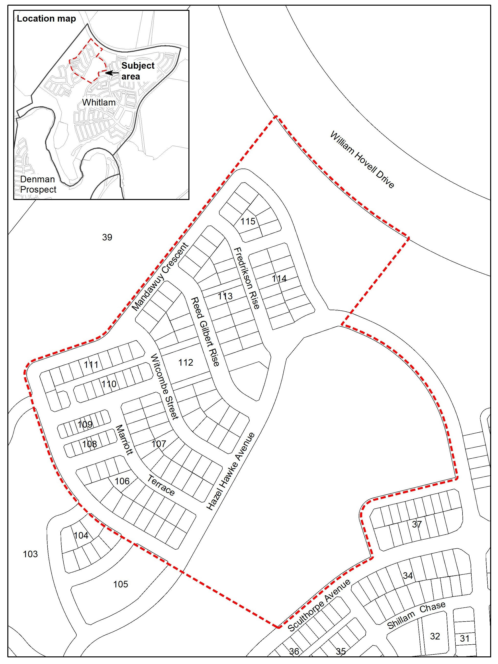

Whitlam – Existing Territory Plan map
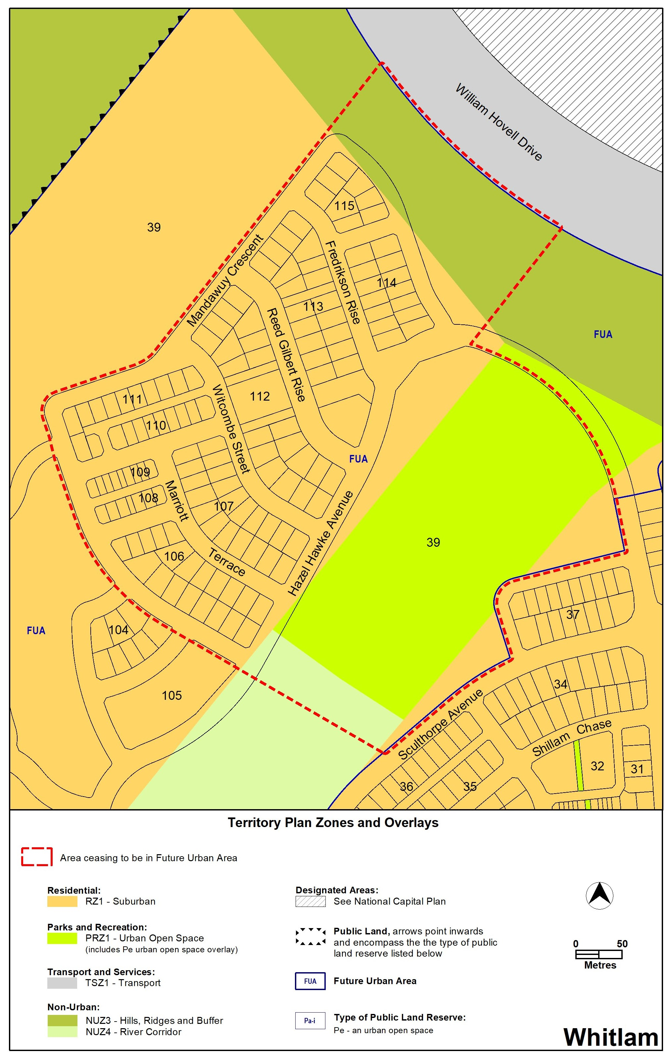

Whitlam – Proposed Territory Plan map
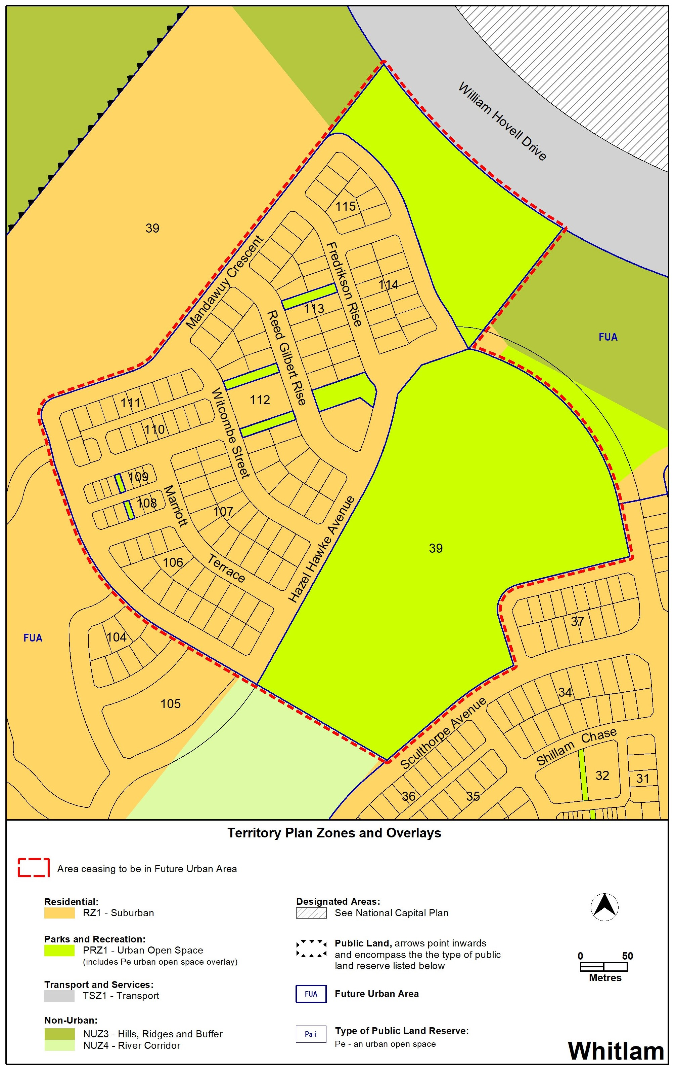

- TERRITORY PLAN AMENDMENT
  - Amendment to the Territory Plan Maps (Part B)
1. Whitlam

The relevant part of the Territory Plan map is varied as indicated below.

INTERPRETATION SERVICE

