Australian Capital Territory
Planning (Watson) Major Plan Amendment 2025

Notifiable instrument NI2025-164
made under the
Planning Act 2023, s 75 (Minister’s powers in relation to draft plan amendments)

1 Name of instrument
This instrument is the Planning (Watson) Major Plan Amendment 2025.
2 Major plan amendment
(1) I approve under section 75 (2) (a) of the Planning Act 2023 (the Act) the Major Plan Amendment C to the Territory Plan.
(2) In accordance with the Act, section 75 (5) (c), a major plan amendment must be presented to the Legislative Assembly and may only commence by commencement notice under section 80 (2).
3 Dictionary
In this instrument:
Major Plan Amendment C to the Territory Plan means the Major Plan Amendment in schedule 1.

Chris Steel MLA
Minister for Planning and Sustainable Development
7 April 2025



MAJOR PLAN AMENDMENT to the
TERRITORY PLAN C

Block 3 Section 95 Watson

April 2025
This major plan amendment was prepared
under division 5.2.7 of the Planning Act 2023
Contents
1.0 Introduction 1
1.1 Purpose 1
1.2 Outline of process 1
2.0 Summary of MPA-C 2
2.1 Site description 2
2.2 Summary of amendments to the Territory Plan 4
2.3 Summary of consequential amendments to other documents 5
3.0 NEED FOR THE MAJOR PLAN AMENDMENT 6
3.1 Application 2023-01 6
4.0 CONSULTATION 7
4.1 Consultation with agencies 7
4.2 Consultation with the public 7
5.0 MAJOR PLAN AMENDMENT C 8
5.1 Amendments to the Territory Plan Map 8
INTERPRETATION SERVICE 9

- Introduction
  - Purpose
This document is major plan amendment C – Block 3 Section 95 Watson (MPA-C) to the Territory Plan.

Key parts of this document are:
- section 2 – summarises the MPA, including amendments to the Territory Plan and associated documents
- section 3 – why this MPA was undertaken
- section 5 – detailed amendment instructions to the Territory plan proposed by this MPA.
  - Outline of process
A major plan amendment (MPA) is statutory process under the Planning Act that enables the Territory Plan to be amended. MPAs can be enabled in one of three ways:
- Proponent-initiated
- Authority-initiated
- Minister-initiated

MPA-C was a proponent-initiated amendment.

After considering and accepting the proponent-initiated amendment application (2023-01), the Territory Planning Authority (the Authority) prepared a draft plan amendment for the proposed changes (DPA-C). DPA-C was subject to consultation with entities and the public.

After consultation concluded, the Authority considered the comments and made and relevant revisions to DPA-C before giving it to the Minister for referral to the relevant Legislative Assembly Standing committee (the Standing Committee). The Standing Committee did not prepare a report in relation to DPA-C.

With the above complete, and in considering the background papers, the ACT Planning Strategy 2018 and the Inner North and City District Policy, the Minister for Planning and Sustainable Development approved MPA-C.

The Minister must now present MPA-C to the Legislative Assembly who may reject it completely or partly. If passed by the Legislative Assembly, the MPA may commence and become part of the Territory Plan.

A commencement notice or rejection notice will be published on the major plan amendment webpage.

For more information about the content of the Territory Plan and the major plan amendment processes please refer to the Environment, Planning and Sustainable Development (EPSDD) website.
- Summary of MPA-C
This section summarises:
- the amendments MPA-C made to the Territory Plan and supporting documents
- outlines the relevant subject area

Amendments to the Territory Plan by this MPA are summarised in section 2.2 and shown in detail at section 5 of this document.
  - Site description
MPA-C relates to the subject area shown in Figure 1. The subject area consists of Block 3 Section 95 Watson. The Territory Plan zoning for the subject area prior to MPA-C can also be seen in Figure 1.

The subject site is located at Block 3 Section 95 Watson in Canberra’s Inner North and City District. The site was previously zoned CZ6 – Accommodation and Leisure zone, with a Future Urban Area overlay and is not subject to any provisions under the National Capital Plan.

The site is situated on the corner of Aspinall Street and Antill Street on the eastern edge of North Watson. The Canberra Carotel Motel occupies the western portion of the site, and the remainder of the site is currently unused. The surrounding land uses vary with low to medium-rise residential developments located to the south and north of the site. There are a range of community uses located to the west of the site, such as the C3 Church Watson, Youth with a Mission and Canberra Potters Society. Located east of the site is the Mount Majura Nature Reserve, which is connected to the Mount Majura Special Purpose Reserve.

The site is well connected to public transport. There is a bus stop directly north of the site on Aspinall Street and another bus stop within 100m of the site along Antill Street. Located within 2km (a 4 minute drive or 25 minute walk) of the site is the Watson local centre with a post office, pharmacy, small supermarket, café and food takeaway. Also located less than 2km from the site is the Majura Primary School. There are many parks and recreational spaces in the surrounding area.

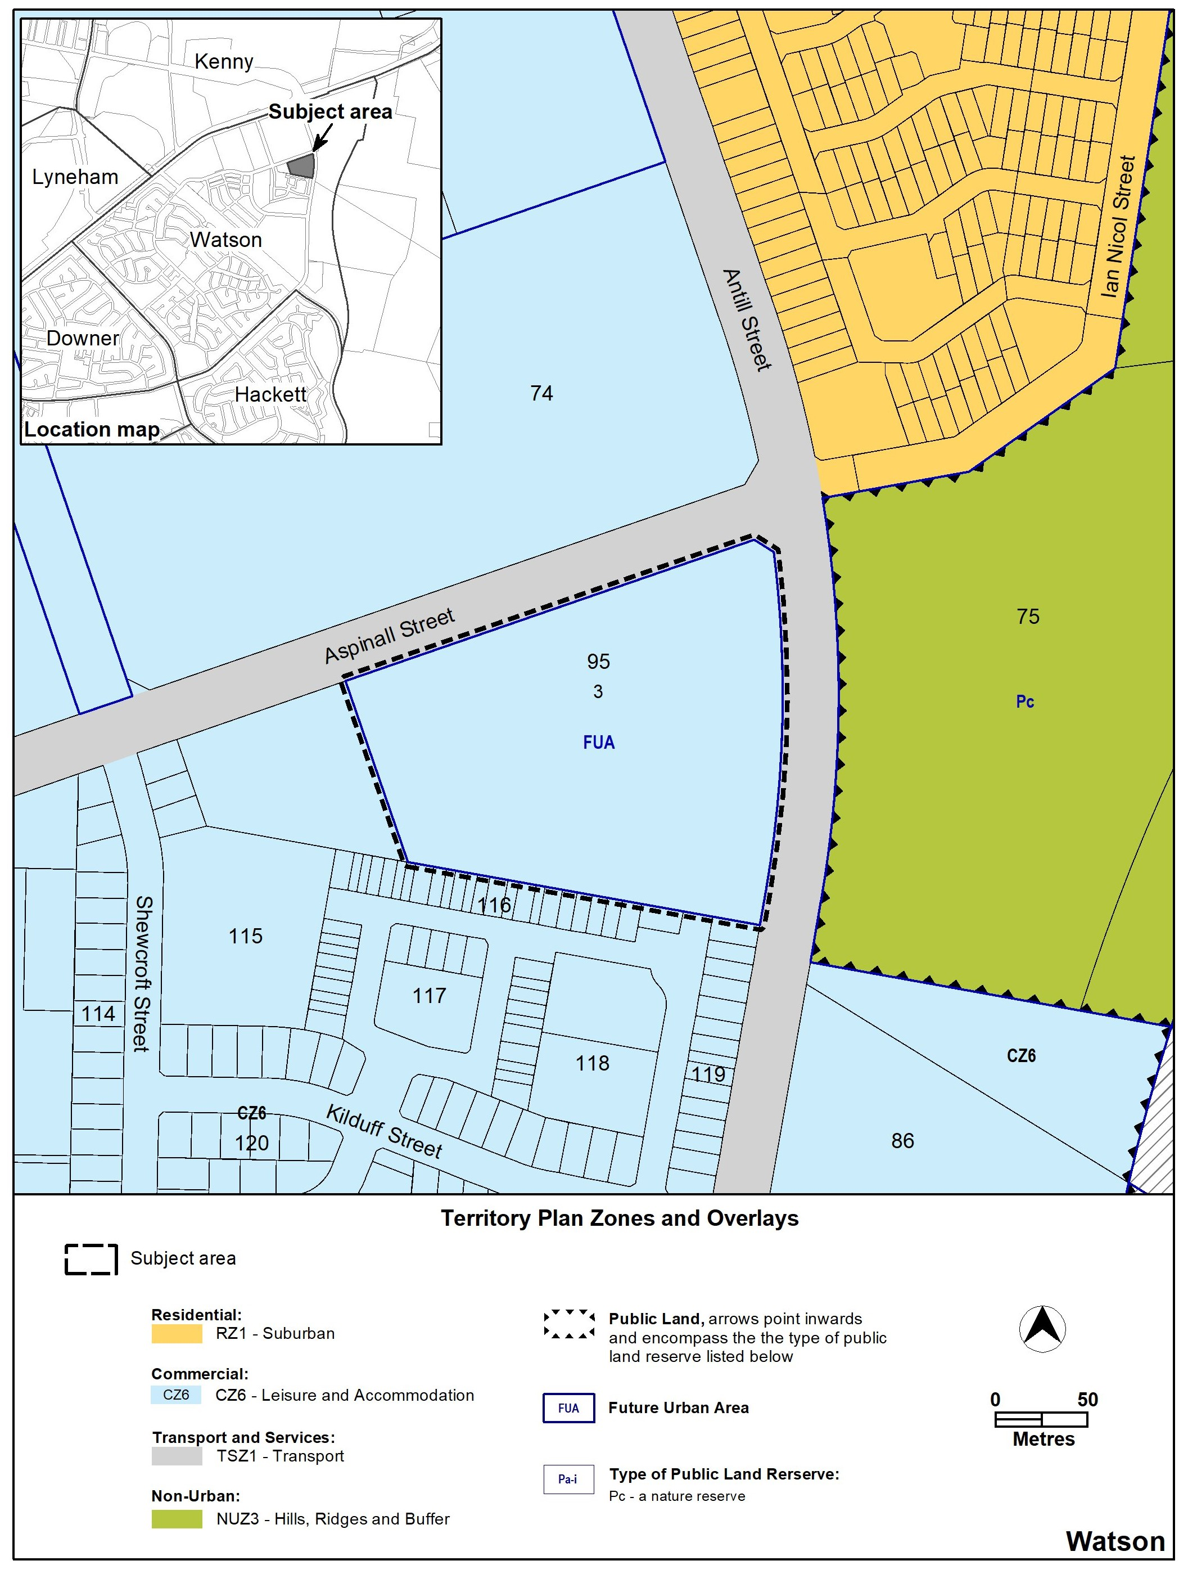
Figure 1 Locality map and previous Territory Plan zoning

  - Summary of amendments to the Territory Plan
MPA-C amends the Territory Plan to permit appropriate development on the site, as outlined in the supporting report, DPA-C proposes to amend the Territory Plan by rezoning Block 3 Section 95 Watson from CZ6 – Leisure and Accommodation Zone to RZ4 – Medium Density Residential Zone (Figure 2).

Further detail of the amendments being made to the Territory Plan by this MPA can be found in section 5 of this document.

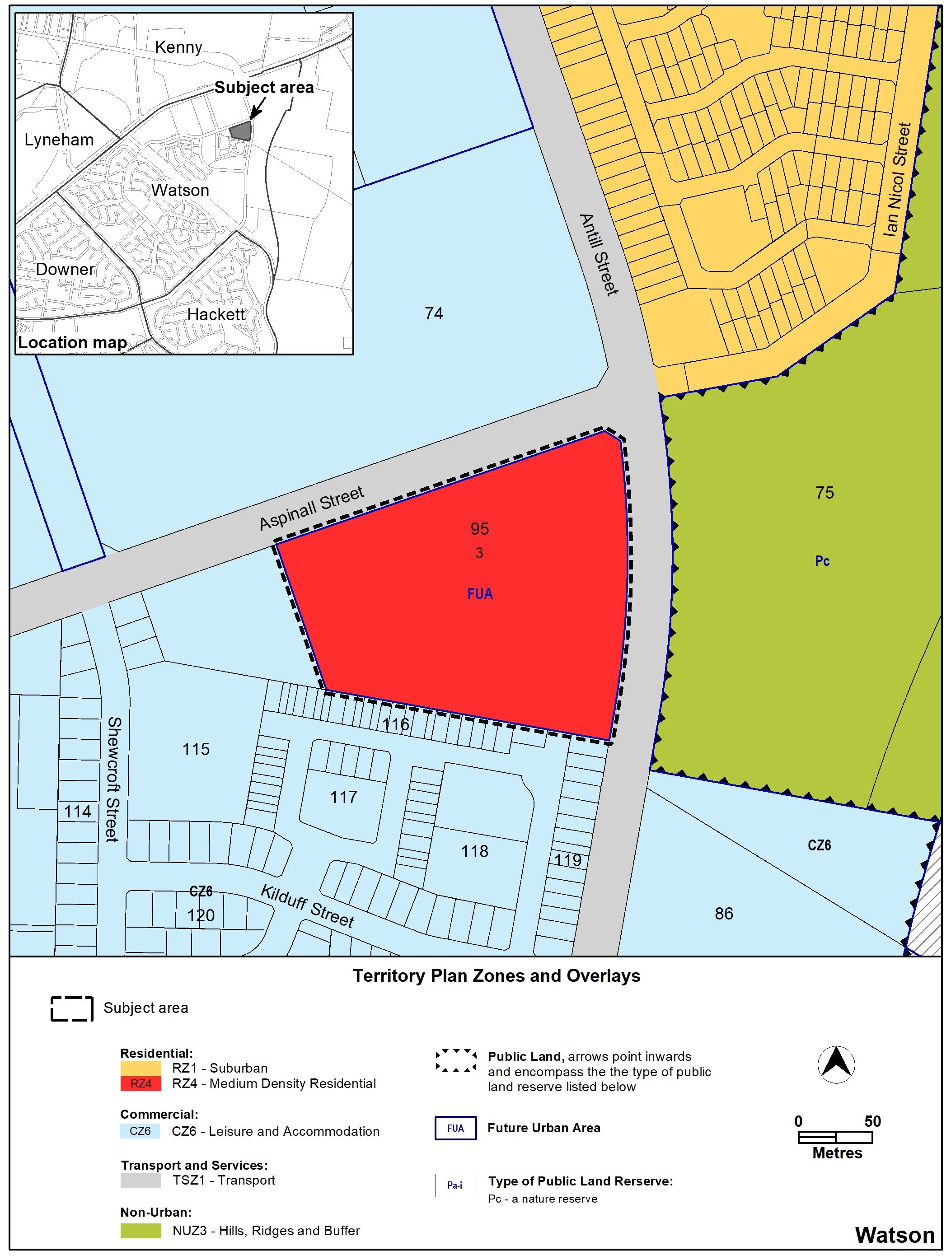
Figure 2 –Territory Plan zoning as amended by MPA-C
  - Summary of consequential amendments to other documents
Documents, such as the technical specifications and development controls are not part of the Territory Plan. Therefore, they cannot be amended as part of an MPA and must be amended separately when/if the DPA commences.

MPA-C does not propose to consequentially amend any other documents.

.

- NEED FOR THE MAJOR PLAN AMENDMENT
Canberra’s population is growing quickly, and the ACT only has a limited amount of available land for new suburbs. To manage future growth in a sustainable way, the majority of new housing is required to be provided within existing suburbs through urban infill and increased density. This provides the opportunity to make sure that current and future residents will have improved walkability to transport, high-quality services, employment, health, education and open space.

Located within the Inner North and City District, Block 3 Section 95 Watson has been identified as a category 1 change area in the Inner North and City District Strategy, where change could happen in the next 0-5 years. MPA-C aims to facilitate this change by rezoning the site to RZ4 and allowing medium density residential development, which looks to provide approx. 134 residential dwellings.

It is intended to provide dwellings of various densities, as shown in the masterplan provided and detailed further in the supporting report, including a mix of single residential blocks and multi unit blocks (containing townhouses and apartments). The range of low to medium density residential typologies are consistent with those in the surrounding North Watson area.

Providing this density of residential development is highly appropriate given the need for additional housing to achieve the ACT Government’s target of at least 70% urban infill and increased densities in existing urban areas. While increasing density, MPA-C considers the existing qualities of the suburb of Watson, particularly by making sure green spaces and trees are preserved, and that streetscapes are enhanced with careful consideration regarding the interface with the surrounding sites.

The supporting report provides further reasoning for the amendment proposed by this MPA. The supporting report is available on the EPSDD website.
  - Application 2023-01
Prior to the preparation of a proponent-initiated amendment, the proponent must lodge an application to be considered and accepted by the Authority. The application must be accompanied by a supporting report.

The supporting report must include how the proposal gives effect to the following ‘key documents’:
- the Planning Strategy
- the relevant District Strategy
- any current or proposed amendments to the Territory Plan
- the Statement of Planning Priorities
- anything else the Authority considers relevant.

In accordance with section 59 of the Planning Act, the Authority accepted application 2023-01 on 13 March 2024 as it was satisfied the intended development outlined in the supporting report gave effect to the ‘key documents’.

The Authority’s reasoning for this MPA can be found in section 3 of this document.
- CONSULTATION
  - Consultation with agencies
In accordance with section 62 of the Planning Act the Authority consulted with the following in relation to this MPA:
- the National Capital Authority
- the Conservator of Flora and Fauna
- the Environment Protection Authority
- the Heritage Council
- each referral entity
- if unleased or leased public land, each custodian of the land likely to be affected.

Comments received from these and other agencies were considered in the preparation of and by the Minister in approving this MPA.
  - Consultation with the public
Written comments were invited from the public on this MPA from 6 September 2024 until 21 October 2024.

Five comments were received during the public consultation period. The main matters raised were:
- objection to rezoning to RZ4 from CZ6
- need for more compact blocks
- concerns about building heights (amenity, solar access, overshadowing and overlooking
- concerns about traffic, access and parking, particularly on Antill Street
- need for a dog park and a men’s shed on the site

Changes were not made to MPA-C because of the above comments. This is because the matters raised have either been addressed or are more appropriately dealt with at the detailed design stage as part of a future development application for the site.

Comments received from the public during the consultation period were considered by the Minister in approving this MPA.

- MAJOR PLAN AMENDMENT C
This section details how MPA-C proposes to amend the Territory Plan.
  - Amendments to the Territory Plan Map
The relevant part of the Territory Plan map is varied in accordance with Figure 3

Figure 3 –Territory Plan Map as amended by MPA-3
INTERPRETATION SERVICE
To speak to someone in a language other than English please telephone the Telephone Interpreter Service (TIS) 13 14 50
LANGUAGE | DETAILS
English | If you need an interpreter please call: 13 14 50
Mandarin (Simplified Chinese) / 简体中文 | 如果您需要翻译，请致电：13 14 50
Arabic / العربية | إذا كنت بحاجة إلى مترجم شفهي اتصل بالرقم: 50 14 13
Cantonese (Traditional Chinese) / 繁體中文 | 如果你需要傳譯員，請致電：13 14 50
Vietnamese /  Tiếng Việt | Nếu bạn cần thông dịch viên, xin gọi: 13 14 50
Korean / 한국어 | 통역사가 필요할 경우 다음 번호로 전화하시기 바랍니다: 13 14 50
Spanish / Español | Si necesita un intérprete, llame al 13 14 50
Persian (Farsi) / فارسی | اگر به مترجم نیاز دارید، لطفاً به این شماره تلفن کنید: 50 14 13
Dari / دری | اگر به یک ترجمان شفاهی نیاز دارید لطفاً به شمارۀ 131450 زنگ بزنید.
Punjabi / ਪੰਜਾਬੀ | ਜੇਕਰ ਤੁਹਾਨੂੰ ਕਿਸੇ ਦੁਭਾਸ਼ੀਏ ਦੀ ਲੋੜ ਹੈ ਤਾਂ ਕਿਰਪਾ ਕਰਕੇ ਫੋਨ ਕਰੋ: 13 14 50
Tamil / தமிழ் | உங்களுக்கு மொழிபெயர்த்துரைப்பாளர் ஒருவர் தேவைப்பட்டால் 13 14 50 என்ற எண்ணை அழைக்கவும்
Greek / Ελληνικά | Αν χρειάζεστε διερμηνέα, τηλεφωνήστε: 13 14 50
Italian / Italiano | Se hai bisogno di un interprete, chiama: 13 14 50
Hazaragi / هزاره گی | اگه ده ترجمان ضرورت ده رید، لطفاً ده شماره 50 14 13 تماس بگیرید.
Thai / ภาษาไทย | หากคุณต้องการล่าม กรุณาโทรไปที่ 13 14 50
Karen / ကညီကျိၥ် | ဖဲနမ့ၢ်လိၣ်ဘၣ်ပှၤကတိၤကျိးထံတၢ်တဂၤအခါ၀ံသးစူၤကိးဘၣ်-၁၃၁ ၄၅၀ တက့ၢ်.

Telephone and Interpreter Service 13 14 50 - Canberra and District - 24 hours a day, seven days a week

