Australian Capital Territory
Heritage (Decision about Provisional Registration of Wesley Uniting Church Complex, Forrest) Notice 2025
Notifiable instrument NI2025–166
made under the
Heritage Act 2004, s 34 (Notice of decision about provisional registration)

1 Name of instrument
This instrument is the Heritage (Decision about Provisional Registration of Wesley Uniting Church Complex, Forrest) Notice 2025.
2 Commencement
This instrument commences on the day after its notification day.
3 Decision about Provisional Registration
On 8 April 2025, the ACT Heritage Council (the council) decided not to provisionally register Wesley Uniting Church Complex, Block 1, Section 32 Forrest (the place).
4 Description of the place
The description of the place is in the schedule.
5 Reasons for the decision
The council is not satisfied on reasonable grounds that the place is likely to have heritage significance as defined by the Heritage Act 2004, section 10. A detailed statement of reasons, including an assessment against the heritage significance criteria, is provided in the schedule.
6 Date decision takes effect
The decision not to provisionally register the place takes effect on 9 April 2025 (being the day after the council made its decision in writing as set out in the schedule).
Dr Mary Clare Swete Kelly
A/g Secretary (as delegate for)
ACT Heritage Council
8 April 2025

Schedule

(See sections 3 and 4)



Statement of Reasons
Decision Not to Provisionally Register
Wesley Uniting Church Complex, Forrest
Block 1, Section 32, Forrest
on the ACT Heritage Register
In accordance with s 32 of the Heritage Act 2004, the ACT Heritage Council has decided not to provisionally register the Wesley Uniting Church Complex, Forrest. This Statement of Reasons provides an assessment of the Wesley Uniting Church Complex, Forrest and finds that the place does not meet any of the criteria under s10 of the Heritage Act 2004.

Reasons for decision
The Council is not satisfied on reasonable grounds that the place is likely to have heritage significance as defined by s10 of the Heritage Act 2004.
This statement refers to the Council’s reasons for its decision as required in s 34(5)(b)(iv) of the Heritage Act 2004.

Location of the place
Wesley Uniting Church Complex, Forrest, also known as: the Wesleyan Church; Wesley Uniting Church and Manse; Wesley Methodist Church; Methodist National Memorial Church and Youth Centre; and the Church of Australian Methodism, Block 1, Section 32, 20-22 National Circuit, Forrest.
This statement refers to the location of the place as required in s 34(5)(b)(ii) of the Heritage Act 2004.

Description of the place
Whatever features are relevant to the heritage of the place;
The site is bound by Sydney Avenue to the north-east, National Circuit to the north-west, Fitzroy Street to the south-west and Dominion Circuit to the south. The church hall runs parallel to National Circuit and is in the southern half of the site. The church is at the centre of the site, perpendicular to the church hall. The manse addresses Sydney Avenue. Features of the site include:
- private car-parking areas at the front and rear of the site
- mature trees providing shade to parking areas
- two fenced tennis courts
- sound shell
- Lancaster Hall
- Wesley Hall and Vercoe Room
- Wesley Music Centre
- church containing organ, reredos and screens, artefacts and stained glass windows
- manse
- caretaker’s dwelling
- internal access roads
This section refers to the description of the place as required in s 34(5)(b)(iii) of the Heritage Act 2004. The boundary of the place and extent of features listed below is illustrated at Figure 1.

Assessment against the heritage significance criteria
This statement refers to the Council’s assessment of the place against the heritage significance criteria as a part of its reasons for its decision as required in s 34(5)(b)(iv) of the Heritage Act 2004.
The Council’s assessment against the criteria specified in s10 of the Heritage Act 2004 is as follows.
In assessing the heritage significance of Wesley Uniting Church Complex, Forrest, the Council considered:
- the original nomination and documentary evidence supplied by the nominator
- the Council’s Heritage Assessment Policy (March 2018)
- information provided by a site inspection on 09 December 2024 by ACT Heritage
- the report by ACT Heritage titled, Background Information Wesley Uniting Church Complex, March 2025, containing photographs and information on history, description, condition and integrity.
Pursuant to s10 of the Heritage Act 2004, a place or object has heritage significance if it satisfies one or more of the following criteria. Future research may alter the findings of this assessment.

(a) importance to the course or pattern of the ACT’s cultural or natural history
Does not meet criterion.
The Council has assessed Wesley Uniting Church Complex, Forrest against criterion (a) and is not satisfied that the place meets this criterion.
The subject site was allocated as part of the 1924 Church Lands Lease Ordinance of the Federal Capital Advisory Committee (FCAC), which established that each religious denomination with a presence in the Federal Capital Territory was exempt from taking a 99-year lease and granted a single lease at peppercorn rent in perpetuity, with a view to ensuring the spiritual needs of the population of the Federal Capital Territory would be met.
Although the site was allocated for the development of a national Methodist Church, the FCAC ordinance for a monumental church was not realised on this site until 1955, and by 1977 the site no longer represented the Methodist Church, but was one of several Uniting Churches in the ACT. The Methodist, Presbyterian and Congregationalist Churches agreed in the 1930s to construct a monumental church (St Andrew’s), which was registered under previous legislation, and remains a site of exceptional ecclesiastical architectural value to the Territory.
Whilst the FCAC ordinance is important to the course of the development of the federal capital, the Wesley Church in Forrest is not the only surviving example of the Church Lands Lease Ordinance, with St. Andrew’s Presbyterian Church (1934) and St Mark’s (1957) also built on planned cathedral sites. Instead, local churches built between 1924 and 1955 on more modest sites, for less money than required for the large cathedrals, found favour.
The site has an association in local history with the development of the ACT, and with the religious development of the region prior to the formation of the federal capital territory through its association with Weetangerra (separately listed) and Parkwood, however the site is not the best example of this ordinance, which was never fully realised. The Wesley Uniting Church Complex in Forrest is an example of an ecclesiastical precinct which was designed to represent the history of Methodism in the federal capital and of the planned co-operative functionality between the Methodist, Presbyterian and Congregational Churches in the early decades of the federal capital. Due to funding shortages and changing priorities the Wesley site was not fully realised.
The national monument to Methodism intended in the 1920s and 1930s and constructed in 1955 was funded by congregations around Australia, to reflect the history of Methodism in Canberra and the region, by incorporating artefacts from the 19th century as well as the contributing states. Whilst this illustrates the church is held in national significance to the Methodist and Uniting Churches, this does not demonstrate Territory significance under this criterion. The artefacts, whilst held by the church and displayed in the foyer, relate to the representations of states and territories who donated money to the building of a national monument to Methodism. The transfer of administration to the Uniting Church in the 1970s moved the church away from the original intention of a national Methodist cathedral. These artefacts have an important local significance to the history of the church but not to the ACT.
The first building on the site, the Cooperative Church Hall (1930), said to have been used as a church in the early years, was designed to represent Methodist, Presbyterian and Congregational churches, however that alone does not illustrate significance to the Territory. The manse/parsonage (1938) is locally significant in relation to the site and the church hall.
Whilst the church ordinance intended the nation’s capital would have monumental churches of prominence, and the Wesley Uniting Church Complex has been continually developed since the formation of the Federal Capital, many of the twenty-first century additions and alterations have obscured views into the site and have diluted the significance of the FCAC story on the site. Whilst it remains part of that story, other sites such as that of
St Andrew’s Presbyterian, provides a stronger example of this time in the development of the federal capital.

The Wesley Uniting Church is not unique in its history in relation to the church ordinance, is not the first church constructed under the ordinance and is not considered to have more than a local significance to the community.

(b) has uncommon, rare or endangered aspects of the ACT’s cultural or natural history
Does not meet criterion.
The Council has assessed Wesley Uniting Church Complex, Forrest against criterion (b) and is not satisfied that the place meets this criterion.
No evidence has been found of uncommon, rare or endangered aspects of the Territory’s cultural history. Long delays in development of the site as funds were raised, saw the erection of other Methodist and Presbyterian churches in the nearby suburbs. After the formation of the Uniting Church in 1977 the original intention of combining the denominations was realised, however this was not limited to this site. Although the plans for the site illustrate a local level of significance for the Canberra community, there is no evidence of any uncommon or rare contributions to Canberra’s cultural heritage.

(c) potential to yield important information that will contribute to an understanding of the ACT’s cultural or natural history
Does not meet criterion.
The Council has assessed Wesley Uniting Church Complex, Forrest against criterion (c) and is not satisfied that the place meets this criterion.
The Wesley Uniting Church site is an example of the FCAC planning for Churches for the wellbeing of the National Capital, however there is no evidence that this site has the potential to yield important information that would contribute to a wider understanding of the ACT’s cultural history.

(d) importance in demonstrating the principal characteristics of a class of cultural or natural places or objects
Does not meet criterion.
The Council has assessed Wesley Uniting Church Complex, Forrest against criterion (d) and is not satisfied that the place meets this criterion.
The principal characteristics of ecclesiastical Inter-War Gothic style, that of traditional cruciform floor plan, apse, transept, thematic chapel, asymmetrical massing of belltower and spire, buttressing enhancing the gothic character of the building, the interior of the church comprising tall expansive spaces, stained glass windows adding to verticality and ornate styling, are present in the church, although there are no ornate decorations such as gargoyles or carved stone figures. Whilst the church displays the principal characteristics of this class, it is not considered to be representative of its class to a Territory level of significance. The building is not known to have influenced other churches in the ACT and is not iconic or a landmark.
As an ecclesiastical complex the church contains an organ, notably not the first of its type in Australia. The organ has been significantly altered, combining the elements of three different organs, therefore does not have high degree of intactness.
Apperly et al (1995) state that Inter-War Gothic style of architecture is utilised almost exclusively in ecclesiastical architecture. This style is seen in registered examples including Canberra Baptist Church Precinct in Reid and the Uniting Church in Reid. This style is not rare in the ACT. There is no evidence that the Wesley Uniting Church displays any rare technical and design elements. The first example of Inter-War Gothic style of ecclesiastical architecture can be found at Reid Uniting Church. A more ornate example can be found at St Andrew’s.
Although it is known that the architect Norman McPherson did not subscribe to ornate buildings, and wrote publicly on church architecture, he contributed to the design and construction of several churches in Australia. Whilst several of his designs are discussed in relation to his life, this church is not mentioned other than in passing in accounts of his work, and it is not known to have influenced other later examples of his work.
nter-War Gothic – not largest or most ornate (St Andrew’s); - architect McPherson did not

(e) importance in exhibiting particular aesthetic characteristics valued by the ACT community or a cultural group in the ACT
Does not meet criterion.
The Council has assessed Wesley Uniting Church Complex, Forrest against criterion (e) and is not satisfied that the place meets this criterion.

The Methodist and Uniting Church communities value some design/aesthetic qualities of the Wesley Church, however there is insufficient evidence before the Council at this time to consider that the complex is highly valued by the broader ACT community for exhibiting outstanding design or aesthetic qualities. Despite its prominent location, as intended by the FCAC plan for landmark churches, there is insufficient evidence that the broader ACT community consider it a landmark. Twenty-first century additions obscure the original buildings and design.

(f) importance in demonstrating a high degree of creative or technical achievement for a particular period
Does not meet criterion.
The Council has assessed Wesley Uniting Church Complex, Forrest against criterion (f) and is not satisfied that the place meets this criterion.
Insufficient evidence of a high degree of either technical or creative achievement.
There is insufficient evidence before Council of a high degree of either technical or creative achievement. Wesley Uniting Church is a modest church in keeping with the 1950s, adjacent to the earlier hall of simple brick construction.

(g) has a strong or special association with the ACT community, or a cultural group in the ACT for social, cultural or spiritual reasons
Does not meet criterion.
The Council has assessed Wesley Uniting Church Complex, Forrest against criterion (g) and is not satisfied that the place meets this criterion.
Evidence of Methodist faith in ACT and was erected in part at a time of co-operative effort of
Methodism was present in the Territory prior to the selection of this site. The co-operative effort of several denominations was eventually realised with the formation of the Uniting Church and is evident in several Churches in Canberra. There is no evidence that these activities are in danger of being lost, nor is there sufficient evidence to suggest they are of exceptional interest within the wider ACT community. The Church is locally valued by Methodists/Wesleyans for its religious associations and activities, however there is insufficient evidence of its importance to a specific cultural group or to the broader community, beyond its primary ecclesiastical and local community function.

(h) has a special association with the life or work of a person, or people, important to the history of the ACT
Does not meet criterion.
The Council has assessed Wesley Uniting Church Complex, Forrest against criterion (h) and is not satisfied that the place meets this criterion.

Many notable people have had associations with the church including members of the congregation, who are memorialised in artefacts, lead lighting, artwork and the names of buildings on the site, as seen in many Churches in the ACT. None of these associations appear to be linked with the history of the ACT.

It is noted that Methodist churches of the time rarely had more than three crosses, and that the contrasting brick of the fourth cross dedicated to migrant bricklayers of the church, is unusual. There are other examples in Canberra of migrant workers being acknowledged after WWII including the Holy Trinity Lutheran Church in Turner (1961) where the migrant Finnish community’s post-WW2 migration, when part of Finland was annexed by the then USSR, was commemorated. There is no evidence that the Wesley Church Complex has a special association with the life or work of a person, or people, important to the history of the ACT.

Nominated area
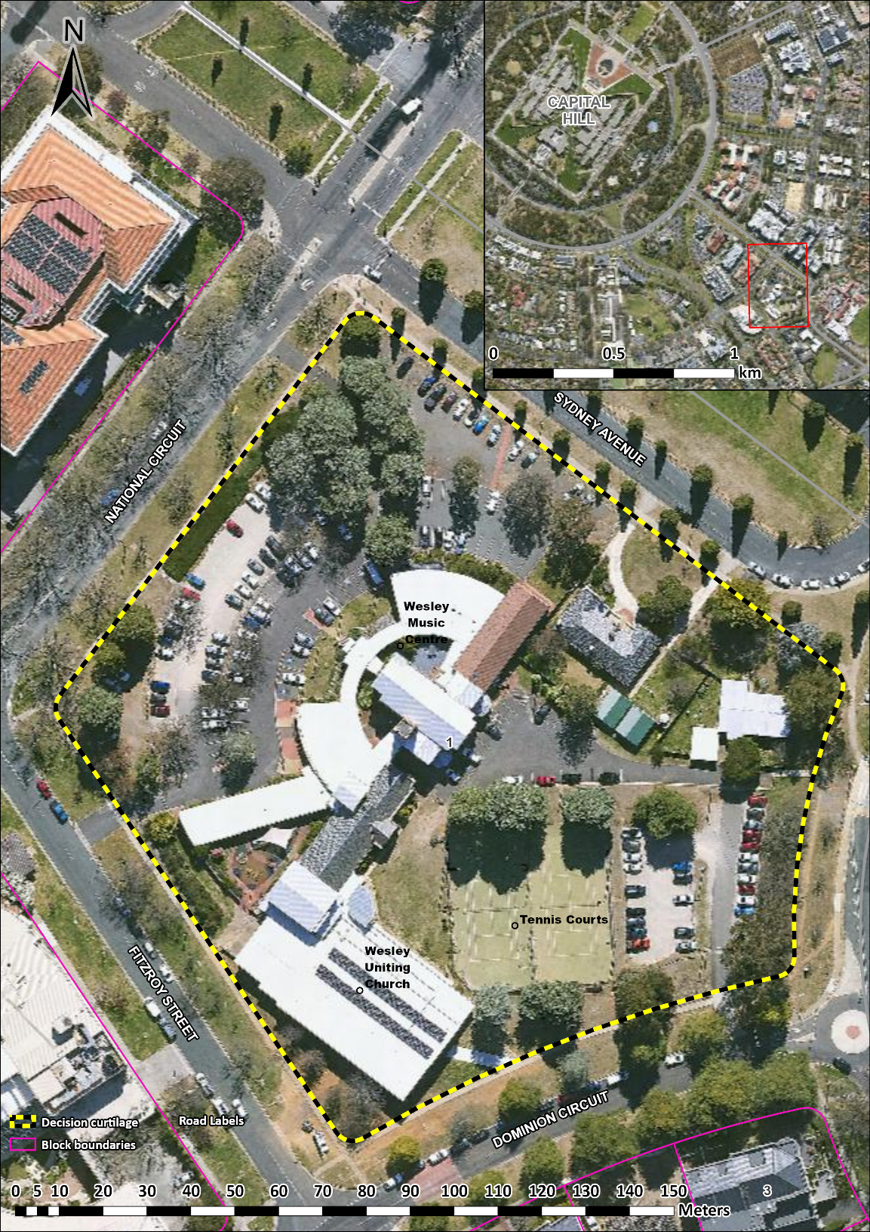
Figure 1 - Decision boundary.

