Australian Capital Territory
Work Health and Safety (Tower Crane Code of Practice) Approval 2025
Notifiable instrument NI2025-173
made under the
Work Health and Safety Act 2011, section 274 (Approved Codes of Practice)

1 Name of instrument
This instrument is the Work Health and Safety (Tower Crane Code of Practice) Approval 2025.
2 Commencement
This instrument commences on 4 August 2025.
3 Code of Practice Approval
Under section 274 of the Work Health and Safety Act 2011 (the Act) and being satisfied that this code of practice was developed by a process described in s274 (2) of the Act, I approve the attached Tower Crane Code of Practice.
4 Revocation
This instrument revokes Work Health and Safety (Tower Crane Code of Practice) 2022 [NI2022-432].

Michael Pettersson
Minister for Skills, Training and Industrial Relations
13 April 2025



Tower Crane

  - Code of Practice
March 2025

Disclaimer
This code is based on a national model code of practice developed by Safe Work Australia under the national harmonisation of work health and safety legislation and has been approved under section 274 of the Work Health and Safety Act 2011 (ACT), following the legislated consultation.
This code of practice commenced in the Australian Capital Territory on the date it was published on the ACT Legislation Register.
Safe Work Australia is an Australian Government statutory agency established in 2009. Safe Work Australia includes Members from the Commonwealth, and each state and territory, Members representing the interests of workers and Members representing the interests of employers.
Safe Work Australia works with the Commonwealth, state and territory governments to improve work health and safety and workers’ compensation arrangements. Safe Work Australia is a national policy body, not a regulator of work health and safety. The Commonwealth, states and territories have responsibility for regulating and enforcing work health and safety laws in their jurisdiction.
ISBN 978-0-642-33299-8 (PDF)
ISBN 978-0-642-33300-1 (DOCX)
Creative Commons
This copyright work is licensed under a Creative Commons Attribution-Non-commercial 4.0 International licence. To view a copy of this licence, visit creativecommons.org/licenses In essence, with the exception of the ACT Government Logo, you are free to copy, communicate and adapt the work for non- commercial purposes, as long as you attribute the work to Safe Work Australia and abide by the other licence terms.
Contact information
Safe Work Australia | info@swa.gov.au | www.swa.gov.au

Contents
Tower Crane 2
Foreword 6
Scope and application 6
How to use this code of practice 6
1. Introduction 7
1.1 What is a tower crane? 7
1.2 Who has health and safety duties in relation to tower cranes? 8
1.3 What is involved in managing risks associated with tower cranes? 13
1.4 Information, training, instruction and supervision 16
1.5 Safe work method statements 19
2. The risk management process 20
2.1 Identifying the hazards 20
2.2 Assessing the risks 22
2.3 Controlling the risks 24
2.4 Maintaining and reviewing control measures 25
3. Before using a tower crane 27
3.1 Planning the work 27
3.2 Selecting a tower crane 27
3.3 Registering a tower crane 29
3.4 Crane siting 31
3.5 Pre-erection inspection and testing 39
3.6 Erecting, commissioning, and dismantling 40
3.7 Crane design loads and controls (stability) 43
3.8 Falls from height and tower crane access 48
3.9 Lighting 52
3.10 Emergency planning and safety equipment 53
4. Using a tower crane 57
4.1 Proper use 57
4.2 High risk work licence 57
4.3 Crane crew 58
4.4 Communication 59
4.5 Pre-start and operational checks 60
4.6 Lifting or suspending loads 61
4.7 Remote operation 70
4.8 Cranes not in use 71
5. Inspecting and maintaining a tower crane 72
5.1 Record keeping 72
5.2 Routine inspection and maintenance 73
5.3 Major inspection 74
5.4 Non-destructive testing of tower crane components 78
Appendix A—Glossary 81
Appendix B—References and other information sources 84
Appendix C: Familiarisation training checklists 85
Appendix D: Example - Annual crane safety certificate 89
Appendix E: Example - Crane safety certificate – major inspection 90

Foreword
This Code of Practice on tower cranes is an approved code of practice under section 274 of the Work Health and Safety Act 2011 (the WHS Act).
An approved code of practice provides practical guidance on how to achieve the standards of work health and safety required under the WHS Act and the Work Health and Safety Regulations 2011 (the WHS Regulations) and effective ways to identify and manage risks.
A code of practice can assist anyone who has a duty of care in the circumstances described in the code of practice. Following an approved code of practice will assist the duty holder to achieve compliance with the health and safety duties in the WHS Act and WHS Regulations, in relation to the subject matter of the code of practice. Like regulations, codes of practice deal with particular issues and may not cover all relevant hazards or risks. The health and safety duties require duty holders to consider all risks associated with work, not only those for which regulations and codes of practice exist.
Codes of practice are admissible in court proceedings under the WHS Act and WHS Regulations. Courts may regard a code of practice as evidence of what is known about a hazard, risk, risk assessment or risk control and may rely on the code in determining what is reasonably practicable in the circumstances to which the code of practice relates. For further information see the Interpretive Guideline: The meaning of ‘reasonably practicable’.
Compliance with the WHS Act and WHS Regulations may be achieved by following another method if it provides an equivalent or higher standard of work health and safety than the code.
An inspector may refer to an approved code of practice when issuing an improvement or prohibition notice.
In circumstances where equipment, or methods, for managing WHS risks are used in the workplace, it is recommended that current Australian standards or recognised international standards are applied, where available. Refer Appendix B of this Code for referenced Australian/New Zealand Standards.

Scope and application
This Code is intended to be read by a person conducting a business or undertaking (PCBU). It provides practical guidance to PCBUs on managing health and safety risks of working with tower cranes.
This Code may be a useful reference for other persons interested in the duties under the WHS Act and WHS Regulations.
This Code applies to all workplaces covered by the WHS Act and WHS Regulations where a tower crane is operated and where tower crane equipment is used or stored.

How to use this code of practice
This Code includes references to the legal requirements under the WHS Act and WHS Regulations. These are included for convenience only and should not be relied on in place of the full text of the WHS Act or WHS Regulations. The words ‘must’, ‘requires’ or ‘mandatory’ indicate a legal requirement exists that must be complied with.
The word ‘should’ is used in this Code to indicate a recommended course of action, while ‘may’ is used to indicate an optional course of action.

1. Introduction

1.1 What is a tower crane?
A crane means an appliance intended for raising or lowering a load and moving it horizontally including the supporting structure of the crane and its foundations, but does not include any of the following:
- an industrial lift truck
- earthmoving machinery
- an amusement device
- a tractor
- an industrial robot
- a conveyor
- building maintenance equipment
- a suspended scaffold
- a lift.
Tower crane means a crane that has a boom or a jib mounted on a tower structure.
The three general types of crane typically referred to as tower cranes used in Australia are hammerhead (including flat top), luffing (including hydraulic luffing jib), and self-erecting.
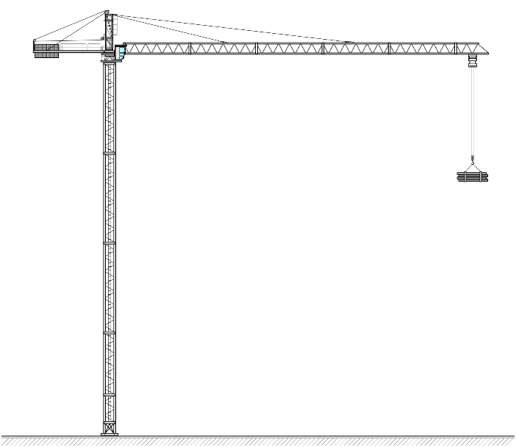  Figure 1 Hammerhead tower crane | 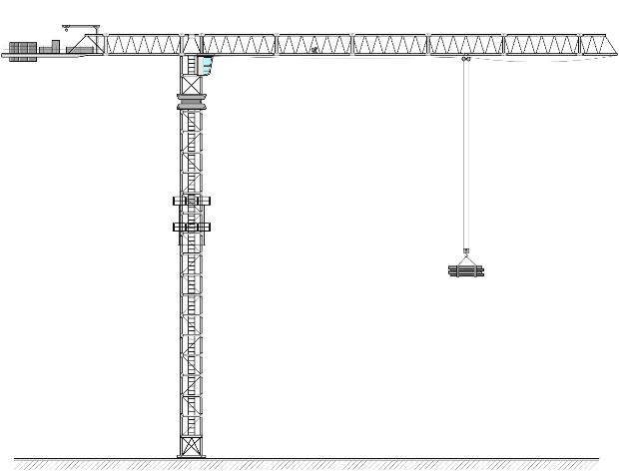  Figure 2 Flat top tower crane
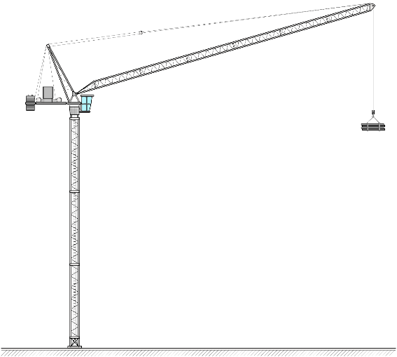  Figure 3 Luffing jib tower crane | 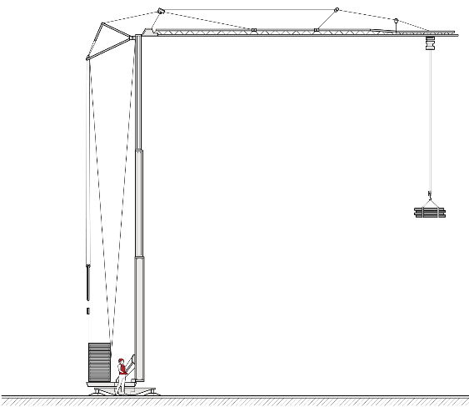  Figure 4 Self-erecting tower crane
For high risk work licensing purposes, a tower crane (if a jib crane) may be a horizontal or luffing jib type and the tower structure may be demountable or permanent. Using a tower crane requires a tower crane high risk work licence.
Using a self-erecting tower crane requires a high risk work licence to operate a self erecting tower crane rather than a tower crane licence. A self-erecting tower crane is a tower crane that is not disassembled into a tower element and a boom or jib element in the normal course of use, and where erecting and dismantling processes are an inherent part of the crane's function.

1.2 Who has health and safety duties in relation to tower cranes?
There are a number of duty holders who have a role in managing the risks of tower cranes in the workplace. These include:
- PCBUs
- officers and principal contractors
- designers, manufacturers, importers, suppliers of plant, substances, and structures
- workers; and
- other persons in the workplace, such as visitors.
A person can have more than one duty and more than one person can have the same duty at the same time. Each PCBU in the supply or contractual chain must ensure, so far as is reasonably practicable, the health and safety of all workers that they engage, cause to engage, influence or direct; and must consult all workers that carry out work for them on health and safety issues.
There are generally a number of people involved with a tower crane during its lifecycle. For example, different people will be involved from its design through to its use and eventual disposal. Throughout this process, a person can have more than one duty, and more than one person can have the same duty at the same time.
For example, if you own and operate a tower crane and you decide to modify it yourself, you will have the duties of a designer and manufacturer as well as a person with management or control of plant at the workplace.

Contractual chain
SWA provides additional information for PCBUs who are working as part of a contractual chain – WHS duties in a contractual chain: Factsheet. This information may assist duty holders understand how individual contractors, including principal contractors, tower crane contractors, and self-employed persons may have the same duty at the same time, or may be both a PCBU and a worker.
Contracting is when a business engages another business to carry out work under a contract agreement. A contractual chain refers to the situation where, in relation to the same project or work matter, there are multiple contractors and subcontractors. There can be several levels in a contractual chain. For example, in commissioning a project a person may engage a head contractor (for example a principle contractor for construction projects, or a contractor with overarching responsibilities and management of the work) to deliver a construction project. The head contractor may engage contractors to undertake parts of the project, and these contractors may engage subcontractors to carry out activities that the contractor is to deliver.
Note: the WHS Act defines a major construction project as a project involving construction work with a contract price that is more than $5,000,000.
Where multiple contractors are on site over a period of time, working together on a project, they will each have duties under the WHS Act to the extent of their control. Their duties are not limited because someone else has the same or overlapping duties. Each person with a duty must ensure that they have complied with the law and should consult with other duty holders to ensure that action is being taken.
An example of contractual chain is shown below:
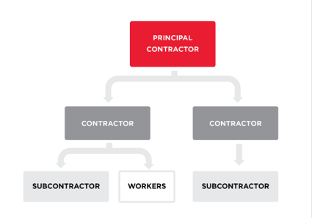
Figure 1 (above) – shows the relationship between the principal contractor, contractors, and subcontractors. It is good practice to understand your part in a contractual chain, as it will help you understand who you may owe WHS duties to and who may owe you a duty of care and allow for necessary consultation about these duties.

Person conducting a business or undertaking
WHS Act section 19
Primary duty of care
A PCBU has a primary duty to ensure the health and safety of workers while they are at work in the business or undertaking and others who may be affected by the carrying out of work, such as visitors.
A PCBU must eliminate or minimise (so far as is reasonably practicable) health and safety risks in the workplace and ensure (so far as is reasonably practicable) the health and safety of all workers.
The WHS Regulation includes more specific requirements for PCBUs to manage the risks associated with plant and structures, including tower cranes.
The primary duty of care requires PCBUs to ensure so far as is reasonably practicable the:
- provision and maintenance of a safe work environment
- provision and maintenance of safe systems of work
- provision of accessible and adequate facilities (for example access to washrooms, lockers, and dining areas)
- provision of any instruction, training, information, and supervision; and
- monitoring of workers health and conditions at the workplace.
PCBUs have a duty to consult workers about WHS and may also have duties to consult, cooperate and coordinate with other duty holders.
PCBUs are also required to work through the hierarchy of controls when managing risks associated with construction work and implement control measures from the highest level of protection through to the lowest.
Section 2.3 of this Code provides more information about the hierarchy of controls.

Further duties of persons conducting businesses or undertakings
WHS Act, section 20
Duty of PCBU involving management or control of workplaces
WHS Act, section 21
Duty of PCBU involving management or control of fixtures, fittings or plant at the workplaces
The person with management or control of a workplace must ensure, so far as is reasonably practicable, that the workplace, the means of entering and exiting the workplace and anything arising from the workplace are without risks to the health and safety of any person.
For example, the person with management or control of the workplace must take reasonable steps to ensure that information on underground essential services or ground conditions is obtained before allowing excavation work or erection work commences.
The person with management, or control of fixtures, fittings or plant at a workplace must also ensure, so far as is reasonably practicable, that the fixtures, fittings and plat are without risks to the health and safety of any person, including requirements to:
- manage the health and safety risks associated with plant
- prevent unauthorised alterations to or interference with plant, and
- use plant only for the purpose for which it was designed unless the proposed use does not increase the risk to health or safety.
The person with management or control of a tower crane is often the crane owner but may also be the principal contractor of a construction project or another PCBU.

Additional duties of principal Contractor
WHS Act, Part 4, Division 5.3
WHS Regulation, Part 6.4
The WHS Act provides that a principal contractor is required for a construction project where the value of the construction work is $250 000 or more.
The principal contractor must ensure, so far as is reasonably practicable, that the health and safety of workers and others is not put at risk from work carried out by the PCBU.
The principal contractor has duties to ensure the construction work is planned and managed in a way that eliminates or minimises health and safety risks so far as is reasonably practicable.
The principal contractor for a construction project must prepare a written WHS management plan for the workplace before work on the project commences. This includes any arrangements in place for managing any WHS incidents that occur and any site-specific health and safety rules.
The principal contractor must also ensure, so far as is reasonably practicable, that each person who is to carry out construction work in connection with a project is, before commencing work, made aware of the WHS management plan.
A construction project has only one (1) principal contractor at any specific time.

Designers, manufacturers, importers and suppliers of plant or structures
WHS Act, section 22
Duties of persons conducting businesses or undertakings that design plant, substances or structures
WHS Act, section 23
Duties of persons conducting business or undertakings that manufacture plant, substances or structures
WHS Act, section 24
Duties of persons conducting businesses or undertakings that import plant, substances or structures
WHS Act, section 25
Duties of persons conducting businesses or undertakings that supply plant, substances or structures
Designers, manufacturers, importers and suppliers of plant, substances or structures must ensure, so far as is reasonably practicable, the plant, substances or structure they design, manufacture, import or supply is without risks to health and safety. This duty includes carrying out testing and analysis as well as providing specific information about the plant.
To assist in meeting these duties, the WHS Regulations require:
- manufacturers to consult with designers of the plant,
- importers and suppliers to consult with designers and manufacturers of plant.

Installers, constructors, and commissioners of plant, substances or structures
WHS Act, section 26
Duties of persons conducting businesses or undertakings that install, construct or commission plant or structures

The WHS Regulations include specific duties for PCBUs that install, construct, or commissions plant or a structure that is to be used, or could reasonably be expected to be used, as, or at, a workplace. This includes ensuring, so far as is reasonably practicable, that the way in which the plant or structure is installed, constructed, or commissioned ensures that the plant or structure is without risks to the health and safety of persons:
- who install or construct the plant or structure at a workplace; or
- who use the plant or structure at a workplace for a purpose for which it was installed, constructed or commissioned; or
- who carry out any reasonably foreseeable activity at a workplace in relation to the proper use, decommissioning or dismantling of the plant or demolition or disposal of the structure; or
- who are at or in the vicinity of a workplace and whose health or safety may be affected by any such work.

Officers
WHS Act, section 27
Duty of officers
Officers, for example company directors, have a duty to exercise due diligence to ensure the PCBU complies with the WHS Act and WHS Regulation. This includes taking reasonable steps to ensure the business or undertaking has and uses appropriate resources and processes to eliminate or minimise risks to health and safety. Further information on who is an officer and their duties is available in the Interpretive Guideline: The health and safety duty of an officer under section 27.

Workers
WHS Act, section 28
Duties of workers
As defined in the WHS Act, workers include employees, contractors and subcontractors and their employees, labour hire workers, outworkers, apprentices, trainees, work experience students and volunteers. Workers have a duty to take reasonable care for their own health and safety and they must take reasonable care that their acts or omissions do not adversely affect the health and safety of other persons. Workers must:
- comply with reasonable instructions including training, as far as they are reasonably able
- cooperate with reasonable health and safety policies that have been notified to workers, if they have been told about it beforehand; and
- if personal protective equipment (PPE) is provided by the business or undertaking, the worker must, so far as they are reasonably able, use or wear it in accordance with the information and instruction and training provided.

Other persons at the workplace
WHS Act, section 29
Duties of other persons at the workplace
Other persons at the workplace, like visitors, must take reasonable care for their own health and safety and must take care not to adversely affect other people’s health and safety. They must comply, so far as they are reasonably able, with reasonable instructions given by the PCBU to allow that person to comply with the WHS Act.

1.3 What is involved in managing risks associated with tower cranes?
WHS Regulation, sections 32–38
Managing risks to health and safety
WHS Regulation, section 203
Management of risks to health and safety
Tower crane operations may present a risk of injury to persons from:
- structural or mechanical failure and collapse
- contact or collision with other plant, structures, or people
- arcing or flashover from an energised overhead or underground electric line
- falling objects
- person falling from height
- extreme weather and related damage or collapse
- fire and related damage or collapse
- noise
- fatigue, or
- psychosocial hazards (e.g. high job demands, remote or isolated work, or poor physical environments).
As a PCBU, you must manage the risks associated with tower cranes using the following systematic process:
- Identify hazards—find out what could cause harm.
- Assess risks—understand the nature of the harm that could be caused by the hazard, how serious the harm could be and the likelihood of it happening. This step may not be necessary if you are dealing with a known risk with known controls.
- Eliminate risks, so far as is reasonably practicable.
- Control risks—if it is not reasonably practicable to eliminate the risk, minimise the risk by implementing the most effective control measures that are reasonably practicable in the circumstances in accordance with the hierarchy of control measures, and ensure they remain effective over time.
- Review control measures to ensure they are working as planned.
Chapter 2 of this Code provides guidance on how to manage the risks associated with tower cranes in the workplace by following the hierarchy of control measures.
Further guidance on the risk management process is in the Code of Practice: How to manage work health and safety risks.

Psychosocial risks
WHS Regulation, section 55C
Duty Managing psychosocial risks
WHS Regulation, section 55D
Psychosocial risks, control measures
A PCBU must ensure, so far as is reasonably practicable, workers and other persons are not exposed to risks to their psychological health and safety at work. A PCBU must eliminate psychosocial risks in the workplace, or if that is not reasonably practicable, minimise these risks so far as is reasonably practicable.
Further information on how to manage psychosocial hazards in the workplace can be found in the Code of Practice: Managing psychosocial hazards at work.

Consulting workers
WHS Act, section 47
Duty to consult workers
WHS Act, section 48
Nature of consultation
As a PCBU, you must consult, so far as is reasonably practicable, with workers who carry out work for the business or undertaking and who are (or are likely to be) directly affected by a health and safety matter.
This duty to consult is based on the recognition that worker input and participation improves decision-making about health and safety matters and assists in reducing work-related injuries, diseases and illnesses.
The broad definition of a ‘worker’ under the WHS Act means a PCBU must consult, so far as is reasonably practicable, with contractors and subcontractors and their employees, on-hire workers, outworkers, apprentices, trainees, work experience students, volunteers and other people who are working for the PCBU and who are, or are likely to be, directly affected by a health and safety matter.
Workers are entitled to take part in consultations and to be represented in consultations by a health and safety representative who has been elected to represent their work group.
Workers usually know the hazards and risks associated with the plant they use. By drawing on the experience, knowledge and ideas of workers it is more likely hazards will be identified so that effective control measures can be implemented.
Workers should be encouraged to report hazards and health and safety problems immediately so the risks can be managed before an incident occurs.
It is important to consult workers as early as possible when planning to introduce new plant or change the way plant is used.

Consulting, cooperating and coordinating activities with other duty holders
WHS Act, section 46
Duty to consult with other duty holders
As a PCBU, you must consult, cooperate and coordinate activities with all other persons who have a work health or safety duty in relation to the same matter, so far as is reasonably practicable.
There is often more than one business or undertaking involved in managing risks of plant in the workplace. Each may have responsibility for the same health and safety matters, either because they are involved in the same activities or share the same workplace.
In these situations, each duty holder should exchange information to find out who is doing what and work together in a cooperative and coordinated way so risks are eliminated or minimised, so far as is reasonably practicable.
If using a crane at a workplace shared with other businesses, the plant owner or manager should talk to those businesses about the risks the plant could cause them and work together in a cooperative and coordinated way to manage the risks.
Further guidance on consultation is available in the. Work Health and Safety Consultation, Coordination and Cooperation Code of Practice 2023

1.4 Information, training, instruction and supervision
WHS Act, section 19
Primary duty of care
WHS Regulation, section 39
Provision of information, training and instruction
WHS Regulation, section 204
Control of risks arising from installation or commissioning
Using a tower crane requires a high risk work licence. Find more information on high risk work licences in Chapter 4.
As a PCBU, you must ensure, so far as reasonably practicable, the provision of any information, training, instruction or supervision that is necessary to protect all persons from risks to their health and safety arising from work carried out as part of the conduct of the business or undertaking. This includes refresher training. Training should be provided by a competent person. High risk work licences are issued by WHS regulators, and require the relevant qualification issued by a Registered Training Organisation.
You must ensure that information, training or instruction provided to a worker are suitable and adequate having regard to:
- the nature of the work carried out by the worker
- the nature of the risks associated with the work at the time the information, training and instruction is provided, and
- the control measures implemented.

familiarisation training
Tower cranes can be fundamentally different in their design, mode of operation, control layout and configuration. This is particularly the case when comparing tower cranes across the three basic categories—luffing, hammerhead and self-erecting tower cranes.
Before a person commences work as a crane operator, the PCBU of the person should:
- assess the person’s knowledge and understanding of safe crane operation
- seek further evidence of competence
- provide additional training prior to allowing the person to work.
Familiarisation training provides crane operators with an opportunity to become familiar with the design, layout and operating functions of a specific tower crane. It should be provided to crane operators prior to commencing work for a new PCBU or prior to working with a crane that has been newly acquired by their PCBU. This process may require the presence of a representative from the tower crane supplier or manufacturer, particularly when the crane is new. The representative from the tower crane supplier or manufacturer should have detailed knowledge of the operational and safety features of the crane in question. The representative from the tower crane supplier or manufacturer should also be endorsed by the crane supplier or manufacturer as being competent to provide familiarisation training.

Familiarisation should include:
- the particular model of crane to be operated, its characteristics, functions and limitations
- the information in the crane’s operating manual
- the crane’s load chart, including all notes and warnings, and how to calculate or determine the crane’s actual net capacity in every possible configuration
- how to safely access and exit the tower crane
- Safe Work Method Statements (SWMS) for tower crane operations involved in high risk construction work
- any site conditions that may affect crane operations, including wind conditions, the presence of energised overhead or underground electric lines, nearby structures or other cranes or mobile plant
- how to carry out inspections, shut-down, cleaning, repair and maintenance
- emergency procedures, including crane malfunctions and rescue procedures
- the correct use of guarding and other control measures, and
- the proper use, wearing, storage and maintenance of PPE.
A record of familiarisation training should be made and kept by the PCBU of the crane operator. A copy of the training record should also be given to and kept by the crane operator.
PCBUs may consider using the familiarisation training checklist at Appendix C of this Code to assist in recording details about how to safely operate the crane. Refer to Appendix C: Familiarisation training checklists.
Evidence should again be sought from all crane crew personnel, and further information, training, instruction or supervision provided, when changes are made to the crane crew.
The PCBU must ensure, so far as is reasonably practicable, that the information, training and instruction are provided in a way that is readily understandable for the person to whom it is provided.
PCBUs should also ensure that persons who work as part of a crane crew (e.g. crane operators, doggers and riggers) receive refresher training. Refresher training may be provided by:
- the PCBU
- an independent consultant
- a third party (e.g. registered training organisation).
Refresher training should be made available on an ongoing basis to ensure that crane operators, doggers and riggers maintain the competencies originally achieved in the relevant licence class for performing high risk work. It is particularly relevant for persons who have not continuously performed work in a class of high risk work.
Refresher training should reflect issues such as:
- the application of new technology, particularly for those persons who obtained their license class while working on more basic cranes
- information in this code
- any relevant changes to work health and safety legislation and Australian Standards which may have an impact on safe crane operations
- safe crane operation.
Refresher training may include:
- conducting a training needs analysis to identify the particular training needs of individual workers
- providing theoretical information, where required
- providing practical demonstration and supervision.

Record of refresher training
It is good practice to keep a documented record of refresher training undertaken by crane operators, doggers and riggers. such as in a logbook.
The record should consist of the following information:
- the person’s name, address and signature
- the person’s relevant classes of high risk work and licence numbers
- the name and signature of the person conducting the training
- the dates and times of the training
- details of the training, including where appropriate, the type of equipment used or operated and the outcomes achieved.
As a person with management or control of plant, you must also provide the necessary safety information to persons who are involved in installing, commissioning, testing, maintaining or repairing plant, as well as decommissioning, dismantling or disposing of the plant. This should include information on the types of hazards and risks the plant may pose to the person when they are carrying out these activities.
Emergency instructions relating to an item of plant should be clearly displayed on or near it.

General construction induction training
WHS Regulation, section 316
Duty to provide general construction induction training
WHS Regulation, section 317
Duty to ensure worker has been trained
A PCBU must ensure that general construction induction training is provided to a worker engaged by the person who is to carry out construction work, if the worker:
- has not successfully completed general construction induction training, or
- successfully competed general construction induction training more than 2 years previously and has not carried out construction work in the preceding 2 years.
A PCBU must not direct or allow a worker to carry out construction work unless:
- the worker has successfully completed general construction induction training, and
- if the worker completed the training more than 2 years previously—the worker has carried out construction work within the preceding 2 years.

1.5 Safe work method statements
WHS Regulation, section 299
Safe work method statement required for high risk construction work
Generally, using a tower crane is high risk construction work. This means it requires a safe work method statement (SWMS).
A SWMS is a written document that must identify the high risk construction work activities to be carried out at a workplace, the hazards and risks to health and safety arising from these activities, the measures to be implemented to control the risks and how the control measures are to be implemented, monitored and reviewed.
The primary purpose of a SWMS is to help PCBUs, supervisors and workers implement and monitor the control measures established at the workplace to ensure high risk construction work is carried out safely.

Who is responsible for preparing a SWMS?
A PCBU must prepare a SWMS—or ensure a SWMS has been prepared—before high risk construction work starts.
The person responsible for carrying out the high risk construction work is best-placed to prepare the SWMS in consultation with workers who will be directly engaged in the high risk construction work.
If more than one PCBU has the duty to ensure a SWMS is or has been prepared, they must consult and cooperate with each other to coordinate who will be responsible for preparing it.

Consultation
Workers and their health and safety representatives, if any, must be consulted when preparing a SWMS. If there are no workers engaged at the planning stage, consultation must occur with workers when the SWMS is first made available to workers, for example during workplace-specific training or a toolbox talk. Workers and their health and safety representatives, if any, must also be consulted when a SWMS is reviewed.

2. The risk management process
WHS Regulation, section 34
Duty to identify hazards
WHS Regulation, section 35
Managing risks to health and safety
WHS Regulation, section 36
Hierarchy of control measures
WHS Regulation, section 37
Maintenance of control measures
WHS Regulation, section 38
Review of control measures
WHS Regulation, section 297
Management of risks to health and safety
WHS Regulation, section 299
Safe work method statement required for high risk construction work.

2.1 Identifying the hazards
The first step in the risk management process is to identify all hazards associated with a tower crane in a workplace. This involves finding things and situations that could potentially cause harm to people. Hazards generally arise from the following aspects of work and their interaction:
- physical work environment
- equipment, materials and substances used
- work tasks and how they are performed, and
- work design and management.
Typical hazards associated with a tower crane include:
- the tower crane itself, for example: structural or mechanical failure and collapse, poor visibility for operator including risks of dust or smoke, significant delays to entering and exiting the tower crane
- collisions, for example, with people, buildings, other cranes and powered mobile plant
- extreme weather, for example, high winds, lightning, extreme cold or heat
- falling objects, for example, during loading and unloading, or crane erection and dismantling, and
- persons falling from height, for example, while accessing the crane cabin or during crane erection and dismantling.

Inspect the workplace
Hazards may be identified by looking at the workplace and how work is carried out. Think about all the activities that may be carried out during the life of the tower crane at your workplace, for example transport, storage, installation, commissioning, operation, inspection, testing, maintenance, repair, decommissioning, dismantling, and disposal. For each of these activities, consider whether the tower crane could:
- cause injury due to entanglement, collision, falling, crushing, trapping, cutting, puncturing, shearing, abrasion or tearing
- create hazardous conditions due to harmful emissions, fluids or gas under pressure, electricity, noise, radiation, friction, vibration, fire, explosion, moisture, dust, ice, hot or cold parts, cleaning, and undisclosed asbestos-containing materials
- cause injury when an operator responds to common failure modes - for example, if operator controls are difficult to reach or require high force to operate.

Safe design and good work design
The best chance to find ways to eliminate hazards and minimise risks is during the design phase.
Safe design of buildings, structures, equipment and vehicles accounts for the hazards and risks present at all stages of the product’s lifecycle. For a tower crane, this means thinking about its manufacture, storage, transportation, installation, commissioning, access, egress, use, inspection, testing, maintenance, repair, decommissioning, dismantling, and disposal.
Tower crane designers include professionals like engineers, industrial designers and designers of plant systems, for example software and electrical systems. However, anyone who modifies plant can be a designer if the modification hasn’t been designed by someone else. For more information, see the Guide for safe design of plant.
Effective design of ‘good work’ considers the work tasks, work systems, the physical working environment, and the workers and others in the workplace. For more information on good work design principles, see Principles of good work design: A work health and safety handbook.

Inspect the tower crane
A person with management or control of plant at a workplace must review the relevant safety information (further described below) and inspect each tower crane in the workplace and observe how it is used. Talk to your workers and their health and safety representatives to find out what their experience is with the tower crane they operate, inspect or maintain. You should also review the manufacturer’s and the supplier’s instructions for safe set-up and use of the tower crane.
If you have hired or leased a tower crane, you should also consult the person who owns the tower crane about potential hazards, because you both have responsibility for ensuring, so far as is reasonably practicable, the tower crane is safe and without risk to health and safety.
Factors to consider include:
- the condition of the tower crane, for example, its age, maintenance history and how frequently the tower crane is used.
- the suitability of the tower crane, for example: Is it being used for its intended purpose? Has it been modified from its intended use?
- the location of the tower crane, for example: What is its impact on the design and layout of the workplace and are workers able to access the tower crane without risk of slips, trips or falls?
- abnormal situations, for example: What abnormal situations, misuse or fluctuation in operating conditions can you foresee?

Review safety information
Information about hazards, risks and control measures relating to tower cranes in your workplace can be obtained from:
- manufacturers, importers or suppliers of the tower crane
- maintenance technicians or specialists, for example engineers
- your workers
- regulators, unions and other organisations
- businesses or undertakings similar to your own, and
- Australian, International or other technical standards.

Review incident records and other data
Check your records of workplace injuries and illness, dangerous incidents, tower crane inspection reports and maintenance logs, workers’ compensation records and the results of investigations to collect information about tower crane hazards.
Crane owners should have systems in place to review similar and reoccurring faults, misuse, or incidents to identify root causes.
Data logging and/or remote monitoring systems should be implemented to better understand crane use, incidents, and load spectrum, and therefore the remaining life of structural and mechanical components.
This analysis should include considering industry trends, known incidents, service bulletins, alerts issued by manufacturers and other information sources to identify factors that may influence the service life of components.

2.2 Assessing the risks
A risk assessment involves considering what could happen if someone is exposed to a hazard and the likelihood of it happening. A risk assessment can help you determine:
- how severe a risk is
- whether existing control measures are effective
- what action you should take to control the risk, and
- how urgently the action needs to be taken.
Hazards have the potential to cause different types (e.g. physical or psychological) and severities of harm, ranging from minor discomfort to a serious injury or death.
Many hazards and their associated risks are well known and have well established and accepted control measures. In these situations, the second step to formally assess the risk is not required. If after identifying a hazard you already know the risk and how to control it effectively, you may simply implement the controls.
In some circumstances, a risk assessment will assist to:
- identify which workers are at risk of exposure
- determine what sources and processes are causing the risk
- identify if and what kind of control measures should be implemented, and
- check the effectiveness of existing control measures.
The nature and severity of risks will depend on various factors.
To assess the risk associated with tower crane hazards you have identified, you should consider the following:

What is the potential impact of the hazard?
How severe could an injury or illness be? For example, a serious or fatal crush injury, lacerations, amputation, burns or loss of hearing.
What is the worst possible harm the tower crane hazard could cause? For example, a crane could collapse causing harm to the operator, workers and others below.

How likely is the hazard to cause harm?
How frequently and how long are workers exposed to the hazard?
What conditions is the tower crane used in? For example, in a windy, muddy, dusty or corrosive environment.
What is the condition of the tower crane? For example, is it old and missing safety features found on new tower cranes? Is it reliable or often needing emergency maintenance?
If there are other people or items of plant in the vicinity, what effect do they have on the likelihood or consequence?
How could the hazards interact and combine to create new, changed or higher risks? For example, psychosocial risks may increase if workers are exposed to high job demands or harassment, as well as remote or isolated work.
Where and when is access required during the installation, operation or maintenance of a tower crane and in an emergency?
What work practices and procedures exist for tower crane safety? For example, is isolation required to carry out maintenance?
What kinds of information, training, instruction and supervision are provided to workers and other persons who may be near or around the tower crane?
Does the tower crane’s safety depend on the competence of its operators?
How is work organised? For example, consider:
- pedestrian and vehicular traffic around the tower crane
- time spent on repetitive tasks
- shift-work arrangements, and
- production incentives that may affect health and safety.

2.3 Controlling the risks
The WHS Regulations require duty holders to work through a hierarchy of control measures when managing risks to health and safety associated with a tower crane.
Specific controls required under the WHS Regulations are discussed in chapters 3 and 4.

Hierarchy of control measures
The WHS Regulations require duty holders to work through the hierarchy of control measures when managing certain risks; however, the hierarchy can be applied to any risk. The hierarchy ranks control measures from the highest level of protection and reliability to the lowest. Further guidance on the risk management process and the hierarchy of control measures is in the Code of Practice: How to manage WHS risks.
Level 1. Eliminate the hazard (for example, discontinue activity or not use the plant).
You must always aim to eliminate the risk. If eliminating the hazards and associated risk is not reasonably practicable, you must minimise the risk by one or more of the following:
Level 2. Minimise the risk, by:
- substituting the system of work or plant (with something safer)
- modifying the system of work or plant (to make it safer)
- isolating the hazard (e.g. introduce restricted work area); and
- introducing engineering controls (e.g. guarding, fencing, safety screens, or intermediate working decks).
Level 3. Other minimising controls:
- adopting administrative controls and safe work practices (e.g. specific training and work instructions); and
- using PPE (e.g. safety lines, eye protection, helmets).
The control measures at Level 1 give the best result and should be adopted. The measures at the lower levels are less effective and they require more frequent reviews of hazards and systems of work. In most situations a combination of control measures may need to be used. However, the control measures recommended by the contractor doing the work should be considered by the principal contractor as part of any WHS Management Plan. Any new control measures should be evaluated to ensure that they are effective, safe and that new hazards are not created.
The hierarchy of control provides control measures from the highest level of protection to the lowest. Where reasonably practicable, a hazard must be eliminated, the most effective control. Where this is not possible, the risk must be minimised as far as reasonably practicable.
If risk remains, it must be minimised by implementing administrative controls, so far as is reasonably practicable.
Any remaining risk must be minimised with suitable PPE.
Administrative control measures and PPE do not control the hazard at the source. They rely on human behaviour and supervision and used on their own tend to be the least effective in minimising risks.
The hierarchy of control measures is listed in terms of levels. Select from the highest level possible. You need to consider all possible control measures and decide which is reasonably practicable for your workplace. A combination of controls may be appropriate to minimise risks.

Combining control measures
In most cases, a combination of control measures will be needed to minimise the risk to the lowest level reasonably practicable. For example, protecting workers from falling objects when erecting a tower crane may involve using restraining systems and tethers to prevent or arrest the fall of crane components and tools, installing a catch platform to catch falling objects, and erecting barriers to separate workers from the area near the crane’s base.
You should check whether your chosen control measures introduce new hazards. For example, hiring a forklift to control hazardous manual tasks introduces risks involving moving plant that also need to be controlled.

2.4 Maintaining and reviewing control measures
WHS Regulation, section 37
Maintenance of control measures
WHS Regulation, section 38
Review of control measures
WHS Regulation section 302
Review of SWMS
Control measures must be maintained so they remain fit for purpose, suitable for the nature and duration of work and are installed, set up and used correctly.
The control measures put in place to protect health and safety should be regularly reviewed to make sure they are effective. If the control measure is not working effectively it must be revised to ensure it is effective in controlling the risk.
You must review and, as necessary, revise control measures so as to maintain, so far as is reasonably practicable, a work environment that is without risks to health or safety. You must review and, as necessary, revise a control measure:
- when the control measure does not control the risk so far as is reasonably practicable
- before a change at the workplace that is likely to give rise to a new or different health and safety risk that the measure may not effectively control
- when a new or relevant hazard or risk is identified
- when the results of consultation indicate that a review is necessary, or
- when a health and safety representative requests a review, if that person reasonably believes that:
  - any of the circumstances listed above may affect the health and safety of a member of the work group represented by the health and safety representative, or
  - the control measure has not been adequately reviewed in response to the circumstance.
Common review methods include workplace inspection, consultation, testing and analysing records and data.
You can use the same methods as in the initial hazard identification step to check control measures. You must also consult your workers and their health and safety representatives.
If problems are found, go back through the risk management steps, review your information and make further decisions about control measures.

3. Before using a tower crane

3.1 Planning the work
Planning is the first step in ensuring a tower crane is used safely. Planning includes:
- developing a scope of work
- selecting a crane, and
- providing a safe system of work.
Planning for tower crane operations should start as early as possible and should involve consultation with all persons engaged in the work. This may include the principal contractor, crane owner, crane supplier, electricity supply authority, designer, project manager, crane operators and crew, and other workers.
Effective planning will help identify ways to protect persons who are:
- erecting, climbing, commissioning, inspecting, and dismantling a tower crane
- directly involved in a lifting operation, such as the crane operator and dogger
- performing other work activities at the workplace, and
- in an area adjacent to a tower crane, including a public area or private property.
The construction project schedule should include dedicated dates and times for inspection and maintenance activities that align with the crane manufacturer’s recommendations.

3.2 Selecting a tower crane
Many injuries and illnesses occur due to a failure to select the right equipment for the job. Before purchasing, hiring, or leasing a tower crane, check it is suitable for the intended use, including the environment it will be used in and the work to be undertaken. Discuss your needs with your tower crane supplier.
In some cases, a tower crane may not be the right tool for the job.
Information must, so far as is reasonably practicable, be passed on from the designer through the manufacturer and supplier to the end user. This information includes:
- the purpose for which plant was designed or manufactured
- the results of calculations, analysis, testing or examination
- conditions necessary for the safe use of the plant, and
- a design registration number if the plant requires design registration.
You should select whatever best suits your workplace and the work. This includes considering:

The workplace
- layout, including site access, space for erection and dismantling, loading areas, distance from other buildings and structures, and plant in or near the workplace
- ground conditions, including stability, slope, and adequacy to support the weight of the crane and loads
- operations of other cranes and lifting plant, including mobile cranes, concrete placing booms, and telehandlers
- traffic, including powered mobile plant, workers, and public access
- weather conditions, including wind, extreme heat or cold, and
- proximity of overhead electric lines and equipment.

The work
- weight and dimension of loads to be lifted
- the range of lift heights and distances
- the type of lifting required, for example, precise placement, loads that will be suspended for lengthy periods of time,
- visibility of loads throughout lifts, either from an operator cabin or using a remote control
- number and frequency of lifts, and
- length of time the crane will be required.
Each type of tower crane has advantages and disadvantages. The types of tower cranes commonly used on construction sites in Australia are shown in the introduction in Chapter 1.
For further information on what to consider when selecting tower cranes, see AS 2550.4: Cranes, hoists and winches – Safe use – Tower cranes.

Second-hand tower crane
A supplier of second-hand plant must ensure, so far as is reasonably practicable, that any faults that may give rise to health and safety risks are identified. The supplier must provide information in writing about the condition of the plant and any identified faults or, if the plant is supplied only for spare parts or scrap, that it is not to be used as plant.
The inspection and maintenance history of a second-hand tower crane should be requested prior to purchase, in addition to plant design and item registration details (where required). Where a tower crane has been in service prior to purchase and information on its condition and safe use is not available, a competent person (for example, a qualified mechanical engineer) should be engaged by the supplier to assess the crane and develop this information.
Where a second-hand tower crane has been imported from overseas, the importer or supplier must obtain design and item registration prior to use.

Hiring a tower crane
Any person hiring or leasing a tower crane to others will have duties as a supplier and as a person with management or control of a tower crane in the workplace. This means that the supplier must ensure, so far as is reasonably practicable, that the crane is safe to use and maintained in accordance with the manufacturer’s instructions, or, if such information is unavailable and is not reasonably practicable to obtain, in accordance with the instructions of a competent person. They must also provide specific information with the crane including on how to use it safely.
Tower crane owners or hiring companies should periodically contact the tower crane supplier or manufacturer for any safety alerts or product advisory bulletins applicable for their crane. Any such additional inspection or maintenance requirements form part of a manufacturer’s maintenance requirements (especially for second-hand or used tower cranes).
When you hire a tower crane, you have duties during the time it is in your possession and have some control over the way it is used.
Before you hire a tower crane you should ensure it is suitable for the intended use. If you do not have the knowledge or expertise regarding crane specifications, limitations and operational requirements, you should consult the supplier and provide all relevant information regarding the nature of the work, the workplace and the type of lift to enable the supplier to provide the appropriate crane. You should also check that the tower crane has been inspected and maintained by the owner according to the manufacturer’s specifications. This may involve checking the logbook or maintenance manual. You should also ensure that the hirer provides you with the manufacturer’s information about the purpose of the crane and its proper use.
In most cases the supplier will be responsible for inspecting and maintaining the crane. However, if the crane is to be hired or leased for an extended period of time, you and the supplier may develop arrangements to ensure that the crane is adequately inspected and maintained throughout the lease. This may involve the supplier coming to your workplace to maintain the crane, or you maintaining the crane while it is at your workplace.
The arrangements you make will depend on your ability to inspect and maintain the crane in accordance with the manufacturer’s specifications. If you choose to maintain the crane yourself during the lease, you should provide all information and records about the maintenance to the supplier at the end of the lease. More information on inspection and maintenance can be found in Chapter 5.

3.3 Registering a tower crane
Certain plant designs and items of plant need to be registered. A tower crane or self-erecting tower crane must be design-registered before being supplied and item-registered before being used.
As a person with management or control of plant in the workplace, you must not direct or allow a worker to use a tower crane in the workplace if it is not registered.

Design registration
WHS Regulation, section 243
Plant design to be registered
WHS Regulation, section 250
Application for registration
Design registration is the registering of a completed design, from which any number of individual items can be manufactured. The original designer or a person with management or control of the item of plant may apply for design registration.
You must register a tower crane design if:
- it has not already been design-registered, or
- you alter the design by modifying the tower crane, if these alterations may affect health and safety.
To register a plant design, the design must be verified by a design verifier who provides a statement that the design meets published technical standards or engineering principles. The design verifier should also certify that the load chart provided is the correct one for the crane.
When registering a plant design, the regulator will issue a plant design registration number. This number must be passed on to the manufacturer, importer, and supplier through to the end user. The person with management or control of the tower crane at the workplace must ensure this number is always readily accessible near the plant (for example, by permanently marking the design registration number on the plant).

Altered design registration
WHS Regulation, section 244
Altered plant designs to be registered
WHS Regulation 245
Recognition of designs by corresponding regulator
If a registered plant design is altered and these alterations may affect health and safety, the altered design must be registered. This is because altering a plant design may require the introduction of new risk control measures. Alterations may include:
- changes in engines, drives, brake systems, control systems, boom sections and other components where the new component is not simply a like-for-like replacement
- the addition of signage with greater wind area or mass, or in a different location, than allowed for in the crane design, and
- the use of tower sections other than those considered in the crane design, and the design of transition sections to accommodate this.
However, registration of an altered design of a tower crane is not required if:
- the tower crane is relocated for use in a different workplace
- the design of the supporting structure or foundations of the tower crane is altered in accordance with a site-specific design prepared for the purpose of the safe operation of the tower crane at the new location, and
- the design of the tower crane is not altered in any other way.
The application for registration of the altered design must be made in the jurisdiction that registered the original design.

Item registration
WHS Regulation, section 246
Items of plant to be registered
WHS Regulation, section 247
Recognition of plant registered by corresponding regulator
Plant item registration applies to a specific item of plant. Each item requires registration.
The purpose of registering an item of plant is to ensure it is inspected by a competent person and is safe to operate. A person is competent to inspect a tower crane if they have educational or vocational qualifications in an engineering discipline or knowledge of the technical standards relevant to the tower crane to be inspected.
You should obtain a copy of the design registration from the supplier of the plant to ensure all registrable plant items are registered.
The design registration number must be included with the application for item registration.

Registration duration and renewal
The duration of item registrations may vary, depending in which state or territory it is registered.
To renew the registration, the registration holder must apply to the regulator before the registrations expires.

Once a tower crane is registered
The regulator will issue a registration document. The registration holder must keep this document and make it available for any inspection required under the WHS Act.
The regulator may impose conditions on registering items of plant including conditions about the use and maintenance of the plant, record keeping or providing information to the regulator.

Changes to item registration
WHS Regulation, section 282
Changes to information
You must inform the WHS regulator in writing if:
- the tower crane is altered so that it requires new risk control measures
- the tower crane is usually at a fixed location but is relocated, or
- the registration holder no longer has management or control of the tower crane.
For more information on plant design and item registration, see the Code of Practice: Managing the risks of plant in the workplace.

3.4 Crane siting
A tower crane and its load present serious risks to the health and safety of workers and others in or near the workplace. This includes risks from crane collapse, collisions, falling objects and electrocution.
When planning where to site a tower crane, consider the location of:
- permanent or temporary building, structures, and plant
- overhead and underground electric lines
- work areas with workers and other persons at the workplace, including loading areas
- traffic, including site access and movement of mobile plant and pedestrians
- assistance including from other workers and emergency services
- public access areas, such as footpaths, roadways and railways in the vicinity of the crane, and
- the vicinity of aerodromes and aircraft flight paths including emergency helicopter landing zones.
Before siting a tower crane, you should consult with relevant persons engaged in the work, including the principal contractor, crane owner, crane supplier electricity supply authority, designer, project manager, crane operators and crew, and other workers.

Falling objects
WHS Regulation, section 54
Management of risk of falling objects
WHS Regulation, section 55
Minimising risk associated with falling objects
As a PCBU at a workplace, you must manage risks to health and safety associated with an object falling on a person if it is reasonably likely to injure the person. Falling objects include part or all of a tower crane, objects being suspended or moved by the tower crane, or equipment and tools being used or carried while on the tower crane.
This is a risk whenever a tower crane is at workplace, including during:
- erection and dismantling
- commissioning
- operator and crew entry and exit
- operation, including loading, unloading, suspending, and moving a load
- inspection, maintenance, and repair, and
- structural or mechanical failures, collapse, fires, and other emergencies.
If it is not reasonably practicable to eliminate the risk of falling objects, you must provide and maintain a safe system of work to minimise this risk. This safe system of work must provide adequate protection against the risk of falling objects, including by:
- preventing an object from falling freely, so far as is reasonably practicable; or
- if this is not reasonably practicable, by providing a system to arrest the fall of a falling object, so far as is reasonably practicable.
For example, during planning, consider if a proposed tower crane site will allow installation of barriers or restraining systems to prevent crane components or other objects falling, or safety nets or catch platforms to catch falling objects.
Consider using tool lanyards to secure tools and equipment to an anchor point, such as a column or beam. If the lanyard is attached to a person, the weight of the tool and lanyard should not impose any additional risks to the person. A lanyard should be made from material such as synthetic or natural fibre, steel rope or webbing, which will maintain the required strength and resistance to abrasion under harsh conditions. If the tool is dropped, the length of the lanyard should be no longer than necessary to prevent the tool from hitting a person below and to reduce the risk of snagging as the worker moves about. For example, a tool lanyard attached at the wrist should have a length of no longer than 300 millimetres.
You must minimise any remaining risks, so far as is reasonably practicable, using substitution, isolation, or engineering controls. For example, when planning where to site a tower crane, consider:
- redesigning the work process to minimise the number of objects at height
- isolating the crane away from people, plant and structures, including work areas and public access areas like buildings, footpaths, roads, railways, and waterways. This includes sufficient space to protect persons if the crane drops a load, collapses, or tips over, and
- erecting a physical barrier to separate workers and other mobile plant from the tower crane’s operating radius.
If risks remain, you must minimise them, so far as is reasonably practicable, by implementing administrative controls, such as supervising exclusion zones near the crane or scheduling crane erection, dismantling, or other operations to minimise the presence of pedestrians and vehicles near the crane. Exclusion zones should include a barrier, for example 1,800 mm high mesh fencing, erected around the base of the tower crane, and security to stop people entering this area. The size of an exclusion zone should be based on a risk assessment.
You must minimise any remaining risks by providing suitable PPE, such as hardhats and eye protection.
A combination of controls may be needed if a single control is not enough to minimise the risks, so far as is reasonably practicable.
Crane instability can cause falling objects. Find information on crane stability later in this chapter.

Dual braking system
A dual braking system should be provided with the luff function of a luffing tower crane and any other function specified by the manufacturer and relevant technical design standards.

Self-erecting tower cranes
Counterweights on self-erecting tower cranes are located at the base of the crane. People who encroach into the slewing arc of the counterweights face the risk of being hit by them.
A barrier, for example 1,800 mm high mesh fencing, should be erected around the base of self-erecting tower cranes to stop people entering this area and being hit by the crane’s counterweights. The barricade should be positioned to provide enough room to avoid people being trapped between the barricade and the counterweights.

Collisions
WHS Regulations, section 219
Plant that lifts or suspends loads
As a person with management or control of the tower crane, you must manage the risks of a tower crane or its load colliding with any person or thing. This means you must identify hazards, assess risk if necessary, control any risks, and maintain and review controls.
The best chance to control the risks of collisions is when planning where to site a tower crane. You must eliminate the risk of collisions. If this is not reasonably practicable, you must minimise it using substitution, isolation, or engineering controls, so far as is reasonably practicable. For example:
- minimise the number of cranes in the workplace
- site the crane away from people, plant and structures
- erect a physical barrier to separate workers and other mobile plant from the tower crane’s operating radius, and
- use an anti-collision system, particularly if multiple tower cranes share the same air space.
You must minimise any remaining risks using administrative controls, so far as is reasonably practicable. This could mean:
- supervise exclusion zones to prevent entry during crane operations
- schedule crane operations to minimise the presence of pedestrians and vehicles in the crane’s area of operation
- implement a method of communication between the crane crew and other plant operators
- use a working radius indicator device to help warn the operator if the crane may be at risk of a collision
- use an audible warning device to alert others when the tower crane is moving, and
- implement a tower crane’s climbing procedure to ensure the crane remains as far above any structure or plant (e.g. jump forms) as practicable.
Any remaining risk must be minimised with suitable PPE, for example, high visibility vests.
In most cases, a combination of controls will provide the best solution to minimise the risk to the lowest level reasonably practicable.
You must maintain control measures to ensure they are effective. You must also review and revise them as necessary to maintain, so far as is reasonably practicable, a work environment that is without risks to health or safety.
When cranes share the same air space but are sited on different workplaces, you must consult, cooperate, and coordinate with all other persons who have a WHS duty in relation to these crane operations. The system of work should identify people from each workplace who will coordinate scheduling requirements and a clear way of communicating between the workplaces.
Where tower cranes are set up in or close to flight paths (e.g. near aerodromes, or due to the height of the crane), the local aerodrome operator must be contacted to ensure the requirements of the Civil Aviation Safety Authority are met. Where necessary, aircraft warning lights should be fitted to the highest part of the crane.

Working radius indicator
A radius indicator should be fitted on a tower crane. A radius indicator displays the radius of the suspended load, generally measured from the centre of the slew ring. The working radius should be displayed in metres and be accurate to +10 per cent and -3 per cent of the actual radius. Where the crane is operated by remote control and the jib is horizontal and fully visible to the operator the indicator may consist of 1 metre graduations marked on the jib with numbers written at intervals that are not excessive—for example every 5 metres.

Anti-collision system
A tower crane should be installed with an anti-collision system where multiple tower cranes are used in a workplace. An anti-collision system combines crane movement tracking, including a crane’s braking capacity, with motion limiting devices that stop or slow crane functions to avoid a collision between cranes or their load.
Zoning technology prevents a tower crane moving the jib or load over critical exclusion zones such as public areas, private properties, site boundaries, roads or railways. The tower crane computer is programmed, and the system monitors the crane’s operations, including load parameters and hook height, preventing entry into those exclusion zones.
A limiting device will provide more reliable and higher protection than an indicator device. While these devices may aid crane operators, you should not rely on them solely to control the risk of collisions.
Where limiting and indicating devices are to be installed on a tower crane, the safety circuits of these devices should generally meet either:
- a reliability level of Category 4 under AS 4024: Safety of machinery, or
- a safety integrity level of 3 under AS 62061: Safety of machinery – Functional safety of safety-related electrical, electronic and programmable electronic control systems.

Overhead and underground electric lines
Electric lines pose significant risks, including electrocution, arcing, explosion, fire causing burns, unpredictable cable whiplash and electrifying other objects including signs, poles, trees or branches. Whether carrying voltage of 400,000V or 230V, contact with energised electric lines can be fatal. It is not necessary to touch an electric line to be electrocuted. A ‘flashover’ or ‘arc’ can electrocute a person close to a line conductor.
WHS Regulation, section 147
Risk management
WHS Regulation, section 166
Overhead and underground electric lines
As a PCBU at a workplace, you must ensure, so far as is reasonably practicable, that no person, plant or thing at the workplace comes within an unsafe distance of an overhead or underground electric line. This includes a tower crane and its load.
Where overhead electrical lines are present and there is any risk of entering the exclusion zone, the principal contractor should ensure documented consultation occurs with the relevant Electrical Supply entity (in addition to other consultation outlined in Chapter 1), and all recommendations from the Electrical Supply entity are followed.
You should consider the distance required to avoid electrical flashover, allow for the inadvertent movement of a person or plant, and allow for the sag and sway of conductors.
If it is not reasonably practicable to ensure a safe distance, you must ensure that a risk assessment is conducted for the proposed work and control measures implemented are consistent with the risk assessment and the requirements of an electricity supply authority where it is responsible for the electric line.
The following should be considered:
- Are workers or plant likely to go near electric lines? If so, how high are the electric lines and the plant and what voltage are the lines?
- Are overhead electric lines hard to see in the sky or are they hidden by trees?
- Have underground electric lines been accurately located?
- Has the relevant state or territory electricity supply authority been contacted for information about specific requirements when working near electric lines, including the qualifications required for those people working near electric lines?
- Have emergency rescue procedures been established, including calling the electricity supply authority to isolate the electricity supply before trying to rescue a person receiving an electric shock?

Approach distances
Approach distances and work zones in each state and territory vary for people and plant depending on the voltage of the overhead electric line, whether the electric lines are insulated or bare, and in some states with or without consultation with the person in control of the energised overhead electric line or exposed part.
As the risk increases a greater approach distance is required. There are three work zones (see Figure 5):
- Zone C is a No Go Zone closest to and surrounding the electric line where Electricity Supply Authority approval is required. A ‘permit to work’ may be issued with specific conditions that must be met.
- Zone B surrounds the electric line and is further away than Zone C. It is for authorised persons only who must be trained in overhead electric line hazards. A safe system of work based on a risk assessment and any requirements of the Electricity Supply Authority is required. A safety observer should also be used.
- Zone A is furthest away from the electric line and is for Instructed persons who do not have sufficient training or experience to enable them to avoid the dangers from overhead electric lines and associated equipment.
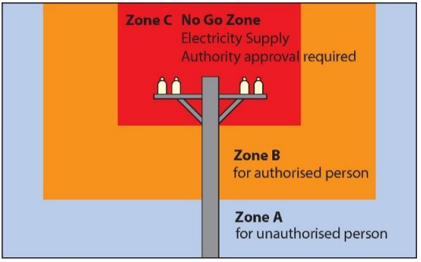
Figure 5 Work zones for tower cranes near overhead electric lines
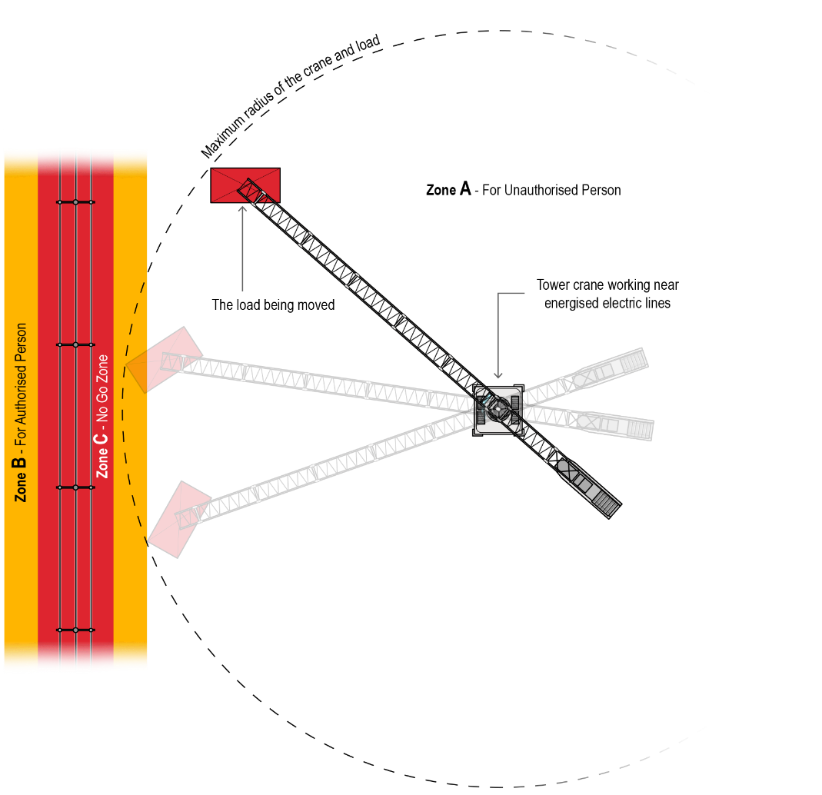
Figure 6 Operations near overhead electric lines

Keeping a safe distance
To ensure a tower crane or its load does not come within an unsafe distance of an overhead electric line, such as entering Zone B (see Figure 6), you should consider:
- the maximum radius of the crane boom, including from luffing
- the size and shape of any load to be lifted
- load swing, including from wind, slewing motion or after the boom comes to rest, and
- electric lines swaying or sagging, usually from wind or temperature changes.
To ensure a safe distance, you should first consider removing the energised electric lines from the workplace or relocate the tower crane so no part of it or its load can enter Zone B. This should be arranged with the electricity supply authority as quickly as possible as this can take some time to arrange. Where electric lines have been de-energised, confirmation should be sought from the person in control of the electric line before undertaking any work.
If this is not reasonably practicable, you should consider using substitution, isolation, or engineering controls, for example:
- use alternative plant which cannot reach or enter an unsafe zone
- set up the crane away from electric lines
- erect a physical barrier to prevent any part of the crane or load entering an unsafe distance, or
- use mechanical stops or an anti-collision system to limit the crane’s movement.
If risks still remain, you should use administrative controls, for example:
- provide a safety observer
- install warning signs to indicate the location of overhead electric lines
- install tiger tails or line markers on overhead electric lines to act as a visual aid to highlight the location of the electric line. (Note: tiger tails do not insulate wires), or
- use warning devices to warn the crane operator before the boom enters the exclusion zone.
In most cases, a combination of the control measures will provide the best solution to minimise the risk to the lowest level reasonably practicable.

Safety observer
A safety observer is a person trained and competent to observe and advise the crane operator. Safety observers should not carry out other tasks, such as dogging duties (described further below), at the time of observing crane operations. All workers on a worksite should be able to clearly identify persons carrying out duties as a safety observer. This ensures that workers do not distract safety observers while they are carrying out spotting duties.
The safety observer should:
- mark the border of Zone B with suitable markers, for example red warning tape easily seen by the crane operator
- stop unauthorised people entering Zone B
- not be required to observe more than one operating crane at a time
- be able to communicate effectively with the crane operator at all times and warn them if a part of the crane or the load it is lifting is about to enter Zone B
- be provided with specialist communication equipment where there is a barrier to communication
- be trained to perform the role, and
- have the authority to stop the work at any time.
To carry out crane operations in Zone B, the operator of the crane and the safety observer require authorisation from the relevant Electricity Supply Authority.
A tower crane may not need a safety observer when:
- the electric lines have been de-energised and steps taken to ensure they cannot be inadvertently re-energised. High voltage electric lines should also be earthed.
- limiting devices have been installed to prevent any part of the crane, plant or load being moved from entering the Zone B, or
- any part of the crane or its load is prevented from entering the Zone B by physical barriers.
For more information, contact your state or territory Electricity Supply Authority.

3.5 Pre-erection inspection and testing
WHS Act, section 25
Duties of persons conducting businesses or undertakings that supply plant, substances or structures
As a supplier, you must ensure the tower crane components you supply are without risks to health and safety of persons who:
- use the tower crane for a purpose for which it was designed or manufactured
- carry out any reasonably foreseeable activity at a workplace in relation to the tower crane’s assembly or use for a purpose for which it was designed or manufactured or its proper storage, decommissioning, dismantling or disposal, or
- are at or in the vicinity of a workplace and who are exposed to the tower crane at the workplace, or whose health or safety may be affected by its use or activity.
You must carry out, arrange, or ensure the carrying out of any calculations, analysis, testing or examination necessary to fulfil your duties. You should ensure this inspection and testing is done prior to the components being delivered to the workplace and erected.
You must pass on information about the tower crane to the end user, including the results of such inspection and testing. You should ensure tower sections are clearly and permanently identified with their model type and serial number and match those specified on the registered tower crane design.
Once the tower crane components have been delivered to the workplace, you should ensure they are inspected for damage and wear during transport.
WHS Regulation, section 204
Control of risk arising from installation or commissioning
As a person with management or control of a tower crane at a workplace, you must ensure that the processes for the installation, construction, commissioning, decommissioning, and dismantling of a tower crane include inspections that ensure, so far as is reasonably practicable, that risks associated with these activities are monitored.
You should work with your supplier to ensure the tower crane is inspected and tested before it is delivered and erected.
Pre-erection inspection and testing includes:
- non-destructive testing of welds on vital components including boom clevises, butt heel bosses and counterweight rope sheave brackets
- non-destructive testing of tower bolts
- non-destructive testing of slew ring bolts
- non-destructive testing of aluminium sheaves
- the condition of the power supply cable, where used
- the condition of motor brakes
- the condition of the slew ring gear and pinions
- air controls and associated valves
- the condition of ropes and sheaves (e.g. erection, hoisting, counterweight and trolley) and correct rope tracking
- the condition of limit switches and limiting devices
- the condition of counterweights
- the condition and fitment of machinery guarding
- brake systems, which must be dismantled and inspected for wear and damage according to:
  - dry brakes—prior to each erection or more frequently if directed by the manufacturer
  - wet brakes—prior to each erection, after 5,000 hours of crane operation or as directed by the manufacturer
- all normal service items, including items supplied by the crane manufacturer (e.g. temperature control units and adequate seating) being maintained in a serviceable condition according to the crane manufacturer’s instructions, and
- other tests and inspections specified by the manufacturer.
You should also inspect:
- the crane base design and engineer’s report
- crane ties and structure to support them where used, and
- the power supply and earthing.
Find more information on inspecting and maintaining a tower crane in Chapter 5.

3.6 Erecting, commissioning, and dismantling
WHS Regulation, section 201
Duties of person conducting businesses or undertakings that install, construct or commission plant
WHS Regulation, section 204
Control of risks arising from installation or commissioning
WHS Regulation, section 237
Record of plant
As a person with management or control of a tower crane at a workplace, you must ensure:
- the person who installs, assembles, constructs, commissions, decommissions, or dismantles the tower crane is competent and is provided with the available information for eliminating or minimising risks to health and safety, and
- the processes for the installation, construction, commissioning, decommissioning, and dismantling of a tower crane include inspections that ensure, so far as is reasonably practicable, that risks associated with these activities are monitored.
You must keep a record of all tests, inspections, maintenance, commissioning, decommissioning, dismantling, and alterations of the tower crane while it is used or until you relinquish control of it. More information on record keeping is in Chapter 5.

Erecting
Erecting a tower crane involves numerous steps, including:
- assembling crane components, usually with a mobile crane
- constructing the tower, the turntable and cab
- hoisting and attaching the jib and counter jib, and
- installing the counterweights and cables.
Much of this is high risk work and requires the relevant high risk work crane or rigging licence.
WHS Regulation, Section 299
Safe work method statement required for high risk construction work
Erecting a tower crane is also high risk construction work, which requires a SWMS. As a PCBU that installs or constructs a tower crane, you must ensure it is installed or constructed having regard to:
- the information provided by the designer, manufacturer, importer or supplier of the tower crane, or
- the instructions provided by a competent person to the extent those instructions relate to health and safety.
When preparing a SWMS, you should also consider:
- technical standards, for example AS 1418.4: Cranes, hoists and winches – Tower cranes
- the crane’s stability
- interaction with other plant, structures or work processes at the workplace
- the use of special tools, jigs and appliances necessary to minimise the risk of injury
- control measures for securing crane components
- environmental factors, such as wet or windy conditions or air quality factors such as dust or smoke, and that
- all relevant electrical installations associated with the crane comply with AS 3000: Electrical installations.

Commissioning
Commissioning tower cranes involves performing necessary adjustments, tests and inspections to ensure the crane is in full working order to specified requirements before the crane is used. A person with management or control of a tower crane must not commission the tower crane unless they have established it is, so far as is reasonably practicable, without risks to the health and safety of any person.
As a PCBU that commissions a tower crane, you must ensure it is installed, constructed or commissioned having regard to:
- the information provided by the designer, manufacturer, importer or supplier of the tower crane, or
- the instructions provided by a competent person to the extent those instructions relate to health and safety.
When commissioning a tower crane, you should also ensure that:
- the commissioning sequence has been developed and implemented according to the risk management process
- an erection plan is developed to cover such things as the sequence of operations, and the safety procedures to be carried out during commissioning
- tests are carried out to ensure the crane will perform within design specifications (e.g. dummy runs), and
- stresses which exceed design specifications are not imposed on the crane.

Commissioning inspection and testing
Commissioning inspections and tests should be carried out by an independent or third-party competent person onsite once the crane has been erected and before it is put into service. Commissioning inspections and tests should include:
- crane electricity supply, where used
- crane base weights or ballast, where used
- tower section identification and access
- tower bolts to correct tension
- climbing frame and connection
- jib connection pins and retainers
- A-frame connections and retainers
- jib and deck pendant pins and retainers, where used
- machinery guarding
- leakage in lines, tanks, valves, pumps, and other parts of air or hydraulic systems
- the condition of the ropes and sheaves (for example, erection, hoisting, trolley and counterweight) and correct rope tracking
- isolating switches
- the condition and phase of the power supply cable
- verification that the crane wiring complies with AS/NZS 3000: Electrical installations
- effective operation of controls including interlocks
- effective operation of indicating devices
- effective operation of travel deceleration switches
- effective operation of hoist upper and lower (where required) working limit switches
- effective operation of warning devices
- effective operation of the hoist and travel brakes when the crane is laden to the maximum rated capacity
- effective operation of the rescue-controlled descent device, and
- other tests and inspections specified by the crane manufacturer.
You should notify the crane owner of commissioning results and provide appropriate documentation, including:
- any problems identified during commissioning that indicate the crane is not performing safely, and
- confirmation that the crane will perform the functions for which it has been commissioned.

Decommissioning and dismantling

As a person with management or control of a tower crane, you must not decommission or dismantle it unless the work can be carried out, so far as is reasonably practicable, without risks to the health and safety of any person.
Dismantling a tower crane is high risk work and requires persons undertaking this work to hold the relevant high risk work licence. It should be decommissioned and dismantled in accordance with the manufacturer’s instructions or, if not available, those of a competent person.
Dismantling a tower crane is also high risk construction work and requires a SWMS.

3.7 Crane design loads and controls (stability)
WHS Regulation, section 54
Management of risk of falling objects
WHS Regulation, section 55
Minimising risk associated with falling objects
WHS Regulation, section 206
Proper use of plant and controls
An unstable tower crane may collapse, or move unexpectedly during erection, operation, or any time until it is dismantled and removed from the workplace. Instability can cause objects to fall, including part or all of the tower crane, objects being suspended or moved by the tower crane, or equipment and tools being used or carried while on the tower crane.
Crane stability depends on a number of factors, including:
- the design of the tower crane
- the footings and foundations
- the design, number, and location of crane ties
- the stabilising moment of the crane—the crane counterweight generally provides the primary stabilising moment
- the crane has the capability to resist the forces applied by the suspended load and wind, and
- wind conditions—stability will vary according to the size and shape of the suspended load and crane boom.
As a PCBU, you must manage risks to health and safety associated with an object falling on a person if it is reasonably likely to injure the person. If it is not reasonably practicable to eliminate this risk, you must provide and maintain a safe system of work to minimise it. This safe system of work must provide adequate protection against the risk of falling objects, including by:
- preventing an object from falling freely, or
- if this is not reasonably practicable, by providing a system to arrest the fall of a falling object, so far as is reasonably practicable.

You must minimise any remaining risks, so far as is reasonably practicable, using substitution, isolation, or engineering controls, so far as is reasonably practicable. For example, when erecting a tower crane consider:
- using a different design for the tower crane base
- isolating the tower crane to protect persons from falling objects during erection and dismantling, or
- supporting or tying the tower crane to another structure, often the building under construction.
If risks remain, you must minimise them, so far as is reasonably practicable, by implementing administrative controls, such as:
- physically inspecting tower components prior to erection
- supervising exclusion zones near the crane, or
- scheduling crane work to minimise the presence of people or plant near the crane.
You must minimise any remaining risks by providing suitable PPE, such as hardhats and eye protection.
A combination of controls may be needed if a single control is not enough to minimise the risks, so far as is reasonably practicable.
Information on lifting or suspending loads with a tower crane is in Chapter 4.

Footings and foundations
Generally, the base of a tower crane is structurally bolted to, or embedded in, the ground or another structure. In some situations, a tower crane can be located on a ‘static’ crane base that relies on the dead weight of the base for its stability.
The size and design of tower crane bases will vary according to factors such as:
- tower height
- wind speed
- terrain type
- ground type and bearing capacity, and
- boom length and crane lifting capacity.
You should ensure a competent person, like a structural engineer, verifies the foundations will be safe for the tower crane and its expected load. This generally requires geo-technical inspections specific to the site and a site-specific crane base designed by an engineer in accordance with engineering principles or relevant technical standards.
Adequate precautions should be taken when it is known that the crane will be sited in the vicinity of underground services, excavations, or embankments.

Self-erecting tower crane
The use of self-erecting tower cranes is common particularly on small to mid-sized building sites as they are self-contained and do not require another crane to erect them. Self-erecting tower cranes (see Figure 4) are generally made up of a horizontal boom that folds out during erection and can include a telescopic tower. The counterweight is usually at the base of the crane.
Unlike tower cranes, self-erecting tower cranes do not require fixing to a crane base. Footings and foundations for the installation of a self-erecting tower crane should be designed in accordance with engineering principles or relevant technical standards. The design should consider the results of geo-technical inspections specific to the location of the crane installation.

Crane standing
The crane standing should conform to the crane manufacturer’s instructions and be capable of withstanding the forces likely to be imposed on it by the crane while in-service, out-of-service, and during erecting and dismantling. These forces include:
- dead weight of the crane
- dead weight of the load and any lifting attachments
- dynamic forces caused by movements of the crane
- wind loadings, and
- other loads as required by the designer of the crane standing.
When a crane is to be supported on, or tied to, a permanent or temporary structure, the design of the structure should be capable of withstanding the forces likely to be imposed on it by the crane, as well as other forces. A competent person should verify the design of the structure.
You should ensure crane ties are installed in accordance with instructions specified by the tower crane designer and manufacturer.

Self-climbing tower crane
Some tower cranes use a specialised method to increase or decrease height without the use of another crane. There are two main methods:
- internal climbing – where the tower is supported by a building and the whole tower is raised as the building rises, or
- external climbing – where the tower is extended outside a building by inserting additional sections.
There is a very high risk of crane collapse during tower crane climbing operations. The climbing frame as a whole must cope with significant static and dynamic forces involved in climbing.
A climbing tower crane has similar risks during erection as other tower cranes and similar control measures are available. One additional control to consider is ensuring the centre of gravity of the tower crane is balanced over the climbing equipment. This includes avoiding slew operations at all times during climbing operations. The ‘balancing’ procedure should be obtained from the designer, manufacturer, importer, or supplier, or from a competent person such as an engineer.

Counterweights
Tower crane counterweights are critical to ensuring crane stability. A counterweight too light for a load and boom configuration may cause the crane to collapse in the direction of the suspended load. A counterweight too heavy for the load and boom configuration may cause the crane to fall over backwards.
Counterweights should be secured to the tower crane in the manner specified by the crane manufacturer.
Some tower cranes are provided with moving counterweights on rails that slope downwards away from the crane (for example the Favco 1500 and Favco STD 1000). These types of tower cranes require the counterweight to be positioned at the top of the counterweight rail during the climbing process. The counterweight is kept in position by means of a latch that locks onto a lug on the bottom of the rail. To help prevent inadvertent release of the latch, a secondary means of securing the latch in place should be provided (e.g. connecting the latch lever to the machine deck with a rope or chain).

Wind and weather conditions
Winds impose extra loads on a crane and may affect the crane’s stability. Wind gusts will also have a different effect on the crane than a constant wind.
An anemometer (wind gauge) should be fixed to a tower crane to provide an accurate wind speed reading. The placement of the anemometer should not be shielded from the wind and will vary according to the type of crane. For example, anemometers should be fixed on:
- the top of the A-frame on luffing tower cranes, or
- either the A-frame or machine deck hand-rail on non-luffing tower cranes.
A tower crane should only be erected, commissioned, used, or dismantled if the environmental conditions are within the designer or manufacturer’s specifications. This includes storms or strong winds that make components uncontrollable when suspended. Wind load can be increased by funnelling effects between adjacent structures or by the large size of components.
Information on operational wind conditions when lifting or suspending loads is in Chapter 4.

Signs on tower cranes
Regardless of their size, signs can impact the operation of a tower crane, particularly in windy conditions. Signs on crane booms can significantly slow down the slew speed when slewing against the wind and increase the speed when slewing with the wind. Signs may make applying the slew brake more hazardous. There is also a risk that signs that are inappropriately attached to the boom or poorly manufactured could detach during crane operations, and result in injury to persons in the vicinity of the crane.
For these reasons, signs should not be attached to tower crane booms. However, signs may be used on machine (rear) decks, but these should be certified by an engineer prior to being installed. Certification from an engineer should state that the design of the sign and its attachments are ‘fit for purpose’. This includes ensuring that maintenance on the sign will not be required for as long as the crane is on site.
Flexible signs should be made of an ultraviolet (UV) resistant material that will not deteriorate over the life of the crane installation. Flexible signs should be securely attached using an appropriate tying system that will withstand potential wind loadings.
Solid signs should be attached by bolted connections. An appropriate means of locking the nuts on the bolts should be used. When attaching solid signs you should not:
- drill holes into the crane structure
- weld joints on to the crane structure, or
- use strapping and cable ties.
Signs may also be attached to wind sails in certain circumstances. Wind sails may be part of a crane design to counteract wind effects on the machine deck - for example, when a short boom is fitted to a hammerhead tower crane. Attaching a sign to a wind sail may reduce the sail’s flexibility and its effectiveness. It may also increase the sail’s weight and the risks of harming someone if the sail collides with something or detaches and falls. Before attaching a sign to a wind sail, you should ensure a competent person, like an engineer, verifies this will be safe for the tower crane.

Overloading
If a tower crane is overloaded, a structural or mechanical component may fail, or the crane may collapse. The safe lifting capacity of a tower crane is generally limited by:
- its structural strength when the working radius is small, and
- its stability when the working radius is greater.
The lifting capacities specified on a load chart should never be exceeded, except during testing of the crane by a competent person under controlled conditions.
More information on overloading when lifting or suspending loads is in Chapter 4.

Load chart
A load chart, also called a rated capacity chart, identifies the weight of a load a tower crane can lift safely. A load chart is generally provided by the crane manufacturer. During the design registration process, the design verifier should verify that the load chart is the correct one.
You must ensure the load charts are provided in a way that is readily understandable by the operator, for example, written in English and using metric units. It should provide enough information to identify the crane configuration it applies to. The load chart should be available in the crane cabin for the crane operator to verify the crane is not being overloaded.

Load indicator
A load indicator should be installed in a tower crane to measure and display the mass of the load being lifted. This indicator assists the operator to stay within the load chart and rated capacity of the crane. The load indicator should be capable of displaying the mass of the suspended load at all times.

Rated capacity limiters
A rated capacity limiter should be installed in a tower crane to prevent overloading of the crane. If an overload is detected, a rated capacity limiter stops any crane function that will increase the overload.
Rated capacity means the maximum gross load that may be applied to the crane while in a particular working configuration. The load to be raised includes the weight of all lifting appliances that are not permanently attached to the crane. Deductions should be made in accordance with the manufacturer’s instructions. The crane’s load chart will also provide instruction on any deductions that may need to be made.
Rated capacity limiters should prevent:
- hoisting a load exceeding 100 per cent of the maximum rated capacity (noting 100 per cent of capacity should only be used during commissioning), or
- the radius being increased if that would cause the load to exceed 100 per cent of the maximum rated capacity.

Motion limiting device
A tower crane should be installed with a motion limiting device to stop or slow the crane when it reaches the limits of the crane’s designed range of motion, including:
- the highest position of the hook
- the lowest position of the hook when persons are lowered in a work box into a shaft
- the extreme permissible operating positions of the jib (luff limiter) where a luffing motion is part of normal working operations
- the end positions of the trolley track on the jib
- the end positions of horizontally telescoping or movable jibs, and
- the end position of the tracks for rail-mounted travelling tower cranes.
A limiting device will provide more reliable and higher protection than an indicator device. While these devices may aid crane operators, you should not rely on them solely to control the risk of overloading.
Where limiting and indicating devices are to be installed on a tower crane, the safety circuits of these devices should generally meet either:
- a reliability level of Category 4 under AS 4024: Safety of machinery, or
- a safety integrity level of 3 under AS 62061: Safety of machinery – Functional safety of safety-related electrical, electronic and programmable electronic control systems.

3.8 Falls from height and tower crane access
WHS Regulation, section 60
Managing risks to health and safety
WHS Regulation, section 78
Management of risk of fall
WHS Regulation, section 79
Specific requirements to minimise risk of fall
WHS Regulation, section 80
Emergency and rescue procedures
As a PCBU at a workplace, you must eliminate or minimise the risk of a fall from one level to another if the fall is likely to injure a worker or any other person. This includes the risk of falling during tower crane:
- erection and dismantling
- commissioning
- operator and crew entry and exit
- operation, including loading and unloading, and
- inspection, maintenance, and repair.

Managing the risk of a fall
If it is not reasonably practicable to eliminate the risk of a fall by working on the ground or on a solid construction, you must provide and maintain a safe system of work to minimise the risk. This safe system of work must provide adequate protection against the risk of fall, including by:
- providing a fall prevention device
- if this is not reasonably practicable, provide a work positioning system, or
- if neither of these are reasonably practicable, provide a fall arrest system, so far as is reasonably practicable.

Fall prevention
A fall prevention device is material or equipment—or a combination of both—designed to prevent a fall for temporary work at heights, which does not require any ongoing adjustment, alteration or operation by any person to ensure its integrity after initial installation. This includes secure fencing, edge protection, scaffolding, or working platforms.
Edge protection is commonly used with tower cranes. It consists of a system of rails, mesh, sheeting or other material to prevent persons from falling off a platform or other surface. The components should be designed to withstand the forces imposed on it if a person fell against it. Where possible, tower crane sections should be designed so edge protection is in place prior to erecting the tower crane.

Work positioning
A work positioning system includes any plant or structure, other than a temporary work platform, that enables a person to be positioned and safely supported at a location in such a way that a fall is prevented. This includes using an industrial rope access system or restraint technique.
Restraint technique is commonly used with tower cranes. It controls a person’s movement by physically preventing the person from reaching a position where there is a risk of a fall. It consists of a harness that is connected by a lanyard to an anchorage or horizontal lifeline. It must be set up to prevent the wearer from reaching an unprotected edge—see
Figure 7. 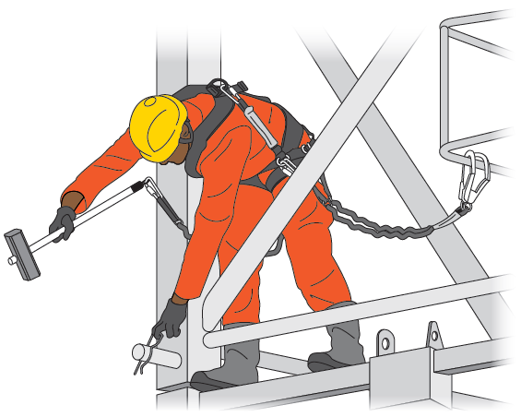
Figure 7 Fall arrest system used during tower crane assembly
Restraint technique should be installed by a competent person in accordance with the manufacturer’s instructions. Restraint anchorage should be designed for a fall arrest loading.

Fall arrest
Fall arrest systems, such as catch platforms, safety nets and individual fall arrest systems (including anchorage lines or rails) are intended to safely stop a worker falling an uncontrolled distance and reduce the impact of the fall.
The system should be designed and installed so that the person travels the shortest possible distance before their fall is stopped. The equipment and anchorages should be designed, manufactured and installed to be capable of withstanding the force applied to them as a result of a person’s fall. If equipment has been used to arrest a fall, it should not be used again until it has been inspected and certified by a competent person as safe.
You must establish emergency procedures, including rescue procedures, if a fall arrest system is used.

Further controls
You must minimise any remaining risks or risks introduced by using these controls, so far as is reasonably practicable, using one or more of the following approaches:
- substitute the new or introduced hazard for something safer, e.g. use a specifically designed anchor device instead of a solid permanent structure as an anchor point
- isolate the new or introduced hazard from people, e.g. use a physical barrier to prevent people from entering an area, or install or place anchor devices away from edges, or
- use engineering controls, e.g. use rope protection to guard ropes from hazardous contact points such as sharp edges or abrasive or hot surfaces.
If risks remain, you must minimise them, so far as is reasonably practicable, by implementing administrative controls, e.g. supervise access to an exclusion zone, use warning signs, plan so work is not carried out for an extended time at height.
You must minimise any remaining risks by providing suitable PPE, e.g. helmets fitted with chinstraps that have suitable impact protection.
You may need a combination of controls to sufficiently minimise the risk of a fall.

Tower ladders
The use of continuous vertical ladders without Tower crane for accessing the total length of the tower is not recommended. However, where used, you must control the risk of a fall, for example, by using a fall-arrest system that does not require the person to constantly hook on and off. The system may incorporate a vertical rail or rope with a locking cam device. The risk of injury to a person falling off a ladder can be reduced by ensuring the length of lanyard between the person and the vertical rail or rope does not exceed 300 mm. Ladder cages or other ladder safety devices may also be used to reduce the risk of a fall. Where a ladder cage is used, the lowest part should be between 2 metres and 2.2 metres above the lower deck.

A-frame ladder cage
A ladder cage should be provided on the A-frame to ensure that if a person falls off the ladder, the person will be confined within the cage and fall onto the machine deck, not off the tower crane. The lowest part of the ladder cage should be between 2 metres and 2.2 metres above the lower deck. The horizontal spacing between the vertical bars on the ladder cage should not exceed 150 millimetres. Mesh infill may be used instead of vertical bars.

Guardrails on machine deck and A-frame platform
Tower cranes should be provided with perimeter edge protection that extends around the machine deck to prevent the crane operator and maintenance workers from falling. The edge protection should consist of a top rail, a mid-rail and a kickboard.
Further information on the design and construction of guardrails for tower cranes can be found in the relevant Australian Standard.

Saddle bag platforms
Saddle bag platforms may be needed on tower cranes with moving counterweights to provide access for riggers while erecting the crane and for people carrying out maintenance. Safe access to the saddle bag platform can be achieved by either providing a trapdoor in the machine deck or a ladder cage on the saddle bag ladder. This platform should be provided with a top rail, mid-rail and kickboard. Climbing over the machine deck guardrail and down a ladder leading onto the platform is not recommended due to the increased risk of a fall.

Cantilevered and hanging platforms
Small access platforms may be needed on tower cranes with moving counterweights to provide access for riggers while erecting the crane and for people carrying out maintenance work. Safe access to these platforms must be provided and people should not have to climb over the machine deck guardrail and down a ladder to access the platforms.
Safe access to these platforms can be achieved by either providing a trapdoor in the machine deck, or a ladder cage on the platform ladder. Platforms should be provided with perimeter edge protection.

Crane jib access
Some tower cranes require riggers and crane operators to access the jibs while erecting, inspecting and maintaining the crane. These tower cranes should be fitted with a rigger’s run and static lines that extend for the complete length of the jib to allow workers to position safely along the jib. Static lines that are permanently installed in each jib section do not require testing after the jib is installed on site and can be tested on the ground prior to erection. Double lanyards should be used to ensure continuous contact while transferring between jib section static lines. If the work positioning system will not prevent a worker from reaching an unprotected edge, the crane should be fitted with a separate anchor point to allow the worker to also be attached to a backup safety line to minimise the risk of a fall.
Some non-luffing tower cranes are fitted with trolley platforms for inspection and maintenance purposes. These platforms should remain on the crane.

Safe access
You must provide safe means of access to and exit from the workplace and any area within the workplace where there is a risk of a fall from one level to another that is reasonably likely to injure a worker or any other person. This includes access to and exit from a tower crane for:
- erection and dismantling
- commissioning
- operation, including loading and unloading, and
- inspection, maintenance, and repair.

Self-erecting tower crane access
Generally, most self-erecting tower cranes do not have to be climbed while in use and maintenance can often be carried out after collapsing the crane.
Some self-erecting tower cranes are provided with ladders for maintenance access. Before a worker uses such a ladder, you must ensure the work is carried out on the ground or a solid structure, so far as is reasonably practicable. Where this is not reasonably practicable, you must provide adequate protection from a fall, including providing a fall prevention device such as an elevating work platform or a work positioning system. If neither of these is reasonably practicable, then provide a fall arrest system, such as catch platforms, safety nets and individual fall arrest systems.

Tower crane access
Long ladder climbs may increase the risk of musculoskeletal injury and fatigue, particularly where a tower crane operator has to regularly climb more than 30 metres to the operator’s cabin. Where reasonably practicable, a personnel hoist should be used to access a tower crane. This may minimise the risk of musculoskeletal injuries and falls. If used with a ladder, a personnel hoist should minimise the distance a worker climbs on the ladder. Installation of a personnel hoist requires a high risk work licence and may also require consultation with the crane manufacturer if the hoist is not an existing part of the crane design.
Ladder landings should be provided where there is available space in the tower crane. Landings allow for rest breaks while climbing ladders. This helps minimise fatigue and the risk of injury to workers.
Where reasonably practicable, the vertical distance between landings should not exceed six metres. However, if the crane manufacturer has designed otherwise, the length of the lowest ladder in the tower should not exceed 12.5 metres and subsequent ladders should not exceed 10 metres.
The provision of rest platforms beside a vertical ladder is not an adequate control measure on its own to reduce the potential fall distance of a person. The use of fold-down type platforms is also not recommended because they can hinder rescue procedures and increase the risk of a person falling down the ladder.
Internal guardrails on tower landings will minimise the risk of a person falling internally down or off the tower. Some tower cranes are provided with an internal guardrail to tower landings to protect people from falling down the access hole. For example, either a guardrail on the internal side of the access hole or a rail that extends around the back of the access hole could be installed. Having ladders offset between landings can also reduce the risk or severity of a fall, if access hatches have been left in the ‘open’ position. It may be impractical to provide an internal guardrail on the top tower landing as slewing of the crane may cause the lower end of the ladder to strike and damage the internal guardrail, and entrapment of people on the top tower landing.

3.9 Lighting
WHS Regulation, section 40
Duty in relation to general workplace facilities
As a PCBU you must ensure, so far as is reasonably practicable, that lighting enables each worker to carry out work safely, persons to move around safely and safe evacuation in an emergency. Workers should be able to perform their job without having to adopt awkward postures or strain their eyes to see.
When considering the type and level of lighting needed in the workplace, the following factors should be taken into account:
- the nature of the work activity
- the nature of hazards and risks in the workplace
- the work environment
- the level of natural light including transitions or changes throughout the day
- the level of artificial lighting
- glare
- contrast, and
- reflections.
It is important that crane operators and crew have adequate lighting when climbing and accessing tower cranes. This could include the installation of permanent lighting in tower sections. Appropriate lighting may also be provided from other sources on the worksite such as lighting attached to a structure in close proximity to the tower crane.
Adequate lighting after dark may also be required for outdoor paths around the workplace and car parks. This should allow workers to move about easily without risk of falling or otherwise risking injury.
Too much lighting can also result in glare or excessive reflection. Measures to ensure correct levels of lighting include:
- providing extra lighting, such as a lamp on a movable arm
- changing the position of existing lights
- changing the location of the workstation
- increasing or decreasing the number of lights
- changing the type of lighting used, for example from white light to blue light
- changing the diffusers or reflectors on existing lights, and
- using screens, visors, shields, hoods, curtains, blinds or external louvres to reduce reflections, shadows and glare.
Emergency lighting must be provided for the safe evacuation of people in the event of an emergency. Extra lighting may be needed for some types of work or at places of particular risk, for example crossing points on traffic routes.

3.10 Emergency planning and safety equipment
WHS Regulation, section 43
Duty to prepare, maintain and implement emergency plan
As a PCBU, you must ensure that an emergency plan is prepared for the workplace. This is a written set of instructions specifically developed for the particular workplace and its specific hazards and covers a range of potential incidents. Persons at the workplace must receive information, training and instruction about implementing the emergency plan.
A reliable and effective means of communication should be established between work areas and persons involved to allow effective evacuation of danger areas.
Rescue equipment should be available and easily accessible so an injured worker can be removed quickly.
A site meeting should occur between the local Fire/ Emergency services, principal contractor, and crane crew to discuss and document emergency rescue and fire response. This will enable local Fire/Emergency Services to be prepared in the event their services are required.
Note: ACT Fire & Rescue is the only legislated Fire and Rescue agency with the responsibility for vertical rescue within the ‘man-made’ or ‘structural’ environment in the ACT.
The emergency procedures in the emergency plan must clearly explain how to respond in various types of emergencies including how to evacuate people from the workplace in a controlled manner. Contact numbers for emergency services should be prominently displayed.
A register of persons at the workplace on a particular day should be kept so in the case of any emergency everyone can be accounted for.
The emergency plan must provide for the following:
- emergency procedures, including an effective response to an emergency
- evacuation procedures
- notifying emergency service organisations at the earliest opportunity
- medical treatment and assistance
- effective communication between the person authorised to coordinate the emergency response and all people at the workplace
- testing of the emergency procedures—including the frequency of testing, and
- information, training and instruction to relevant workers in relation to implementing the emergency procedures.

Preparing emergency procedures
The procedures should be written clearly and be simple to understand. Emergency procedures may include:
- the personnel in charge of emergencies including personnel to respond to and oversee the evacuation of injured persons
- the warning system (for example, the alarm signal for evacuation)
- the safe assembly point
- shutting down of work including plant and electrical equipment
- information regarding hazardous chemicals located on site
- provision of firefighting and rescue equipment at appropriate locations
- procedures for assisting injured people and people whose means of escape are limited
- procedures for managing the risk of combustible materials (such as paper, card, wood, dust, timber, plastic and polystyrene) and highly flammable liquids and gases (such as solvents, liquefied petroleum gas (LPG) and oxygen)
- procedures following an evacuation, for example undertaking a headcount to determine if persons that were at the workplace have been accounted for, and
- procedures regarding incident investigation, counselling and debrief.
The evacuation procedures should be displayed in a prominent place, for example on a noticeboard and may also need to be incorporated into Safe Work Method Statements where relevant. The emergency plan and evacuation procedures must be tested on a regular basis.
Emergency procedures could also consider having a secondary crane driver (preferably part of the crane crew) to make the crane safe or move the crane to a safe position if the primary crane driver becomes incapacitated.

Shared workplaces
In shared workplaces PCBUs must consult, cooperate and coordinate activities with all other persons who have a work health or safety duty in relation to the same matter, so far as is reasonably practicable.
In shared workplaces where there are multiple PCBUs, a master emergency plan could be prepared that all relevant duty holders use. Examples of shared workplaces include shopping centres, construction sites or office buildings.
Further guidance on emergency plans and procedures is available in the Emergency plans fact sheet and AS 3745–2010: Planning for emergencies in facilities.

Fire suppression
As a PCBU with management or control of a tower crane at a workplace, you must manage the health and safety risks associated with the tower crane, in accordance with the hierarchy of control measures. This includes the risk of fire.
There are a number of factors that can contribute to a fire on a tower crane, including:
- diesel and electric engines, which can be a source of heat, fuel, and ignition
- combustible liquids, including diesel and hydraulic fluid, in tanks or pumped through hoses, and
- lightning strikes, particularly in areas prone to storms.
Fire presents a significant risk to isolated workers, such as crane operators or crane crew working on the crane, as well as people near the crane if the heat causes crane components to fall or the crane to collapse.
All tower cranes should provide a pre-plumbed extinguisher system aimed at locations where combustible fluids could pool and burn. Where this is not reasonably practicable, appropriate fire extinguishers or a fire suppression system should be provided at readily accessible locations to the operator. You should use a fire suppression system if it is reasonably practicable.
Only necessary quantities of combustibles should be stored on the machine deck, and should be stored in accordance with the materials data sheet information.
A fire warning system (for example, a fire detection system or camera within the power pack with operator cabin display) should be implemented where reasonably practicable. Where a fire warning system is not fitted, you will need to record that consideration and determination in the crane documentation (for example, how the existing engine monitoring systems provide adequate early warning).
Fire suppression and warning systems must be maintained, inspected, and tested, and workers must be provided the information, training and supervision they need to maintain and use them in an emergency.
All fire suppression device suction and feed hoses running from the hydraulic oil tank should have fire resistant, or better grade, hydraulic hoses. The selection of replacement hoses should be made in consultation with the crane manufacturer or a specialist hydraulic hose supplier.

- Using a tower crane

4.1 Proper use
WHS Regulation, section 206
Proper use of plant and controls
As a person with management or control of a tower crane at a workplace, you must take all reasonable steps to ensure that the tower crane is used only for the purpose for which it was designed, unless you have determined that the proposed use does not increase the risk to health or safety. To determine this, you must ensure the proposed use is assessed by a competent person.
You must take all reasonable steps to ensure that all health and safety features and warning devices (including guarding, operational controls, emergency stops and warning devices) are used in accordance with the instruction and information provided by that person under regulation 39.
More information on information, training, instruction and supervision is in Chapter 1.

4.2 High risk work licence
WHS Regulation, section 81
Licence required to carry out high risk work
WHS Regulation, section 82
Exceptions
WHS Regulation, section 85
Evidence of licence—duty of PCBU
Schedule 3 to the WHS Regulation
High risk work licence and classes of high risk work
As a PCBU, you must not direct or allow a worker to carry out high risk work for which a high risk work licence is required, unless you see written evidence that they hold the relevant high risk work licence.
A high risk work licence is not required if the work is carried out during a training course to get the relevant high risk work licence and the work is supervised by a person licensed to perform that work. A high risk work licence is also not required if the person has—within the last 60 days—received a certification from a relevant Vocational Education and Training (VET) course and applied for that licence.

Tower crane operation
A person must hold a high risk work licence to use a tower crane. For high risk work licensing purposes, a self-erecting tower crane is not a tower crane and requires a self-erecting tower crane licence.
A high risk work licence for a tower crane is not required if the work is:
- solely for manufacturing, testing, trialling, installation, commissioning, maintenance, servicing, repair, alteration, demolition or disposal of the tower crane or self-erecting tower crane, or
- solely moving the tower crane or self-erecting tower crane within the workplace, including loading or unloading it from a vehicle or equipment used to move it.
In these situations, the tower crane must be operated or used without a load except when standard weight loads with predetermined fixing points are used for calibration of the crane.
If a person is setting up or dismantling a tower crane, they must hold the relevant high risk work licence.

Dogging work
A person performing dogging work is called a dogger or dogman and must have a dogging high risk work licence. Dogging work is work that requires judgement when:
- selecting an appropriate slinging method and lifting gear by considering load size and shape and determining load weight and centre of gravity
- inspecting lifting gear, like chains, slings, ropes, cables and hooks, and
- directing the crane operator in the movement of a load when the load is out of the operator’s view by communicating with the operator using hand signals, whistles, or two-way radios.
To effectively perform or supervise dogging work, a dogger should not carry out other work or functions, such as operating the crane or being a ‘safety observer’ when the crane is operating close to overhead electric lines.
If the tower crane operator is a licensed dogger, they may make judgements on the load and slinging methods, and select and inspect lifting equipment, but they should first turn off the crane controls and secure them to prevent unintended activation. A tower crane operator must not supervise a dogger, even if they are a licensed dogger, because they would be at the crane controls and therefore unable to provide supervision effectively.
The dogger should be positioned to safely observe the entire lifting operation they are responsible for. If a load is being controlled by more than one dogger, the different doggers should know what part of the lifting operation they are responsible for.
For more information on dogging work, see the High risk work licensing for dogging information sheet.

4.3 Crane crew
When determining the number of persons in each crane crew, you should consider the following risks:
- collision of the tower crane or load with people, other cranes and plant, or structures (including neighbouring property and temporary structures such as scaffolding)
- loads obstructing walkways, roads, and work areas
- proximity of overhead electric lines
- ability of the operator and crane crew to maintain visibility of the load, and
- the safety of the dogger while slinging and unslinging the load.
Additional control measures may be required during the lift process because of:
- the positioning of the proposed crane crew
- the size or complexity of the site or structure
- the proximity of collision hazards, or
- the lift process or procedure.
Examples of additional control measures may include:
- re-design of the proposed lift or use of different crane
- isolation of area during the lift
- anti-collision devices and systems
- cameras fitted to the crane, crane hook or structure
- use of additional crew, including a safety observer or a dogger, and
- flagging and insulated covers on overhead electric lines.

4.4 Communication
WHS Regulation, section 48
Remote or isolated work
A worker using a tower crane is often isolated from assistance, including rescue, medical assistance, or attendance by emergency service officers. Find information on emergency planning in Chapter 3.
As a PCBU, you must manage the risks to both the physical and psychological health and safety of a remote or isolated worker. If you cannot eliminate these risks, you must minimise them by providing a safe system of work. This includes providing effective communication with the isolated worker.
The type of communication system will depend on the site-specific conditions, such as the size of the workplace, noise and weather conditions. Expert advice and local knowledge may be needed to assist with the selection of an effective communication system.
You must ensure workers are provided information, training, or instruction how to use the communication systems provided.
The use of two-way radios is common practice in the tower crane industry. Persons using radio equipment should be familiar with the manufacturer’s operating instructions. A dedicated radio frequency should be selected for the duration of the crane operations to prevent interference to or from other radio equipment being used in the vicinity of the crane. Only one person, such as a dogger, should communicate with the crane operator at any one time. When more than one dogger is involved in a lift, each dogger should understand when responsibility for their part of the lifting operation should be handed over to another dogger.
All persons using radios should be aware of the risk of interference and signals from other radio equipment. Work should stop immediately if there is a loss of radio communication.
The safe use of two-way radio communication usually involves:
- the crane operator and dogger performing an operating safety check to ensure the radios are dry, handled with care and performing satisfactorily, and that a fully charged battery and spare are available
- ensuring operators are familiar with the specific procedures for using radio communication for that workplace, and
- adopting a constant talk method between radio users so that all involved persons are aware of the progress of the lifting operations at all times.
You should ensure workers also have other forms of communication available to use alongside radios or when radios are not available. This includes hand signals, whistles, bell and buzzer signals. For more information, see AS 2550.1: Cranes, hoists and winches – Safe use – General requirements.
Mobile phones should not be used to direct tower crane operations.
Further information can be found in the Code of Practice: Managing the work environment and facilities. For information on managing the psychosocial risks see the Code of Practice: Managing psychosocial hazards at work.

4.5 Pre-start and operational checks
A pre-start visual inspection and operational test of the crane should be carried out by the crane operator at the start of each work shift. These checks should include all relevant items indicated in the manufacturer’s operations manual.
A pre-start check should include a visual inspection of the condition and setup of:
- the crane, including structure, crane access, and logbooks
- counterweights, wire ropes, rope winch drums, anchorages, splices and lifting hooks
- power systems, including power supply, electrical cabinet and main isolation switch
- fluid systems, including fuel, coolant, oils, hydraulics, lubrication and any spillages
- brake mechanisms and any emergency load lowering equipment
- load radius indicator, load chart, rated capacity and manufacturer’s data plate, and
- warning lights and devices and firefighting equipment.
An operational check involves:
- starting the crane as required by the workplace procedures and the manufacturer
- testing and where practical inspecting all limits, governors, controls, gauges, mechanisms, warning devices, indicators, switches, fixtures, brakes, locks, and pins, and
- checking rated capacity and radii measurements are on the load moment indicator.
The person with management or control of a tower crane must keep a record all tests and inspections while it is used or until they relinquish control of it. More information on record keeping is in Chapter 5.
All PPE should be inspected to ensure it is functioning correctly. All safety-related problems should be recorded and rectified prior to crane use.

Inspect lifting gear
A person with management or control of lifting gear must ensure the maintenance, inspection, and if necessary, testing of lifting gear is carried out:
- in accordance with the manufacturer’s recommendations, if any
- if there are no manufacturer’s recommendations, in accordance with the recommendations of a competent person, or
- in relation to inspection, if it is not reasonably practicable to comply with the above, annually.
Lifting gear should be checked before and after each use and inspected regularly by a competent person, typically a dogger, to determine whether it is suitable to remain in use. It should be stored appropriately and not left on the crane hook overnight. Checks should ensure:
- the lifting gear is tagged and all relevant information listed, for example the date of the last inspection, relevant information for a chain sling includes grade of chain, rated capacity, manufacturer, chain size and relevant Australian Standard marking
- lifting hooks are provided with operable safety latches shackles are prevented from unscrewing, for example mousing or similar
- lifting eyes and inserts are compatible
- lifting slings are not damaged, for example excessive wear, damaged strands, cracks, deformation, or severe corrosion, and
- the sling is suitable for loads being lifted, including adequate capacity and protection from sharp edges.
You should also consider the severity of use, particularly for materials that are easily worn or damaged. The inspection of synthetic slings should be carried out at three-monthly intervals (see AS 1353.2: Flat synthetic-webbing slings – Care and use and AS 4497.2: Round slings – Synthetic fibre – Care and use for further information).
A PCBU must ensure, so far as reasonably practicable, the provision of any information, training, instruction or supervision that is necessary to protect all persons from risks to their health and safety arising from work carried out as part of the conduct of the business or undertaking. For example:
- seek evidence of a dogger’s familiarity with specific lifting gear and how to inspect it
- provide the dogger with information and instruction about inspecting the lifting gear provided by the designer or manufacturer, and
- provide additional training or refresher training.
Find information on the use and inspection of chains, wire ropes and synthetic slings in:
- AS 2759: Steel wire rope – Use, operation and maintenance
- AS 3775.2: Chain slings – Grade T – Care and use
- AS 4497.2: Round slings – Synthetic fibre – Care and use
- AS 1353.2: Flat synthetic-webbing slings – Care and use
- AS 4991: Lifting devices.

4.6 Lifting or suspending loads
WHS Regulation, section 54
Management of risk of falling objects
WHS Regulation, section 219
Plant that lifts or suspends loads
WHS Regulation, section 220
Exception – Plant not specifically designed to lift or suspend a person
There are numerous duties related to managing the risks of using tower cranes to lift or suspend a load. Some are discussed in Chapter 3, including managing the risks relating to:
- falling objects, particularly when lifting loads near people
- collisions, particularly loads colliding with a person or thing, and
- crane stability, particularly overloading.
As a person with management or control of a tower crane at a workplace, you must also ensure, so far as is reasonably practicable, that the lifting and suspending is carried out:
- with lifting attachments that are suitable for the load being lifted, and
- within the safe working limits of the plant.
You must ensure:
- loads are lifted or suspended in a way that ensures the load remains under control during the activity, and
- no load is lifted simultaneously by more than one item of plant, unless the method of lifting ensures that the load placed on each item of plant does not exceed the design capacity of that plant.
Selection of an appropriate slinging method and lifting gear is dogging work and requires a high risk work licence. More information about dogging work is in section 4.2 of this chapter.
You must ensure, so far as is reasonably practicable, that the plant used is specifically designed to lift or suspend the load. This includes lifting gear. If this is not reasonably practicable, you must ensure the plant used does not cause a greater risk to health and safety than if specifically designed plant were used.
For example, synthetic slings should only be used for round loads as sharp edges may damage or tear this type of sling.
For lifting or suspending some materials, such as plasterboard sheets, this means using a material box, so far as is reasonably practicable.
For lifting or suspending persons, this means using scaffolding or an elevating work platform, so far as is reasonably practicable, rather than a tower crane. If this is not reasonably practicable and a tower crane is used to lift or suspend a person, you must ensure a design registered work box is used in accordance with the relevant manufacturer’s specifications.
Lifting multiple loads at the same time (commonly known as high/low loads) is not permitted by the regulator and the dogger is not underneath the suspended loads during rigging, slinging and attachment of loads.
The practice of high/low lifts where multiple loads are slung in a vertical configuration from a crane in the one lifting operation. This practice is no longer permitted by the regulator and the crane industry must remove this practice from all lifting operations in the ACT.
Lifting operations for Tower and Mobile Cranes performing High-Low or multiple vertically loaded lifts (‘Christmas tree’ lifts) are deemed dangerous during lifting operations and must not be implemented to ensure consistency with legislative requirements and safety of all lifting operations in the ACT.
Australian Standards AS3775.2:2014 stipulates that dual independent loads or separately reeved loaded slings are NOT to be used where the loads are reeved to different heights. Refer to figure below.
The context of this rationale is that it is accepted that a single load lift cannot be eliminated or avoided (on the basis it is a necessary part of construction activity). However, a High-Low lift can be avoided (on the basis that a High-Low lift is optional rather than a necessary part of construction activity).
In summary, WorkSafe ACT considers that in order to demonstrate compliance with section 36 of the Work Health and Safety Regulation 2011 a person conducting a business or undertaking (PCBU) must not undertake High-Low lifts as the hierarchy of control mechanisms require the risk to be eliminated.
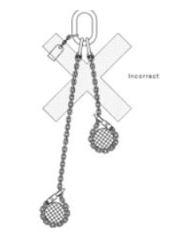
Figure 8: Unsafe hi-low lift
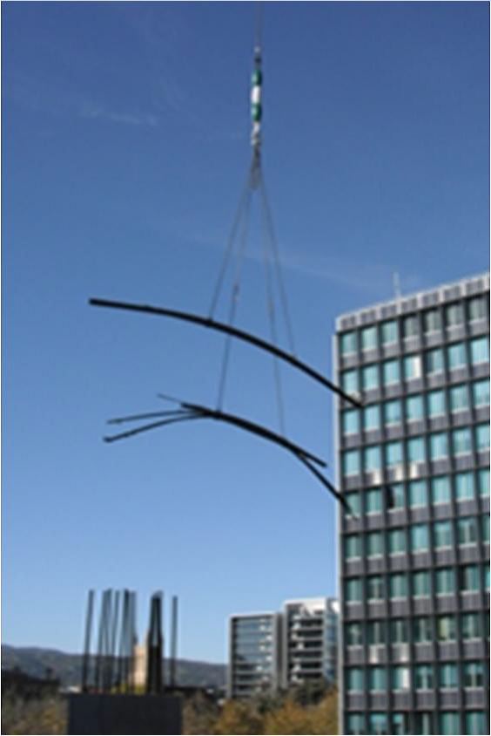
Figure 9: Unsafe multiple vertically loaded lifts (Christmas Tree Lift)

Slinging techniques
Only a competent person, such as a dogger, should sling loads. Loads should be slung and secured to ensure the load is balanced and stable and no part can fall. You should ensure:
- slings placed around a load are not crossed or twisted
- the point of the lift is located directly above the load’s centre of gravity
- tag lines or similar control devices are used to control loads while lifted or suspended
- formwork frames are tied together, secured in a lifting frame, or lifting slings wrapped around the load
- loads of pipes, joists, timber or sheeting are strapped together and lifted in a flat position to prevent individual items slipping
- loads are supported where possible with dunnage, with the load uniformly distributed over the supporting surface
- wherever basket hitches are used, the sling is positively restrained from sliding along the load, and
- load factors for various slinging techniques are included in calculations to ensure slings are not overloaded.
The following table provides examples of correct and incorrect use of slinging techniques. These are provided as examples only and do not replace the need for an assessment of the correct slinging techniques by a competent person.
Table 1 Correct and incorrect slinging techniques
Image | Summary | Safe use | Comments
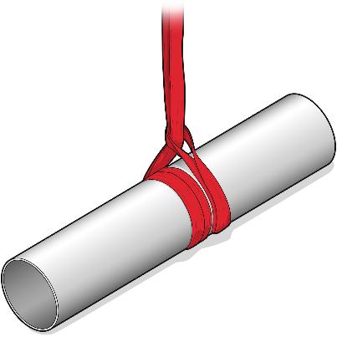 | Round webbing sling with double wrap choke around steel pipe. |  | Large radius so sling protection not required.
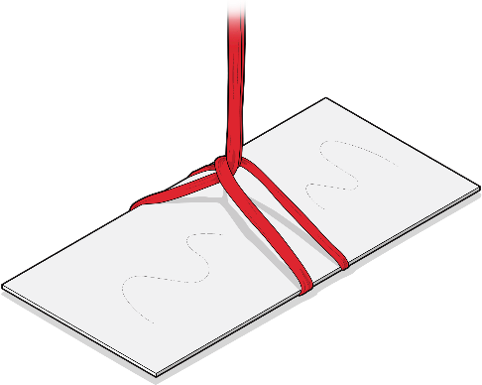 | A synthetic sling being used to lift metal sheeting. |  | Edges may cut this type of sling.
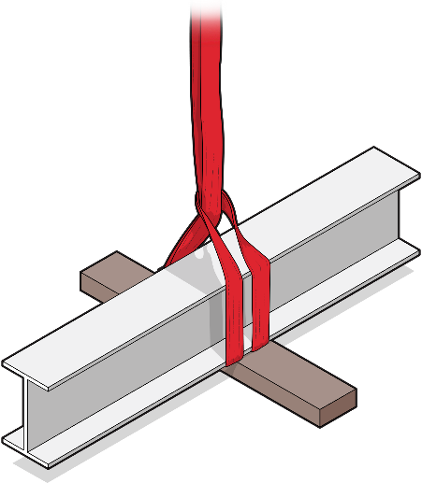 | A synthetic sling being used to lift an I-Beam |  | Edges may cut this type of sling.
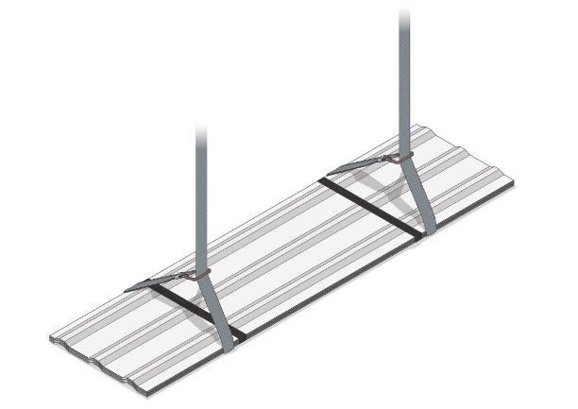 | A steel webbing sling being used to lift metal sheeting. |  | Edges will not damage this type of sling.
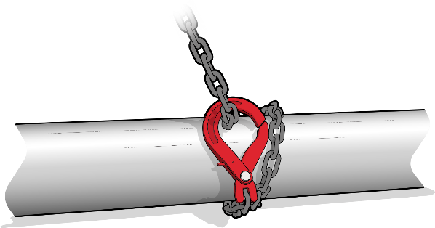 | Chain sling with double wrap choke around steel pipe. |  | Double wrap helps to prevent any slippage.
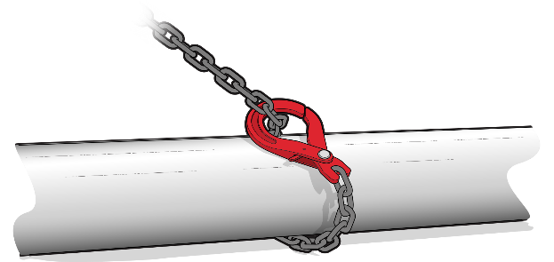 | Chain sling with single wrap choke around steel pipe. |  | Likely to slip.
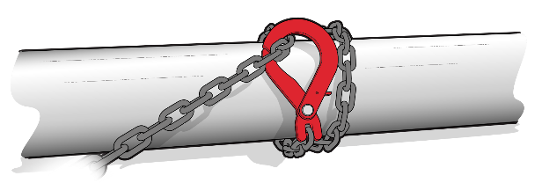 | Chain sling with double wrap choke around steel pipe. |  | Chain bearing against latch.
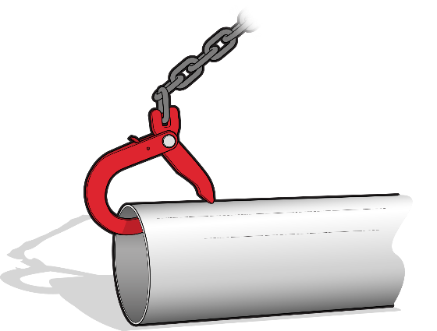 | Sling hook inserted into pipe. |  | Likely to slip.

Material boxes
A material box is a carrying device designed to be suspended from a crane to lift materials. You must ensure the material box is suitable for the material being lifted. Material boxes should:
- be designed and certified by an engineer
- have the tare mass and working load limit (WLL) clearly marked. A distinct identification number on the box that can be cross referenced to the design drawing or certificate for the box will assist to verify this.
- have four chains—one in each corner—attached during lifting
- have enclosed sides or robust mesh, with openings less than the minimum size of materials being lifted
- have loads secured against movement, and
- not have materials stacked higher than the side of the material box unless they are adequately secured—but at no time should the material box become top heavy.
For loads such as plasterboard sheets, if a material box is not used then the lifting system should:
- be certified by an engineer or a person who holds an intermediate or advanced rigging licence
- specify the minimum and maximum load, for example the minimum and maximum number of plasterboard sheets
- specify the number and locations of lifting slings, and
- specify the capacity of lifting slings.

Work boxes

Features and use of work boxes
A work box is a personnel carrying device designed to be suspended from a crane to provide a working area for a person elevated by and working from the device.
Crane-lifted workboxes may be used by workers to gain access to elevated work areas that are otherwise difficult to reach to perform minor work of short duration. Generally, crane-lifted workboxes do not provide a level of safety equivalent to properly erected scaffolding, elevating work platforms and other specifically designed access systems. A crane-lifted workbox can, however, provide a higher level of safety than fall-arrest harness systems.
Before workboxes are selected as a means of access, a risk assessment should be undertaken and recorded demonstrating that the use of other means of access, such as scaffolding or elevating work platforms, is impractical.
Crane-lifted workboxes should meet the following criteria:
- The work box is to be design registered.
- Correctly tagged lifting slings must be supplied with the work box and attached to lifting points by means of hammerlocks or moused shackles.
- The factor of safety for each suspension sling must be at least eight for chains and ten for wire rope.
- Have fall-arrest anchorage points.
- The rated capacity, tare mass and design registration number of the workbox must be clearly marked (e.g. on a data plate).
- If the workbox is provided with a door, this should be inward opening only, self-closing and provided with a latch to prevent accidental opening.
- The sides of the work box must be at least one metre high.
- A handrail should be provided that runs around the inside of the box perimeter. This handrail helps to prevent injury to occupants’ hands in the event of the box contacting other obstructions.
- All persons in the work box must wear full body fall-arrest harnesses at all times. Harnesses must be attached to fall-arrest anchorage points in the work box or to the main sling ring above the workers’ heads. Energy absorbers must be provided on the lanyards (see AS/NZS 1891 Series: Industrial fall-arrest systems and devices for further information).
- At least one person in the work box must hold a dogger’s licence class or equivalent to ensure correct directions are communicated to and from the crane operator.
Further guidance on the design and safe use of work boxes and cranes is provided in:
- AS 1418.17: Cranes (including hoists and winches) – Design and construction of workboxes and
- AS 2550.1: Cranes, hoists and winches – Safe use – General requirements.
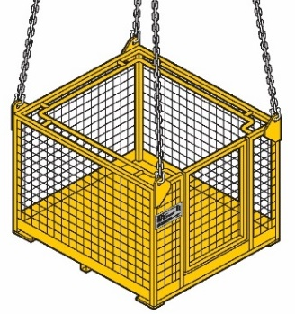
Figure 10 Work box with data plate
You must ensure a work box is design registered. Information about design registration is in Chapter 3.

Features and use of first aid boxes
First aid boxes are a type of crane-lifted work box and must only be used for the retrieval of injured persons.
A crane-lifted first aid box may be required in emergency response and retrieval situations. First aid boxes should be readily accessible on the site to ensure that an effective emergency response can be initiated if they are required.
Crane-lifted first aid boxes should meet the following criteria:
- The first aid box is to be design registered.
- First aid boxes should be clearly identified and marked as first aid boxes.
- Boxes are to be provided with sides and a roof except that a horizontal gap may be provided around all sides of the box. First aid boxes must be designed in accordance with AS 1418.7 – (1996)
- A grab rail is to be provided along the sides of the box and to be recessed to minimise the risk of crush injuries.
- If the first aid box is provided with a door this may be provided with outward opening doors, but the door is to be lockable to help prevent inadvertent opening.
- Persons in the first aid box are not required to use fall arrest harnesses as the first aid box is enclosed.
- Correctly tagged lifting slings must be supplied with the first aid box and attached to lifting points by means of hammerlocks or moused shackles.
- The factor of safety for each suspension sling must be at least eight for chains and ten for wire rope.
- The rated capacity, tare mass and design registration number of the first aid box must be marked on the first aid box.
- At least one person in the first aid box must hold a dogger’s licence class or equivalent to ensure correct directions are communicated to and from the crane operator.
- When using first aid boxes, emergency retrieval arrangements should be put in place before the lift so that workers can safely exit the work box in the event of crane failure.
An example of a compliant first aid box under this section can be seen below:
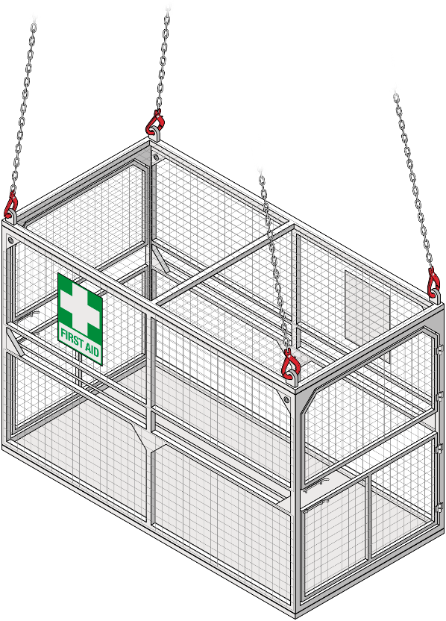
Figure 11 First aid box
Strong winds may affect the safe use of first aid boxes in emergency situations. It is recommended that first aid boxes not be used when wind speeds exceed 54km/hr or in adverse weather conditions such as electrical storms. The use of first aid boxes is more suitable in locations which are less susceptible to windy conditions, such as the side of a building structure which is not as exposed to high winds. First aid boxes should be lifted away from structures to avoid collision.
When wind speeds exceed 54km/hr, alternative emergency retrieval means should be used such as hoists.
When using a tower crane to lift or suspend a work box, the crane should:
- where practicable, be equipped with a secondary back-up system that will prevent the load from falling if the primary lifting device fails
- have a minimum rated capacity of at least twice the total load of the work box and its contents, at the maximum radius for the task to be performed and not less than 1000 kg
- be fitted with an upper hoist limit—anti-two block—that stops operation of the hoist, luff and telescope functions of the crane or be designed so two-blocking cannot damage part of the crane or lifting gear, and
- have levers and foot pedals fitted with a constant pressure system so crane motion stops immediately after the operator removes pressure from the controls.
If the crane is fitted with a free fall facility, this function should be positively locked out to prevent inadvertent activation when lifting a work box.
Where a crane has a brake acting directly on the drum, the braking efficiency of the hoisting drive train should be tested by hoisting and holding a load:
- equivalent to the line pull of the hoist winch, or
- not less than twice the maximum hoisted load.
If the crane will be used to lift other loads this test should be repeated before re-lifting the work box.
During operation of the crane with a work box, the line pull of the hoist winch should not exceed that used in the test.
Find further information on the design and safe use of crane-lifted work boxes in:
- AS 1418.17: Cranes (including hoists and winches) – Design and construction of workboxes,
- AS 2550.1: Cranes, hoists and winches – Safe use – General requirements
- AS/NZS 1891 series – Industrial fall arrest systems and devices.

Overloading when lifting or suspending loads
Before lifting a load, the crane operator or dogger should:
- check the hoist rope hangs vertically above the load
- verify if the marked load mass is correct and not in excess of the crane’s rated capacity
- verify the correct counterweight is correctly mounted and the outrigger settings, where applicable, are in accordance with the load chart being used, and
- control crane movement to stop excessive load swing that may overload the crane.
The crane operator should perform additional checks after the load has been lifted a few centimetres, including:
- ensure the dogger confirms the load remains slung securely, balanced and stable
- test the hoist brakes
- check the mass recorded on the load indicator, and
- recheck the load chart.

Operational wind conditions
You should check the manufacturer’s recommendations on the maximum operational wind speed for the crane. Generally, this maximum is for operating the tower crane only and ignores the load. This means that the safe maximum operating wind may be less then designer or manufacturer recommends.
When lifting or suspending loads in windy conditions, particularly loads with large surface areas, you should ensure a competent person carries out a risk assessment to determine:
- the types of loads that can be lifted under these conditions, and
- the control measures that need to be applied.
You should consult with the principal contractor, crane owner, crane operator, and crane crew to consider:
- load surface area
- size to weight ratio (density) (e.g. a timber wall form will be more easily affected by the wind than a concrete panel of the same frontal area)
- boom length and surface area of the boom, including any attachments
- the ability of the crane’s slew motors and brakes to operate safely in high winds
- the ability of doggers to control load movement, particularly when it is being slung or unloaded
- the ability of the crane operator to see the load, particularly when the load is being slung or unloaded, and
- the effect of wind on crane movement (e.g. slewing against wind or luffing down against wind), which may present a risk of rope bunching on the drum and the boom dropping on rope luffing tower cranes.
Windy conditions increase the risk of crane collapse during climbing operations. Generally, this means the safe maximum wind speed for climbing operations is less than other crane operations. You should check the manufacturer recommendations and ensure a competent person carries out a risk assessment to determine if climbing operations are safe to proceed and what control measures should be applied.

4.7 Remote operation
Many tower cranes may be remotely operated by either hard-wired pendant controls or wireless controls. While this feature can sometimes be an advantage, as it allows the operator to walk around the site, it has also led to incidents where the crane has collided with powerlines or other obstacles because the operator was not located in the best position to view the crane’s load. For this reason, remote controls should generally not be used if the crane is fitted with a cabin.
The reliability of the circuits on the controls should be the same as that achieved by controls in a cabin. Wireless remotes should be uniquely coded to avoid corruption of signals and interference from other devices.
Remotely operated tower cranes including self-erecting tower cranes should have a dedicated operator who is available to operate the crane. A number of competent people should be available to safely complete the lifts especially where there are multiple drop-off points that are out of sight of the operator. Directing a crane operator to move a load that is out of the operator’s view is dogging work. This requires a high risk work licence.
The tower crane operator should remain stationary when the load is in motion. If the tower operator has to move to a different location, the crane should not be operated while moving and the travel path should be free from obstacles, penetrations and other hazards.
If the tower crane operator is undertaking other tasks, the remote control should be turned off and secured to prevent unintended activation of remote functions or other people using the crane, and effective communications should be maintained between the crane operator and other personnel.
If the tower crane operator is a licensed dogger, they cannot perform dogging work while operating the tower crane. More information on dogging work is at the start of this chapter.

4.8 Cranes not in use
WHS Regulation, section 207
Plant not in use
As a person with management or control of plant at a workplace, you must ensure, so far as is reasonably practicable, when a tower crane is not in use that it is left in a state that does not create a risk to the health or safety of any person.
An unattended tower crane may collide with other things, become unstable, or be used by a person not competent to operate it. Except in an emergency due to fire or other life threatening reasons, the crane operator should never leave the crane cabin or controls without adequately securing it.
If a tower crane is to be left unattended, you should ensure:
- the manufacturer’s instructions are followed or, if not available, those of a competent person
- loads are removed from the hook or lifting device
- the hook or lifting device has been secured or raised to a position where it is clear of people, plant, and other things, and will remain clear as the crane moves during weathervaning
- the power supply and controls are isolated and locked off, including remote control equipment
- the keys removed or the starting device locked out, and
- adequate systems are in place to prevent unauthorised access to the tower crane or provide warning of unauthorised access, for example, 2400 mm high boarding with anti-climb screen mesh around the base of the tower crane, a lockable hatch to restrict access to the crane cabin, and fitting of movement detectors, security camera or intruder (back to base) alerts.
If there is no risk of a tower crane boom contacting other structures or things, the crane should be left to weathervane when unattended, according to the manufacturer’s instructions or, if not available, those of a competent person.
If weathervaning is not possible, the crane’s jib should be tethered in accordance with manufacturer’s instructions or those of a competent person.
A warning light visible for up to 60 m should be used that confirms the crane has been placed in weathervane mode. An additional warning light should be used to verify that the jib has been stowed at the angle or radius recommended by the manufacturer’s instructions or as recommended by a competent person such as the commissioning engineer.

- Inspecting and maintaining a tower crane
WHS Regulation, section 204
Control of risk arising from installation or commissioning
WHS Regulation, section 213
Maintenance and inspection of plant
WHS Regulation, section 237
Record of plant
As a person with management or control of a tower crane at a workplace, you must ensure that the processes for the installation, construction, commissioning, decommissioning, and dismantling of a tower crane include inspections that ensure, so far as is reasonably practicable, that risks associated with these activities are monitored.
You must ensure the maintenance, inspection, and if necessary, testing of the tower crane is carried out by a competent person. This must be carried out:
- in accordance with the manufacturer’s recommendations, if any
- if there are no manufacturer’s recommendations, in accordance with the recommendations of a competent person, or
- in relation to inspection, if it is not reasonably practicable to comply with the above, annually.
Earlier chapters discussed specific inspections and testing that should be undertaken:
- pre-erection inspection and testing in Chapter 3
- commissioning inspection and testing in Chapter 3, and
- pre-start and operational checks in Chapter 4.
Tower crane inspection and maintenance should also include:
- routine inspection and maintenance
- annual inspection, and
- major inspection.

5.1 Record keeping
As a person with management or control of a tower crane at a workplace, you must keep a record of all tests, inspections, maintenance, commissioning, decommissioning, dismantling, and alterations of the tower crane while it is used or until you relinquish control of it.
Tower crane records include maintenance logbooks of the significant events concerning the safety and operation of the crane must be kept and readily available. Records should be kept in a suitable format and must be transferred with ownership of the crane. Entries in the maintenance logbook should:
- clearly describe the work carried out and parts replaced
- be dated

- note the name of the person carrying out the work, and
- be signed by the person carrying out the work.
The checks, adjustments, replacement of parts, repairs, inspections performed and irregularities or damage concerning the crane’s safe use must be recorded.
Inspection records should include a statement from a competent person confirming the item of plant has been inspected and whether it is safe to operate until the next scheduled inspection. This should include a reference to the date or other indicator for that future inspection.
Inspection records should include:
- What was looked at – component specification or areas of the plant inspected.
- What was looked for – signs of wear, damage, cracking or corrosion.
- What criteria were used – rejection criteria.
- How was it looked for – techniques used.
- What was found – test results, photographs or measurements.
- What was recommended – repairs required before continued use.
- What recommendations were actioned – recommendations acted upon and date tasks were completed.

5.2 Routine inspection and maintenance
Cranes should be routinely inspected and maintained even if they are not operated regularly, because their condition can deteriorate over time, including from corrosion or damage.
Routine inspection can take place weekly, monthly, or quarterly and should include an inspection of:
- crane functions and the controls for speed, smoothness of operation and limits of motion
- emergency and safety switches and interlocks including limiting and indicating devices
- lubrication of moving parts
- verify accuracy of any load moment indicator (LMI) and rated capacity indicator (RCI) devices with a test lift using a certified test weight
- ensure the effective functioning and calibration of all limiting and indicating devices
- filters and fluid levels and leaks
- visual inspection and measurements as necessary of structural components and critical parts including brakes, gears, fasteners, pins, shafts, wire ropes, sheaves, locking devices and electrical contactors
- signage including warning signs and control markings, and
- extra items nominated in the crane manufacturer’s instructions.
If replacement parts are needed as a result of the inspection, these parts should meet the original part’s specification.
If a tower crane has been damaged and there are risks to health and safety, it should be immediately taken out of service and people prevented from using it. If, however, there is a need for the crane to be operated during maintenance or cleaning and this need cannot be eliminated, risk control measures must be taken to allow the crane to be operated in such a way that any risks to any person carrying out maintenance and cleaning are eliminated so far as is reasonably practicable or, if not, minimised so far as is reasonably practicable.

Annual inspection
An annual inspection may be less comprehensive than a major inspection. It should include every item specified by the crane manufacturer for annual inspection and every item included in the routine inspection and maintenance programs.
Annual inspections should include a detailed check of:
- functioning and calibration of limiting and indicating devices
- structural and wear components
- tolerances for wear limit
- evidence of corrosion
- critical areas for evidence of cracking, and
- relevant items in the pre-erection inspection and tests that can be safely completed while the crane is erected.
Where a tower crane owner is aware a crane will be erected when the scheduled annual inspection falls due, the owner should carry out an annual inspection during the pre-erection inspection.
As part of annual inspections, any manufacturer’s or supplier’s safety alerts or product advisory bulletins applicable to the crane should be addressed. Any such additional inspection or maintenance requirements are considered part of the manufacturer’s maintenance requirements.
Appendix D: Example - Annual crane safety certificate may be used as evidence that the crane has received an annual safety inspection by a competent person.

5.3 Major inspection
WHS Regulation, section 235
Major inspection of registered tower cranes
As a person with management or control of a registered tower crane at a workplace, you must ensure that a major inspection of the tower crane is carried out:
- at the end of the design life recommended by the crane manufacturer
- if these recommendations are not available, in accordance with the recommendations of a competent person, or
- if neither of these are not reasonably practicable, every 10 years from the date the crane was first commissioned or registered, whichever occurred first.
You must ensure that a major inspection is carried out by, or under the supervision of, a competent person.
Under the WHS Regulations, a competent person means a person who has acquired through training, qualification or experience the knowledge and skills to carry out the task. For major inspection of tower cranes, a competent person must also be registered under a law that provides for the registration of professional engineers. A WHS regulator can also determine a person to be a competent person.
As part of major inspections, any manufacturer’s or supplier’s safety alerts or product advisory bulletins applicable to the crane should be addressed. Any such additional inspection or maintenance requirements form part of the manufacturer’s maintenance requirements.
Appendix E: Example - Crane safety certificate – major inspection may be used for by an engineer to document as evidence that the crane has received its major inspection.

Items requiring inspection
A major inspection means an examination of all critical components of the crane, if necessary by stripping down the crane and removing paint, grease and corrosion to allow a thorough examination of each critical component, and a check of the effective and safe operation of the crane. The competent person carrying out or supervising a major inspection should determine what is examined and how.
Where there is documented evidence that inspection and testing has been carried out on certain items, for example slew ring bolts, drive systems and braking systems, within a reasonable preceding period as determined by a competent person, the item may not have to be stripped down in the major inspection. The competent person should still inspect the safe operation of the item to certify it is operating safely and document the reasons for the decision.
Suggested inspection methods are listed below. Some of the items may not apply, for example where the item does not exist on the crane.

Slew ring
- Remove the slew ring bolts and split the slew ring.
- Measure the wear in the slew ring.
- Replace worn bearings and spacers.
- Carry out non-destructive testing and repair of bearing race.
- Measure the backlash and teeth width in the pinion drives and ring drive to ensure they are within the manufacturer’s specifications.
- If the manufacturer specifies that slew ring bolts can be reused, the bolts are crack tested by non-destructive testing, or replace all bolts with new bolts.

Hydraulic motors
- Remove, strip down and inspect all hydraulic motors.
- Replace all worn valves and other components where measurement identifies wear has exceeded the manufacturer’s fail criteria.
- Ensure tolerances comply with manufacturer’s specifications prior to reassembly.
- Ensure motors are pressure and performance tested prior to re-entering service.

Hydraulic pumps
- Remove, strip down and inspect all hydraulic pumps.
- Replace all worn valves and other components where measurement identifies wear has exceeded the manufacturer’s fail criteria.
- Ensure tolerances comply with manufacturer’s specifications prior to reassembly.
- Ensure pumps are pressure and performance tested prior to re-entering service.

Valve blocks (bodies)
- Remove, strip down and inspect all valve blocks.
- Replace all worn valves and other components.
- Ensure tolerances comply with crane manufacturer’s specifications prior to reassembly.
- Ensure valves are pressure and performance tested prior to re-entering service.

Hoist and luff drums
- Remove luff drums and replace drive shaft bearings as required.
- Inspect grooves on the luff drum.
- Inspect the drive pinions for wear and correct allowable backlash.
- Replace drive pinions if the tolerances are outside of the manufacturer’s specifications.
- Inspect rope anchor points to ensure they are correct for rope dimensions.

Braking systems
- Remove and dismantle all brakes from the crane.
- Check pins, springs and bushes for correct tolerance.
- Replace rubber seals.
- Check pistons for correct operation.
- Ensure welds in braking systems are crack tested by non-destructive testing.
- Inspect hydraulic systems for leaks prior to reassembly on the crane.
- Inspect wear limits on brake linings.

Rope sheaves
- Remove all rope sheaves and replace bearings as necessary.
- Check sheave groove size and replace the sheave if it is outside of the manufacturer’s specifications.
- Inspect sheaves for cracking, alignment and damage.
- Replace synthetic sheaves if recommended to do so by the sheave manufacturer.

Hydraulic luffing cylinder
- Remove cylinder and ram from the crane and strip the cylinder and valve blocks.
- Ensure gland nuts are crack tested and threads are checked for wear.
- Replace seals and re-chrome ram where necessary.
- Ensure the reassembled cylinder is pressure tested and checked for operation and leaks.
- Ensure welds on rod ends and caps are crack tested by non-destructive testing.

Gear boxes and drive shafts
- Remove and dismantle gear boxes, drive shafts and flexible couplings to the extent that a thorough inspection is possible.
- Replace worn and damaged bearings and gears.

Boom
- Ensure all non-destructive testing on boom components required in the pre-erection tests is carried out.
- Ensure ultrasonic chord thickness of boom is performed.
- Ensure a minimum of 10% of lacing welds on each boom section are crack tested by non-destructive testing. If any cracks are found, ensure all lacing welds on the boom section are tested.

A-frame
- Remove all pins.
- Ensure non-destructive testing is carried out on all connector welds on primary chords.
- Ensure a minimum of 10% of lacing welds are crack tested by non-destructive testing.

Pins with moving parts (e.g. Boom heel pins, ram pins)
- Remove and inspect all pins with moving parts.
- Measure the diameter of the pin and bush to ensure it is within the manufacturer’s tolerance. If not, the pin must be re-machined or replaced and the bush replaced.
- Inspect restraint systems (that is, cheek plates) and grease nipples.

Static pins
- Remove and inspect all static pins.
- Repair pins if necessary.

Steel wire ropes
- Inspect all ropes for wear, including hoist, luff, pendant, trolley and counterweight ropes.
- Ensure ropes are only replaced with the type of rope specified by the crane manufacturer unless a competent person specifies otherwise.
- Inspect pins and terminations on pendant ropes.

Electrical systems
- Ensure a qualified and licensed electrician inspects switchboards, wiring, motors and other electrical components in accordance with AS 3000: Electrical installations and other relevant standards.
- Replace damaged or worn components.
- Ensure sign-off is provided by the electrician.

Control systems
- Ensure electrical control systems and components are inspected by a competent person.
- Replace damaged or worn components.
- Ensure sign-off is provided by the competent person.

Electric motors
- Remove and dismantle electric motors from the crane.
- Inspect brushes, bearings, switches and motor wiring for damage and wear.
- Inspect splines and shaft keyways for wear and cracks.
- Ensure sign-off is provided by the competent person.

Hook trolley (non-luffing cranes)
- Inspect hook trolley wheels for damage and wear.
- Replace hook trolley wheels if necessary.
- Ensure welds on the trolley are crack tested by non-destructive testing.

Hook assembly
- Dismantle and dimensionally inspect the hook assembly to ensure it is within the manufacturer’s specifications.
- Ensure the hook is crack tested by non-destructive testing.

Actions following a major inspection
The competent person who carried out or supervised the major inspection should provide a written report with the results of the major inspection to the person with management or control of the tower crane. This includes making recommendations of what needs to be done to ensure the tower crane can be safely operated, for example, upgrading the crane to comply with relevant technical standards. The competent person should state the period by which the next major inspection is due for the tower crane.
Completion of a major inspection does not indicate that the components inspected will have a further 10-year life. It should not be assumed that the items included in the list only require inspection at 10-yearly intervals. Items will require some type of inspection and maintenance at more frequent intervals, for example, at annual and other inspection intervals, according to the manufacturer’s instructions.

5.4 Non-destructive testing of tower crane components
Non-destructive testing (NDT) is the testing of materials to detect internal, surface and concealed defects, cracks, breaks or gaps using methods which do not damage or destroy the material being tested.
As a person with management or control of a tower crane at a workplace, you must ensure any necessary testing is carried out by a competent person. This includes ensuring the person performing NDT has suitable knowledge and experience in NDT methods and is able to determine the appropriate NDT method for the component being tested.
When using magnetic particle NDT to detect cracks in metals, remove the paint from the metal surface. This is not required for Eddy current NDT.
NDT of specific tower crane components should take place according to the manufacturer’s instructions and at set intervals, for example, pre-erection tests and major inspection. Table 1 recommends minimum frequencies for some common NDT of particular crane components.
Table 2 Minimum frequency of NDT of particular crane components
Component tested | NDT description | NDT frequency
Boom clevises | Crack test | Pre-erection
Counterweight sheave bracket welds – moving counterweights only | Crack test | Pre-erection
Cruciform welds – luffing cranes only | Crack test | Pre-erection
Butt heal bosses – luffing cranes only | Crack test | Pre-erection
Band brake welds | Crack test | Pre-erection
Slew ring bolts – where slew ring must be split at disassembly | Crack test | Pre-erection
Tower bolts (where applicable) | Crack test minimum 10% bolts | Pre-erection
Boom lacing welds | Crack test minimum 10% | Pre-erection
Tower sections | Crack test minimum 10% | Pre-erection
Aluminium sheaves | Crack test | Pre-erection
Slew ring bolts – slew rings | Crack test bolts | 5 years
Boom chord thickness | Material thickness testing | 10 years
Slew ring | Crack test | 10 years
Hydraulic luffing cylinder gland nut | Crack test | 10 years
Hydraulic luffing cylinder and ram-rod ends and caps | Crack test | 10 years
A-frame – connector welds on primary chords | Crack test | 10 years
A-frame lacing welds | Crack test minimum 10% | 10 years
Hook | Crack test | 10 years
Welds on hook trolley | Crack test | 10 years

Crack testing of booms and counterweight sheave bracket welds
Booms on non-self-erecting tower cranes are connected by pins passing through male and female clevises on the ends of each boom section. Every weld on male and female clevises on the ends of every boom section should undergo NDT before each crane erection for non-self-erecting cranes. Magnetic particle testing is the usual method used for performing these tests.
Counterweight sheave bracket welds, butt heal bosses and welds in cruciform area on luffing crane booms are known to crack and should also be crack tested by NDT before each crane erection.

Crack testing of band brakes
Older designs of luffing tower cranes use band brakes. On some of these cranes, the steel band is welded to an end fitting that has a pin passing through it. These welds have been known to crack.
You should crack test the weld between the band and the end fitting by NDT before each time a luffing tower crane fitted with band brakes is erected, keeping in mind there may not be a weld on some brake bands.

Crack testing of slew ring bolts
The integrity of slew ring bolts is critical for making sure both the machine deck and boom remain attached to the tower. Once removed, slew ring bolts should be replaced unless the manufacturer’s instructions state they can be reused. If bolts can be reused, they should be tested.
For tower cranes where the slew ring needs to be split each time the crane is moved, and for which the manufacturer allows the slew ring bolts to be re-used, all bolts should undergo NDT. Where each bolt has a unique identifier marking, the number of bolts to be tested can be reduced to 10 per cent of the total number of bolts. In such cases, bolts to be tested should be selected from the slew ring by a competent person, and different bolts should be tested prior to each erection until all bolts have been tested.

Crack testing of tower bolts or pins
Tower bolts or pins are a critical part of the crane and permit the effective transfer of load from the crane boom to the crane base. Tower bolts or pins can become damaged, and their effective life can be reduced if the bolts are either under or over-torqued. Some tower bolts are made from extremely high grade steel and can be more susceptible to cracking.
Unless the manufacturer’s instructions state tower bolts can be reused, they should be replaced prior to each erection. If tower bolts can be reused, crack test a minimum of 10 per cent by NDT before each crane erection. If any cracks are detected, all bolts should be tested.
A system that makes sure all tower bolts or pins are tested over time is preferred. However, a random system of testing can also be used. The tested bolts should be identified by a method that does not damage the bolt.

Chord thickness testing
Steel lattice-type tower crane booms can be prone to internal and external corrosion affecting the thickness of the boom. The thickness of the chord wall can be reduced through abrasive blasting of the boom.
Main chord sections on tower crane booms should undergo thickness testing at intervals not exceeding 10 years. Ultrasonic thickness testing is one method of verifying the strength in the chords of the boom.
Review chord sections for structural adequacy when the thickness is shown by testing to be 90 per cent or less than 90 per cent of the original thickness.

Appendix A—Glossary
Term | Description
Boom | A member, attached to the crane structure, from which the load is suspended and which may be luffed, telescoped or slewed.
Competent person | A person who has acquired through training, qualification or experience the knowledge and skills to carry out the task.  For the purpose of conducting major inspections of tower cranes, a competent person must:  have the skills, qualifications, competence and experience to inspect the plant, and be registered under a law that provides for the registration of professional engineers in jurisdictions where such a law exists, or  be determined by the regulator to be a competent person.
Counterweight | A weight added to a crane or appliance in such a position to assist stability.
Crane | An appliance intended for raising or lowering a load and moving it horizontally including the supporting structure of the crane and its foundations, but does not include any of the following:  (a) an industrial lift truck;  (b) earthmoving machinery;  (c) an amusement device;  (d) a tractor;  (e) an industrial robot;  (f) a conveyor;  (g) building maintenance equipment;  (h) a suspended scaffold;  (i) a lift
Dogging work | The application of slinging techniques, including the selection and inspection of lifting gear, to safely sling a load; or  the directing of a plant operator in the movement of a load when the load is out of the operator’s view.
Duty holder | Any person who owes a work health and safety duty under the WHS Act including a person conducting a business or undertaking, a designer, manufacturer, importer, supplier, installer of products or plant used at work (upstream duty holder), officer or a worker.
Hammerhead | A slewing non-luffing horizontal jib.
Jib | A member, attached to the crane structure, from which the load is suspended and which is not capable of being luffed while the crane is handling a load.
Load chart | A notice fitted on a crane specifying the rated capacities as supplied by the manufacturer.
Load moment system indicator | A system which indicates visually or audibly, or both, to the operator when the rated capacity is approached and reached.
Luffing | Angular movement of a crane boom or jib, in a vertical plane.
May | ‘May’ indicates an optional course of action.
Must | ‘Must’ indicates a legal requirement exists that must be complied with.
Officer | An officer under the WHS Act includes:  - an officer under section 9 of the Corporations Act 2001 (Cth)  - an officer of the Crown within the meaning of section 247 of the WHS Act, and  - an officer of a public authority within the meaning of section 252 of the WHS Act.  A partner in a partnership or an elected member of a local authority is not an officer while acting in that capacity
Person conducting a business or undertaking (PCBU) | A PCBU is an umbrella concept which intends to capture all types of working arrangements or relationships.  A PCBU includes a:  - company  - unincorporated body or association  - sole trader or self-employed person.  Individuals who are in a partnership that is conducting a business will individually and collectively be a PCBU.  A volunteer association (defined under the WHS Act, see below) or elected members of a local authority will not be a PCBU.
Person with management or control of plant at a workplace | A person conducting a business or undertaking to the extent that the business or undertaking involves the management or control of fixtures, fittings or plant, in whole or in part, at a workplace.
Rated capacity | The maximum gross load which may be applied to the crane or lifting attachment while in a particular working configuration and under a particular condition of use.
Self-erecting tower crane | A crane that is not disassembled into a tower element and a boom or jib element in the normal course of use, and where erecting and dismantling processes are an inherent part of the crane’s function.
Should | ‘Should’ indicates a recommended course of action.
Tower | Part of a structure which provides elevation and support for the boom, jib mounting or platform.
Tower crane | A crane that has a boom or a jib mounted on a tower structure.  For high risk work licensing purposes, a tower crane, if a jib crane, may be a horizontal or luffing jib type and the tower structure may be demountable or permanent, but ‘tower crane’ does not include a self-erecting tower crane
Tower section | A standardised interchangeable structural component used to support a crane.
Work box | A personnel carrying device, designed to be suspended from a crane, to provide a working area for a person elevated by and working from the device.
Work positioning system | Any plant or structure, other than a temporary work platform, that enables a person to be positioned and safely supported at a location for the duration of the relevant work being carried out.
Worker | Any person who carries out work for a person conducting a business or undertaking, including work as an employee, contractor or subcontractor (or their employee), self-employed person, outworker, apprentice or trainee, work experience student, employee of a labour hire company placed with a ‘host employer’ or a volunteer.
Working load limit (WLL) | See ‘rated capacity’.
Workplace | Any place where work is carried out for a business or undertaking and includes any place where a worker goes, or is likely to be, while at work. This may include offices, factories, shops, construction sites, vehicles, ships, aircraft or other mobile structures on land or water.

Appendix B—References and other information sources
Australian/New Zealand Standards
AS 1353.2–1997: Flat synthetic-webbing slings – Care and use
AS 1418.1–2021: Cranes, hoists and winches – General requirements
AS 1418.4–2004: Cranes, hoists and winches Part 4: Tower cranes
AS 1418.17–1996 (R2016): Cranes (including hoists and winches) – Design and construction of workboxes
AS/NZS 1891.2–2001: Industrial fall-arrest systems and devices – Horizontal lifeline and rail systems
AS 1891.4–2009: Industrial fall-arrest systems and devices – Selection, use and maintenance
AS 2550.1–2011: Cranes, hoists and winches – Safe use – General requirements
AS 2550.4–2004: Cranes, hoists and winches – Safe use, Part 4: Tower cranes
AS 2550.20–2005 Cranes, hoists and winches – Safe use – Self-erecting tower cranes
AS 2759–2004: Steel wire rope – Use, operation and maintenance
AS 3775.2–2014: Chain slings – Grade T and V– Care and use
AS/NZS 4024 (Series): Safety of machinery
AS 4497.2–1997: Round slings – Synthetic fibre – Care and use
AS 4991–2004: Lifting devices
AS/NZS 62061–2019: Safety of machinery – Functional safety of safety-related electrical, electronic and programmable electronic control systems
Available from:
SAI Global Limited
Tel: 131 242
Email: sales@saiglobal.com
Website: https://www.saiglobal.com
Other information sources
Code of Practice: How to manage work health and safety risks
Code of Practice: Work health and safety consultation, cooperation and coordination
Code of Practice: Managing the risks of plant in the workplace
Code of Practice: Construction Work
Code of Practice: Managing psychosocial hazards at work

Appendix C: Familiarisation training checklists
Electric tower crane
Crane make and model used for training:
The operator demonstrated the ability to correctly perform and operate the following on the first or on the second (or follow up) occasion:
 | 1st | 2nd |  | 1st | 2nd
- Seat adjustment |  |  | - Hoist limiter
- Control identification (levers and switches) and operation |  |  | - Slew lock pin
- Warning devices (including horn) |  |  | - Anti-collision device operation (where fitted)
- Slew lock |  |  | - Maximum wind speed
- Load charts |  |  | - Electricity isolating switch
- Load chart (capacity at radius) |  |  | - Safety inspection:  - ropes  - rams  - wire rope wear of pads/sheaves  - boom  - grease points  - fluid leaks  - fluid levels  - brakes  - cabin visibility  - lights  - tower bolts  - slew ring bolts  - fall-arrest harness and lanyard  - boom pins and retainers
- Load chart (variations for different boom lengths)
- Load chart (variations for different rope
- falls)
- Rated capacity limiter
- Rated capacity limiter – features
- Rated capacity limiter – set up and operation
- Rated capacity limiter – relationship to load chart
- Rated capacity limiter – override procedures
- Rated capacity limiter – digital display
- Slew function
- Luff function (where applicable)
- Trolley function (where applicable)
- Hoist function |  |  | - Platform and tower edge protection
- Slew brake |  |  | - Cable drum and cable guide
- Slewing ring ball races |  |  | - Hoist, travel and trolley brakes
- Slipring unit |  |  | - Fluid couplings
- Wheel bogies |  |  | - Fire control procedures and equipment

Worker statement:
I have received instruction in the operation, maintenance, inspection and safe use of this crane.
I understand its safety features and how to carry out pre-operation, daily routine and logbook checks.
I understand the manufacturer’s instructions and guidelines for the safe operation and driving of this crane.
I confirm I am able to safely operate this crane and I agree to comply with safety instructions.
In the event of being unsure of a task, I will request further training or instruction before performing the task.
Worker name:
Worker signature: Date:
PCBU representative name:
Signature: Date:

Diesel hydraulic tower crane
Crane make and model used for training:
The operator demonstrated the ability to correctly perform and operate the following on the first or on the second (or follow up) occasion:
 | 1st | 2nd |  | 1st | 2nd
- Seat adjustment |  |  | - Re-fuelling procedure
- Gauge and indicator function |  |  | - Anti-collision device operation (where fitted)
- Control identification (levers and switches) and operation |  |  | - Grease applications for ropes, pinions, slew rings and sheaves
- Warning devices (including horn) |  |  | - Engine/gearbox/hydraulic tank levels and site gauges
- Slew lock |  |  | - Isolator switches locations and functions
- Free slew procedure |  |  | - Weather vane radius (based on engineer design drawings and other possible plant)
- Load charts |  |  | - Safety inspection:  - ropes  - rams  - wire rope wear pads/rollers  - boom  - grease points  - fluid leaks  - fluid levels  - brakes  - cabin visibility  - lights  - tower bolts  - slew ring bolts  - boom pins and retainers
- Load chart (capacity at radius)
- Load chart (variations for different boom lengths)
- Load chart (variations for different rope falls)
- Rated capacity limiter
- Rated capacity limiter – features
- Rated capacity limiter – set up and operation
- Rated capacity limiter – relationship to load chart
- Rated capacity limiter – override procedures
- Rated capacity limiter – digital display
- Slew function |  |  | - Maximum wind speed
- Luff function |  |  | - Anti-cavitation switch, operations and functions
- Luff brake |  |  | - Platform and tower edge protection
- Hoist function |  |  | - Fire control procedures and equipment
- Slew brake |  |  | - Hoist/luff decal and ultimate limit functions (radius and height they are set at)
- Operation and control of slew brake controls, luffing lever controls, hoisting lever and winch clutches |  |  | - Cabin control panel annunciator functions and warning signals
- Hoist limiter |  |  | - Sludge tank taps and functions
Worker statement:
I have received instruction in the operation, maintenance, inspection and safe use of this crane.
I understand its safety features and how to carry out pre-operation, daily routine and logbook checks.
I understand the manufacturer’s instructions and guidelines for the safe operation and driving of this crane.
I confirm I am able to safely operate this crane and I agree to comply with safety instructions.
In the event of being unsure of a task, I will request further training or instruction before performing the task.
Worker name:
Worker signature: Date:
PCBU representative name:
Signature: Date:

Appendix D: Example - Annual crane safety certificate

Certificate no.:

Crane type: Crane manufacturer:

Crane serial no.: Design registration no.:

Design/Plant registration no.: Manufacture date:

Owner’s name:

Address:

Inspection date:

Name of competent person:

Address of competent person:

Telephone number:

Qualifications of competent person (e.g. professional engineering qualification, membership of professional organisation, crane industry experience, other tertiary qualifications, trade qualifications):

Inspector identification number:

Competent person statement:
I hereby certify that the crane, serial number: , has received its annual safety inspection in accordance with the instructions of the crane designer and manufacturer, and with relevant Australian Standards, and is safe to use.

Competent person signature: Date:

Comments:

Appendix E: Example - Crane safety certificate – major inspection

Certificate no.:

Crane type: Crane manufacturer:

Crane serial no.: Design registration no.:

Design/Plant registration no.: Manufacture date:

Owner’s name:

Address:

Inspection date:

Name of competent person:

Address of competent person:

Telephone number:

Professional Engineer (if relevant) number:

Competent person statement:
I hereby certify that the crane, serial number: , has received its major safety inspection in accordance with the instructions of the crane designer and manufacturer, and is safe to use. This inspection includes mechanical, structural and electrical items of the crane.

Competent person signature: Date:

Comments:

Amendments
This code of practice: Tower Crane has been amended as:
Date | Purpose
Notified 8 September 2022 | First publication – ACT Tower Crane Code of Practice
Current | Revised to adopt model Tower Crane Code of Practice as published by SWA 19 June 2023

