Australian Capital Territory
Public Roads (Phillip) Closure Declaration 2025
R14/25
Notifiable instrument NI2025–283
made under the
Public Roads Act 1902, s 20 (Closing of roads)

1 Name of instrument
This instrument is the Public Roads (Phillip) Closure Declaration 2025.
2 Commencement
This instrument commences on the day after its notification day.
3 Closure of road reserve
I declare the parts of Bowes Street and Bradley Street road reserves, indicated in the schedule by grey shading, to be closed.
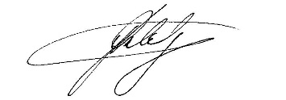
Greg Ledwidge
Delegate of the Minister for Planning and Sustainable Development
28 May 2025

